

Assessment 1 – Reading Task Template
PART 1: Upload your photo of your A3 in-class notes here:
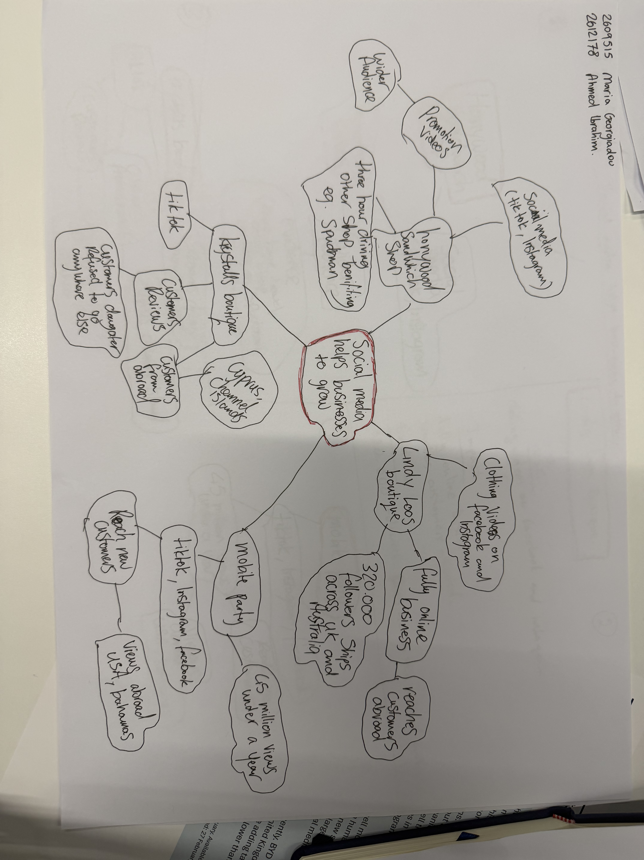

PART 2:
- Answer every question below in 1-3 full sentences.
- Use your own words. Do not use generative AI to answer these questions.
- Include a specific detail from the text when asked.
REMINDER
- The main idea is the overall message of the whole text.
- A key point helps to explain the main idea.
- A specific detail or example from the text shows that the key point is true.

- What is the main idea of the whole text?

The basic idea is that social media helps businesses to grow by promoting their products and reaching more customers.

- What is one key point that supports the main idea, and which specific example from the text shows this?

One key point is that social media can help a company’s reach customers in different locations. Lindy Loos Boutique boasts 320,000 followers and ships orders all over the UK and Australia.

- What is a different key point that supports the main idea, and which specific example from the text shows this?

Another important point is that videos can popularise a business and attract new customers. For instance, the Mobile Party got 45 million views in under a year.

- Which part of the text do you think is most important, and why?

I believe the Mobile Party example is the most important one because 45 million views show quickly social media can help a business to become popular and reach new customers.

Reflection:
- What did you find difficult in this task (including in-class components), and why was it difficult?

The main points were difficult for me to choose and to connect examples to.
There was a variety of different businesses and details in the mind map.

- What helped you with this difficulty, and how did it help you?

The mind map helped me because it helped organise the main idea, key points and examples. That made it easier to choose information for my answers.

