Lampeter Railways: The Rise and Fall of the Lampeter Railway

(1) Lampeter During the late 1800’s:
(1.1) Industry and economy
(1.2) County location and population
(1.3) Transport

(2) The Construction:
(2.1) Railway Company
(2.2)Economy
(2.3) Local Impacts

(3) Important uses:
(3.1) WWII evacuees
(3.2) Dalis Fair

(4) The Fall:
(4.1) Economy
(4.2) Local Impacts
(4.3) Future initiatives

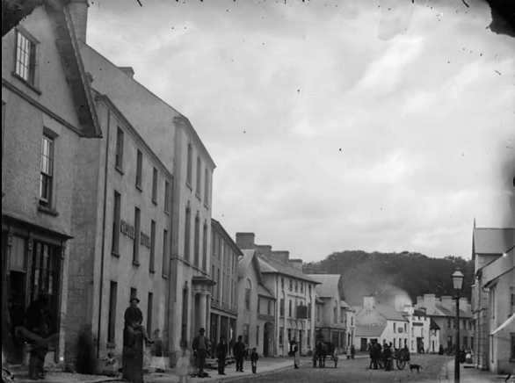
- Lampeter During the 1800’s:

  - Industry and Economy
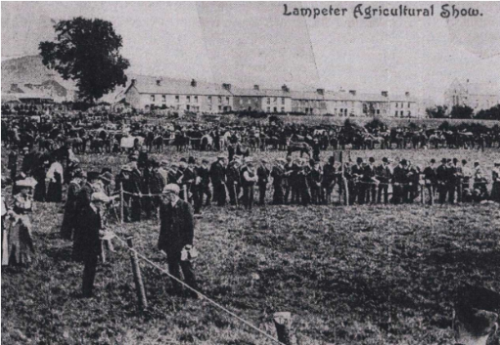
Lampeter’s industry was primarily based in agriculture with additional interests from animal husbandry specifically in cattle and sheep farming, producing business in dairy and meat production. It is evident in the 1881 census (Vision of Britain, n.d.) that agriculture was a profitable occupation for the area with 265 individuals taking part in it and rich farmland surrounding the town. Buyers from north and south would be showcased with the farm's merchandise at local markets or shows held by the council, increasing outsider investment in Lampeter’s economy (Ceredigion History, n.d.). The construction of the University buildings and subsequent buildings such as the Canterbury building in 1890 led to an increase in employment for staffing and construction work (Torode, 2023). Moreover, the establishment kept an influx of students coming each year (Torode, 2023) which allowed for businesses to profit off the students and therefore adding money into the economy of the town. The use of the railway added to the accessibility of the markets, shows and job opportunities for those outside of Lampeter with a steady income from the use of such transport (the purchase of tickets or farmers using it to transport animals ( British Film Institute, 1914)).
Figure 2: Lampeter Agricultural Show
Figure 1: Lampeter 1875

  - County location and population
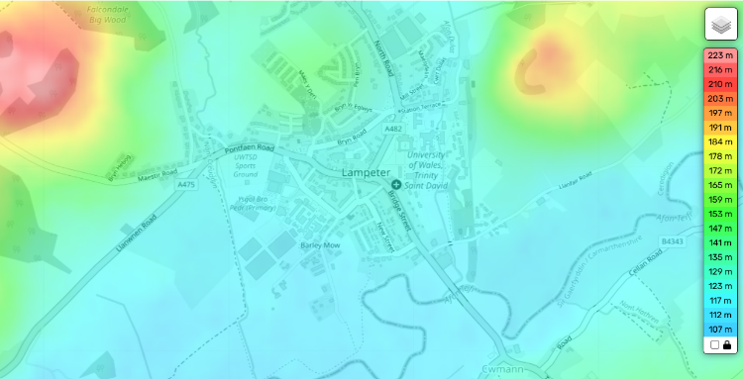
Lampeter sits on the border of Ceredigion, historically Cardiganshire, nearest Carmarthenshire. Ceredigion itself neighbours Gwynedd to the north, Powys to the east, Carmarthenshire and Pembrokeshire to the south and the coasts of the Irish sea (Ceredigion History, n.d.). Lampeter for a majority of its life has been a small farming community that spanned a growing population of an estimated 2,700 to 3,000 in the years 1861 to 1911 (Vision of Britain, n.d, ‘Total Population’). Lampeter hands itself to agriculture due topographic characteristics of hills, valleys, woodland and rivers and streams (Topographic Map, n.d.). The hilly landscape of the area allows for natural drainage and therefore creates an ideal space for farming. Additionally, the nutrient rich soils from the rainfall to the decomposition of plant and animal matter also create a model environment for farmers (Welsh Government, 2022) . Furthermore, despite the rural nature of the town, Lampeter has been connected to main road or trail lines since the 18th and 19th century due to the increase in development linked to transport infrastructure around the UK (Bogart, 2004), however, there is also evidence of smaller roads since the 12th century (Genuki, 2000).
Figure 3: Topographic Map of Lampeter

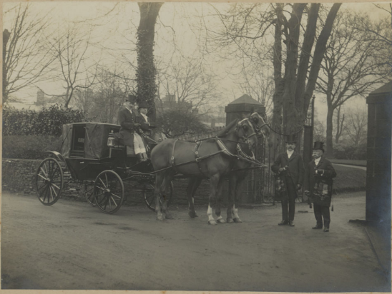

  - Transport
Transport in the late 1800’s had not yet implemented the common use of cars (History.com, 2018), rather horse and carts were still in practice in everyday life. Due to Lampeter’s rural status, modes of transport such as farm wagons, stagecoaches (BBC, 2006) and buggies would have been commonplace and used for both work and travel . It was not until the 1920’s where cars became more accessible and used more liberally, as shown in maps where the first recordings of roads began in the 1920’s (Francis Frith, 1923). However, it was not until the train line’s construction that transport to Lampeter became more streamlined.
Figure 4: Thomas Morgan outside of UWTDS gates

- The Construction

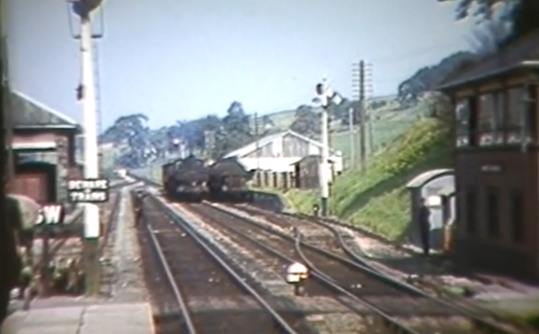
  - The Railway Company
Manchester and Milford Railway Company was incorporated in 1860 by the Manchester and Milford Railway Act passed by UK parliament on the 23rd July, however, the concept for the line was thought of in 1954 (Welsh Railways Research Circle, n.d.). This act allowed for the company to construct a rail line between Pencader in Carmarthenshire to Lampeter (which they did in 1866) and would later be connected to Aberystwyth in 1867 in order to connect Manchester to Milford Haven on the coast. The company was originally owned by private investors and shareholders who funded the operations, however, after financial distress they were leased to the Great Western Railway (GWR) company in 1906 before being fully absorbed by them in 1911 (Alchetron, 2024). During the time of GWR ownership they implemented the New Quay Light Railway which was built in April 1911 to improve transportation from Lampeter to Aberaeron, however, an extension into New Quay was not achieved due to financial constraints (The Cambrian, 1905). In 1964 flooding damaged tracks and caused the closure of lines north of Strata Florida, the companies lack of funding caused them to close the lines to the public officially in 1965 and fully in 1973 after being used for the transport of dairy from Felin Fach (Alchetron, 2024). Stations closed were shut down and defunded while others were repurposed and used by other train lines such as the Vale of Rheidol Railway company that uses the bay at Aberystwyth (Alchetron, 2024).
Figure 5: The Lampeter Station

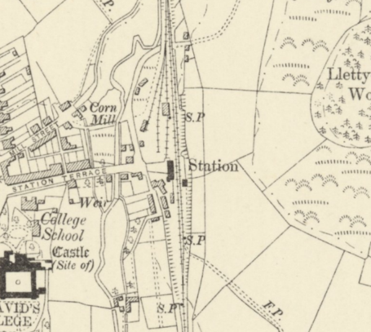
  - Economy
Economically the company had never had a surplus amount of money, rather at the creation of the train lines the money was gathered by investments and loans. Such as the loan from Frederick Beeston in which he paid £30,000 towards the construction of a section of the railway in return for instalments from the company due to their lack of funds (Alchetron, 2024). Before the Pencader to Lampeter rail was opened the company’s underfunding was unable to pay for the laying down of a necessary third rail in order for the line to conduct (due to an 1865 act); having to get their own contractor to finish the line before it was opened in 1866 (Trawslink Cymru, n.d.). Overall the company spent £700,000 on the construction of the line and an extra £75,000 on the Llangurig section, however having only 3 trains a day from Monday to Friday did not gain a large income (Alchetron, 2024). As a result of false claims to the public the company used other train lines in return for a fee, however, they were unable to pay back on their agreement leading to the company being sued and owing Cambrian Railways £62,500 by 1875- causing them to fall into receivership (Alchetron, 2024).
Figure 6: Map of Lampeter Railway 1888- 1913

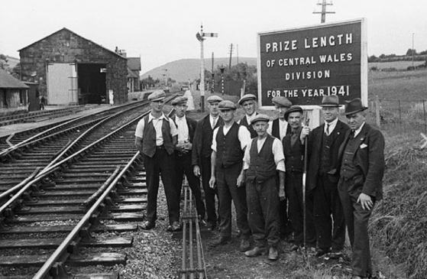
  - Local Impacts
Figure 7: Railway Workers in Lampeter
The railway's construction had a large impact on Lampeter both socially and economically, with it providing not only work but also allowed for residents to seek work outside of Lampeter- opening larger opportunities for people (Trawslink Cymru, n.d.). As the first large locomotive in the area it allowed for people to travel faster, additionally it reduced the need for horse drawn carts for common use such as stage coaches. Furthermore, there was opposition from certain trades such as the timber, mineral and coal trades in which they believed that it may cause disruption to traffic (Ceredigion Archives, 1862).

- Important Uses:

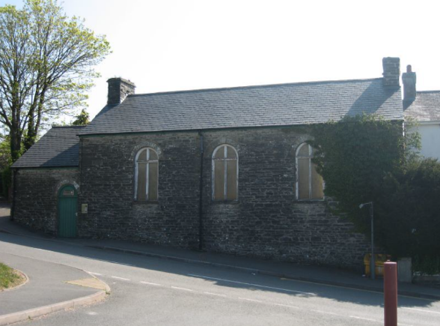
  - WWII Evacuees
During the second world war the railway was used to transport 330 evacuees into Lampeter on July 8 1944, stopping at the Grammar school before transporting them further into the Welsh countryside away from the V-1 bombings (Camden New Journal, 2019). The children were from Kentish Town in London and used the Paddington Station to travel into Wales where they were given refreshments (Camden New Journal, 2019). Despite their short lived stay in Lampeter having been taken further into the country and then returne d the following year, the railway played a key role in the protection of many children and women during the war.
Figure 8: Lampeter Grammar School

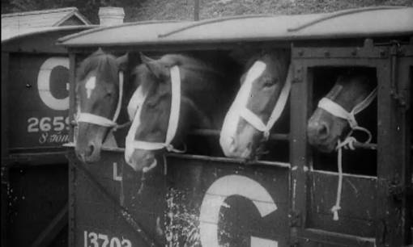
  - Dalis Horse Fair
The Dalis Horse Fair in May 1914, just a few months before World War I, was a multi-day show that promoted the buying and selling of horses and cattle (BFI, 1914). Farmers came from across Wales to sell their horses or to organise horse breeding, this was possible with the train carriages designed to hold animals (BFI, 1914). This big fair created a boost in the Lampeter economy with horses being sold at £10 to £20, which would convert to around £1,474 to £2,300 today (The Cambrian News, 1900). Local farmers were able to accommodate the demand for horses and there were prompts for Lampeter to begin increasing the business on horse breeding from the paper (The Cambrian News, 1900).
Figure 9: Horses from the fair being loaded into the train to leave

- The Fall:

  - Economy
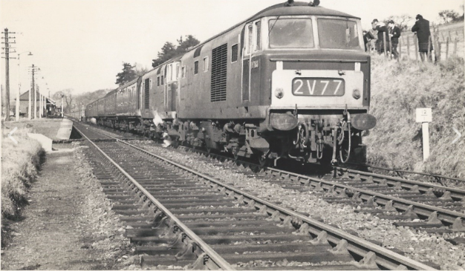
The Great Western Railway company took responsibility for building back up the Manchester and Milford Railway line by spending £57,000, however, the company was also in debt from loans and interests for around £400,000 (Alchetron, 2024). This led to the absorption of the organisation in 1911 and therefore the end of the company. Government action was the final push that closed the lines to the general public in 1965 with the Beeching axe cuts that were implemented to cut costs from train lines that were financially failing and modernise the railways in general (National Archives, 2013). After a history of economic problems the railway closed its lines in 1966.
Figure 10: Last passenger train to leave from Lampeter to Carmarthen
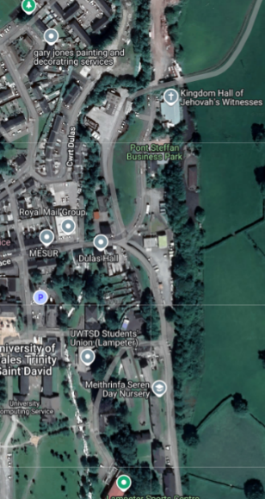
  - Local Impacts
As a result of the closure the factors that improved Lampeter’s reach and business would be effectively knocked, this includes things such as the transport for students and the farmers using it to transport livestock or horses. Shows such as the Agricultural Society show, which began in 1877 (Lampeter Show, n.d.), and the local markets became less accessible to the rest of Wales, decreasing the economic impacts these organisations put into Lampeter. Additionally, the closure of the rail line led to the unemployment of those who worked on the trains and in the stations, the closure negatively affected the town.

Figure 11: Present Train line in Lampeter
  - Future Initiatives
In 2015 the idea of revitalising the Aberystwyth-Carmarthen line emerged with the discovery that 97% of the original track bed was still clear and possibly functional (Nation.Cymru, 2023). Three years later a report suggested a proposed route that would pass through Pencader, LLanybydder, Lampeter, Tregaron and Llanilar. However, this project would be an estimated £750 million which many suggested was an average cost for bigger train line projects (Nation.Cymru, 2023, ‘Government..’). Financial costs were not the only thing blocking the construction of the old railway, rather the environment of the old lines was unstable and susceptible for flooding, especially around the Gwili area. Furthermore, the time it would take to remake the line would be an estimated 30 to 50 years due to the relocating certain tracks and building the line up to code (RailTech, 2023).

Bibliography:
Alchetron (2024) Manchester and Milford Railway. Available at: https://alchetron.com/Manchester-and-Milford-Railway (Accessed: 7 February 2025).
BBC (2006) BBC Mid-Wales Lampeter Davies Archive Photo Collection. Available at: https://downloads.bbc.co.uk/wales/archive/bbc-mid-wales-lampeter-davies-archive-photo-collection.pdf?form=MG0AV3#page2 (Accessed: 7 February 2025).
BFI (1914) The Great Dalis Horse Fair, Lampeter, May 1914. Available at: https://player.bfi.org.uk/free/film/watch-the-great-dalis-horse-fair-lampeter-may-1914-1914-online (Accessed: 7 February 2025).
Bogart, D. (2004) Transport Revolution in Industrializing Britain. Available at: https://sites.socsci.uci.edu/~dbogart/Bogart_transport_revolution.pdf?form=MG0AV3 (Accessed: 7 February 2025).
British Film Institute (1914) The Great Dalis Horse Fair, Lampeter, May 1914. Available at: https://player.bfi.org.uk/free/film/watch-the-great-dalis-horse-fair-lampeter-may-1914-1914-online (Accessed: 7 February 2025).
Ceredigion Archives (1862) Archifdy Ceredigion: Documents and Records - DB/040/08. Available at: https://archifdy-ceredigion.org.uk/sched/db.040.08.html?form=MG0AV3 (Accessed: 7 February 2025).
Ceredigion History (n.d.) 'Lampeter', Ceredigion History. Available at: https://ceredigionhistory.wales/lampeter/?form=MG0AV3 (Accessed: 7 February 2025).
Ceredigion History (n.d.) 'Towns in Ceredigion', Ceredigion History. Available at: https://ceredigionhistory.wales/towns-in-ceredigion/ (Accessed: 7 February 2025).
Francis Frith (1923) Map of Lampeter 1923. Available at: https://www.francisfrith.com/lampeter/map-of-lampeter-1923_pop751830?form=MG0AV3 (Accessed: 7 February 2025).
Genuki (2000) A Topographical Dictionary of Wales by Samuel Lewis (1833). Available at: https://www.genuki.org.uk/big/wal/CGN/Lampeter/Lewis1833?form=MG0AV3 (Accessed: 7 February 2025).
History.com (2018) Automobiles. Available at: https://www.history.com/topics/inventions/automobiles?form=MG0AV3 (Accessed: 7 February 2025).
Lampeter Show (n.d.) Our History. Available at: https://www.lampetershow.co.uk/aboutus/ourhistory?form=MG0AV3 (Accessed: 7 February 2025).
National Archives (2013) 'The Beeching Axe'. Available at: https://blog.nationalarchives.gov.uk/the-beeching-axe/?form=MG0AV3 (Accessed: 7 February 2025).
Nation.Cymru (2023) 'Government urged to crack on with Aberystwyth-Carmarthen rail line after report finds it could be done'. Available at: https://nation.cymru/news/government-urged-to-crack-on-with-aberystwyth-carmarthen-rail-line-after-report-find-it-could-be-done/?form=MG0AV3 (Accessed: 7 February 2025).
Nation.Cymru (2023) 'No chance of rail link between Carmarthen and Aberystwyth being restored in next 40 years, councillors told'. Available at: https://nation.cymru/news/no-chance-of-rail-link-between-carmarthen-and-aberystwyth-being-restored-in-next-40-years-councillors-told/?form=MG0AV3 (Accessed: 7 February 2025).
RailTech (2023) 'Carmarthen's next train to Aberystwyth will depart in thirty years'. Available at: https://www.railtech.com/all/2023/05/30/carmarthens-next-train-to-aberystwyth-will-depart-in-thirty-years/?form=MG0AV3&gdpr=deny (Accessed: 7 February 2025).
The Cambrian (1905) ‘Llandilo-Lampeter Light Railway’, 21 July. Available at: https://newspapers.library.wales/view/3347792/3347794 (Accessed: 7 February 2025).
The Cambrian News (1900) ‘Lampeter Dalis Fair’, 11 May. Available at: https://newspapers.library.wales/view/3317082/3317087/29/lampeter%2BOR%2BDalis%2BOR%2BHorse%2BOR%2BFair (Accessed: 7 February 2025).
Topographic Map (n.d.) 'Lampeter', Topographic Map. Available at: https://en-gb.topographic-map.com/map-b7b9m/Lampeter/?form=MG0AV3&center=52.11212%2C-4.08109&zoom=15 (Accessed: 7 February 2025).
Torode, B. (2023) Middleton and St David’s Lampeter. Cheltenham Local History Society. Available at: https://cheltlocalhistory.org.uk/wp-content/uploads/2023/04/Middleton-and-St-Davids-Lampeter-CLHS.pdf (Accessed: 7 February 2025).
Trawslink Cymru (n.d.) History of the Lines. Available at: https://trawslinkcymru.org.uk/en/history-of-the-lines/?form=MG0AV3 (Accessed: 7 February 2025).
Vision of Britain (n.d.) 'Total Population', A Vision of Britain through Time. Available at: https://www.visionofbritain.org.uk/unit/10548469/cube/TOT_POP (Accessed: 7 February 2025).
Welsh Government (2022) Review of Welsh Soil Evidence. Available at: https://www.gov.wales/sites/default/files/publications/2022-08/review-welsh-soil-evidence_0.pdf (Accessed: 7 February 2025).
Welsh Railways Research Circle (n.d.) Manchester and Milford Railway. Available at: https://wrrc.org.uk/m&mrrc.php (Accessed: 7 February 2025).

Figure Bibliography:
Figure 1: https://www.peoplescollection.wales/items/1483#?xywh=-111%2C-26%2C808%2C488
Figure 2: https://www.lampetershow.co.uk/aboutus/ourhistory?form=MG0AV3
Figure 3:https://en-gb.topographic-map.com/map-b7b9m/Lampeter/?form=MG0AV3¢er=52.11212%2C-4.08109&zoom=15
Figure 4 :https://www.peoplescollection.wales/items/510113#?xywh=6%2C125%2C882%2C533
Figure 5:https://trawslinkcymru.org.uk/en/history-of-the-lines/?form=MG0AV3
Figure 6: https://places.library.wales/search/52.11-4.072/15.40?refine=&page=1&rows=100&sort=score&order=desc&query=lampeter
Figure 7: https://trawslinkcymru.org.uk/en/carmarthen-to-aberystwyth-line/?form=MG0AV3
Figure 8: https://www.flickr.com/photos/bettsy1970/514767045
Figure 9: https://player.bfi.org.uk/free/film/watch-the-great-dalis-horse-fair-lampeter-may-1914-1914-online
Figure 10: https://trawslinkcymru.org.uk/en/carmarthen-to-aberystwyth-line/?form=MG0AV3
Figure 11: https://places.library.wales/search/52.114/-4.072/16.10?refine=&page=1&rows=100&sort=score&order=desc&query=lampeter

