BUSINESS SKILLS FOR INTERNATIONAL HOTEL
INDUSTRY

Module Code: BX01917
Emilian Tuluca 1814973
REFLECTIVE REPORT



INTRODUCTION
As part this assessment of been create 500 words reflection that is based group, reflection that is based group.
The presentation in which I talking is reflective GIBBS cycle to structure my work:

For our learning reflection is extremely important

Gibbs Reflective cycle is based on a theory that promotes reflective learning

Gibbs's reflective cycle can inform debriefing practice.
(Schön, 1991, Illeris and Nordgård, 2012, Moon, 2013, Rosser et al., 2013).

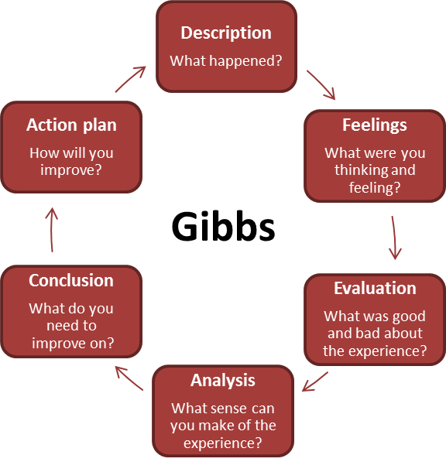

DESCRIPTION
The description given to us was to identify the use and effectiveness of a PDP when planning your future, our group was highly interested in the importance of Personal Development Plans and how they can help enable decision making explore new avenues and empower the individual. To meet and work together is helpful all our team to make new knowledge about the personal development. With all my team I try to search on internet information and read some documentation about the some cases. I try to speak with my team with one real case.

FEELINGS
The feelings in our group was interesting and we communicated well and everybody understand the importance PDP and development of our PowerPoint presentation. We all had different areas to concentrate and develop. To work with my group is send me a feeling than I have more courage and I have more trust in me. I’m been an emotional persona I try to speak more of the time with my team in English for when I need to present in front of the class to be more easy but for my whitening is not what I’m think all the emotion is not leave me to be concentrate and attention at all the manner.

EVALUATION
As a group we evaluated the importance a PDP along with the importance of CV skills and interview techniques. We felt that are presentation addressed all the main points in highlighting the importance of PDP CV and interview techniques. After a long presentation I understand is need to be more concentrate and need to have more interest when you want with real to have a good result.

ANALYSIS
As a Individual I feel we have archived our objective and identified the importance and relevance of PDP, throughout our presentation the audience was engaged and enlightened.

CONCLUSION

In conclusion we have identified that a PDP along with the other presentations on cv writing and interview techniques has been a success. We have all enjoyed the presentation and learnt a lot from this process. To work in a large group, I learn to stay and listen all the opinion and have wait in time for to have an result not to have the first answer to be the correct one. For the last point I can say now I’m an motivate and stimulate person.

References:
Webb, S. (1991). Personal development in information work. London: Aslib.
Personal Development eBook. (2006). my-skills.

