
Power Electronics and Drives - Assignment 1
UWTSD | ELECTRICAL & ELECTRONIC ENGINEERING

Lloyd Davies
2019
Contents
Abstract 1
Introduction 2
Research 2
Power factor 2
Power factor correction 3
PWM motor drives 5
Over current Protection 7
Method 7
Experiment 1 8
Experiment 2 8
Experiment 3 9
Experiment 4 10
Results 11
Experiment 1 11
Experiment 2 12
Experiment 3 13
Discussion 14
Conclusion 17
References 17

Equation 1 - Power Factor calculations [1] 2

Figure 1- Circuit phasor diagram 2
Figure 2- Example of a passive power factor correction circuit 3
Figure 3- Example of Active Power factor correction circuit 4

Table 1 Passive vs Active 5
Table 2 Pre-Fault Results and calculations 12
Table 3 Post Fault results and calculations 12

Abstract
In this Report I will be investigating the control, accuracy and efficiency of motors. The experiment is based on a set of lab sheets provided in the brief. Four experiments were carried out. First power factor correction was applied to a synchronous AC motor, a fault was entered and then identified. I found that one of the capacitors was now at a far higher level of capacitance. Using a three-phase inverter the second experiment investigated Pulse width modulation. Due to the operating voltage of the circuit being so low and for class room use, there are some characteristics cannot be seen. Ripple voltage for example might be visible on a higher voltage circuit. Moving onto experiment three, the boards over current protection was tested, observing the circuits reaction to a short circuit across the load. The board has 2 stage protection which functions like specified, protecting the components. The last experiment was identifying a fault which had been introduced to a single-phase synchronous motor circuit. Using a mustimeter, the fault was specified as a connection fault somewhere between the Power factor correction capacitors.

Introduction

Research

Power factor
Power factor is a calculated value, made to determine the ratio between the power that is used in a circuit, and the power that is supplied to the circuit (Apparent power). The value is always -1≤PF≤ 1 Power factor in AC circuits can vary but a value of 1 is desired. The Power Factor in a DC circuit is always 1. If the value is less than one this is an indication that the current and the voltage are not working in phase with each other. This means the current is either leading or lagging the voltage. The amount of lead/lag is measured as an angle (Ø), and cannot be greater than 90°. To calculate this angle a phasor diagram for the circuit must be drawn:

Figure 1- Circuit phasor diagram
To calculate power factor of a circuit where the lead/lag angle is known:
$Power Factor=Cos$(Ø)

Power factor can also be calculated without the angle, using the active power and apparent power.
Power Factor Calculation without Phase angle:
$$Apparent power = VI$$
$Active power=$VICosØ
$$Power Factor=\frac{Active Power}{Apparent Power}$$
$$Phase angle=\cos^{-1}(PF)$$
Equation 1 - Power Factor calculations [1]
Ideally all power from the Supply is taken up by useful work. Being out of phase causes some of the power from the supply to be lost. Poor power factor makes for an inefficient power delivery system. The further away from a power factor of 1, the more losses an electric supply company makes. To balance these losses utility companies, penalise industrial facilities financially depending on how far off 1 their power factor actually is. Industrial facilities commonly have their current lagging the voltage (inductive), this is down to the large amounts of induction motors seen in these environments.
[2]

Power factor correction
Due to the extra costs of having a bad power factor in many cases companies will attempt to increase their PF, and correct it to as near 1 as possible. To improve power factor the reactance of the circuit must be reduced by adding an opposite type of inductance (capacitance).

Passive PFC
This method of PFC involves a Low pass harmonic filter on the AC input. Using a capacitor and an inductor a series resonance circuit is created. This method can be cheap and efficient giving an industrial facility a simple solution. However, this method does not allow for voltage regulation, and only functions on a limited range of input voltages. At higher voltage levels the size of the filter inductors increases possibly causing issues due to their increased size and weight. Passive methods tend to be rugged and reliable, being unaffected by noise or power surges.
[3]

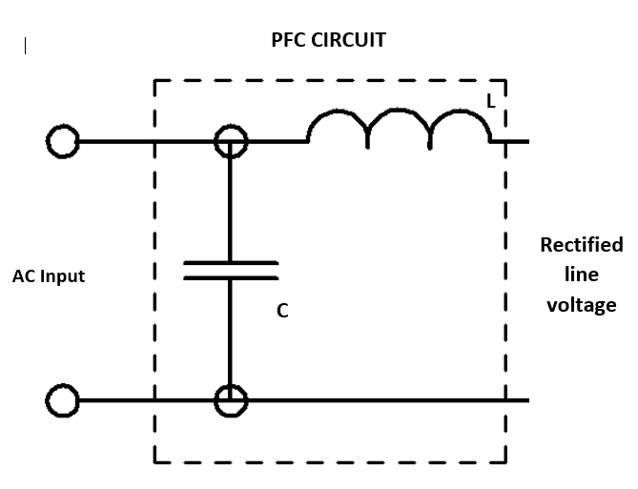
Figure 2- Example of a passive power factor correction circuit
As seen in figure 2 a capacitor is placed parallel to the supply. Once the Power factor and phase angle has been calculated, the value of this capacitor can be worked out. Apparent power and Active power should be equated.
Reactive power = Q can now be calculated using this equation:
$$Reactive power= \sqrt{({Apparent Power}^{2}-{Real Power}^{2})}$$
Equation 2 -Reactive Power equation

Figure 3- Phasor diagram including correction Capacitor
The resistive and reactive components need to be calculated in order to calculate Ic:
$$I_{R}=I\cos{θ}$$
$$I_{L}=I\sin{θ}$$


Figure 4- Phasor diagram showing resistive and reactive components
The value for $θ_{2}$ is calculated using the desired Power Factor. For example for a Power factor 0f 0.9 : $\cos^{-1}0.9$=25.84…°.
$$I_{1}=\frac{I_{R}}{\cos{θ_{2}}}$$
To calculate the size of the opposite side of the triangle involving $θ_{2}$ Pythagoras theorem is used.
$$\left|I_{L}-I_{C}\right|=\sqrt{{I'}^{2}-{I_{R}}^{2}}$$
This equation can then be rearranged to find $I_{C}$.
The capacitance can be calculated using the following formula:

$$X_{C}=\frac{V}{I_{C}}$$
$$C=\frac{1}{2πfX_{C}}$$

Active PFC
This method of PFC is achieved using active electronics circuits. Due to the complexity and the need for better filtering, the cost overall is higher than other methods.
[3]

Table 1 Passive vs Active

PWM motor drives

Pulse width modulated motor drives are becoming the primary way of variable speed motor control. This method can be seen in electric cars to washing machines, not only in the industrial world. To control the speed of an AC motor a three-phase supply is required. By varying the voltage and the frequency, a variable speed field rotates in the motor’s stator. This allows for the speed of the rotor to be controlled with low slip. This type of three phase motor is capable of turning in both directions and is done by changing the phase rotation. The torque is at maximum at all speeds.

Figure 5 – three phase inverter

An inverter turns DC pulses into an AC waveform
[4]
As seen in figure 4 the PWM motor drive consist of a 3-phase supply, a rectifier and filter, a DC Bus, an inverter and a Motor. The three-phase supply goes through the rectifier and the filter and a DC bus is created. The DC bus is used as a power supply for the inverter section. Multiple drives can be powered by this DC bus meaning less supplies therefor less potential for noise.
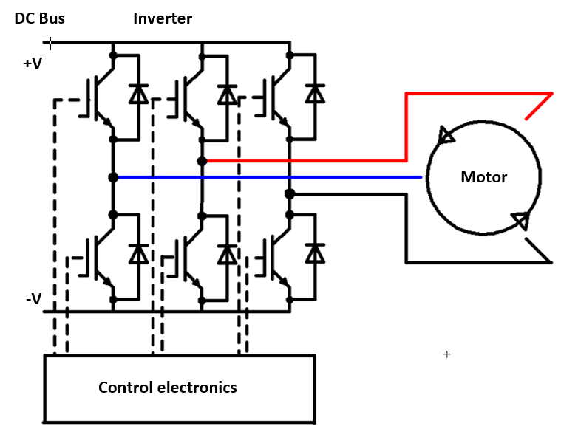
Figure 6 Three phase inverter diagram
Inverter consists of three pairs of semiconductors switches with their specific diode. Each phase uses a pair of switches to output the power. The electronic controller choses the status of the switches, and on the output of each phase, creates a square wave pulse. Each phase alternates in a ring causing the motor to rotate.
The frequency of pulses can be increased, decreasing the time between pulses (T). the more pulses the higher the average voltage and therefore the faster the motor will spin. To increase or lower the torque the voltage should be increased/decreased.
Figure 7 - Three phase induction motor

Over current Protection
Over current is when there is an excess of current in the circuit. It can be caused by a faulty grounding, a short circuit or overloading the circuit. Over current can damage electrical components or cause them to break. The most common types of over current protection are breakers and fuses. Every circuit from domestic to industrial must have a form of circuit protection. circuit breakers are commonly found in a house at a service panel, if a higher level of current than what the circuit is rated to is detected, then the breaker will trip protecting itself. If more current is drawn than the circuit can safely handle then the circuit is overloaded. The most common type of overload is caused when many electrical appliances draw a surge of power in order to turn on. This can momentarily overload the circuit.
[5]

Method
The equipment used in the experiments:

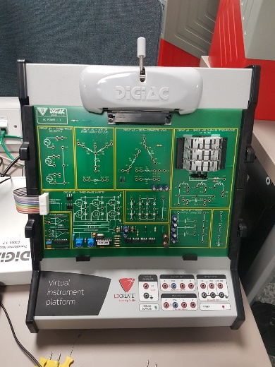
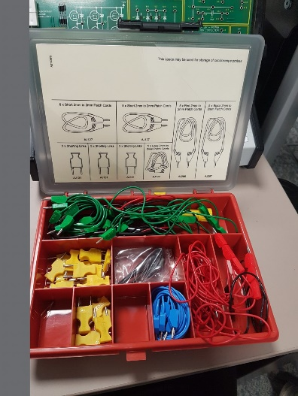
Figure 8- Lab Equipment
A virtual instrument platform with a digiac AC Power 1, a box of connectors and a transformer module. The system is then connected to a pc.

Experiment 1
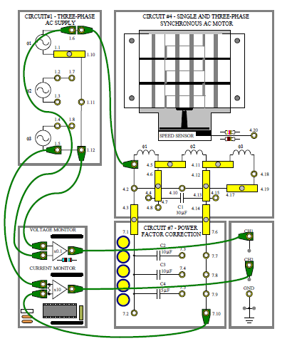
Connections were specified in the lab sheets and is shown below.
Figure 9- Task one connection diagram
Using LJ creates virtual oscilloscope a set of data is recorded using different combinations of correction capacitors and then used to calculate phase angle and current amplitude.
The second part involved repeating the experiment after a fault was introduced. Using the data recorded the fault needed to be identified.

Experiment 2
This task investigates a three-phase inverter outputting a PWM Signal.
The lab sheets specified that the circuit should be connected like the following:
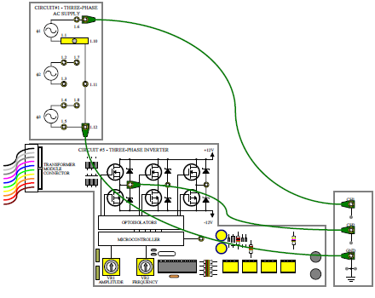
Figure 10- Task 2 PWM connection diagram

Experiment 3
In this exercise the circuits over current protection will be tested, investigating the circuits reaction to a short circuit across the load. The circuit has two stage over current protection built in. The project board was set up like the following figure:
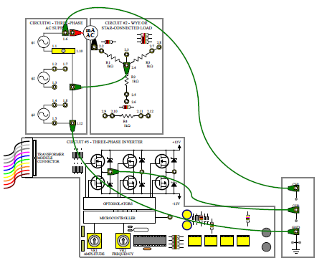
Figure 11-Over current protection circuit
The circuit consists of a three-phase supply, a star connected load and the three-phase inverter. A multi meter was placed across the supply and the star load (1.9 & 2.1). Short circuit connected between points 2.2 & 2.3.

Experiment 4
This experiment involves a single-phase synchronous motor in need of power factor correction. The single-phase supply is at maximum frequency. There has been a fault inserted into the circuit. The circuit is connected as follows:
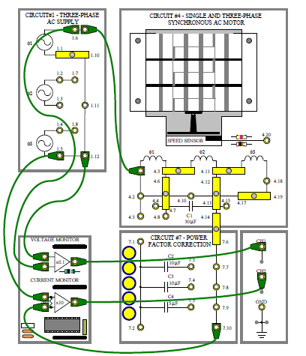
Figure 12- Single-phase fault-finding circuit
To improve the power factor a shorting link is introduced between the motor and correction capacitors at sockets 4.3 & 7.1

Results

Experiment 1
Two sets of results were recorded in task 1 Pre and post fault. The lead /lag was measured in ms using the digital oscilloscope, then used to equate the angle and current amplitude.
Time period of one wavelength measured as = 14.229ms
Results calculated from the circuit pre-fault:
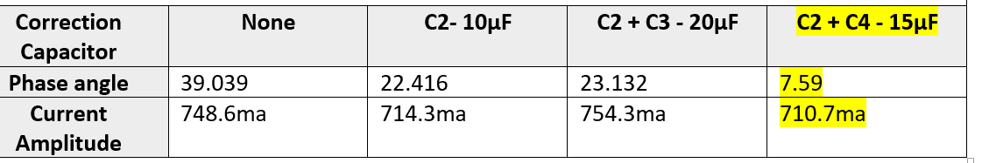
Table 2 Pre-Fault Results and calculations
Table 2 shows the phase angle smallest with the 15μF capacitance and by far the largest with no correction capacitor.
The same process was followed after the fault had been introduced:

Table 3 Post Fault results and calculations
Table three shows a big increase in phase angle across the correction capacitors

Experiment 2
The waveform created showed individual pulses from the PWM, after tuning VR2 frequency and time base control the pulses were stabilized.
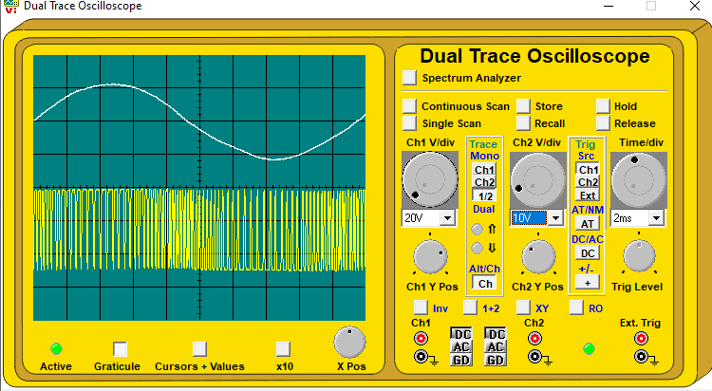
Figure 13- Experiment 2 PWM Waveform
Changing the oscilloscope to negative triggering shows the negative half cycle:
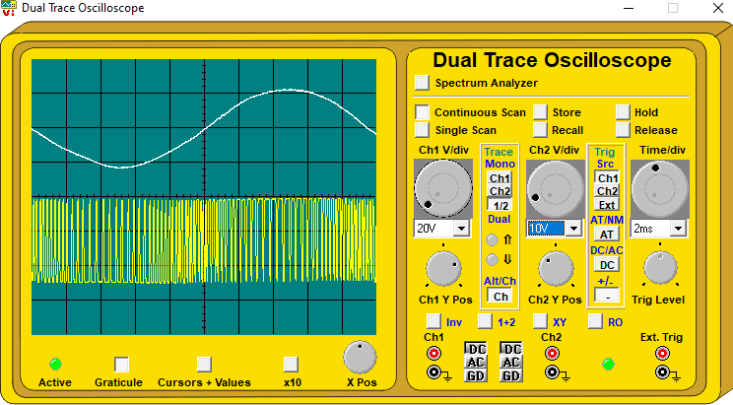
Figure 14- Experiment 2 negative half cycle

Experiment 3
After setting up the oscilloscope to the parameters specified in the lab sheets, the value for current across the load is measured by the multimeter.
Load Current = 26.5mA AC
After shorting the circuit, the effect on the voltage and current was observed. when the short is connected the supply, voltage falls to a very low value. The current rises to maximum before falling to zero. when the short circuit is removed, the voltage and current levels do not change, they remain low.

Experiment 4
Before the fault was entered voltage, measurement taken using multimeter 2 between points 7.2 and 7.10, between capacitors and the motor
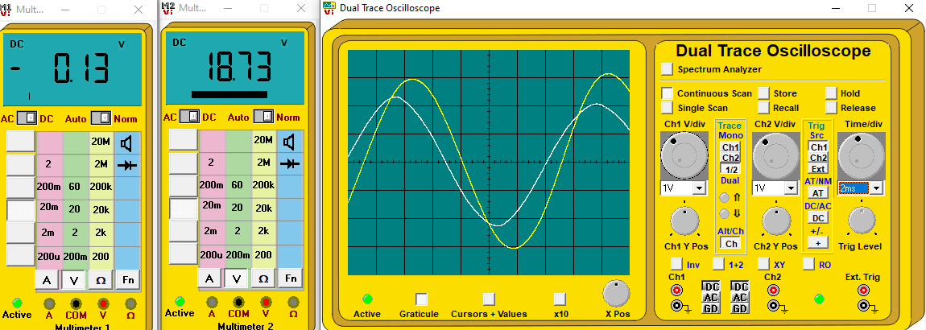

This screenshot was taken after the fault was introduced:
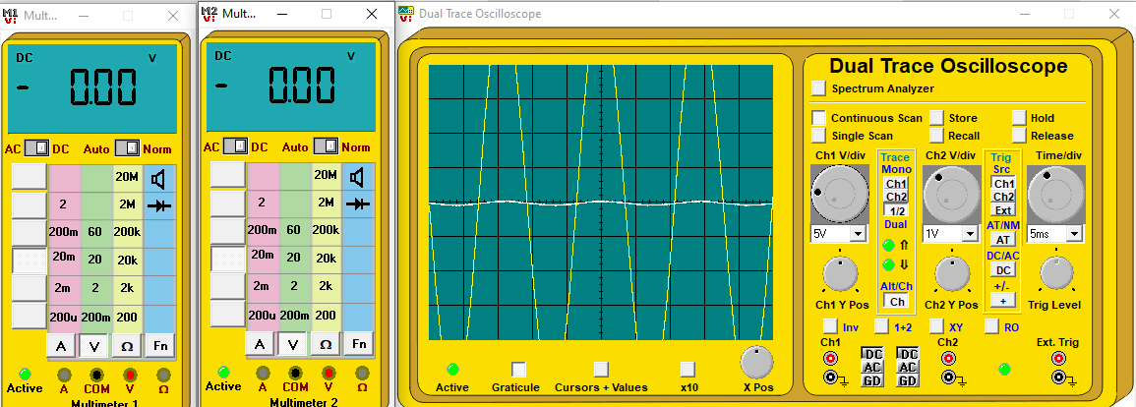

Discussion
Experiment 1
To obtain the values in table 2 a set of calculations were done using results recorded on the oscilloscope. The time period of One wavelength was measured as 14.229ms (T) and the difference in time between the voltage and the currents sign wave (DT) was also recorded using the oscilloscope. this equation was used to find phase angle:
$$Phase angle=\frac{360}{T}×DT$$
From this the current was calculated by:
$$Current amplitude=\frac{2×peak×1000}{10}$$
Out of the capacitor combinations C2 + C4 bring the nearest to complete correction of the phase angle. When there is no correction capacitor in the circuit it is mainly inductive therefore the current will lag the voltage. The value for the phase angle with no capacitor was 39.039, around 5 times more than the best correction capacitor. Like previously mentioned in the introduction, the closer the current is to being in phase with the voltage, the better the Power factor. the excess current caused by bad power factor can not be used as useful energy it is wasted and costs money. To prove this the power factor for both the worst and the best correction capacitors will be calculated.
With no capacitor, Power factor=$\cos\left(phase angle\right)$
Power factor=cos (39.039)
$$=0.777$$
With C2 + C4:
Power factor=cos (7.59)
=0.991
The combination of C2 and C4 improve the power factor to near perfect. The circuits inductance has been countered by capacitance. The improvements can be seen in the active power value. The apparent power will be the same for both where as the active power is the amount of it actually available for use in the circuit. For a circuit with a good power factor the amount of apparent power and active power should be as close to the same as possible:
$$Power Factor=\frac{Active Power}{Apparent Power}$$
The calculation of active power is done using this equation:
$$Power=V×I×cos⁡(θ)$$
Voltage is taken from the voltage reference display on the oscilloscope then converted to RMS. Current (ma) and phase angle is taken from the previous calculations in table 2.
Power supply with no correction capacitor:
$$P=2.257×451.4×cos⁡(39.039)$$
$$=0.791$$
Power supply with C2 + C4:
$$P=2.314×763.4×cos⁡(7.59)$$
$$=1.751$$
Calculations show due to the introduction of C2 + C4, the circuits active power increased by 0.96W double and more the active power previously.
A fault was then entered into the circuit. After repeating the phase angle and current amplitude calculations it was clear that there was a big difference in some of these results compared to the previous. The values recorded with the C2-10uf over the two experiments:
C2 – 10uf | Pre-fault | Post fault
Phase angle | 22.416 | 53.741
Current Amplitude | 714.3ma | 832ma

Studding the results from the second set of results, there is a big difference in all three capacitance values. The common factor is C2. Capacitor C2 & C3 have the same value of capacitance (10uf). To prove that C2 is now faulty the same calculations are done with capacitors C3 & C4. If C2 is not faulty then (C3 + C4) = (C2 + C4).
Correction Capacitor | C2 + C4 15uf | C3 + C4 15uf
Phase angle | 48.442 | 26.344
Current Amplitude | 810ma | 748ma
Figure 15- fault finding comparison table
Since the vales are far from similar, it is clear that capacitor C2 is the fault, it seems the capacitor now has a far higher capacitance.
Experiment 2
Examining the screenshots from the oscilloscope we can see that on the positive peak of the sign wave, the pulses produced by the micro controller get broader.

Referring back to the research on page 5, the wider the pulses produced in the PWM signal the higher the voltage being output. As the sign wave peaks the pulses are at their widest, as the waveform goes past the peak the pulses begin to get smaller. The pulses are at their smallest on the negative half cycle of the waveform. The more pulses created by a controller the closer to a sign wave the signal will be. The more pulses the smoother the output. The higher the frequency the smaller the current ripple, the screenshots show no ripple from the diagram the number of pulses per waveform can be counted. Here quarter of a cycle is visible, this number was counted as roughly 20, meaning there are around 40 pulses per half cycle. The duty cycle of the signal can be calculated as:
$$Duty Cycle=\frac{Pulse Width}{Time}$$
Then using this value, the average voltage can be calculated:
$$Average Voltage=Duty Cycle × High Voltage Level$$

The screenshots show no current ripple, this can be down to a couple of factors; the frequency of the pulses is high enough to produce a smooth waveform. The smaller the supply voltage generally the smaller the current ripple.
Experiment 3
The two-stage current protection built into the board purposely causes the reactions observed during the short circuit. First the output voltages are closed down, reducing it to a very low value. Then if the short remains, the current will rise to a level far higher than the operating current. This is due to the resistive load being removed leaving nothing to regulate the current. If the current rises high enough a thermal protection circuit is brought into operation. To observe the circuits reaction to a short, I connected a lead across the load, shorting it out. Using the digital multimeter I observed the voltage fall like specified. When the bulk of the circuit’s resistance is taken away, ohms law says the voltage will reduce also.
$$V=IR$$
If R=0 Then V=0
The resistance of the circuit doesn’t fall to zero because even though the majority of the resistive load is cut out by the short, there is still a small amount of resistance.
Whilst the short across the load remained, multimeter 2 was used to monitor the load current. When the load is taken out of the circuit there is no longer any resistance to regulate the current causing it to rise. This can again be proven by ohms law
$$I=\frac{V}{R}$$
If the value for resistance falls by a large amount the value for I is going to increase. Current rising to far higher than the operating level can cause components and/or wires to get hot and eventually fail. The protection system is designed to allow the current to rise to a level that is just before danger. When this level is reached a thermal protection, circuit comes into action. Like previously stated in the introduction over current can damage or destroy electrical components. Once the circuit senses dangerous temperature levels the current is driven down by even further reducing the voltage. A thermal fuse disconnects the current, and then resets when the temperature falls to a safe level.
When the short is removed, the voltage and current do not return to their normal operating levels they remain very low. The power supply must be turned off for several minutes, allowing the fuse to cool down before it the current and voltage recover to their normal values.

Experiment 4
The results from task 3 suggest there is some kind of connection fault going on between 7.1 & 7.2. the only components between these two points is a set of correction capacitors. The most likely cause for this fault is a capacitor breaking. capacitors are not designed to withstand currents higher than their normal operating levels, this causes heat to be produced within the capacitor, possibly shorting its lifetime. The capacitors are not designed to be repeatedly heated and cooled they will eventually fail. A large enough current will cause the capacitor to fail instantly, this is often shown physically by the capacitor, blowing the top out. From examining the capacitors, we can rule this out it is likely one of them lost its connection internally. The voltage falls to zero when the fault is entered meaning there is no flow. The motor stops instantly as the fault is introduced

Conclusion
Carrying out these experiments has greatly increased my understanding of electrical drive systems. i have researched the subject and produced a literature review prior to doing the experiments to ensure I had the required knowledge. Fault finding has been a large part of the experiments, finding a fault demonstrates understanding. I understand the importance of power factor, and how to correct it. Using the lab equipment, I have monitored and documented a PWM signal, explaining what is happening and why using my understanding. The boards over current protection was tested and works as specified. It successfully protects the components in the circuit. After analysing what happened when the fault is introduced in experiment three, the fault was then identified with help from the digital multimeter as a connection fault across the correction capacitors.

References

[1] | “Chapter 11 - Power Factor,” All About circuits, 2018 (last edited). [Online]. Available: https://www.allaboutcircuits.com/textbook/alternating-current/chpt-11/calculating-power-factor/. [Accessed 05 12 2019].
[2] | R Nave, “Power factor for AC Power,” Hyperphysics, 2009. [Online]. Available: http://hyperphysics.phy-astr.gsu.edu/hbase/electric/powfac.html. [Accessed 05 12 2019].
[3] | Gary Bocock , “AC Input Current & Harmonics,” 29 03 2018. [Online]. Available: https://www.xppower.com/Blog/AC-Input-Current-Harmonics. [Accessed 05 12 2019].
[4] | Faride Akretch, “Power Analysis Of PWM Motor Drives,” Tektronix , 27 06 2013. [Online]. Available: https://www.powerelectronics.com/motion-systems/power-analysis-pwm-motor-drives. [Accessed 06 12 2019].
[5] | Edvard, “Tips for power factor correction and good protection of capacitors,” Electrical Engineering Portal, 26 10 2016. [Online]. Available: https://electrical-engineering-portal.com/power-factor-correction-protection-capacitor. [Accessed 28 11 2019].
[6] | “Power Factor Correction (PFC),” SunPower Electronics , [Online]. Available: https://www.sunpower-uk.com/glossary/what-is-power-factor-correction/. [Accessed 28 11 2019].
[7] | “Power Factor Correction,” Circuit Globe, [Online]. Available: https://circuitglobe.com/power-factor-correction.html. [Accessed 28 11 2019].
[8] | “Pulse Width Modulation Chapter 11 - DC Motor Drives,” All About Circuits, [Online]. Available: https://www.allaboutcircuits.com/textbook/semiconductors/chpt-11/pulse-width-modulation/. [Accessed 28 11 2019].
[9] | “Power Analysis Of PWM Motor Drives,” Power Electronics, 2017. [Online]. Available: https://www.powerelectronics.com/motion-systems/power-analysis-pwm-motor-drives. [Accessed 28 11 2019].

