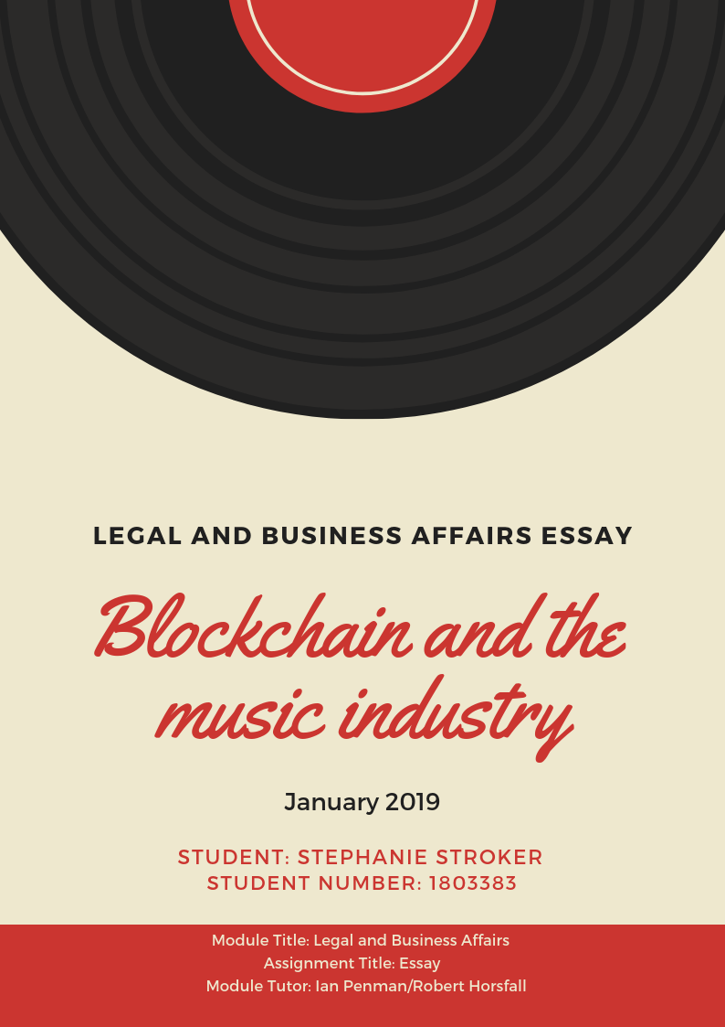
Index

1. Introduction .........................................................................................................................3
2. Intellectual property in the music industry .........................................................................3
3. Blockchain ............................................................................................................................5
3.1. What is blockchain and how can it protect intellectual property?..................................5
3.2. Feasibility of blockchain in the music industry................................................................6
4. Bibliography..........................................................................................................................9

- INTRODUCTION
This essay aims to describe how artists in the music industry can benefit from intellectual property law and the emergence of blockchain technology. The usage of blockchain technology for royalty payments, safe contracts and agreements will be explored, and the question of whether blockchain is actually beneficial and if it will be widely adopted by society will be posed.
If blockchain is really as safe as some people claim it to be, then why is it taking so long to switch to using this technology? What will the consequences be for record companies, publishers and other parties in the music industry once everyone starts adopting the use of blockchain? With the help of scientific articles and books specialised in these topics, all of these questions will be answered in order to get a better understanding on the general role, the benefits and also the disadvantages of blockchain in the music industry.
- INTELLECTUAL PROPERTY IN THE MUSIC INDUSTRY
As Field Jr (2006, p. 3) pointed out, “patents, copyrights, trademarks and related interests are known as intellectual property (IP)”. If we consider intellectual property within the music industry, artists can protect their work with copyright, which protects it from being illegally used, copied and sold by other people and losing potential earnings that are meant to go towards the artist. The artist´s works are protected via copyright by federal law, and are of limited duration, until 70 years after the death of the last living author of a particular song (Clark & Penman, 2018; Field, 2006 p. 4). Artists do this to ensure the payment process, through royalties and granting licenses for example, but also to make sure that their work is properly credited when used by others. (Field, 2006)
According to Demers (2006, p. 84) “arrangements of original musical compositions are considered alternative pieces of work and, under the Copyright Act, are derivative works”. This implies that if an artist wants to publish a specific arrangement of a previously published piece, that artist would need to ask the original copyright holder for permission and set a licensing fee to be able to use and market it. Copyright law protects authors against individuals who try to reproduce their works in any way, without having obtained authorization. Even though remixes of songs and using samples of other works are widely popular amongst society, these are only allowed as long as permission is obtained from the original author(s), and illegal when it is released without correct permission. Copyright essentially motivates artists to keep being creative and release more songs and/or albums, because they know their work will be protected and they will earn money from it. To sum up, intellectual property law exists to protect artists against plagiarism, to stop people from illegally downloading songs on the internet and copying the physical albums, and to ensure fair payment to the author. (Demers, 2006)
It is crucial to protect an artist´s music, especially since the way of consuming music is changing from ownership to a more access based consumption through online and streaming platforms such as Spotify, Deezer and YouTube. This and the overall switch from an offline to an online world has caused a decrease in CD sales, and an increase in online music consumption, which does not provide as much revenue as physical copies of music. Because of piracy and easy access to the internet it is relevant to make sure the right permission is given to people who use an artist's songs for other works that they are making money from (on platforms such as YouTube or DJ remixes on SoundCloud, for example). Downloading songs is usually cheaper than buying a CD, and the same goes for streaming platforms. Online streaming platforms such as Spotify only pay artists a fraction of what they would earn from selling physical copies, receiving a limited amount of money per stream (it takes many streams to earn the same amount as a digital paid download of that same song, via iTunes for example). Even though these online streaming platforms are very popular, they have not made much profit yet, spending most of their income from advertisements and subscription fees to the record labels, who own the rights to the songs that they have in their online database. (Rethink Music Initiative, 2015)
A problem that many artists face is that they often do not get paid the royalties they are entitled to, or that they are not aware that they should be paid royalties in some cases. A lot of the money from these royalties tends to end up in the wrong place (usually with the intermediaries) which is mainly caused by a lack of information or a lack of it. So if it is so hard to earn money from selling music online, why not switch to only selling physical copies? We live in a time where everyone expects to instantly find anything online, so the artist would be losing the majority of its potential audience, because they would lose interest as soon as they are not able to find the artist´s work online, resulting in one less opportunity to create an online following, being featured in playlists and of course potential money. The younger generation is not used to buying physical copies and expect to be able to listen to music for free or pay a small amount to enjoy music without advertisement, only paying a larger amount of money when attending a live concert. In 2009, the global digital revenue for music was 4.4 billion dollars, and increased to 6.9 billion dollars in 2014, clearly showing a relevant and rapid increase in online music consumption (O’Dair, 2016; Rethink Music Initiative, 2015, p. 9).
Going back to incorrect royalty distribution, this often happens because publishers and even labels might not have the correct information in time to give credit to each party that worked on the creation of the song, or it could be as simple as a spelling mistake, creating confusion as to who should be paid. To add to this, royalties generally take a long time to reach its owners and fees are deducted when passing through different intermediaries. (O’Dair, 2016; Rethink Music Initiative, 2015)
- BLOCKCHAIN
3.1. What is blockchain and how can it protect intellectual property?
As can be concluded from what was mentioned in the previous section, the music industry is in need of a system that ensures a fair royalty payment to the artists, making sure the information from the different parties is complete, payments are completed in a decentralised, quicker and more efficient way, that ensures that intermediaries do not keep any part that should be going into the artist´s account.
In essence, blockchain can be described as “a technology that has as main purpose the securization of the transparency in all kind of transactions by eliminating intermediaries and giving the possibility to users to directly transact with each other” (Gheorghe, Ţigănoaia & Niculescu, 2017, pp. 215-216). If this technology is applied to online music consumption through Spotify (to name an example) the process would roughly look like this: the exact amount of plays of a song are registered through the blockchain technology, where all of the details and information about the number of plays, the time stamp of the transaction and the song itself are recorded in different blocks in chronological order, creating a chain of information. Each time a song is played, the chain would register that, creating a clear history on how many plays it has had, which then could be used to calculate how much money is owed to the artist. In other words, “when a song is streamed, the track itself has a smart contract that will take a payment instantly, divide it between the rights holders and pay them directly into their account instantly” (Heywood 2016, p. 8). This information is encrypted and cannot be altered, so there is no chance to modify the number of clicks or the time stamp. This chain can only be seen and accessed by people who have permission to do so. The encryption also means that initial data such as the artist´s name and year of the album release cannot be changed, having to make sure the author´s names are correctly spelled and the same way for every piece of music. With blockchain technology, there are no intermediaries (eliminating any possible cuts or trust issues), creating a direct contact between the parties, making it a decentralised system. (O’Dair, 2016)
The way that a blockchain transaction works is the following: first the transaction has to be defined in terms of content, addressing its value and adding a digital signature; then it needs to be authenticated by the other computers connected to the blockchain network (not by an intermediary); after this, a block with the information is created, which is then synchronised as soon as it gets classified as valid by the network; finally, the validated block of transactions is placed into the blockchain network. Ideally, this whole process is completed within a few seconds. (Gheorghe, Ţigănoaia & Niculescu, 2017)
Blockchain is not only used “for transactions, but also as a registry and inventory system for the recording, tracking, monitoring, and transacting of all assets” (Swan, 2015, p. XI), such as any kind of intellectual property like a song or the art work for an album cover. Furthermore, it can be used to create and manage smart contracts, stating the party's agreement, as well as their obligations and duties, which are coded into the contract. Again, no intermediaries such as banks are needed in the process, since the blockchain network already automatically supervises and checks if the parties comply with the terms. All of the information that needs to appear in the blocks can be taken from already existing databases, needing only to transform them into the blockchain format, and possibly adjusting any details that need updating (which can only be done the first time that the information is inserted). The currency used to make a payment would be a virtual crypto currency, like Bitcoin. Via smart contracts, one of the ideas is to control the access and ownership to a particular asset, such as a music file, a property or anything else which can be done once the asset is registered in the digital world. This contract and asset could be accessed only with a private key. (Gheorghe, Ţigănoaia & Niculescu, 2017)

3.2. Feasibility of blockchain in the music industry
Although the whole idea of using blockchain technology sounds like a viable option on paper, in reality, the majority of the population does not completely comprehend the concept of it and how it works exactly. Many people associate blockchain and Bitcoin with the dark web and overall criminal activity, they do not trust the concept of crypto currency yet. This is mainly because of a lack of information and because it is not mainstream, but the same thing happened with the Internet, people had never heard of it, but somehow everyone is using it and no one questions that it is a necessary tool for day to day operations. In a world where there are constant technological changes, more and more people are paying and buying online, paying contactless, and even with their phones nowadays, so it should not be too hard to imagine a world where everyone is paying with crypto currency (with no commissions taken by any intermediaries) instead of physical money. In reality, the process of making a Bitcoin transaction (Bitcoin is used as an example for the purpose of this essay, but it is not the only crypto currency) through this technology is not too hard, the most important elements that the individual needs to have are a billing address, their own private key and specialised wallet software. “The address is where others can send Bitcoin to you, and the private key is the cryptographic secret by which you can send Bitcoin to others. Wallet software is the software you run on your own computer to manage your Bitcoin” (Swan, 2015, p. 3). Having said this, there is also no way in which a person could recover its password if needed since there are no intermediaries who back this information up.
To give an example on who is already experimenting with blockchain technology within the music industry, the singer-songwriter Imogen Heap released one of her songs through the Ethereum blockchain network, with the theory that more artists would join if they received instant royalty payments. To name another example, the American music platform UJO Music has also been using this exact technology to offer their users a streaming and downloading platform that records the user´s transactions and ensures that artists are paid with crypto currencies for each play. Full credit can be given through this technology, such as information on copyright, who designed the art work for an album cover, who did the marketing for a specific tour and which royalty percentage goes to the songwriter, composer and singer. (Burchardi & Harle, 2018; Heywood, 2016)
To conclude, some of the challenges but also advantages of blockchain technology will be discussed in this next section. In the case of the music industry, the biggest problem is that information about songs, artists and the corresponding copyrights is all over the place, there is no single database which holds all of this data together, making it harder to find out who own what. Some of the information is duplicated or incorrectly inserted into different databases, which can create confusion and affect royalty payments. This makes it harder to create a single universal database with everything needed for the blockchain structure to start to function. Another problem is that there are currently too many different types of blockchain structures which all have a different crypto currency, so it is hard to judge which one of these will end up being the one that is used in the music industry. And the main challenge is making this technology mainstream, since many people associate it with money laundering activities and the dark web and/or do not comprehend what blockchain is about and how it works. (O’Dair, 2016; O’Dair & Beaven, 2017)
On the other hand, some of the main advantages of using the blockchain structure is the rapid (immediate) and frictionless payment of royalties and the reduction of transaction costs by cutting out the middleman, directly receiving payments in their digital wallets. This is crucial because it usually takes six months until the money from royalties reaches the artists, passing through the record labels and publishers first, who take a cut as well (in the case of international payments it can even take years to reach the people who hold the rights to the songs). Since blockchain technology facilitates micro payments in a decentralised manner for each online stream, the digital crypto currencies have extremely low transaction costs. (Heywood, 2016; O’Dair, 2016; O’Dair & Beaven, 2017) Blockchain technology is also the perfect platform for crowd funding opportunities for artists that do not have the financial support from bigger labels. Because of the blockchain´s transparency it is easier for potential investors to oversee any activity the artist engages in, being able to keep track of the outcomes of their investments. Through smart contracts, the artist can provide the guarantee that any initial investment will be returned if the set goals are not reached. (O´Dair, 2016)
The overall blockchain technology will provide the industry with a more transparent value chain, making it easy to track down relevant information, but it will take a lot of time and effort to become mainstream. If someone wanted to go back and check if any transaction was made or to confirm any activity that a company has been engaging in, it could be checked and verified through the blockchain technology. (Swan, 2015)
And lastly, there will probably be more favourable royalty percentage splits for the artists and the songwriters with this technology, but that does not imply that the role of record labels and music publishers becomes less relevant, it will probably simply shift; the record labels might focus more on artist development and music distribution, and the music publishers more on playlist curation, artist and repertoire and creating promotional material like demos instead of making royalty payments to the artists. (O’Dair, 2016; O’Dair & Beaven, 2017)

4. BIBLIOGRAPHY
Burchardi, K., & Harle, N. (2018) ‘The blockchain will disrupt the music business and beyond’ Wired, 20 January. Available at: https://www.wired.co.uk/article/blockchain-disrupting-music-mycelia
Clark, A., & Penman, I. (2018) Lecture 4: Basic Contract Law, Copyright and Trademark . [Legal and Business Affairs. London: Tileyard Education]. 22 October.
Field Jr, T.G., (2006) ‘Intellectual Property: The Practical and Legal Fundamentals.’ Pierce Law Faculty Scholarship Series. Paper 32. Available at: http://lsr.nellco.org/piercelaw_facseries/32
Gheorghe, P.N.M., Ţigănoaia, B. and Niculescu, A., (2017) ‘Blockchain and Smart Contracts in the Music Industry–Streaming vs. Downloading’. In International Conference on Management and Industrial Engineering (No. 8, pp. 215-228). Niculescu Publishing House.
Heywood, A. (2016) ‘Blockchain: Disruptive technology and its effects within the music industry.’ Available at: https://www.researchgate.net/profile/Alex_Heywood/publication/305033376_Blockchain_Disruptive_technology_and_its_effect_within_the_music_industry/links/577f805608ae69ab8823e762.pdf (Accessed: 25 November 2018)
Joanna Demers (2006) ‘Steal This Music: How Intellectual Property Law Affects Musical Creativity’ The University of Georgia Press.
O’Dair, M., (2016) ‘Music On The Blockchain: Blockchain For Creative Industries Research Cluster’. Middlesex University Report, 1.
O’Dair, M. and Beaven, Z., (2017) ‘The networked record industry: How blockchain technology could transform the record industry’. Strategic Change, 26(5), pp. 471-480.
Rethink Music Initiative, (2015) ‘Fair Music: Transparency and Payment Flows in the Music Industry.’ Boston: Berklee Institute of Creative Entrepreneurship.
Swan, M., (2015) Blockchain: Blueprint for a new economy. O'Reilly Media, Inc.

