  Fracture/Fatigue Failures of products and components in service  Material Science ACDA 6016 | Rachel McColm  2223157

Contents

Table of Figures 3
Abstract 4
Precursory Information 5
Fracture 5
Fatigue 5
Corrosion 6
Cyclic Loading 6
Fuselage 7
Introduction 8
Accident Overview 9
Damage Investigation 10
Issue 1 - Disbonding 10
Issue 2 – Fatigue 11
Issue 3 – History of Corrosion 12
Issue 4 – Inspection Program Limitations 12
Issue 5 – Maintenance Practices 13
Findings and Lessons Learned 14
Key Findings 14
Lessons Learned 14
Recommendations 15
Aging Aircraft Structural Management 15
Inspection and Maintenance Improvements 15
Regulatory Oversight 15
Design Changes 15
Training 16
Record Collection 16
Conclusion 17
References 18

Table of Figures

Figure 1 - Brittle vs Ductile Fracture [3] 5
Figure 2 - Corrosion [9] 6
Figure 3 - Labelled Airplane Parts [12] 7
Figure 4 - Aloha Airlines Flight 243 [16] 8
Figure 5 – Disbonding of Fuselage [15] 10
Figure 6 - Illustration of Metal Fatigue [20] 11

Abstract

The 1988 structural failure of Aloha Airlines Flight 243 is a significant case study in fatigue related structural failures. This report will examine the mechanisms of failure that contributed to this accident. The findings highlight the significance of integrating material science principles with realistic operational and environmental considerations to ensure safety and structural integrity throughout an aircraft’s service life.

Precursory Information

This assignment will discuss material failures such as fracture and fatigue. It will also discuss a phenomenon known as cyclic loading. As well as this, there will be terminology relating to aircrafts. The following definitions should be useful throughout.

Fracture

Fracture is the forced separation of a material into two or more pieces. This occurs as a result of applied stress, weakening and eventual loss of structural integrity. Fracture can be classified into two types: Brittle fracture and Ductile Fracture.
Brittle Fracture occurs with little to no plastic deformation and propagates rapidly. Whereas, ductile fracture involves significant plastic deformation before failure and can absorb a large amount of energy. This can be demonstrated from the figures below. In engineering structures, fracture is the last stage of failure. It can be the result of many mechanisms such as, fatigue, corrosion, impact etc [1, 2].

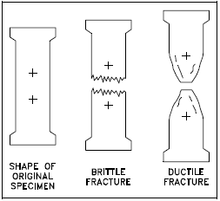
Figure 1 - Brittle vs Ductile Fracture [3]

Fatigue

Fatigue is the weakening and eventual failure of a material due to the repeated application of load. It can also result from constant temperature fluctuation (Thermal Fatigue). It is an irreversible process, and is a localised and progressive type of structural damage. This can occur even when the applied stresses are below the material’s yield or ultimate strength. Under cyclic loading – microscopic cracks can initiate at stress concentrations. Stress concentrations occur around surface defects, joints, corrosion sites etc. When under continuous loading, the cracks will propagate until the material can no longer support the load, resulting in failure of the material. Structures most at risk of fatigue are bridges, airplanes and automotive suspension equipment to name a few [4, 5, 6].

Corrosion

Corrosion is the natural degradation of a material due to a reaction with environment it is in. When a metal reacts with a substance such as water, oxygen, acids or salts, it slowly breaks down and weakens over time. The most common type of corrosion that people will be very familiar with is iron corrosion. Iron is reacting to oxygen and moisture to form iron oxide, also known as, rust (seen in figure 2 below) [7, 8].

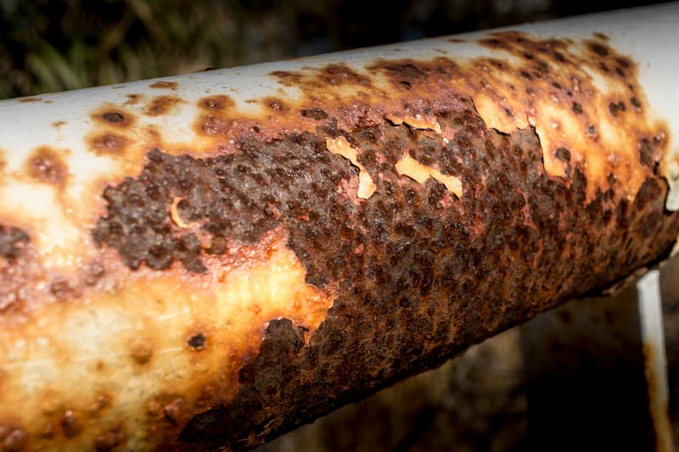
Figure 2 - Corrosion [9]

Cyclic Loading

Cyclic loading is the repetitive application and removal of load over time. Instead of the material experiencing a constant load, it experiences fluctuating or varying loads repeatedly. It can occur over a long period of time, causing fatigue in the material and eventually failure. When the material experiences repeated load cycles, i.e. tension to compression, this initiates microscopic cracks that propagate with each load cycle. This is an especially important consideration when designing airplanes as they experience constant pressurisation and depressurisation during each flight, multiple times a day [10, 11].

Fuselage

Discussed throughout this assignment is the failure of an aircraft fuselage. The term fuselage refers to the main body of the plane. It houses the cockpit, passenger cabin and cargo. It maintains a pressurised cabin, provides structural continuity and protects against aerodynamic forces and environmental effects. The fuselage carries a significant portion of the aerodynamic and pressurisation loads, which is why consideration of failure mechanisms like fracture and fatigue are of the utmost importance, as failure of the fuselage would be catastrophic. See figure 2 below for a detailed schematic of an airplane [12, 13].

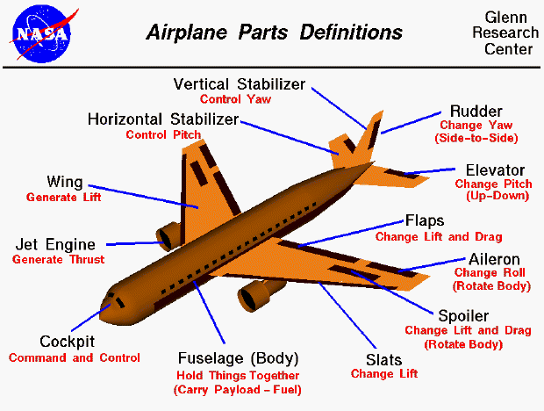
Figure 3 - Labelled Airplane Parts [12]

Introduction

April 28, 1998 – Aloha Airlines Flight 243 was a passenger plane that was scheduled to complete several inter-island flights. While cruising at around 24 thousand feet, between the islands of Hilo and Honolulu, the aircraft suffered a catastrophic failure, which resulted in one fatality and multiple injuries.
A large portion of the aircraft's fuselage tore away (see figure 4 below), which exposed the passenger cabin to the open air, ejecting a flight attendant from the plane. Despite the severity of the damage, the pilot was able to perform an emergency landing at Kahului Airport, Maui.
The subsequent investigation that was carried out by the National Transportation Safety Board (NTSB) determined that the failure was caused by widespread metal fatigue and corrosion, exacerbated by the high number of short flight cycles, combined with inadequate inspection and maintenance protocols.
Flight 243 became a pivotal moment in aviation safety, prompting major changes in inspection programs, maintenance standards, regulatory oversight and compliance [14, 15].
This assignment aims to identify and analyse the mechanisms of failure that led to the structural failure of Aloha Airline Flight 243, with particular focus on fatigue, corrosion and cyclic loading. Based on the analysis, recommendations will be made to improve aircraft design, maintenance procedures, robust inspection regimes and appropriate material selection.

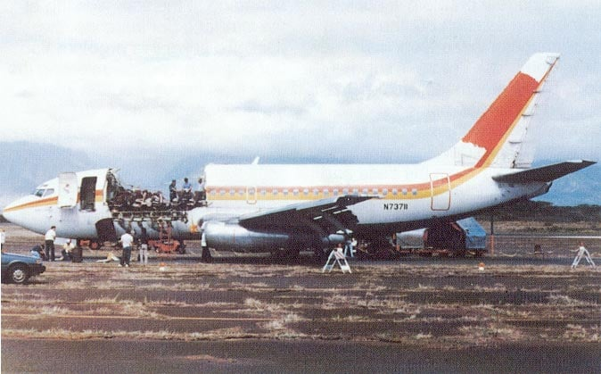
Figure 4 - Aloha Airlines Flight 243 [16]

Accident Overview

28th April 1988.
Aloha Airlines flight 243 was scheduled for multiple flights. A pre-flight check was conducted at the beginning of the day by the first officer, who found nothing unusual. The aircraft flew 3 roundtrips from Honolulu to Hilo, Maui, and Kauai with the same crew throughout all flights. Between flights, there were no visual inspections conducted by the flight crew as this was not required by the airline.
Flight 243 then departs as scheduled at 13:25 from Hilo for Honolulu. However, when the plane reaches 24 thousand feet at around 23 minutes into the flight, with 89 passengers and 6 crew members on board, the aircraft experienced a sudden explosive decompression. An explosive decompression is a very rapid a sudden loss of air pressure inside a sealed space. At high altitudes, an airplane is kept at a much higher pressure than the air outside. When the fuselage detached from the aircraft on flight 243, the pressurised air violently rushed out of the cabin to equalise with the lower pressure outside of the aircraft.
When the decompression occurred, a flight attendant that was standing at the front of the plane was swept overboard. At this stage, the captain immediately took over controls to begin an emergency decent, successfully landing in Maui despite the severely damaged structure. This incident resulted in one fatality (the flight attendant that got swept away) and 8 serious injuries.
When boarding the plane, a passenger noted that there was a visible crack along the fuselage but she did not report this to the crew, only mentioning the sighting after the accident occurred.
At the time of the accident, this aircraft had amassed 89’680 flight cycles, and 35’496 flight hours [15, 17, 18].

Damage Investigation

The obvious primary structural damage was a roughly 18 foot section of the upper fuselage being torn away from the aircraft. This missing portion extended from just aft of the cockpit to near where the wing connects to the fuselage. The failure occurred along the fuselage lap joints, where multiple fatigue cracks had propagated and joined together. An investigation was required to determine where these came from and how it was missed.

Issue 1 - Disbonding

The aircrafts fuselage panels were joined by overlapping the metal edges and fastening them together. In the earlier models of Boeing 737s, the overlapping sections were held together by glue and reinforced with rivets. This design was heavily reliant on the glue, not the rivets, to carry the stresses of cabin pressurisation.

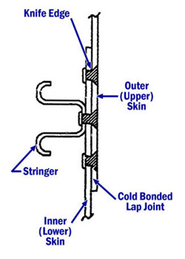
Figure 5 – Disbonding of Fuselage [15]

The type of adhesive that is used in this process is known as a cold bond adhesive. This means that the adhesive must be kept below a certain temperature to prevent premature curing. The process itself is also very sensitive to moisture, cleanliness and timing. While manufacturing took place for this process, there were difficulties with the quality of the surface preparations, moisture in the joints during assembly and the premature curing of the adhesive. This led to the development of degradation within the adhesive bonds, making them susceptible to corrosion and disbonding. Over time, this would cause the panels to slowly separate and make the structure more vulnerable to damage.

Issue 2 – Fatigue

When the adhesive holding the panels began to fail, the load from the cabin pressurisation that was supposed to be transferred by the adhesive, was instead transferred by the rivets. The rivets were not designed to carry that load which meant there was a higher stress concentration in the surrounding metal, lowering the fatigue life significantly [19]. Gradually, this extra stress caused microcracks to form around the nearby rivets. These cracks will progressively propagate, growing larger in size, until they eventually meet and cause a larger crack.

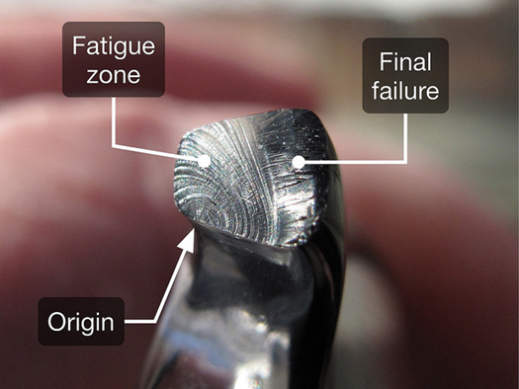
Figure 6 - Illustration of Metal Fatigue [20]

Metallography was conducted by using cross-sections that were prepared from fuselage skin samples. The metallography revealed that fatigue cracks initiated at the rivet hole edges, there were multiple cracks growing independently, and there were no abnormal microstructural defects within the material which was a 2024-T3 Aluminium alloy.
Scanning Electron Microscopy (SEM) was also used to examine the fracture surfaces. This indicated cyclic crack growth, variable crack growth rates and a final overload region. These results confirmed long term fatigue growth and sudden final fracture when critical crack length was reached.
When this occurred on the aircraft, the structure became to weak to withstand the cyclic loading occurring throughout multiple flights a day. The typical design expectations for pressurisation cycles ranges from around 20’000 to 60’000, whereas, this aircraft was around 89’680 cycles. Clearly, this significantly exceeded typical fatigue assumptions.
This is known as widespread fatigue damage, which is what ultimately led to the structural failure of this aircraft.

Issue 3 – History of Corrosion

Corrosion in fuselage lap joints was first reported in 1970. This led to Boeing issuing a Bulletin advising the sealing of the joint to reduce moisture. The cold bond lap joint (used in flight 243) was discontinued, and they introduced a stronger design that relied more on rivets instead of the adhesive.
In the years that followed, many more issues were discovered. There were reports of corrosion, joint separation and later fatigue cracking. This led to inspection programs expanding, but only in specific areas of the aircrafts.
Despite the changes to the inspection regime, and the multiple bulletins released by Boeing, the corrosion and cracking present on the flight 243 aircraft was missed. This aircraft was built before the design changes were introduced, and the location where the failure occurred was not one of the locations that was required to be inspected. This was one of the main contributors to the accident.

Issue 4 – Inspection Program Limitations

In 1978, the aircraft safety rules were amended to require designs that could tolerate damage without failing suddenly. Fracture mechanics analysis was utilised to do this. For older aircrafts that were built before this amendment and prior design changes, a Supplemental Structural Inspection Program (SSIP) was introduced.
Unfortunately, the SSIP only focused on parts of the aircraft that needed special inspections to detect hidden damage. Structures that were believed to show obvious signs of damage were excluded from this inspection regime. This meant that the fuselage was not included as the assumption was made that any failure would be visible and wouldn’t cause major structural failure. Ultimately, this was a flawed assumption to make, and led to the events that occurred on flight 243.

Issue 5 – Maintenance Practices

Aloha Airlines adopted a 15 thousand flight-hour heavy maintenance check, which aligned with Boeing guidance. However, due to their short-haul flight schedule, the aircraft underwent flight cycles twice as fast. Fatigue in pressurised fuselage structures, like aircrafts, is dependant on cycles, not hours. As a result, the inspections were not carried out frequent enough for the actual stress experienced due to cyclic loading.
This maintenance period was split into multiple separate work packages, and spread across overnight checks. Although the inspections were reportedly performed, post-accident investigation uncovered fatigue cracks that should have been detected in an inspection. It was also found that training and documentation for these inspections were not sufficient, so it cannot be said that these inspections were conducted correctly. The investigation also found widespread corrosion and fuselage skin damage throughout the fleet. Again, there was an assumption made that the maintenance and inspection regime was sufficient to track and prevent material failures. Unfortunately, this was not the case and it led to this catastrophic structural failure.

Findings and Lessons Learned

Key Findings

Ultimately, the National Transportation Safety Board (NTSB) found that the probable cause of this incident was the failure to detect the presence of fatigue damage and disbonding through inspection and maintenance programs.
Contributing factors included:
- Inadequate oversight of the inspection and maintenance program by Aloha Airlines Management
- Insufficient regulatory action by the Federal Aviation Administration (FAA) in limiting the inspection to a single lap joint location rather than all affected joints
- The absence of corrective action following the reports of early production issues with the Boeing 737 cold bonded lap joints, corrosion and premature fatigue cracking

Lessons Learned

This incident highlighted fundamental limitations in traditional damage-tolerant design philosophies when applied to aging structures. In particular, it demonstrated that multiple micro cracks can pose a much greater risk than a dominant single crack, as their interaction can rapidly undermine structural integrity without visual warning signs.
Another critical lessons that came from flight 243 was the need to account for widespread fatigue damage in design and inspections/maintenance. It prompted major regulatory and industry changes, including enhanced aging aircraft inspection programs, mandatory structural modifications to fuselage lap joints, and the development of more non-destructive testing (NDT) techniques.
It also highlighted the importance of aligning the maintenance and inspections strategies with actual operational usage.
Overall, Aloha Airlines Flight 243 became a landmark case in aerospace engineering and safety regulation. The lessons learned form this accident reshaped inspection requirements, fatigue analysis methodologies and certification standards.

Recommendations

Aging Aircraft Structural Management

- Implement robust again aircraft maintenance and inspection programs that explicitly address widespread fatigue damage.
- Establish mandatory reassessment for aircrafts that are operating beyond their original design assumption, for example, undergoing more pressurisation cycles that assumed.
- Require structural modifications or replacements for components approaching their defined cycle limits, especially those that are susceptible to corrosion or fatigue.

Inspection and Maintenance Improvements

- Expand the scope of inspections to include more components rather than isolated locations.
- Conduct inspections on a more frequent basis, as well as, increasing the depth. As observed from this accident, visual inspections were not sufficient, more thorough and in-depth inspections are required. This is especially important for structures operating in high cycle or corrosive environments.
- Utilise advanced non-destructive testing (NDT) techniques such as eddy current, magnetic particle inspection (MPI), that are capable of detecting flaws that cannot be seen by the naked eye.

Regulatory Oversight

- More stringent regulation surrounding the inspection and maintenance of aging aircrafts.
- Ensure bulletins are appropriately investigated and addressed when widespread structural risk has been identified
- Frequent audits conducted by the regulator to ensure compliance and quality control

Design Changes

- Incorporate redundancies within the design. Cold bonding was notorious for being a difficult process, so why was it relied upon so heavily? The rivets should have been designed in such a way, that if disbonding occurred, the rivets (or another component) should have been able to withstand the stress.
- Enhance corrosion protection measures, especially for aircrafts that are operating in marine or humid environments like this aircraft was. This can be done by choosing materials that are corrosion resistant or applying a protective coating [21].

Training

- It is of vital importance that the personnel conducting the maintenance and inspections are appropriately trained and experienced to do so. Having knowledge about corrosion and fatigue, and how to look out for it, is very important for the improvement of safety in aircraft maintenance.
- Showing personnel the limitations of visual inspections compared to in depth NDT, and how easily flaws can be missed.
- Improve accountability and supervision around maintenance and quality control.

Record Collection

- Detailed maintenance and inspection schedule. Maintain a list of jobs that should be done within a maintenance package, record findings, actions that were taken to address any defects that arise. If a step wasn’t completed in the maintenance package – provide reasoning as to why it wasn’t. These are all very important to show a history of maintenance of the aircraft and possible common defects with the aircraft. It will also help with decision making and justification in the future.
- Industry wide sharing of data collected from inspections. This could aid in the identification of fleet-wide issues early on.

Conclusion

The Aloha Airlines Flight 243 is a critical case study in material science and structural failure in aging aircrafts. It highlighted the failure, at an organisation level, to pick up catastrophic structural defects within their maintenance and inspection regimes. It also highlighted the significance in accounting for widespread fatigue and corrosion, especially in an aging aircraft.
This assignment identified the main mechanisms of failure present in Aloha Airlines 243. It showed how catastrophic the effects of widespread fatigue, corrosion and cyclic loading can be to an aircraft. It also provided methods in detecting these defects and improving the materials to be more tolerant to stress. Moreover, it highlighted the organisational and regulatory shortfalls present that contributed to this accident and how they can be significantly improved for the future.
The lessons learned and recommendations provided, should provide a solid basis for reducing the likelihood and severity of an accident like this occurring again.

References

[1] | U.S Naval Academy, “EN380 Naval Materials Science and Engineering Course Notes, U.S. Naval Academy,” [Online]. Available: https://www.usna.edu/NAOE/_files/documents/Courses/EN380/Course_Notes/Ch11_Fracture.pdf. [Accessed Jan 2026].
[2] | Science Direct, “Fracture (Material),” [Online]. Available: https://www.sciencedirect.com/topics/earth-and-planetary-sciences/fracture-material. [Accessed Jan 2026].
[3] | U.S. Department of Energy, “Brittle Fracture,” in DOE Fundamentals Handbook: Material Science, 1993.
[4] | Science Direct, “Fatigue of Materials,” [Online]. Available: https://www.sciencedirect.com/topics/materials-science/fatigue-of-materials. [Accessed Jan 2026].
[5] | D. P. Holden, Fracture, Fatigue & Creep (PPT), 2025.
[6] | Metal Supermarkets, “What is Metal Fatigue?,” 21 Nov 2019. [Online]. Available: https://www.metalsupermarkets.co.uk/what-is-metal-fatigue/?srsltid=AfmBOorCeV-7glQ0JDAeA-7dm2GyUUxsiTnRv4h7xBy0EwWp1WBBNzXh. [Accessed Jan 2026].
[7] | NASA, “Corrosion Fundamentals,” [Online]. Available: https://public.ksc.nasa.gov/corrosion/corrosion-fundamentals/. [Accessed Jan 2026].
[8] | Science Direct, “Corrosion,” [Online]. Available: https://www.sciencedirect.com/topics/engineering/corrosion. [Accessed Jan 2026].
[9] | S. Sild, “What is Corrosion & the 10 Most Common Types,” 30 Sep 2024. [Online]. Available: https://fractory.com/types-of-corrosion/. [Accessed Jan 2026].
[10] | Science Direct, “Cyclic Loads,” [Online]. Available: https://www.sciencedirect.com/topics/engineering/cyclic-loads. [Accessed Jan 2026].
[11] | Rexarc, “What is Cyclic Loading?,” [Online]. Available: https://rexarc.com/blog/what-is-cyclic-loading/. [Accessed Jan 2026].
[12] | NASA, “Airplane parts,” [Online]. Available: https://www.grc.nasa.gov/www/k-12/VirtualAero/BottleRocket/airplane/airplane.html. [Accessed Jan 2026].
[13] | Science Direct, “Fuselage,” [Online]. Available: https://www.sciencedirect.com/topics/engineering/fuselage. [Accessed Jan 2026].
[14] | G. Spiteri, “Article 2: Uncovering the Failures – The Investigation and Human Factors of Aloha 243,” 23 June 2025. [Online]. Available: https://www.aviathrust.com/article/Aloha-Flight-243-ARTICLE-SERIES-2#:~:text=The%20official%20NTSB%20probable%20cause,until%20it%20was%20too%20late.. [Accessed Jan 2026].
[15] | Federal Aviation Administration, “Boeing 737-200,” 19 Dec 2022. [Online]. Available: https://www.faa.gov/lessons_learned/transport_airplane/accidents/N73711. [Accessed Jan 2026].
[16] | worldfootprints, “Today in History: Aloha Airlines flight 243 (April 28, 1988),” 28 Apr 2022. [Online]. Available: https://worldfootprints.com/world-briefs/today-in-history-aloha-airlines-flight-243-april-28-1988/. [Accessed Jan 2026].
[17] | Aviation Safety Network, [Online]. Available: https://aviation-safety.net/wikibase/326559. [Accessed Jan 2026].
[18] | National Transportation Safety Board, “Aircraft Accident Report - Aloha Airlines Flight 243,” United States Government, Washington D.C., 1989.
[19] | Federal Aviation Administration , Aloha Airlines 737 Fuselage Skins Animation, 2021.
[20] | YENA Engineering, “What is Metal Fatigue? - An Overview,” [Online]. Available: https://yenaengineering.nl/what-is-metal-fatigue/. [Accessed Jan 2026].
[21] | NASA, “Corrosion Control,” [Online]. Available: https://public.ksc.nasa.gov/corrosion/corrosion-control/. [Accessed Jan 2026].

