Homework sheet
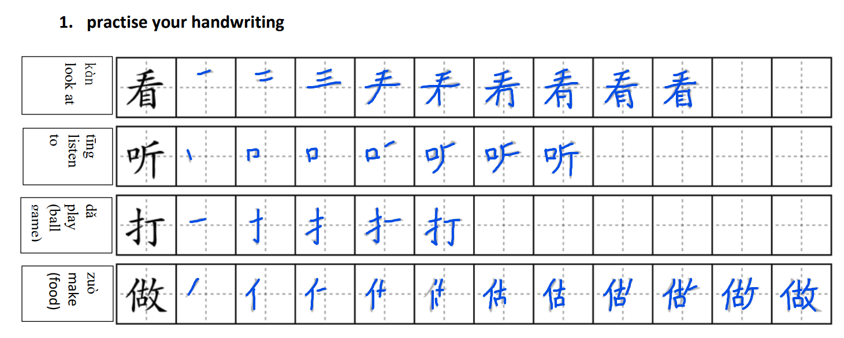

- Fill in the blanket with the correct verb from above.

（ 看 ）电视 diànshì
（ 打 ）乒乓球 pīngpāngqiú
（ 做 ）蛋糕 dàngāo
（ 打 ）橄榄球 ɡǎnlǎnqiú: rugby
（ 打 ）网球 wǎngqiú
（ 打 ）篮球 lánqiú
（ 做 ）饭 fàn
（ 打 ）羽毛球 yǔ máo qiú: badminton
（ 看 ）书 shū
（ 听 ）音乐 yīnyuè
（ 看 ）电影 diànyǐnɡ
（ 做 ）中国菜 zhōngguó cài: Chinese food
（ 看 ）杂志 zházhì: magazine
- Translate the following sentences
- Dw i’n hoffi bwyta bwyd Tsieineaidd. Wǒ xǐhuān chī zhōngguó cài.
- Dw i’n hoffi gwilio rugby. Wǒ xǐhuān kàn gǎnlǎnqiú.
- Dyw e ddim yn hoffi darllen cylchgrawn. Tā bù xǐhuān kàn zázhì.
- Mae hi’n chwarae tenis bob penwythnos. Tā měi zhōumò dōu dǎ wǎngqiú.
- Ydy e’n hoffi yfed te gwrydd? Tā xǐhuān hē chá ma?

- Type a paragraph to introduce yourself and your family. Then recording yourself reading it afterwards. (Please feel free to look up the words you are not sure about, e.g.: jobs and adjectives that are not included in our lesson. I will give you some feedback on that afterwards.)
you can talk about:
- your name
- your nationality
- your age and birthday
- your job and location
- the subject you teach
- what you like and dislike
- how often do you do your hobbies
- people in your family (What are they like? What are their jobs? What are their hobbies?)
- your pet
- Chinese food you want to eat
- Chinese tea that you would like to drink

Hi, I am called Alex. I am English. I am 26. My birthday is September 23rd. I work in a school in Wales. I am a French teacher.

I like to play table tennis, I play table tennis every day, but I do not like to cook meals, I often cook meals.

I have 3 people in my family. My mum is called Laura. I think she is very clever. She is an accountant. My dad is called Steve. I think that he is not fat. He is retired. I don't have pets. I want to eat chicken chow mein. I think chow mein is so delicious. I want to drink iced water.

你好, 我叫Alex。 我是英格兰人。我二十六岁。 我的生日是九月二十三号 。我在威尔士的学校工作。我是法语老师。

我喜欢打乒乓球，我每天都打乒乓球，但是我不喜欢做饭，我经常做饭。

我家有三口人。 妈妈叫Laura。我觉得她很 聪明。她是 会计。爸爸叫Steve。我觉得 他不胖。他退休了。我没有宠物。我要吃鸡肉炒面。我觉得炒面太好吃了。
我要喝冰水。

Nǐ hǎo, wǒ jiào yà lì kè sī. Wǒ shì yīnggélán rén. Wǒ èrshíliù suì. Wǒ de shēngrì shì jiǔ yuè èrshísān hào. Wǒ zài wēi'ěrshì dì xuéxiào gōngzuò. Wǒ shì fǎyǔ lǎoshī.

Wǒ xǐhuān dǎ pīngpāng qiú, wǒ měitiān dū dǎ pīngpāng qiú, dànshì wǒ bù xǐhuān zuò fàn, wǒ jīngcháng zuò fàn.

Wǒjiā yǒu sānkǒu rén. Māma jiào láo lā. Wǒ juédé tā hěn cōngmíng. Tā shì kuàijì. Bàba jiào shǐ dì fū. Wǒ juédé tā bù pàng. Tā tuìxiūle. Wǒ méiyǒu chǒngwù. Wǒ yào chī jīròu chǎomiàn. Wǒ juédé chǎomiàn tài hào chīle. Wǒ yào hē bīng shuǐ.

5. Cultural study
Recording:
https://us02web.zoom.us/rec/share/10MVjRlf-ofskZNmzKrYGj67qxhAYgHWA38s0NptJ3VUzYg2X3mRMR_Ht2L2_qwC.9MC1tXaKDlk5rP8O

Passcode: g8.$RnAv

What Chinese cultural elements are involved in Starbucks? What are the possible effects?

More exciting loyalty schemes compared to those in the UK and US. Redeemable gifts after 150 yuan purchase including: cute laptop bags, note books, fancy sticky tape, cute toys related to Chinese festivals. The effect of this is that it encourages particularly the younger generation to continue to buy from this store. China as a nation is increasingly becoming accustomed to coffee but nowhere near as Europe and the US so there is a possibility the gifts are more enticing than the coffee.

What is the coffee brand frequently seen in Wales?

As someone who lives in a small town in Pembrokeshire, artisanal cafés are regularly seen. The three big chains are Starbucks, Costa and Caffe Nero but these are only seen in larger towns. Sometimes you can see a Costa, Starbucks or McCafé concession stores at petrol stations on main roads. Coffee is therefore being promoted to consumers who need caffeine for long-haul commutes.

Do you prefer coffee from famous chain stores or small art design cafés?

Neither – I am not a coffee drinker. I have been to each of the 3 big chains a few times in my lifetime but once you have been three or so times it is the same experience. If I were to meet up with friends I would prefer to meet at an independent coffee shop to support local businesses and for a difference experience. I don’t mind good quality espressos but I can only drink small quantities of it. The Chinese Tea House culture would interest me much more as I love herbal teas.

When you are at a coffee store, what concerns you most: quality of the coffee beans, good taste, atmosphere of the shop, etc?

The quality and good taste – I find coffees at the three big chains too ‘artificial’ or too ‘tampered’ to suit a stereotypical Westerner’s palette. They are too sweet and creamy, and the black coffees are just a cheap quality. I prefer coffee shops abroad in countries like Italy and Switzerland where the emphasis is on the type of coffee bean and its aroma or taste to make just a plain espresso. In my opinion less is more!

