Report for Community Engagement Assignment 2 2018 – Problems being faced by Home Bargains


April 2018

MODULE NAME: COMMUNITY ENGAGEMENT (M4X00799)
PROJECT NAME: PROBLEMS FACED BY HOME BARGAINS
NAME: SAM THOMAS
STUDENT NUMBER: 1706610

TABLE OF CONTENTS
EXECUTIVE SUMMARY……………………………………………………………………3
INTRODUCTION………………………………………………………………………………4
Report Remit……………………………………………………………………………..4
Brief Background of the Organisation………………………………………...4
The Problem.................................................................................5
PROBLEM SOLVING TECHNIQUES......................................................6
Solving the Problem.....................................................................8
Problem Solving Implementation.................................................10
CONCLUSION....................................................................................11
REFERENCES.....................................................................................11

List of Figures
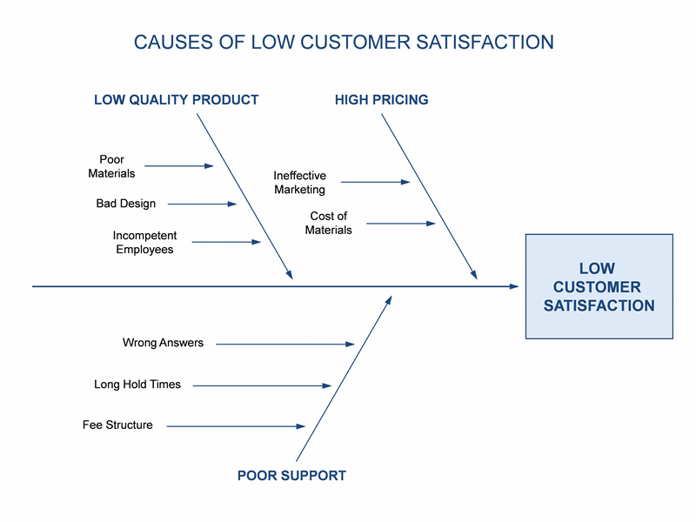
Available from: https://templates.office.com/en-us/Cause-and-effect-diagram-TM02809154 [Accessed on April 28th, 2018].
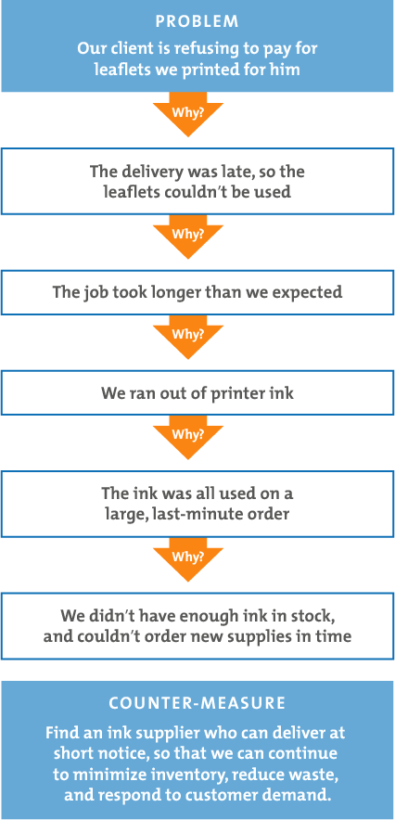
Available from: https://www.mindtools.com/pages/article/newTMC_5W.htm [Accessed on 29th April 2018].

- EXECUTIVE SUMMARY
The main aim of this report was to apply problem-solving techniques to help a business of our choice to deal with a problem they are being affected by. The business I have chosen is my place of work Home Bargains.

The problem Home Bargains has been facing for some time is that they are unable to grow any more than what they currently are despite ambitions to increase their reach and market share. Although a difficult task due to the market they are operating in, I have found that it is possible to do so to some extent.

Using both Ishikawa’s fishbone technique alongside the 5 whys, I determined through the report that the most effective way to do this is by developing a loyalty strategy and implementing it to follow the likes of Tesco and Sainsburys with Clubcard points etc.

We will monitor the affect of the loyalty scheme by recording sales figures across stores and seeing if they improve. It may be beneficial to trial the method in stores across just one region, e.g. Swansea, to see whether this would work for the company.

It is a difficult ask to improve Home Bargains market share in such a competitive market, however this is what I believe to be the most effective way of doing so.

- INTRODUCTION

  - REPORT REMIT
For the report we have been asked to produce, the main aim of this is to look at and evaluate a problem faced by an organisation. Once we have discovered the problem, we must look to use problem solving techniques which we have learned throughout our learning experience and apply them to the problem to figure out the best way to help the organisation to overcome the issue. Once we have explained the techniques, we must make recommendations to the organisation that I believe would help them to overcome their issues that relate to the problem-solving techniques used.

  - BRIEF BACKGROUND OF THE ORGANISATION
The organisation I have chosen to apply the problem-solving techniques to is discount store Home Bargains. The reason for this is that I have been working there for over two years part time alongside my studies and can see clearly how the organisation hopes to grow in terms of market share, profits etc as well as see potential problems they may have to face. “Home Bargains is a chain of discount stores founded in 1976 by Tom Morris in Liverpool, England. It is the trading name of TJ Morris Ltd, stocking up to 4000 branded product lines and employs over 17,000 people from head office staff to warehouse staff and shop staff”- Wikipedia. Home Bargains is very popular across the United Kingdom however it does not have any stores in other countries. Although not a market leader like Asda or Tesco, Home Bargains does attract many customers due to the cheap prices they have for all product types. “In 2013, the company estimated they served over three million customers and published a record breaking turnover of £1 billion which was subsequently increased by 50% just three years later in 2016”- Wikipedia. These statistics only prove the growth of the company in recent history, with the numbers only continuing to grow in 2017 and 2018. As of 2017, Home Bargains currently operate 481 stores around the United Kingdom in different locations. The yearly revenue of the company is estimated at £1.6bn as of 2016. The slogan of Home Bargains is “Top Brands, Bottom Prices”- Home Bargains.

  - THE PROBLEM- MARKETING AND GROWTH
The main point of this report is outlined in this section, the problem. What exactly is the problem which Home Bargains is currently facing and how does this problem damage the company? As shown in the above section Home Bargains is clearly popular in terms of the number of customers it attracts, with over 3 million being served nationwide in 2013. It is also turning over a very healthy profit which allows the company to continue creating more stores across the UK. Although Home Bargains is not labelled directly as a super market, it has been made clear by the owners that they hope to someday be operating on a similar scale. This seems unreasonable at present time but to even begin to be on the same scale as Asda, Tesco and others they must properly evaluate where they are behind and must do everything to improve that. Compared to just Tesco alone, Home Bargains has just 481 stores nationwide compared to the 6553 stores currently for Tesco. Tesco also has over 476,000 staff working for them compared to just 17000 of Home Bargains. Finally, Tesco generate a yearly revenue of roughly £56 billion which is massive compared to just £1.6 billion of Home Bargains. These figures alone show the work that would have to be done by Home Bargains’ owners to get anywhere near to these supermarkets. Clearly there is a problem here, as Home Bargains is trying to become this big but is not sustaining the same level of growth. The problem isn’t to get as big as Tesco as it clearly won’t happen any time soon, but they do have a problem in terms of wanting to grow to get a reasonable market share. This links with the second problem of marketing. The small discount stores do not have the same audience as bigger supermarkets, they do not attract enough customers and do not have the same voice in the market. For example, Tesco and the other supermarkets in the ‘big four’ are constantly advertising through things such as TV, radio and even online advertising. However, it is very rare to see a Home Bargains advert on TV or hear one on the radio, simply because they can not afford the advertising space, where as Tesco and Asda can afford to constantly produce adverts. This is a massive part of the success of these businesses as they can attract new customers regularly as well as entice regular customers to continue to shop with them. Home Bargains however does not have the same ability to attract these new customers and must rely on things such as word of mouth. This in total means that Home Bargains are unable to pull away customers that currently do not stray away from the big supermarkets and this is a massive negative that is hindering the growth of Home Bargains.

- PROBLEM SOLVING TECHNIQUES
Now that I have highlighted the problem faced by Home Bargains, it is important to look at all the possible problem-solving techniques learned which we could apply to the problems. There are many different techniques available, these include Ishikawa problem solving, 5 whys, 5 W’s and H alongside others. The first technique available is Ishikawa’s problem-solving technique. This uses a diagram known also as the ‘fishbone diagram’ and is “a visualization tool for categorizing the potential causes of a problem in order to identify its root causes”. The Ishikawa diagrams were popularised in 1960 by a man called Kaoru Ishikawa as he looked at how many different outside influences could affect a problem. These include things such as equipment, process, people, materials, environment and management. The theory also looked at both primary and secondary causes. For each problem, the aim is to look at what could be causing it from all different angles. “Brainstorm all the possible causes of the problem. Ask: “Why does this happen?””. It is important to establish any potential causes that could relate to the problem. Once all the initial causes are accounted for, we must then go in to more depth and continue to ask ‘why’ to get to the deeper roots of the problem being faced by Home Bargains. Whilst going in to detail on each cause, we create sub branches by continuing to ask why, which will help us to clearly see how we can solve this problem. “Again ask “why does this happen?” about each cause. Write sub-causes branching off the causes. Continue to ask “why?” and generate deeper levels of causes.”. Once all ideas are dried up and everything has been thought of, it is easier to distinguish between problems and how they can be solved to help the company. Below is an example of how a basic fishbone diagram would look whilst brainstorming.

Available from: https://templates.office.com/en-us/Cause-and-effect-diagram-TM02809154 [Accessed on April 28th, 2018].

Although we have already identified one valid technique for this problem-solving task, it is very important that we use a secondary technique, this is important to make comparisons between the two, it can allow a deeper level of analysis. For example, if one technique is harder to apply to a problem, having a second technique is important as it may be easier to use to solve the problem as quickly as possible. The second problem-solving technique is called the 5 whys. The 5 whys are a technique that was developed in the 1930’s by Sakichi Toyoda, the creator of Toyota and became popular later in 1970. “You can use 5 Whys for troubleshooting, quality improvement and problem solving, but it is most effective when used to resolve simple or moderately difficult problems.” -MindTools.com. Although it says it is most effective for simpler problems, it can also be applied to larger scale problems, however it is important not to rely solely on this technique and it must be used alongside the Fishbone technique in comparison for more widescale issues. In total, the 5 whys technique uses a simple seven step process to troubleshoot each problem, the seven steps start by assembling a group of however big is necessary to establish what exactly the problem is. Once the problem has been defined, we begin by asking the first ‘why’. “Ask your team why the problem is occurring. (For example, "Why isn't team A meeting its response time targets?"); answering it requires thought and intelligent application”. - MindTools.com. Once we have asked the first why, we then continue to ask why a further four times. We are asking in response to the answer given to each previous why. This is shown in an example below.

Available from: https://www.mindtools.com/pages/article/newTMC_5W.htm

The diagram above shows how we are developing the questions in response to each previous answer. This allows a steady train of thought and clarifies exactly what the problem is, how its occurred and how it can be solved. There is however potential like with the fishbone diagram to branch out and give many different reasons why, however it is important to not over-complicate. The penultimate step is to address the initial root cause. “what counter-measures will prevent the problem from recurring”. – MindTools.com. Once we know the counter measures, its important to understand how they can be used to prevent a similar situation arising in the future. The final step is to monitor how these counter measures are affecting the problem and if they are working.

  - SOLVING THE PROBLEM
Now that in the above sections we have broken down the techniques and can clearly understand how to apply them, we must now look to apply them in the real situation when looking at the problems faced by Home Bargains. As discussed in section 2.3, the problem Home Bargains as a company is facing is growth within their market, and how marketing can help them to improve this. We can first look to solve the problem using Ishikawa’s fishbone diagram. Home Bargains main problem that they need to address is poor marketing and advertisement. To combat this, I must look at the potential branches that come off this problem. The first problem is the promotion Home Bargains is currently performing. Promotion is defined as “the entire set of activities, which communicate the product, brand or service to the user. The idea is to make people aware, attract and induce to buy the product, in preference over others”. – Economic Times. Currently Home Bargains operates all its promotional material purely off its website, alongside having reasonable amounts of followers on Twitter and other social media platforms. This is where it ends though as it is very rare to see a Home Bargains advertisement on TV or radio, this is due to the price of the advertising space and so they must rely on their social media platforms alongside word of mouth. The second problem is place. The place is very important for almost every business, especially those which operate on trying to attract customers in to stores. Although not all stores will be the same nationwide, it is prominent across Swansea that the Home Bargains stores are situated near to supermarkets. (e.g. Gorseinon store located opposite to a large Asda, Phoenix Way store has both a Tesco and Asda within walking distance, also Parc Tawe store in Swansea City centre located close to both a Tesco and Morrisons). This means that for someone living around the area, Gorseinon specifically for this example, people may be more inclined to go to a more reputable company such as Asda rather than trying a cheaper alternative as they know exactly what they are getting. This draws business away from Home Bargains and could damage sales. To combat this, they may need to aim to set up in places not as close to supermarkets but still with good transport links and footfall. This is easier said than done however as all good sites are usually used by the bigger supermarkets. Another problem is price, people may be genuinely put off by the low price, due to the belief that low-price equals to low quality. Although this is not the case, it is very hard to convince people otherwise as they are not advertising well enough to convince people. The final major branch on the fishbone diagram is the people/personnel within the business. This includes everyone from the owners, managers all the way down to the shop floor staff. It is important that the owners understand the importance of advertisement and all forms of marketing if they do want to expand the company. They must make sure then that these ideas are pushed down throughout the whole company to ensure they are attracting all potential customers available to them.
The second problem-solving technique is the 5 whys. Although this is used for smaller problems it can be applied now. The first initial statement is that Home Bargains is unable to improve its market share in its field. When you apply the first ‘why’ its because there is a lack of advertising being done by the company. The second ‘why’ would lead to saying that its because they cannot afford to purchase the advertising space from TV, radio and the like. The third ‘why’ is answered by saying they are not making enough profits in comparison to the companies around them who can afford to advertise. The fourth why is answered by saying this is because they are not a market leader and so do not have the ability to do so. Finally, the fifth ‘why’ is since there are ‘the big four’ ahead of them with a firm grip on the market in Asda, Tesco, Sainsbury’s and Morrisons. When using the two problem-solving techniques above, we can clearly see the problems being faced by Home Bargains and now it is important that a plan is thought of to combat the issue. Companies like Tesco make good use of advertising such as enticing customers to repeat purchase through Clubcard’s. Clubcard’s give customers points which allow them to spend on things such as in-store discounts, vouchers and other things such as cinema tickets and theme park tickets. This is a very effective form of sales promotion. “Sales promotion represents a variety of techniques used to stimulate the purchase of a product or brand”. If home bargains ever plans on becoming a bigger company loyalty rewards like this need to be implemented as it is the best possible way of attracting new customers and repeat buyers. Overall, I feel like the best possible way to improve sales figures is to take the same approach as other big supermarkets and implement loyalty cards. A loyalty system would help Home Bargains massively to attract customers. Once these new customers have been brought over, the boost in sales could potentially help the company to get the advertising space they need. The extra sales revenue generated from the loyalty cards would make it easier to purchase advertising space. This would also generate more sales and so a domino effect would occur and massively help the business.

  - PROBLEM SOLVING IMPLEMENTATION
Now that we have clearly identified what the problem is for Home Bargains, alongside the way in which we want to solve it, we now must look at how we can implement the solution to stop the problem. Firstly, it is important that the idea is communicated effectively to the relevant stakeholders. “A person, group or organization that has interest or concern in an organization. Stakeholders can affect or be affected by the organization's actions”. – Business Dictionary. In terms of the customers it is important that it is fully advertised to them about the new loyalty scheme. Also, to communicate this to the owners, T.G Morris do regular store visits, which means that it could easily be communicated to them when they visit. In total it would take roughly a few months to implement the system as it would need time to go through prototyping, market research etc. To measure the success of the idea, it would simply be done by seeing whether the loyalty scheme improves sales, as well as gaining new customers. The figures could be monitored monthly to see whether this is having just an initial boost, or a long-term improvement.

- CONCLUSION
In conclusion, the problem Home Bargains faces is clearly the ability to advertise and gain customers, however, using the problem-solving techniques we can see a clear solution to the problem and how It could be initiated effectively.

- REFERENCES
1. “Home Bargains is a chain of discount stores founded in 1976 by Tom Morris in Liverpool, England. It is the trading name of TJ Morris Ltd, stocking up to 4000 branded product lines and employs over 17,000 people from head office staff to warehouse staff and shop staff”- Wikipedia. Available from: https://en.wikipedia.org/wiki/Home_Bargains [Accessed on 27th April 2018].
2. “In 2013, the company estimated they served over three million customers and published a record breaking turnover of £1 billion which was subsequently increased by 50% just three years later in 2016”- Wikipedia. Available from: https://en.wikipedia.org/wiki/Home_Bargains [Accessed on 27th April 2018].
3. “Top Brands, Bottom Prices”- Home Bargains. Available from: homebargains.co.uk.
4. Tesco generate a yearly revenue of roughly £56 billion. Available from: https://en.wikipedia.org/wiki/Tesco [Accessed on 28th April 2018].
5. “a visualization tool for categorizing the potential causes of a problem in order to identify its root causes”. – WhatIs.com. Available from: https://whatis.techtarget.com/definition/fishbone-diagram [Accessed on 28th April 2018].
6. “Brainstorm all the possible causes of the problem. Ask: “Why does this happen?”” -asq.org. Available from: http://asq.org/learn-about-quality/cause-analysis-tools/overview/fishbone.html [Accessed on 28th April 2018].
7. “Again ask “why does this happen?” about each cause. Write sub-causes branching off the causes. Continue to ask “why?” and generate deeper levels of causes.” – asg.org. Available from: : http://asq.org/learn-about-quality/cause-analysis-tools/overview/fishbone.html [Accessed on 28th April 2018].
8. “You can use 5 Whys for troubleshooting, quality improvement and problem solving, but it is most effective when used to resolve simple or moderately difficult problems.” -MindTools.com. Available from: https://www.mindtools.com/pages/article/newTMC_5W.htm [Accessed on 28th April 2018].
9. “Ask your team why the problem is occurring. (For example, "Why isn't team A meeting its response time targets?"); answering it requires thought and intelligent application”. - MindTools.com. [Accessed 28th April 2018].
10. “what counter-measures will prevent the problem from recurring”. – MindTools.com. [Accessed on 29th April 2018].
11. “the entire set of activities, which communicate the product, brand or service to the user. The idea is to make people aware, attract and induce to buy the product, in preference over others”. – Economic Times. Available from: https://economictimes.indiatimes.com/definition/promotions [Accessed on 29th April 2018]
12. “Sales promotion represents a variety of techniques used to stimulate the purchase of a product or brand”-Wikipedia. Available from: https://en.wikipedia.org/wiki/Sales_promotion [Accessed on 30th April 2018].
13. “A person, group or organization that has interest or concern in an organization. Stakeholders can affect or be affected by the organization's actions”. – Business Dictionary. Available from: http://www.businessdictionary.com/definition/stakeholder.html [Accessed on 30th April 2018].
14. Community Engagement PowerPoint.

“Home Bargains is a chain of discount stores founded in 1976 by Tom Morris in Liverpool, England. It is the trading name of TJ Morris Ltd, stocking up to 4000 branded product lines and employs over 17,000 people from head office staff to warehouse staff and shop staff”- Wikipedia. Available from: https://en.wikipedia.org/wiki/Home_Bargains [Accessed on 27th April 2018].
“In 2013, the company estimated they served over three million customers and published a record breaking turnover of £1 billion which was subsequently increased by 50% just three years later in 2016”- Wikipedia. Available from: https://en.wikipedia.org/wiki/Home_Bargains [Accessed on 27th April 2018].
“Top Brands, Bottom Prices”- Home Bargains. Available from: homebargains.co.uk.
Tesco generate a yearly revenue of roughly £56 billion. Available from: https://en.wikipedia.org/wiki/Tesco [Accessed on 28th April 2018].
“a visualization tool for categorizing the potential causes of a problem in order to identify its root causes”. – WhatIs.com. Available from: https://whatis.techtarget.com/definition/fishbone-diagram [Accessed on 28th April 2018].
“Brainstorm all the possible causes of the problem. Ask: “Why does this happen?”” -asq.org. Available from: http://asq.org/learn-about-quality/cause-analysis-tools/overview/fishbone.html [Accessed on 28th April 2018].
“Again ask “why does this happen?” about each cause. Write sub-causes branching off the causes. Continue to ask “why?” and generate deeper levels of causes.” – asg.org. Available from: : http://asq.org/learn-about-quality/cause-analysis-tools/overview/fishbone.html [Accessed on 28th April 2018].
“You can use 5 Whys for troubleshooting, quality improvement and problem solving, but it is most effective when used to resolve simple or moderately difficult problems.” -MindTools.com. Available from: https://www.mindtools.com/pages/article/newTMC_5W.htm [Accessed on 28th April 2018].
“Ask your team why the problem is occurring. (For example, "Why isn't team A meeting its response time targets?"); answering it requires thought and intelligent application”.- MindTools.com. [Accessed 28th April 2018].
“what counter-measures will prevent the problem from recurring”. – MindTools.com. [Accessed on 29th April 2018].
“the entire set of activities, which communicate the product, brand or service to the user. The idea is to make people aware, attract and induce to buy the product, in preference over others”. – Economic Times. Available from: https://economictimes.indiatimes.com/definition/promotions [Accessed on 29th April 2018]
“Sales promotion represents a variety of techniques used to stimulate the purchase of a product or brand”-Wikipedia. Available from: https://en.wikipedia.org/wiki/Sales_promotion [Accessed on 30th April 2018].
“A person, group or organization that has interest or concern in an organization. Stakeholders can affect or be affected by the organization's actions”. – Business Dictionary. Available from: http://www.businessdictionary.com/definition/stakeholder.html [Accessed on 30th April 2018].

