

Master of Business Administration Programme
LCMB7035 – Dissertation Proposal

Online Review Management and Brand Reputation in the UK Hotel Industry: An Extended Literature Review

Supervisor Name: Professor Ebad Banissi
Student Name: Md Sohidul Islam
Student ID: 2504070
Word Count: 2672
Group : 3 , Term : 3
Date of Submission: 16th July

Table of Contents
Introduction and Background 2
Research Problem 2
Research Aim 3
Research Objectives 3
Research Questions 3
Literature Review 4
Online Reviews and Brand Reputation 4
Review Helpfulness, Trust, and Customer Behaviour 4
Online Review Management and Service Recovery 5
Employee Behaviour and Reputation 5
Research Gap 6
Research Methodology 6
Research Philosophy: Interpretivism 7
Research Approach: Deductive with Inductive Flexibility 7
Research Strategy: Multiple Case Study 7
Research Design: Qualitative Secondary Data Analysis 7
Data Collection Method: Document Analysis 8
Data Analysis Method: Braun and Clarke’s Six-Step Thematic Analysis 8
Expected Contributions 9
Ethical Considerations 9
Research Timeline 9
Conclusion 10
References 11

Introduction and Background
Online reviews are an integral part of performance and reputation in the UK hotel sector. Nowadays, tourists take ratings seriously. Written comments, photos, and management responses are also important for a booking. In recent times, online review management is more than a customer service activity. It's a strategic branding activity. Online reputation can affect hotel profitability, as demonstrated by Anagnostopoulou et al. (2020) in terms of revenue, occupancy power and pricing power. Similarly, Dewani (2023) states that online reviews influence perceptions of service quality as they can become publicly visible. The fact that being a hotel shopper is an activity in which there is risk associated with it, as consumers are not able to fully judge the service in their assessment before staying in the hotel, is important (Choi and Leon, 2020). Electronic word of mouth can be used by customers to mitigate uncertainty as well as compare the options (Sann, Lai and Chen, 2021). It is also possible that there are emotions, bias or scepticism in reviews (Wen and Ha, 2024). Therefore, it is significant that there is a management response. They are able to deliver trustworthy messages, messages of accountability, service recovery messages, and messages that represent a company's values and brand. This study investigates guest voice, response quality and public brand meaning within the group of online reviews, their management as a reputation-building process in UK hotels organised by different categories and online review platforms.

Research Problem
Many studies have shown how online reviews affect customer decision-making and the performance of businesses, thus substantiating the existing research in hospitality. Some researchers, for instance, relate review helpfulness to the financial situation of the company, as Mariani and Borghi (2020) do. Kim and Kim (2022) reveal that customers' feelings and experiences can be shown via online reviews. Moreover, Sutherland, Sim and Lee (2021) demonstrate the interaction effects between online review signals and quality certification and pricing strategy. Although they're useful studies, they illustrate the quantifiable impact of reviews (Tsai et al., 2020). However, they tend to pay attention to more subjective feedback, such as rating, sentiment, helpfulness or profitability, rather than on the communication that the hotel exercises around reviews as part of brand reputation (Mariani and Borghi, 2020). This results in the research question. While they can gather reviews and reply to them, not all review response tactics would have the same effect on the hotel's reputation. While a brief apology might seem courteous, it may not win back the goodwill. An elaborate answer demonstrates care while at the same time indicating service failure. Niu and Fan (2021) propose caution so that review management practices are different among the different hospitality services. But further analysis is required to understand how these practices impact reputation in the context of the UK. This study fills this gap by analysing public commentaries (secondary qualitative data) and management's responses.

Research Aim
This research aims to analyse how online review management influences brand reputation in the UK hotel industry through secondary data analysis of reviews, management responses, and industry sources.

Research Objectives
- To examine how UK hotels use online review management to respond to guest experiences.
- To identify key themes in customer reviews that shape hotel brand reputation.
- To analyse how management responses communicate trust, accountability, and service recovery.
- To evaluate how online review management may support or weaken brand reputation.
- To develop practical recommendations for reputation management in the UK hotel industry.

Research Questions
Primary question: How does online review management influence brand reputation in the UK hotel industry?
Sub-questions:
- What review themes are most important in shaping hotel reputation?
- How do hotel management responses address negative and positive guest feedback?
- How are trust, service recovery, and accountability communicated in review responses?
- What can UK hotels learn from online review management practices?

Literature Review

Online Reviews and Hotel Brand Reputation
According to Sann et al. (2022) when it comes to brand reputation, online reviews in hospitality play a crucial role since hotel services are intangible products when people are looking to book them. The customers then refer to the ratings, review narratives, images and management responses as the cues before booking. As mentioned, online reputation influences the profit of the hotel business, which was demonstrated by Anagnostopoulou et al. (2020). It should also be noted that review sites hold strategic value, not only in providing feedback to customers, but also in enhancing the profit of firms. Dewani (2023) also states that reviews can shape perception and decision-making in the areas of tourism and hospitality. For the hotel industry in the UK, reputation is something co-created by customers and hotels and is done via digital communication.

Electronic Word-of-Mouth and Review Helpfulness
Shamim et al. (2021) state that electronic word of mouth refers to the manner in which customers' opinions are disseminated online and impact the next set of customers. According to Sann, Lai and Chen (2021), eWOM becomes more influential when it comes to the hospitality industry because customers seek to mitigate the risk in purchasing through the experience of other customers. Positive feedback can include a sense of cleanliness, professionalism of staff, comfort and good value for money; regular negative feedback can undermine brand credibility. But not all reviews carry the same weight. According to Choi and Leon (2020), detailed and credible review content has more persuasive power than helpful reviews. However, in this study, Tsai et al. (2020) also indicate that the sentiment and helpfulness attributes allow for a better understanding of the reviews in hotels. So, themes including room quality, staff behaviour, location, facilities and service failure are key barometers of how successful a brand is.

Underpinning Theories
This study is underpinned by five theories. Signalling Theory proposes that hotels communicate their service quality via overt behaviours (prompt and timely), which are visible to the customers. Answers may indicate accountability, and generic responses or silence may indicate poor customer orientation. According to Service Recovery Theory, complaints received are opportunities to fix dissatisfaction. Wen and Ha (2024) further state that if hotels have to apologise, they can minimise reputational harm by describing what's happened and taking action to put it right. According to Expectation Confirmation Theory (ECT), satisfaction is an outcome of whether the actual service transcends or falls short of expectations, which were established before the event. Sutherland and Lee (2021) determine that these expectations are influenced by the internet and the reviews given online, which in turn influence the post-stay evaluations. Relationship Marketing is the term used to describe how review management can pass on the message of caring and commitment that adds to the ongoing trust. Niu and Fan (2021) demonstrate that eWOM theory accounts for the impact of Guest to Guest sharing on next accommodation and meanings of public brand.
Online Review Management and Service Recovery
Review management is not just about responding to reviews, but a reputation management process that takes place online. Niu and Fan (2021) demonstrate divergent review management practices across different types of hospitality services – response style, response speed, and response depth are important. An apology is helpful, but may not restore confidence, particularly if presented as a brief comment. Answering with too much detail can demonstrate caring, but also reveal elements for which the service is poor (Sann et al., 2022). So, hotels should maintain a balance between empathy, responsibility and professionalism. Management responses are considered in the public domain and therefore will be read by the guest who sounded off as well as other prospective guests. Luo et al. (2021) state that this ensures that the quality of the response is visible, and therefore is recovery from service.
Employee Behaviour, Trust and Reputation
Employee behaviour is directly related to hotel reputation—hotel guests mention employee attitude, helpfulness and professionalism. Yao, Han and Bi (2024) point to employee loyalty and how it influences online reviews, indicating that internal service culture has an impact on external comments. There's trust, too. Wiedmann and von Mettenheim (2021) state that credibility is based on trustworthiness and expertise. Mariani and Borghi (2021) discuss how these qualities could manifest themselves in hotel responses through honest-worded explanations, specificity of explanations and an implicit promise for improvement.

Conceptual Model
As displayed in the conceptual model in Figure 1, online review management affects the hotel brand reputation dimension, which includes trust, service recovery, accountability and perceived service quality (Kim and Kim, 2022). Response rate, delay, tone and quality are indicators of online review management. These habits serve as indicators and actually define the dependability and professionalism of a hotel, from the perspective of prospective visitors (Niu and Fan, 2021). Average rating, sentiment of the reviews, and key "recurring words" within the reviews are all indicators of brand reputation. Wiedmann and von Mettenheim (2021) state that the UK hotel industry context is taken into account by including control variables like hotel size, star rating, chain or independent, region and price. Different hotels may manage reviews differently.
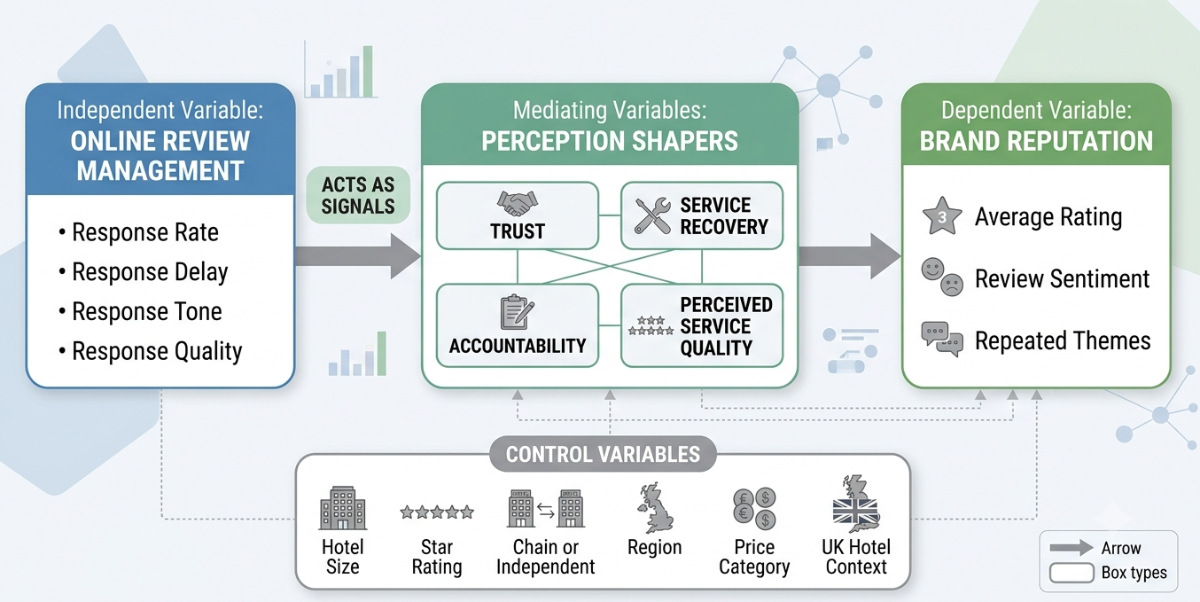
Figure 1: Conceptual Framework
Source: (Kim and Kim, 2022; Niu and Fan, 2021; Wiedmann and von Mettenheim, 2021)

Research Gap
The literature relates reviews, trust, satisfaction, helpfulness and performance. However, the lack of understanding about online review management as a qualitative brand reputation process in the UK hotel industry remains. For many research studies, big data, sentiment analysis or financial models are utilised (Anagnostopoulou et al., 2020; Tsai et al., 2020; Sann et al., 2022). Though these methods are sound, they can also ignore the significance of response language. The study aims to fill the gap by analysing the process of constructing, reinforcing or undermining reputation from the perspective of review management communication using Braun and Clarke's (2006) thematic analysis.

Research Methodology
This study will be structured according to Saunders’ Research Onion with a secondary data approach.
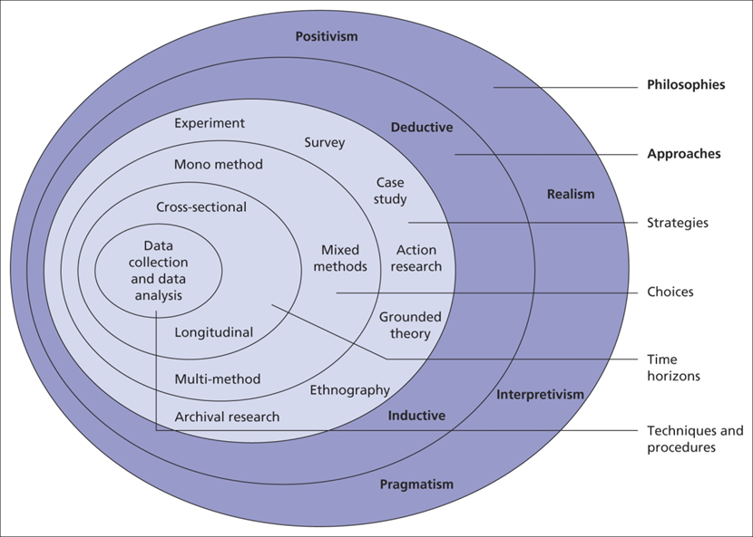
Figure 1: Saunders’ Research Onion Modle
Source: (Saunders, Lewis and Thornhill, 2023)

Research Philosophy: Interpretivism
Interpretivism will be used in the study. This is argued in that the research is investigating meanings within texts of reviews and the managers' responses. Continuing with the example of the brands, their reputation is established in a social manner with narration, emotions, and hotel responses (Saunders, Lewis and Thornhill, 2023). A positivist would measure ratings, but this way, the expression of reputation does not get understood in its entirety. This is enhanced by the use of interpretivism, which enables the researcher to analyse the meaning of trust, blame, apology, disappointment and reassurance in text.

Research Approach: Deductive with Inductive Flexibility
In this study, deductive methods will be used with eWOM, Signalling Theory, Service Recovery Theory and the literature regarding trust and brand reputation, but new themes from the reviews will be accepted (Snyder, 2019). There will be 60 hotels in the sample from the UK (20 three-star, 20 four-star and 20 five-star). Hotels need to be UK-based with 100+ public reviews, and a rating plus management responses at the hotel need to be visible on either TripAdvisor, Google Reviews or Booking.com (Saunders, Lewis and Thornhill, 2023). Hotel size will be coded small (<50), medium (50-150), large (>150) rooms. Star rating, chain/independent ownership, UK region and price category (budget, mid-range through premium based on the average nightly rate in the same week of the data collection.

Research Strategy: Multiple Case Study
A multiple case study approach will be applied. A selection of hotel categories within the United Kingdom's hotel sector will be examined – including budget, mid-range and premium hotels. It is helpful as the position in the market can dictate reputation management (Aguinis, Bergh and Molina-Azorin, 2022; Yin, 2018). Value and efficiency may be a thing for budget hotels, while personalised service may be a thing for the higher quality hotels. Because they will compare cases, this will add strength to the analysis and eliminate the weakness in analysing one hotel only.

Research Design: Qualitative Secondary Data Analysis
Data Source | Data to be Analysed | Purpose
TripAdvisor | Reviews, ratings, management responses | To analyse guest feedback and hotel replies
Booking.com | Review comments and guest ratings | To identify satisfaction and reputation themes
Google Reviews | Star ratings, review text, responses | To compare public customer opinions
Expedia | Ratings and service-related feedback | To support review comparison across platforms
Trustpilot | Complaints and trust-related comments | To assess brand trust where available

Data Collection Method: Document Analysis
TripAdvisor, Booking.com, Google Reviews, Expedia and Trustpilot, where available, will be the sources for secondary data collection by document analysis. There will be 60 hotels in the UK in the dataset. 20 three-star and 20 four-star hotels, and 20 five-star hotels. Based on each hotel, the study will document the following. Number of reviews, average rating, date of review, text of review, number of management replies, reply rate, time lag of reply, and average sentiment of reply (Aguinis, Bergh and Molina-Azorin, 2022). Guest website data will be utilised, and pre-confirmation will be made on location, star rating, chain status or independent and price category through data provided by the hotel website. All data will be inputted into MS Excel for cleaning, coding, comparison and later analysed using descriptive and qualitative thematic coding techniques.

Data Analysis Method: Braun and Clarke’s Six-Step Thematic Analysis
The Excel data set will be analysed by quantitative and qualitative procedures. These will be first summarised using descriptive statistics for each variable: number of reviews, average rating, response rate, response delay and sentiment score. Secondly, the associations between review management indicators and reputation outcomes (rating and sentiment) will be examined using correlation analysis (Saunders, Lewis and Thornhill, 2023). Third, multiple regression analyses will be conducted to determine if response rate, delay and sentiment are predictors of brand reputation, controlling for hotel size, hotel star rating, hotel chain or independent, UK region and hotel price category. Fourth, the texts of reviews will be classified as positive, negative or neutral through sentiment analysis. NVivo will be used for coding of common themes that are observed during the review process; where necessary, Excel will be used for cleaning, calculations, correlation, regression, as well as sentiment analysis and data visualisation.

Expected Contributions
This study will make two particular contributions. Academically, it will investigate the relationship between response rate, response delay, response tone and sentiment in relation to hotel brand reputation in the context of 60 hotels in the UK. In practice, it will equip hotel managers with knowledge of what actions they need to take in review management that will boost ratings, trust and service recovery (Ragab and Arisha, 2017). The data will also provide actionable insights into how to handle negative reviews, enhance the quality of responses and segment-wise (3, 4 and 5-star hotels) comparisons.

Ethical Considerations
The maximum number of ethical problems will be avoided since only the secondary data obtained from review platforms will be used. The names of reviewers, names or images of users, etc. will not be recorded in the Excel data (Rashid et al., 2019). Quotes will be paraphrased if needed to maintain anonymity. Only information from public pages that are easily accessible will be collected, and data will be used according to the terms of the platform. There will be correct referencing of sources and without any distortion in the reporting of findings.

Research Timeline
The research will be finished within 12 weeks. There will be a topic finalisation during Weeks 1–2. Weeks 2-4 will be dedicated to literature review and proposal writing. The methodology design and data collection will follow in Weeks 4-6. Data analysis, findings and final writing will continue from Weeks 6–10. The editing will take place in Weeks 9–11, and a successful submission shall be made during Weeks 11–12.
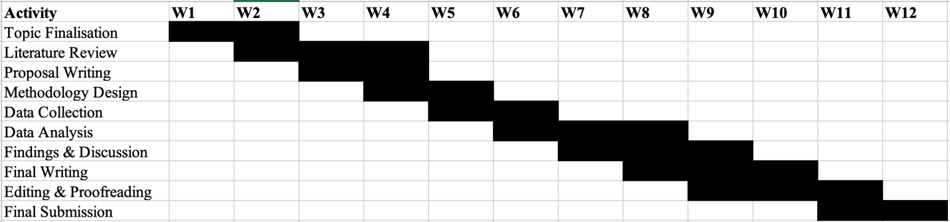

Conclusion
This idea will, without a doubt, be a significant help in hotel brand reputation through online review management. Reviews are connected to trust, satisfaction and monetary results. However, hotel response is crucial to reputation, as well. Six-step thematic analysis by Braun and Clarke 2006 can be used to reach the study to a focused and credible understanding of the review management from the use of secondary data in the UK hotel industry.

References
Aguinis, H., Bergh, D. and Molina-Azorin, J.F. (2022) ‘Methodological challenges and insights for future international business research’, Journal of International Business Studies. Available at: https://doi.org/10.1057/s41267-022-00578-8.
Anagnostopoulou, S.C., Buhalis, D., Kountouri, I.L., Manousakis, E.G. and Tsekrekos, A.E. (2020) ‘The impact of online reputation on hotel profitability’, International Journal of Contemporary Hospitality Management, 32(1), pp. 20–39. Available at: https://doi.org/10.1108/ijchm-03-2019-0247.
Choi, H.S. and Leon, S. (2020) ‘An empirical investigation of online review helpfulness: A big data perspective’, Decision Support Systems, 139, p. 113403. Available at: https://doi.org/10.1016/j.dss.2020.113403.
Dewani, P.P. (2023) ‘Online reviews in tourism and hospitality industry: a meta-analytical perspective’, J. for Global Business Advancement, 15(4), p. 420. Available at: https://doi.org/10.1504/jgba.2022.130443.
Kim, Y.-J. and Kim, H.-S. (2022) ‘The Impact of Hotel Customer Experience on Customer Satisfaction through Online Reviews’, Sustainability, 14(2), p. 848. Available at: https://doi.org/10.3390/su14020848.
Luo, J.M., Vu, H.Q., Li, G. and Law, R. (2021) ‘Understanding service attributes of robot hotels: A sentiment analysis of customer online reviews’, International Journal of Hospitality Management, 98, p. 103032. Available at: https://doi.org/10.1016/j.ijhm.2021.103032.
Mariani, M. and Borghi, M. (2021) ‘Customers’ evaluation of mechanical artificial intelligence in hospitality services: a study using online reviews analytics’, International Journal of Contemporary Hospitality Management, 33(11). Available at: https://doi.org/10.1108/ijchm-06-2020-0622.
Mariani, M.M. and Borghi, M. (2020) ‘Online Review Helpfulness and Firms’ Financial Performance: An Empirical Study in a Service Industry’, International Journal of Electronic Commerce, 24(4), pp. 421–449. Available at: https://doi.org/10.1080/10864415.2020.1806464.
Niu, R.H. and Fan, Y. (2021) ‘A comparative study of online review management in hospitality services’, International Journal of Services and Operations Management, 38(1), p. 22. Available at: https://doi.org/10.1504/ijsom.2021.112513.
Park, C.W., Sutherland, I. and Lee, S.K. (2021) ‘Effects of online reviews, trust, and picture-superiority on intention to purchase restaurant services’, Journal of Hospitality and Tourism Management, 47, pp. 228–236. Available at: https://doi.org/10.1016/j.jhtm.2021.03.007.
Ragab, M.A. and Arisha, A. (2017) ‘Research methodology in business: a starter’s guide’, Management and Organizational Studies, 5(1), p. 1. Available at: https://doi.org/10.5430/mos.v5n1p1.
Rashid, Y., Rashid, A., Warraich, M.A., Sabir, S.S. and Waseem, A. (2019) ‘Case study method: a step-by-step guide for business researchers’, International Journal of Qualitative Methods, 18, pp. 1–13. Available at: https://doi.org/10.1177/1609406919862424.
Sann, R., Lai, P.-C. and Chen, C.-T. (2021) ‘Review papers on eWOM: prospects for hospitality industry’, Anatolia, 32(2), pp. 1–30. Available at: https://doi.org/10.1080/13032917.2020.1813183.
Sann, R., Lai, P.-C., Liaw, S.-Y. and Chen, C.-T. (2022) ‘Predicting Online Complaining Behavior in the Hospitality Industry: Application of Big Data Analytics to Online Reviews’, Sustainability, 14(3), p. 1800. Available at: https://doi.org/10.3390/su14031800.
Saunders, M.N.K., Lewis, P. and Thornhill, A. (2023) Research methods for business students. 9th edn. Harlow: Pearson.
Shamim, S., Yang, Y., Zia, N.U. and Shah, M.H. (2021) ‘Big data management capabilities in the hospitality sector: Service innovation and customer generated online quality ratings’, Computers in Human Behavior, 121, p. 106777. Available at: https://doi.org/10.1016/j.chb.2021.106777.
Snyder, H. (2019) ‘Literature review as a research methodology: an overview and guidelines’, Journal of Business Research, 104, pp. 333–339. Available at: https://doi.org/10.1016/j.jbusres.2019.07.039.
Sutherland, I., Sim, Y. and Lee, S.K. (2021) ‘Impacts of quality certification on online reviews and pricing strategies in the hospitality industry’, International Journal of Hospitality Management, 93, p. 102776. Available at: https://doi.org/10.1016/j.ijhm.2020.102776.
Tsai, C.-F., Chen, K., Hu, Y.-H. and Chen, W.-K. (2020) ‘Improving text summarization of online hotel reviews with review helpfulness and sentiment’, Tourism Management, 80, p. 104122. Available at: https://doi.org/10.1016/j.tourman.2020.104122.
Wen, T. and Ha, H.-Y. (2024) ‘An Empirical Test of the Impact of the Online Review–Review Skepticism Mechanism on Behavioral Intentions: A Time-Lag Interval Approach between Pre- and Post-Visits in the Hospitality Industry’, Journal of theoretical and applied electronic commerce research, 19(3), pp. 2070–2087. Available at: https://doi.org/10.3390/jtaer19030101.
Wiedmann, K.-P. and von Mettenheim, W. (2021) ‘Attractiveness, trustworthiness and expertise – social influencers’ winning formula?’, Journal of Product & Brand Management, 30(5), pp. 707–725. Available at: https://doi.org/10.1108/jpbm-06-2019-2442.
Yao, Y., Han, T. and Bi, J.-W. (2024) ‘The role of employee loyalty in online reputation: evidence from tourism and hospitality sector’, International Journal of Contemporary Hospitality Management, 36(7). Available at: https://doi.org/10.1108/ijchm-03-2023-0409.
Yin, R.K. (2018) Case study research and applications. 6th edn. Los Angeles: SAGE.

