Ballistics testing materials for the Automotive Industry

Relevance of the project

With the increase in Carbon Fibre within the Automotive industry especially on the bodywork. This dissertation would look at the damage that can be caused by objects on the road and how different materials are affected by these objects. I intend to use Carbon fiber, aluminium and fiberglass as test pieces and use a verity of different speeds (between 30MPH and 90MPH). This is relevant since Carbon fiber is currently for high end cars and this project will aim to look at whether damaged sustained by the carbon fiber is economical depending on the damaged caused on the car.
An experiment will be set up. This experiment will look into different size projectiles thrown at the materials. Each projectile will be thrown at different speeds. This will gather data that can be examined using non-destructive testing. As well as visible damage that may be done to the part. The result will be implemented into an excel sheet and will be compared with each other. These results will be compared in a variety of different ways. Firstly, by the damage caused at the different speeds. These will be shown on a graph per material. These will then all be combined onto one graph. Comparing the three. These will be done for all the different sizes of projectiles.

Aims

- To see the affect that projectiles such as rocks have on materials
- How different speeds effect impact caused onto the materials
- Compare the three materials
- Show which is the materials is most susceptible to damage
- What angles are more susceptible to damage
These aims show what damage are caused to cars while being driven on the road. These aims will also show what material is most suited to the road conditions.

Gantt chart

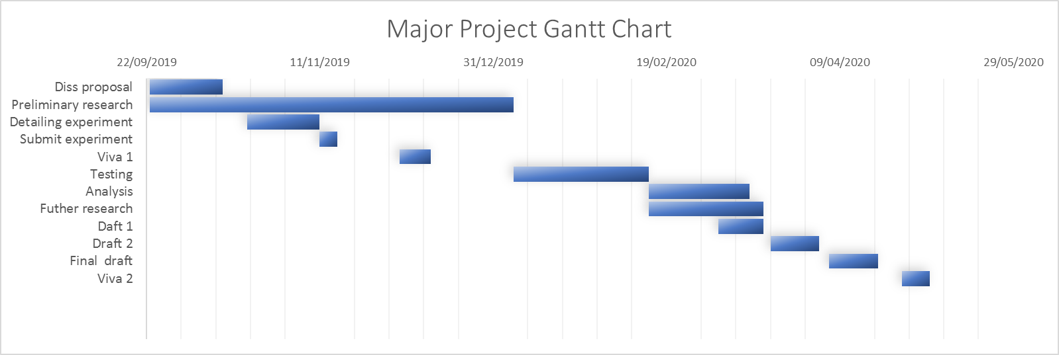
This gantt chart show what I plan to do and when during this project. Giving myself enough time throughout this project to work on every section from research to writing up the final project.

Background research

Carbon fiber has traditionally been for high end cars, such as, your Ferraris, Lamborghinis and McLarens. However, they have recently been introduced into mid ranged cars such as BMW and Alfa Romeo (Berman, 2015) . These raise the question of how does carbon fiber compare against materials such as fiberglass and aluminium. With resistance to projectile materials such as stones on the road. Will it be worth swapping from traditional materials to carbon fiber. Fiberglass has become more popular in recent years as an alternative to steel due to it being a lightweight material as well as corrosive resistant (Aleksiev, 2019). Aluminium is the second most used material on a car after steel (Noor, 2013). Aluminium is also lighter than steel and was recently chosen for the body work of Tesla and Ford (Maw, 2018). All of these materials have extensive future in the automotive industry. All are considered lightweight. This is why I chose these three materials to test.

Facilities required

- Ballistic lab
The ballistics lab is where the experiment will take place with materials.
- Non-destructive testing lab
The non-destructive testing lab will be used to get accurate information of the damaged caused by the projectiles.

Equipment

- Compressed air gun
- Carbon fiber
- Aluminium
- Fiberglass
- Ultrasonic testing
- Jig to hold the material

Experiment

All of the equipment needed for the experiment must first be collected and set up correctly. There a parameters set for the experiment. These include three materials used as test pieces. The projectile itself which will be kept at the same size throughout the hole experiment. The change in speed of the projectile will range between 30MPH to 80MPH with six data points. The angle in which the test pieces are held shall be changed. These angles will range between 45degrees to –45degrees and will be done with five data points. The hole test will contain around 90 projectile shots.

Analysis

The analysis will be done by visual damage but mainly through non-destructive testing. These would give me the exact damage caused to the piece. The analysis will compare each material to itself and how damage may be increase as the speed increases. This will then be compared with the other materials used throughout the experiment. Then we will be looking at different angles in which the projectile has been hit by. These will be analysed to find which angle caused the most amount of damage for each material. This should show the best angle and the best material to use in each angle. This will also show the worst material to use at each angle maybe the worst material to use.

Supervisor

I have spoken to Robert Goodson and he has agreed to be my supervisor for my major project and is interested with the project and the potential within the project. We have already started to discuss ideas for the experiment.

