

Programme: Master of Business Administration

Module Code: LCMB7034
Module Name: International Business Concepts

Student Name: Deepa Sureshbhai Suthar

Student ID: 2523541

Assignment Title: Individual report

Lecturer Name: Gladius Kulothungan

Tesla's International Market Entry into Bangladesh
Table of Contents
Executive Summary 4
Introduction 5
Section 1 a. Organizational Classification and Global Strategy 5
Strategic Categorization Using Bartlett and Ghoshal's (1989) Model 5
Global Configuration 6
Section 1 b. Macro-Environmental Appraisal and Market Attractiveness 8
Political Environment 9
Economic Environment 11
Legal Environment 12
Cultural Environment 13
Market Entry Analysis Using Dunning's Eclectic (OLI) Paradigm 14
Section 1 c. Entry Mode Strategy and Strategic Synthesis 16
Historical Pattern Recognition 16
Strategic Fit and Justification 18
Conclusion and Recommendations 19
Recommendation 1: Adopt a Phased Export-Led Market Entry Strategy 19
Recommendation 2: Develop Strategic Partnerships to Build the EV Ecosystem 19
Section 2: Reflective Account Using Gibbs' Reflective Cycle 21
Description 22
Feelings 22
Evaluation 23
Analysis 23
Conclusion 24
Action Plan 24
References 25

Executive Summary
This report is a SWOT of Tesla, Inc. (Tesla) potential market entry into Bangladesh where it has not been operating significantly as on 1 st June 2026. Based on Bartlett and Ghoshal's model of the strategy, the report classifies Tesla's strategy as a transnational strategy: "Both global integration and local responsiveness". The political, economic, legal and cultural surroundings are discussed and it is revealed that Bangladesh has strong market potential in the long-term though there are certain setbacks and issues such as managing uncertainty, infrastructures and affordability. In this analysis, the Eclectic (OLI) Paradigm of Dunning was used to assess the ownership of Tesla, its competitive advantage in location and internalization advantages, which showed that Tesla has significant competitive advantages, although they should not be ventured into with too vigor. The report recommends export penetration in the market, strategic collaborations should follow this, and come before wholly owned operations, basing on the historical growth trend of Tesla. The reflective aspect looks back at the research process, how theories were applied in international businesses and the major learning outcomes in the process of developing the paper.

Introduction
Given the competitive globalized world of running a business in the current era, a suitable location to sell a business product is significant to the long-term sustainability of the business should they be a multinational enterprise. Tesla, Inc. is keen on the idea of expanding to Bangladesh, though at this moment the company does not have any significant presence in this country. This report focuses on Tesla, Inc. expansion to Bangladesh. The report also looks into the international business theories that will illuminate how the Tesla business will be implemented in the world, the existing empirical evidence to get an insight into the macro-environment and market attractiveness of Bangladesh, and the steps and market entry avenues of Tesla company.

Section 1 a. Organizational Classification and Global Strategy

Strategic Categorization Using Bartlett and Ghoshal's (1989) Model
Figure 1 Bartlett and Ghoshal's International Strategy Framework
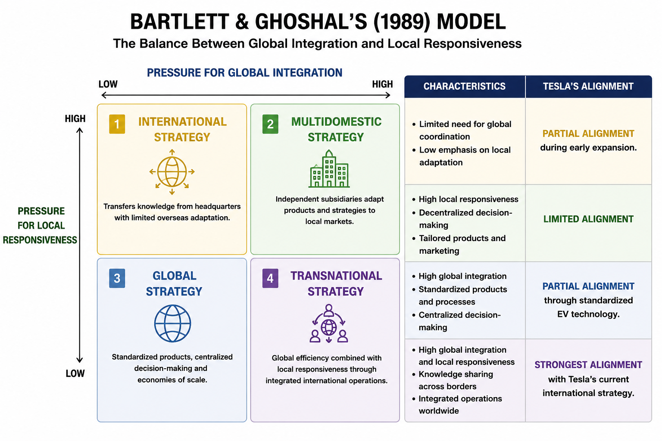
Source: Adapted from Bartlett and Ghoshal (1989).
A transnational strategy fits best with the parameters in Bartlett and Ghoshal's model: Tesla primarily ensures operational efficiency on a worldwide scale, but also aims to respond to some of the features found in the local markets where it operates. Tesla's approach is not just to standardize everything across the board, but rather the technology, software development, battery innovation, manufacturing standards are retained centrally, and payments, regulations, charging rates and production sites are customized to suit a nation's requirements and expectations. On one hand, Pereira et al. (2022) contend that digital transformation can enhance multinational companies’ capabilities for the coordination of globally integrated operations while keeping them responsive to market need in various geographical markets, and on the other, Lopes et al. (2022) assert that innovation-based companies increasingly use internationally integrated knowledge networks to bolster their competitive advantages in different geographical markets.
Additionally, Tesla's investment in Gigafactories in certain nations attests to both a focus on integration and responsiveness of investment to the local context. The manufacturing facilities in America, China, Germany and elsewhere help the company fulfill technological standardization, compliance with local regulations, and improve production costs and transfer them to the customer as well as build a more resilient production chain as a company. According to Dana et al. (2022), firms in emerging international markets tend to be dual actors of two types: global players with local intuition, and local players with global capabilities, making it suitable to develop local adaptation strategies alongside global innovation ones; Galvão et al. (2021) state that internationally integrated production networks enable improved operational efficiency by leveraging shared resources and joint strategic collaboration. Therefore, the international extension of the vehicle manufacturer Tesla shows more traits of a transnational firm than of a "purely global" or multidomestic firm.

Global Configuration
Tesla's Global Geographic Footprint
Figure 2 The Tesla Motors world empire mapped and charted
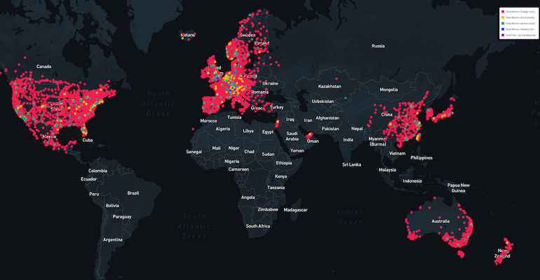
Source: Fruhlinger (2019)
Tesla has beefed up its worldwide reach with its geographically distributed manufacturing, scientific, and marketing system. The company has its manufacturing units in the U.S., China and Germany and markets its products in North America, Europe, Asia Pacific and a few in the Middle East. Tesla has been proactively expanding capacity by its Gigafactory plants, addressing the increasing global demand and reducing transportation delays and supply-chains. Similarly, UN Trade and Development (2024) says that in a more regionalized manufacturing environment, global automotive manufacturers are shifting to the manufacturing hub of the corresponding region, which enables multinational companies to engage in an efficient trade and increase their participation in the global value chains. This kind of geographic diversification reduces overdependence of the markets, and enhances the resilience of operations.
The global network of Tesla also helps in its competitor advantages as a combination of manufacturing efficiency and electronic invention. The result of the highly centralized process of software system development, proprietary battery technologies, features of artificial intelligence and ability to provide over-the-air software updates is the international product standardization and management of quality and customer experience. According to Ozturk (2024), the enhancement of the efficiency of manufacturing of electric vehicles and innovation performance depends to a great extent on the technologies of the Industrial Internet of Things (IIoT) whereas AlHousry et al. (2025) mention the increase of digital competitiveness, optimization of supply chains, and international trading as the main applications of EAI. The ability of the company to progressively incorporate advanced technologies in all geographically spread operations therefore enhances its operational efficiencies and market differentiation in the highly competitive worldwide automotive market.
Its presence in the international market also opens up to sustainable value, promoting innovation, sustainability, and organizational resilience. Tesla has created a complete product line of renewable energy, battery storage, autonomous vehicle software, digital services and charging stations instead of merely making vehicles. The diversification of its business model brings various competitive advantages with it, builds a loyal client base and assists in expanding internationally, in the future. Tesla has been strategic in corporate social responsibility (CSR) and sustainable innovation to create the resilience of the organization in the uncertain times, as Liu and Zhou (2025) point out, and its sustainability-driven actions in international business have long-term competitive advantages in terms of stakeholder trust, resource use, and value creation, as suggested by Pillai et al. (2025). Hence, the globally-linked operational structure of Tesla is rather obvious to have created a considerable strategic platform of evaluating its possible future development to certain emerging markets such as Bangladesh.

Section 1 b. Macro-Environmental Appraisal and Market Attractiveness
Table 1: Summary of Tesla's Macro-Environmental Analysis for Bangladesh
Environmental Factor | Key Opportunities | Key Challenges | Implications for Tesla
Political | • FDI reforms  • Renewable energy support  • Industrialization policies | • Political instability  • Bureaucratic delays  • Governance issues | Cautious entry with strong government engagement.
Economic | • Strong GDP growth  • Large consumer market  • Urbanization | • Inflation  • Exchange rate volatility  • Limited EV infrastructure | High long-term potential but gradual investment required.
Legal | • Investment reforms  • Industry incentives  • Improved IP protection | • Regulatory complexity  • Policy inconsistency  • Limited EV regulations | Monitor regulatory changes before major investment.
Cultural | • Young population  • Digital adoption  • Rising environmental awareness | • Price sensitivity  • Low EV awareness  • Preference for conventional vehicles | Invest in consumer education and brand awareness.

Political Environment
Political landscape is one of the most crucial for defining the success of Tesla in the country of Bangladesh as the policy of government directly impacts foreign investments, industrial development, and assures its role towards sustainability and sustainable transportation. Bangladesh has been actively promoting the process of economic modernization through investment liberalization, improving infrastructure and industrial diversification leading to a generally favorable investment climate for the multinational corporations. Bangladesh has been working on moving towards increased productivity, institutional effectiveness and private sector development, to ensure long-term economic growth continuously, according to the World Bank (2025). Likewise, Kim and Choi (2020) conclude that the quality of institutions shapes the internationalization of multinationals since good governance lowers the uncertainty for multinational investors, and consequently boosts investor confidence, and Ndofirepi (2024) adds that a conducive institutional environment is one of the most significant factors affecting successful firm internationalization.
However, Bangladesh still has recent political and institutional issues that could impact Tesla's introduction. Operational uncertainty is affected by the presence of these inefficiencies, delays in the application process, and the presence of disturbances and outbreaks of political tension from time to time, all of which foreign investors with relatively high capital requirements face. The governance issues discussed here can continue to result in delays in transactions with regards to licensing, infrastructure approval, and implementation of investments, which can lead to higher transaction costs and fewer strategic options. The International Monetary Fund (2026) points out that structural reforms along with enhancing governance and institutional effectiveness will be necessary for macroeconomic stability to be maintained.
Although political opportunities and risks are present and should be leveraged and managed for Tesla strategically. Because the government's Renewable Energy and Sustainable Industrial Development initiative are very much in sync with Tesla's corporate mission of accelerating the global transition to sustainable energy. To commercialize, though, the firm would need to build positive partnerships with government authorities, infrastructure providers and energy regulators prior to big investments. Liu and Zhou (2025) contend that sustainable proactive engagement with stakeholders and responsible governance operations have come to play a key, emerging role in corporate resilience; Pillai (et al.) 2025 suggest that multinationals incorporating sustainability into their international business plans have a greater chance of gaining governmental and societal support. As such, Bangladesh will bring opportunities for Tesla's long-term strategic goals, yet also the need for a gradualist and relationship-oriented strategy to market entry.

Economic Environment
Despite some short-term limitations in the electric vehicle market, Bangladesh presents a sizeable opportunity for Tesla over the long-term. This has been the case for the country, which has shown robust performance in economic growth over the last 20 years (see Figure 3), with rich domestic consumption, expansion in manufacturing, growth in exports, and investment in infrastructure. The International Monetary Fund (IMF) (2026) projects that Bangladesh is likely to experience positive growth even amid inflationary pressures and external economic uncertainty and the World Bank (2025) views continued improvements in productivity, and a process of structural transformation, as essential indicators of developments in the future. Overall, these economic data suggest Bangladesh has these long-term traits of an emerging market that can sustain the growing demand for technologically complex consumer products.
Figure 3 GDP growth rates in Bangladesh between 1995 to 2018
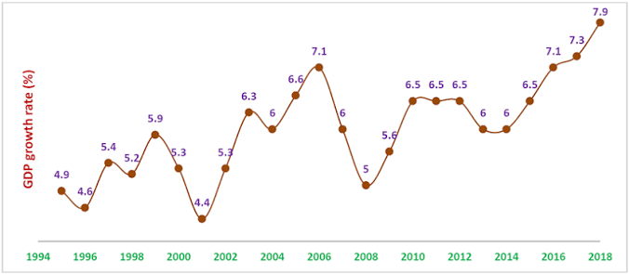
Source: Ahmmed et al. (2020)
However, a few challenges in economics may prevent Tesla from having immediate commercial success in Bangladesh. The fact that premium EVs are still much more costly than the conventional gas-powered car gives rise to affordability concerns in a market that has relatively low incomes in the household. These also add to the effective purchase cost of imported EVs, which further depresses possible EV consumer demand, due to inflationary pressures, exchange rate depreciation and import costs. Based on the International Monetary Fund (2026) report the inflation issue and exchange rate volatility are still macro-economic risks for Bangladesh, and International Energy Agency (2023) said the overall situation for EV adoption in emerging economies remains slow, mainly attributed to infrastructure development and affordability.

Legal Environment
Legal environment plays a critical role in defining the Tesla strategy of entering the Bangladesh market because of the high restricting nature of the car market in the country and the necessity to comply with certain requirements in the investment policy, trade regulations and environmental law that may influence its business. To introduce foreign finance investment, to facilitate the business process as well as to encourage the enterprise investment in the key areas, Bangladesh has progressively empowered their related territory structure. The World Bank (2025) indicated that investment climate reform has become an important component of the overall development agendas of Bangladesh with UN Trade and Development (2024) indicating that in most developing countries, investment regulations have been revised to improve their investment climates in order to make them attractive to multinationals in automotive value chains. The dynamism of the Bangladesh legal environment forms an enabling environment in terms of future investments although implementation needs to take place.
However, some legal blocks will be a concern for Tesla if they decide to enter into the Bangladesh market. Regulatory processes continue to be fairly cumbersome, involving a time-consuming approval process, multiple agencies having overlapping functions, and fragmented policies and enforcement. There are stiff obstacles because these could delay investment approvals, import licenses, environment clearances, and charging network and after sales set up as in the case of Tesla. Moreover, the production of EVs, battery recycling, charging infrastructure, and autonomous vehicles technologies are not as detailed a legislation in Bangladesh. The International Energy Agency (2023) researches to unveil the reality that the uncertain nature of the policies can decrease the growth of the EV market in the countries that possess a weak EV regulatory framework.

Cultural Environment
Consumer behaviors, technologies, market acceptance are also shaped by the cultural factors, which are especially crucial for Tesla's possible expansion in Bangladesh. Tesla is an innovation-based business selling high quality, expensive electric vehicles, and like all businesses needs to be profitable from both a stock and customer perspective; the perception about environmental sustainability, the technology and the virtue of the product from the stockholders' perspective. With youthful and steadily urbanizing population along with greater digital engagement, over the years, Bangladesh has emerged as a strong base for future adoption of advanced technology. The Bangladesh Bureau of Statistics (2024) indicates that the country is a population with a rapidly growing urban population, both of which are transforming the nature of consumption, whereas the World Bank (2025) recognizes education, information technology, and human capital development as enabling changing expectations in the areas of consumption.
However, there are significant cross-cultural problems that could potentially dampen the extent of Tesla's entrance into the market during the near future. The purchasing behavior is also price-sensitive with affordability playing a major role, consistent maintenance costs and long-term reliability are factors that continue to influence vehicle buying process in Bangladesh. The general knowledge of consumers of conventional petrol and diesel vehicles is higher than for the EV car, and public knowledge of EV charging and ownership advantages and EV battery performance is still relatively low. This means Tesla would have to put in a significant effort into educating consumers, building brand awareness, and implementing a demonstration program in order to be accepted by the mass market. The IEA (2023) states that one of the main reasons for the slow uptake of EVs in many emerging economies is the lack of public understanding.
For Tesla, an internationally renowned brand is a powerful benefit that it may be able to harness to alleviate some of these culture issues in the future. Its invention, sustainability and superior quality of products have earned the company global recognition which is becoming more and more attractive to today's young, environmentally aware consumers in emerging markets. At the same time, direct transfer of the global brand equity to Bangladesh market does not suffice as there is need to adjust the marketing communications based on Bangladesh consumers' values and purchasing behavior. Lopes et al. (2022) claim that innovative MNL firms are able to support international competitiveness by maintaining consistency around their international brand by balancing with local responsiveness in the international market. Bangladesh can present significant long-term prospects for Tesla, but rather than hitting the market full force, the company must work on a thoughtful approach to the culture and conducting market development and engagement initiatives.

Market Entry Analysis Using Dunning's Eclectic (OLI) Paradigm

Ownership Advantages
An aspect of Dunning's Ownership advantage is the firm-specific assets that give a multinational corporation a competitive edge over firms based in the host country. Tesla enjoys significant ownership advantages based on their proprietary battery technologies, AI, autonomous driving investments, software integration, worldwide brand recognition and ongoing innovation capabilities. The resources are hard to manufacture by local rivals, and they make a huge difference in terms of technological setbacks that Tesla has in the competition among all countries in the world. The United States Securities and Exchange Commission (2025) states that Tesla remains dedicated to R&D investments as a way of enhancing product innovation and also efficiency.
The ownership benefits of Tesla go beyond innovation in technology to the efficiency and development of its ecosystem. Tesla's business model is different than most auto companies because the electric vehicle, renewables systems, batteries, digital software services and charging stations are all merged together. This holistic approach provides significant value for customers and offers competitive benefits in several countries. While AlHousrya et al., (2025) propose that IOT technologies contribute more to the competitive difference in the industry of electric vehicles, Pereira et al., (2022) argue that digital transformation can help MNCs in coordinating the innovation in regions that are geographically dispersed. Therefore, in case of penetrating the market of Bangladesh, Tesla owners would gain a competitive edge due to the ownership advantages.
Location Advantages
Location benefits are an indicator of the appropriateness of investment in the host country because of its features. The location-specific advantages of Bangladesh are enormous in favor of the long-term expansion plan of Tesla including the high population base, a stable economic growth, increasing urbanization, the relative low cost of the labor resource, and the increasing government attention to the sustainable development of the industry. Bangladesh has a population of over 170 million which makes it one of the biggest possible consumer markets in South Asia, as per Bangladesh Bureau of Statistics (2024). Moreover, the economy of the country has been classified as the economy of structural changes in structural transition because of industrialization and productivity increase in Bangladesh by the World Bank 2025. The rise in the number of emerging markets gives also the international diversification opportunities to multinational companies, as De Perea et al. believe (2019), and the market size and development potential continues to play a role in internationalization decision-making as Ndofirepi (2024) argues.
But the country has certain major geographical disadvantages as well that can restrain the initial plans of Tesla investment in Bangladesh. It is not the time when the country is able to progress to the stage of general adoption of EVs because of the insufficient amount of charging stations and untruthfulness of electric power sources available, as well as poor development of EV supply chain and comparatively low purchasing power of EVs. The International Energy Agency says there are two components for effective EV markets to emerge: the energy infrastructure side and the charging network side. Similarly, Kim and Choi (2020) note that technological capability of the host country may be a decisive factor in foreign investment performance, whereas Ozturk (2024) insists that technology readiness is turning into a decisive factor in the competitiveness of countries in the digitally integrated sectors.
Internalization Advantages
Justifications for internalization include the benefits that an MNC may gain from owning and controlling its assets over the cost of licensing or franchising them to external parties to run on its behalf, or to empty the money. The entire business model of the company is hinged on clarity of vision, as Tesla is built with proprietary technology, integrated software systems, The Battery that's a first-of-its-kind, integrated Artificial Intelligence, and a globalized customer experience. Tesla has always kept an eye on manufacturing, sales, customer service and software updates of its products, ensuring high quality and safeguarding its intellectual property, unlike many automotive manufacturers who heavily depend on independent dealerships or license agreements. The United States Securities and Exchange Commission (2025) states that Tesla is still pursuing a vertically integrated model to achieve greater efficiency and stay ahead technologically.

Section 1 c. Entry Mode Strategy and Strategic Synthesis

Historical Pattern Recognition
Direct Foreign Investment (Greenfield Investment)
Tesla’s most successful historical strategy for market penetration has been by co-developing wholly-owned Gigafactories involving Greenfield foreign direct investment (GFDI). The company prefers to develop production operations from scratch; an example is manufacturing facilities in the United States, China and Germany. This approach offers total control of operations, security of proprietary technologies and ability to design plants optimized in terms of manufacturing efficiency and innovation. The United States Securities and Exchange Commission (2025) points out that vertically integrated manufacturing is a key part of Tesla's long-term growth plans. Likewise, by enabling the creation of efficient production networks, Greenfield investments contribute to international competitiveness, as cited by Galvão et al. (2021), and high-control modes are more suitable for firms with high-proprietary assets when looking to enter international markets according to Ndofirepi (2024).
Wholly Owned Sales and Service Subsidiaries
In all key international markets, Tesla has approached the market with a wholly owned local subsidiary that is accountable for its direct sales, customer experience, maintenance and investments in charging infrastructure. Tesla has no dealerships to rely on as indirect sales agents—that is, unlike most car companies, it never relies on an extended chain of dealerships to sell its cars and to maintain direct relationships with customers through the buying and owning experience. This not only improves customer experiences but also facilitates direct software support and maintain brand uniformity in global markets. It has been suggested that sustaining organizational control plays a major role in Tesla's long-term vitality by Liu and Zhou (2025), and digital integration makes coordination of multinational corporations' geographically distributed activities easier, as Pereira et al. (2022) explain.
Strategic Alliances and Supplier Partnerships
While Tesla holds the ownership of its core businesses, it has built large-scale supply chains by making strategic alliances with battery manufacturers, technology companies, logistics providers and raw materials suppliers. The alliances allow Tesla to acquire the necessary resources without giving up the confidence and essence that comes with product development and manufacturing. UN Trade and Development (2024) show that the world of automotive manufacturing relies on an increasing number of interconnected value chain. Similarly, Dana et al. (2022) suggest that through partnerships innovation can be realized in emerging markets, and Lopes et al. (2022) claim that international cooperation can improve firms' capacity to adjust to market and technological shifts.
Direct Exporting Prior to Local Investment
Direct exports have proven to be Tesla's preferred method of entering new markets, as the company has done so many times in the past without investing heavily there. This slow-and-steady method allows the business to gauge customer interest, boards, and understand regulatory areas, and build brand awareness without significant financial risk. Historically, export-led entry has proven to be an effective market test and affirmed the readiness for further service center, charging infrastructure and manufacturing investments. De Perea et al. (2019) claim that trying out phased internationalization decreases of the uncertainty that is part of the process of expanding to foreign markets, and Kim and Lim (2022) point out that phased market development grants firms time for strategizing before committing more resources to foreign markets.

Strategic Fit and Justification
Direct Exporting: Recommended Initial Market Entry Strategy
From among the historical techniques of entering the market, exporting is the most suitable approach for Tesla to enter the Bangladesh market. The transportation of vehicles out of the existing manufacturing plants would allow Tesla to test demand for their vehicles, build top-of-mind brand awareness, and create customer relationships in regions long before investing a large amount of money. The gradual process ensures that the company does not commit a significant amount of money, while enabling it to keep track of potential governmental rules, the development of infrastructure (e.g., charging stations), and consumer readiness for EVs. Tesla could gradually take over sales operations and, at some time in the future, have factories or assemble vehicles locally to meet demand. De Perea et al. (2019) posit that internationalization is a gradual process that lowers uncertainty, and NForepi (2024) suggest that firms that make their commitment in resources to hosting countries looked forward would only be likely to be successful in international business in a sustainable way. Hence, direct exporting through strategic relations is the most feasible option for an optimistic budgetary performance and long-term strategy for Tesla in Bangladesh.

Conclusion and Recommendations
This analysis shows that Bangladesh has limited near-term potential as a Tesla market but is essentially one that is ripe for the company to invest in in the future, especially on a large scale; but if it does that, the company faces a high risk of that investment going awry due to political, economic, legal, and operational factors. In contrast, Bartlett and Ghoshal's model explained that Tesla was following a transnational approach that is adept at global integration and selective local responsiveness that allows the company to take advantage of innovation and achieve adaptation to international markets. The macro-environmental analysis also found that the country of Bangladesh has good long-term fundamentals such as continued high economic growth, growth in the country's urban population and Government interest in sustainable industrial development. Yet, regulatory, infrastructure, price and the still relatively nascent EV market slow the pace of taking a quick big-bet on the electronics side.

Recommendation 1: Use a Progressive Export-Led Market Access Strategy.
Firstly, Tesla needs to start exporting out of the existing manufacturing facilities, and then a small fossilization facility to launch the market and build brand awareness. This will assist in lowering capital risk and corresponding market knowledge on consumer preferences, regulation changes, EV acceptance and trends. Tesla can gradually build its sales and service operations, with the resultant revenue stream once it achieves commercial viability, before deciding on bigger investments. On the matter of the argument, phased internationalization would reduce the uncertainty and would be more conducive to strategic decision making and Kim and Lim (2022) have demonstrated how the gradual development of markets can be used to ensure that firms react well to the new market conditions.

Recommendation 2: Develop Strategic Partnerships to Build the EV Ecosystem
Strategic collaborations with government bodies, electricity companies, infrastructure builders, financial institutions and technology companies have the potential to further boost the EV ecosystem in Bangladesh, and this action should be part of the export plan for Tesla. The pledges would simplify the rollout of the charging stations, increase consumer awareness, establish rapport with the regulators, and reduce the amount of uncertainty faced by Tesla in its operation. These joint venture opportunities would enable additional investments in service facilities, Battery technologies and possibly local assembly project in the growing market. According to Dana et al. (2022), strategic partnerships can serve as an accelerator in the creation of innovation and competitiveness in the new market, and Galvão et al. (2021) have a strong argument in favor of the necessity of cooperation networks to succeed in the long term.

Section 2: Reflective Account Using Gibbs' Reflective Cycle
Figure 4 Summary of Gibbs' Reflective Cycle
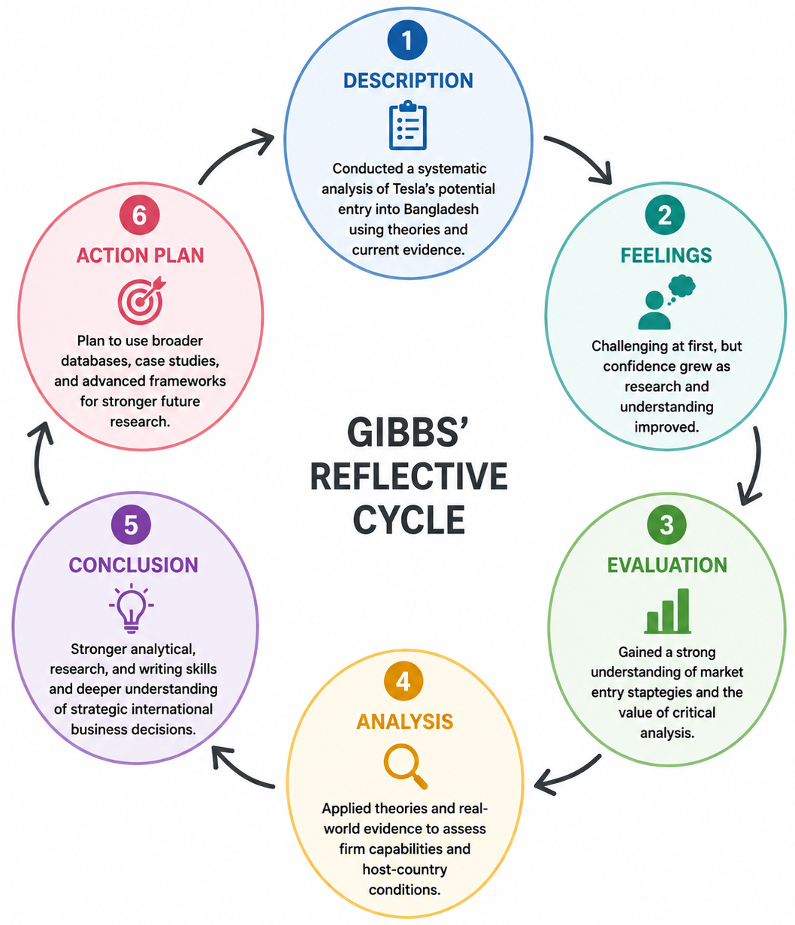
Source: Made using Canva

Description
This assessment was achieved via a systematic research, evaluation and synthesis of academic as well as contemporary statistical data that captured Tesla's potential expansion into Bangladesh. Tesla was chosen as the global leader in the field of sustainable innovation and EVs for the multinational company for a few reasons. Bangladesh was chosen as a target country because it was determined that there would be no notable presence of Tesla in the country as of 1st June 2026 thus good to consider for an international market entry strategy. Once I have set my research scope, I organized my assignment around the theories that are required such as Bartlett and Ghoshal model, macro-environmental analysis, macro-economic theory/dunning theory: eclectic paradigm and market entry strategies. In order to support the evidence-based analysis remaining constant throughout the research process, peer review and institutional reports from the World Bank, International Monetary Fund, UNCTAD, the International Energy Agency, the Bangladesh Bureau of Statistics, and Tesla Annual Report 2025 were utilized. International studies are significantly enriched by the use of digital technologies (Pereira et al., 2022), and to comprehend internationalization decisions, systematic analysis is necessary (Ndofirepi, 2024).

Feelings
Initially, the assignment was challenging since the students had to combine several theories about the international business, and on top of that, assess a fast-growing industry based on up-to-date statistical data. At the outset, I had a few problems to differentiate between description and analysis, but especially in evaluating the political, economic, legal and cultural context in Bangladesh. As I went through the literature, however, I grew more confident every day as I figured out how I could arrange the information nicely with the theory model. The credits were due to looking at the past expansion of Tesla in various foreign markets as well as understanding how a multinational company might adapt its strategies to foreign markets based on circumstances.

Evaluation
Looking back at the overall research process, I think I have strengthened my skills as an evaluative researcher to analyze international business decisions based on theoretical and empirical methods instead of descriptive analysis, which I was trying to achieve by this assignment. A major strength of my approach was investigating the same business problem using several academic frameworks, and this is something that I'm very accustomed to. Bartlett and Ghoshal's model provided an insight into the international strategy of Tesla as Dunning's OLI Paradigm provided understanding of the opportunities and constraints in Bangladesh for the future investment. The macro-environmental analysis also revealed that an understanding of firm-specific capabilities is key to the successful internationalization process when reacting to the outside environment. However, I also knew that looking at a “new” industry involved a process of constant checking of statistical data, since the market rapidly changes underfoot. Kim and Choi (2020) note that institutions have a great impact on the outcomes of international investments and that evidence-based analysis enhances strategic decision-making in international business, as Pillai et al. (2025) state.

Analysis
One of the most important lessons from this assessment was knowledge on the interconnection conditions of international business theories rather than their self-determination approach. Initially, in my eyes each theory was an analytical tool unto itself. However, when the assignment was completed, it was found that successful international expansion can only be considered through the lenses of the organizational capabilities, host-country conditions, quality of institutions, competitive strategy and sustainability. For instance, whereas the ownership advantage identified by Dunning's OLI Paradigm gained importance when placed in the context of Bangladesh's political and economic landscape, Bartlett and Ghoshal's concepts were helpful in elaborating how Tesla was able to integrate it globally while making concessions to the local market. In addition, an examination of recent economic information highlighted the significance of drawing evidence-driven conclusions from both theory and practice, to inform strategic recommendations. Some researchers have highlighted the integration of innovation into responsible organizational strategy as essential for organizational resilience (Liu and Zhou, 2025), and others have suggested that technology change influences trade and investment decisions on the international scene (Ozturk, 2024).

Conclusion
Overall, I found doing this assignment a great help to understanding international business strategy and the intricacy of decisions of multi-nationals with regard to going into the market. I became more confident in using theory in applied business situations, and by developing an ability to critically interpret and analyze academic texts, and to justify arguments with credible statistical evidence. It also confirmed that conducting research within the company decision making process meant evaluating opportunities as well as risks prior to implementing international concepts and strategies for expanding. I found that mergers of organizational resources and host country conditions is more a subject of strategy than about a "good fit" for rapid growing economies to become investment destinations.

Action Plan
To the future ideas in my country, I would like to look at more than one country before I could recommend a country to enter the market and this is in a more comparative standpoint. This would enable a better evaluation of the relative market attractiveness, and improve strategic decision making. I am equally on a collision path of further utilizing international datasets, industry reports and comparative case studies in future analyses within the context of empirical world. In addition, I will continue to work more synergically with theory – more synthetically, enabling me to make more integrated and critical evaluations of the issues of international business problems. Finally, I would like to improve my academic writing abilities by developing more analytical argumentation, evidence synthesis and critical thinking.

References
Ahmmed, Md.M., Babu, Md.A. and Ferdosy, J. (2020) 'Direct and indirect effects of COVID-19 on maternal and child health in Bangladesh,' Journal of Statistics and Management Systems, 24(1), pp. 175–192. https://doi.org/10.1080/09720510.2020.1833465.
AlHousrya, O., Bennagi, A., Cotfas, P. A., & Cotfas, D. T. (2025) 'The Role of the Industrial IoT in Advancing Electric Vehicle Technology: A review,' Applied Sciences, 15(17), p. 9290. https://doi.org/10.3390/app15179290.
Bangladesh Bureau of Statistics (BBS). (2024): Bangladesh: Population and Housing Census Dataset | Humanitarian Dataset | HDX. (n.d.). https://data.humdata.org/dataset/populationa-and-housing-census-dataset
Dana, L., Salamzadeh, A., Mortazavi, S., & Hadizadeh, M. (2022) 'Investigating the impact of international markets and new digital technologies on business innovation in emerging markets,' Sustainability, 14(2), p. 983. https://doi.org/10.3390/su14020983.
De Perea, J.G.-Á., Ramírez-García, C. and Del Cubo-Molina, A. (2019) 'Internationalization Business Models and Patterns of SMES and MNEs: A Qualitative Multi-Case Study in the agrifood sector,' Sustainability, 11(10), p. 2755. https://doi.org/10.3390/su11102755.
Fruhlinger, J. (2019) 'The Tesla Motors world empire mapped and charted,' The Business of Business, 20 December. https://www.businessofbusiness.com/articles/the-tesla-empire-on-a-world-map/.
Galvão, A. R., Mascarenhas, C., Marques, C. S., Braga, V., Moreira, L., Ferreira, P., & Castro, T. (2021) 'Sustainable international expansion via cooperation networks in the manufacturing industries,' Sustainability, 13(24), p. 14013. https://doi.org/10.3390/su132414013.

International Energy Agency. (2023). ‘World Energy Outlook 2023 – Analysis – IEA,’ IEA. https://www.iea.org/reports/world-energy-outlook-2023
International Monetary Fund (2026). ‘World Economic Outlook Update, July 2026: Global economy in crosscurrents of war and technology,’ IMF. https://www.imf.org/en/publications/weo/issues/2026/07/08/world-economic-outlook-update-july-2026
Kim, K. and Lim, G. (2022) 'International Dynamic Marketing Capabilities of Emerging-Market Small Business on E-Commerce,' Journal of Theoretical and Applied Electronic Commerce Research, 17(1), pp. 199–211. https://doi.org/10.3390/jtaer17010010.
Kim, S. and Choi, B. (2020) 'The impact of the technological capability of a host country on inward FDI in OECD countries: the moderating roles of institutional quality,' Sustainability, 12(22), p. 9711. https://doi.org/10.3390/su12229711.
Liu, X. and Zhou, Y. (2025) 'The Impact of Strategic Corporate Social Responsibility on Organizational Resilience—An exploratory case study based on Tesla,' Administrative Sciences, 15(6), p. 212. https://doi.org/10.3390/admsci15060212.
Lopes, J. M., Gomes, S., Oliveira, J., & Oliveira, M. (2022) 'International Open Innovation Strategies of Firms in European Peripheral Regions,' Journal of Open Innovation Technology Market and Complexity, 8(1), p. 7. https://doi.org/10.3390/joitmc8010007.
Ndofirepi, T.M. (2024) 'Investigating the Drivers of Firm internationalisation: A fuzzy set analysis using Global Entrepreneurship Development Index data,' Economies, 12(9), p. 252. https://doi.org/10.3390/economies12090252.
Ozturk, O. (2024) 'The impact of AI on international trade: opportunities and challenges,' Economies, 12(11), p. 298. https://doi.org/10.3390/economies12110298.
Pereira, C. S., Durão, N., Moreira, F., & Veloso, B. (2022). The importance of digital transformation in international business. Sustainability, 14(2), 834. https://doi.org/10.3390/su14020834
Pillai, M., Bennasr, H., Hassen, T. B., & Al-Yafei, W. B. (2025) 'The importance of digital transformation in international business,' Sustainability, 14(2), p. 834. https://doi.org/10.3390/su14020834.
UN Trade and Development. (2024). Shifting map of car production reflects changing patterns in trade and investment. UN Trade and Development (UNCTAD). https://unctad.org/news/shifting-map-car-production-reflects-changing-patterns-trade-and-investment
United States Securities and Exchange Commission. (2025) Tesla Inc. Financial Report for Year 2025. USSEC. https://ir.tesla.com/_flysystem/s3/sec/000162828026003952/tsla-20251231-gen.pdf
World Bank. (2025). World Development Report 2025: Standards for Development. World Bank. https://www.worldbank.org/en/publication/wdr2025

