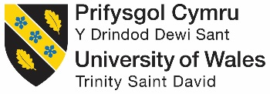

Modern theories of Leadership

Critically evaluating the modern theories of leadership in the context of working within the QINETIQ Test Range Operation & Appraising the effects of the established Culture on implementing change within the work environment.

by
Ralph Whittaker

Student ID: P148322

Module: Engineering Management and Law
M6X00943

Lecturer: Professor John Rees

BEng (Hons) Test Range Engineering

February 2018

Abstract
This report critically reviews modern theories of leadership, highlighting how they have evolved over time in response to the continually changing ways of modern business. Cultural analysis summarises how QINETIQ is currently applying these theories to help deal with the inevitable organisational changes and demands occurring within its business model, namely Transform. Internal documentation provides evidence that Situational and Transformational theories are the main techniques being used to implement the new framework, helping to sustain the workforce culture and encourage the delivery of the company’s vision into reality. Uncertainty of employment rigidity or unclarity of direction, can strike fear and upset amongst employees, as proven by feedback at QINETIQ Q-Talk seminars. For smooth transformations, it proves vital to always keep everyone in the loop with critical knowledge of the bigger picture. Communicating and clarifying the status quo of the organisation, its intensions, methods and timeframes to achieve targets, has been challenging. Much of the report builds on official summarised versions of research provided in the Appendix (Original documentation is internal QINETIQ proprietary).

TABLE OF CONTENTS
SECTION PAGE
TITLE PAGE 1
ABSTRACT 2
TABLE OF CONTENTS 3
- INTRODUCTION 4

Aim of report
Scope

- RESEARCH 5-8

What is Leadership?
Summarising and Critically Evaluating the modern theories of Leadership

- LEADERSHIP IN THE WORKPLACE 8-10

QINETIQ Leadership
Examples of QINETIQ workforce leadership techniques

- ANALYSIS 11-13

QINETIQ’s established workplace culture
What is Transform
The impact of the workplace culture on facilitating change within the work environment (Transform)

REFERENCES 14
BIBLIOGRAPHY 15
APPENDIX 16-20
Appendix A: A Summary of 6 Leadership Skills, QINETIQ’s PDR Toolkit
Appendix B: Terms of Reference for Environmental Trials Team Leader - Shoeburyness
Appendix B2: Summary of Team Leader Objectives
Appendix C: Examples of QINETIQ leadership techniques
Appendix D: A Summary of the QINETIQ Competency Framework 2002
Appendix E: Blog from QINETIQ CEO, Steve Wadey; Acting on your feedback to resolve the ‘niggles’

Appendix F: Blog from QINETIQ CEO, Steve Wadey; Roadshows: your opportunity to give us feedback

- INTRODUCTION

Aim of report

The report identifies and critically evaluates the modern theories of leadership, and includes an investigation into team dynamics of the test range operations at QINETIQ. A performance appraisal will assess how the established culture deals with change within the working environment, emphasising how specific leadership styles and techniques encourage and support the modern growth of the business.
Scope

The structure of the report:
- Research: A summary and evaluation of modern leadership theories.
- An investigative evaluation of leadership skills and techniques used at QINETIQ.
- Analysing the work force culture within the operations teams and the support this has given to the recent structural change, namely Transform.

- RESEARCH

What is Leadership?

Leadership is the role earned by individuals to lead followers within a specified area of business. Leaders possess certain influential qualities, directive skills and styles that enable them to encourage others to follow directions and instructions, resulting in successful team work and output. Management is about coping with complexity, whereas leadership is about coping with change.

A simple military analogy of leadership is that described by John P. Kotter;

A peacetime army can usually survive with good administration and management up and down the hierarchy, coupled with good leadership concentrated at the very top. A wartime army, however, needs competent leadership at all levels. No one yet has figured out how to manage people effectively into battle; they must be led [1].

Modern business is very demanding on team leaders, expectations and responsibilities broaden with time. Businesses including QINETIQ, continually restructure the roles and availability of employees, including team leaders and management, to coincide with improving efficiency and attaining new company visions. The umbrella of employees and structured guidance that team leaders are expected to lead and provide, can vary dramatically, depending on the level in the organisation, the size of the workforce and environment of work. An effective leader has awareness of and appropriately uses a combination of modern leadership frameworks (styles) to their advantage. At QINETIQ it is important that leaders are flexible in their roles and can adapt to directional business changes by blending certain styles together.

To summarise, leadership is ‘the ability to influence a group toward the achievement of a vision or set of goals’ [2]. ‘Good leaders are made not born. If you have the desire and willpower, you can become an effective leader. Good leaders develop through a never-ending process of self-study, education, training, and experience (Jago, 1982)’ [3].

Summarising and Critically Evaluating the modern theories of Leadership

Throughout modern history, the theories of leadership frameworks that have been proposed by business people and psychologists include; Trait, Behavioural, Contingency, Lead-member Exchange (LMX), Charismatic, Transformational and Authentic [2].

The following summarises the more common theories, often used by QINETIQ to identify and teach good leadership.

- Trait theories:

An earlier theory that predicts leadership and aids consideration for the emergence of leaders within a group by identifying key qualities and characteristics in people. It suggests the building blocks of a good leader include personality traits such as; integrity, empathy, assertiveness, extraversion, emotional stability and intelligence, conscientiousness, good decision-making skills or likeability etc [2, 3]. All are elements which employers commonly seek to differentiate between leaders and non-leaders. This technique helps evaluate candidates at interview, identifying suitable leaders, but doesn’t guarantee successful selection until they prove that they can lead followers to achieve certain goals. Effective leaders can be taught certain traits through development over time but as well as having such qualities it is important that leaders have awareness of other styles of leadership.
QINETIQ continually seeks to recruit individuals that already have an inbuilt foundation of positive traits but also provides training courses to teach their leaders on certain styles and techniques to further develop necessary skills as described in the Leadership Tool Kit (Appendix A).

- Behavioural theories

Focusses on what the best leaders productively do and how they behave, enabling such positive operative ways of conduct to be taught to others. This approach questions and defines behavioural characteristics of leaders that appear related to constructive performance effectiveness. For example, do they initiate structure to their role and have consideration for others in their team through work-based and interpersonal relationships? Do they involve teams in decision making to encourage and support their team? or do they simply dictate instructions and expect full cooperation and tasks to be completed? [3].

Three types of behavioural focused leadership styles include;

Autocratic: Team’s input is not required and leaders make quick decisions without consulting their followers. Good for quick turnaround but can negatively impact workers self-value and enthusiasm.

Democratic: Leaders consult the team and allow input before making a final decision. It can be useful when full team agreement is of importance and makes workers feel valued. QINETIQ uses this style of leadership at operational level, highlighted by weekly team meetings and monthly site meetings that encourage input from everybody. This is evident when confirming the technician and engineer partnerships for each trial, all parties confirm competency requirements and partnership compatibility.

Laissez-faire leaders: Leaders don’t interfere and loosely supervise, allowing team members to make many of the decisions. It can make workers feel more powerful and valued but can produce or be a result of lazy leadership and production failures. At QINETIQ operational level there is an element of this style being in place when leaders allow the engineers on a trial to take lead and control of all stages of a trial from set-up, through to completion of testing, including giving full guidance to technicians. Team Leaders don’t usually get involved in the operation of equipment or the physical trial unless issues (failure or staff absenteeism) arise.

- Contingency (Situational) theories

This suggests using specific styles based on the current situation, and to vary the leadership approach accordingly to suit the best chance of a successful outcome. ‘The styles used in normal day to day running of a business may be different during a crisis etc’ [4]. A prediction is made on what style will be used for the present scenario, e.g. whether more team support is required, an impulse decision needs to be made or whether a leader should be more people-orientated or task-orientated. This is a very flexible approach to leadership and currently being used by QINETIQ during Transform. It is useful when situations change dramatically or rapidly but leaders need to remain cautious regarding the clarity of leadership being provided to workers to avoid confusion and distrust. Situational leadership assures team leaders of safer practice and supports the safety culture we have at QINETIQ. The Path-Goal Theory developed by Psychologist Robert House (1971) and the Fiedler Contingency Model created by Fred Fiedler (mid-1960’s) [also 4] are existing models that can help leaders identify the style or approach to use (behavioural considerations and Least Preferred Co-Worker scale).

- Power and influence theories

Focusses on how leaders use their power and evaluates the styles they use to influence others in the team to achieve successful outcomes. The French and Ravens Five Forms of Power is an example of this theory that identifies the types of positional and personal power; legitimate, reward and coercive, expert and referent [4]. It suggests a leader should develop their expertise and that this more legitimate personal power is a stronger form of leadership. Operational team leaders at QINETIQ use elements of this technique to motivate the manual work force and drive the workload, ensuring trials are completed to schedule in accordance with customer expectations and QINETIQ’s Code of Conduct. Transactional leadership is another style of power driven leadership. It uses the idea of rewarding team members for their work and focusses on setting tasks with reward structures. Although not a long-term relationship building tool, it can be useful for attaining objectives out of the ordinary. There is an element of this style being used during employee Personal Development Reviews at QINETIQ, where leaders often make it clear as to what personal objectives need to be achieved and skills shown, to move up a level on the global pay grading scale. This can be motivational but sometimes the prospect can be demoralising with such far set goal posts.

- Transformational theories

Introduced by J. Burns in his book Leadership (1978), when he defined the occurrence of transformational leadership as being when ‘leaders and their followers raise one another to higher levels of morality and motivation [5]’. Further developed by B. Bass in his book Leadership and Performance Beyond Expectations (1985) he suggested this type of leader ‘Is a model of integrity and fairness, sets clear goals, has high expectations, encourages others, provides support and recognition, stirs the emotions of people, gets people to look beyond their self-interest and inspires people to reach for the improbable [6].’ Leaders at QINETIQ are trained to see the bigger picture and use transformational leadership to guide their teams through business transformations to achieve company vision. By showing integrity and motivating people to buy into the vision, leaders can direct the delivery of transforming the business model, hopefully building stronger and more successful teams along the way. This is the most common theory of leadership that businesses use to identify good leaders for helping them cope with the inevitable model changes they are having to continuously execute to meet demand and survivability.

The requirements of leadership have often been the focus of leadership scholar research. According to a study by Mumford et al (2007), modern leadership skill requirements can be thought of as being ‘layered (strata) and segmented (plex)’ [7], aka strataplex, the tool for analysing leadership skills across an organisation. By applying this type of model to varying levels of management, the study proposes that leadership skill requirements can be segmented into four main categories; Cognitive skills, Interpersonal skills, Business skills, and Strategic skills. More importantly, it highlights that the categories of leadership required, varies at different organisational levels. Leading at higher levels in an organisation requires higher levels of leadership skills and even though ‘Cognitive skill requirements are important across organizational levels; certain Strategic skill requirements only fully emerge at the highest levels in the organization’ [7].

Table 1 [also 7] summarises the skills incorporated into modern leadership, and are supportive findings to this study by associated researchers from past studies;

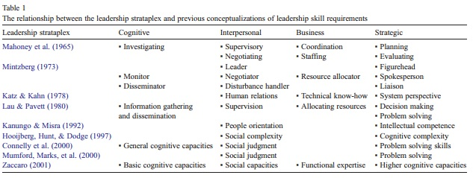

Strataplex is a good ideology of how leadership can be broken down into the valuable skill categories necessary for leaders to fulfil certain control-led responsibilities. It enables businesses to identify individual key elements for specific leadership roles when recruiting suitable candidates, to teach leadership at beginner’s level when developing new leaders and identify underperforming leaders.

Each approach to leadership has advantages and disadvantages depending the different styles used. The most commonly called upon nowadays are that of Situational and Transformational leadership. By understanding the different styles, leaders can become better at guiding teams through challenging situations. As business needs and targets change, leaders can adapt the style to fit each unique situation.

- LEADERSHIP IN THE WORKPLACE

QINETIQ Leadership

The focus of Leadership at QINETIQ is about creating good customer based relations and securing future contracts through trial output satisfaction. According to a QINETIQ Internal Presentation 2017, leadership is about projecting a business that has a strong leading and trusted presence in the market place with a ‘can-do, know-how’ attitude and being ‘the chosen partner around the world for mission-critical solutions, innovating for our customers’ advantage.’

With the business offering increasingly more services and technological facilities by branching out to alternative markets (Space and Satellite), leadership is focussing on harnessing the energy of others to develop their performance as team players. Employees are becoming multi-skilled (cross-trained) and more interchangeable across other sites as well as their local site. Advanced training is increasing experience and levels of certified competence to perform different tasks, improving staff efficiency.

Due to the operational environment being a Potential Explosion Site (PES), leadership also concentrates on encouraging a safety culture that promotes a Stop moment policy. If anyone feels the need to stop a task for safety reasons, saying “Stop, Stop, Stop” ensures everyone downs tools so the task can be further investigated. Leaders are also tasked to enforce Risk Assessments, to ensure employees have read and understood all potential risks prior to undertaking any task.
Leaders and managers are to act as role models for the QINETIQ values and standards at all times. They are responsible for; promoting and upholding standards, providing advice and guidance and ensuring employees have the right knowledge and resources to follow high standards and meet legal requirements. QINETIQ frequently reminds its leaders to refer to and study the Leadership Charter, as found on the online operating framework (Fig.1).
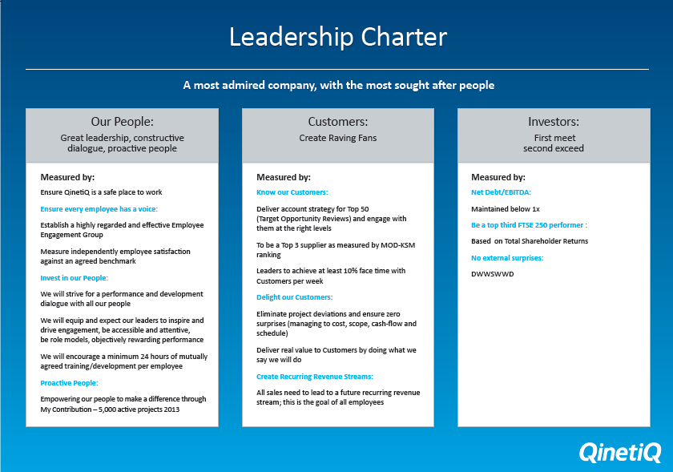 Fig.1
Examples of QINETIQ workforce leadership techniques

For all level of leaders, there are six admirable leadership skills, as identified by QINETIQ’s Personal Development Review (PDR) Toolkit [8, Appendix A]; Leading Our Values, Focus and Deliver, Communicate and Inspire, People and Team Development, Delivering Customer Advantage and Strategic Purpose. This suggests that QINETIQ promotes a mixture of strategic techniques to incorporate various stylistic and interpersonal leadership skills, to lead with a transformational and situational approach in combination with personal traits. At its operational level QINETIQ promotes Transformational leadership and employs leaders with integrity and high emotional intelligence, good communication skills and abilities to motivate teams with a shared vision of the future. Leaders should have certain traits; be influential, authentic, focussed, empathetic, humble and inspirational and adapt the way that they lead to deal with situational changes. It is important however, that leaders do not get blinded by the vision and give short deadlines and expect followers to work long hours. This however, is often the reality in the defence industry when trials need to be completed within short lead times for asset life extension plans so that they can continue to be used in the theatre of combat.

Obvious operational examples of leadership at QINETIQ are that of the two Dynamic and Climate team Leaders at the Environmental Test Centre (ETC) Shoeburyness of whom lead the technicians and engineers within the Dynamics and Climatic teams respectively. From studying the specific key responsibilities of an Environmental Trials Team Leader, as specified on Terms of Reference for the role (Appendix B), there’s a huge expectation with many specific objectives that the leaders must fulfil regularly, as supported upon questioning the current Team Leaders (Appendix B2). Leaders are to perform partly managerial roles as well as leading, driving and overseeing team performance whilst reporting to the Operations Manager. In addition to focussing on the personal characteristics of leaders, QINETIQ is exploring and teaching leaders how to deal with continual changes to the business. Leaders should not only be adding personally value to the business but helping to turn vision into reality by guiding their team to success through the changes and challenging times ahead.

From studying the Leadership styles within the 2IC Development Programme issued by QINETIQ during training, it is evident that a Situational style of leadership is preferred. The training suggests ‘You should not wake up in the morning and say to yourself: “I have a certain type of leadership style.” It continues; ‘It is appropriate to use different leadership styles every day…As a leader you do so openly…Think of your role as adding value to a specific situation’ [9].

The document Examples of QINETIQ leadership techniques (Appendix C) refers to four situational examples of where a leader should adapt the style and approach to followers, depending on their behaviour. In each case leaders set goals but the level of supervision varies depending on the known abilities of the follower. This is a good form of leadership that encourages flexible leading but requires high level competencies of judgement with regards to the capabilities and trust of other people.

The following Situational leadership behavioural diagrams; Fig.2 and Fig.3 [9] are provided during QINETIQ leadership training to aid understanding of the way leaders should be supporting followers during various levels of directive and supportive tasks and can work towards building the follower’s development level with the use of less time-consuming leadership styles.

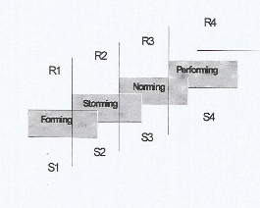
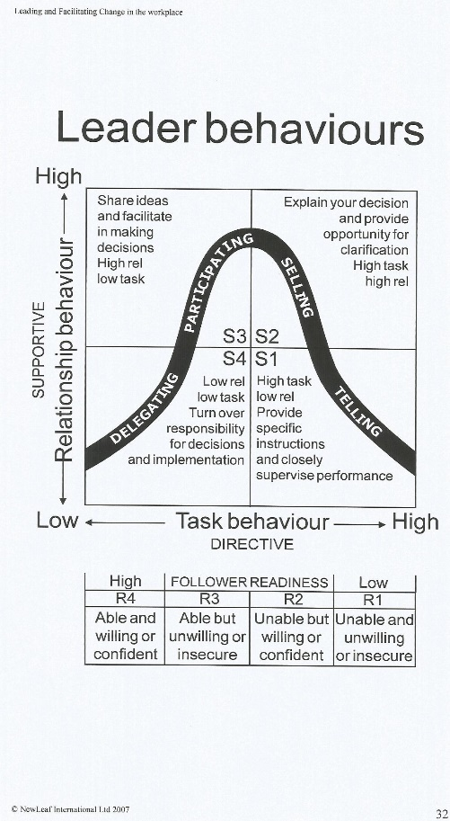
Fig.2 Fig.3

According to the QINETIQ Competency Framework (Appendix D), Leadership at QINETIQ should encompass the following competencies: Commercial Vision, Rapid Engagement, Driving Ambition and Leading Others. This suggests QINETIQ’s operational leadership is driven mainly by the company vision and the customer experience it wants to promote. Leadership focusses on achieving fast responses to customer requests and channelling its operational workers to preserve customer values and business reputation. Using the 3 E’s of leadership: Envision, Energise and Enable [10] (directing, influencing, motivating, target setting and developing workers’ skillsets etc), leaders should act as role models and help identify and promote common values and beliefs of the company vision.
- ANALYSIS

QINETIQ’s established workplace culture

QINETIQ’s plans to facilitate change in the workplace usually conform to a well-prepared and accepted process but naturally, Transform has not been without some issues. It is important that everyone understands the reasons for change but clarity can sometimes be too complex or unclear for followers at lower levels to understand. The established culture at QINETIQ has continued to sit comfortably, with employees feeling valued throughout the change but the hint of future unclarity and unknown time scales for remodel completion, did grow fear amongst some. A transform team, TAG (Transform Action Group) was created, specifically to help deal with the review and understanding of the transform throughout the whole process and provided regular online updates. Site presentations were regularly scheduled but often raised temperatures when certain questions surrounding rumours of redundancies, due to team restructures, could not be rectified in the moment. There has been a level of uncertainty regarding what the outcome will mean with regards to job posts and so the fear of the unknown caused some upset.

What is Transform

QINETIQ is currently dealing with the evolution of its business and facing up to the rate at which its organisation is having to rapidly change to stay functionally efficient, competitive and at the forefront of the defence industry. Evidently, the speedily rate at which the technological industry grows, means QINETIQ sits within a highly competitive market for work. QINETIQ’s ability to adapt the services and scale of work of which it offers, is paramount.

Transform is a two-year internal strategic programme that was introduced in March 2016 to help deliver ‘a vision of the chosen partner around the world for mission-critical solutions, innovating for our customer’s advantage’ (QINETIQ Internal Marketing Presentation 2017). It aims to change and improve how the company teams work together, streamlining its processes, and modernising its working environment. The first year was focused on creating the right organisation and having the right people in the right places to deliver for our customers and to drive growth. The final year is focused on embedding the new ways of working and all the systems and processes that support the workforce.
The impact of the workplace culture on facilitating change within the work environment (Transform)
Workplace culture has a huge impact on the ability to manage change in a company. Generally, if employees feel empowered to make the changes themselves, the transformation happens smoothly. If employees are forced to make changes to the way they work without inclusion of reasoning, involvement in decision making or opportunity to provide feedback, they tend to feel uneasy. If the culture of the workplace is good and people feel part of the change through clarity of the process, an honest period of work and business tends to flow.

According to the TAG, culture can be described as ‘the self- sustaining pattern of behaviours that determines how things are done…QINETIQ’s overall objective is to make its culture one of its biggest assets’ [11]. To support the vision and strategy, cultural change needs to occur at all levels of the business so that the changes being made are embedded and become part of ‘the way we do things around here’ [also 11], delivering the benefits promised to employees, customers and shareholders.
QINETIQ’s failure to clearly communicate the hierarchical restructure resulted in some negative reactions and feedback from employees, as pointed out by CEO Steve Wadey, according to his article titled ‘Acting on your feedback to resolve the niggles’ [Appendix E]. Key areas of Transform needed to improve, including the niggles of the new operating model and ensuring people understood where they fit in and how they could contribute. In response to the new operating model not being widely understood and consistently applied, Wadey stated that ‘you cannot understand how you can contribute if you are not sure how you fit in the new organisation’ [12]. Subsequently, QINETIQ produced a Quick Reference Guide to clarify key Operating Principles of how the company is operated and organised to win contracts and deliver projects.
Wadey closed the article stating his ‘expectation is that each and every one of us in QINETIQ rises to the challenge of making our new operational model ‘live’ in our company and takes personal accountability for making it work. This is a critical enabler to our growth’ [also 12]. He advises employees to discuss the new business model with their team leaders to help clarify its application and understanding of how the balanced matrix model works. Employees will hopefully then understand how they can contribute through customer focussed and multi-disciplined teams. Wadey’s statement lends itself to a hint of self-frustration in not communicating the vision earlier on and a motivational plea for support; that everyone needs to pull their weight and together help make this change happen.

During a later blog (Appendix F) after having received feedback from onsite presentation roadshows, one year on from the start of Transformation, Steve Wadey said QINETIQ had started to
‘make improvements to our communication, accelerated the reorganisation by three months and included local slides to highlight local successes from last year and set out objectives for the coming year’ [13].
This reflects that improvements had to be made to the methods being used during Transform to improve clarity and motivation of the employees whilst trying to maintain a positive working culture.
The current state of the economy and competitiveness of the defence technology market (due to availability of smaller private, online and international services), means large company survival is driven by vision and change. The present cyclical life stage of most businesses is Transformation, which has single-handedly defined the best working methods for leadership style. QINETIQ is a prime example of using a blend of modern day leadership theories to encourage the aspirations of their employees, shadowed behind the focus of what is best for the company’s future. During Transformation it is important that employers don’t get carried away with aiming too high and losing sight of what they already possess. When proposing the future to employees, it is important to clarify what the company’s streamlined vision entails and that people understand their own role in the plan and how they can make a difference by playing their part. QINETIQ needs to ensure employees feel valued and secure in their roles, influenced to work more efficiently with a positive business outlook and possess drive for career development. Consideration should be made for employees that are uninformed of the business structure. QINETIQ should not make assumptions that all employees will understand the move without having all the information.
Transform has highlighted the struggles associated with making organisational changes. Complex models and business jargon interrupted peoples understanding and this resulted in notable frustration and ignorance. Simplifying Q-Talk presentations of the vision with clearer projected forecasts, has rebuilt confidence in people and their understanding of what is changing and by when it will be completed. Team leaders are working hard to succeed at clarifying business expectations and achieving shared beliefs. As more of the vision is unveiled with promises of a better future, younger employees are beginning to envisage the positive impact this could have on their careers. Advances in training and an increase in variations of upcoming projects are opening new doors of opportunity. The general consensus of the older workforce is that change is being received negatively. As commonly seen with such organisational reforms, people don’t favour change when they already feel comfortable with plodding along in their roles that they have sat in for over 20 years. When the future is not necessarily people’s concern because they are nearing retirement, change is inconvenient.
Cultural change is supported by the QinetiQ Visible Active Leadership (QVAL) training programme that brings together processes and practices already in use with new ways of working. It is used in many areas of the business, as its flexibility allows business leaders to tailor the programme to meet their specific needs, whether improving productivity, operation efficiently or re-energising safety management systems.
Overall, QINETIQ’s culture is changing for the better, with employees embracing the need for changes through realisation of marketplace competitiveness. The business will continue to evolve with strength, so long as vision remains clear and Transform goals can be achieved as promised.

REFERENCES
[1] John P. Kotter, The Difference Between Management and Leadership, What Leaders Really Do, Havard Business Review, No. 90309, The Magazine of the Thoughtful Manager, President and Fellows of Havard College, May-June 1990, No. 3, pg. 104. [Magazine]. Available as PDF, pg. 4: http://15f6u431ku111j2j642gabgw.wpengine.netdna-cdn.com/wp-content/uploads/2011/02/What-Leaders-Really-Do-John-Kotter.pdf [Accessed 01/01/18]
[2] Organisational Behavior, Leadership, Stephen P. Robbins, Timothy A. Judge, Edition 15, Chapter 12, pg. 367-401, 2013. [Online Book PDF download] Available: http://bba12.weebly.com/uploads/9/4/2/8/9428277/organizational_behavior_15e_-_stephen_p_robbins__timothy_a_judge_pdf_qwerty.pdf. [Accessed 12/12/17].
[3] Leadership Management: Principles, Models and Theories, Concepts of Leadership, Leadership Management: Principles, Models and Theories, Global Journal of Management and Business Studies, Dr. Manoj Kumar Sharma and Miss. Shilpa Jain, ISSN 2248-9878 Volume 3, Number 3 (2013), pp. 309, [Online] Available: https://www.ripublication.com/gjmbs_spl/gjmbsv3n3spl_14.pdf [Accessed 05/01/18]
[4] Core Leadership Theories, Learning the Foundations of Leadership, Mind Tools Content Team [Online]. Available: https://www.mindtools.com/pages/article/leadership-theories.htm [Accessed 23/12/17]
[5] Burns, J. M. (1978) Leadership. New York: Harper & Row, pg. 20
[6] What is Transformational Leadership, Transformational Leadership, Becoming an Inspirational Leader, Mind Tools Content Team [Online]. Available: https://www.mindtools.com/pages/article/transformational-leadership.htm [Accessed 23/12/17]
[7] The leadership skills strataplex: Leadership skill requirements across organizational levels, Troy V. Mumford, Michael A. Campion, Frederick P. Morgeson, PDF: The Leadership Quarterly 18 (2007) pg. 154-166. [Online]. Available: http://citeseerx.ist.psu.edu/viewdoc/download?doi=10.1.1.605.5725&rep=rep1&type=pdf [Accessed 24/12/17].

[8] QINETIQ PDR TOOL KIT, 6 Leadership skills, [only available to QINETIQ employees via online intranet Nucleus], see appendix below for article.

[9] Leadership, Leadership styles, Chapter 4, 2IC Development Programme, QINETIQ iX Shoeburyness, Autumn 2008, New Leaf International, pg. 27.
[10] QINETIQ Competency Framework 30 June 2002, pg. 5. [Hand out provided inside QINETIQ Learning and Development Management Skills Safari – Part 2, accredited by the Chartered Management Institute, 2006]
[11] Culture Transformation Action group, online blog, [only available to QINETIQ employees via online intranet Nucleus]
[12] Acting on your feedback to resolve the ‘niggles’, Latest blog from Steve Wadey, CEO, 14 July 2017, [only available to QINETIQ employees via online intranet Nucleus], see appendix below for article.

[13] Roadshows: your opportunity to give us feedback, Latest blog from Steve Wadey, CEO, 02 May 2017, [only available to QINETIQ employees via online intranet Nucleus], see appendix below for article.
BIBLIOGRAPHY
1. Leading and Facilitating Change in the workplace, Leadership styles, Chapter 4, 2IC Development Programme, QINETIQ iX Shoeburyness, Autumn 2008, New Leaf International, pg. 26-34. [In house hard copy folder, Available for download from http://www.newleafinternational.co.uk/resources/]
2. Leading and Facilitating Change in the workplace, Change management, Chapter 7, 2IC Development Programme, QINETIQ iX Shoeburyness, Autumn 2008, New Leaf International, pg. 87-100. [In house hard copy folder, Available for download from http://www.newleafinternational.co.uk/resources/]
3. Role of a Manager, Section 1, QINETIQ Learning and Development Management Skills Safari – Part 1, accredited by the Chartered Management Institute, 2006 [Hand out]

4. On Becoming A Leader, Warren Bennis, Section 1, QINETIQ Learning and Development Management Skills Safari – Part 1, accredited by the Chartered Management Institute, 2006 [Hand out]

5. Managing Change, Section 5, QINETIQ Learning and Development Management Skills Safari – Part 1, accredited by the Chartered Management Institute, 2006 [Hand out]

6. QINETIQ Learning and Development Management Skills Safari – Part 2, accredited by the Chartered Management Institute, 2006 [Hand out]
7. QINETIQ Competency Framework June 2002, [Hand out]
8. QINETIQ PDR TOOL KIT, 6 Leadership skills, [QINETIQ Nucleus Intranet, Accessed 20/12/17]
9. What is Leadership and Important Skills that Managers Need for Effective Leadership, Leadership Skills for Managers, Jobs, The Telegraph, 15th March 2017 [Online]. Available: https://jobs.telegraph.co.uk/article/leadership-skills-for-managers/ [Accessed 02/12/17].

10. Personality Traits of a Successful Manager, Traits of Successful Managers, Jobs, The Telegraph, 5th December 2016 [Online]. Available: https://jobs.telegraph.co.uk/article/leadership-skills-for-managers/ [Accessed 02/12/17].

11. Stephen P. Robbins, Timothy A. Judge, Organisational Behavior, Leadership, Edition 15, Chapter 12, pg. 367-401, 2013. [Online Book PDF download] Available: http://bba12.weebly.com/uploads/9/4/2/8/9428277/organizational_behavior_15e_-_stephen_p_robbins__timothy_a_judge_pdf_qwerty.pdf. [Accessed 12/12/17].

12. Brent J. Goertzen, Contemporary Theories of Leadership, Chapter 6, pg. 83-98. [Online]. Available: http://samples.jbpub.com/9780763781507/81507_CH06_Printer.pdf [Accessed 01/12/17].

APPENDIX


