Synthesize a Solution to a Potential Real-Life Scenario

Ethan Ridd – P144898 – UWTSD
Abstract – Cyber security has become a larger concern for many network administrators with a large demand for cybersecurity experts. With the increase in IoT it is critical to realise the importance of standard security measures such as some good network security policy that details what a user can do or should do. Proper network configurations must also be applied to all network devices such as encryption, shutting down ports and other proprietary measures. It is essential to keep an eye out and decide on a proper course of action in case of an attack such as a denial of service attack or if your network is experiencing flooding.
Introduction
With the University of Wales Trinity Saint David moving into a newly created campus that has many technologies that are considered under the banner of Internet of Things (IoT) it is important more now than ever that the network is secure and can handle the resources needed. In this report the author is going to detail the network he has built for the new campus and outline many security measures he has implemented to prevent attacks and unauthorised access. the author will also present some research he has done in the field if IoT and Smart City security, focusing on the vulnerabilities and the preventions methods used throughout the industry. The internet of things has become greatly popular over the last few years with many experts in the industry thinking it to be the next step in networking technology[1]. The use of interconnected devices and sensors have already been seen to be a great benefit of to the industrial sector with many factories using IoT to monitor production and development of products. But as with all technology it is finding a larger market with consumers with many homes and even whole cities implementing IoT[2].

Task 1 – Design and Securing the UWTSD network.
In this section of the report the author will detail the design and implementation of the UWTSD network. the author will talk about the network such as topology and the configurations used and will focus on the security aspects of the
Topology
They author decided that to implement a multilayer hierarchical network topology with the core and distribution layers being made of layer 3 switches with gigabit ethernet capabilities, this allows for fast switch and routing and removes the centralized network infrastructure making it more secure. If the scope of this assignment allowed, then the author would have also implemented more redundancy with configurations such as Etherchannel or gateway redundancy using Gateway Load Balancing Protocol (GLBP). The author used standard layer 2 switches for the access layer with an extra switch attached to the access layer that acts as a switch for each room each location. For the purpose of this assignment the author has decided to simulate only a few rooms, as per the assignment brief the author has implemented a smart garden with a variety of IoT devices, he has also created a server room with 3 servers the first being a registration server for all the IoT devices which allows for the IoT devices to communicate and work under a specific set of conditions. The second server is a web and application server which hosts the websites and other applications like mail and domain name systems (DNS), the third is a simple storage server using File Transfer Protocols. Within the server room the author has also added a remote access PC which allows the network administrator to configure the devices remotely wherever they may be physically in the UWTSD campus. The author also created a smart carpark and a singular lab for to act as example for the numerous labs throughout the campus. For security the author placed a cisco ASA to act as a firewire wall and improve the security of the network from outside attacks through the gateway. The author has also created an example home network for a member of staff this is to simulate the Virtual Private Network which allows remote access to the UWTSD network. the author used 3 cisco routers, the first to act as a gateway for the UWTSD network, the second to act as the ISP and grant internet access. The third router will be the home network router for the staff members home this is to allow VPN access. within each of the locations there is a wireless access point that allows the student and staff to bring their own devices to the campus.
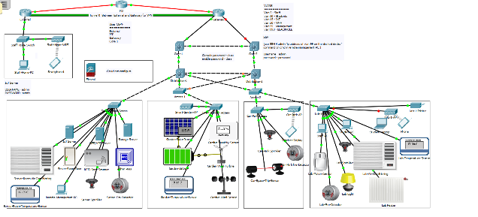
Figure 1 - Screen capture of the topology developed by the author.
IoT
The scenario outlined the assignment specifications detail that the campus will need security for the smart garden and other IoT devices, for this simulation the author placed many devices. As can be seen in figure 1 the author placed 3 sensors within the smart garden one being a temperature sensor another being a humidity sensor and a third being a wind sensor, all three of these sensors allow for the monitoring of the weather conditions with in the smart garden. To power these devices the author created 2 methods of renewable energy collection the first being a solar panel and the second being a wind turbine, to store the energy the author added a battery to the network. The wind turbine, the solar panel and the battery are all connected to each other using a IoT cable.
In the server room the author also Implemented a few IoT devices some of which regulated the temperature of the room, as server generate a lot of heat it is important ot keep the temperature low, so they can run at optimal settings. The author also added a door, RFID card and RFID readers to improve security. With the server room having a huge amount of electrical equipment the author has taken precautions to add a fire detector and a sprinkler system, but for a server room water would damage the expensive equipment so the author would implement a sprinkler that uses foam to prevent too much damage to the equipment.
For the labs the author also implemented so temperature controls, there is a temperature sensor that monitors the temperature change within the room, if the room gets too hot or cold then the temperature is altered using the radiator and the air conditioner. To save energy there is a light that is connected to the motion sensor that only activates when there is movement within the room. If there is no movement after a while, then there the light is shut off. The author also implemented the same fire protections as the server room, with a fire detector and a sprinkler system that will activate if a fire is detected.
The smart car park needs to have a way of notifying people if there are any free spots in the structure before they enter, to do this the author has decided to use a trip wire over every parking space. If the trip wire is triggered for longer than minute then the car spot is highlight as being occupied, once a spot is occupied then it is updated within the display outside of the carpark this is represented as a wireless mobile device. The author has also though about fire protection in the same way as the other rooms by using a fire detector and a sprinkler.
Configurations
The author configured some basic setting within the network devices by issuing commands such as the no ip domain-lookup command this prevents any misspelt commands from being treated as a hostname or telnet. The author also configured a message of the day banner to give a legal warning against unauthorized access.
To segment the network the author divided up some traffic into 6 VLANs the names of the VLANs and what the uses of the VLANs are seen in figure 2. The author also configured trunks between the switches to allows VLANS to travel through the network and enable switch based VLAN routing on the layer 3 switches using the ip routing command. The author configured the access ports on the switches in the locations to only access certain VLANs using the switchport mode access and switchport access vlan “VLAN No.” commands.
VLAN Number | Name
5 | Staff
10 | Students
15 | IoT
20 | Wi-Fi
99 | Management
999 | BLACKHOLE
Figure 2 - VLAN table
To allocate IP addresses to the end devices the author implemented a layer 3 switch on the core layer to act as a DHCP server, he did try to implement a DHCP server on the distribution layer with the other servers, but the author was unsuccessful in getting it to work. The DHCP server creates and allocated IP address for all the devices on each of the VLANs, this saves time in a having to configure each host individually. To use
To allow the routers to communicate the author implemented the Open Shortest Path First(OSPF) dynamic routing protocol on all the routers and the layer 3 switch named Core-1. To simulate the use of a Virtual Private Network(VPN) tunnel the author used GRE tunnel to allows communications between the External router of the staff home network and the Gateway of the UWTSD network. Ideally the author would have implemented IPsec over the GRE tunnel, but packet tracer had some issues with this configuration.
Security Configurations
To secure the network the author has implemented many configurations throughout the network. on each router and switch the author has implemented some basic security features, the first being to place a password of “cisco” on the console line and a password of “class” on the privilege EXEC mode. This prevent unauthorized access from anyone attempting to reconfigure the network device through the console cables. The author has also encrypted the passwords, so they can not be seen when the show running-configuration command is issued.
On the switches the author has implemented some security on the ports, for example if a port has no active connection the author has set the port to be administratively down. Setting the port to administratively down prevents someone from just walking up to the switches in the labs and plugging in a ethernet cable and connecting it to a foreign host. Another method of security of the switch ports implemented by the author was the use of port security. By issuing the switchport port-security command on the active ports with cables already in use, the author has prevented anyone from removing cables already being used by IoT device or hosts in the labs and replacing the connection with a foreign host. This is done by setting the maximum amount of mac addresses on a single port to 1 which can be changed but the author has kept it at the default value of 1. If the cable is replaced the mac address would change and the violation of the single mac address rule would trigger a shutdown of the active port.
As mention before the author has separated the traffic in the network using VLANs and configured ports to only work within specific VLANs. With the unused ports the author has placed them within a blackhole VLANs with of VLAN number of 999 used the same processes previously mentioned. VLAN 999 has not be allowed to take part in the switch based VLAN routing thus making it unable to communicate with the rest of the network, this a precaution for if one of the unused switch ports is accidentally left in an up state then the intruder will be unable to go any further that that single port.
When configuring the SSH the author set SSH to version 2 this is more secure as it employs more strict encryption measures. The author set the SSH to create crypto key using RSA with a 1024 bit key, when creating the SSH configuration the author implement the username of “admin” and password of “password” also encrypted so they don’t show up on the “show running-configuration” commands. Finally, the author set the SSH to only work on VLAN 99 so no other users within the network can remotely configure the network devices.
Another way the author would have implemented security within the network is to create access control lists or ACLs. Unfortunately, due to the way the author has configure his network anytime an ACL was place on an interface within the router the routeing would stop, if the author had a bit more time and implemented routing differently he was sure he could get them to work. The ACLs the author was considering we the following:
- Prevent the IoT network from leaving through the gateway.
- Prevent anyone gaining access to the network that isn’t a part of the Allow access list.
- Prevent the student and staff VLANs from accessing VLAN 99.
- Allows the VPN and staff home network to only access the HTTP server.
- Prevent remote access through SSH from outside the network.
The author would have liked to implement a cisco 5505 ASA firewall but all attempts to configure the device within packet tracer resulted in either the device not functioning or the network unable to connect, this is because the author lack the in-depth knowledge to configure the device despite his research into the configurations.
The author has also configured some physical security within the network, this is seen in figure 1 as a door with and RFID reader which only the network administrator would have the RFID card for. The server rack in which all the network devices are stored and maintained would also be kept locked to prevent anyone who manages to get past the locked door from physically damaging the network equipment.
Packet Monitoring
To analyse the packets going through the network the author had wanted to use Wireshark, but packet tracer has no way if implementing this. Packet tracer does have a basic packet monitoring/simulating system built within it, this is found within the lower right corner of the software depicted as the stopwatch.
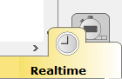
Figure 3 - Packet tracer packet monitoring
The monitoring system already in packet tracer has allowed the author to see what packets are being sent through the network and where they are getting stopped and checked by each device. Unfortunately, it is not quite as detailed as Wireshark but can be still be helpful.
In figure 4 we can see the ARP update packets and the DHCP request packets move through the network. from this example we can see the timeframe, device the packet is at and which device it came from. The packets are also colour coded, so we can identify them moving through the network.
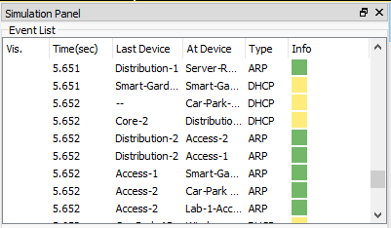
Figure 4 ARP and DHCP packet capture
In figure 5 we can see a green coloured envelope moving through the network, this represent an ICMP packet from the staff home PC, the author ping the address 192.168.5.2 which is a pc within the staff VLAN. There are more screen captures of packets detailing OSPF, IoT, IoT TCP and ICMP with a larger copy of figure 5 in the appendices.
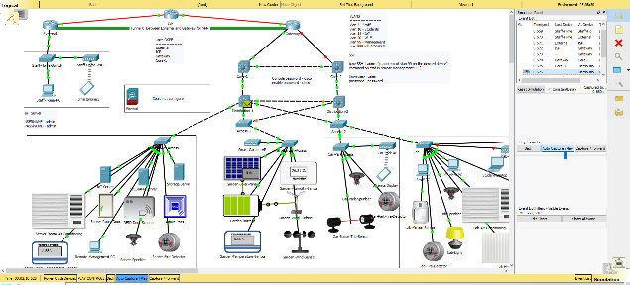
Figure 5 - Screenshot of ICMP packet moving through the network
Network Policies
The assignment scenario it is mentioned that the campus will have the capability for the student and the staff to bring their own devices(BYOD) in to the university to conduct work. This could present a security issue, so it is common in the industry for the admin to create security policies for BYOD. The author has developed some security policies as detailed below:
- Passwords of devices must be over 7 letters and contain variation of letters (upper case and lower case), number and symbols e.g. “P@ssword”.

- The devices must be protected by either a first-party software i.e. windows defender or the third-party software i.e. Bitdefender

- Passwords must be changed every 40 days or and at the start of every semester.

- Mobile phones must be locked with either a full worded password or finger print scanners, no patterns or 4-digit pin codes.

- Facial recognition software can also be used but only as part of a 2-factor authentication system.

- All Android, IOS, Mac OS, Windows (windows 7 will not support some security features) and Linux operating systems must be updated to the latest version to prevent security issues.

- Devices location must be kept on so adequate tracking of device can be obtained if it is lost or stolen.

- Device must be capable of a remote wipe or remote locking in case device is lost or stolen with sensitive data present.

Task 2 – Internet of Things and Smart City Security issues

As mentioned before the author has implemented devices that are part of the Internet of Things(IoT) phenomena, which uses networked devices to gather data through sensors and automated systems[3]. IoT has become increasing popular in the recent years with experts predicting a 1.7 trillion-dollar economic impact by the year 2020[4]. With the boom in this technology there have been many countries have been implementing IoT into their cities such as Barcelona and even plans for Las Vegas to be implement IoT into its city infrastructure[5]. But with the massive increase in use of the technology the odds of an attack from a malicious party increases drastically. In this section of the report the author is going to highlight the security issues found in IoT and Smart Cities and talk about prevention methods that are commonly implemented.

Common attacks against IoT
There are many common attacks that have been used in the past and continue to be used against IoT networks ranging from simple attacks such as a physical attack on the sensors or other network devices to more complex attacks like a Man in the middle attack. The author has researched and detailed some of these attacks below.
Physical tampering of devices
Despite its unlikeliness there is a potential physical attack that could affect the performance and operation of a network with IoT devices. The most obvious way of physical tampering is the destruction of the IoT devices, for security cameras connected to a network and security server damaging the cameras could result in loss of real time surveillance increasing the possibility of property theft. Physical damage can also be done to the ethernet cables that can be used to both power the device and connect them to the network. Some IoT smart devices allow for firmware and software updates to be performed through USB or MicroSD cards, this opens a potential vulnerability as a bad actor could install their own version of software or firmware which could allows them to collect or steal data[6].
Man-in-the-middle attacks
A man in the middle attack is a fairly common form of intercepting and reading data. This occurs when a malicious user places itself in between 2 nodes on a network by pretending to be the destination node and forwarding the packets intercepted to the real destination node[7]. This allows the fake node to capture and store data that it was not meant to see. This method is most commonly executed alongside an Address Resolution Protocol poisoning attack which inserts the false address of the node which will be used in the attack into the ARP tables of the legitimate nodes[8]. An easy prevention method to this is to encrypt all data being sent through the network and to clear the ARP cache every so often. Man-in-the-middle attacks can be very damaging to IoT devices as it allows a disruptive host to intercept the sensor data from RFID readers or important monitoring systems, this is even more dangerous in smart cities when infrastructure and key equipment used by the city is monitored by IoT devices.
Denial of Service
Denial of Service is a very common attack that aims to temporally or permanently take a service or website out of action by flooding associated servers with data and requests that it cannot handle thus resulting in a crashing of the system[9]. DoS attacks against an IoT network can be very disruptive as it practically makes the server that the IoT devices send their data to shut down. IoT is very susceptible to attack from DoS as they use a wide range of protocols that might have undetected flaws that allows easy access to an individual with the right knowledge[10]. It has been a massive struggle for security experts to find an effective strategy to combatting Denial of Service attacks. One of the many method employed by network administrators is to use Access Control Lists which can block IP addresses or protocols from entering the network[11].
Ransomware
Ransomware is a type of program that prevents a user from accessing their computers or other devices by locking the system and demanding the user pay a fee usually in untraceable cryptocurrencies, to unlock the device and gain access to their data[12]. With the massive increase in popularity IoT has obviously become a big target of malware attacks, locking the IoT servers of large corporations and holding the data of the autonomous systems ransom. This can cost a company a lot of money in downtime and ransom costs. The best way to combat ransomware is to fragment file shares and create backups of all vital data. It is also good to have redundant IoT servers so that if the one is locked by ransomware the other could take its place[13].
Flooding
Flooding is in many ways like a Denial of Service attack in the way it attempts to disrupt services in a network. Flooding occurs when a malicious node gains access to a network and begins to flood the network with hello broadcast packets to every host on the network, essentially prevents other packets from traversing the network as the bandwidth is taken up by these hello packets. The slows the network throughput down a lot and can prevent the IoT devices from reporting sensor data. To prevent flooding attacks a firewall with a decent packet filtering policy and access control should be able to prevent attacks from getting out of hand[14].
Eavesdropping
Eavesdropping is like a man in the middle attack but is specifically designed to intercept data and listen in on all packets being sent through a network, this can include packets that hold, routing information, DHCP requests or TCP data. Many IoT technologies such as RFID and Bluetooth are very susceptible to eavesdropping[15]. This allows the attacker to learn about the network and is often used as reconnaissance for a more devastating attack further down the line. The best way to prevent eavesdropping is to encrypt data and place authentication on all connection on the network such WPA2 PSK on access points or 802.1x authentication for ethernet port based connections[16].
Conclusion
To conclude the author has implemented a variety of security within the designed network from physical security to prevent anyone gaining access to the network devices to configurations such as switchports security and blackhole VLANs that prevent anyone from accessing the network just by simply plugging into an access layer switch. The author has also implemented some IoT devices into the network and has segmented the traffic on the network. Finally, the author details some research into the field of IoT security. He highlighted some common attack and how they could affect IoT devices on a network. the author also detailed some prevention methods such as firewall with strict access list policies, encrypting data and clearing ARP caches. In the future the author would like to be able to get the firewall working and include more redundancy within the network using EtherChannel and Gateway redundancy. The author would also choose to implement some of this security on a physical device so that he could run Wireshark and see how the packets behaved under such security.
References
[1] J. Biron, “The State of the Industrial Internet of Things 2017.”
[2] D. for B. I. & Skills, “SMART CITIES: Background paper,” 2013.
[3] G. Association, “Understanding the Internet of Things (IoT),” GSMA Connect. Living, 2014.
[4] “IoT 2020: Smart and secure IoT platform ®.”
[5] “Las Vegas’ Smart City Push.” [Online]. Available: http://www.ioti.com/smart-cities/viva-las-vegas-smart-city-plans. [Accessed: 01-May-2018].
[6] M. B. Barcena and C. Wueest, “Insecurity in the Internet of Things,” 2015.
[7] Z. Cekerevac, Z. Dvorak, L. Prigoda, and P. Cekerevac, “INTERNET OF THINGS AND THE MAN-IN- THE-MIDDLE ATTACKS – SECURITY AND ECONOMIC RISKS,” 2017.
[8] M. Conti, N. Dragoni, and V. Lesyk, “A Survey of Man In The Middle Attacks,” IEEE Commun. Surv. Tutorials, vol. 18, no. 3, pp. 2027–2051, 2016.
[9] M. Hangargi, “Denial of Service Attacks in Wireless Networks.”
[10] M. Anirudh, S. Arul Thileeban, and D. J. Nallathambi, “Use of honeypots for mitigating DoS attacks targeted on IoT networks,” Int. Conf. Comput. Commun. Signal Process. Spec. Focus IoT, ICCCSP 2017, pp. 8–11, 2017.
[11] S. Rao and S. Rao, “Denial of Service attacks and mitigation techniques: Real time implementation with detailed analysis.”
[12] Registered, England, and Wales, “Ransomware White Paper,” VAT Reg. Number, vol. 880, pp. 8618–88, 2016.
[13] “Ransomware Whitepaper.”
[14] M. Malik, “Contiki-based mitigation of UDP flooding attacks in the Internet of things,” pp. 1296–1300, 2017.
[15] D. Mendez, I. Papapanagiotou, and B. Yang, “Internet of Things: Survey on Security and Privacy.”
[16] “Configuring IEEE 802.1X Port-Based Authentication.”

Appendices
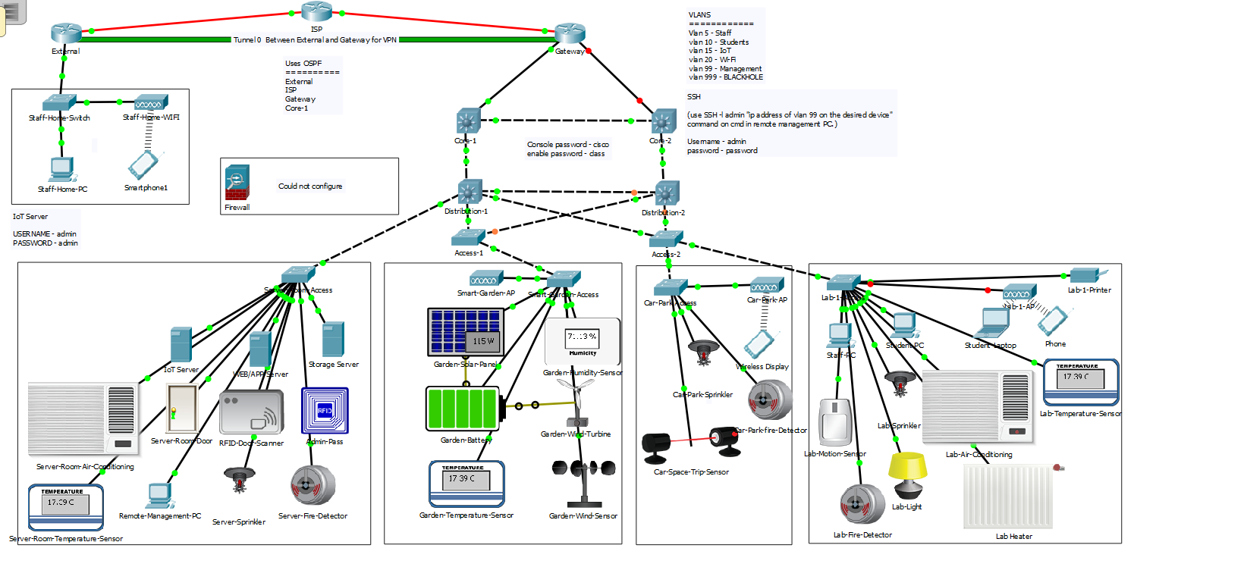

 | 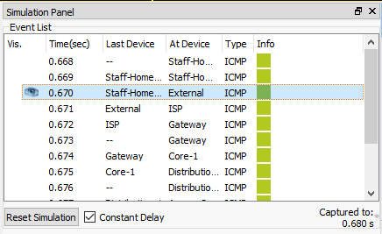
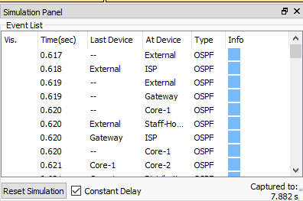 | 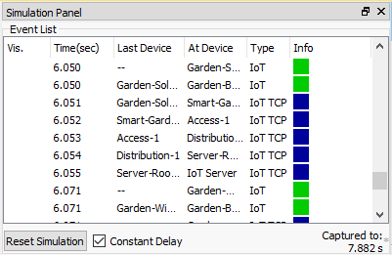
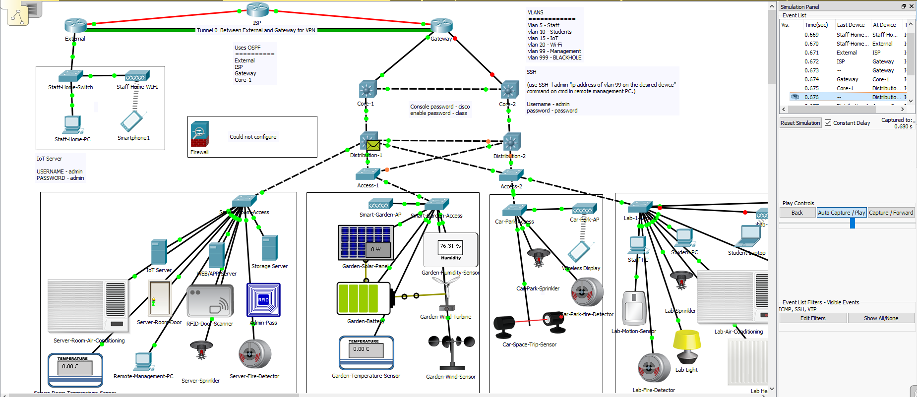

marking criteria and Student FEEDBACK

This section details the assessment criteria. The extent to which these are demonstrated by you determines your mark. The marks available for each criterion are shown. Lecturers will use the space provided to comment on the achievement of the task(s), including those areas in which you have performed well and areas that would benefit from development/improvement.

Common Assessment Criteria Applied (Assignment 1) | Marks available | Marks  awarded
1. Research-informed Literature
Extent of research and/or own reading, selection of credible sources, application of appropriate referencing conventions.
Inclusion of a wide range of research-informed literature, but you could expand the scope of reference sources. Some areas could do with more referencing. (Grade mark: 73.33%) | 15 | 11
2. Knowledge and Understanding of Subject
Extent of knowledge and understanding of concepts and underlying principles associated with the discipline.
Clear awareness of challenges to established views and the limitations of the knowledge base. (Grade mark: 73.33%) | 15 | 11
3. Analysis
Analysis, evaluation and synthesis; logic, argument and judgement; analytical reflection; organisation of ideas and evidence
The practical area covered the documentation of the setting up and configurations of tools and software. No discussion on any test or simulation conducted to draw inferences about the design. How does your implementation inter-relate with your research aspect. No cross-referencing evidence. In your conclusion use paragraph to summarise key aspect from the report and you future recommendations. (Grade mark: 70.00%) | 30 | 21
4. Practical Application and Deployment
Deployment of methods, materials, tools and techniques; application of concepts; formulation of innovative and creative solutions to solve problems.
A good approach utilising the IoT as instructed, basic usage of the BYOD you could have implemented a staff network to improve this section. The inclusion of ACLs would have also improved the network security to prevent unwarranted intrusions and access. Shutting the ports down on devices aids the physical security and its pleasing to see that this has been done. (Grade mark: 76.67%) | 30 | 23
5. Skills for Professional Practice
Attributes in professional practice: individual and collaborative working; deployment of appropriate media; presentation and organisation.
Can communicate professionally and confident in a suitable format. Avoid contraction grammar and other minor errors. (Grade mark: 80.00%) | 10 | 8

Assignment Mark (Assessment marks are subject to ratification at the Exam Board. These comments and marks are to give feedback on module work and are for guidance only until they are confirmed. ) | Late Submission Penalties (tick if appropriate) |  | 74%
 | Up to four weeks late |  | 74%
 | First Attempt? |  | 74%

