

Module Title: Research Methods & Project
Name: Irfan Yaqoob
Student ID: P145563
Course: BSc (Hons) Automotive Engineering
Module No: M3X9486
Lecturer: Andrew Gibson
Supervisor: Andrew Gibson
Date: 20-11-2017

Project Title
The effect of EGR on combustion and exhaust emissions characteristics of a spark-ignition system

Abstract (Non-specialist)
This paper reports on the exhaust gas recirculation (EGR) technique which is widely used in automotive spark injection engines and other engines, because it provides an effective mean of reducing nitrous oxide emissions (NOx) (Serrano, 2005). EGR is applied during partial load operation, as it is here where it’s potential is of the greatest benefit. Recirculating exhaust gas through the EGR valve into the intake manifold lowers combustion temperature and reduces emission levels of oxides of nitrogen (Knowles, 1984). A spark injection engine which enhances with EGR will be tested on the rolling road to monitor exhaust emissions gases such as CO, CO2, HC and particularly NOx. Pollutant emissions during the transient phase are evaluated by examining the state of the five exhaust gas analysers (Chen, 2014). This experiment will be conducted with and without EGR to analyse the benefit of EGR by applying throttle load using the rolling road at rates of 100%, 50%, 25% and 0% load at between 1000-5000 revolutions per minute (RPM). The results obtained will be analysed using an Excel spreadsheet with the graph.

Abstract
Nowadays customers require modern SI engines to have a high power output as well as a low fuel consumption in the part-load range (Resitoglu, 2014). Since the maximum compression ratio of an SI engine is limited due to knock problem when operating at wide-open throttle (WOT), losses in brake efficiency have to be accepted at part load (Adams, 1987). Meanwhile, atmospheric pollution and global warming are extremely important environmental issues. Passenger vehicles emit many different pollutants, some of which are regulated by the European Union (EU) and by most other countries in the world. In the EU, CO, HC and NOx are the three regulated pollutants relating to petrol engines (Kokkinou, 2009). The most difficult challenge in purifying exhaust gas that has been generated by a lean burn engine is the conversion of nitrogen oxide (NOx) under oxygen-rich conditions. The EGR system reduces NOx by the recirculating small amount of exhaust gas into the intake manifold where it mixes with charge air. NOx is produced during periods of combustion when the combustion temperature exceeds about 1700°C (Berry, 1996). Diluting the incoming air with a small quantity of exhaust gas enhances the specific heat capacity of the Air/Fuel mixture thus helps in reducing the peak combustion temperature. The reduction in combustion temperature limits the NOx production. However, it is to be noted that though EGR system assists in reducing emissions (Hori, 1997). To control global warming issues, it has been beneficial to use external Exhaust Gas Recirculation (EGR) to improve SI engine (Hori, 1997). Recirculating the exhaust gas on petrol engines is employed primarily to reduce throttling losses at part load range thus reducing fuel consumption, and reducing nitrogen oxide emission levels (Blank, 2002). This study will investigate the theoretical and practical use of EGR intervention on the part-load range, on a port fuel injection engine. The theoretical investigation will be conducted through the use of relevant publications and online resources. The practical will be conducted by the monitoring of exhaust gases by using the exhaust gas analyser in conjunction with the use of running the VW Lupo 1 lt (2001) petrol on the rolling road. One of the testing procedures will be designed to conform with the New European Driving Cycle (NEDC) regulations for Real Driving Emissions (RDE) in order to obtain valid readings from the emissions.

Acknowledgments

First, the author would like to thank Mr Andrew Gibson who supports me during this project and his guidance.
Secondly, the author would like to thank Sir Malcolm McDonald who, in a professional manner, helped me when I needed it. The author also acknowledges the technical support provided by Mr Barry and Mr Marcus Mathew.
Also, big thank my wife who is well organised with my children and also motivates/supports me throughout my study to achieve the best career. Without my family Support, it is not possible, for me to achieve any success in life.
.

Table of Contents
Abstract (Non-specialist)
Abstract
Acknowledgments
List of Figures
List of table
List of Notations
Chapter 1 1
1.1 Introduction 1
Chapter 2 3
2.1 Literature Review 3
2.2 Background 3
2.3 Thermodynamic laws analysis 4
Chapter 3 5
3.1 Engine Emissions 5
3.2 Environmental Effects 6
3.3 European Emission Regulations 7
3.4 Euro NEDC standard 7
Chapter 4 9
4.1 NOx pollutant emissions 9
4.2 Exhaust gas recirculation (EGR) 10
Chapter 5 11
5.1 Project planning 11
Chapter 6 12
6.1 Conclusion 12
Reference/ Bibliography 12

List of Figures
Figure 1 shows the material of internal components of cylinder 3
Figure 2 shows the emissions gasses from tailpipe 5
Figure 3 shows the UK GHG transport emissions pie chart 6
Figure 4 shows the exhaust emissions pie chart 6
Figure 5 shows RDE produces for NEDC 7
Figure 6 shows the NEDC graph for three phases 8
Figure 7 shows NEDC procedures for EURO 3 URBAN cars 8

List of table

Table 1 Euro Emissions standard for petrol passage car. 7
Table 2 EGR data obtain by Qin et al 2010 11

List of Notations

CO Carbon Monoxide
CO2 Carbon Dioxide
EGR Exhaust Gas Recirculation
EU European Union
HC Unburned Hydrocarbon
IC Internal Combustion
NO Nitrous Oxide
NOx Nitrous Oxides
NEDC New Emissions Driving Cycle
O₂ Oxygen
PFI Port Fuel Injection
RDE Real Driving Emission
RPM Revolutions per minute
SI Spark-Ignition
WOT Wide Open Throttle
λ Air-Fuel Ratio

Chapter 1
This chapter will explain the introduction and aim of this project, which relates to exhaust gas recirculation with a view to limiting harm to the environment.

Introduction

The main objectives of this report are to investigate the exhaust gas recirculation (EGR), emission control system, and the effect of emissions produced, with the focus on reducing the production of harmful emissions from the internal combustion engine. The first mention of the effect of on-road traffic on air quality was in the 1940s in California (Lenz, 1993). Exhaust emissions and its effect on the environment is complex as the effect varies depending on the source of emissions. For example, power plants release carbon dioxide (CO₂), sulphur oxides (SO_{x}), and nitrogen oxides (NOx). However, automotive emissions comprise of NOx, hydrocarbons (HC), and carbon monoxide (CO). Sulphur oxides (SOx) and nitrogen oxides (NOx) (Pritchard, 2005). Each of these emissions lends themselves strongly to a particular health problem of growing concern (Pritchard, 2005). The Current regulated emissions limit of internal combustion engines is becoming even more stringent. The ongoing European emissions standard Euro 6 entered into force in September 2014 reducing the NOx limit of about 50% compared to the previous Euro 5 standard (Belgiorno, 2017). On the other hand, the CO₂ limit in Europe for passenger cars will be cut from the present value of 130 g/km, for the average fleet, to 95 g/km by 2021 (Belgiorno, 2017).

Automotive industries are attempting to create a machine that not only makes life easier but is also beneficial to health (Duleep, 1984). In order to understand the exhaust gas recirculation (EGR) principle, on spark ignition engines, will be used for examination. This test will be conducted on multipoint fuel injector system VW Lupo 1.0 engine (2001), Euro 3 legislation. This will take the form of conducting experiments with EGR and without EGR. Lupo 1.0 lt spark ignition engine will be examined by using an exhaust gas analyser and rolling road. In addition, emission in the internal combustion engine will be monitored by turning EGR on and off and by increasing the RPM from cold to warm engine. The purpose behind the different kinds of testing will be to determine a method of combustion control. The success of the EGR concept could lead to a better and safer environment resulting from a decrease in pollution. While testing particular care will be taken to conform to Health and Safety standards. The data from the pollutant emissions will be tested under operational conditions. The objective of employment of EGR in automotive engines is to keep gaseous pollutants under legal emission standards without fuel penalization.

The EGR has been widely used as Exhaust Gas Recirculation (EGR) helps in control of Nitrogen Oxide (NOx) emissions from automobile exhaust. This is accomplished by recirculating the exhaust gases into the combustion chamber through the air intake system. The charge air and exhaust air are combined before they enter the intake manifold, resulting in an equal distribution of gas in all the cylinders. Maximum EGR rates of 15-20 % are achieved, depending on engine load point and combustion stability. At these points, where engine combustion stability (COV ≤ 3.0%) (William, 2010). Also enhance, benefits of external Exhaust Gas Recirculation (EGR) on petrol engine efficiency are well known, and advantages for low-pressure EGR (LP-EGR) and high-pressure EGR (HP-EGR) have been presented. The use of intensive EGR for normal aspirated or charged petrol engine was announced by several automotive industries to reach engine efficiency of more than 40% (William, 2010). In addition to fuel economy improvements, future emission legislation in Europe is designed to identify tailpipe emissions under Real Driving Conditions (RDE) (Fischer, 2017). This will be an added challenge, especially for downsized engines because they often operate at higher loads resulting in higher exhaust temperatures. Fuel enrichment is typically applied under such conditions for component thermal protection. However, it increases fuel consumption and emissions (Fischer, 2017).

The main aim of this report is to analyse the impact of running with and without exhaust gas recirculation (EGR) on a vehicle emissions control system.
This will be done by live testing not only of the exhaust gases emitted but also the calculation of the gas that is recirculated internally. The exhaust will be subject to testing with an exhaust gas analyser with recirculation and without recirculation. Calculations will then be made to find out what affect the recirculation has had on the emissions of harmful gases. The results will be entered into an Excel spreadsheet which will be displayed in graphical format by utilising Excel software.

Chapter 2
This chapter reviews the investigation on internal combustion engine and explains the engine thermal efficiency.

2.1 Literature Review
Recently there has been extensive research and development into the exhaust emissions from spark injection engines. For this exercise, research will be necessary for emissions related articles and papers concerning developments in the automotive industries in this area. The emission control components will be researched through written sources to understand their role in the exhaust system and investigate the new developments in production vehicles which control emissions.

2.2 Background
The concept of the internal combustion (IC) engine dates back to 1680 when a Dutch Physicist named Christian Huygens designed an IC engine which was fuelled by gunpowder (Stone, 1999). The next significant breakthrough came in 1876 when Nicolaus Otto built the first practical four-stroke IC engine (Wu, 2007). The Otto cycle displayed the underlying working principle of the operation of the IC engine, and it has become the universally adopted cycle for all liquid fuelled spark-ignited IC engines to this day (Bennett, 2013). Internal combustion engines are classified as thermal engines (Bosch, 2014). Enhancing the maximum engine thermal efficiency is essential for SI engines because the engine operating points are mainly in the high engine load area where engine thermal efficiency is close to the maximum possible. This is because the internal combustion process in spark ignition engines causes the temperature of the burning gases in the engine cylinder to reach up to 1500 to 2000°C (Hill, 2017).
Figure 1 shows the material of internal components of cylinder

This is above the melting point of the material of the cylinder body, engine head and internal components of the engine as can be seen in figure (1). Titanium is a metal which has one of the highest melting points melting at 1668°C. Iron melts at 1530°C and aluminium at 657°C. Therefore, if the heat is not dissipated, it will result in the failure of the material from which the cylinder is constructed. As a result of extreme temperatures, the film of lubricating oil becomes oxidized and deposits carbon on the surface of the cylinder. This will result in piston seizure. Large temperature differences due to overheating may lead to distortion of the engine components due to the thermal stresses which occur. This makes it necessary for temperature variation to be kept to a minimum. Also, higher temperatures lower the volumetric efficiency of the engine (Hill, 2017). In addition, the running of the engine is also subject to the laws of thermodynamics, which are referenced below. During the internal combustion process, the air/fuel mixer generates a number of by-products. With the engine warmed to its normal operating temperature and running with a stoichiometric mixture composition ($λ=1)$ the proportion of these by-products in the engine untreated emissions (exhaust gas after combustion, but before treatment) is about 1% of the total exhaust gas quantity (Hochkönig, 1992). The most significant of these combustion by-products are Hydrocarbons (HC), Carbon monoxide (CO), and Nitrous oxides (NOx). Therefore, these by-product pollutants are a main issue in global warming (Bosch, 2006). These by-products are converted from chemical fuel energy into mechanical energy to drive the vehicle. About 32% of the fuel's chemical energy content is converted into crankshaft power while 68% is accounted for by heat due to energy loss. This heat must be dissipated in order to ensure steady-state operation. From 30 to 50% of the fuel energy is carried off by exhaust gases. The remaining 18 to 35 % must be removed from the engine by means of a coolant EGR operation temperature will be in the range 450C-650C (Hochkönig, 1992).

2.3 Thermodynamic laws analysis
Thermodynamics is the science of converting heat into work. It is this science that provides a theoretical foundation for the understanding of the operation of engines. The science of thermodynamics is based on two laws or principles commonly called the First and Second Laws of Thermodynamics. These laws simply express the results of our experiences and are only as valid as our experiences.

First Law: “Energy is always conserved. You can’t get out more energy than you put in.
Energy can neither be created nor destroyed” (Myers, 1953).

Second Law: “No engine can be 100% efficient.
Heat cannot be completely converted into work” (Myers, 1953).

The First Law of thermodynamics leads to the concept of energy conservation. It states that energy is conserved in every device or process. Energy may exist in many different forms and may be converted from one form to another within a thermodynamic system, but energy is neither created nor destroyed. Petrol combusted in SI engines is converted into mechanical energy and thermal energy. A measure of the potential for energy to perform useful work is availability. The concept of availability is derived from the Second Law of thermodynamics and, unlike energy, availability is a non-conservative quantity. Availability may be destroyed. When destruction occurs, the thermodynamic system loses some of its potentials to perform useful work. To properly evaluate energy-use strategies for vehicle power plants both energy and availability must be considered (Primus, 1984).

Chapter 3
This chapter mainly deals with emissions by-products characteristics, environmental effects and European emissions regulations.

3.1 Engine Emissions
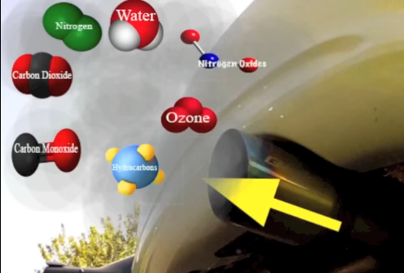
It has been explained above, how engine emissions are produced or created by the internal combustion SI engine. However, the term ‘engine emission’ refers primarily to pollutants in the engine exhaust. In addition, there are unavoidable combustion products of carbon dioxide (CO₂) and water (H₂O). The concentration of these is dependent on the composition of the fuel. Nitrogen oxides (NO_{x}), non-combusted hydrocarbons (HC) and carbon monoxide (CO) are the main emissions from an SI engine. Nitrogen oxides (NO_{x}) require four factors to be created: oxygen, nitrogen, high temperature, and time. Because the amount of oxygen and nitrogen is determined by the mixture composition in SI engines, and the available time is determined by way of the engine speed, nitrogen oxides in SI engine can only be reduced through low maximum combustion chamber temperature (e.g. using ignition retardation and exhaust gas recirculation (EGR). Hydrocarbons (HC) and carbon-monoxide emissions (CO) result in incomplete combustion. Due to the lack of oxygen in rich-burn engine operation, there is an increase in both HC and CO emissions. On the other hand, in lean-burn operation with the reduced flame temperature, a more intensive extinguishing of the flame is encountered, particularly in the area close to the wall resulting in an increase in HC emissions. Nevertheless, because of the excess oxygen, the slight oxidation CO emissions are reduced (Bosch, 2014) p.410.
Figure 2 shows the emissions gasses from tailpipe
Hydrocarbons (HC)
Carbon monoxide (CO)
Carbon dioxide (CO₂)
Oxygen (O₂)
Nitrogen Oxides (NOx)
Above engine, emissions will be explained in the main project paper.

3.2 Environmental Effects
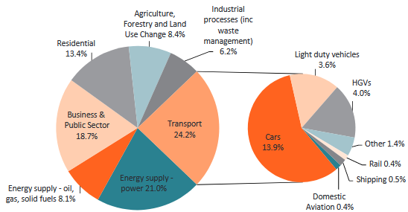
In 1975 the State of California passed an Energy Policy and Conservation Act (Darlington, 2008). Congress established the Corporate Average Fuel Economy (CAFE) program. This is administered by the National Highway Traffic Safety Administration (NHTSA). The CAFE standards impose limits on fuel economy in terms of miles per gallon, which can be directly translated using a mathematical formula to emissions of CO₂ on a gram per mile basis. The UK transport sector is responsible for 24.2 percent of UK domestic greenhouse gas emissions according to Gov 2017 as can be seen in figure (3). The sources, which make up this amount of transport only, are further broken down in the smaller pie chart to the right of the larger pie chart. This shows the largest proportion comes from car usage.
Figure 3 shows the UK GHG transport emissions pie chart

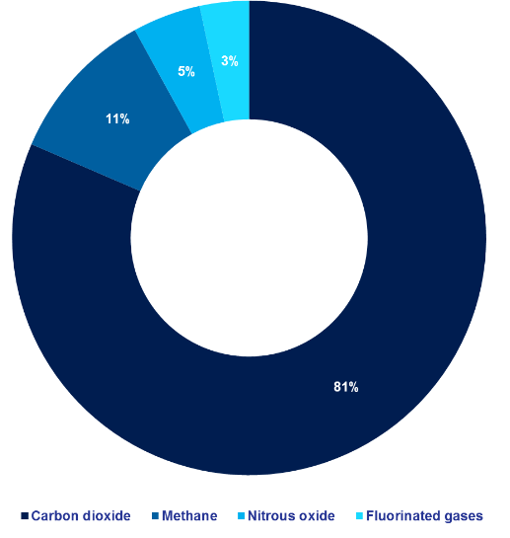
When further broken down by type of gas, as can be seen in figure (4) the main UK emission from transport is carbon dioxide, which accounted for 81 percent of the UK’s greenhouse gas emissions in 2015. Weighted by global warming potential, methane accounted for 11 percent of UK emissions and nitrous oxide for 5 percent of emissions in 2015. The remainder, around 3 percent was accounted for by Fluorinated gases (Gov, 2017). For the UK government to meet its GHG reduction targets, the transport sector will have to contribute to a reduction in emissions. The use of a larger proportion of biofuels is recognized as an important contributor to the reduction of CO₂ emissions from road transport. The UK agreed to adopt the EU's New Car CO₂ regulations in April 2009 (Przybyla, 2013). This puts in place a framework that effectively forces car manufacturers to develop vehicles with lower GHG emission. The average emission of CO₂ by new cars on UK roads fell from 190g_{CO2}/km to 158g_{CO2}/km between 1997 and 2008. The EU's new regulation targets an average for new cars of 130g_{CO2}/km starting in 2012, with full compliance by 2015. This will then drop to 95g_{CO2}/km by 2020 (Li, 2008). For light commercial vehicles such as that used here, new legislation from the European Commission targets a fleet average for all new light commercial vehicles of 175g_{CO2}/km from 2014 phased-in to 2016 and a target of 135g_{CO2}/km in 2020 (Przybyla, 2013). The Greenhouse gases produced by the transport sector include CO₂, methane (CH₄) and nitrous oxide (N₂O). The CO₂ is a dominant GHG which has been extensively investigated. Currently, the CO₂ emissions from the transport sector accounted for around 23% of the total CO₂ emissions in the UK (Przybyla, 2013). A lean-burn SI engine is an attractive concept in engine design as it provides improvements in engine efficiency, which is a key factor in reducing CO2 output. Reduction of the total quantity of CO₂ emitted by SI engines will lead to improved atmospheric condition and a reduction in harm to the environment.
Figure 4 shows the exhaust emissions pie chart

Recently, engine technologies such as lean-burn engines for high fuel economy improvement have become well developed. However, these high economy engine concepts are currently limited in their application because their oxygen-rich exhaust does not allow for reduced NOx emissions even with a three-way catalyst (Tabatha, 1995). The Government is committed to reducing the levels of pollutants which are causing poor air quality which is detrimental to health (Tabata, 1995). Responsible authorities across Europe require working towards agreeing on Limit Values to ambient concentrations of nitrogen dioxide (NO₂). A principal source of NO₂ is the NOx emitted from road vehicle exhausts, particularly from engines. NO₂ is, for the most part, formed when nitrous oxide (NO) present within the exhaust gases oxidises within the atmosphere to form NO₂. Thus one way of controlling NO₂ formation is to reduce emissions of NOx and its constituent NO (GOV, 2017).

3.3 European Emission Regulations
Exhaust regulated pollutants depend on several parameters, such as the fuel used, combustion mixture and engine design, engine tuning, after-treatment devices and driving conditions (Zervas, 2003). However, in every case, exhaust emissions of regulated pollutants have to meet the regulations limit on a standardised driving cycle which has been explained below in Real Driving Emissions (RDE) legislation 2017. The table (1) below illustrates the emissions regulations between 1992 and 2014. This table illustrates the improvements in the exhaust emissions control system which has been monitored throughout from 1992. It demonstrates the improvement in the parameters, which have been decreased in petrol vehicles to improve and protect the environment. These parameters are still being changed in order to reduce further damage to the environment, such as GHG leading to global warming.

See further below for information regarding EU Real Driving Emissions (RDE) legislation concerning exhaust emissions control.
Table 1 Euro Emissions standard for petrol passage car.
Euro Emission standard for Petrol passage car
Stage | Date | Co g/Km | Hc g/km | HC + Nox g/Km | NOx g/Km | PM g/Km | PN Km
Euro 1 | 1992.07 | 2.72(3.16) |  | 0.97(1.13)
Euro 2 | 1996.01 | 2.2 |  | 0.5
Euro 3 | 2000.01 | 2.3 | 0.2 |  | 0.15
Euro 4 | 2005.01 | 1 | 0.1 |  | 0.08
Euro 5 | 2009.09 | 1 | 0.1 |  | 0.06 | 0.005
Euro 6 | 2014.09 | 1 | 0.1 |  | 0.06 | 0.005 | 6.0×10¹¹

3.4 Euro NEDC standard
A Real Driving Emissions (RDE) clause using Portable emissions measurement system (PEMS) as can be seen in figure (5), as discussed above, is now being brought into EU legislation (Vehicle Emissions Testing Programme, 2016). This consists of portions of different driving environments, performed where possible in the order presented below, which also as can be seen in figure (6).
1. 34% Urban operation, typified by vehicle speeds up to 60 km/h
2. 33% Rural operation, typified by vehicle speeds between 60 and 90 km/h
3. 33% Motorway operation, typified by vehicle speeds over 90 km/h (Thomas, 2017)
Figure 5 shows RDE produces for NEDC
In order for the tests to be valid there are specifications concerning the environmental conditions that must be adhered to:
1.The test must be performed under ambient conditions of 0°C ≤ T ≤ 30°C or ‘extended conditions’ of -7°C ≤ T ≤ 0°C or 30°C ≤ T ≤ 35°C.
2. The test must be performed at a moderate altitude of less than or equal to 700 meters above sea level, or an ‘extended altitude’ of 700 m ≤ altitude ≤ 1300 m.
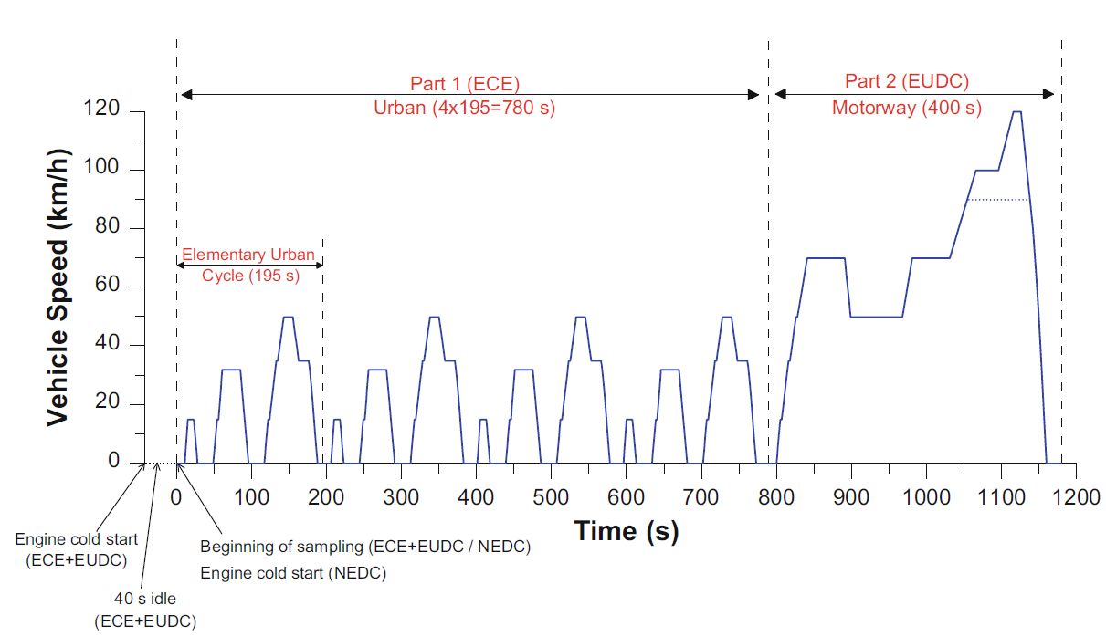
The following data points are excluded from the calculation of the CO2 mass:
1. Cold start (when engine coolant temperature has not yet reached 70 °C)
2. Durations with vehicle speeds under 1 km/h (idle)
3. Durations where the vehicle engine is switched off
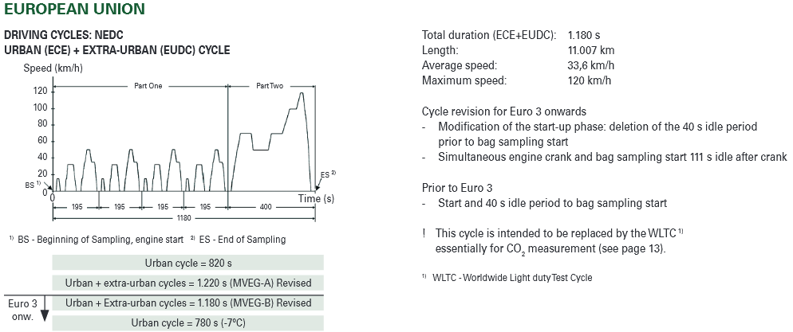
The NEDC can apply to the VW Lupo 2001, which complies with the Euro 3 legislation as can be seen in figure (7) which illustrates the driving cycles briefly for Euro 3. This indicates that the investigation would be suitable for monitoring the emissions according to the NEDC by using the exhaust gas analyser on the rolling road. The change to be seen in the NEDC which enhances the Euro 3 legislation vehicle is the starting phase on the newer urban vehicle which recommends 30 seconds idle on the start-up phase, whereas, on Euro 3 vehicle it is 40 seconds idle (Delphi, 2017)
Figure 7 shows NEDC procedures for EURO 3 URBAN cars
Figure 6 shows the NEDC graph for three phases
The above NEDC cycle is criticised by experts as it does not represent real-life driving conditions. The outcome does not take into consideration the influence of external factors, such as road type and weather or traffic conditions because the tests are conducted in a workshop. For example, accelerations are very soft, many of the cruises are at constant speed, and there are many idle events. This makes it impossible to achieve certifiable values for the use of the vehicle in real driving conditions. Because of this replacement of the current NEDC is being explored by the appropriate branch of European legislators. The primary purpose of the regulations is to match the NOx emissions from vehicles better.

Depending on the driving conditions, NOx emissions can be many times higher than that measured on the test cycle on the rolling road. For example, they can average about 3X higher in rural and urban conditions, and 2X higher in motorway conditions for Euro 5 and Euro 6 (Johnson,2014). Also, it was found in another paper by Merkisz et al that NOx emissions were also higher for on-road testing than NEDC tests (Merkisz, 2010).

It should be noted that through the legislation automakers are allowed up to 50% of the RDE type-approval tests provided these are witnessed by a technical services company. The remainder of the tests must be performed via the approved authorities or their legal representatives (Anon, 2017).

Chapter 4
This chapter relates to the reduction of harmful NOx emissions through implementation of an EGR control system.

4.1 NOx pollutant emissions

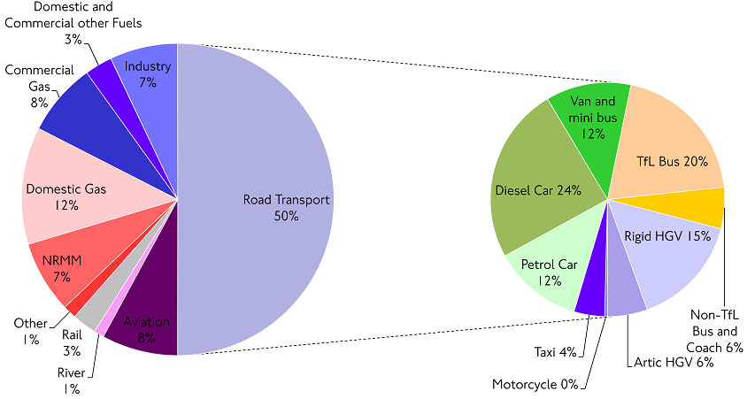
Atmospheric pollution and global warming are amongst the most important environmental issues. Passenger cars emit many different pollutants, some of which are regulated in the European Union (EU) and in almost all countries in the world (Kokkinou, 2009). In the light of the current requirements regarding the reduction of pollutant emissions, manufacturers have developed different methods to meet this requirement. For example, variable valve timing (VVT), variable fuel injection, cold start characteristics, air injection and water injection. The NOx emission target resulted from consideration of the following factors prevalent in California April 1967 (Campau,1971):
When further broken down the road transport NOx pie chart as can be seen in figure (8). Exhaust gas recirculation which provides an important contribution to achieving the development target of low exhaust emission levels on petrol engines as can be seen in Figure (8). The lean operation of SI engines excludes the possibility of using three-way catalysts, so EGR rates as high as possible are required to reduce overall nitrogen oxide emission levels. Resultant from high EGR rates, nitrogen oxides in the untreated exhaust gas are reduced by up to 70%, and air throughput is also significantly reduced. The consequent increase in exhaust gas temperature promotes improved catalytic conversion, thereby further reducing emission levels. In the environment, NOx contributes to the formation of ground-level ozone, which when mixed with water in the atmosphere becomes nitric acid. This nitric acid falls to the ground as acid rain. NOx is, therefore, an environmental hazard, and consequently, tailpipe emissions of NOx are regulated by law (Campau, 1971).
Figure 8 shows the source of NOx
According to the International Institute for Applied Systems Analysis (IIASA) has been reported 5000 deaths annually across the Europe and 425,000 peoples ill across the Europe by NOx (Jonson et al., 2017).
According to a press release by the International Council on Clean Transportation (ICCT) on 15-05-2017, figures (9) shows the NOx global effect on humans which causing the premature deaths attributable to the on-road vehicle. (Anenberg et al., 2017)

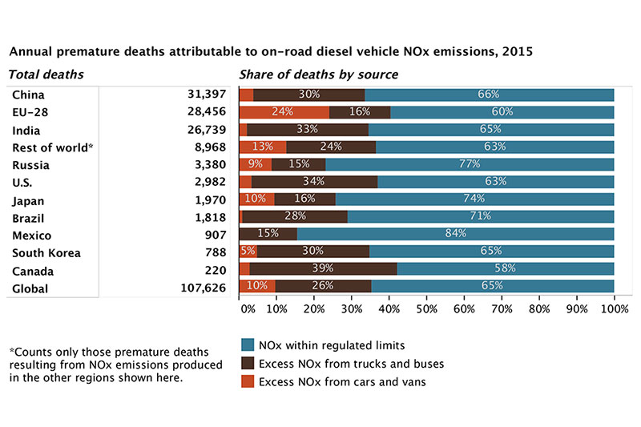
Figure 9 shows the Global annual premature deaths cause by NOx

4.2 Exhaust gas recirculation (EGR)
Since the Clean Air Act of the 1970s, Exhaust Gas Recirculation (EGR) is used to control NOx emissions in every automotive engine currently built (Gordon, 2007). Early EGR systems were only marginally successful in the reduction of tailpipe emissions, but they were responsible for a reduction in propulsion. Even when they worked correctly, they were often unable to satisfy customer complaints regarding surging and stalling. After 30 years of development, EGR systems are now more effective, they rarely fail and are now completely transparent to the driver. If there is light on the dashboard and EGR codes appear on the scan tool an understanding of the strategies behind them can help to pinpoint the real problem. In a spark-ignition engine, in-cylinder NOx formation increases with temperature, combustion pressure and excess air in the air/fuel mixture. An air/fuel mixture that is rich enough to ensure all of the oxygen is used up in combustion would almost eliminate NOx formation. However, a rich mixture increases fuel consumption and also dramatically increases emissions of both hydrocarbon (HC) and carbon monoxide (CO). When the EGR valve should be turned OFF or ON is determined by the control algorithm. During cranking, cold engine temperature (engine warm-up), idling and acceleration the EGR valve is turned OFF (Gordon, 2007). Exhaust gases may be recycled in two different ways, either internally or externally.
Internal EGR uses modified valve timing to allow the exhaust gases to be re-admitted to the cylinder via the exhaust valve. Internal EGR may be introduced very efficiently into an engine, essentially only requiring a modified camshaft. However, the control over EGR flow cannot be fully independent without an infinitely variable valve timing. This factor effectively precludes the use of internal EGR in a fixed-camshaft engine design (Brunt, 1996).
External EGR is the most popular form of implementation in use today. Exhaust gases are piped through a control valve from the exhaust manifold to the intake manifold. The use of a dedicated EGR control valve, therefore, allows fully independent control over the whole operating range of the engine. Furthermore, exhaust gases are allowed to cool to a temperature close to that of the intake charge if a significant length of piping is used, benefiting from the limitation of combustion temperatures.
These systems are difficult to install in the engine, and considerable transport delays result from repairs required by the control valve and the intake system, due to the necessary length of piping (Brunt, 1996).

There are several types of EGR systems depending on the situations where EGR gas is extracted and introduced.
Low-pressure loop EGR (LP-EGR) system: EGR gas is extracted downstream of the turbine and introduced upstream of the compressor.
High-pressure loop EGR (HP-EGR) system: EGR gas is extracted upstream of the turbine and introduced downstream of the compressor and/or throttle valve.
- Mixed-pressure loop EGR (mixed EGR) system: EGR gas is extracted upstream of the turbine and introduced upstream of the compressor (Takaki, 2014),

Chapter 5
This chapter gives detailed information on; the project planning, how this project will take place, details of the engine, the procedures that will be used and information relating to the equipment.

5.1 Project planning
This project planning is based on the effects of exhaust gas recirculation (EGR), which will be tested on the rolling road in the university laboratories. The engine to be tested will be the VW Lupo 1.0 Litre petrol (2001) under Euro 3 emissions regulation. The device are (Exhaust gas analyser) will be used for five gas measurements of exhaust emissions of liquid and gaseous fuels. The exhaust gas drawn from the exhaust will then be analyzed in a flue gas analyzer system for direct reading of CO, CO2, NO, NO2 and hydrocarbon (HC) emissions (Chaudhary, 2017), exhaust gas analyser made by Bosch. Before starting the analysis, the engine temperature needs to be taken. Room temperature will also be noted. Also, the necessary health and safety precautions will be taken to ensure a safe working environment. When satisfied with a safe environment, the VW Lupo will be placed on the rolling road to obtain the reading, which will then be taken at different RPMs and varying loads. This will be done by monitoring tailpipe emissions from the engine of NOx, CO and HC contained in the exhaust. Variations in the exhaust will be recorded at different states of the engine performance, such as cold cranking, warm up, idling and acceleration. The testing will commence with obtaining data with EGR. Once data has been recorded for this state the EGR will be blocked and data obtained for EGR off. The table below (2) shows the data obtained from a small petrol engine with EGR which has been tested to monitor the NOx (Qin et al, 2010). His experiment started at the full throttle operation point of 100% load. He then measured at 75%, 50%, 25% and 0% load. This clearly proved the effects of EGR (Qin et al 2010). The author in this project will adopt a similar experimental method to monitor the NOx from exhaust emissions by applying throttle load using the rolling road at rates of 100%, 50%, 25% and 0% load at between 1000-5000 RPM.
Table 2 EGR data obtain by Qin et al 2010

This project will be based on the similar elements to prove the effects of EGR on and off. The time constraints on this project will require being closely monitored to ensure that the investigation covers sufficient data collection and analysis in the time available to allow for a meaningful study. This will require all paths on the flowchart to be followed in the time allowed for completion of the project. Any test which fails to produce satisfactory data, for whatever reason, will need to be re-run. In the event of equipment failure that cannot be resolved the fall-back position will be theoretical analysis by reference to textbooks. The second test of this session will follow the new Real Driving Emissions (RDE) testing procedures to obtain data tailpipe emissions from VW Lupo with and without EGR.

Chapter 6
This chapter relates to the evaluation of the results obtained and resulting conclusions.

6.1 Conclusion
One of the aims of this project is to review the characteristics of the main pollutant emissions (CO, HC, CO₂, and NOx) from port fuel injection engines. Another aim is to investigate the standards and regulations which relate to the control technologies for these pollutant emissions . Among this pollutant emission, CO and HC are emitted due to incomplete combustion and unburned fuel while NOx emissions are a result of high combustion temperatures.

This project will give the author a greater understanding of emissions gases, in particular, the NOx pollutant emissions, which the author will investigate to ascertain their harmful effects on the environment and human health (Resitoglu, 2014). Further study and validation of EGR control and estimation will be undertaken on a representative test vehicle. The method proposed has been tested on the PFI engine using a dynamometer with a gas analyser and the results should demonstrate a close match between the estimated transient EGR and measured EGR. The idle, partial and high-load operations will be experimentally evaluated for the use of EGR on the PFI engine. That the EGR system will decrease total engine output emissions, as this experiment conducted by Qin et al in 2010 has shown in the table (2) should be confirmed by the experimental data. This paper will show that EGR is an efficient method for reducing NOx levels.

Reference/ Bibliography
Bosch GmbH, Robert Bosch GmbH. Gasoline-Engine Management. 3rd ed. Chichester: John Wiley & sons Ltd, 2006. Print.
Lenz, H.P et al. Emissions, Air Quality And Effects Of Exhaust GAS Constituents. Warrendale: Society of Automotive Engineers, INC, 1993. Print.
Hill, Agric. "Cooling And Lubrication." 2017. Lecture.
Schwaller, A.E., 2005. Total automotive technology, Clifton Park, NY: Thomson/Delmar Learning.
Corolla, David A. Automotive Engineering: Powertrain; Chassis System And Vehicle Body. 1st ed. Burlington: Butterworth-Heinemann, 2009. Print.
Stone, Richard, and Jeffrey K Ball. Automotive Engineering Fundamentals. Warrendale [PA]: SAE International, 2004. Print.
Knowles, D., 1984. Automotive emission control and computer systems, Reston, VA: Reston Pub. Co.
"Worldwide Emissions Standards Passenger Cars And Light Duty." Delphi.com. N.p., 2017. Web. 1 Nov. 2017.
Souza, M.T.D., Vianna, J.N.D.S. & Fraga, A.G., 1998. Study of an Engine Operating with Exhaust Gas Recirculation at Different Compression Ratios. SAE Technical Paper Series.
Bosch, Robert. Automotive Handbook. 9th ed. Cambridge: Bentley Publishers, 2014. Print.
Lenz, H.P et al. Emissions, Air Quality And Effects Of Exhaust GAS Constituents. Warrendale: Society of Automotive Engineers, INC, 1993. Print.
Tabata, M., Yamamoto, T. & Fukube, T., 1995. Improving NOx and Fuel Economy for Mixture Injected SI Engine with EGR. SAE Technical Paper Series
Myers, P.S., 1953. Thermodynamics Of Engines. SAE Technical Paper Series.

Duleep, K.G., 1984. Future Automotive Emission Control Technology and Strategy. SAE Technical Paper Series.

Pritchard, E. & Johnson, R.R., 2005. Hybrid Electric School Bus Technical Feasibility. SAE Technical Paper Series.

Johnson, T., 2016. Vehicular Emissions in Review. SAE International Journal of Engines, 9(2).
Rapolu, G.Y., 2011. Optimization of Exhaust Gas Recirculation System. SAE Technical Paper Series.

Hochkönig, M. & Michael, R., 1992. Cooling System Layout for High-Performance Cars. SAE Technical Paper Series.
Bates, G.J. & Germano, S., 1994. Vehicle Tail Pipe Emissions - A Comparison of Natural Gas and Petrol Injection. SAE Technical Paper Series.
Dimitriou, P., Burke, R., Copeland, C., and Akehurst, S., 2015. Study on the Effects of EGR Supply Configuration on Cylinder-to-Cylinder Dispersion and Engine Performance Using 1D-3D Co-Simulation, SAE Technical Paper.
Kashdan, J.T. & Thirouard, B., 2009. A Comparison of Combustion and Emissions Behaviour in Optical and Metal Single-Cylinder Diesel Engines. SAE International Journal of Engines, 2(1), pp.1857–1872.
Hori, M. et al., 1997. Development of New Selective NOx Reduction Catalyst for Gasoline Leanburn Engines. SAE Technical Paper Series.
Adams, W.H. et al., 1987. Analysis of the Combustion Process of a Spark-ignition Engine with a Variable Compression Ratio. SAE Technical Paper Series.
Kokkinou, T. & Zervas, E., 2009. Comparison Between the Exhaust Emissions of Regulated Pollutants and CO2 and Regulation Limits of European Passenger Cars. SAE Technical Paper Series.
Chaudhari, A.J., Kulkarni, V. & Sahoo, N., 2015. Effect of Variable Compression Ratio and Intake Charge Dilution on Fuel Efficiency and Emission for a Spark Ignition Engine. SAE Technical Paper Series
Wei, L. et al., 2007. Study on the improvement of fuel economy and reduction in emissions for stoichiometric gasoline engines. Applied Thermal Engineering, 27(17-18), pp.2919–2923.
Chen, T. et al., 2011. Continuous Load Adjustment Strategy of a Gasoline HCCI-SI Engine Fully Controlled by Exhaust Gas. SAE Technical Paper Series.
Klein, P., Grüter, R. & Loffeld, O., 2007. Real-Time Estimation of the Exhaust Gas Recirculation Ratio Based on Cylinder Pressure Signals. SAE Technical Paper Series.
Thomas, D. et al., 2017. A Comparison of Tailpipe Gaseous Emissions for RDE and WLTC Using SI Passenger Cars. SAE Technical Paper Series.
Zervas E., Montagne X., Lahaye J. (2003), Emissionof regulated pollutants from a SI engine. Influence of fuel composition and of air/fuel equivalence ratio, Environ. Sci. Technol., 37, 3232-3238.

Vlachos, T.G. et al., 2014. In-Use Emissions Testing with Portable Emissions Measurement Systems (PEMS) in the Current and Future European Vehicle Emissions Legislation: Overview, Underlying Principles and Expected Benefits. SAE International Journal of Commercial Vehicles, 7(1), pp.199–215

Zhao, F.-Q., Lai, M.-C. & Harrington, D.L., 1997. A Review of Mixture Preparation and Combustion Control Strategies for Spark-Ignited Direct-Injection Gasoline Engines. SAE Technical Paper Series
Berry, I.J. & Brunt, M.F.J., 1996. Improved Control of EGR During Speed/Load Transients. SAE Technical Paper Series.
Qin, J. et al., 2010. Study on the Effect of EGR System on the Emissions from a Small Off-road Gasoline Engine. SAE Technical Paper Series
Nakata, K. et al., 2015. Engine Technologies for Achieving 45% Thermal Efficiency of S.I. Engine. SAE International Journal of Engines, 9(1).
Department for Transport, “Vehicle Emissions Testing Programme,” 2016
Zervas, E., 2007. European CO2 change from the increased percentage of diesel passenger cars in the European Union. SAE Technical Paper Series
Primus, R.J. et al., 1984. An appraisal of advanced engine concepts using second law analysis techniques. SAE Technical Paper Series.
Li, H. et al., 2008. Investigation of Regulated and Non-Regulated Cold Start Emissions using an EURO3 SI Car as a Probe Vehicle under Real World Urban Driving Conditions. SAE Technical Paper Series.
Przybyla, G. et al., 2013. Real World Diesel Engine Greenhouse Gas Emissions for Diesel Fuel and B100. SAE Technical Paper Series.

"In Service Emissions Performance Of Euro 6/VI Vehicles.." Content.tfl.gov.uk. N.p., 2017. Web. 1 Nov. 2017.
Nicolas, R. (2013). The different driving cycles. [online] Car Engineer. Available at: http://www.car-engineer.com/the-different-driving-cycles/ [Accessed 1 Nov. 2017]..
Merkisz, J, and P Fuc. The Comparison Of The Emissions From Light-Duty Vehicle In On-Road And NEDC Tests. SAE International, 2010. Web. 7 Nov. 2017.
Gordon, Jacques, 2007. EXHAUST GAS RECIRCULATION. Motor Age, 126(10), pp.70–77.
Anon, 1995. Lean Burn Versus EGR S. I. Engine. Lean Burn Versus EGR S. I. Engine, pp.Future Transportation Technology Conference & Exposition, 01 August 1995.

Blank, H. et al., 2002. EGR and Air Management for Direct Injection Gasoline Engines. SAE Technical Paper Series.

Campau, R.M., 1971. Low Emission Concept Vehicles. SAE Technical Paper Series
Darlington, T.L. & Kahlbaum, D., 2008. Evaluation of California Greenhouse Gas Standards and Federal Energy Independence and Security Act - Part 2: CO2 and GHG Impacts. SAE Technical Paper Series.
Gov, 2017. 2015 UK GREENHOUSE GAS EMISSIONS, FINAL FIGURES. https://www.gov.uk/government/uploads/system/uploads/attachment_data/file/604350/2015_Final_Emissions_statistics.pdf. Available at Gov.uk.
Siokos, K. et al., 2016. Physics-Based Exhaust Pressure and Temperature Estimation for Low-Pressure EGR Control in Turbocharged Gasoline Engines. SAE Technical Paper Series.
Reşitoğlu, I.A., Altinişik, K. & Keskin, A., 2014. The pollutant emissions from diesel-engine vehicles and exhaust aftertreatment systems. Clean Technologies and Environmental Policy, 17(1), pp.15–27.
Serrano, J.R. et al., 2005. Global Analysis of the EGR Circuit in an HSDI Diesel Engine in Transient Operation. SAE Technical Paper Series.
Anenberg, S., Miller, J., Minjares, R., Du, L., Henze, D., Lacey, F., Malley, C., Emberson, L., Franco, V., Klimont, Z. and Heyes, C. (2017). A new study quantifies global health, environmental impacts of excess nitrogen oxide emissions from diesel vehicles. [online] Theicct.org. Available at: http://www.theicct.org/news/nature-impacts-diesel-nox-may2017 [Accessed 17 Nov. 2017].

.

