Assessment 1
Question 1
a. 1.465
b. 2.18
c. 3.975
d. 0.82
e. 1.505
Question 2
- 51.85m
- 52.07m
- 50.35m
- 50.43m
- 1.595m
- 1.595m
- 50.53m
- 51.38m
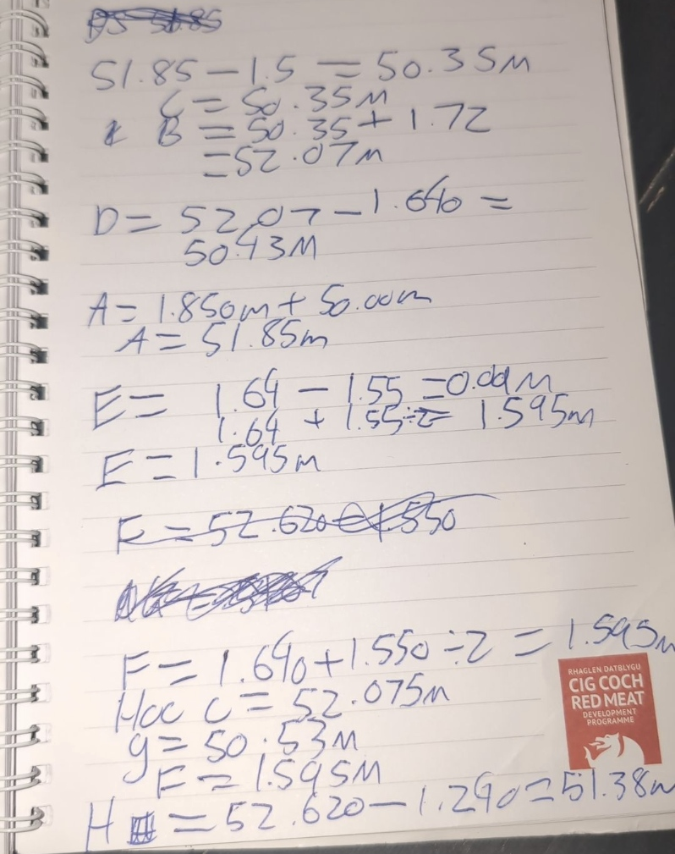
Question 3
Area = 36918.84m
Perimeter = 747.63m

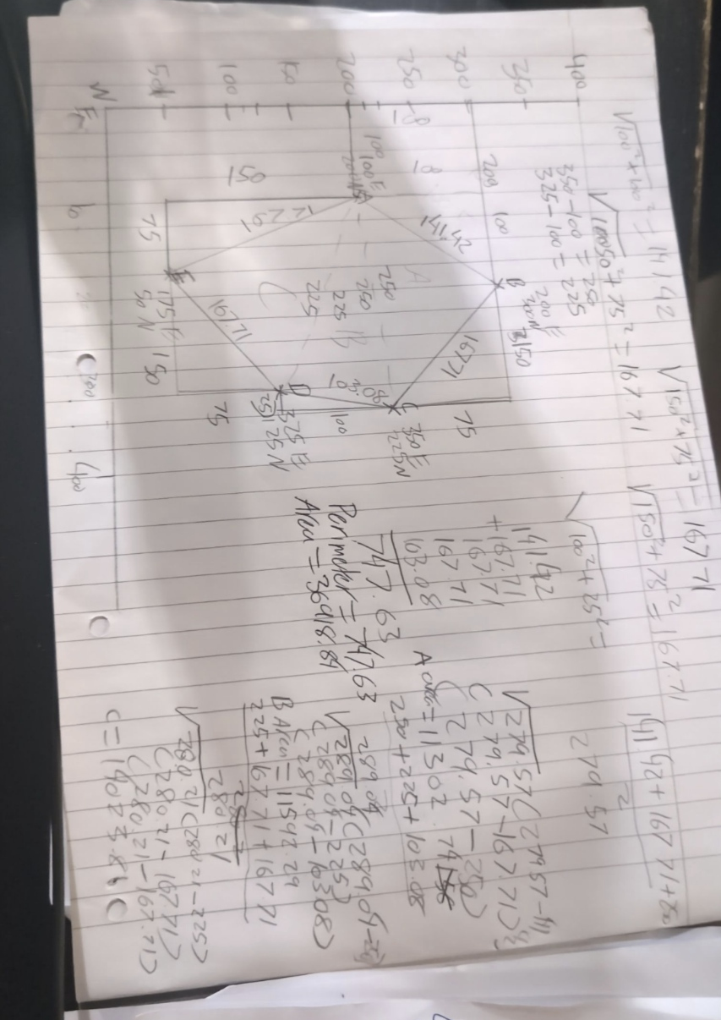
Question 4
- 2.18m
- 1.55m
- 1.02m

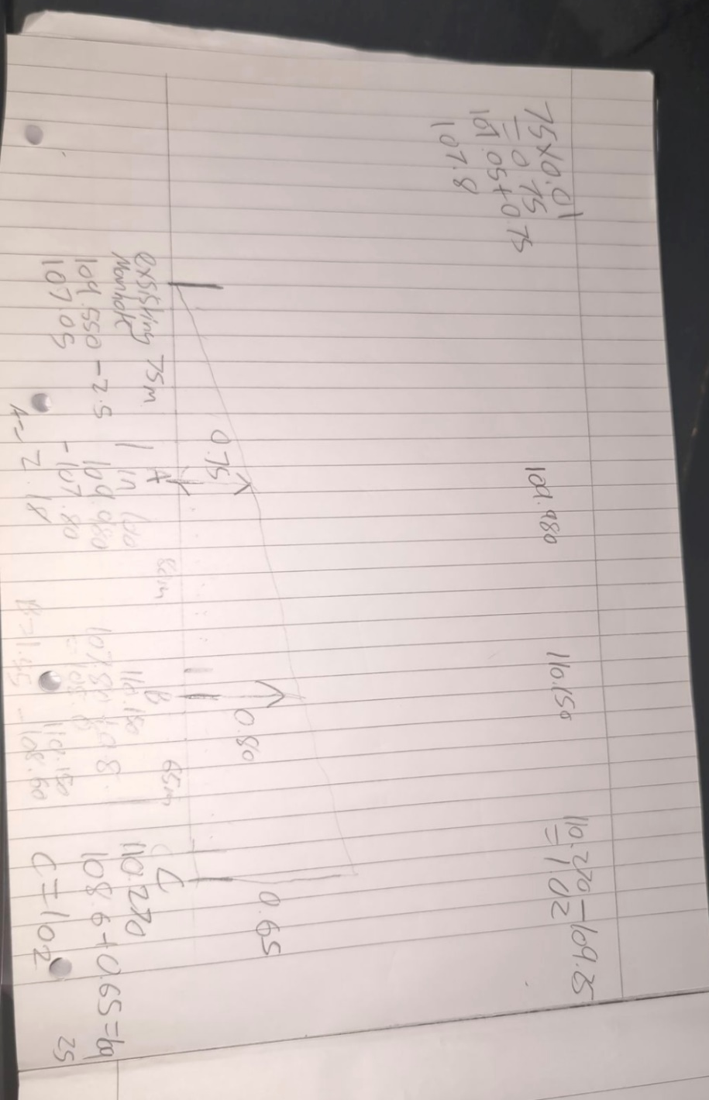

Question 5, A total station is used to measure, angle measurements, distances, coordinate measurements and data processing. It works by sending out a laser beam which reflects off the mark measuring distance to the target and angle of reflection. Once this information is obtained the built in computer calculates the coordinates of the target. It consist of a tripod, prism, detail pole and Total station.

