
Name: | Kuah Chee Kin, Rampavin and Kausyigan
Student ID: | 23010002 (Kuah Chee Kin)  22090051 (Rampavin)  (22090051) (Kausyigan)
Subject: | Dual Awards Studies
Lecturer: | Dr. Emma Roberts
Submission Date: | 5th September 2024 (Thursday)

Kuah Chee Kin’s Work
Section 2
My group’s task is to do a presentation about the significance of the global team in effective problem solving where each person in the group has to prepare slides which are two minutes’ worth of presentation time, including the introduction as well as conclusion slides of this entire slideshow. Pictures are encouraged to be included in the slides to contribute in this section of the assignment where the style of wording of the content can be in bullet pointed form, yet has to be scholarly conceptual. There is no word limit as this are just slides with text and images.
There are three students in my group and the order of our slideshow begins by introducing the first five slides, followed by the second three slides and concluding our project are the last three. The summary of the whole exhibition talks about how important multinational groups are in critical thinking and the conclusion is global teams amplify the ability to solve predicaments and decision-making through various outlooks from different individuals of multiple backgrounds. With the assistance of machinery, group circles can remain alert and even adapt to disparate challenges.
The summary of my two minutes of the whole presentation with relatable subject matters in my slides is mainly the introduction of said topic followed by the very own wickedness of everyday difficulties themselves with solutions to interpret them. There is especially the functions of creative problem-solving to research, suggest and appraise results to several, typical predicaments. Lastly, there is content on structures and approaches mentioning about choice-making, showing one of the examples of it.
The summary of the second segment identifies personal differences and feelings in settling disputes, mediates in cooperation and thinks considerately to find answers. The substance in the first five slides associates with my teammate’s slides where the situation possesses multiple solutions to one problem and people must decide which one is implement without arguing. Another teammate’s ideas concentrate on how morals determine answers, combined decision-making and the conclusion. How his and my ideas link each other are where only upright solutions are discussed and evaluated in the presence of wicked problems.
The method on how my own content contributes to the overall group conclusions focuses on what is the particular circumstance even about, not to mention, the features included in said problem to and analyze and utilize as hints. There are also countless ways to think of interpretations during the midst of a deadlock, alongside assessing the most feasible option among the many alternatives laid out.
My contribution to the key ideas in the presentation is primarily about finding relatable results from reliable sources based on the subject of the assignment and providing the platform required for the rest of my team to complete their divisions of the slideshow, even if we are far apart. I even lead by example where I only put the main points of in the correct format whereas my groupmates refer and follow the arrangement of said content. Sometimes, I check, adjust our slides several times and add images to make it look neat as well as presentable to look at.

Section 3
My group’s task is to present a slideshow on the noteworthiness of worldwide group circles in effectual critical thinking where every member in the group needs to think of and make slides that are two minutes’ worth to showcase, not to mention, the introduction followed by conclusion slides of this entire slideshow. Pictures are encouraged to be added in the slides to support in this segment of the project where the formation of wording of the text can be in bullet pointes, however must be notional. There is no word limit as this are only slides with content and images.
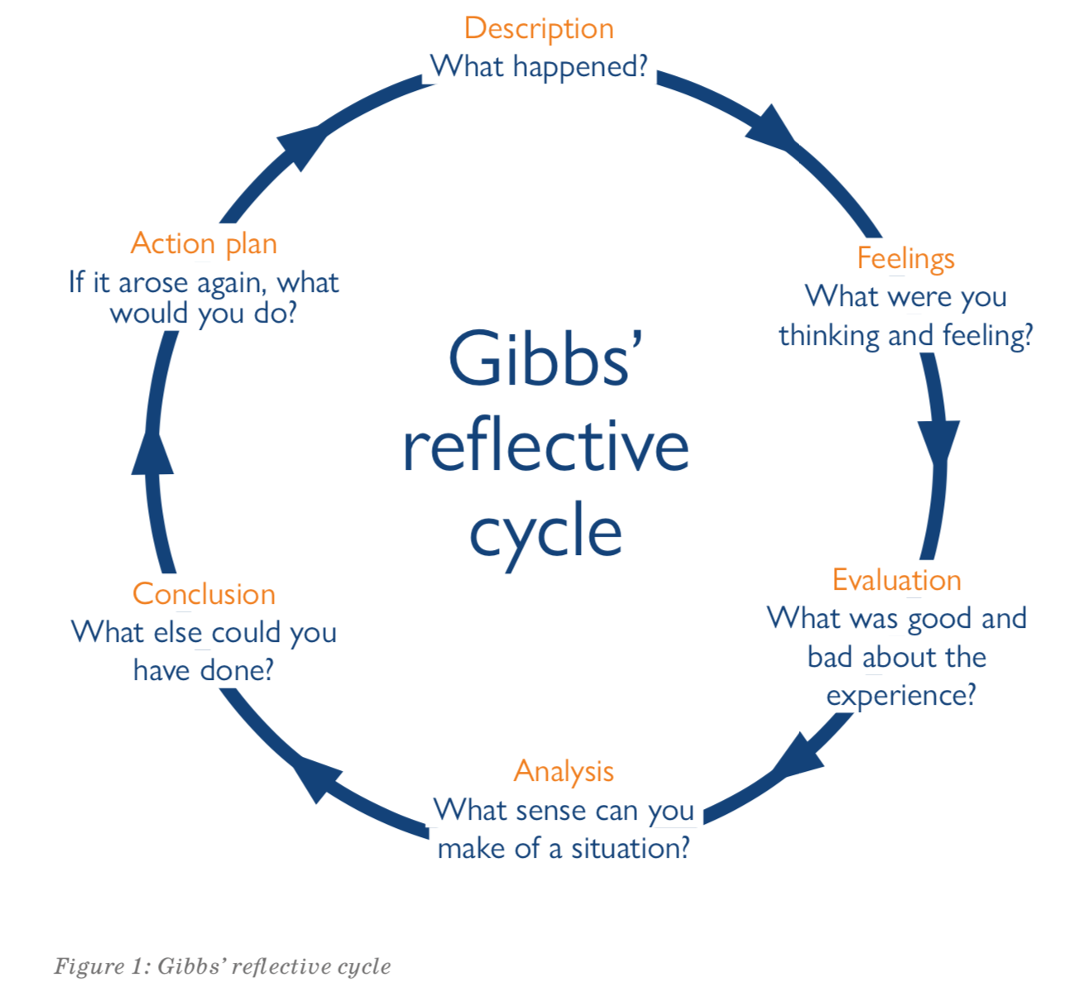
A Gibbs’ reflective cycle operates in an endless rotation judging by the name and has six stages, which are the action plan to counter the problem, the description containing the characteristics of said problem with the emotional expressions and thoughts of solving the predicament in front. There is even the assessment about the experience when tackling the issue as well as what is being investigated during the current situation ahead. Lastly, the conclusion to summarize the cycle’s first five topics.
My teammates and I discussed over a group chat in the night, consulting about the details of the assignment such as the submission date, mechanics of the presentation followed by allocating the right subtopics to the suitable members of the team to do. Once we agreed who does what to contribute in the project, all that is left to do and record our own individual parts of the online video presentation, alongside combining the separate clips into a whole recording. My own learning regarding the group project section is that it is actually not that easy of being able to lead a team where it needs to operate properly in order to ensure everything and everyone stays on track, not to procrastinate or execute the assignment in a haphazard manner. It is even not that simple where one of the group members does their task, but does not follow instructions and has to redo their part from scratch as well.
In critical thinking on how to do our presentation, Canva is choses from past experiences as it possessed slideshow editing and video recording features. To influence my teammates to do their tasks, I led by example by typing my content according to instructions in the rubrics and added images when necessary. In conflict management, I either spoke up first or let my group members have their say and go along with it to avoid disputes and to decide which subtopics each person does, I took on the first four subtopics, another member with the second three and the third member with the last three.
In conclusion, despite the downsides of group leading and working together, the benefit is that it is not so bad once in a while to segregate one large assignment into smaller pieces of work for each member to accomplish. It makes it easier to achieve a vast project with many hands to pitch in and help.

Rampavin’s Work
Section 2
The group was tasked with delivering a presentation on the importance of global teams in problem-solving, focusing on wicked problems, design thinking, decision-making frameworks, emotional intelligence, diplomacy, interdisciplinary thinking, ethics, and collective decision-making. Each member contributed a two-minute section, demonstrating how these elements can be used to address complex issues. This discussion will analyze the presentation structure, contributions, and how each section interrelates to the overall conclusions.
The group comprised three members who sequentially presented their respective findings. The presentation commenced with an overview of the theoretical framework underpinning conflict management, emphasizing the multifaceted nature of conflict and the importance of adopting a holistic approach. The subsequent sections delved into the specific themes outlined above.
The members' two-minute segment concentrated on the role of individual differences in conflict resolution. By examining personality traits, cultural backgrounds, and communication styles, it was argued that tailoring conflict management strategies to these variables is crucial for effective outcomes. This section laid the foundation for understanding the complexities involved in managing conflict within diverse groups.
The following presentations built upon this foundation. One group member delved into the concept of emotional intelligence, highlighting its significance in recognizing and managing emotions during conflict. Their analysis demonstrated how emotional intelligence can be leveraged to de-escalate tensions, foster constructive dialogue, and build empathy among conflicting parties. Another member focused on the intricacies of diplomacy, persuasion, and negotiation, emphasizing the importance of these skills in reaching mutually beneficial agreements.
Their presentation offered practical strategies for building rapport, communicating effectively, and finding common ground while maintaining respectful and productive interactions. The final presentation delved into the benefits of interdisciplinary thinking, showcasing how insights from various fields can be integrated to develop innovative conflict resolution approaches. For instance, the presentation explored how psychology, sociology, and law can be combined to create holistic solutions that address the root causes of conflict and promote long-term peacebuilding.
The member’s emphasis on individual differences provided a contextual framework for understanding the subsequent discussions. By recognizing the diverse perspectives within the group, it became evident that effective conflict management requires a nuanced approach that accommodates individual needs and preferences, while also fostering a shared understanding of common goals. Moreover, the member’s contribution aligned with the overall conclusion that a combination of emotional intelligence, diplomacy, and interdisciplinary thinking is essential for navigating complex conflict situations.

The collaborative study on conflict management emphasizes the significance of considering individual differences, emotional intelligence, diplomacy, persuasion, negotiation, and interdisciplinary thinking. The member's focus on individual differences helped shape the group's understanding of conflict and contributed to the development of a more nuanced approach. This integrated approach allowed the group to explore the complex interplay between these factors and develop a comprehensive framework for conflict management. The member's contribution was crucial in achieving the group's goal of identifying key strategies for addressing conflict in a diverse and interconnected world.

Section 3
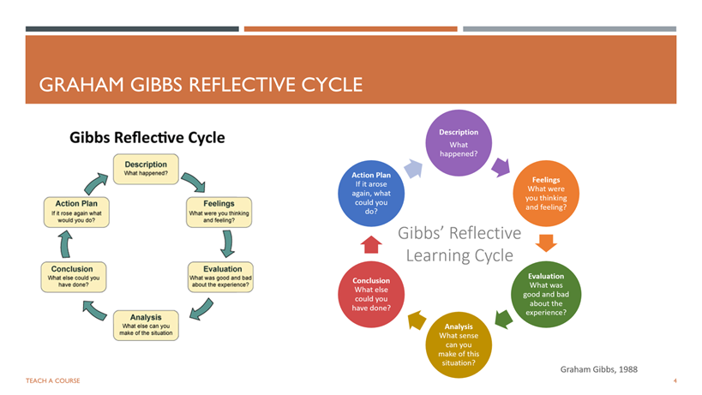
The Gibbs Reflective Cycle is a structured learning process consisting of six stages: description, feelings, evaluation, analysis, conclusion, and action plan. It helps individuals gain insights, identify growth areas, and develop strategies for future endeavors. This reflection will apply the Gibbs Reflective Cycle to a group project, focusing on collaborative working, critical thinking, influencing, conflict management, and decision-making.
The group project involved three individuals with diverse academic backgrounds and skill sets, analyzing a specific topic. They established clear goals, defined roles, and developed a timeline. Each member took ownership of specific research areas, with regular checkpoints and discussions to align with the project objectives. Collaborative tools like Google Docs and Microsoft were used for information sharing and progress tracking.
The project involved a complex interplay of emotions, including initial enthusiasm, challenges, camaraderie, accomplishment, and satisfaction. It highlighted the importance of effective conflict resolution and continuous adaptation to evolving challenges. The project also induced cognitive responses, such as introspection and self-doubt, due to the dynamic interplay of personalities and working styles.
Navigating these complexities required adaptability, empathy, and assertiveness. The project also triggered a sense of responsibility, as each team member's contribution was essential to the project's success. This interdependence fostered a strong commitment to the shared goal, motivating the team to push beyond their comfort zones. The project underscored the need for adaptability, empathy, and assertiveness in navigating complex challenges.
The project faced challenges in achieving objectives, including equitable workload distribution and timely deliverable completion. Despite these, the team successfully achieved core objectives through effective communication, time management, and leveraging each member's unique strengths. Open communication helped build trust and was a valuable learning experience, emphasizing the importance of teamwork and communication.
The project's success was attributed to efficient communication, time management, and team collaboration. Balancing workloads and maintaining fair contributions was challenging. Open communication, openness, and consensus-building were key. Active listening, constructive criticism, and effective conflict management techniques were essential for fostering a collaborative environment and improving the project's quality.
The project highlights the importance of collaborative learning, highlighting the need for effective communication, mutual respect, and shared responsibility. Building trust among team members is crucial for open communication, shared decision-making, and collective ownership. Effective conflict management and resolution are essential for maintaining a positive team dynamic.
Critical thinking and problem-solving are also crucial for generating innovative solutions and making informed decisions. Time management and organization are essential for meeting deadlines and achieving a healthy work-life balance. The project provides valuable insights for personal and professional growth, emphasizing the complexities of teamwork and the need for trust, communication, and conflict management skills.
The member plans to prioritize early communication, clear expectations, and time management strategies in future collaborative projects. They aim to create a supportive and inclusive team environment, continuously developing active listening and conflict resolution skills. To enhance collaboration effectiveness, the member will seek opportunities to develop leadership and facilitation skills, delegating tasks efficiently, and navigating disagreements.
They will also seek training in conflict resolution and mediation to find common ground within the team. The member will cultivate a growth mindset, viewing setbacks as learning opportunities, fostering a culture of continuous improvement and innovation. This mindset will build resilience and a positive team dynamic.
The member will also prioritize the development of strong interpersonal skills, such as empathy, active listening, and emotional intelligence, to foster trust, respect, and collaboration. By doing so, the member aims to become a more effective and influential team member.

Kausyigan’s Work
Section 2
My group's goal is to give a presentation regarding the importance of the global team in effective issue solving, and each member of the group is responsible for preparing slides that will last two minutes, including the introduction and conclusion slides. Pictures are advised to be incorporated on the slides to help with this section of the project, where the content can be worded in bullet point form but must be scholarly conceptual. There is no word restriction because these are basically slides including text and photos.
My group consists of three students: me, Kuah Chee Kin, and Rampavin. The order of our slideshow is as follows: I introduce the first five slides, Rampavin follows with the next three, and Kausyigan finishes with the final three. The conclusion of the entire show discusses how vital multinational organizations are in critical thinking. The summary of my two minutes of the whole presentation is about thoughts focus on how morals influence answers, as of the role ethics in identifying solutions, decision-making, and conclusion about the significance of the global team in effective problem solving.
The summary of Kuah Chee Kin’s section is basically about the introduction of the topic, where the functions of creative problem-solving are particularly important in researching, suggesting, and evaluating solutions. It even results in a variety of common problems and also literature on structures and techniques that mentions choice-making. The summary of Rampavin's section analyzes human differences and emotions in resolving disputes, mediates in collaboration, and thinks carefully to discover solutions. The content of my slides corresponds to Rampavin's, in which the circumstance contains numerous solutions to a single problem and people must determine which one to apply without debating.
The approach I take to show how my personal work adds to the group's overall conclusions is on identifying the specific situation at hand as well as the elements of the problem that I examine, evaluate, and apply as guidance. In a deadlock, there are a plethora of ways to come up with interpretations in addition to determining which of the numerous options presented is the most practical. My contribution to the presentation's key ideas is primarily about finding relatable results from credible sources based on the subject of the assignment
It is especially about providing the platform needed for the rest of my team to complete their slideshow divisions, even if we are geographically separated. This integrated approach enabled the group to investigate the complicated interplay of various variables and create a comprehensive framework for conflict resolution. The member's input was critical in helping the group achieve its goal of finding key conflict-resolution solutions in a varied and interconnected environment.

Section 3
My group's task is to present a slideshow on the importance of global group circles in effective critical thinking, in which each member of the group must think of and create two-minute-long slides to showcase, as well as the introduction and conclusion slides of the entire slideshow. Pictures are advised to be included in the slides to help with this section of the assignment, where the wording of the text can be in bullet points but must be hypothetical. There is no word limit because these are merely slides containing material and graphics.
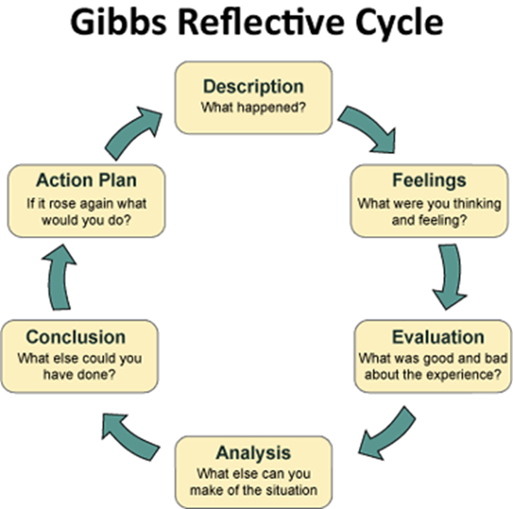

According to the name, a Gibbs' reflective cycle functions in an endless rotation and comprises six stages, which include an action plan to counter the problem, a description of the situation's characteristics, emotional expressions, and thoughts about how to solve the predicament at hand. There is even an appraisal of the experience gained when addressing the issue, as well as what is being investigated in the current scenario. Finally, the conclusion summarizes the cycle's initial five subjects.
The project experienced obstacles in meeting its objectives, such as equal workload sharing and timely deliverable completion. Despite this, the team met its key objectives through good communication, time management, and exploiting each member's individual abilities. Open communication fostered trust and provided a tremendous learning experience, emphasizing the value of teamwork and communication.

The achievement of the task was due to effective communication, time management, and teamwork. Balancing responsibilities and ensuring equitable contributions was difficult. Open communication, openness, and consensus building were essential. Active listening, constructive criticism, and effective conflict resolution skills were critical for creating a collaborative environment and boosting project quality.
The project emphasizes the value of collaborative learning by emphasizing good communication, mutual respect, and shared accountability. Building trust among team members is essential for open communication, collaborative decision-making, and collective ownership. Effective conflict management and resolution are critical to sustaining a positive team environment.
Critical thinking and problem-solving skills are also essential for developing innovative ideas and making sound decisions. Time management and organization are critical for managing deadlines and maintaining a healthy work-life balance. The project offers useful insights for personal and professional development, emphasizing the intricacies of teamwork and the importance of trust, communication, and conflict resolution skills.
Our groupmates intend to prioritize early communication, clear expectations, and time management tactics in future joint initiatives. We strive to foster a friendly and inclusive team atmosphere while continually honing active listening and dispute resolution abilities. To improve collaboration effectiveness, we will look for ways to improve leadership and facilitation abilities, delegate duties more efficiently, and navigate conflicts.
We will also seek conflict resolution and mediation training to help the team establish common ground. My groupmates and I will adopt a growth attitude, viewing setbacks as learning opportunities and encouraging a culture of continual progress and innovation. This approach will increase resilience and foster a positive team environment.
We will also prioritize the development of strong interpersonal skills, such as empathy, active listening, and emotional intelligence, in order to create trust, respect, and cooperation. By doing so, my group hopes to become a more successful and influential team member.

Group Presentation Youtube Link
https://youtu.be/340CF-OZIMY

