Learning in the Digital Era ACCA 4025
Assignment 1 – ePortfolio
Lecturer: James Williams
Due Date: 6th December 2020
Martin Darzins Student ID: 1909722
BSc Applied Computing

Table of Contents

Please note that Units 1 to 4 are all included within the Wix ePortfolio.
https://wix.to/v8AJDFs

The ePortfolio, under heading Learning in the Digital Era, contains the 4(four) units for;
Unit 1 – Written Summary (PDF document)
Unit 2 – Mind Map (MindMaster)
Unit 3 – Video Presentation (PowerPoint)
Unit 4 – A3 Academic Poster (PDF document)

Please note:
Due to upload and (possible payment requirements) the MindMaster Mind Map for Unit 2, would not allow access to the embedded notes. A further PDF document is included, beneath main Unit 2 link, to show notes.

ePortfolio - Homepage

Please note that Units 1 to 4 are all included within the Wix ePortfolio.
https://wix.to/v8AJDFs



Unit 1 – Written Summary (PDF document)

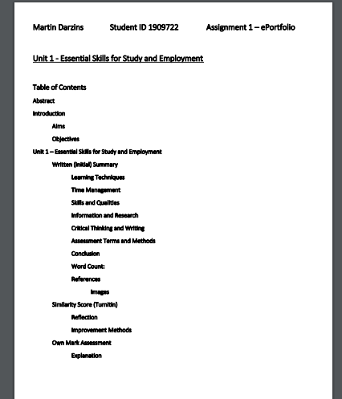
Unit 2 – Mind Map (MindMaster)

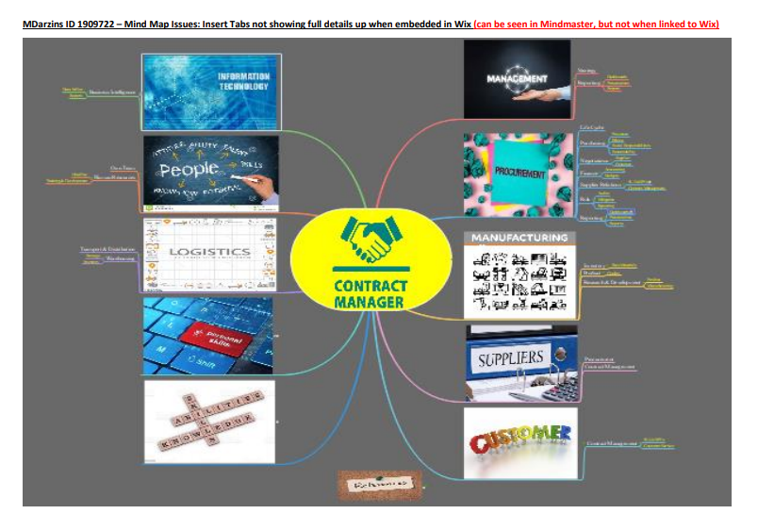
Unit 3 – Video Presentation (PowerPoint)


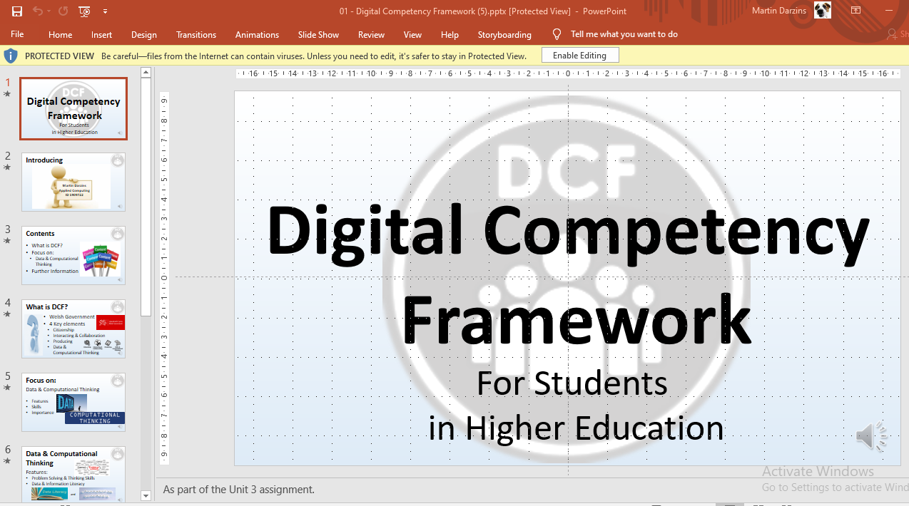
Unit 4 – A3 Academic Poster (PDF document)



