Awe and Wonder- science, mathematics and the outdoors portfolio

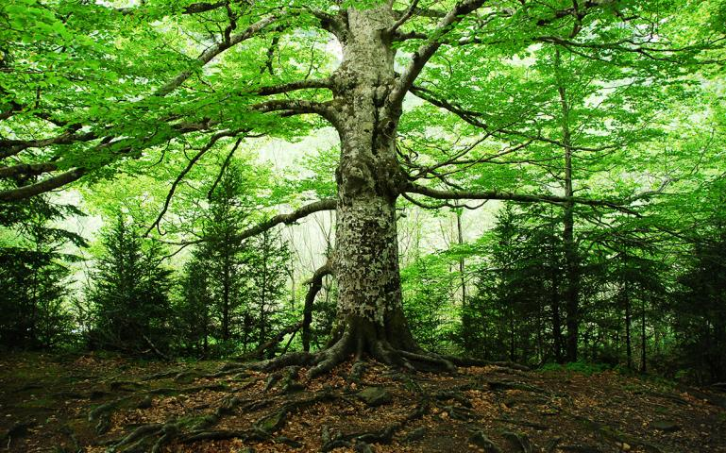
(Image by Clemares 2020)

Part 1

The above photo is a picture of a longstanding tree in the middle of a forest. There are a number of features in this photo, which could benefit children’s science and mathematical skills outdoors however the three main features to focus on in this portfolio are the tree itself, the loose parts on the ground and the different colours.

Feature 1 – The tree in the middle.

The tree consists of multiple difference shapes. Gifford (2020) suggests a focus on shape and space will provide a more understandable route to mathematics for some children, as appose to focusing mainly on numbers. Gifford (2020) states shapes are everywhere in day-to-day life, and in the picture above there are a number of different shapes and angles that children can explore.

The tree in the middle of the picture has a great depth and is a solid surface, meaning the children are unable to move the object which will change their way of playing as rather than being able to move things around they will have to use their imagination and move themselves conducting free play. They can explore the height, width, depth and circumference of the tree using their fine motor skills and this way their mathematic and scientific skills will develop freely.

According to the Welsh Government (2015) during the early years, play forms an important part in the development of mathematics and numeracy. It is thought that enabling children to solve problems, explore ideas, establish connections, and collaborate with others will improve their mathematical skills and enable them to develop skills such as problem solving.

The tree in the picture also includes several different branches all shapes and sizes, which children could explore. They could put their mathematical skills to the test by counting the amount branches there are or assessing the length of the branches both of which will encourage the children to count and enhance their mathematical skills.

McMillan (2019) states sticks and branches can quickly become a treasured possession for children during outdoor play as they often use their imagination to make magic wands or unicorn horns or anything that comes to mind which teaches them measurements. McMillan (2019) also states that children love muddy puddles and practitioners should generally encourage them to play in them as much as possible.
However, there are some occasions where a puddle may be too deep for children to safely splash in them and in order to determine whether puddles are safe to jump in, practitioners may encourage children to first use a stick or a small branch to test the depth of the water. This provides children with the opportunity to learn about risk assessment and measurement simultaneously.

Feature 2 – Loose parts on the ground.

Loose parts play an important role in the development of mathematically and scientific skills. From the sticks on the ground, to the t leaves both on the ground and hanging off the tree, children have plenty of objects to work with in the photo above which they can develop their skills. Gifford (2020) suggest that one of the early steps in understanding numbers and letters is to recognise their shapes which children will develop over time when given the opportunity to play outdoors and use free play as their main objective.

The Welsh Government (2015) suggests using mathematics requires strategic capability in the use of demonstrating, and children will develop resilience, as well as a sense of achievement and enjoyment as they overcome the challenges involved when carrying out activities in the outdoors using natural loose parts. Furthermore, The Welsh Government (2015) states mathematical activities outdoors such as measuring loose parts, assessing the weight or depth, or identifying colours teaches children not to be afraid of tackling complex problems, as they can be reduced to a progression of simpler problems.

The picture above shows a number of loose parts such as the sticks where children can attempt to measure the sticks. A good activity used by The Welsh Government (2015) suggests gathering a number of sticks together and lining them up in size order. This will encourage the children to firstly, count the number of sticks they have, secondly, measure to see which is the smallest and which is the biggest, and thirdly the practitioners will be give the opportunity to ask open ended questions to the children regarding their findings to open their minds to the task and encourage them to enhance their mathematics and science skills. The Welsh Government (2015) suggests that as children reflect on the approaches they used, and on their own mathematics and numeracy learning, they will develop metacognitive skills, which can help them identify steps to take to improve performance. Through this they can become ambitious, capable learners and will be ready to learn throughout their lives.

Feature 3 – Different leaves and colours.

In the picture above, there are several different colours to be identified as well as different shades and tones of one colour. Little Starlings (2020) states colour recognition is a key cognitive developmental step for children, as it plays an important role in object recognition and is a vital part in helping children to develop their descriptive language skills, which encourages clear communication and understanding as they grow up.

In the picture the children will find different shapes, life cycles and shades of leaves in which they can collect and make decisions as to what part of their life they are at. For example, in the picture below is an example of six leaves that can be found in the forest. Each leaf represents a particular part of its life. On the left the leaf has freshly fallen off the tree and is still healthy, and then the leaf on the right is at the end of its time. The leaves in between represent the process of the life cycle. If children learn to identify this using their scientific skills, they can apply it to many different aspects of life as they grow up.
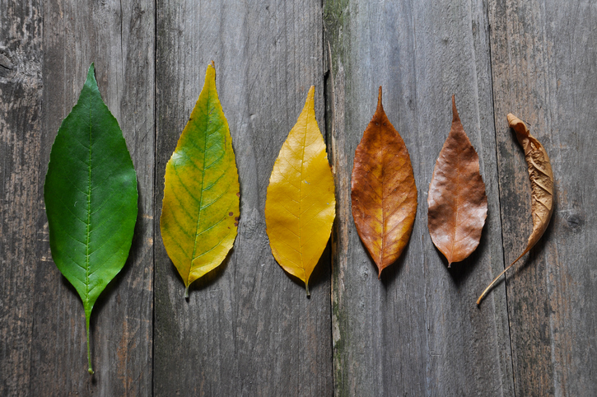
The Welsh Government (2015) supports this within the new curriculum and encourages children to build on their concepts and ideas, which will deepen their knowledge and allow them to experience increasingly complex mathematical and scientific ideas. The Welsh Government (2015) continues and states that by learners finding examples it will deepen their understanding and allow them to find connections between different representations which agrees with the idea of the children learning about the life cycle of a leaf will help them understand a lifecycle in general. As well as the different leaves, there is also many different plants in which are different shapes, sizes and colours which the children can explore and learn about.
Ivan (no date)

The idea of loose parts for children can be presented in the picture above as there is a number of options for children to put their mind to practice using the loose parts on the ground. Nicholson (1971) states the theory of loose parts is an opportunity for children to express creativity through use of materials that can be manipulated, transformed, and created through self-guided play such as leaves, sticks, mud, water, branches and stones. Ginsburg (2007) suggest this type of outdoor free play allows children to lead their own inquiry, show creativity, and demonstrate understanding of various cognitive, social, and emotional skills.

Risk Assessment
Part 2

ACTIVITY | How will young people BENEFIT from this activity? | Hazards and risks | Who is at risk? | PRECAUTIONS in place to reduce the risk of injury | Overall risk RATING: L/M/H
Climbing Trees | Being off the ground provides children with the opportunity to challenge themselves whilst having fun and exercise. Climbing trees brings children into close contact with nature and some children will find being in trees calms them. Climbing trees also stimulates the senses. For some children they will have a sense of being allowed to do something new which is often forbidden to them.  Climbing trees encourages children to think ahead while navigating from branch to branch. Determining the best path to take up, and then subsequently the safest way to climb down, develops both critical thinking and problem-solving skills. | The first risk would be falling or slipping from heights causing back, head, internal injury, bruising or broken limbs,  Secondly, too many children in one tree. Thirdly, Child standing on another child’s fingers climbing below – crush injuries, increased chances of falls  Lastly, a child getting stuck – panic and then an accident such as falling out of the tree and getting injured. | The children climbing the tree and any children stood below the tree. | Adult’s alert and supervising activity – wind changes, cracking, presence of wildlife, ongoing observations of children  Children only climb where they can climb up and down unaided. No ‘bunk ups’ or climbing aids such as ropes. Adults will spot.  Respect children’s self-imposed limits on how high they want to climb. | High
Playing with sticks | Playing with sticks ignites children’s' imaginations because they are such a great open-ended play item – and allows children to express themselves freely. Sticks also have therapeutic benefits. Branches and long sticks can build strength and muscles as children lift, drag or carry them from place to place. | Some hazards presented with children playing with sticks may include then play fighting or using them as swords, throwing them at one another which could potentially injure themselves or others running with the sticks can be dangerous as the children may fall. | The children themselves, other children around them and potentially the practitioners. | It is important that adults supervise when the children are playing with sticks as well as ensure the children are not in possession of any sharp sticks that would increase the risk of any injury. Lastly the practitioners must educate children on how to play safely with the sticks whilst also enabling them to conduct free play. | Medium
Leaves all over the ground | Along with sensory benefits, leaf play provides opportunities for language development, fine motor development, and creative dramatic play. By the children identifying the leaves all of the ground, they can use different skills such as counting and color recognition to benefit their overall mathematical and scientific skills. | There are several risks associated with the fallen leaves on the ground. Often, fallen leaves can become slippering and therefore a risk of the children slipping and hurting themselves is presented. Furthermore, in large piles of leaves, sometimes there may be hidden objects such as sharp rocks or sticks which if the child falls into the leaves or jumps into them, they may get injured. | The children | Practitioners must educate the children so they are aware the leaves may be slippy and they can also tell the children they must not jump into any piles of leaves. The practitioners should keep close supervision on the children to reduce the risk. | Medium
Branches on the floor coming from the tree | The branches on the floor coming from the bottom of the tree will benefit the children’s fine motor skills as they will have to think about where they are always stepping. They can conduct activities around the branches such as counting how many there are in one space, measuring the length of them or measuring the width. These activities will benefit the children’s mathematical skills as they will be doing math’s during their play. | The hazards and risks associated include the children tripping over the branches where they may injure themselves. | The children who are playing near the tree | The practitioners may decide due to the age of the children that it is best for them to not play too close to the base of the tree to limit the risk of them tripping over the branches. On the other hand, the practitioners could warn the children of the risk of tripping over which will encourage the children to think methodically and not run around too close the branches on the floor. | Low

Different insects and bugs | In the photo, there will be many insects hiding and living within the leaves, ground, and trees and during the activity children will discover a range of insects. The benefits of this would be children can learn about appreciating nature and that some of the environments may be home to insects. It will also make children braver in the outdoor as they will understand what they will be presented with. Another benefit would be that all insects have different appearances for example spiders has 8 legs, worms don’t have any legs at all. This will encourage the children to use their mathematical skills to count the number of legs an insect has and then they will be able to user their scientific skills to understand why the insects all look differently. | Some hazards may include the children being frightened or startled with may encourage them to run away where they may trip or fall and injure themselves. Another risk may be that some insects are not harmless such as ants, they will bite if presented on the skin and therefore this will present a risk to the children. Following this, insects such as bees or wasp sting and therefore they may be a risk of children getting hurt or having an allergic reaction. | The children and the practitioners | The children must be educated on the different wildlife they may be presented with as well as taking care if they do come across any insects. The practitioners must ensure they carry appropriate first aid such as an eppy pen should there be a case of an allergic reaction. It is important the practitioners are trained so they are aware of what to do should a child have an allergic reaction to an insect sting. | High

Part 3

There are several ways in which adults can help support children while developing their mathematical skills and scientific concepts in an outdoor space, particularly in the picture above of a forest with a large tree in the middle.
Nicholson (1971) states the theory behind loose parts is an opportunity for children to develop creativity through use of different objects and materials that can be manipulated, changed, and created through self-directed play. Nicholson (1971) continues and suggests this type of outdoor free play allows children to lead their own initiative, show creativity, and establish an understanding of various cognitive, social, and emotional skills. Tremblay (2015) agrees and states providing opportunities for children to play outdoors with their natural environment is important for their development and encourages children to take part in self-directed play in all environments, not just at home or school.
Ginsburg (2007) would suggest loose parts play an enormous part in teaching early math skills in a way that will promote the types of critical thinking and inquiry necessary for more advanced computation. In the picture above, the loose parts would include the leaves on the ground, different size sticks and twigs and any stones that may be lying around. Ginsburg (2007) suggests practitioners can encourage children to use the different loose parts as part of their mathematical development by moving them to areas where children will clearly see them and so they can use their imagination to out those loose parts to practice. While doing so, Ginsburg (2007) suggests practitioners can ask open ended questions such as what that loose part is, or what similarities that object has. This will engage the children in the learning which will benefit both their mathematical skills and their scientific skills.

Bruce (2022) considers when practitioners are planning activities for children, they need to be exciting. In the picture above there is several activities practitioners could develop to benefit the children. Bruce (2022) states the use of wooden poles or in the case of the above photo wooden branches can be used to create dens in both large and small spaces. According to Bruce (2022) during den making set out by practitioners, children will require materials such as tarpaulins, netting and wooden sticks. Furthermore, as they are building on their ideas for their den, they will be considering the scale or size, height, capacity, length, and estimation. Bruce (2022) states that by children measuring the size and scale of the materials they will often have to carry out group work to achieve their goal in making a den. It is considered that this will enable children to enjoy mathematics in an outdoor environment as although den making may be challenging at times, it is also rewarding when the children complete the task. There is plenty of opportunity for children to put these skills to the test in the picture above as there are several different areas with loose parts that where the opportunity to make a den would occur.

Following adding loose parts to children’s outdoor time, practitioners can also support children’s mathematical development by carrying out observations following their participation in in open ended and child led play. Hughes (2007) states Child-led play is a type of play where children are given the independence to choose what they play with as well as how and when they do so. Hughes (2007) suggests this is essential for children’s learning and development, as children explore and learn from their own thoughts and ideas through the choice and creativity that child-initiated play enables.

MA Education (2017) carried out observations of children carrying out child led play outdoors in a forest and it was found that the children aged 3 to 5 were more engaged in problem solving, reasoning and sustained shared thinking which was supported by their creativity of their task. MA Education (2017) suggests children used their communication skills through child led play by using expressions and talking to one another. MA Education (2017) explains through the context of the children’s play, the practitioners began to see how mathematical the children became and what areas they understood. This case study has similarities to the outdoor place in the picture above as practitioners can encourage child led play in an area where there is opportunity for children to carry out child led play by using the loose parts such as sticks, rocks and leaves where they can use their imaginations to play how they choose.

Practitioners can support children’s mathematical and scientific development through, adding loose parts, encouraging child led play and observing the children. Additionally, practitioners can encourage sustained shared thinking. Bullough (2021) defines sustained shared thinking as “an episode in which two or more individuals work together” in an academic way to solve a problem, clarify a concept, evaluate activities. Bullough (2021) states this can help develop children’s mathematical skills as they can use their ideas and discuss and evaluate them with each other to conclude. For example, Bullough (2021) states that if a child has an idea and another disagrees with them, they can try both ideas out and conclude as to what works best. In the picture above the children may have two different length sticks to build the door of the den, and they may try each one and see which one is the stronger option and they will use sustained shared thinking to do this.

Early years practitioners can use different approaches to enhance the children’s developments in mathematics and science outdoors. One practitioner may consider would be the Reggio Emilia approach. The Compass School (2017) states the Reggio approach views the environment in which the children are working in as a third practitioners that may influence the child daily. Because of their influence, it offers children the opportunity to experience different learning opportunities and encourages them to explore, discover and problem solve.

White (2020) explains the Reggio Emilia approach as included several concepts that separate it from other year years theorists such as Waldorf or Montessori. White (2020) states although each of these theories focus on the education of a child there are difference between the methodology. The Compass School (2017) argues one of the greatest differences between Reggio Emilia, Waldorf and Montessori is not only the guiding principles but is the environment that produced the foundation of each. For example, The Compass School (2017) states there is no real training for a Reggio teacher, there are 7 guiding principles to follow which are explained by White (2020) and demonstrates how practitioners can support children in their opportunities to engage with mathematical and scientific concepts.

White (2020) states the first concept to the Reggio theory is that children are capable of constructing their own learning, also known as self-directed play. White (2020) states children should be the main initiators of their learning and play and that they should inspire themselves to learn. Secondly, children are collaborators and should learn through interaction with their community. Watts (2020) agrees with this theory and suggests that learning is based off interrelationships meaning close interaction with teachers, parents, and peers. Watts (2020) states as indicated by the first principle; children work best when included in a community as appose to working independently. Practitioners can support this in an outdoor environment by putting the children into small groups to carry out a task.

White (2020) states the third concept to the Reggio theory is that children are naturally communicators and should be encouraged to express themselves however they feel they can. Keith (2018) agrees and states within the Reggio theory there is an aspect called the hundred languages of children. This was recognised as children are natural communicators and practitioners should encourage children to communicate however, they feel possible. Keith (2018) states this form of communicating may include movements, drawings, paintings, building or sculptures, hand gestures, or different noises. Furthermore, Keith (2018) explains because of the way children express themselves and learn, they should be encouraged by practitioners to use materials such as loose parts for discovery and enhancing their knowledge. Keith (2018) states loose parts can also be used as a form of communication as materials can help them demonstrates what they understand, wonder, question, feel or imagine. Lastly, Keith (2018) states it is the practitioner’s responsibility to facilitate the child’s development in providing the surroundings for children to learn in.

The Compass School (2017) suggest the classroom environment also acts as a third teacher in encourages children so engage in their mathematical development. The compass school (2017) the outdoor environment for learning should be “a place of shared relationships among the children, the teachers, the parents, and a feeling of belonging in a world that is alive, welcoming, and authentic.” Keith (2018) supports this and suggests if practitioners provide children with a suitable learning environment full of opportunities to learn their development will be enhanced and children will grasp concepts of what is being thought to them with ease.

Another theory to take into consideration during children’s development would be Lev Vygotsky. Cherry (2022) states Vygotsky believed that parents, caregivers, peers, and the culture at large are responsible for helping a child’s development. Vygotsky's theories explain role of social interaction in the development of cognition as he believed that community plays a central role in the process of "making meaning."
Unlike Piaget's belief that children’s' development must necessarily precede their learning, Vygotsky argued, "learning is a necessary and universal aspect of the process of developing culturally organized, specifically human psychological function" (1978, p. 90).
To conclude, there are several ways in which early years practitioners can support children in their mathematical and scientific development. There are theories to follow as well as research supporting the different options such as adding loose parts and asking open ended questions to children as well as consulting parents and carers to ensure the children are receiving support throughout their childhood. The space in the picture above represents a key area in which children can learn to play and explore an outdoor space that has plenty of opportunity to enhance their mathematical and scientific skills. Furthermore, there is an opening for practitioner to support children in several ways.

Reference List

Bruce, T. (2022) Exploring the Fantastic Possibilities of Maths Outdoors. Available at: https://earlyexcellence.com/latest-news/press-articles/maths-outdoors/ (Accessed 14th March 2022).

Cheery, K. (2022) What Is Sociocultural Theory? Available at: https://www.verywellmind.com/what-is-sociocultural-theory-2795088 (Accessed 20th March 2022).

Gifford, S. (2020) The Importance of Shape and Space in the Early Years. Available at: https://nrich.maths.org/14544 (Accessed 15th March 2022).

Ginsburg, K. R. (2007) The importance of play in promoting healthy child development and maintaining strong parent-child bonds. Pediatrics, 119, 182-191. Available at: http://pediatrics.aappublications.org/content/119/1/182 (Accessed 14th March 2022).

Hughes, B. (2006) How to Encourage Children’s Participation: Ensuring a Good Balance Between Adult-led and Child-led Activities. Available at: https://www.parenta.com/wp-content/uploads/2020/12/How-to...-Encourage-childrens-participation.pdf (Accessed 15th March 2022).

Ivan, B. (no date) Life cycle of leaves on the wooden background. Color of leaves in autumn from green and yellow to brown. Available at: https://stock.adobe.com/uk/images/life-cycle-of-leaves-on-the-wooden-background-color-of-leaves-in-autumn-from-green-and-yellow-to-brown/174501814 (Accessed 12th March 2022).

Keith, L. (2018) Developing Young Children’s Mathematical Learning Outdoors: Linking Pedagogy and Practice. Oxon: Routledge.

Little Starlings (2020) Why is Colour and Shape Recognition Important? Available at: https://www.little-starlings.com/blog/february-28th-2020 (Accessed 15th March 2022).

MA Education (2017) Recognising Mathematical Mystery in Child-led Play. Available at: https://www.earlyyearseducator.co.uk/features/article/recognising-mathematical-mastery-in-child-led-play (Accessed 15th March 2022).

Mark, J. (2020) The Outdoors Can Be an Antidote to Quarantine Anxiety. Available at: https://www.sierraclub.org/sierra/nature-rx-outdoors-can-be-antidote-quarantine-anxiety (Accessed 15th March 2022).

McLeod, S. (2020) Vygotsky's Sociocultural Theory of Cognitive Development. Available at: https://www.simplypsychology.org/vygotsky.html (Accessed 17th March 2022).
McMillan, M. (2019) Learning Maths Through Outdoor Play. Available at: https://woodlandoutdoorkindergartens.com/blog/learning-maths-through-outdoor-play.html (Accessed 15th March 2022).

Nicholson, S. (1971). How not to cheat children – The theory of loose parts. Landscape Architecture, 62, 30-34. (Accessed 12th March 2022).

The Compass School (2017) Key Elements of the Reggio Emilia Approach. Available at: https://www.thecompassschool.com/blog/key-elements-reggio-emilia-approach/ (Accessed 16th March 2022).

The Welsh Government (2015) Mathematics and Numeracy. Available at: https://hwb.gov.wales/curriculum-for-wales/mathematics-and-numeracy/ (Accessed 12th March 2022).

Tovey, H. (2016) Bringing the Froebel Approach to your Early Years Practice. London: David Fulton.

Vygotsky, L. S. (1987). Thinking and speech. In R.W. Rieber & A.S. Carton (Eds.), The collected works of L.S. Vygotsky, Volume 1: Problems of general psychology (pp. 39–285). New York: Plenum Press. (Original work published 1934).

Watts, A (2020) Outdoor Learning through the Seasons: An Essential Guide for the Early Years. Oxon: Routledge.

White, J (2020) Playing and Learning Outdoors: The Practical Guide and Sourcebook for Excellence in Outdoor Provision and Practice with Young Children. Oxon: Routledge.

