Lecturer : Dr. Rajeev Nath

DAta warehousing & data mining
Assessment June 2026
Catalin Dragomir (2327893)
2327893@student.uwtsd.ac.uk

Contents
Introduction 2
TASK 1 2
1.1 OLTP vs. Data Warehouse 2
1.2 Data Warehouse Architecture & ETL 3
1.3 Data Marts for Management Decision-Making 3
1.4 OLTP Normalisation vs. Data Warehouse Dimensional Modelling 4
TASK 2 5
2.1 Source System Identification 5
2.2 Star Schema Design 5
2.3 Data Marts and Schema 7
2.4 ETL Plan 8
2.5 Data Quality and Governance 8
Conclusion 9
References 9

Introduction
This report has been produced for the Chief Executive and senior leadership team of NHS England in my capacity as an external data warehousing consultant. The purpose of this report is to outline a strategic data warehousing solution that consolidates data from the fragmented operational systems currently in use across NHS England's regions and care pathways. By integrating data from systems such as Electronic Patient Records, Patient Administration Systems, workforce platforms, and financial systems into a unified data warehouse, NHS England will be able to gain near real-time visibility of performance, improve patient outcomes, and support evidence-based decision-making at a national level. The report is structured in two parts. The first part explains the key concepts behind data warehousing and how they apply to NHS England's operational context. The second part provides a detailed design and implementation plan for the proposed solution.

TASK 1

OLTP vs. Data Warehouse
NHS England currently relies on a range of Online Transaction Processing systems to manage day to day healthcare operations. Systems such as the Electronic Patient Record, the Patient Administration System, and workforce management platforms are all examples of OLTP systems. These are designed to handle large volumes of individual transactions in real time, recording patient admissions, updating appointment schedules, processing payroll, and managing bed availability as events happen [1]. They are optimised for speed and accuracy at the point of data entry, and they are essential for keeping hospitals running on a daily basis.
However, OLTP systems are not designed for strategic analysis. Each system operates in isolation, storing only the data relevant to its specific function. This means that NHS England currently has no single, unified view of performance across its regions, care pathways, or service areas. A Finance Director trying to understand cost per patient episode, or a Medical Director tracking readmission rates across trusts, would need to manually pull data from multiple disconnected systems, a process that is slow, inconsistent, and prone to error.
A data warehouse solves this problem by acting as a central repository that consolidates historical data from all of these source systems into one place. Unlike OLTP systems, a data warehouse is not updated in real time with individual transactions. Instead, it receives regular snapshots of data from across the organisation, which are cleaned, standardised, and stored in a format optimised for reporting and analysis. This gives NHS England's leadership team the ability to identify trends, monitor performance against national targets, and make informed, evidence-based decisions at scale.

Data Warehouse Architecture & ETL
The architecture of a data warehouse consists of three main layers that work together to consolidate data from multiple source systems into a single, unified platform for analysis and reporting.
The first layer is the source systems layer. In the context of NHS England, this includes all existing operational systems such as the Electronic Patient Record, the Patient Administration System, workforce management platforms, financial systems, and clinical systems. These systems generate data continuously as part of daily healthcare operations across all regions and care pathways.
The second layer is the staging area. This is a temporary storage zone where raw data extracted from source systems is held before being processed. The staging area is where data is cleaned, validated, and standardised. For example, patient identifiers may be formatted differently across NHS trusts, and the staging area is where these inconsistencies are resolved before the data moves further into the warehouse.
The third layer is the data warehouse itself, which stores the processed, integrated data in a format optimised for querying and reporting. From here, data can be accessed by analytical tools and distributed to departmental data marts.
The process that moves data between these layers is called ETL, which stands for Extract, Transform, and Load [2]. During the Extract phase, data is pulled from each source system at scheduled intervals, typically overnight or at weekends, so that live healthcare operations are not disrupted. During the Transform phase, data is cleaned, deduplicated, and standardised to ensure consistency across all sources. During the Load phase, the processed data is loaded into the warehouse ready for analysis.
It is important to reassure NHS England's leadership that the ETL process runs separately from live operational systems. Patient records will continue to be updated in real time, and clinical staff will not experience any disruption to their systems as a result of data warehouse operations.

Data Marts for Management Decision-Making
While a data warehouse consolidates all of NHS England's operational data into a single repository, not every member of the senior leadership team needs access to the same information. Data marts are smaller, subject specific subsets of the data warehouse, each designed to meet the analytical needs of a particular department or decision-maker [3]. By tailoring the data presented to each user group, data marts make it faster and easier for senior leaders to access the insights most relevant to their role.
For the Chief Executive, a performance and operations data mart would provide a high-level view of NHS England's performance against national targets. This would include referral-to-treatment times across regions, emergency department waiting times, bed occupancy rates, and elective care backlog figures. With this data consolidated in one place, the Chief Executive can quickly identify which regions or trusts are underperforming and make informed decisions about where to direct resources or intervention.
For the Finance Director, a financial data mart would consolidate data from NHS England's financial systems, including treatment costs, national tariff reimbursements, budget adherence, cost per patient episode, and agency workforce expenditure. This would allow the Finance Director to monitor spending patterns across trusts, identify cost pressures early, and ensure that financial planning is grounded in accurate, up-to-date data rather than end-of-month reports compiled manually from multiple systems.
For the Medical Director, a clinical quality data mart would provide visibility of patient outcomes, readmission rates, mortality indicators, patient safety incidents, and compliance with clinical standards. This data mart would draw from EPR and clinical systems across all care pathways, giving the Medical Director the ability to monitor quality of care at both a regional and national level, identify areas of concern, and support evidence based clinical improvement programmes.
Together, these three data marts ensure that each member of the senior leadership team has access to timely, relevant, and accurate data to support their specific decision making responsibilities.

OLTP Normalisation vs. Data Warehouse Dimensional Modelling
OLTP systems such as those used by NHS England are built on normalised database structures. Normalisation is a process of organising data to reduce redundancy and ensure consistency. In a normalised OLTP database, data is split across many separate tables, each storing a specific piece of information. For example, a patient record might be split across tables for demographics, diagnoses, admissions, and treatments, all linked together through foreign keys. This structure is efficient for recording and updating individual transactions quickly, but it is not well suited for running complex analytical queries across large volumes of historical data.
Data warehouses use a different approach called dimensional modelling. Instead of splitting data across many tables, dimensional modelling organises data around business questions. The most common structure used is the star schema, which consists of a central fact table surrounded by dimension tables [4]. The fact table stores measurable events, such as patient admissions or treatment episodes, while the dimension tables store descriptive context, such as patient demographics, locations, time periods, and staff details.
For NHS England, a star schema based on patient activity might look like this:
- Fact Table: Fact_PatientActivity storing measures such as length of stay, treatment cost, and readmission flag
- Dimension Tables: Dim_Patient, Dim_Location, Dim_Time, Dim_Staff, Dim_Treatment
Diagram: Insert star schema diagram showing Fact_PatientActivity in the centre connected to Dim_Patient, Dim_Location, Dim_Time, Dim_Staff, and Dim_Treatment
This structure makes it much faster and simpler to run the kinds of queries that NHS England's leadership team needs, such as average length of stay by region, or treatment cost by patient group, without having to join dozens of normalised tables together.

TASK 2

2.1 Source System Identification
NHS England draws data from a range of internal and external operational systems that will feed into the proposed data warehouse. Internal sources include the Electronic Patient Record, which captures clinical interactions, diagnoses, and patient histories [5]. The Patient Administration System records referrals, admissions, discharges, and waiting list data. Workforce management platforms provide staff scheduling, agency usage, and sickness absence information. Financial systems hold treatment costs, national tariff reimbursements, and expenditure by trust. Clinical systems capture diagnostic results, theatre utilisation, and outpatient activity.
External sources include NHS England's national performance reporting systems, which track compliance with targets such as referral-to-treatment times. Public health datasets from NHS Digital and the Office for National Statistics support population health planning and demand forecasting.

2.2 Star Schema Design
To support analytical reporting across NHS England's operational regions and care pathways, I have designed a star schema centred on patient activity as the primary business process. This structure follows the dimensional modelling principles established by Kimball and Ross [4], organising data around a central fact table surrounded by descriptive dimension tables that provide context for each measurable event.
The central fact table, Fact_PatientActivity, records one row for each patient episode across NHS England. It stores quantitative measures including length of stay in days, treatment cost in pounds, waiting time in days from referral to treatment, and a readmission flag indicating whether the patient was readmitted within thirty days of discharge. These measures allow NHS England's leadership to analyse performance, cost efficiency, and clinical quality at any level of granularity.
The fact table connects to five dimension tables through foreign keys.
Dim_Patient stores demographic information about each patient, including their NHS number, age group, gender, and home region. This allows analysis to be filtered or grouped by patient demographics, supporting population health planning and demand forecasting.
Dim_Location captures details about the hospital or care setting where the episode took place, including the hospital name, NHS trust, region, and care type, such as acute, community, or mental health. This enables regional performance comparisons across NHS England's operational areas, from London teaching hospitals to rural South West providers.
Dim_Time records the date, month, quarter, financial year, and calendar year associated with each patient episode. A dedicated time dimension is essential for trend analysis, seasonal demand planning, and reporting against financial cycles.
Dim_Staff holds information about the clinical and administrative staff involved in each episode, including their role, department, and whether they are permanent or agency staff. This dimension supports workforce planning and helps identify the impact of agency usage on treatment costs.
Dim_Treatment contains details about the treatment or procedure delivered, including the treatment name, ICD-10 diagnostic code, care pathway, and national tariff value. This allows financial and clinical analysts to understand cost per treatment type and monitor compliance with nationally commissioned standards.
Together, this star schema provides a flexible and scalable foundation for NHS England's data warehouse. Queries that would require joining dozens of normalised tables in an OLTP system can be answered quickly and simply by querying the fact table against one or more dimensions.

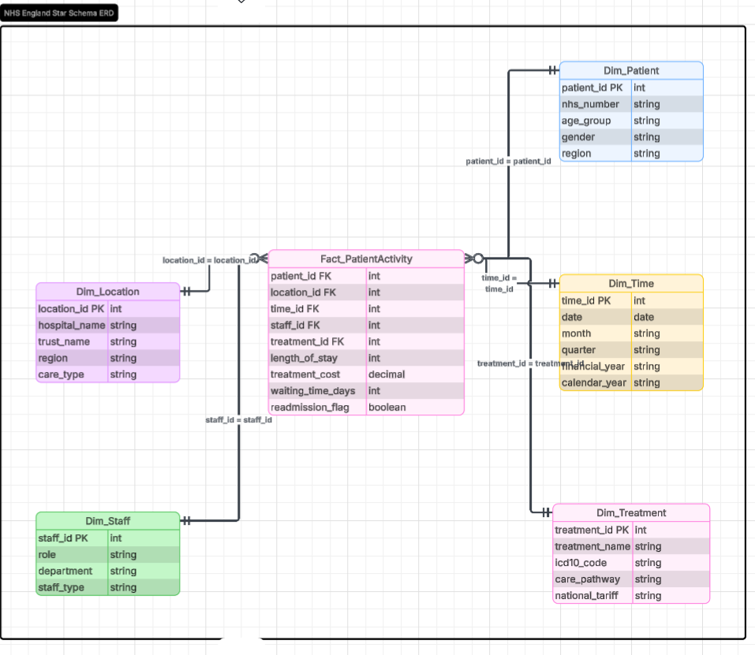

2.3 Data Marts and Schema
To support departmental decision-making across NHS England, I propose three dedicated data marts, each drawing from the central data warehouse and presenting a focused subset of data relevant to a specific operational area.
The first is the Finance Data Mart, designed for the Finance Director and budget holders across NHS trusts. This mart draws from Fact_PatientActivity and Dim_Treatment to provide visibility of treatment costs against national tariffs, cost per patient episode, and budget adherence by trust. Key fields include treatment_cost, national_tariff, length_of_stay, and staff_type from Dim_Staff to identify the financial impact of agency usage.
The second is the Operations Data Mart, designed for regional managers and the Chief Executive. It draws from Fact_PatientActivity combined with Dim_Location and Dim_Time to provide a view of bed occupancy, waiting times, and referral-to-treatment performance by region. Key fields include waiting_time_days, length_of_stay, and care_type from Dim_Location.
The third is the Clinical Quality Data Mart, designed for the Medical Director and clinical governance teams. It draws from Fact_PatientActivity combined with Dim_Patient and Dim_Treatment to monitor readmission rates, patient outcomes, and compliance with clinical standards. Key fields include readmission_flag, icd10_code, care_pathway, and age_group from Dim_Patient.
Each data mart is populated through scheduled ETL processes from the central warehouse and is accessible only to authorised users within the relevant department [3].

2.4 ETL Plan
The table below outlines a simplified ETL plan for each dimension and fact table in the NHS England data warehouse.
Target Table | Source System | Key Transformations
Fact_PatientActivity | EPR, PAS, Financial Systems | Deduplicate episodes, standardise NHS numbers, calculate length of stay
Dim_Patient | EPR, PAS | Standardise age groups, anonymise identifiers, remove duplicates
Dim_Location | NHS Trust registers | Standardise region names, map trust codes to locations
Dim_Time | System timestamps | Generate date hierarchy, align to NHS financial year
Dim_Staff | Workforce systems | Standardise role categories, flag agency vs permanent staff
Dim_Treatment | Clinical coding systems | Map procedures to ICD-10 codes, align to national tariff values

All ETL processes run overnight to avoid disruption to live clinical systems [2].

2.5 Data Quality and Governance
Maintaining data quality and robust governance is essential for NHS England's data warehouse to be trusted and effective. During ETL, data must be validated for accuracy, completeness, and consistency before loading. The warehouse must comply fully with the UK Data Protection Act 2018 and GDPR, as it stores identifiable patient data. Access must be role-based, and ongoing governance should include regular data audits and nominated data stewards within each NHS trust [6].

Conclusion
This report has outlined a comprehensive data warehousing solution for NHS England, designed to address the fragmented data landscape that currently prevents a unified view of healthcare performance across regions and care pathways. By consolidating data from disparate operational systems such as EPR, PAS, workforce, and financial platforms into a central data warehouse, NHS England will gain the analytical capability needed to support strategic decision-making at a national level. The proposed star schema, ETL plan, and dedicated data marts for finance, operations, and clinical quality provide a scalable and governable foundation for this transformation. Implemented correctly, this solution will help NHS England improve patient outcomes, optimise resource utilisation, and meet national performance targets more effectively.

References

[1] | G. S. Reddy, “Data Warehousing, Data Mining, OLAP and OLTP Technologies are essential elements to support decision-making process in industries,” 2010.
[2] | R. K. &. J. Caserta, THE DATA WAREHOUSE ETL TOOLKIT, 2004.
[3] | A. Ado, “Building a Diabetes Data Warehouse to Support Decision making,” IOSR Journal of Computer Engineering, 2014.
[4] | R. a. R. M. Kimball, The Data Warehouse Toolkit: The Definitive Guide to Dimensional Modeling, Wiley, 2013.
[5] | A. Shahid, “Big Data Warehouse for Healthcare-Sensitive Data Applications,” Sensors, vol. 21, no. 7, 2021.
[6] | G. E. Camilla Bjørnstad, “Data work: A condition for integrations in health care,” Health Informatics Journal, vol. 26, 2019.

