

BMHP5015: Building Your Personal Brand for Sustainable Employment
Component 1 – Portfolio

Name: Ejiro P. Opiri Odi
Student ID: 2309592

Word count: 2094
Task 1 – Personal Brand
Your personal brand is how other people see you‚ based on your values‚ your behaviour and your skills‚ as well as your professional image․ A positive brand is important in health and social care roles as employers want people who are trustworthy‚ compassionate and reliable‚ and who are committed to delivering high quality care․ A strong personal brand can help learners differentiate themselves in the job market‚ and signal their ambition and commitment to lifelong learning and growth (World Economic Forum‚ 2023; LinkedIn Learning‚ 2024).
Generally‚ I think my personal brand is one of candour‚ respect‚ empathy‚ and a willingness to learn․ I love working with others and hearing people out‚ and helping them where I can․ Just as they do‚ I try to address all tasks with a sense of responsibility and without complaint․ I also realise that I still need to improve my presentation‚ leadership and networking skills for effective engagement with peers and superiors․ This is becoming increasingly important as employers are looking for graduates with a combination of technical‚ communication‚ teamwork and digital skills (CIPD‚ 2024).
I will continue to build my personal brand through attending formal workshops and online training‚ using my personal LinkedIn account to connect with people in the health and social care workforce‚ and volunteering further and reflecting on my volunteering experience to continue to develop my confidence and my communication skills․ This will strengthen my professional identity and prepare me for possible future work or study in the UK health and social care sector․

Task 2 – Network Map and Rationale
Network Map
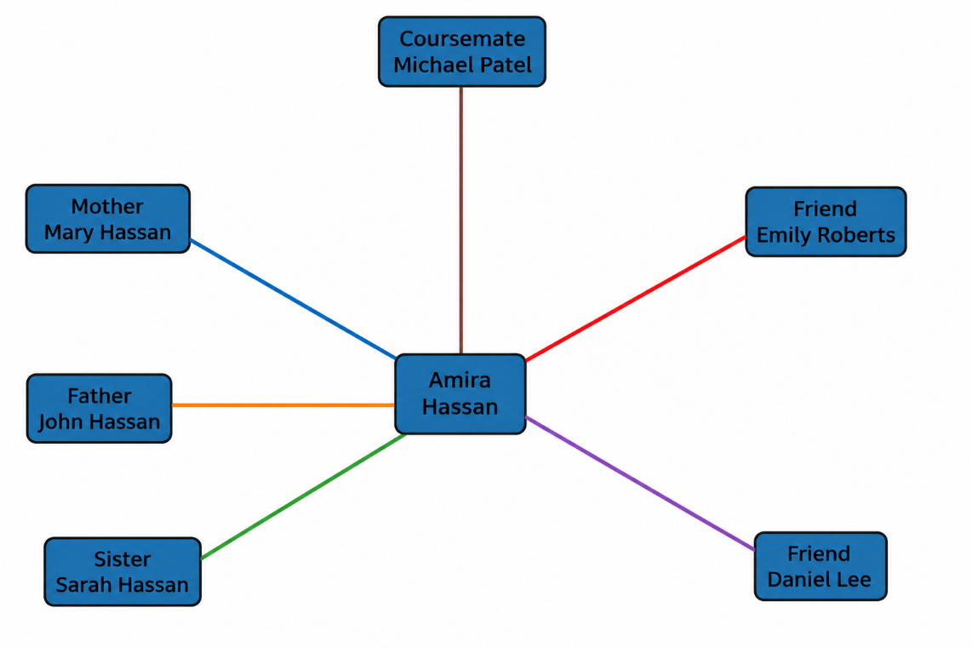

Rationale
My network is what I would describe as a hybrid network of personal and academic/professional contacts․ My family members have provided me with emotional support and have encouraged and motivated me throughout my studies․ My friends provide me social support and they help me to balance my study and my health․ My course mate and university lecturers provide me academic support in terms of teaching knowledge and giving feedback about the things that I need to improve․
I'd say my network is quite strong‚ with some gaps․ Bonding social capital is high since I am really connected to my family‚ and I can rely on close friends in case I do need to reach out in a crisis․ An area I need to develop and improve is my bridging social capital‚ specifically by making more connections with professionals outside of my organization or healthcare industry․ The other aspect of my social capital that I need to develop is my linking social capital‚ by making more connections with the NHS managers‚ healthcare professionals‚ and industry leaders that are in positions of influence and mentoring․
To build my professional network‚ I plan to attend university careers fairs and volunteering events‚ improve my LinkedIn activity‚ and join health and social care professional organizations․ These activities will improve my employability‚ give me access to useful career insights‚ and help me to achieve my goal of working in the UK health and social care sector (LinkedIn Learning‚ 2024; CIPD‚ 2024).

Task 3 – Blog
Digital Inclusion: Why Everyone Should Benefit from Digital Healthcare
Target audience: Patients, families and carers
Furthermore‚ communication with the NHS is shifting‚ with more people booking appointments‚ ordering repeat prescriptions and accessing health information via the NHS App or other online services in the United Kingdom‚ which are often faster and more convenient but not always accessible or straightforward for all patients to use․ This is why digital inclusion is becoming increasingly important in health and social care (NHS England‚ 2024).
Digital inclusion is about ensuring that people have access to technology and the internet as well as the skills to use them to access digital health services․ However‚ older people‚ disabled people‚ low-income households and people living in rural locations can have problems using digital technology․ They may experience barriers to accessing the healthcare services or information that they need (Good Things Foundation‚ 2024). More broadly‚ the NHS is working to reduce digital exclusion by making its online services easier to use‚ providing support to those who need help to use digital technology‚ and providing face-to-face services to those who cannot or prefer not to use digital healthcare services․ This ensures everyone can access the right care at the right time regardless of their digital skills (NHS England‚ 2024).
Healthcare professionals have a role in supporting patients to use digital services‚ though it is acknowledged that some may need additional support or alternative modes of access․ Good communication and patient-centred care remain of core importance to the effective delivery of care‚ regardless of mode of service delivery․ Digital healthcare will continue‚ but not at the cost of equality․ Technology must avoid creating and securing health inequalities․ The NHS must support and engage everyone‚ through supporting improvements in digital skills‚ better access for those whose circumstances make them vulnerable and the provision of digital services for everyone․

Task 4 – NHS Equality, Diversity and Inclusion Quiz
1. What is the primary goal of the NHS Equality, Diversity and Inclusion Improvement Plan?
The first priority is to build an NHS that is fair to all and a place where all staff are valued and supported so they can deliver high-quality care (NHS England‚ 2023).
2. How does the NHS EDI Improvement Plan propose to tackle the gender pay gap?
The NHS plans to analyse pay data‚ understand pay inequalities‚ promote flexible working‚ and improve women's career progression․
3. What is meant by the term 'intersectionality'?
Intersectionality refers to the idea that people can experience more than one form of discrimination‚ such as due to their race‚ gender‚ disability or age․
4. Why is it important for the NHS to create a psychologically safe work environment?
This creates a psychologically safe environment: staff feel able to voice concerns and report and learn from errors‚ helping to improve care․
5. How does the NHS EDI Improvement Plan suggest improving the experience of internationally recruited staff?
The NHS has called for better induction‚ mentoring‚ training and continuing support to help international staff settle into roles․
6. What role does leadership play in advancing EDI objectives?
They should be advocates for equality‚ build inclusive workplaces‚ set EDI targets‚ and monitor progress across their organizations․
7. Identify one way the NHS EDI Improvement Plan aims to reduce health inequalities within the workforce.
The NHS plans to improve the wellbeing of its staff through fair access to training‚ career development‚ and health support․
8. Why does the NHS EDI Improvement Plan emphasise collecting and analysing data on protected characteristics?
Data collection can highlight disparities‚ measure progress and influence policy-making to improve equity in the NHS workforce․
9. Explain how flexible working policies can contribute to equality and inclusion in the NHS workforce.
Flexible working enables employees with caring responsibilities‚ health issues or other commitments to carry out their work․
10. What is one strategy mentioned in the NHS EDI Improvement Plan to combat bullying and harassment in the workplace?
These may include promoting strong‚ assertive management‚ creating a zero-tolerance culture‚ encouraging staff to share concerns‚ and taking action on bullying and harassment․

Task 5 – A Letter to Yourself
Dear Younger Me,
And I know‚ there were times when you were afraid for the future‚ and wondered whether you would overcome the challenges faced‚ and thought that mistakes meant you were not good enough․ Those experiences‚ difficult as they were at the time‚ contributed to who I am becoming. I wish you had understood how every experience is an opportunity for learning and growth․
One lesson I have learned is the importance of emotional intelligence․ Understanding your feelings helps you stay calm during tough times and make better decisions․ Having empathy means you can recognise how others are feeling‚ which can help you to share information‚ work with others and build relationships․ These skills are important in health and social care settings because you will be speaking to people from a wide variety of backgrounds‚ and often supporting people at a difficult time in their life (NHS England‚ 2023).
Another best skill I could have given you would be resilience‚ which means‚ every time you face an obstacle‚ learning rather than giving in․ Every tough moment I have experienced has made me more confident‚ organised‚ and more determined to reach my goals․
Just believe in yourself‚ and don't be afraid to ask others for help‚ but don't compare yourself to somebody else․ Keep learning‚ listen to feedback․ Celebrate achievements big and small․ Get to know people and make sure to ask questions and remember why you chose to work in health and social care - you want to make a positive difference to people's lives․
Everything you're going through today is helping lead you to a better tomorrow․ Believe in yourself: it will happen․
Yours sincerely‚
Your Future Self

Task 6 – Development Plan: Gantt Chart
Table 1: Career Development Plan (March 2025 – February 2027)
Activity / Task | Description | Mar–May 2025 | Jun–Aug 2025 | Sep–Nov 2025 | Dec 2025–Feb 2026 | Mar–May 2026 | Jun–Aug 2026 | Sep–Nov 2026 | Dec 2026–Feb 2027 | Expected Outcome
Complete Degree | Successfully complete all coursework, placements and final assessments. |  |  |  |  |  |  |  |  | Degree completed
Build Professional Brand | Develop a professional CV, LinkedIn profile and online portfolio highlighting knowledge, skills and achievements. |  |  |  |  |  |  |  |  | Strong professional identity established
Attend Employability Workshops | Participate in university careers events, interview preparation sessions and CV workshops. |  |  |  |  |  |  |  |  | Improved employability skills
Expand Professional Network | Attend networking events, connect with healthcare professionals and join relevant professional groups. |  |  |  |  |  |  |  |  | Wider professional network established
Volunteer in Health & Social Care | Gain practical experience through volunteering in community or residential care settings. |  |  |  |  |  |  |  |  | Practical work experience gained
Complete Professional Training | Complete safeguarding, infection prevention, dementia awareness and other CPD courses. |  |  |  |  |  |  |  |  | Additional professional qualifications obtained
Develop Leadership Skills | Take part in leadership activities, group projects and volunteering roles with responsibility. |  |  |  |  |  |  |  |  | Leadership skills strengthened
Apply for Healthcare Roles | Search for vacancies, tailor applications, attend interviews and apply for entry-level NHS or social care positions. |  |  |  |  |  |  |  |  | Job applications submitted
Prepare for Interviews | Practise interview techniques, improve confidence and prepare supporting documents. |  |  |  |  |  |  |  |  | Interview readiness improved
Secure Employment | Accept a graduate or entry-level health and social care position and begin career development. |  |  |  |  |  |  | ■ | ■ | Employment secured

The construction of this development plan provides an outline of the short term and long term goals that I need to achieve in order to meet my career aspirations of working in health and social care within the UK․ My first goal is to complete my degree and develop my professional identity․ I would also like to attend employability workshops and networking events to improve my communication skills and meet other healthcare professionals․ Volunteering and attending professional training courses will also allow me to gain first-hand experience and further my person-centred care knowledge․ I plan to build on this foundation by developing my leadership skills and applying for competitive positions․ After securing a position in healthcare‚ I plan to focus on professional development opportunities as a means to grow․ This action plan will ensure that my academic performance‚ work experience and skills are developed concurrently to improve my employability and to ease my long term career goals․
Task 7 - Making Changes Report
Electronic Care Records in a Care Home
Introduction
As manager of a care home‚ I would have an Electronic Care Record (ECR) system to replace paper-based records․ An ECR would improve communication between care professionals and reduce documentation errors and increase accessibility to patient information․ Furthermore‚ they improve quality and safety by providing accurate information to people at the right time (NHS England‚ 2024).
Implementing the Change
To implement this change, I would use Lewin's Three-Step Change Model․ The first stage‚ unfreezing‚ would involve telling staff why electronic records are being used and their advantages. This would help reduce anxiety and prepare employees for change․ During the change stage‚ employees would receive technical support‚ have on-the-job training‚ have their questions answered‚ and become accustomed to the new system․ Finally‚ in the refreezing stage‚ the new way of working would become the norm through a process of monitoring‚ feedback and refresher training (Burnes‚ 2020).
Possible Barriers
Other staff may refuse to use new technology․ Barriers include discomfort with the use of electronic systems‚ the cost of training and implementation‚ lack of IT skills and disruption caused to staff as they are trained․
Recommendations
These issues may be alleviated with communication‚ staff participation and training and continuing technical support․ Staff react positively when their efforts are recognised and team-work is encouraged․ We will work more efficiently and as part of an improved team through the successful implementation of Electronic Care Records․

Task 8 ‚ Self-Reflection
Reflection Using Gibbs' Reflective Cycle
Taking this module has helped me to understand that employability is much wider than just having the relevant qualifications․ At the start of the module‚ I thought that a degree would be sufficient to get a job․ I later learned that communication‚ leadership‚ resilience‚ building networks and professional development mattered to potential employers․
I have learned about personal branding‚ networking‚ emotional intelligence‚ reflective practice‚ and the importance of digital technology to health and social care services․ This has helped with identifying my strengths and weaknesses‚ and I feel I am more confident putting myself forward to employers․ I have learned about the importance of having a professional digital presence‚ for example on LinkedIn․
Looking back at my learning‚ I realised the importance of continuous improvement․ Gibbs' Reflective Cycle prompted me to analyse my experiences critically‚ extract lessons‚ and formulate specific plans for future improvement (Gibbs‚ 1988). I now look to reflection as a way of ensuring my practice is safe‚ effective and person-centred․
In the future I will develop my leadership‚ communication and digital skills through volunteering‚ training‚ further formal professional study and networking․ I will continue to maintain my professional profile and seek feedback to continue to improve my practice․
Overall‚ this module has developed my confidence and prepared me for a career in health and social care․ It has helped me learn how to adapt to the workplace and what employers are looking for in a candidate․ It has helped me become a more reflective‚ adaptable and lifelong learner․

References
Burnes, B. (2020) 'The origins of Lewin's three-step model of change', Journal of Applied Behavioral Science, 56(1), pp. 32–59.
Chartered Institute of Personnel and Development (CIPD) (2024) Profession Map. Available at: https://www.cipd.org (Accessed: 1 July 2026).
Gibbs, G. (1988) Learning by Doing: A Guide to Teaching and Learning Methods. Oxford: Oxford Polytechnic.
Good Things Foundation (2024) The Digital Inclusion Blueprint. Available at: https://www.goodthingsfoundation.org (Accessed: 1 July 2026).
Kanasan, R.K. (2024) 'The influence of personal branding on career success in the digital age', Journal of Communication, 8(3), pp. 15–28.
LinkedIn Learning (2024) Workplace Learning Report 2024. Available at: https://learning.linkedin.com (Accessed: 2 July 2026).
NHS England (2023) NHS Equality, Diversity and Inclusion Improvement Plan. Available at: https://www.england.nhs.uk (Accessed: 2 July 2026).
NHS England (2024) Inclusive Digital Healthcare: A Framework for NHS Action on Digital Inclusion. Available at: https://www.england.nhs.uk (Accessed: 5 July 2026).
Office for National Statistics (2025) Labour Market Overview, UK. Available at: https://www.ons.gov.uk (Accessed: 1 July 2026).
Ofcom (2025) Online Nation Report 2025. Available at: https://www.ofcom.org.uk (Accessed: 4 July 2026).
Phillips, J. and Ellinas, E. (2014) The Social Media Survival Guide. New York: McGraw-Hill.
Skills for Care (2024) The State of the Adult Social Care Sector and Workforce in England 2024. Leeds: Skills for Care.
World Economic Forum (2023) The Future of Jobs Report 2023. Geneva: World Economic Forum.
World Health Organization (2021) Global Strategy on Digital Health 2020–2025. Geneva: World Health Organization.
Zwilling, M. (2021) 'Personal branding for career success in the digital economy', Forbes. Available at: https://www.forbes.com (Accessed: 5 July 2026).

