Hotel Placement Research Project
Module code: BMIH6008

Module Lead: Dr. Ernest Balutie Wavei
Student Name: Cristina Veronica Vlasceanu
Student ID: 2125765

AI Acknowledgement
I declare that this assignment is all my own work and that I have acknowledged all materials used from the published or unpublished works of other people. All references have been duly cited. No software tools, including Generative AI (GAI) applications, have been used in developing and completing the assessment.

Topic
"Impact of adopting effective motivational strategies for employees on business growth in Delta Hotel by Marriot, Swansea"
Abstract
The motivation of employees to grow the competitive advantage of organisations have been assessed in this study. In addition, there is an assessment of the internal and external department of Delta Hotels by Marriott in Swansea, laced with netnography and other statistical representations. Contradicting and comparing opinions have endorsed an understanding of the current employee motivation scenario at the hotel.
In the case study section, different frameworks, including the SWOT Analysis, Competitive Analysis, Thematic Analysis, and many more, were discussed to gather data from secondary resources, books, articles, and company websites.
In the discussion chapter, the concept of motivation and its significance for organisational purposes were highlighted to align with Delta Hotels by Marriott. The benefits and the issues which they face have been noted and this has been followed by the development of strong recommendations to grow the competitive advantage of the organisation for the future.

Table of Contents
Introduction 6
Literature Review 8
Methods 12
Case study 13
Discussion 30
Conclusion 35
Recommendations 36
Reference List 38

Introduction
Background of the Study
Motivational strategies which are used in organisations tend to improve the productivity of the employees and their engagement (Kittel, Kunz and Seufert, 2021). This also proves to reduce the turnover of the employees and increase the innovation in the workplace. The customer service of the organisation improves significantly and the employees remain committed to ensuring that the organisational goals are achieved and this leads to the workplace having a positive work culture. Some of the strategies which are commonly applied are that of providing rewards and recognition and opportunities for the growth of the career of the employees (Saputra et al., 2021). Engaging in work which is meaningful ensures that the tasks of the organisation align with the values and interests of the employees which make them believe that their contributions hold significant value. Providing the employees autonomy and freedom to take their own decisions empowers them and makes them more loyal to the organisation (Kalogiannidis, 2021). Communication and good leadership are essential for the motivation of the employees as they would be more comfortable with the sharing of feedback and their concerns (Witama and Wono, 2024). Finally, the employees must have a good balance between their work and personal lives to ensure that they are refreshed and can have a good mental health.
Overview of the Case Study
The Delta Hotel by Marriot, Swansea operates in the hospitality industry and they have about 200 employees working for them (Marriott, 2025). The company is headquartered in Bethesda, Maryland and they operate under the brand Marriott. The brand operates in 145 countries and has more than 30 leading brands under them. They have 9100 properties and give their customers the opportunity to expand, connect and experience. The biggest market of the brand is in North America and some of the competitors of the brand are Hilton Worldwide Holdings, Galaxy Entertainment Group and MGM Resorts International (Statista, 2024). The overall brand awareness of the hotel stood at 81% in the year 2023. In the same year, the organisation generated a revenue of US$ 22.2 billion. The mission of the hotel is to make sure that customers have a seamless experience and they can have a warm and flexible service in the organisation.
Purpose of Research Activity
The research study addresses the case of effective employee motivation strategies and their impact on the business growth of Delta Hotel by Marriot, in Swansea.
Research Questions
Q1: How have changing employee motivation strategies been influencing business productivity for Delta Hotels?
Q2: How can Delta Hotels improve its employee engagement in terms of being able to enhance business growth?
Aims of Research Activity
The research study aims to investigate the adoption of motivational strategies aimed at influencing employee engagement and its impact on the business growth of Delta Hotels by Marriott, in Swansea.
Objectives of Research Activity
1. To carry out an extant literature review of employee motivation strategies
2. To investigate the benefits of adopting employee motivation strategies for the growth of Delta Hotels
3. To analyse the challenges imposed on Delta Hotels for adopting employee motivation strategies for changing needs
4. To devise strategic recommendations for Delta Hotels to enhance its strategies for keeping employees motivated and fuelling business growth

Literature Review
Concept of Employee motivation strategies
It was mentioned by Kalogiannidis (2021), that the different approaches, plans and tactics which are used by the leaders of the organisation or the employers to uplift the spirits of the employees is known as the motivation strategies for the employees. It also encourages them to work hard and connect with the organisation and to inspire them to contribute to the success of the organisation. Kumar (2022), has stated that in today’s world where everything changes very quickly in the business world it is very important for an organisation to retain their talented employees so that their production does not gets affected negatively. A study has shown that the employees who stay motivated in their workplace are supposedly contributing to 13% more work done in comparison to the other employees who does not feel motivated (University of Oxford, 2025). As mentioned by Aliyyah et al. (2021) and Zacharias, Rahawarin and Yusriadi (2021), that employee motivation practices are one of the most essential tasks done by the Human Resource Management (HRM) department of an organisation as it impacts the overall organisation. Practicing good employee satisfaction strategies can help an organisation to grow more and on the other hand if these practices are not followed properly, it also brings serious consequences to the organisation. Waworuntu, Kainde and Mandagi (2021) draw attention to the factor that when a a company which does not motivates their employees to work hard and look after their health, needs and requirements tends to have a negative brand value.
Benefits of adapting employee motivation strategies
It has been mentioned by Agustian et al. (2023), that in the modern-day business environment HRM policies plays an important role in determining the value of an organisation in the market and how the company is being perceived by the customers and their employees. Motivating the employees and looking after their well being and making sure the employees get a positive environment for working helps the employees to feel a sense of being valued in the organisation. Kang and Lee (2021), has stated that the organisation where employees are focused and motivated have seen lower absenteeism rate and are able to retain their top talent. In the recent study it has been seen that companies who have motivated and engaging employees have seen 21% more profit in the UK (EFX CO UK, 2025). Battour, Barahma and Al-Awlaqi (2021), highlighted that motivated employees are more likely to engage more with the company and due to this the employee engagement rate of the organisation also gets improved. It also helps the brand to mark its position in the market and have a positive brand image which allows the organisation to gain more public attention and increase its sales. As mentioned by Azeem (2021) the companies who have HRM practices which are made keeping in mind the well being of the employees and making sure they feel safe, secure and comfortable helps the organisation to attract top talent. In the UK 75% of the people leaves their job because of toxic working environment and net feeling safe and motivated in their company and chooses a company where they have good HRM practices (Beyond HR, 2025).
Challenges faced for adopting employee motivation strategies
Al-Suraihi (2021) and Lin, C.Y. and Huang (2021), stated that the companies who lack in motivating their employees and make them comfortable with their work in the working environment faces a lot of challenges and one of their major problems stand out to be higher turnover rate of the employees. Due to this the employees make a decision of leaving their jobs or switch to a different company where the employees are valued. It has been stated by Manzoor, Wei and Asif (2021) and Basalamah (2021), that the quality of the work gets affected negatively when the employees are not motivated enough to contribute their full potential. Due to this the sales of the organisation gets affected leaving a bad effect on the overall organisation. A study has highlighted that 3 out of 10 people in the UK have left their job and started working as a freelancer to avoid workplace toxicity (Consultancy UK, 2025). It has been mentioned by Tessema et al. (2022) that after COVID-19 people have changed their thoughts about their work life and prioritises their mental health and work life balance. Due to this when the employees feel their working environment is getting toxic and they are unable to balance their personal and professional life they feel demotivated. This eventually makes them consider their decision about continuing their job or resigning it.
Strategic recommendations for motivating employees and fuelling business growth
Sinambela, Darmawan and Mendrika (2022), has stated that when the employees of an organisation feel valued and recognised for their hard work, they get motivated to work harder. Organisations having reward system and recognition policies for the employees will allow them to feel that their hard work is being noticed by the company. Due to this the employees will feel motivated and work according to their full potential which will directly impact the overall business positively. 49% of the employees in the UK have better productivity when their work gets recognised and they get appreciated because of it (Reward Gateway, 2025). As mentioned by Gabriel and Aguinis (2022), providing flexible working hours to the employees allows them to balance their professional and personal life and improves both their mental and physical health. This helps the employees to feel valued and, in their organisation, and motivates them to work more. Enforcing rules and regulations in the organisation for maintaining a positive working environment helps the employees to concentrate fully on their work. The positive environment also allows them to be comfortable and work without panicking which improves their productivity of work.
Theories underpinning
Maslow’s Hierarchy of Needs: The theory of Maslow’s Hierarchy of Needs helps an organisation to organise and analyse the different stages of needs of an individual in a hierarchical way (Cui et al., 2021). This theory has 5 different stages according to the needs of the people which are psychological, safety, love and belonging, esteem and self-actualisation. Applying this theory in the business model allows the organisation to value the needs and desires of their employees according to its importance. Due to this the employees feel motivated and valued in their organisation.
Expectancy Theory: The psychological theory which helps in understanding the procedure of why the particular individuals’ choses to react in a certain way and what their expectations are regarding the outcome of their work is defined as expectancy theory (Bushi, 2021). This model will help the organisation to improve their employee engagement rate and helps in motivating their employees by prioritising their personal needs.
Conceptual Framework
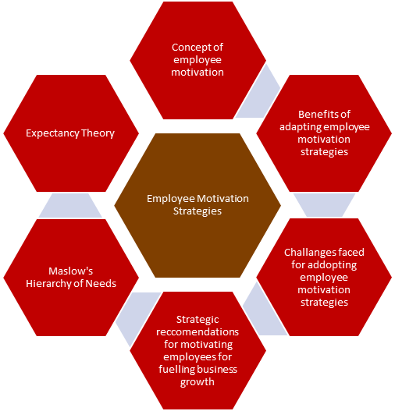
Figure 1: Conceptual Framework
(Source: Created by the Learner)
The concept which highlights the different theories, purposes and objectives in the literature review is defined as conceptual framework. This particular framework has highlighted the different objectives of employee motivation strategies such as the concept of employee motivation, advantages, disadvantages and different strategies which can improve the employee motivation in an organisation.
Literature Gap
This literature review is done on the topic- employee motivation strategies and has been done very precisely with putting all the real data. This literature review has not only analysed the different objectives of employee motivation but also highlights the different theories which helps in making it more effective than the other literature review present.

Methods
In this research study, the methods selected are both primary and secondary and will be applied to the operations of Delta Hotels. Herein, both a quantitative survey and a qualitative thematic analysis will be carried out in this research. With the support of the interpretivism research philosophy, the conclusive research design and the deductive research approach, this study will be carried out. A survey, with the help of the probability or random sampling technique, will be carried out on 10 employees of Delta Hotels. None of the participants will be harmed or forced for their consent in responding to the survey questions. Moreover, no private information or data of the respondents will be disclosed. In addition to the ethical approach to carrying out primary research, for secondary research, no journals, articles or books beyond 5 years will be selected for the analysis and study.
Methodological approach
The case study approach includes the evaluation of groups, specific events and cases (Cruz et al., 2022). This can be applied to develop and test theories and can be used to solve the problems of the real world. This method allows the application of both quantitative as well as qualitative study and this can be used to identify the patters and causes of events and human behaviour. The data can be allowed to describe, explain and explore phenomenon and events (Calandra et al., 2023). It gives a substantial level of flexibility and can be applied to study both quantitative and the qualitative data (Pollard et al., 2023). The problems of this study are that this is able to limit any form of simplification.
Netnography
Netnography mentions to the technique of qualitative research and this can be applied to use the observation of the participants to understand the experience of the culture of the people online (Smith et al., 2023). The information is collected from online sources such as online surveys (Kabel et al., 2024). The method is not highly obtrusive and this ensures that the process is not expensive (Discetti and Anderson, 2023).

Case study
SWOT Analysis
Strengths  - Delta Hotels by Marriott is a hospitality company that employs over 501 to 1000 people and has an overall revenue strength of $50 million to $100 million in recent years (Zoominfo, 2025).  - The company is present across the globe including Africa, Asia, Europe, the Middle East and North America, Central America and the Caribbean (Delta Hotels, 2025). | Weaknesses  - The hospitality brand has been negatively by its past employees due to poor management systems and a toxic work atmosphere to affect employee morale (Indeed, 2025).  - Delta Hotels faced several challenges including economic downstream and inventory shortages due to the changing customer preferences and the sudden outbreak of the pandemic session.
Opportunities  - The organisation can collaborate with other brands to share common goals and resources for further expansion and raise awareness to generate positive outcomes (Armstrong, Brown and Chapman, 2021).  - It can raise funding from stakeholders and bank loans to invest in employee training and development for higher efficiency levels (Tousek et al., 2021). | Threats  - In the UK, the total number of hotel businesses was about 9.8 thousand in 2020, however, it increased gradually by 9.9 thousand in 2021 (Statista, 2024).  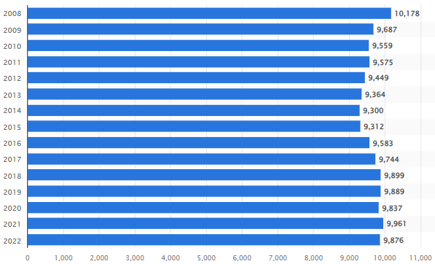  Figure 2: Number of hotel chains in the UK  (Source: Statista, 2024)  - The rising cost of living crisis and high inflation rates in the UK might affect the internal operation of the business to support local communities and reduce the bargaining power of customers (BBC, 2025).
Table 1: SWOT Analysis
(Source: Created by the learner)
PEST Analysis
Political
The corruption perception index of the UK recorded around 71 points in the year 2023 and the political stability index was recognised to be 0.51 in the year 2023 (The Global Economy, 2024; The Global Economy, 2024). Although Delta Hotels may avoid fraudulence, it may come across uncertainties.
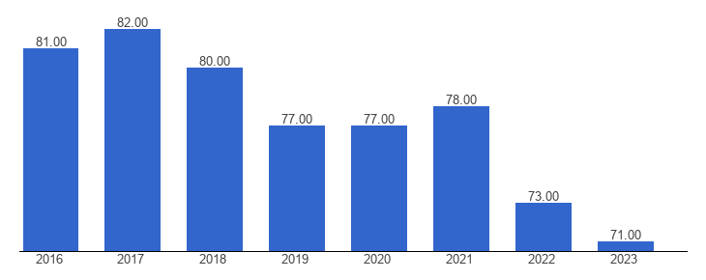
Figure 3: Corruption Perception
(Source: The Global Economy, 2024)
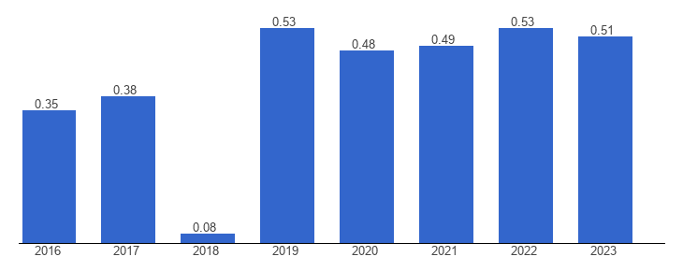
Figure 4: UK Political Stability
(Source: The Global Economy, 2024)
Economic
Inflation across the UK peaked at 11.1% in the year 2022 while its economic growth rate experienced an increase of 8.13% to $3,340.03 billion in the year 2023 (Statista, 2025; Macrotrends, 2025). Delta Hotels may initially experience supply chain shortages although employment may increase in the long run.
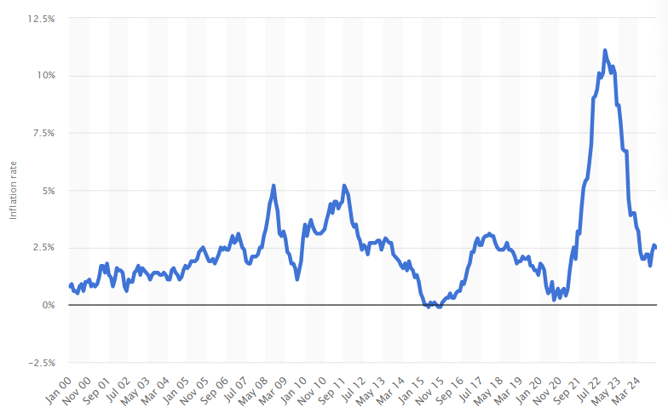
Figure 5: UK Inflation
(Source: Statista, 2025)
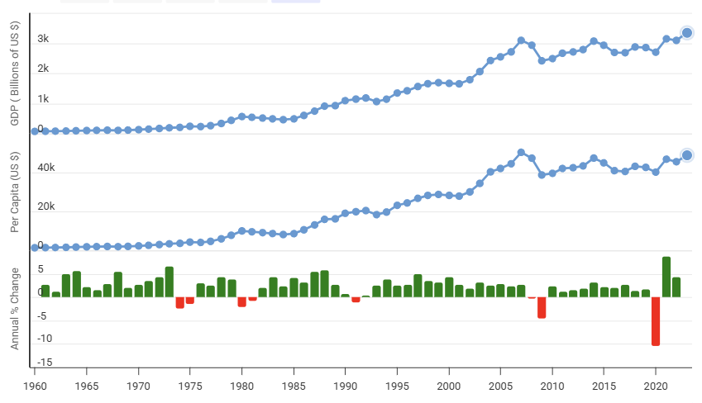
Figure 6: Economic Growth
(Source: Macrotrends, 2025)
Social
Although the population of the UK increased to 68,180,606 by 0.32% in the year 2025, the income inequality rate also hiked by 1.3% from 34.4% to 35.7% (Macrotrends, 2025; O’Neill and Croal, 2023). Delta Hotels may find new guests or target audiences but may lose its employee base.
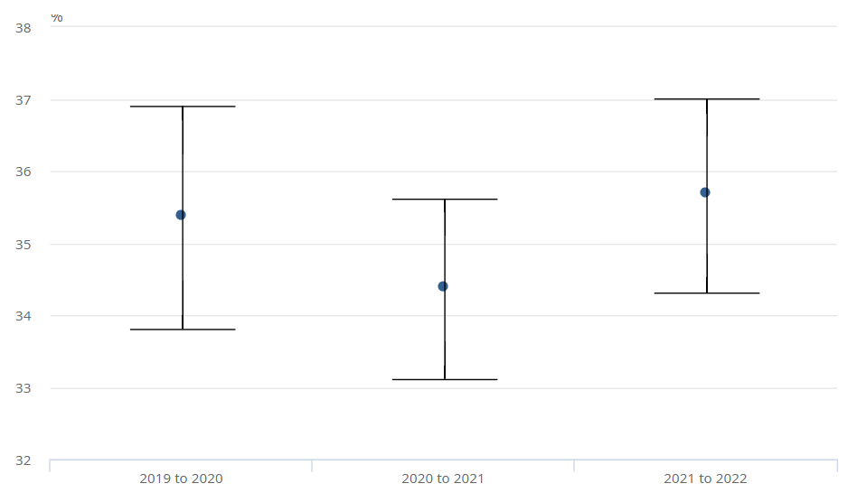
Figure 7: UK Income Inequality
(Source: O’Neill and Croal, 2023)
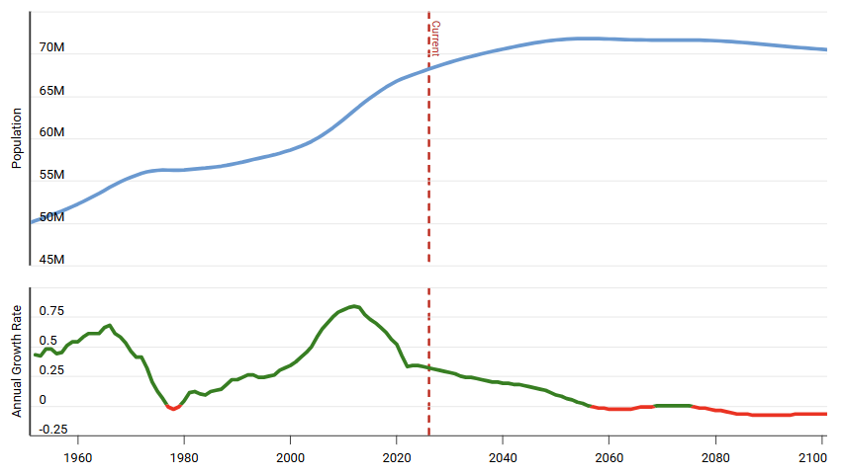
Figure 8: UK Population
(Source: Macrotrends, 2025)
Technological
With social media users accounting for 56.2 million representing 82.8%, the internet penetration rate reached 97.8% in the year 2024 (Statista, 2025; Statista, 2024). Delta Hotels can make use of social media technologies and the Internet of Things to expand brand awareness.
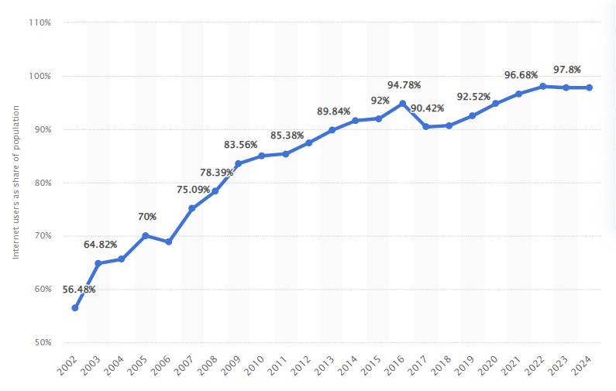
Figure 9: UK Internet Penetration
(Source: Statista, 2024)
Competitor Analysis
Under positioning, Delta Hotels by Marriott belongs to the high price and high-quality dimensions as it is considered as a premium brand as compared to other respective Marriott brands (Dudovskiy, 2023). There are other well-known hotel brands present in the UK including Premier Inn, Holiday Inn, Travelodge, Hilton, Ramada, Ibis and many more (Statista, 2025). Doubletree by Hilton Tower of London has been negatively reviewed by its past customers due to poor customer care services and terrible management systems which leads to a bad experience for them. Holiday Inn is also a popular brand to offers services at affordable prices, however, it lacks compliance with the Equality Act and does not respect disabled people (Trustpilot, 2025). Lastly, Ramada Hotels by Wyndham provides effective offerings and quality services at the lowest prices during online booking systems to gain competitive advantages (Ramada, 2025).
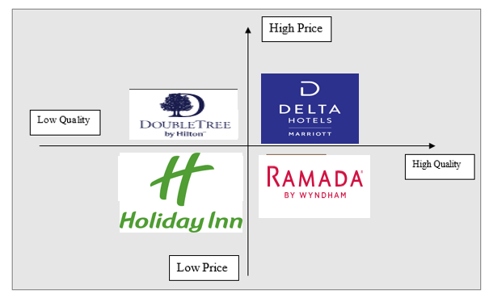Figure 10: Positioning map
(Source: Created by the learner)
Netnography
In addition to being present in Swansea, Delta Hotels is present in more than 80 other locations across Europe, Canada, the United States, the Middle East and China (Hospitality Net, 2025). Herein, on cultural grounds, Delta has a distinct style of “Simple Made Perfect” ensuring that guests can experience seamless travel experiences through welcoming familiar rooms, convenient dining options, and free Wi-Fi. Geographically, 2 branches in Africa, 4 in Asia, 3 in Central America and the Caribbean, 34 across Europe, 3 in the Middle East and 93 in North America (Delta Hotels, 2025). With a rating of 4, Delta Hotels in Swansea ranks 12th out of 23 hotels with a 4.5 rating for its geographical location and 3.5 for cultural values (Tripadvisor, 2025). Spacious accommodation, compelling attractions, versatile venues, impressive marina views, complimentary facilities and a delectable British Cuisine make the hotel culturally, locationally and geographically viable. However, despite its facilities, Delta Hotels has also been rated only a 2 on average with value being 3 and services being 2 (Tripadvisor, 2025). On cultural grounds, the cuisine has been terribly ranked with accommodation issues although the location has been appreciated, intensifying damages.
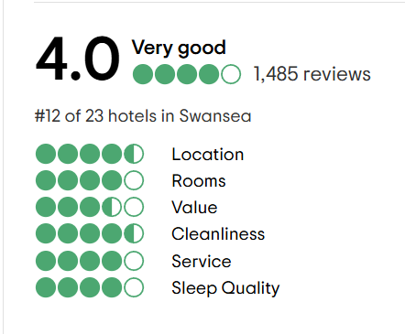
Figure 11: Online Rating
(Source: Tripadvisor, 2025)
Survey
Q1. What may be your age?
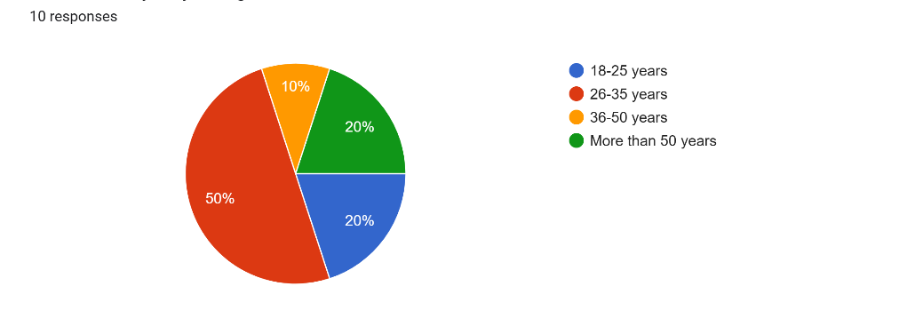
Figure 12: Q1
The survey findings reveal that around 50% of the respondents are between the ages of 26 and 35 years, serving Delta Hotels. Herein, 20% are also above the age of 50 years which implies that age discrimination does not exist at the hotel. Although the work pressure on the younger employees is higher, employee motivation without discriminative measures can be persuasive.
Q2. How long have you been serving Delta?
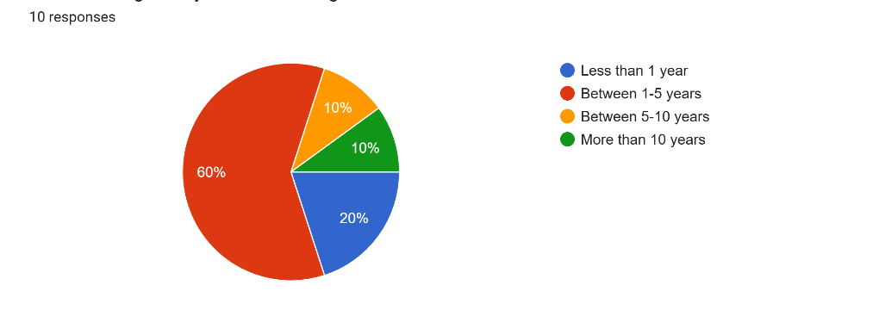
Figure 13: Q2
Around 60% of the survey participants in this statistical representation reveal that they have been serving Delta for 1 to 5 years. This interprets job security since employee turnover rates seem lower at this hotel based on their engagement over the years, especially around 10% being present in the organisation for more than 10 years.
Q3. How far do you agree that the management style of Delta is motivational and relevant for business growth?
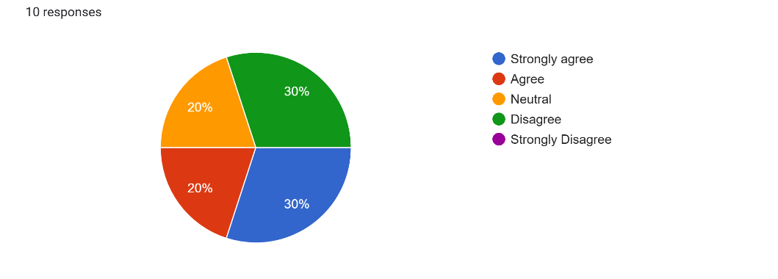
Figure 14: Q3
According to collectively 60% of employees from Delta, 30% strongly agree and 30% disagree with the idea that the management style of Delta may be relevant and motivational for business growth. In addition to none of the employees strongly disagreeing with this statement, around 20% strongly agree. This implies that while a few workers are satisfied with the environment, indicating that they are more favoured by managers, other staff members are not motivated to serve the hotel and contribute to its business growth.
Q4. What are the benefits offered to you by the organisation?
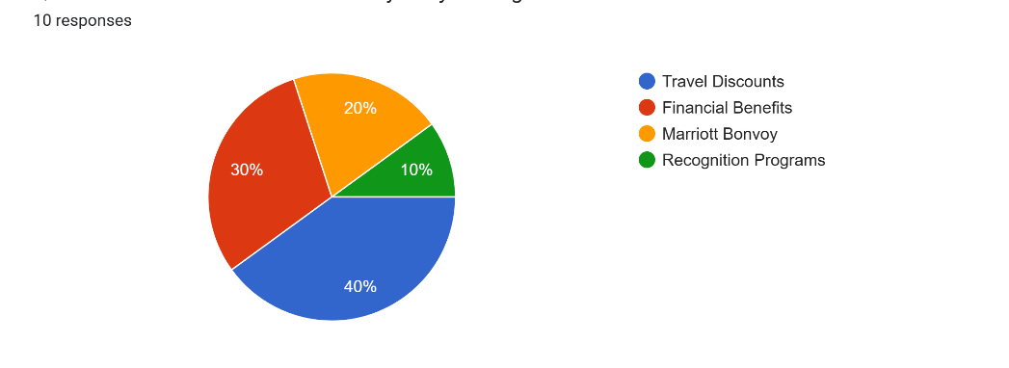
Figure 15: Q4
Around 40% believe that travel discounts are exclusive benefits offered by Delta Hotels while 30% demand financial benefits. However, there are also other benefits listed by the hotel with the most articulated one being the Marriott Bonvoy for them. Not many demand recognition programs, implying that the organisation does not pay attention.
Q5. What are the challenges that you have experienced working at Delta Hotels?
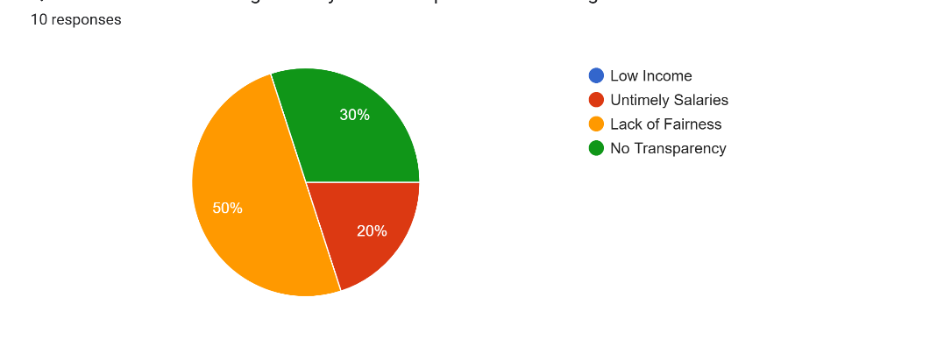
Figure 16: Q5
Around 50% of the survey respondents revealed that the lack of fairness was a crucial problem across Delta Hotels with 30% believing it to be a lack of transparency and 20% demanding timely salaries. However, none of them opinionated that the hotel offered them low incomes. Herein, although the employees of the hotel are subject to workplace discrimination in the form of favouritism or the absence of communication in any required change, they are well-paid.
Q6. What changes can Delta endorse for improvement in its motivational strategies?
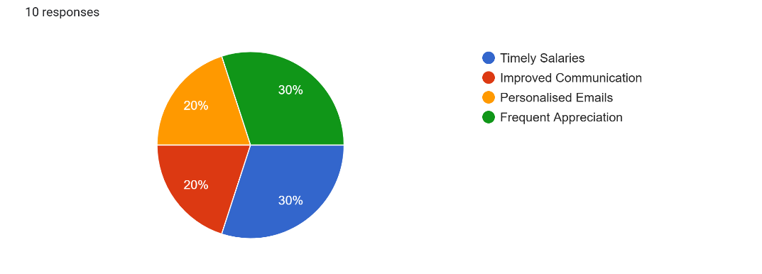
Figure 17: Q6
Equally divided, 30% of employees shared their opinion that timely salaries and frequent appreciation can keep them motivated to serve business growth for Delta. Another 40% suggested changes in the form of personalised emails and better communication. It is important for Delta to establish an active interactive landscape for staff members at the workplace and communicate, with fairness and transparency, the need for new changes and innovations.
Q7. Would you recommend the hotel to other individuals looking for a job in this sector?
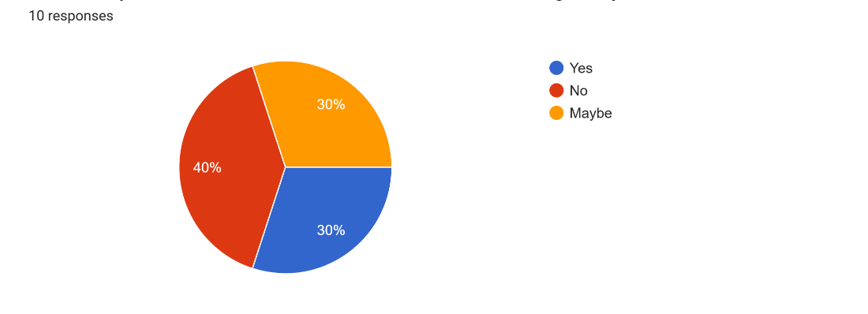
Figure 18: Q7
Destructive enough for Delta Hotels, 40% of employees said no to recommending the hotel to their peers or any other individual looking for a job. Herein, it is the responsibility of the management to change the viewpoint of this 40% and maintain what the other 30% has experienced to agree with referring this hotel to peers.
Q8. Does Delta have the capacity to deal with calamities without adversely impacting jobs?
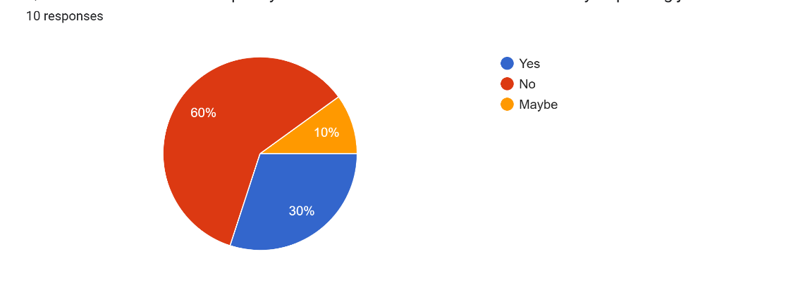
Figure 19: Q8
Again, a majority of 60% believe that Delta may not be able to overcome external or internal challenges without disrupting jobs. This implies that most of the employees are not secure about their jobs, indicating that Delta has axed roles earlier and can do it again without thinking about its staff.
Thematic Analysis
Themes | Title | Authors | Year | Analysis
Theme 1- Employee motivation strategies | IMPACT OF EMPLOYEE MOTIVATION ON ORGANIZATIONAL PERFORMANCE. A SCOPING REVIEW PAPER FOR PUBLIC SECTOR | Kalogiannidis | 2021 | The article highlighted the concept of motivation as a significant factor in business growth for every employer to align with long-term objectives and achieve sustainable development. There are different types of motivation including achievements, affiliation-based, power, competence, attitude-based and incentive motivation. Besides, employers should promote a positive work culture and build strong relationships with employees to generate better results.
Theme 2- Benefits | An Empirical Study of Employees’ Motivation and its Influence Job Satisfaction | Ali and Anwar | 2021 | This article specified the impact of reward systems and job satisfaction for employees to resolve internal issues and recognise their hard work to value their moral ethics. Besides, creating a highly satisfied workforce would help to design effective compensation packages for people which leads to high satisfaction levels.
Theme 2- Benefits | Fostering Public Sector Employees’ Innovative Behavior: The Roles of Servant Leadership, Public Service Motivation, and Learning Goal Orientation | Nguyen et al. | 2023 | It can be depicted that leadership plays a crucial role in the workplace to deliver quality approaches and encourage people to learn about different topics to achieve long-term goals in future aspects. Additionally, effective learning and training facilities also motivate workers to work dedicatedly and increase work efficiency levels.
Theme 3- Challenges | How Toxic Workplace Environment Effects the Employee Engagement: The Mediating Role of Organizational Support and Employee Wellbeing | Rasool et al. | 2021 | This study explored the negative impact of a toxic work culture on employee engagement to reduce transparency levels and affect organisational success in the long run. It is also considered as a climate factor to demolish a person's sense of security and affects employee well-being.
Theme 3- Challenges | Gender Discrimination and Unfair Treatment: Investigation of The Perceived Glass Ceiling and Women Reactions in The Workplace – Evidence from Indonesia | Sunaryo et al. | 2021 | Women have rapidly increased their participation in the workplace in recent years. However, they remained underrepresented in upper positions due to gender discrimination and excessive pay gap which might result in low consistency levels. This could be challenging for female workers to support their daily lives and compete with male employees to gain competitive advantages in the business environment.
Theme 4- Strategic recommendations | The Impact of Talent Management Strategies on Employee Retention | Urme | 2023 | This article specified the current competitive business world to prioritise employee retention through talent management strategies. Besides, other ways include employee training and development programmes, pay and benefits, selection and recruitment procedures, performance tracking and promoting a healthy workforce to assist in positive results.
Table 2: Thematic Analysis
(Source: Created by the learner)
Analysis
Employee motivation strategies
The article by Kalogiannidis (2021) discussed the basic concept of employee motivation to influence employee motivation and align with long-term goals to generate the desired outcomes. For example, Delta Hotels has an overall staff of 7,000 workers under the leadership of CEO Kenneth Greene which shows a positive impact on employability assets (Indeed, 2025).
Benefits of motivational strategies
According to Ali and Anwar (2021), reward and recognition strategies play a crucial role in employee satisfaction to resolve personal conflicts and deliver quality services to achieve organisational success. In contrast, Nguyen et al. (2023) stated that leadership is also essential for employee motivation to lead the team and encourage workers to work dedicatedly for higher efficiency growth. For instance, Delta Hotels provides a wider range of offerings with great benefits, free lunch facilities, discounted hotel and food purchase options to grab the attention of workers in future aspects (Indeed, 2025).
Challenges
As per Rasool et al. (2021), a toxic work environment might have a negative impact on business transformation to reduce employee retention rates and create personal conflicts among workers. Delta Hotels should take necessary actions against offenders to maintain high business standards and abide by ethical considerations. Contrastingly, the article by Sunaryo et al. (2021) said that women have been underrepresented by employers with low payments as compared to male employees which can be challenging for female colleagues to enhance their well-being in society. For example, the manager of Racine Hotel which operates Delta Hotels by Marriott, has charged the company after allegedly sexually assaulting a co-worker in the workplace (Griffith, 2023).
Recommendations
Urme (2023) stated that the current business world mainly prioritises employee retention rates through talent management strategies to value their moral ethics and acquire suitable resources to maximise the profitability ratio. This shows a positive impact on business performance to get easy access to resources and invest in employee training and development programmes to increase job satisfaction levels. Lastly, Delta should track the performance of its workers regularly and identify areas for development to take strict action against wrongdoers to maintain high ethical standards.
Reflective Account
After carrying out enough research on the case study of Delta Hotels in Swansea, I believe that I have been able to hone my skill sets, personally, academically as well as professionally. My professional observations, although limited to the online survey that I have conducted, I have been able to improve my communication skills and commercial awareness. I have also come across the essence of ethical standards required in terms of carrying out effective research studies. My experience in carrying out a secondary qualitative thematic analysis extracted an opinion of being time-consuming, which was more difficult than the survey. My professional observations further helped me understand that carrying out an online survey can save both effort and time while curbing financial constraints. In addition, a survey is an essential tool to collect feedback from employees, delivering productivity, while identifying required potential improvements (Kennedy, 2020; Forbes, 2022; Murphy, 2024).

Discussion
In the Literature Review section, Aliyyah et al. (2021) depicted that employee motivation practices are considered as an essential element or factor by the HRM department of the business to influence internal operations. This reflects a positive impression on staff retention rates to acquire sufficient resources and support local societies to maximise the profit ratio. Similarly, it was mentioned by Kalogiannidis (2021) that there are different employee motivation plans, approaches and tactics to influence their performance and uplift the spirits to attain competitive success. This also encourages people to work dedicatedly and stay connected to contribute to organisational success. For instance, a study revealed to highlight that employees who stay motivated in the workplace are likely to contribute about 13% more work to be done as compared to other workers (University of Oxford, 2025). Apart from these, Kumar (2022) has stated that the business world is changing gradually to enhance employability assets and retain talented employees to increase work efficiencies. Besides, practising good employee satisfaction strategies can help companies to grow more, however, if they fail to maintain properly, this may bring serious consequences within the workplace.
For example, Delta Hotels by Marriott has been employing more than 7,000 employees across the globe under the leadership of the CEO to show a positive impression of employee activities (indeed, 2025). It would help the business to understand the basic demands of workers and value their moral ethics to enlarge its operations globally for higher productivity levels. There are different types of employee motivational approaches and tactics including attitude-based motivation, incentive, achievement, affiliation-based, competence and many more to grab the attention of local societies and build strong coordination with employees and stakeholders. Additionally, employers must ensure that all workers get fair treatment to create a positive work culture for eliminating biases and fostering innovative skills and abilities in the future. Therefore, Delta Hotels can raise funding through various resources like bank loans and stakeholders to invest in employee training and development programmes to acquire sufficient resources without any external intervention.
In the thematic analysis framework, employers should promote a positive workforce to create an inclusive and diverse business environment to assist in positive outcomes. Therefore, Delta Hotels can hire skilled labourers to compete with other brands and create a positive brand value in society to avoid unnecessary conflicts. Waworuntu, Kainde and Mandagi (2021) explained the crucial factor of employee motivation to consider the health condition of workers and understand the basic needs and requirements which might tend to a positive brand image. However, if a company fails to motivate employees and does not pay attention to its worker’s health situation, it could be challenging for them to survive in the competitive environment. Delta Hotels should consider all these factors before making any vital decisions and assess its current state to create a wider space in the existing marketplace.
As mentioned by Agustian et al. (2023), motivating the employees can be done by taking care of their well-being. This is meant to improve the overall productivity of the company and the work environment of work becomes easier. As it has been stated by Ali and Anwar (2021), having high performance teams in the organisation can make sure that there are effective packages for compensation, and this can develop high levels of job satisfaction. This would prove to increase the creativity of the organisation. As it has been pointed out Kang and Lee (2021), this can make sure that there are lower rates of absenteeism. This also proves to motivate the other employees of the organisation and they will be able to appreciate the efforts of the employers.
According to Battour, Barahma and Al-Awlaqi (2021), this is able to make sure that the organisation can have employees who are highly engaged with their work. This can ensure that the recognition of the employees can have a good understanding that their organisation cares for them. Nguyen et al. (2023) have pointed out that the leadership styles within an organisation plays a significant role in the motivation of the employees. Managers have to convince the employees to keep upskilling themselves by learning new skills and training to improve their work efficiency. This gives them the opportunity to develop in their careers and they are able to remain loyal to the organisation. As this is able to ensure that the workforce will be able to be more confident and the company can enhance their reputation.
Azeem (2021) has stated that the organisations which look after their employees due to competent HR processes are able to make them feel comfortable and secure. This means that they are able to keep the morale of the workforce high and hence, they can perform better and increase the competitive advantage of the organisation. This is able to make sure that the rate of absenteeism in the company can be reduced and the costs of operations can be saved. Hence, it is essential to make sure that the employees of an organisation are motivated. Improving the creativity and innovation in the organisation is able to see to it that the company can develop new services and products. This means that the customers will be highly satisfied with the performance of the company and they will become loyal to the same. One of the things which have to be noted is that when the employees of a company are motivated, there is also lower chances of conflicts and more team collaboration. This is primarily because the culture of the company remains positive and they enjoy working for the company. This is also possible when there are proper human resource policies and strong leadership within the organisation.
In terms of integrating the challenges that have been prevalent across organisations concerning employee motivation strategies and business growth, with the opinions of employees from Delta Hotels, the literature review and thematic analysis can support the survey findings. For instance, Al-Suraihi (2021) and Lin, C.Y. and Huang (2021) shared their opinion that organisations which lack motivation for employees and make them uncomfortable at the workplace come across crucial challenges. On a contradictory note, Rasool et al. (2021) opinionated that a toxic workplace environment may adversely influence business transformation in terms of reducing employee retention rates leading to personal conflicts between workers. On a similar note, the survey entails an understanding of the fact that around 30% of the respondents believe that the management department of Delta Hotels has failed to convey motivational approaches leading to a decline in business activities for profit. This indicates that the current managerial style at the hotel demands renovation and this can be made possible by adhering to the needs and preferences of employees.
Herein, it is important to focus on the changes that workers have been going through and how have they been accepting such innovations. It is important to carry out a survey and collect employee feedback to know what their problems are based on existing changes and proposed alternatives. Manzoor, Wei and Asif (2021) and Basalamah (2021) shared their opinion that the quality of work can be adversely influenced by the lack of employee motivation, leading workers to be reluctant to deliver their best potential. However, in the survey, employees are disturbed by favouritism and discrimination instead of ongoing changes. Agreeing with this, Sunaryo et al. (2021) that women have been underrepresented by employers, especially with lower payment issues in comparison to male workers. From a different perspective, timely salaries are not much of an issue at Delta Hotels with the most prevalent problem being the lack of fairness among managers. This leads to discrimination, not concerning society, but the representation of low-paid workers as a result of fair and unbiased treatment.
For instance, agreeing with this, Griffith (2023) observed that Delta Hotels has been accused of harassment within the workplace. In addition, the survey has also stated that the absence of transparency has been creating a crucial problem for them since they are only being subject to the changes without even knowing what has already been decided by Delta. For instance, in case Delta Hotels decides to axe job roles, employees are likely to have no clue and simply be thrown out of the organisation without prior notice. This can lead to job insecurity and problems with finding new opportunities within a short span. Herein, while untimely salaries have been extracted as an issue, Tessema et al. (2022) argue that the pandemic has changed how individuals are valued in the workplace in general. This does not justify the lack of fairness and transparency at Delta, demanding changes, especially in the field of communication in terms of conveying the need for change.
The changes that have actually been demanded by the employees serving Delta Hotels are mostly improved communication and frequent appreciation. It is one of the key entities that can help endorse employee motivation with efficacy across the workplace landscape since it ensures satisfaction for staff members. Cui et al. (2021) investigated that Maslow’s Hierarchy of Needs can be implemented in organisations to ensure employee well-being and help them deliver their best for the hotel. On a contradictory note, the survey states that they are not willing to recommend Delta to other candidates or individuals. This can stand out to be a major risk for Delta Hotels leading to a rapidly increasing employee turnover rate. Similarly, this is justified by Bushi (2021) through the Expectancy Theory, capable of understanding psychological concepts while determining why individuals react the way they do. From a different perspective, Urme (2023) showcased the need for prioritising employee retention rates as the key approach to delivering moral ethics while maximising the profitability ratio.
Herein, it is important for the organisational managers of Delta Hotels to undertake new approaches and establishment innovation across the workplace environment to fuel employee well-being and boos organisational productivity at the same time. Other than this, Delta Hotels can also implement training and development sessions and track employee performance to endorse an understanding of the skills, needs and preferences. Posing attention to individual needs can ensure wellness for employees and adhere to their fields of specialisation. Sinambela, Darmawan and Mendrika (2022) shared their opinion that employees of an organisation are likely to feel valued as well as recognised for their hard work. This has also been agreed within the survey at Delta Hotels, stating that frequent appreciation can resolve the issue of the lack of transparency and fairness across the organisation. In addition, the survey respondents also reveal that their needs and preferences have been changing and they expect the managers of the hotel to look after their safety and mental health.
Around 49% of staff members across the UK endorse better productivity as a result of appreciation and recognition. This is similar to the views of the survey but is different from what has been stated concerning training facilities in the thematic analysis. It can be derived from the findings that the potential requirement of employee motivation is adhering to their needs and changing preferences. Herein, Gabriel and Aguinis (2022) have highlighted the implications of flexible working and its capability to enhance employee engagement strategies while contributing to morale and organisational growth. A positive workplace environment lies at the core of valuable fields at Delta Hotels while implications depend on the crucial element of addressing employee needs and ensuring workplace security or stability across the organisation. However, one of the key limitations of this research study is that it has not considered a primary qualitative interview resulting in a lack of opinions and arguments from the managers of Delta Hotels. This may have ensured a better understanding of the viewpoints of employees.

Conclusion
To conclude this research study, it can be said that employee motivation is one of the most crucial aspects in the organisation as it helps in understanding and determining the values and needs of their employees. This research study has highlighted how employee motivation has positively impacted the organisation and the challenges faced by the company to implement motivation strategies for the employees. A detailed literature review is done on the topic with different objectives on concept of employee motivation, advantages and limitations and strategies of employee motivation. Different theories have been used like Maslow’s Hierarchy of needs. This research study has also highlighted a SWOT and PEST analysis to determine the internal and external factors. A competitor analysis has also been done in this research study to analyse the major competitors of the organisation. A thematic analysis and findings section is also presented in this research study. A reflective account is also present in this study to make it more effective. At the end of this research study recommendations have also been provided to improve the employee motivation strategies.
The theme 1 of the literature review which is the concept of employee motivation is also present in the thematic analysis. The second third and fourth theme which is benefits of adapting employee motivation strategies, challenges faced in implementing employee motivation theories and strategies to improve it is present in the literature review, thematic analysis and in some parts of the survey. This generalised finding can be implemented in the future for the same type of research study.

Recommendations
One of the recommendations which can be offered is ensuring that there are proper benefits and compensation to make sure that there is a lower rate of turnover. This allows the employees to feel like they are valued in the organisation and they are ready to feel like they are committed (Kang and Lee, 2021). Their skills also have to be improved to make sure that they are able to perform confidently and these primarily have to be the scope to upskill the employees. The employees have to be given strong leadership where they can mentor the employees to ensure that they can feel like the organisation cares for them (Engidaw, 2021).
To ensure that the quality of work remains high, there needs to be a proper line of communication among the employees and the leaders. This means that the expectations from the employees have to be set clearly and there needs to be proper goals (Men, Qin and Jin, 2022). Their performance must be recognised and rewarded in the forms of financial compensation. The culture of the company must be kept positive and the work environment must be supportive to make sure that there is a process of trust among the employees and the management (Al-kharabsheh et al., 2022). There needs to be process of collaboration and communication among the employees to make sure that they are able to have a process of consistent support (Ghani et al., 2022). The employees also have to be given a significant level of autonomy to ensure that they can take decisions on projects on their own. This motivates them to be more invested in the same and they are able to have a good understanding of the ways in which they can help their organisation grow. There should also be a process of flexibility in how they complete their tasks. This gives them the scope to regulate their strengths and skills on the basis of their personal skills and the responsibilities which they have (Tien and Manh, 2021).
The organisations also have to make sure that they are able to improve the balance between the work and life of their employees to ensure that the level of turnover can be lowered. This means that they should be given a clear working schedule and any overtime they do should be well-paid (Xu et al., 2022). To achieve this, one of the first things which have to be done is that there should be arrangements which should be flexible. This can be in the form of remote working, flexible hours and hybrid models. Their performances should be tested on the basis of their results and there should be enough paid leaves, personal time and vacation days. This ensures that the risk of a burnout can be avoided and they are not overworked (Han, 2022). To support the mental well-being of the employees, the organisations have to see to it that there should be programmes to manage stress and services for counselling (Beckel and Fisher, 2022). The organisation can have gym memberships which the employees can easily avail. This also gives them the impression that the company cares for them.
One of the considerations which have to be made by the Delta Hotels is that they must avoid any issues with fraudulence at any cost. This would demotivate the employees as they may fear that the hotel may run into the risk of negative governmental action which can cause the employees to lose their livelihood (Othman and Ameer, 2022). This shows that it is important for the organisation to be as transparent as possible to retain the employees and make them feel secure. This would lower their costs of operations and they would be able to invest in the development of new and innovative services and products.
The organisation will also have to see to it that they can improve the management of their supply chain to avoid internal issues within the organisation (Gu et al., 2023). This is primarily because it would make it harder for the employees to perform when they do not have the resources to do the same. This would cause them to lose motivation as they will not be able to provide good customer service and hence, not perform well. This would also increase the workload of the employees and they can potentially burnout (Cahyadi et al., 2023). They would be overwhelmed by the unrealistic expectations which have been set and then this causes the issue of high rates of employee turnover. There will be delays, shortage of resources and incorrect deliveries which would frustrate them and cause issues of mental health. This would reduce their overall engagement with the organisation and not lead to the development of high performing teams. This would lead to poor satisfaction of the customers, which would cause the organisation to lose their competitive advantage (Hitka et al., 2021).

Reference List
Agustian, K., Pohan, A., Zen, A., Wiwin, W. and Malik, A.J. (2023) Human resource management strategies in achieving competitive advantage in business administration. Journal of Contemporary Administration and Management (ADMAN), 1(2), pp.108-117.
Ali, B.J. and Anwar, G. (2021) An empirical study of employees’ motivation and its influence job satisfaction. Ali, BJ, & Anwar, G.(2021). An Empirical Study of Employees’ Motivation and its Influence Job Satisfaction. International Journal of Engineering, Business and Management, 5(2), pp.21-30.
Aliyyah, N., Prasetyo, I., Rusdiyanto, R., Endarti, E.W., Mardianah, F., Winarko, R., Chamariyah, C., Mulyani, S., Grahani, F.O., Rochman, A.S.U. and Kalbuana, N. (2021) What affects employee performance through work motivation?. Journal of Management Information and Decision Sciences, 24(1).
Al-kharabsheh, S.A., Attiany, M.S., Alshawabkeh, R.O.K., Hamadneh, S. and Alshurideh, M.T. (2022) The impact of digital HRM on employee performance through employee motivation. International Journal of Data and Network Science, 7(1), pp.275-282.
Al-Suraihi, W.A., Samikon, S.A., Al-Suraihi, A.H.A. and Ibrahim, I. (2021) Employee turnover: Causes, importance and retention strategies. European Journal of Business and Management Research, 6(3), pp.1-10.
Armstrong, P.W., Brown, C. and Chapman, C.J. (2021) School‐to‐school collaboration in England: A configurative review of the empirical evidence. Review of education, 9(1), pp.319-351.
Azeem, M., Ahmed, M., Haider, S. and Sajjad, M. (2021) Expanding competitive advantage through organizational culture, knowledge sharing and organizational innovation. Technology in Society, 66, p.101635.
Basalamah, S.A. (2021) The role of work motivation and work environment in improving job satisfaction. Golden Ratio of Human Resource Management, 1(2), pp.94-103.
Battour, M., Barahma, M. and Al-Awlaqi, M. (2021) The relationship between HRM strategies and sustainable competitive advantage: testing the mediating role of strategic agility. Sustainability, 13(9), p.5315.
BBC (2025) UK inflation rate: How quickly are prices rising?. Available at: https://www.bbc.com/news/business-12196322 (Accessed 8 February 2025).
Beckel, J.L. and Fisher, G.G. (2022) Telework and worker health and well-being: a review and recommendations for research and practice. International journal of environmental research and public health, 19(7), p.3879.
Beyond HR (2025) HR Statistic in the UK. Available at: https://wegobeyondhr.com/hr-statistics-in-the-uk/ (Accessed: 8 February 2025).
Bushi, F. (2021) An overview of motivation theories: The impact of employee motivation on achieving organizational goals. Calitatea, 22(183), pp.8-12.
Cahyadi, W., Candrasa, L., Cen, C.C., Cahyadi, L. and Pratama, I. (2023) Green supply chain, green communication and firm performance: empirical evidence from thailand. Systematic Reviews in Pharmacy, 11, pp.398-406.
Calandra, D., Secinaro, S., Massaro, M., Dal Mas, F. and Bagnoli, C. (2023) The link between sustainable business models and Blockchain: A multiple case study approach. Business Strategy and the Environment, 32(4), pp.1403-1417.
Consultancy UK (2025) Flexibility attracts one-in-four workers to go freelance. Available at: https://www.consultancy.uk/news/35903/flexibility-attracts-one-in-four-workers-to-go-freelance (Accessed: 8 February 2025).
Cruz, Y.J., Rivas, M., Quiza, R., Haber, R.E., Castaño, F. and Villalonga, A. (2022) A two-step machine learning approach for dynamic model selection: a case study on a micro milling process. Computers in Industry, 143, p.103764.
Cui, L., Wang, Y., Chen, W., Wen, W. and Han, M.S. (2021) Predicting determinants of consumers' purchase motivation for electric vehicles: An application of Maslow's hierarchy of needs model. Energy Policy, 151, p.112167.
Delta Hotels (2025) Where You Need Us. Available at: https://delta-hotels.marriott.com/our-locations/ (Accessed: 8 February 2025).
Delta Hotels (2025) Where You Need Us. Available at: https://delta-hotels.marriott.com/our-locations/ (Accessed: 8 February 2025).
Discetti, R. and Anderson, V. (2023) The value of netnography for research in HRD. Human Resource Development Review, 22(1), pp.59-83.
Dudovskiy, J. (2023) Marriott Marketing Mix (Marriott 7Ps of Marketing). Available at: https://research-methodology.net/marriott-marketing-mix-marriott-7ps-of-marketing/ (Accessed: 8 February 2025).
EFX CO UK (2025) 38 Statistics On Employee Recognition & Motivation (2025) Available at: https://www.efx.co.uk/36-statistics-on-employee-recognition-and-motivation/ (Accessed: 8 February 2025).
Engidaw, A.E. (2021) The effect of motivation on employee engagement in public sectors: in the case of North Wollo zone. Journal of Innovation and Entrepreneurship, 10(1), p.43.
Forbes (2022) Six Reasons To Invest In An Employee Survey Tool. Available at: https://www.forbes.com/councils/forbeshumanresourcescouncil/2022/04/01/six-reasons-to-invest-in-an-employee-survey-tool/ (Accessed: 8 February 2025).
Gabriel, K.P. and Aguinis, H. (2022) How to prevent and combat employee burnout and create healthier workplaces during crises and beyond. Business horizons, 65(2), pp.183-192.
Ghani, B., Zada, M., Memon, K.R., Ullah, R., Khattak, A., Han, H., Ariza-Montes, A. and Araya-Castillo, L. (2022) Challenges and strategies for employee retention in the hospitality industry: A review. Sustainability, 14(5), p.2885.
Griffith, J. (2023) Racine hotel manager charged after allegedly sexually assaulting co-worker. Available at: https://www.tmj4.com/news/local-news/racine-hotel-manager-charged-after-allegedly-sexually-assaulting-co-worker (Accessed: 8 February 2025).
Gu, M., Zhang, Y., Li, D. and Huo, B. (2023) The effect of high-involvement human resource management practices on supply chain resilience and operational performance. Journal of Management Science and Engineering, 8(2), pp.176-190.
Han, J.W. (2022) A review of antecedents of employee turnover in the hospitality industry on individual, team and organizational levels. International Hospitality Review, 36(1), pp.156-173.
Hitka, M., Schmidtová, J., Lorincová, S., Štarchoň, P., Weberová, D. and Kampf, R. (2021) Sustainability of human resource management processes through employee motivation and job satisfaction. Acta Polytechnica Hungarica, 18(2), pp.7-26.
Hospitality Net (2025) Delta. Available at: https://www.hospitalitynet.org/brand/23000139/delta.html (Accessed: 8 February 2025).
Indeed (2025) Delta Hotels. Available at: https://ca.indeed.com/cmp/Delta-Hotels/reviews?ftopic=paybenefits#:~:text=good%20job%20with%20room%20to%20grow&text=The%20job%20comes%20with%20lots,discounted%20hotel%20and%20food%20purchases. https://uk.indeed.com/cmp/Delta-Hotels (Accessed: 8 February 2025).
Indeed (2025) Delta Hotels. Available at: https://uk.indeed.com/cmp/Delta-Hotels/reviews (Accessed: 8 February 2025).
Indeed (2025) Delta Hotels. Available at: https://uk.indeed.com/cmp/Delta-Hotels (Accessed: 8 February 2025).
Kabel, D., Martin, J., Elg, M. and Witell, L. (2024) Capturing the voice of the customer: focus groups versus netnography?. Total Quality Management & Business Excellence, 35(11-12), pp.1359-1377.
Kalogiannidis, S. (2021) Impact of employee motivation on organizational performance. A scoping review paper for public sector. The Strategic Journal of Business & Change Management, 8 (3), 984, 996(3).
Kalogiannidis, S. (2021) Impact of employee motivation on organizational performance. A scoping review paper for public sector. The Strategic Journal of Business & Change Management, 8 (3), 984, 996(3).
Kalogiannidis, S. (2021) Impact of employee motivation on organizational performance. A scoping review paper for public sector. The Strategic Journal of Business & Change Management, 8 (3), 984, 996(3).
Kang, E. and Lee, H. (2021) Employee compensation strategy as sustainable competitive advantage for HR education practitioners. Sustainability, 13(3), p.1049.
Kang, E., & Lee, H. (2021) Employee compensation strategy as sustainable competitive advantage for HR education practitioners. Sustainability, 13(3), 1049.
Kennedy, Y. (2020) Are Surveys Giving You Enough Information? How To Reveal Deeper Insights. Available at: https://www.forbes.com/councils/forbeshumanresourcescouncil/2020/07/07/are-surveys-giving-you-enough-information-how-to-reveal-deeper-insights/ (Accessed: 8 February 2025).
Kittel, A.F., Kunz, R.A. and Seufert, T. (2021) Self-regulation in informal workplace learning: influence of organizational learning culture and job characteristics. Frontiers in psychology, 12, p.643748.
Kumar, S. (2022) The impact of talent management practices on employee turnover and retention intentions. Global Business and Organizational Excellence, 41(2), pp.21-34.
Lin, C.Y. and Huang, C.K. (2021) Employee turnover intentions and job performance from a planned change: the effects of an organizational learning culture and job satisfaction. International Journal of Manpower, 42(3), pp.409-423.
Macrotrends (2025) U.K. GDP 1960-2025. Available at: https://www.macrotrends.net/global-metrics/countries/gbr/united-kingdom/gdp-gross-domestic-product#:~:text=U.K.%20gdp%20for%202023%20was,a%205.39%25%20decline%20from%202019. (Accessed: 8 February 2025).
Macrotrends (2025) U.K. Population Growth Rate 1950-2025. Available at: https://www.macrotrends.net/global-metrics/countries/GBR/united-kingdom/population-growth-rate#:~:text=The%20current%20population%20of%20U.K.,a%200.34%25%20increase%20from%202022. (Accessed: 8 February 2025).
Manzoor, F., Wei, L. and Asif, M. (2021) Intrinsic rewards and employee's performance with the mediating mechanism of employee's motivation. Frontiers in psychology, 12, p.563070.
Marriott (2025) We Are Marriott International. Available at: https://www.marriott.com/marriott/aboutmarriott.mi (Accessed: 8 February 2025).
Men, L.R., Qin, Y.S. and Jin, J. (2022) Fostering employee trust via effective supervisory communication during the COVID-19 pandemic: Through the lens of motivating language theory. International Journal of Business Communication, 59(2), pp.193-218.
Murphy, M. (2024) Finally, A Billionaire Who Understands The Purpose Of Employee Surveys. Available at: https://www.forbes.com/sites/markmurphy/2024/02/21/finally-a-billionaire-who-understands-the-purpose-of-employee-surveys/ (Accessed: 8 February 2025).
Nguyen, N.T.H., Nguyen, D., Vo, N. and Tuan, L.T. (2023) Fostering public sector employees’ innovative behavior: the roles of servant leadership, public service motivation, and learning goal orientation. Administration & Society, 55(1), pp.30-63.
O’Neill, J. and Croal, P. (2023) Household income inequality, UK: financial year ending 2022. Available at: https://www.ons.gov.uk/peoplepopulationandcommunity/personalandhouseholdfinances/incomeandwealth/bulletins/householdincomeinequalityfinancial/financialyearending2022#:~:text=Income%20inequality%20in%20the%20UK,as%20seen%20in%20Figure%201). (Accessed: 8 February 2025).
Othman, R. and Ameer, R. (2022) In employees we Trust: Employee fraud in small businesses. Journal of Management Control, 33(2), pp.189-213.
Pollard, J., Osmani, M., Grubnic, S., Díaz, A.I., Grobe, K., Kaba, A., Ünlüer, Ö. and Panchal, R. (2023) Implementing a circular economy business model canvas in the electrical and electronic manufacturing sector: A case study approach. Sustainable Production and Consumption, 36, pp.17-31.
Ramada (2025) Members Always Get the Lowest Price. Available at: https://www.wyndhamhotels.com/ramada#:~:text=See%20Our%20Locations-,Members%20Always%20Get%20the%20Lowest%20Price,Sample%20the%20World%C2%AE (Accessed: 8 February 2025).
Rasool, S.F., Wang, M., Tang, M., Saeed, A. and Iqbal, J. (2021) How toxic workplace environment effects the employee engagement: The mediating role of organizational support and employee wellbeing. International journal of environmental research and public health, 18(5), p.2294.
Reward Gateway (2025) 21 employee recognition statistics worth memorising. Available at: https://www.rewardgateway.com/uk/blog/21-key-employee-recognition-statistics (Accessed: 8 February 2025).
Saputra, F. (2021) Leadership, communication, and work motivation in determining the success of professional organizations. Journal of Law, Politic and Humanities, 1(2), pp.59-70.
Sinambela, E.A., Darmawan, D. and Mendrika, V. (2022) Effectiveness of Efforts to Establish Quality Human Resources in the Organization. Journal of Marketing and Business Research (MARK), 2(1), pp.47-58.
Smith, S.E., Sivertsen, N., Lines, L. and De Bellis, A. (2023) Netnography: A novel methodology for nursing research. Journal of Advanced Nursing, 79(11), pp.4207-4217.
Statista (2024) Internet penetration in the United Kingdom (UK) 2002-2024. Available at: https://www.statista.com/statistics/1124328/internet-penetration-uk/ (Accessed: 8 February 2025).
Statista (2024) Marriott International - statistics & facts. Available at: https://www.statista.com/topics/1872/marriott-international/#topicOverview (Accessed: 8 February 2025).
Statista (2024) Number of hotel businesses in the UK 2008-2022. Available at: https://www.statista.com/statistics/558040/hotel-number-of-enteprises-uk-united-kingdom/#:~:text=The%20number%20of%20hotel%20and,UK%20was%20over%209.8%20thousand. (Accessed: 8 February 2025).
Statista (2025) Active social media users in the United Kingdom (UK) 2024. Available at: https://www.statista.com/statistics/507405/uk-active-social-media-and-mobile-social-media-users/#:~:text=Active%20social%20media%20users%20in%20the%20United%20Kingdom%20(UK)%202024&text=Social%20media's%20influence%20in%20the,82.8%20percent%20of%20the%20population. (Accessed: 8 February 2025).
Statista (2025) Inflation rate in the UK 2000-2024. Available at: https://www.statista.com/statistics/306648/inflation-rate-consumer-price-index-cpi-united-kingdom-uk/#:~:text=The%20UK%20inflation%20rate%20was,11.1%20percent%20in%20October%202022. (Accessed: 8 February 2025).
Statista (2025) Most popular hotel brands in the UK Q4 2024. Available at: https://www.statista.com/statistics/951262/most-popular-hotel-brands-uk/ (Accessed: 8 February 2025).
Sunaryo, S.I.N.T.O., Rahardian, R.E.Z.A., RISGIYANTIa, J.O.K.O. and Usman, I. (2021) Gender discrimination and unfair treatment: Investigation of the perceived glass ceiling and women reactions in the workplace–Evidence from Indonesia. International Journal of Management and Economics, 15(2), pp.297-313.
Tessema, M.T., Tesfom, G., Faircloth, M.A., Tesfagiorgis, M. and Teckle, P. (2022) The “great resignation”: Causes, consequences, and creative HR management strategies. Journal of Human Resource and Sustainability Studies, 10(1), pp.161-178.
The Global Economy (2024) United Kingdom: Corruption perceptions. Available at: https://www.theglobaleconomy.com/United-Kingdom/transparency_corruption/ (Accessed: 8 February 2025).
The Global Economy (2024) United Kingdom: Political stability. Available at: https://www.theglobaleconomy.com/United-Kingdom/wb_political_stability/ (Accessed: 8 February 2025).
Tien, N.H. and Manh, N.H. (2021) Solutions to Enhance Working Motivation in International High School Education in Vietnam. Journal of Critical Reviews, 8(2), pp.167-176.
Tousek, Z., Hinke, J., Malinska, B. and Prokop, M. (2021) The performance determinants of trading companies: A stakeholder perspective. Journal of Competitiveness, 13(2), p.152.
Tripadvisor (2025) Delta Hotels Swansea. Available at: https://www.tripadvisor.co.uk/Hotel_Review-g186466-d192327-Reviews-Delta_Hotels_Swansea-Swansea_Swansea_County_South_Wales_Wales.html (Accessed: 8 February 2025).
Tripadvisor (2025) Sadly not good enough. Available at: https://www.tripadvisor.com/ShowUserReviews-g186466-d192327-r958618790-Delta_Hotels_Swansea-Swansea_Swansea_County_South_Wales_Wales.html (Accessed: 8 February 2025).
Trustpilot (2025) HolidayInn. Available at: https://uk.trustpilot.com/review/www.holidayinn.com (Accessed: 8 February 2025).
University of Oxford (2025) Happy workers are 13% more productive. Available at: https://www.ox.ac.uk/news/2019-10-24-happy-workers-are-13-more-productive (Accessed: 8 February 2025).
Urme, U.N. (2023) The impact of talent management strategies on employee retention. International Journal of Science and Business, 28(1), pp.127-146.
Watters, E.R. (2021) Factors in employee motivation: Expectancy and equity theories. Journal of Colorado Policing, 6(1), pp.4-8.
Waworuntu, E.C., Kainde, S.J. and Mandagi, D.W. (2022) Work-life balance, job satisfaction and performance among millennial and Gen Z employees: a systematic review. Society, 10(2), pp.384-398.
Witama, S. and Wono, H.Y. (2024) Leadership Communication and Employee Motivation: a Case Study of CV Utama. Jurnal Spektrum Komunikasi, 12(2), pp.176-183.
Xu, Y., Jie, D., Wu, H., Shi, X., Badulescu, D., Akbar, S. and Badulescu, A. (2022) Reducing employee turnover intentions in tourism and hospitality sector: The mediating effect of quality of work life and intrinsic motivation. International journal of environmental research and public health, 19(18), p.11222.
Zacharias, T., Rahawarin, M.A. and Yusriadi, Y. (2021) Cultural reconstruction and organization environment for employee performance. Journal of Ethnic and Cultural Studies, 8(2), pp.296-315.
Zoominfo (2025) Delta Hotels. Available at: https://www.zoominfo.com/c/delta-hotels/32131359 (Accessed: 8 February 2025).

