Kallum Doyle
2237962@student.uwtsd.ac.uk
Word Count | 5000
Deadline | 30/07/2024
research and case scenario
Data Security and Compliance

Contents
The Importance of Cryptography in Data Security 3
I. Introduction 3
II. What is Cryptography 1
III. Types of Cryptography 1
A. Symmetric Cryptography 1
B. Asymmetric Cryptography 1
C. Hash Cryptography 1
IV. Encryption Algorithms 2
A. What is an Encryption Algorithm? 2
B. Symmetric Algorithms 2
1) Triple Data Encryption Standard (3DES) 2
2) Advanced Encryption Standard (AES) 2
C. Asymmetric Algorithms 2
1) Rivest–Shamir–Adleman (RSA) 2
2) Elliptic Curve Cryptography (ECC) 2
V. Real World Applications 3
A. Secure Communication 3
B. Quantum Computing Cybersecurity 3
VI. Result 3
A. Symmetric Cryptography 3
B. Asymmetric Cryptography 3
C. Hash Cryptography 3
D. Encryption Algorithms 4
E. Real World Applications 4
VII. Conclusion 4
Case Scenario 5
I. Introduction 5
II. Data Protection Compliance and Security Standards 5
A. A risk management system. 5
B. Procedures for systems and personnel 5
C. Education and training 5
D. Network security 1
E. Monitoring 1
F. Data Protection Compliance 1
III. Contingency Planning and Planning for Security 1
A. Planning for security 1
B. Contingency planning 2
IV. Risk Management and Organisational Structure 2
V. Policies and Procedures 2
VI. Designing the Unit 3
A. Risk Management System 3
B. Policies and Procedures 3
C. Network Security 3
D. Monitoring and Incident Response 3
E. Data Protection Compliance 3
F. Contingency Planning 3
G. Training and Education 3
VII. Conclusion 3
References 5

The Importance of Cryptography in Data Security
Kallum Michael Doyle
Student University of Wales, Trinity Saint David, Swansea, Wales
2237962@student.uwtsd.ac.uk

Abstract - In today’s world, data security and compliance are essential considerations for organisations. Every day countless organisations will face attempted cyber-attacks, some of which may even be successful. A magnitude of various data security regulations and methods have been created to counteract bad actors, one method is cryptography.
Objective - This paper explores the role of cryptography in securing sensitive data and ensuring compliance and how various cryptography techniques impact data security. This paper provides a comprehensive review of cryptographic techniques, alongside their strengths and weaknesses. With this knowledge, organizations can use these techniques to protect their IT systems and infrastructure.

Introduction
Today's organisations rely heavily on digital technologies for daily operations and customer interactions. As organisations became increasingly reliant on these technologies and began transferring their paper records to [3] digital, data security and compliance practices also became proportionally important. This adaptation was required because the rise of cyber-attacks has been on the rise ever since 2005, and due to the ever-increasing amount of data present online, they have increased in frequency and creativity. Figure 1 showcases the frequency of the largest data breaches over each year since 2004, with the largest spike [15] being in 2018.
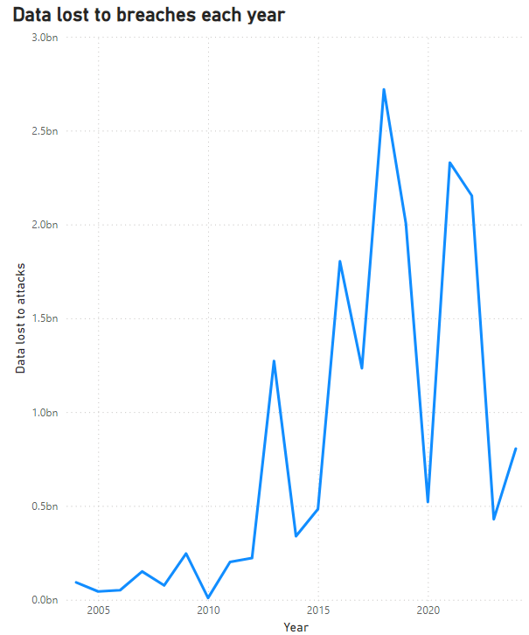
Figure 1. Amount of data lost to large data breaches each year since 2004.

[1] Organisations have a legal obligation to protect all sensitive data from cybercriminals. To fulfil this obligation, various cyber security practices are created to provide a robust system that protects, detects and reacts to any potential data security threat.
Figure 2 [15] demonstrates how hacking has been the dominant cause of data breaches for the last 20 years.
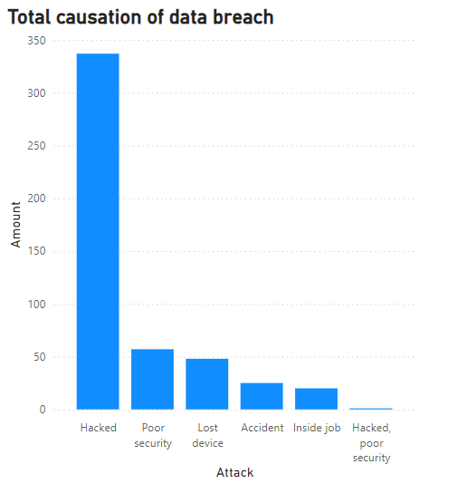
Figure 2. A count of what caused each data breach.
Examples of these practices include [2] the implementation of access controls, data encryption and security software. These practices aim to enhance data security by utilizing different perspectives. Access controls focus on ensuring individuals or servers that have access to data are limited to only what they require for their functionality. Security software such as antivirus software focuses on catching any malicious software present on an authorized computer before any breach can occur.
The questions of what cryptography is, what different types of cryptography exist, how these types differ from each other, and what forms these cryptography types take, are all important questions to understanding the role cryptography plays in protecting digital information, securing sensitive data and ensuring compliance. This paper answers all these questions through its respective sections.

What is Cryptography
Cryptography [4-5] is the utilization of specialized techniques developed to safely store data and ensure any communication comes from an authorized source, while [6] preventing any entity that could intercept the data stream from viewing the data.
The specialized techniques use advanced algorithms to protect the data. Given a string of text of any definable length that is readable to humans, it is passed through an advanced cryptographic algorithm to convert the text into a non-readable format. The unreadable text is known as [5] “cypher text”. For the cypher text to become readable again, it must be decrypted by use of an encryption key that only the intended recipient carries.
[4] Cryptography is commonly used in applications such as securing and authenticating passwords, where if a hacker gains access to the database, they will not be able to identify the password due to its unreadable format. Additionally, it is used to secure communications between users by shielding the data being relayed. Protocols such as the “Secure Sockets Layer” (SSL) and “Transport Layer Security” (TLS) utilize cryptography to protect the data stream.

Types of Cryptography
There are two primary types of Cryptography, [6] symmetric and asymmetric cryptography. While both are used to secure data, they differ slightly. The naming convention is centralized around whether two separate keys are used for encryption and decryption.

Symmetric Cryptography
[6] Symmetric Cryptography is when the same key is used to encrypt outgoing data and decrypt incoming data. In this method, there is the additional consideration of implementing a secure channel to transfer the key between the two clients. Figure 3 demonstrates the process of symmetrical cryptography.

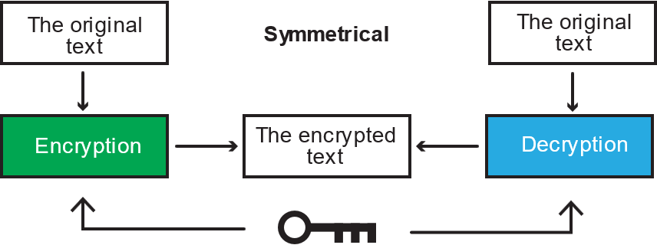
Figure 3. Symmetrical cryptography where the same key is used for encryption and decryption

[25] A primary challenge in utilizing symmetric cryptography is being able to distribute the key securely. If the key were to be lost or the key was intercepted in motion to the intended recipient, encryption of the data becomes pointless as hackers can decrypt and read the data. This challenge means that for any data that needs to be communicated over a medium, asymmetric cryptography should be utilized.

Asymmetric Cryptography
[6] Asymmetric Cryptography on the other hand uses two keys, one is used for encrypting the outgoing data, and the other is used for decrypting the incoming data. These are typically referred to as the “private” and “public” keys, where the private key is usually restricted to one owner and the public key is well known to a group of people varying in size depending on the data.
Once the data has been encrypted using the public key, there is no way to decrypt the data without the private key. This means the only way the information can be viewed is with the private key, offering a secure channel of communication without the possibility of an interception. Figure 4 demonstrates how asymmetrical cryptography works.

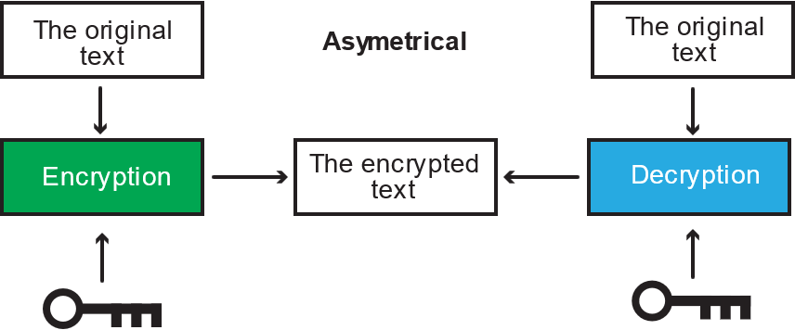
Figure 4. Asymmetrical cryptography where two separate keys are made for encryption and decryption

Hash Cryptography
[4-7] There is often confusion regarding whether hashing is an encryption method, however it is not. Hashing differs from encryption [7] in their purposes.
The purpose of encryption is to provide a secure way to transfer data from one location to another without any interference. However, the purpose of hashing is to prove the authenticity of the data. The data gets passed through a hashing algorithm such as [8] SHA-512. This process transforms data of any length into a fixed-length message.
[4, 8] Any hash function should ensure the output data is unique, given two different inputs into the hash function they should not return the same output. This is called “collision resistance”. Hash functions also aim to ensure that the process of finding the original input data is extremely difficult, alongside making finding a different input that produces the same hash output extremely difficult.

Encryption Algorithms

What is an Encryption Algorithm?
[9] An encryption algorithm refers to a mathematical process that will convert a string of text from a readable format into a secure unreadable format. For increased security, they can contain multiple layers of encryption alongside other implementations such as scrambling the positions of the original text (repeated permutation).

Symmetric Algorithms

Triple Data Encryption Standard (3DES)
[10] 3DES is a cryptographic method that is an advanced adaptation of the original Data Encryption Standard (DES) cryptographic algorithm. DES is a type of symmetric cryptography method that contains a lengthy eight-step process for both encryption and decryption. The key used in DES cryptography to decrypt and encrypt the data contains 56 bits.
3DES and DES differ in the fact that the length of the key used to encrypt and decrypt the data is 168 bits (triple the length). This key consists of three sub keys unlike the key used in DES.
3DES was recently [11-12] disallowed on 31st December 2023 for encryption other than certain circumstances due to it no longer being considered secure in comparison to modern algorithms due to the limitations in the size of individual keys.

Advanced Encryption Standard (AES)
An algorithm considered to be the replacement for 3DES is AES, [13] primarily due to its larger key sizes and originally having a practical use case in both hardware and software applications. AES is another symmetric encryption algorithm that has been adopted and used by the US government for 23 years. AES is considered the industry standard in terms of symmetric cryptographic methods. There are multiple different AES encryption methods for different use cases. They differ in the capacity of the key used to encrypt and decrypt data, alongside the amount of encryption rounds taken to process the data. Key sizes of 128, 192, and 256 are used in AES.
While all AES encryption methods are considered secure, using a lower number of bits for the key results in a lower level of security in a trade-off for faster processing, and while AES has been widely adopted and is a trusted encryption method, it is worth noting that it is still susceptible to brute force attacks given a large enough resource and must be implemented correctly.

Asymmetric Algorithms

Rivest–Shamir–Adleman (RSA)
RSA is [14-15] an encryption algorithm that is widely used today and can be found in popular electronic appliance companies that use RSA in their chips. RSA uses a public and private key, where the keys are calculated from a complex mathematical formula containing two prime numbers multiplied together and a random coprime number.
[15] The algorithm is utilized where secrecy is required or to prove the authenticity of communication such as a digital signature. To send a message to someone, the recipient must provide their public key. The sender can then use this key alongside a padding scheme to encrypt the message and forward it to the recipient, where it will only be decryptable by their private key.
While still one of the most widely used encryption methods today, it is questionable whether RSA is still a secure method to use. RSA is susceptible to brute force attacks, where an attacker will neverendingly input different numbers into the algorithm to retrieve the key and the data behind the encrypted text. However, it is worth noting that this would take an incredibly long time due to the nature of prime numbers creating complexity in mathematical formulas. One team needed the equivalent of 2,700 years running computer cores to break the code.

Elliptic Curve Cryptography (ECC)
[15] ECC is an encryption algorithm based on the principle of elliptical curves. The algorithm utilizes the properties of an elliptic curve to generate a private and public key, where the private key is calculated by choosing a random number greater than 1, and less than a specific limit which is determined by the properties of the elliptic curve.
On the other hand, the public key is then calculated using a formula that involves the private key and a specific point on the elliptic curve, which is known as the generator point. The recipient can then share their public key with anyone they wish to receive a message from, and they can decrypt the message using their private key.
One benefit of ECC over RSA is the key is significantly smaller, using a 164-bit key to encrypt the data versus a 1024-bit key for RSA. This results in less resources being used to encrypt the data to be communicated. It is [16] generally reported that RSA is approximately 10 times slower than ECC for “signature generation or key management” and is significantly slower in terms of key generation by up to 1000 times slower.

Real World Applications

Secure Communication
[17] Secure communication is one of the primary situations where cryptography is utilized. Cryptographic algorithms are utilized in the [21] TLS protocol which is the primary protocol used in the modern day to ensure communication between two clients is secure by encrypting the transmitted data, alongside digitally signing the data to ensure the data has not been modified.

The predecessor SSL protocol was invented due to any information that was connected to the internet was transmitted in plaintext. This means anyone could intercept the message and read the data, which causes significant security concerns. If a person were to insert their national insurance number into a website without SSL or TLS, anybody connected to the internet would be able to see it and cause significant issues for the individual.
Figure 5 demonstrates a login form, where the data should be encrypted to prevent any hackers from intercepting and possibly securing access to the account.

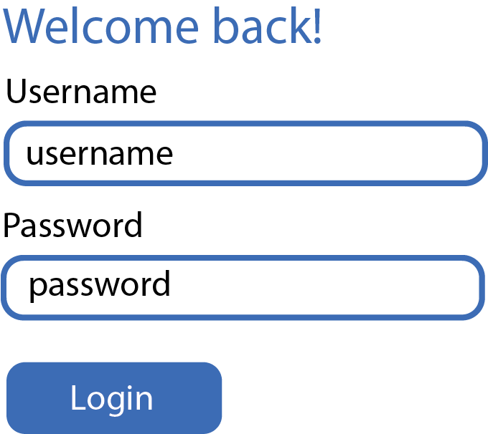
Figure 5. A typical login form that communicates a username and password to a server for access to a service.

A survey by GlobalSign, [19] an organisation that manages millions of digital identities, [18] found that 84% of customers will halt purchasing any products from a company if their data is not being transmitted over a secure connection, and approximately 29% of individuals specifically looking for an SSL certificate, which makes it highly beneficial to organisations from a sales perspective to use TSL/SSL.
[20] Additionally, the UK GDPR requires all organisations to ensure that personal data is processed securely. Encryption is specified as one measure to protect personal data. This means by implementing cryptographic methods in communications, the company is contributing towards its legal requirement of protecting personal data.

Quantum Computing Cybersecurity
[23] While cryptography is essential for secure communications today, in the future many cryptosystems will be futile with the introduction of large quantum computers, [22] a new technology that is theorized to outclass any modern-day supercomputer. [23-24] Quantum computing is a threat to our current encryption techniques due to the premise that the significant amount of processing power they could possess would mean they could initiate a brute force attack that would take an incredibly shorter amount of time.
However, the concept of post-quantum cryptography could allow organisations to be ready to protect against the potential security threat of quantum computing by increasing the size of the encryption key significantly. This means it is vital for organisations to stay up to date with current cryptographical advances and security measures, to protect their data against any cyber security attack done via quantum computing.

Result
This paper delves into the topic of cryptography, alongside its various types and the various applications it has in ensuring data is stored and communicated securely. The examination of the different cryptographic techniques revealed the following findings:

Symmetric Cryptography
Symmetric cryptography utilizes the same key for encrypting and decrypting data. It is best suited for closed systems where the task of securely transmitting the key is not a large task or not required.

Asymmetric Cryptography
Asymmetric cryptography is a suitable solution for transmitting data over an open network securely due to utilizing a public and private key. Unlike symmetric cryptography, designing a secure method of delivering the key is not required as the public key can be shared openly, while the private key is kept secluded. Some asymmetric algorithms such as RSA can have an impact on the performance of a system, however.

Hash Cryptography
While often confused as an encryption method, hash functions still play a crucial role in data integrity and authentication. Hash functions such as SHA-512 provide robust security measures by ensuring data authenticity and providing collision resistance, which makes discovering the original text and receiving the same hash output from two different inputs difficult.

Encryption Algorithms
In terms of symmetric algorithms, AES and similar algorithms remain the industry standard as a contribution to their balance of security and performance. Whereas for asymmetric algorithms, both RSA and ECC offer suitable security standards for exchanging keys and digital signatures, however, ECC is more efficient in terms of both key size and computational requirements.

Real World Applications
Cryptographic techniques are an essential component in secure communication, found in protocols such as TLS/SSL which are primary protocols for encrypting transmitted data over the internet. Organisations must stay up to date with any cryptographic advancements to ensure they protect against future threats such as quantum computing. This means they must also review their implementations often to ensure they are meeting their legal obligations set forth by regulations such as the GDPR, alongside ensuring they maintain sales.

Conclusion
In today’s world, digital communication is one of the most essential components in organisational operations. As a result, the number of hackers who launch cyber-attacks on these systems will only continue to increase.
This paper has demonstrated how cryptography and its related components play an essential role in the design process of making online communication secure, and its role in protecting IT systems and infrastructure, while ensuring an organisation meets its legal obligations and keeps customer and organisational data secure, which in turn results in trust from their customers.
Organisations must stay up to date on any advancements in cryptographic technology to counter any emerging threats such as quantum computing. With any new advancements, the organisation must review their existing security implementations and updates where necessary to mitigate risks.
To summarise, the implementation of cryptographic techniques is essential to create a secure digital environment. Organisations need to adopt a security framework that focuses on protection, detection, and reaction mechanisms. By regularly reviewing existing infrastructure and implementing any new technologies that aim to increase security while maintaining and updating existing technologies, an organisation can ensure they safeguard their digital assets, remain compliant with regulations, and retain consumer trust.

Case Scenario
Kallum Michael Doyle
Student University of Wales, Trinity Saint David, Swansea, Wales
2237962@student.uwtsd.ac.uk

Abstract- The integration of technology in life has led to an exponential increase in the amount of data stored and generated online. Organisations must implement effective information security measures to outline the processes of securing this data. This report summarises information regarding multiple security measures an organisational security unit can implement to protect customer and organisational data. Some key measures include a risk management system, clear policies and procedures and network security tools like firewalls.
Additionally, this report showcases how important it is to continuously monitor various systems and implement a system to report and respond to security incidents while outlining the importance of ensuring compliance with data protection regulations. Contingency planning is also emphasized as it provides the organisation with a plan to continue operations during cyber-attacks, and the report also emphasizes providing regular employee training on cyber threats and security protocols as it allows for the strengthening of the organisation’s defences.
Through the integration of these strategies, an organisation can develop an information security unit with in-depth strategies to safeguard data against cyber threats, which ensures long-term security and compliance, alongside operational uptime and the protection of an organisation's integrity. The findings demonstrate the need for ongoing adaptation and reviewal of security measures to ensure their strength.

Introduction
In a world where technology is becoming more prevalent, the line between online and the real world becomes thinner every day. Information is being increasingly created and stored digitally, [26] approximately 403 million terabytes of data a day, and each year the amount of data generated annually has only increased since 2010.
With the ever-increasing reliance on technology to store data, companies must have a system to safeguard organisational and customer data. This report outlines an approach to developing a new information security unit and reviews the importance of different factors of varying influence that go into creating a strong information security unit. The [40] figure below demonstrates the world's ever-increasing reliance on technology, through the increasing e-commerce sales from 2009 to 2019.

Figure 6. A graph demonstrating the increase in e-commerce sales from 2009 to 2019 in businesses with a workforce larger than 10 employees.

The more dominant factors that impact how the security unit functions include creating appropriate policies, procedures, and security standards, and implementing a maintenance and planning system for data security.
Factors with a lesser impact but still influence how the security unit should function include the structure of the organisation, remaining compliant with data protection regulations, having plans for contingency cases and managing risk.

Data Protection Compliance and Security Standards
[29] Some essential considerations must occur regarding the development and maintenance of the information security unit. These considerations are essential in making standards for the organisation to follow, regarding maintenance and development. Some of the most important considerations include:

A risk management system.
A risk management system helps an organisation assess and manage the risks faced.

Procedures for systems and personnel
Procedures that outline security measures for reporting a security incident ensure operational damage is minimized and that any future chance of the same or any incident is minimized. Additionally, procedures for managing user privileges help keep access to sensitive information to a minimum.

Education and training
Measures designed to educate employees on common cyber-attack methods can help prevent data breaches by ensuring employees stay vigilant. When an employee encounters a potential physical or online attack, they could utilize their knowledge to stop it.

Network security
An organisation needs to be aware of all risks associated with network connections. Any network connection can contain potentially vulnerable exploits that can be exposed.

Monitoring
Implementing a method of monitoring organisational systems enables the detection of any successful or attempted attacks. An organisation needs to implement a monitoring system as it can reduce the impact of any attack significantly if responded to promptly, and it will allow the organisation greater analysis of how these attacks are occurring.

Data Protection Compliance
[31] All organisations need to comply with data protection regulations. Organisations must plan for compliance to become a regular part of organisational procedures, which also must be reviewed regularly. They not only benefit the customers but also the organisation.
For an organisation to comply with data protection regulations, it is important to be wary of what personal data is required for company operations. Organisations must only collect and hold the necessary data for their operations. This means an organisation should not retain an individual's address if they cannot explain why they need to store it.
The data must be securely stored and when no longer needed destroyed securely. Data should be destroyed securely because [32] just hitting the delete button can result in the data still being rebuildable. Depending on the way the data is stored depends on how the data is destroyed. For example, onboard storage on monitors can have any sensitive data removed by displaying non-sensitive data on the screen for several minutes.
In the instance of storage devices such as Hard Disk Drives (HDDs) however, HDDs should have their data removed with a strong magnetic field by a method called degaussing, before each platter is broken up into four equal-sized pieces. Figure 7 provides a visual concept of this process.


Figure 7. A diagram depicting the process of destroying all data on each hard disk platter

On the other hand, the advisable way to erase data from a Solid-State Drive (SSD) is to check whether the manufacturer provides a data erasure tool. This makes data erasure very effective. If the manufacturer does not provide one, however, it is impossible to determine that all data has been erased. Therefore, it is advisable for organisations to only use SSDs from manufacturers with known data erasure tools.

Contingency Planning and Planning for Security

Planning for security
[34] Modern-day attackers can utilize a wide range of methods to access secure information. As a result, it is important companies are ready for these attacks, which makes it essential to plan to protect digital information. This can be done by developing and maintaining countermeasures to known attack methods.
Countermeasures vary in the way they work and what they target. A countermeasure such as a key entry system is designed to prevent any physical access to the infrastructure, while countermeasures exist to protect against unwarranted access via an online connection.
In this case, a company might utilize measures such as firewalls that [35] have a wide array of applications, such as next-generation firewalls (NGFWs). These are by far the most advanced version of firewalls, as they cover most applications in a network where security is required, from the physical to the virtual. NGFWs can gather data, which enables specialists to act on any discovered vulnerabilities.

Contingency planning
[36] After any cyber-attack occurs, an organisation must have a way to maintain operations in which it utilizes any secure information. This is important to ensure that in the following attack, the business is affected minimally operationally, which in turn means any revenue lost is minimized.
There are a few types of contingencies planning an organisation should implement. One of the key types of planning is the business continuity plan. This plan focuses around having procedures in place to ensure in the incident of a disruption, key services can carry on. This includes customer service or payroll processing.
To implement any type of contingency planning, an organisation should first analyse its operational processes alongside the resources it takes to run them to identify which aspects are the most critical. Finally, a risk assessment should take place to determine what and how severely each process could affect the business if it were taken down.

Risk Management and Organisational Structure
[28] Risk management enables organisations to monitor, consider and control a range of different risks they could potentially face. There are many different types of risks, such as legal liabilities or technology issues.
A well-known standard of risk management [27-28] would be the ISO 31000 standard, developed for a system where both employees and employers take responsibility and know the “importance of monitoring and managing risk”. An organisation can implement the guidance provided by this standard by reviewing the organisation’s key objectives and assessing the current governance structure.
By performing these two tasks, an organisation can develop a better understanding of what tasks are required for achieving the key objectives, and therefore identify and analyse any risks present in these tasks.
Additionally, by reviewing the current governance structure, information regarding organisational roles and their responsibilities will be revealed. Given this information, a review of the risk level each role provides can occur, and appropriate action to mitigate this risk can follow.

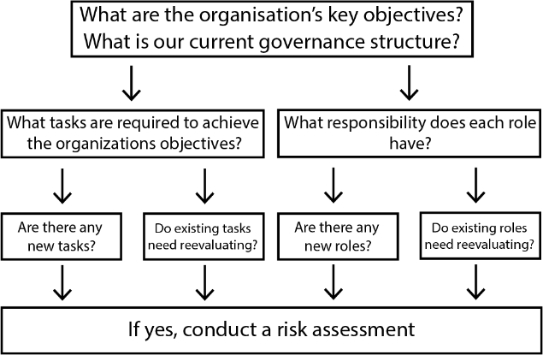

Figure 8. A demonstration of the risk assessment process.

For example, if the organisation conducts annual reviews into the governance structure, they may make note of a new role that carries a lot of risk such as a manager who has access to a wide range of systems but only needs access to a portion. Action can then be taken to reduce the access to the required databases to mitigate the chance of a breach occurring. [30] This follows an important principle in IT called the Principle of Least Privilege (POLP), whereby by reducing the access level to only the amount required, the number of methods a hacker can take to cause a data breach is minimized.
The ISO 31000 also provides guidelines for defining the number of resources that should be allocated for managing the risk management system. This allows for the growth and development of the risk management system as the organisation grows.

Policies and Procedures
Any security system requires [37] a definition and determination of how security will be upheld within the organisation. Implementing policies and procedures that are clearly understood and enforced without exception is essential to ensuring all internal employees know of their duties in information security.
Policies and procedures relate to each other, where the procedure is based on the policy. A policy should be an array of principles relating to the security of information. They can be limited in the amount of information provided. Procedures provide an expansion on what policies are in place and describe how they should be used within the organisation. Procedures should be backed by legal requirements to ensure organisations are meeting their legal duties, and they should be made easy to understand to assist all employees with following procedures safely.
[38] On the other hand, policies should revolve around “confidentiality, integrity and availability” to maximize security. By considering confidentiality, unauthorized access to people both inside and outside of the organisation is prevented. Integrity involves consideration of the accuracy and non-interference of unauthorized sources of internal data to ensure organisational data is usable. Finally, focusing on availability allows for a determination of whether certain entities need access to classified data.
Examples of policies that should be implemented include an acceptable user policy and password management. The former describes the proper way to utilize digital resources and information, so everyone is aware of the correct process for utilizing the technology. The latter should be implemented to outline what a strong password is, as passwords are often the key to accessing confidential information.
[39] A strong password should consist of at least 12 characters and a combination of different characters, alongside words that have no relation to you personally. Outlining how to keep passwords secure should also be a consideration, which can be done by not sharing the password and creating a unique password for every application that requires one.

Designing the Unit
Given the research conducted above, an information security unit can now be designed with the above measures in place. By implementing the following steps, the organisation can create a strong legally compliant information security unit that can protect against potential threats. The unit should:

Risk Management System
Implement a sufficient risk management system that allows the assessment and management of potential threats. The system should be able to identify, analyse and determine the priority of each risk, with follow-up measures to mitigate them.

Policies and Procedures
Develop and ensure enforcement of policies and procedures that are easy to understand. The policies should be centralized around the concepts of confidentiality, integrity and data availability. Examples of such policies include acceptable use and password management, and all procedures should be regularly reviewed to ensure the standards are up to date, alongside being legally compliant.

Network Security
Enhance network security by implementing advanced tools such as NGFWs that allow for identifying and addressing found vulnerabilities through monitoring of the network. The firewall should be regularly updated to mitigate the chance of any attacks.

Monitoring and Incident Response
Establish a monitoring system to detect and respond to security incidents as quickly as possible. Additionally, procedures should be implemented to report and manage these incidents to minimize any damage and prevent the situation from occurring in the future. The unit should regularly review and update these procedures.

Data Protection Compliance
Implement strict data management practices to ensure compliance with data protection regulations. The unit should ensure only necessary data for the organisation's operations is collected, and that the data is stored securely when in use. When no longer required, tools such as degaussing for HDDs and manufactured-provided erasure tools for SSDs should be used to securely destroy any confidential information on the devices.

Contingency Planning
Develop a business continuity plan to ensure operations are as unaffected as possible during and after a cyber-attack. Critical processes and resources should be identified, followed up by a risk assessment to determine any inherent vulnerabilities. Additionally, plans should be created to support essential operations such as customer service or processing payroll during and after any attacks.

Training and Education
Educate employees on how cyber-attacks can occur and methods to prevent them. The unit should conduct regular training sessions with all employees with access to sensitive data to ensure they are aware of security protocols and recognise potential threats.

Conclusion
Creating an information security unit is essential in today’s world, where data is being generated and stored all day. Several key components are important to establish a strong security framework, starting with the risk management system which allows for assessing and mitigation of security threats. Policies and procedures that are clear should additionally be in place, whose key components are confidentiality, integrity and availability of data to ensure employees can understand their responsibilities.
Network security defences such as NGFWs are essential tools to protect the network against vulnerabilities. In the case of an attack, a monitoring and incident response system will allow the organisation to detect threats swiftly, and systematically manage any security breaches. This allows for minimal damage and minimizes the chance of recurrence. Strict data management is essential to being compliant with data protection regulations, whether the data is currently in storage or is to be destroyed when no longer required.
Developing a business continuity plan and other forms of contingency planning is an essential part of maintaining operations through the before and after of a cyber-attack. Identifying critical processes and applying risk assessments to them, ensures critical functions continue with minimal disruption. Finally, by providing mandatory training and education for employees on cyber threats and organisational security protocol, the strength of the organisation's defence against cyber-attacks is increased.
Through the integration of these elements, the result will be a strong information security unit within an organisation that can efficiently safeguard organisational and customer data against data breaches. Reviewing and adapting in place measures regularly means the organisation will experience long-term resilience against data breaches and will remain compliant with legal standards, ensuring the organisation’s integrity stays intact and operations continue when the organisation is faced with potential cyber-attacks.

References
[1]
‘Data Security: Definition, Importance, and Types’, Fortinet. Accessed: Jul. 01, 2024. [Online]. Available: https://www.fortinet.com/resources/cyberglossary/data-security
[2]
‘Data Security Best Practices to Protect Your Business’, Netwrix. Accessed: Jul. 01, 2024. [Online]. Available: https://www.netwrix.com/data-security-best-practices.html
[3]
‘Cybersecurity History: Hacking & Data Breaches’, Monroe College. Accessed: Jul. 10, 2024. [Online]. Available: https://www.monroecollege.edu/news/cybersecurity-history-hacking-data-breaches
[4]
‘What Is Cryptography? | IBM’. Accessed: Jul. 11, 2024. [Online]. Available: https://www.ibm.com/topics/cryptography
[5]
‘Defending Yourself from a Man in the Middle Attack’, www.kaspersky.com. Accessed: Jul. 11, 2024. [Online]. Available: https://www.kaspersky.com/resource-center/threats/man-in-the-middle-attack
[6]
‘What types of encryption are there?’ Accessed: Jul. 12, 2024. [Online]. Available: https://ico.org.uk/for-organisations/uk-gdpr-guidance-and-resources/security/encryption/what-types-of-encryption-are-there/
[7]
‘Hashing vs. Encryption: Definitions & Differences | Okta UK’. Accessed: Jul. 12, 2024. [Online]. Available: https://www.okta.com/uk/identity-101/hashing-vs-encryption/
[8]
I. T. L. Computer Security Division, ‘Hash Functions | CSRC | CSRC’, CSRC | NIST. Accessed: Jul. 12, 2024. [Online]. Available: https://csrc.nist.gov/projects/hash-functions
[9]
‘Cryptographic algorithms - AWS cryptography services’. Accessed: Jul. 15, 2024. [Online]. Available: https://docs.aws.amazon.com/crypto/latest/userguide/concepts-algorithms.html
[10]
‘Ratnadewi, R. P. Adhie, Y. Hutama, A. Saleh Ahmar, and M. I. Setiawan, “Implementation Cryptography Data Encryption Standard (DES) and Triple Data Encryption Standard (3DES) Method in Communication System Based Near Field Communication (NFC),” Journal of physics. Conference series, vol. 954, no. 1, pp. 12009-, 2018, doi: 10.1088/1742-6596/954/1/012009.’, [Online]. Available: https://www.proquest.com/docview/2571967517
[11]
E. Barker and A. Roginsky, ‘Transitioning the use of cryptographic algorithms and key lengths’, National Institute of Standards and Technology, Gaithersburg, MD, NIST SP 800-131Ar2, Mar. 2019. doi: 10.6028/NIST.SP.800-131Ar2.
[12]
‘Why 3DES Or Triple DES Is Officially Being Retired?’ Accessed: Jul. 15, 2024. [Online]. Available: https://www.encryptionconsulting.com/why-3des-or-triple-des-is-officially-being-retired/
[13]
‘AES encryption definition – Glossary | NordVPN’. Accessed: Jul. 15, 2024. [Online]. Available: https://nordvpn.com/cybersecurity/glossary/aes-encryption/
[14]
‘RSA Encryption: Definition, Architecture, Benefits & Use | Okta UK’. Accessed: Jul. 15, 2024. [Online]. Available: https://www.okta.com/uk/identity-101/rsa-encryption/
[15]
I. is Beautiful, ‘World’s Biggest Data Breaches & Hacks’, Information is Beautiful. Accessed: Jul. 15, 2024. [Online]. Available: https://informationisbeautiful.net/visualizations/worlds-biggest-data-breaches-hacks/
[15]
Data from A. Zargar, M. Manzoor, and T. Mukhtar, ‘Encryption/Decryption Using Elliptical Curve Cryptography’, International Journal of Advanced Research in Computer Science, vol. 8, no. 7, Jul. 2017, Accessed: Jul. 15, 2024. [Online]. Available: https://www.proquest.com/docview/1931125055/abstract/745E028D126B4377PQ/1
[16]
K. Maletsky, ‘RSA vs. ECC Comparison for Embedded Systems’, 2020, [Online]. Available: https://ww1.microchip.com/downloads/en/DeviceDoc/00003442A.pdf
[17]
J. Schneider, ‘Cryptography use cases: From secure communication to data security’, IBM Blog. Accessed: Jul. 16, 2024. [Online]. Available: https://www.ibm.com/blog/cryptography-use-cases/www.ibm.com/blog/cryptography-use-cases
[18]
‘Why You Should Be Establishing SSL Trust for Your Business’, KeyCDN. Accessed: Jul. 16, 2024. [Online]. Available: https://www.keycdn.com/blog/ssl-trust

[19]
‘GlobalSign | THINK Digital Partners : THINK Digital Partners’. Accessed: Jul. 16, 2024. [Online]. Available: https://www.thinkdigitalpartners.com/directory/digital-id/globalsign/
[20]
‘Encryption’. Accessed: Jul. 16, 2024. [Online]. Available: https://ico.org.uk/for-organisations/uk-gdpr-guidance-and-resources/security/a-guide-to-data-security/encryption/
[21]
‘What is SSL (Secure Sockets Layer)?’ Accessed: Jul. 16, 2024. [Online]. Available: https://www.cloudflare.com/learning/ssl/what-is-ssl/
[22]
‘Explainer: What is a quantum computer?’, MIT Technology Review. Accessed: Jul. 16, 2024. [Online]. Available: https://www.technologyreview.com/2019/01/29/66141/what-is-quantum-computing/

[23]
D. J. Bernstein and T. Lange, ‘Post-quantum cryptography’, Nature, vol. 549, no. 7671, pp. 188–194, Sep. 2017, doi: 10.1038/nature23461.
[24]
‘Explainer: What is post-quantum cryptography?’, MIT Technology Review. Accessed: Jul. 16, 2024. [Online]. Available: https://www.technologyreview.com/2019/07/12/134211/explainer-what-is-post-quantum-cryptography/
[25]
‘What is Symmetric Cryptography? - Utimaco’. Accessed: Jul. 16, 2024. [Online]. Available: https://utimaco.com/service/knowledge-base/keys-secrets-management/symmetric-cryptography
[26]
‘Amount of Data Created Daily (2024)’, Exploding Topics. Accessed: Jul. 17, 2024. [Online]. Available: https://explodingtopics.com/blog/data-generated-per-day

[27]
‘What is Risk Management and Why is It Important?’, Security. Accessed: Jul. 17, 2024. [Online]. Available: https://www.techtarget.com/searchsecurity/definition/What-is-risk-management-and-why-is-it-important
[28]
‘ISO 31000 - Risk management’, Risk management, [Online]. Available: https://www.iso.org/publication/PUB100426.html
[29]
L. Irwin, ‘What are the 10 steps to cyber security?’, IT Governance UK Blog. Accessed: Jul. 17, 2024. [Online]. Available: https://www.itgovernance.co.uk/blog/what-are-the-10-steps-to-cyber-security

[30]
‘What Is the Principle of Least Privilege?’, Palo Alto Networks. Accessed: Jul. 17, 2024. [Online]. Available: https://www.paloaltonetworks.com/cyberpedia/what-is-the-principle-of-least-privilege

[31]
‘Getting started with data protection’. Accessed: Jul. 22, 2024. [Online]. Available: https://ico.org.uk/for-organisations/advice-for-small-organisations/frequently-asked-questions/getting-started-with-data-protection/
[32]
‘Secure sanitisation of storage media’. Accessed: Jul. 22, 2024. [Online]. Available: https://www.ncsc.gov.uk/guidance/secure-sanitisation-storage-media
[33]
‘Step 2 - Protecting your organisation from malware’. Accessed: Jul. 22, 2024. [Online]. Available: https://www.ncsc.gov.uk/collection/small-business-guide/protecting-your-organisation-malware

[34]
T. R. Rakes, J. K. Deane, and L. Paul Rees, “IT security planning under uncertainty for high-impact events,” Omega (Oxford), vol. 40, no. 1, pp. 79–88, 2012, doi: 10.1016/j.omega.2011.03.008.
[35]
‘Benefits & Challenges of Firewalls: What Businesses Need to Know’. Accessed: Jul. 22, 2024. [Online]. Available: https://nordlayer.com/learn/firewall/benefits-of-firewall/
[36]
J. Maurer, B. Clark, and Y. B., “SOHO: Information Security Awareness in the Aspect of Contingency Planning,” International journal of advanced computer science & applications, vol. 6, no. 10, 2015, doi: 10.14569/IJACSA.2015.061003.
[37]
‘Policies, Standards, Guidelines & Procedures | NPSA’. Accessed: Jul. 22, 2024. [Online]. Available: https://www.npsa.gov.uk/insider-risks/policies-standards-guidelines-procedures
[38]
‘What Is an IT Security Policy?’, Fortinet. Accessed: Jul. 22, 2024. [Online]. Available: https://www.fortinet.com/resources/cyberglossary/it-security-policy
[39]
‘Create and use strong passwords - Microsoft Support’. Accessed: Jul. 22, 2024. [Online]. Available: https://support.microsoft.com/en-gb/windows/create-and-use-strong-passwords-c5cebb49-8c53-4f5e-2bc4-fe357ca048eb
[40]
Data from ‘E-commerce and ICT activity - Office for National Statistics’. Accessed: Jul. 24, 2024. [Online]. Available: https://www.ons.gov.uk/businessindustryandtrade/itandinternetindustry/datasets/ictactivityofukbusinessesecommerceandictactivity

