

[ENVIRONMENTAL RISK AND INHERITED GENETIC FACTORS AFFECT THE DEVELOPMENT OF SKIN CANCER IN UK ADULTS: A SYSTEMATIC REVIEW]

by

Priyaben Bhupendrabhai Patel

A Dissertation submitted in partial fulfilment of the requirements for the degree of Masters of Science in Public Health and Social Care in Practice

The Institute of Inner-City Learning
University of Wales Trinity Saint David – London Campus

2025-26

DECLARATION

I, Priyaben Bhupendrabhai Patel declare that this dissertation has been composed by myself, that the work contained herein is entirely my own except where explicitly stated otherwise in the text, and that this work has not been submitted for any other degree or qualification, in whole or in part, except as specified.

Priya patel
Signed:……………………………………………
24/09/2026
Date:...………………………………………………

Acknowledgements

I want to showcase my gratitude to the supervisors who gave me this golden opportunity to perform the research in this topic’ Environmental Risk and Inherited Genetic Factors Affect the Development of Skin Cancer in UK Adults: A Systematic Review’. Without their help and support completing this vast research work feels challenging for me. I also want to thanks my parents and friends for their love a throughout supports.

Abstract
This study intends to conduct a systematic literature review and synthesis of available literature regarding the role played by environmental and genetic risk factors in the development of skin cancer among adults in the UK. For gathering secondary evidence from academic databases and credible health-related sources, this study used a systematic literature review method. Inclusion and exclusion criteria was used for screening the studies for ensuring reliable and credible data for proposing valid and meaningful conclusions. Ethics were followed for marinating academic integrity.
Findings revealed that UV radiation acts as a major environmental factor for the development of skin cancer. Where individual vulnerability also increases with family history and inherited genetic susceptibility. Lastly, there were also some personalisation areas that could be done to manage the skin condition, which include genetic and genomic testing, polygenic risk score, proper skin cancer surveillance, and chemoprophylaxis. The results obtained from this chapter have shown that skin cancer pathogenesis is indeed multifaceted and cannot be attributed solely to environmental factors or genetic factors individually. The discussion in this chapter calls for an integrative perspective where both environmental exposure and genetic risk are addressed.
Recommendations emphasise the targeted UV-protection campaigns, integration of family history and ultimately genetic susceptibility into risk assessment, and combined environmental-genetic screening. These approaches could assist in strengthening the personalised prevention while detection diseases early among the UK adults, although behavioural barriers, resource requirements and limited evidence on gene–environment interactions might hinder the implementation.

Table of Contents
Chapter 1: Introduction 10
1.1 Introduction 11
1.2 Background to the Study 11
1.3 Research Context and Problem Statement 13
1.4 Rationale for the Study 14
1.5 Research Question 14
1.6 Aims of Research 14
1.7 Objectives of Research 15
1.8 Scope of the Study 15
1.9 Significance of the Study 15
1.10 Chapter Summary 16
1.10 Structure of the Dissertation 17
Chapter 2: Literature review/theoretical framework 19
2.1 Introduction 20
2.2 Theoretical Framework 20
2.3 Environmental Risk Factors Affecting Skin Cancer Development 22
2.4 Inherited Genetic Factors and Susceptibility to Skin Cancer 26
2.5 Analyse the Interaction Between Environmental and Genetic Factors 28
2.6 Personalised Prevention, Early Screening, and Targeted Treatment Interventions for High-Risk Groups 31
2.7 Literature Gap 33
2.8 Conceptual Framework 34
2.9 Chapter Summary 35
Chapter 3: Research Methodology 36
3.1 Introduction 37
3.2 Research Philosophy 37
3.3 Research Approach 39
3.4 Research Design 39
3.5 Research Strategy 40
3.6 Data Collection Method 40
3.7 Data Extraction 41
3.8 CASP Assessment 45
3.9 Inclusion and Exclusion Criteria 45
3.10 Data Analysis Method 46
3.11 Reliability and Validity 47
3.12 Ethical Considerations 48
3.13 Summary 48
Chapter 4: Results 49
4.1 Introduction 50
4.2 Thematic Coding 50
4.3 Thematic Analysis 52
4.4 Summary 65
Chapter 5: Discussion 66
5.1 Introduction 67
5.2 Discussion on Theme 1 67
5.3 Discussion on theme 2 69
5.4 Discussion on theme 3 71
5.5 Discussion on Theme 4: 73
5.6 Limitations 74
5.7 Recommendations for Future Research 74
5.8 Conclusion 75
Chapter 6: Conclusion 76
6.1 Key Summary 77
6.2 Answer to the Research Question 77
6.3 Recommendation 79
6.4 Reflection 80
6.5 Contribution of the Research 80
6.6 Final Conclusion 81
Reference list 82
Appendix 1: Skin Cancer: Genetics and Prevention 100
Appendix 2: Diagrammatic representation of the detailed mechanism of tumor vascularization 101
Appendix 3: CASP 102

List of figures
Figure 1.1: Riskiest skin cancer cases hit the UK 13
Figure 1.2: Dissertation Structure 18
Figure 2.1: Newly diagnosed cases of skin melanoma cancer in England 23
Figure 2.2: Burden of Cancer Results 24
Figure 2.3: Genetic risk factors for melanoma 27
Figure 2.4: Variation in Ultraviolet-B (UV-B)-induced DNA damage repair mechanisms in plants and humans 29
Figure 2.5: Skin cancer: understanding the journey of transformation from conventional to advanced treatment approaches 32
Figure 2.6: Conceptual Framework 34
Figure 3.1: Saunders Research Onion 36
Figure 3.2: PRISMA Flow Diagram 40
Figure 4.1: Solar radiation on human health 47
Figure 4.2: Workers work in high sunlight 48
Figure 4.3: An Epidemiological Update 49
Figure 4.4: Gene–environment 50
Figure 4.5: FAMMM syndrome 51
Figure 4.6: Environmental & health impacts 53
Figure 4.7: Pathway in DNA repair systems 55
Figure 4.8: Polygenic Risk Scores (PRS) Mapping 57
Figure 4.9: Chemoprevention in Skin Cancer 57

List of tables

Table 3.1: PRISMA Flow Diagram 41
Table 3.2: Braun and Clarke's Six-Step Thematic Analysis Framework 42
Table 4.1: Thematic Coding Table 46

List of abbreviations
UV – Ultraviolet Radiation
DNA- Deoxyribonucleic acid damage
AAD- American Academy of Dermatology
BAD- British Association of Dermatologists
BCNS- Basal Cell Nevus Syndrome
BRAF B-Raf Proto-Oncogene, Serine/Threonine Kinase
CDK4- Cyclin-Dependent Kinase 4
CDKN2A- Cyclin-Dependent Kinase Inhibitor 2A
DNA- Deoxyribonucleic Acid
FAMMM- Familial Atypical Multiple Mole Melanoma
GEN- Genomics England
HSE- Health and Safety Executive
IARC- International Agency for Research on Cancer
MC1R- Melanocortin 1 Receptor
NHS- National Health Service
NLM- National Library of Medicine

Chapter 1: Introduction

1.1 Introduction
The purpose of the chapter is to introduce the research topic “Environmental risk and inherited genetic factors affect the development of skin cancer in UK adults: a systematic review”. These chapters demonstrate the background of the research, outlining the skin cancer growing prevalence and its importance as a public health concern. Therefore, objectives, research question, aim, research problem, and rationale are outlined in this research that direct the study. At the end of the chapter, the significance and scope of the research have been emphasised and the analysis of its contribution to existing knowledge. Dissertation structure presents an overview and directs the audience through the subsequent chapters.

1.2 Background to the Study
Skin cancer is emerging as the most significant form of cancer that raises a public health concern in the UK due to associated health burdens and increasing incidences. Pecorelli and Valacchi (2022, p.1) illustrated that skin cancer rises when abnormal skin cells experience uncontrolled growth for the reason of the damage to their DNA caused through the UV exposure. Therefore, non-melanoma skin cancers (NMSC), melanoma, squamous cell carcinoma (SCC), and basal cell carcinoma (BCC) with melanoma are different skin cancer forms and are responsible for the skin cancer-related deaths (Roky et al. 2025, p.91).
This is supported through the Roberts (2026) report, which discloses that melanoma had 20,980 new cases (2022) within the UK, and most of them were seen for the reason of the deadliest skin cancer found in the figure below. These facts clearly point towards the fact that increasing prevalence of melanoma shows the inability to prevent melanoma has failed to cover the effects of accumulated environmental impact along with genetic susceptibility, so a simultaneous evaluation of various contributing risk factors (Hasan et al. 2023, p.3) is required. This assessment has facilitated a better understanding and improved earlier detection, the implementation of customised approaches to risk management and prevention and the development of tailored treatment options for the at-risk population.
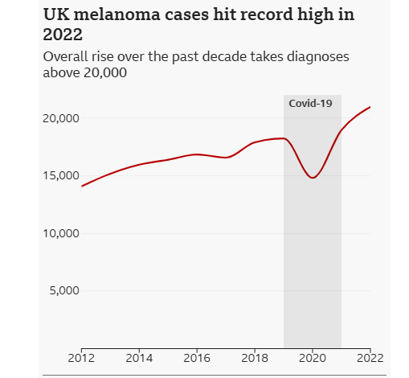

Figure 1.1: Riskiest skin cancer cases hit the UK
(Source: Roberts, 2026)
Globally, melanoma emerges as an increasing concern as the Agency for Research on Cancer reports that in 2022, almost 332,000 new melanoma cases were reported, and almost 80% of cases has been caused by UV radiation exposure (International Agency for Research on Cancer, 2025). As a result, it outlines the environmental factors, such as the use of sunbeds, excessive sun exposure, and inadequate sun-protection behaviours substantial contribution to skin cancer development.
Besides that, the Fiasconaro et al. (2025, p.1) emphasised the inherited factors like genetic mutations CDKN2A and MC1R, including family history, which raise an adult's susceptibility to skin cancer. Increasing skin cancer in the UK affects the health of all by raising health costs through taking the healthcare services and the pressures on the health service, and by imposing damage upon a patient's health status and therefore quality of life.
Therefore, a brief understanding of the inherited genetic risk factors as well as environmental factors is important for aiding personal prevention strategies, targeted interventions and early detection programmes aimed at decreasing the skin cancer burdens among UK adults.

1.3 Research Context and Problem Statement
Research Context
Skin cancer within the UK has become a public health concern as the affected rates constantly rise in spite of the ongoing awareness campaigns, upgrades in treatment options and improvements in diagnostic techniques. Gaining knowledge about these factor commit to skin cancer development, which is very important. Therefore, Royalmarsden (2026) report demonstrated that within the UK, almost 15,400 people suffer from melanoma, and it has been found that within the UK, it is the 5th most common cancer, which highlights that multiple cases are potentially preventable. On the other hand, skin cancer has emerged as a multifactorial condition encouraged through inherited genetic susceptibility and environmental exposures.
Merin et al. (2022, p.4) illustrated that UV radiation exposure, like an environmental risk factor, emerges as the most important contributor to skin diseases. This is supported by Thomas's (2025) research, which presents that every year in the UK, 87% of melanoma cases, “equivalent to 17,100”, are found because of overexposure to UV radiation. As people are often exposed to extreme amounts of UV exposure, thus showing that sun exposure has not been the key determining factor. However, the high focus in the research on UV exposure has overemphasised the contribution of this factor to the pathogenesis of disease. Lifestyle factors and occupational factors (prolonged daytime hours outside), and the use of sunbathing, tanning beds and not adequately covering oneself from the sun (Ward et al 2024, p1). In spite of the enhancement of public awareness, these growing high-risk behaviors highlight that knowledge individually has not changed the preventive actions.
Problem Statement
In spite of the extensive research, the past evidence remains fragmented as multiple researches analysis the genetic and environmental risks instead of considering their mixed effects. Besides the limited knowledge about how these important factors work to impact skin cancer development between adults in the UK (Fiasconaro et al. 2025, p.1). To mitigate these gaps, the current research will synthesis existing evidence and systematically review the inherited genetic risk factors to offer brief knowledge about their contribution to the risk of skin cancer and provide treatment strategies and personalised prevention.

1.4 Rationale for the Study
In the UK, skin cancer constantly emerges as a public health challenge, outlining the requirement for a better understanding of the risk factors. Harris et al. (2024, p.4) research analyses the inherited genetic susceptibility, and it sometimes separately investigates the isolations, and it offer minimum understanding about the disease risk. Therefore, literature written based on public health, epidemiology, genetics and dermatology. As a result, gaining knowledge about a transparent understanding of risk and because factors related to skin cancer development emerges as challenging. Here, conducting a systematic review is justified as it offers a transparent and rigorous method for synthesising, assessing and identifying evidence from different sources. Finally, through consolidating knowledge, this research aided risk assessment strategies, screening and future prevention.

1.5 Research Question
What are the environmental risk factors and inherited genetic influences contributing to the development of skin cancer among UK adults, and how can this knowledge support improved personalised prevention and treatment strategies?

1.6 Aims of Research
The aim of this study is to systematically review and synthesise existing literature on the role of environmental and genetic factors in the development of skin cancer in UK adults, in order to inform more effective personalised prevention and treatment approaches.

1.7 Objectives of Research
- To evaluate the impact of environmental risk factors, including UV radiation exposure, occupational sun exposure, and lifestyle behaviours, on the incidence of skin cancer in UK adults.
- To examine the role of inherited genetic factors and family history in increasing individual susceptibility to skin cancer.
- To analyse the interaction between environmental and genetic factors in influencing skin cancer development.
- To identify evidence-based strategies for personalised prevention, early screening, and targeted treatment interventions for high-risk groups.

1.8 Scope of the Study
This research concentrates on the inherited genetic and environmental factors that relate to skin cancer development among 18-year-old individuals. Therefore, this review has considered secondary evidence as well as credible reports and published academic literature that are associated with non-melanoma and melanoma skin cancers and included within this research.
The research has investigated the environmental risk factors, like lifestyle behaviours, occupational sun exposure, and UV radiation exposure, as well as family history and inherited genetic susceptibility. To give assurance of the currency and relevance of the evidence, the research published between 2022 and 2026 has been reviewed. These boundaries are made to assure that reviews link with the research objectives as they are manageable and focused.

1.9 Significance of the Study
This research is significant as academically these research address the gaps found in literature through offering brief analysis of existing evidence on inherited genetic and environmental factors link with skin cancer development within UK (Merin et al. 2022, p.4). Through implementing the findings from the different researches these study will raise knowledge about how these factors commit to the disease risk and offer a base for future research.
Apart from that, from a clinical perspective, these research findings have helped the health care professionals in finding out peoples that can face the increased skin cancer risk. As a result, growing understanding of genetic susceptibility and environmental exposures has aided effective risk assessment, personalised prevention strategies and early detection, mainly for high-risk populations.
At the end, these research findings aided the policymakers to establish the evidence-related policies associated with the skin cancer screening programmes, occupational UV protection and sun safety and skin cancer screening programmes. Through informing the resource allocation decision and prevention strategies, this study has the strength to commit to decreasing the skin cancer burden and raising population health outcomes, mainly among adults within the UK.

1.10 Chapter Summary
This chapter explaining the rising trend of skin cancer and its relevance to public health issue. The significance of the study has been illustrated at the end of the chapter, explaining its contribution to existing literature. Structure of the dissertation provides a brief insight to further chapters.

1.10 Structure of the Dissertation

Figure 1.2: Dissertation Structure
(Source: Self-Developed)
This dissertation is divided into six parts. Where Chapter 1 introduces objectives, questions, as well as scope, rationale, and significance of the research. Chapter 2 analyses the relevant literature on the factors of inherited genetic and environmental factors, linking to the theoretical framework and skin cancer. Chapter 3, emphasising the systematic review, along with the data analysis methods and data collection procedures, outlines the research methodology. Chapter 4 analyses the findings taken from the secondary studies and presents results. Within Chapter 5, findings are discussed in association with the existing literature and research objectives. At the end of Chapter 6, the findings are concluded, offers recommendations and presents the conclusion and finding out areas for future research.

Chapter 2: Literature review/theoretical framework

2.1 Introduction
This chapter critically analyses the past literature that associates with the inherited genetics and environmental factors that connect with skin cancer. The purpose of the literature review chapter is to develop knowledge, debates within the literature, find out the significant patterns, and lastly, find out gaps that justify the requirement for this research. Therefore, with the help of the systematic examination of past literature, this literature chapter offers empirical and theoretical foundation for gaining knowledge about critical causes of skin cancer.
Therefore, the chapter emphasised themes like environmental risk factors like lifestyle behaviours, occupational sun exposure, and UV radiation exposure, as well as family history and inherited genetic susceptibility. It also analyses the interactions among the genetic and environmental factors and analyses the relevant theoretical points of view that assist to analysis the skin care development.
Moreover, this literature chapter is aligned with the research objectives through assessing the existing data on inherited genetic risk and environmental factors and their mixed impact on skin cancer development. These chapters offer the base for addressing the research question and finding out the integrations for targeted interventions, early detection and personalised strategies.

2.2 Theoretical Framework
Gene–Environment Interaction Theory
Combined effect of an individual’s genetic susceptibility and their exposure to the environment resulted in disease development from the perspective of the view from Gene–Environment Interaction Theory (Agustíet al., 2022, p. 512). However, the interaction of these factors is dynamic and context-dependent rather than acting independently (Zhang and Belsky, 2022, p. 296). In the context of skin cancer development, the application of this theory is highly significant. Ultraviolet (UV) rays are a key detriment in damaging skin, where the genes of an individual affect whether the body is capable of protecting and repairing itself from UV-induced damage. Melanin is less produced in the body when there is MC1R gene mutation (Liu et al., 2024, p.2).
Lower levels of melanin in the body decrease the natural protection from the UV rays. As a result, there is a higher risk of skin damage and skin cancer. Thus, even in similar environmental conditions, individuals with these variants are exposed to a high level of DNA damage compared to others without these variants (Liebmann et al., 2023, p.754). This indicates that the variability in DNA repair capacity and pigmentation genes resulted in diverse levels of risk in the development of skin cancer. Deeper insights into environmental factors and inherited gene factors' impact on UK adults' skill development chances can be explained with the application of this theory.
Multifactorial Disease Theory
Complex diseases arise in a body influenced by the integrated influence of behavioural, environmental and genetic factors, as supported by the Multifactorial Disease Theory, which is a well-known biological and epidemiological theory. There is a multifactorial condition which is responsible for the development of skin cancer (Muresanu and Khalchitsky, 2022, p.343). Thus, it cannot be explained only by UV exposure, even though it is one of the primary causes of this cancer. In contrast, when it is explained with only one factor, like UV rays, it oversimplifies the complexity of skin cancer. Rather than gaining better insights into the UK adult people susceptibilty to skin cancer, there is a requirement to look at a varied range of factors like skin type, inherited risk, exposure range to the sun due to occupation and lifestyle behaviour (Shraim et al., 2023, p.2). Different outcomes may be received in a similar kind of environment with protective behaviour and genetic susceptibility. Overall, skin risk among UK adults can be reduced by adopting robust and integrated prevention strategies.
Somatic Mutation Theory of Carcinogenesis
In an individual’s body, uncontrolled cellular growth and tumour formation are the direct results of too many genetic mutations, posing negative impacts on normal cells from the viewpoint of the Somatic Mutation Theory of Carcinogenesis (Monti et al., 2022, p.1). DNA within skin cells, particularly in melanocytes and keratinocytes, damages with the exposure to UV rays, which often results in skin cancer. DNA damage needs to be repaired in the body; otherwise, it can have a negative impact on important genes. Important genes, when they are unable to control how cells grow, divide, die, and repair themselves, can results into abnormal growth of cells. Abnormal cell growth in the body is prevented with key genes like CDKN2A that minimise the risk of skin and other types of cancer development in the body (Gopalakrishnan et al., 2025, p.1428). From the view of this theory, it has been noted that environmental exposure leads to changes in DNA in the body over time, which often results in cancer development. Thus, in gaining insights into biological and environmental impact on UK adults' skin cancer development, the application of this theory is justified.

2.3 Environmental Risk Factors Affecting Skin Cancer Development
Solar ultraviolet radiation has become the reason for the environmental risk factor and causes cancers within skin as intermittent exposure and prolonged exposure raise the likelihood of tumour development and DNA damage (Neale et al. 2023, p.1). Cancerresearchuk (2025) reports support these through presenting that melanoma incidence rates have raised almost 164%, and it continuously grow 26% over the last decade. These growing numbers emphasised that adults have continuously exposed to UV radiation for the reason of the lifestyle’s behaviourism, outdoor recreations and occupational activities, and it raises their cumulative life exposures.
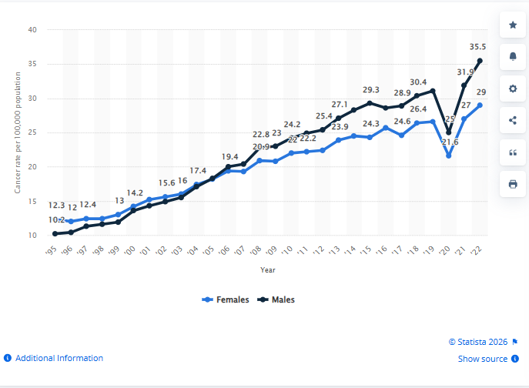

Figure 2.1: Newly diagnosed cases of skin melanoma cancer in England
(Source: Stewart, 2026)
On the other hand, though the solar UV radiation emerges as an environmental risk, it brings opportunities for the prevention of skin cancer as UV exposure decreases through public health interventions and behavioural interventions argue by Cherrie and Cherrie (2022, p.47). The above figure supports these by emphasising a temporary decline that was found in 2020, and it reached 25.0 per 100,000 from 30.4 per 100,000, presenting a 17.8% decrease (Stewart, 2026). These data emphasised that the skin cancer risk has decreased with the help of effective prevention measures and outlined the value of sun protection behaviours and awareness campaigns. This evidence is justified as the high number of reported melanoma skin cases in UK adults represents a continued trend, influenced by UV exposure, and so identifying its link with health in the general population has allowed this risk factor to be removed in future through preventive measures, reducing melanoma cases.
From sunbeds, artificial UV radiation has emerged as a significant environmental risk factor, emphasising that indoor tanning raises the chances of other skin cancers as well as developing melanoma. WHO (2017) research support these through presenting that before the age of thirty-five, the first use of sunbeds raises the risks of melanoma by almost 59%. This is because DNA alterations created from artificial exposure to UV radiation highlight damage caused by sun radiation and raise the risk of mutations linked to skin cancer. International Agency for Research on Cancer (2009) places the UV-emitting tanning devices in the same category as asbestos and tobacco smoking as it is a Group 1 carcinogens UV-emitting tanning devices.
Therefore, Maria Neira, WHO Director, supports these and stated that “There’s no doubt about it: sunbeds are dangerous to our health, and Countries need to consider whether to ban or restrict their use, and to inform all users about the health risks” (WHO, 2017). The argument is justified as the growth in melanoma risks relates to early sunbed use. In spite of the enhancing scientific evidence related with indoor tanning and harmful impacts in some populations, presenting that public health interventions and stronger regulations are needed to lower preventable skin cancer cases.
In contrast, recognising artificial UV radiation emerging from the sunbeds brings opportunity for skin cancer prevention as the awareness campaigns a regulations guide adults to change their behaviours (Akram et al. 2025, p. 236). Therefore, it is aided through the evidence from Australia as between 2015 to 2016 commercial solariums were banned, here that line up with the artificial UV exposure become the reason for skin cancer. As 43 melanoma deaths occur annually along with 2,800 skin cancer cases found and the research presents that the melanoma risk is almost 59% higher before the age of 35 (Medsana, 2026). The argument is justified as the Australian experience illustrates that understanding the risks, the regulatory measures sometimes prevent the intervention. As a result, sunbed utilisation can be avoided, and it decreases skin cancer causes relate with mortality within UK adults. This point of view aided the Multifactorial Disease Theory through emphasising that modifying environmental factors, like artificial sunbeds, decreases the likelihood of skin cancer development in spite of underlying genetic susceptibility (Muresanu and Khalchitsky, 2022, p.3).
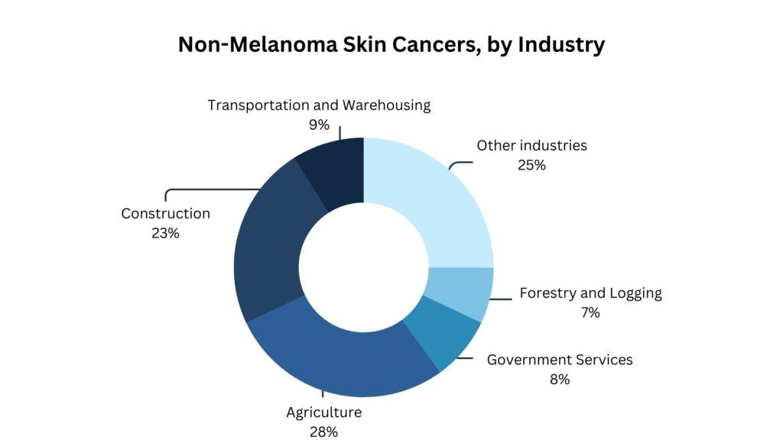

Figure 2.2: Burden of Cancer Results
(Source: Occupational Cancer Research Centre, 2025)
However, the risk factors associated with occupational sunlight exposure have been documented by Ward (2023, p.1), where the contribution of individual behaviour and skin type towards skin cancer development was identified. CAREX Canada (2024) states that construction workers and farm labourers have increased exposure to the sun and develop non-melanoma skin cancer (Occupational Cancer Research Centre, 2025).
The above figure discloses that almost 1.5 million workers face solar radiation, and 23% of workers from construction and 28% of workers from agriculture develop UV-related cancers within them. This argument is justified as occupational and environmental exposures alone are inadequate to account for the profound variations in the incidence of skin cancer within a population who work within similar circumstances. Over-emphasising the effect of UV exposure in the occupational setting while disregarding the possible influence of susceptibility has led to an inaccurate assessment of skin cancers.
Recreational exposure to the sun, emerge as a behavioural risk factor, has not fully able to analysis the development of the disease in question, as other populations of adults can be subjected to the same experience of radiation and present different results illustrated by Laschewski and Matzarakis, (2022, p.1). Cancer Research UK (2024) reports support these through presenting 87% of melanoma cases within the UK, aligning with the overexposure of UV radiation (Thomas, 2025). On the other hand, these report also discloses the behavioural differences where 35% of women face skin cancer on their lower limbs, and 40% of males face melanomas within the torso. As a result, these differences emphasise that UV exposure is the reason for skin cancer among adults, though different factors like family history and skin pigmentation influence individual vulnerability to UV-induced damage.

2.4 Inherited Genetic Factors and Susceptibility to Skin Cancer
Inherited genetic factors contributes prominent while measuring an individual’s risk for the development of skin cancer. However, this factor’s measurement in isolation is not effective in providing a broader picture of the context; rather, there is a requirement to consider the varied environmental context. From the view of Gene–Environment Interaction Theory, it has been noted that individuals’ disease development is impacted by the combination of genetic and environmental factors (Cobaleda et al., 2024, p.397). In the context of an individual’s exposure to UV rays, DNA damage. However, the extent of damage depends on the gene of an individual. For instance, while measuring the likelihood of skin cancer development among UK adults, both factors measurement is significant.
Wunderlich et al. (2024, p.1), cited that a higher inherited risk of skin cancer development is indicated with a family history, particularly melanoma. In contrast, individuals with no such history face less risk of developing skin cancer. Shared genetic variants alongside environmental factors like exposure to sunlight also determine the risk of skin cancer development. Inherited gene changes significantly affect the body’s ability in controlling excessive growth of cells. Whereas Saeed et al., (2024, p.2) stated that, despite a family history of skin cancer, there is no guarantee of the development of skin cancer across all members in the family. The reason behind this is the influence of environmental and behavioural factors. It indicates that genetic predisposition alone is not sufficient to discuss skin cancer development among people.
Physical traits like reduced melanin production, red hair and fair skin are directly linked to the MC1R gene. Individuals are more vulnerable to skin cancer when they have reduced melanin in the body, as it acts as natural protection against UV rays. Calbet‐Llopart et al., (2022, p.754), noted that a person’s risk of developing skin cancer is influenced in a low-to-moderate manner by the influence of MC1R gene variations, though they are not the only factor responsible for skin cancer development. While the CDKN2A gene is responsible for controlling the growth of the cell. However, there can be a higher risk of the abnormal growth of cells when this gene is damaged (Danishevich et al., 2023, p.1). Comparing the CDKN2A gene with the MC1R gene, it can be stated that there is a stronger influence on the changes in the CDKN2A gene. However, this gene mutation is only seen in a small number of people. In malignant transformation, there is a significant impact of UV exposure, which highlights the requirement for an interactive model of disease development.
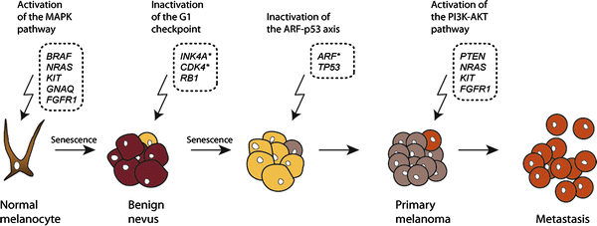

Figure 2.3: Genetic risk factors for melanoma
(Source: Link.springer, 2026)
Castellani et al., (2023, p.1), opined that in melanoma, the BRAF gene mutation is commonly found, which is a sign of abnormal growth of cells. From a contrasting viewpoint, Shreberk-Hassidim et al., (2023, p.1), highlighted that in benign nevi, which are harmless moles, there is the presence of BRAF gene mutations. Thus, in the explanation of cancer development, the presence of this mutation is not only sufficient. Besides this genetic heredity, environmental exposure needs to be explained collectively, which supports the combined genetic–environmental causation model’s perspective.
For finding high-risk individuals of developing skin cancer, the genetic screening for mutations such as MC1R and CDKN2A is significant at the current time. Targeted interventions in terms of behavioural change and surveillance can be adopted with the early detection (Susanto et al., 2025, p.1). However, a clear sign is not revealed from genetic variations; it is challenging to predict who has a higher possibility of developing skin cancer. For better understanding, there is a requirement to combine genetics with environmental factors. An integrated model that combines behavioural, genetic, and environmental data for the review of skin cancer development is highly effective. However, in the UK clinical practice, the development and wider implementation of this model are limited.
Genetic research is highly advanced in the current time, though there is a limitation in understanding the nature of skin cancer development due to a single-factor focus. The multifactorial nature of skin cancer can only be understood when there is a focus on the combined factors that affect it (Benachour et al., 2026, 165). Longitudinal studies focusing on diverse genetic backgrounds and sun exposure behaviours within the UK context can be effective in gaining insights into the likelihood of skin cancer development among adults. Well understanding of inherited genetic factors and environmental factors leads to early level of detection and supports a personalised and robust prevention approach against skin cancer.

2.5 Analyse the Interaction Between Environmental and Genetic Factors
The relationship between what we are exposed to and the commonest potentially lethal cancer, skin cancer, has become apparent for some years now. Thus, skin cancer development is thought to be the result of multiple exposures as well as inherited genetic susceptibility. In the UK, there are more than 17,000 new cases of melanoma diagnosed each year. Skin cancer is one of the most common cancers in the UK, says Cancer Research UK. It shows that excessive UV exposure is the primary environmental risk factor and accounts for 85-90 percent of melanomas (Cancer Research UK, 2026). However, it does not mean all who receive the same dosage of UV rays develop skin cancer, so there are also other genetic factors involved. As an EXAMPLE, people with fair skin, red hair, and blue eyes, and mutations in genes such as MC1R have less natural protection against UV-induced DNA damage (Ascsillán and Kemény, 2024). An illustrative UK example is the rise in melanoma levels among people of Northern European descent living in recreationally sunny areas. Zhang, and Belsky, (2022), presented a pattern that supports Gene-Environment Interaction Theory, which states that genetically programmed character causes the individual’s response towards the environmental risk character. Therefore, the incidence of skin cancer cannot be fully explained by environmental exposure alone; it requires consideration of biological susceptibility as well as behavioural and environmental factors.
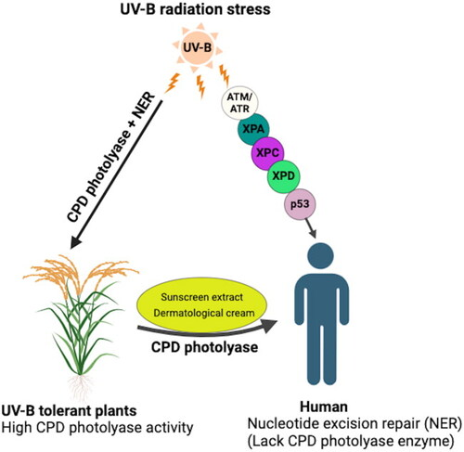

Figure 2.4: Variation in Ultraviolet-B (UV-B)-induced DNA damage repair mechanisms in plants and humans
(Source: Mmbando, 2024)
Shraim et al., (2023), explains that environmental stimuli act alongside any gene mutation to make you more likely to develop skin cancer. Some genes which significantly raise the likelihood of having melanoma have been located over many years of study. Among these are BRAF, MC1R and CDKN2A. Fiasconaro et al., (2025) reports that the lifetime risk associated with being CDKN2A positive increases considerably with a predicted melanoma risk of as high as 50% especially for a history of high UV exposure. Also a genetic family history of melanoma represents one of the major melanoma risk factors as acknowledged by UK National Health Service and UK dermatology registers. An example of a real-life situation is the occurrence of FAMMM syndrome, which results in mutations that predispose an individual to a higher chance of developing cancer. However, Gbemudu, (2023), finds that most mutation carriers do not suffer from skin cancer unless they subject themselves to environmental triggers such as sunburn and use of tanning beds. The above example illustrates multifactorial disease theory since diseases arise due to the interaction between genetic and environmental factors (Muresanu and Khalchitsky, 2022). The theory explains the failure of the genetic predisposition. Similarly, preventive efforts to reduce environmental exposures are still needed even in genetically susceptible populations.
The importance of personalised prevention and treatment strategies lies in the interaction of environmental and genetic factors. Clark et al., (2022), report that the clinician’s ability to identify high-risk individuals through genetic screening and risk profiling has accelerated with genomic medicine. For instance, dermatology practices are beginning to recommend increased surveillance for patients with a significant family history of melanoma or a known mutation. In parallel, there are many ongoing public health and patient-based campaigns that advocate for sun safe practices such as sunscreen and wearing UV protective clothing and seeking shade during peak UV times (Sugden et al., 2024).
Wu et al., (2023), pointed out that the individual who has alternative variants of the gene MC1R shall not be affected by melanoma where they utilize the right and suitable techniques to be safe from the sunrays. Also, Ciombor et al., (2022) noted that the pathway that patients with mutated tumours have taken has shifted due to drugs that have mutations of BRAF and various mutations directed. But Groos et al., (2024), mention that the analysis of these interactions is key to reducing the burden of skin cancer in the UK adult population. This shows that genetic knowledge could be used to make decisions regarding clinical practice. As per the Gene-Environment Interaction Theory and Multifactorial Disease Theory, skin cancer arises due to the interaction between biological susceptibility and the environment.

2.6 Personalised Prevention, Early Screening, and Targeted Treatment Interventions for High-Risk Groups
Recognising effective evidence-based personalised prevention strategies is increasingly seen as an approach which can reduce skin cancer in high-risk populations. According to Cancer Research UK, around 86% of melanoma cases in the UK have preventable causes, primarily due to excessive exposure to ultraviolet (UV) radiation. In contrast, according to WHO’s latest statistics, exposure to ultraviolet radiation is the number one risk factor from the environment that causes skin cancer and leads to hundreds of thousands of new cases per year (WHO, 2022). Thus, the results indicate that preventive measures need to be taken by people who are more prone to this disease. For instance, the risk is markedly higher than average for people with light skin, multiple atypical moles, a family history of melanoma, and genetic variants such as MC1R. Tando, and Matsui, (2023), reports that a person’s genetic inheritance alters that individual’s biological response to Environmental exposures (such as UV rays)–this is the core of Gene-Environment Interaction Theory. With this in mind, tailored preventive strategies – such as targeted education, behavioral counselling, sustained sunscreen use, and avoidance of indoor tanning are likely to have a bigger effect among genetically at-risk groups. Consequently, Susanto et al., (2025), suggest moving away from generic prevention campaigns towards risk-stratified interventions that deal with environmental and genetic determinants of skin cancer aetiology.
According to Yang et al., (2023), taking an earlier screen can reduce mortality risk and suffering for at risk patients. In Britain, it is stated by the National Health Service and Cancer Research UK, that more than 90% of people survive with early diagnosis of melanoma. Also, the ability to use skin check with the help of a global dermatology program can also help diagnose very thin melanomas before metastases form (Martin et al., 2024). For instance, individuals who have the FAMMM syndrome have a higher life expectancy and therefore are routinely tested by Dermatology (Siddiqui et al., 2025). The idea of Multifactorial Disease claims that disease is governed by a number of genes and environmental factors. In other words, it tells you that it could be a combination of anything. Therefore, screening programmes that include family history, genetic susceptibility, skin phenotype, and environmental exposures are more likely to identify those who need close surveillance. Nonetheless, Siddiqui et al., (2025), concerned that the blanket use of genetic screening may incur costs and cause anxiety for patients, which they believe entails a risk. While Asgari, and Crane, (2023) indicate that screening will be of great benefit to someone who is at the highest risk of skin cancer.
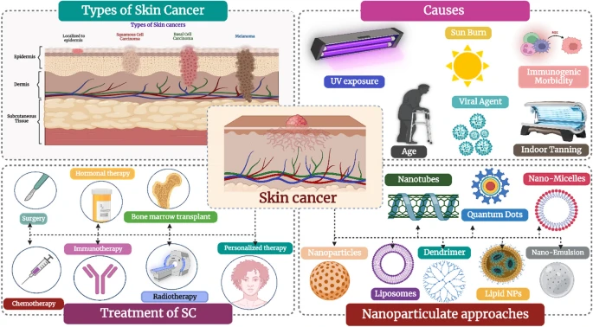

Figure 2.5: Skin cancer: understanding the journey of transformation from conventional to advanced treatment approaches
(Source: Hasan et al., 2023)
Hasan et al., (2023) reports that targeted therapeutic interventions have revolutionized the management of skin cancers as therapies can be customized based on the genetics of the tumor and risk of the patient. One of the major advances in treatment is the use of BRAF inhibitors for patients with melanoma BRAF gene mutation that occurs in almost 40–50% of melanomas (Lopes et al., 2022). Various clinical studies have indicated that targeted drugs dabrafenib and vemurafenib can effectively increase the survival rates of cancer patients compared to regular chemotherapy. In addition, Fujimura et al., (2022), stated that immunotherapies such as checkpoint inhibitors have contributed to the rates of advanced melanoma patients in the UK and around the world. For instance, genetic testing incorporated in the NHS cancer pathway is leading to more personalized treatment of cancer based on individual tumors. Muresanu,and Khalchitsky, (2022), suggested that Gene-Environment Interaction Theory says that damage to the environment interacts with genetic defects in the individual to cause the development of a tumour. While, Multifactorial Disease Theory states that there is a progressive mechanism of multiple biological and environmental forces which contribute to the disease and its response to treatment.
These clinical and theoretical perspectives underscore the importance of personalized medicine in skin cancer care. Therefore, genetics-guided prevention and screening and treatment interventions, will ultimately combine with each other to improve outcomes among high-risk populations and reduce overall skin cancer burdens.

2.7 Literature Gap
Although many studies have been carried out investigating the effects of external risk factors such as ultraviolet rays, occupational exposure to sunlight, artificial tanning beds, and personal habits in the development of skin cancers. In Neale et al., (2023) and Ward, (2023), both authors concentrate on examining the effect of the mentioned risk factors independent of the genetic susceptibility factors. Similarly, according to Danishevich et al., (2023), various genetic risk factors have been associated with skin cancer. For example, changes in MC1R, CDKN2A, and BRAF genes, with inadequate information about the interaction between genetic susceptibility and environmental risk factors that lead to skin cancer among adults in the UK.
Moreover, Zhang and Belsky, (2022), stated that whereas the Gene–Environment Interaction Theory and the Multifactorial Disease Theory stress the joint impact of the biological and environmental determinants, in the UK. Moreover, Muresanu and Khalchitsky, (2022) have conducted in this respect and have not attempted to examine whether the knowledge acquired through such an approach could be used for devising personal prevention approaches for people at high risk in the UK. Hence, there is a huge research gap regarding the examination of the interaction of the inherited genetic susceptibility with the environmental risks in relation to the occurrence of skin cancer among adults in the UK.

2.8 Conceptual Framework
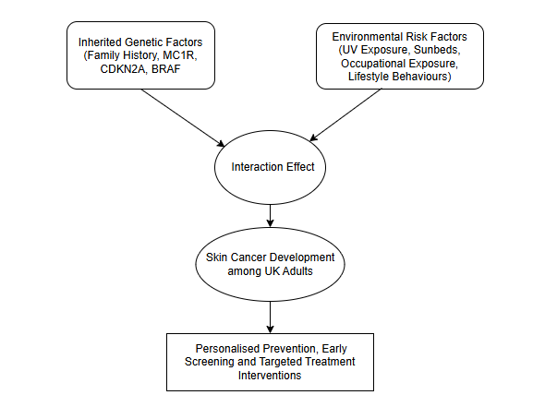

Figure 2.6: Conceptual Framework
(Source: Self-developed)
The conceptual framework of this study is grounded on the notion that the development of skin cancer among adults in the UK is related to the interplay of inherent genetic factors and environmental risks. Inherent genetic susceptibility (family history, mutations in MC1R, CDKN2A, and BRAF genes), UV radiation, occupational sun exposure, indoor tanning, and lifestyle activities constitute independent variables that operate to determine skin cancer development, which is considered a dependent variable. The framework operates through the principles of Gene-Environment Interaction Theory and Multifactorial Disease Theory.

2.9 Chapter Summary
It is concluded that decreasing indoor tanning practices through effective public health actions can decrease skin cancer. It is concluded that inherited genetic factors and environmental relative contribution offer knowledge about how their interaction impacts skin cancer development. From a Theoretical Point of View, it has also decided through the theory that Ultraviolet (UV) rays were the major damaging effect and that it relied upon an individual's genes for how a body can prevent and repair itself. With the figures rising it is thought that Adults will be repeatedly exposed to UV rays as a result of lifestyle behaviours, outdoor pastimes and work roles, and this will build their cumulative lifetime exposures. Factors like fair skin, low melanocyte activity and red hair being connected to MC1R clearly identified the need for a model which interacted as a disease pathway.
Inherited genetic components have also been reported to contribute significantly to an individual's overall likelihood of contracting skin cancer. However, next chapter should demonstrate an absence of skin cancer in one member of the family is not necessarily an indicator for whether other members of the same family will go on to develop the condition themselves. Despite the identification of both the set of key inherited factors and environmental factors of relevance, much of the evidence reported considered these factors separately from one another, with little emphasis on their combined effects on skin cancer risk; hence, to mitigate these gaps required systematic investigation.

Chapter 3: Research Methodology

3.1 Introduction
This chapter provides a detailed discussion on the secondary methodology utilized in this study, aimed at understanding the contribution of environmental and genetic factors towards skin cancer in adult patients in the UK. As per Saunders, (2023) this method presents research philosophy, research approach, research design, data collection methods, inclusion and exclusion criteria, data analysis methods, and ethical considerations to explain the significance of this study. To consolidate the available information about the topic, a systematic review methodology will be utilized in this research.
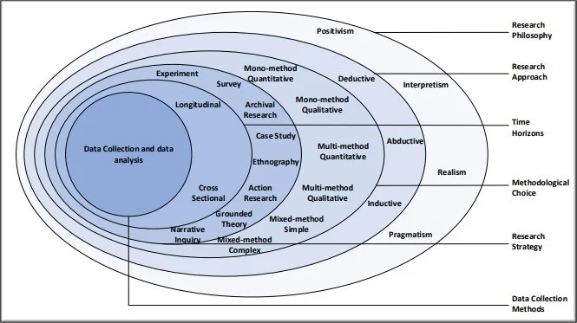

Figure 3.1: Saunders Research Onion
(Source: Saunders, 2023)

3.2 Research Philosophy
The research philosophy is an approach consisting of beliefs and assumptions about knowledge and methods of its production. The following by Saunders, (2023) research framework four types of philosophies are used in the research process, such as positivism, interpretivism, realism, and pragmatism.
Positivism
This philosophy stresses objective measurements and hypothesis testing based on the use of quantitative data, which particularly focuses on measurable data (Gamage, 2025).
Interpretivism
This philosophy is aimed at the comprehension of social and scientific events by means of existing meanings and experiences, which sees reality as subjective (Pervin, and Mokhtar, 2022).
Realism
This philosophy is a combination of objectivity and subjectivity of interpretations, which assert the existence of entities of a controversial kind (Zhang, 2023).
Pragmatism
This philosophy highlights the use of effective methods of research problem-solving and takes a flexible approach, mixing methods as needed (Gillespie et al., 2024).
An interpretivist philosophy has been chosen in this study because this is the most suitable method for this research since there is no primary quantitative data will be collected, and no hypothesis will be tested. Interpretivism involves conducting a critical analysis of results derived from past research and obtaining an overall understanding of the intricate interplay of environmental and genetic factors in causing skin cancer (Junjie and Yingxin, 2022).
Conversely, positivism has not been adopted in the current study because it mainly deals with hypothesis testing using numbers. The current study does not involve the collection of primary quantitative data or hypothesis testing using statistics. Rather, the current study involves a review and interpretation of the existing literature to understand the complex interaction between environment and genetics with respect to skin cancer.

3.3 Research Approach
The research approach is the process by which knowledge is generated and conclusions are drawn within the study. There are basically two research approaches that can be employed, such as the deductive and inductive approaches.
Deductive
This approach starts with theories and hypotheses and tests them through primary data collection and statistics.
Inductive
This approach is one that develops knowledge from observations and evidence.
The inductive research methodology will be selected in this study due to its purpose to combine the available literature on the environmental and genetic risk factors for skin cancer in the UK population. This research will not test any hypothesis, as it involves an analysis of the literature on the issue of skin cancer development. In other words, the inductive approach will help to achieve the objectives of the systematic review and will be suitable for this particular type of research (Yuwono and Rachmawati, 2023).
On the other hand, the deductive approach was not selected as it is usually linked to testing of hypotheses and gathering of primary quantitative data. In the present research, no hypotheses will be formulated and tested as the aim of the research is synthesis.

3.4 Research Design
An exploratory design will be adopted for this study to investigate and review the role of environmental and genetic factors in causing skin cancer in adult residents of the UK. It is a suitable design for the proposed systematic review as it allows gathering and analysing information from many pieces of research conducted on environmental and genetic factors leading to the development of skin cancer in UK adults (Shraim et al., 2023). This design offers a rigorous way of gathering information, which ensures objectivity, avoids researchers’ biases, and allows evidence-based research. At the same time, it is relatively cheap and time-saving since it relies on the existing information. But the reliability of its results depends on the quality of sources used and publication bias.

3.5 Research Strategy
The systematic literature review (SLR) approach is applied in this research and relies on the PRISMA structure in conducting an organized and systematic process of reviewing the literature (Lawal and Oguns-Obasohan, 2025). The PRISMA structure comprises four main processes, namely identification, where sources of information are collected. Screening, where duplicate and irrelevant sources are discarded and eligibility, where full-text sources are evaluated in line with the inclusion and exclusion criteria set; and inclusion, where the final sources are selected. This methodology helps in maintaining transparency, reproducibility, and minimizing researcher biases.

3.6 Data Collection Method
The research uses a secondary data collection technique since it is concerned with studying the impact of the environment and genetics on the development of skin cancer in UK adults by reviewing available literature. Secondary data was gathered from credible academic and health care databases, such as PubMed, ScienceDirect, Web of Science, NHS, WHO, and Cancer Research UK, from Google Scholar and informative websites. The selection of these sources is justified by their credible and peer-reviewed information regarding skin cancer, melanoma, environmental risk factors, and genetics.
Here using different Boolean operators such as AND, OR, and NOT which helps me to optimize the search process. The search phrase used was “Skin Cancer” OR “Melanoma” AND “Environmental Risk Factors” OR “UV Exposure” AND “Genetic Predisposition” OR “Family History” AND “UK Adults.”
Under the PRISMA framework, 325 articles were found, of which 75 were duplicate studies, and 250 were screened. Following the application of inclusion/exclusion criteria, 45 papers underwent full-text assessment, and finally, 20 studies were selected for the systematic review.
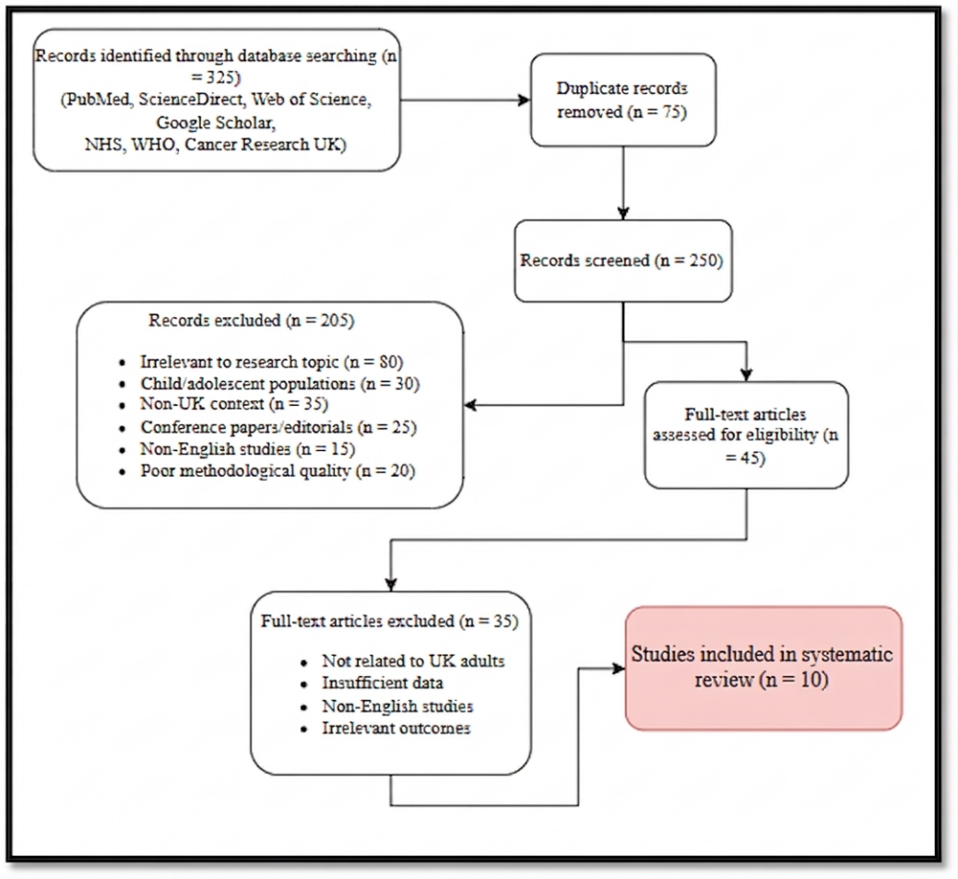

Figure 3.2: PRISMA Flow Diagram
(Source: Self-developed)

3.7 Data Extraction
Author & year | Aim | Design / Population | Environmental factors | Genetic factors | Key findings | Relevance to RQ
Memon et al., (2021) | To examine changing melanoma incidence in England | Retrospective population-based study; 265,302 melanoma cases, 1981–2018 | UV/sun exposure | Age, sex and population characteristics | Melanoma incidence increased considerably, particularly in older adults | Establishes UK environmental burden
Pega et al., (2023) | To estimate global NMSC burden attributable to occupational solar UV | WHO/ILO systematic analysis | Occupational solar UV | Not primary focus | Occupational UV contributes to NMSC burden | Supports workplace UV risk
Cherrie and Cherrie, (2022) | To examine occupational UV exposure and cancer prevention | Review | Workplace UV exposure | Not primary focus | Outdoor workers face cumulative solar UV exposure | Relevant to UK outdoor workers
Shraim et al., (2023) | To examine gene–sun exposure interactions | Systematic review; 15 studies | Sun/UV exposure | MC1R, CAT, NOS1, HAL, IL23A, XRCC1 | Evidence of gene–sun interactions in melanoma, BCC and SCC | Directly addresses interaction between environment and genetics
Calbet-Llopart et al., (2022) | To identify genetic variants associated with melanoma risk/naevi | Genetic association study | UV-related melanoma context | MC1R and common variants | Genetic variants influence melanoma susceptibility | Supports inherited susceptibility
Liebmann et al., (2023) | To investigate UV and MC1R-related melanoma risk | Melanoma study in children/adolescents | UV radiation | MC1R germline mutations | UV and MC1R variants contribute to melanoma risk | Supports gene–environment mechanism
Fiasconaro et al., (2025) | To assess germline variants in familial melanoma | Retrospective melanoma series | Environmental risk considered | CDKN2A, CDK4, POT1, BAP1, MITF, ATM, TERT | Multiple germline genes may contribute to hereditary melanoma | Demonstrates genetic heterogeneity
Jackson et al., (2023) | To investigate family history and hereditary cancer penetrance | Population-based UK study | Family/environmental context | Hereditary cancer susceptibility | Family history modifies interpretation of inherited cancer risk | Strong UK evidence for inherited susceptibility
Hodgson et al., (2025) | To review inherited cancer susceptibility | Review | Environmental influences | Germline pathogenic variants | Inherited variants can substantially increase cancer susceptibility | Provides genetic/clinical framework
Wunderlich et al., (2024) | To review skin-cancer risk factors and risk assessment | Review | UV exposure and other environmental factors | Genetic/phenotypic susceptibility | Skin-cancer risk results from interacting environmental and individual factors | Supports integrated risk model

Table 3.1: Data Extraction
(Source: Self-developed)

3.8 CASP Assessment
The assessment of quality of the 10 selected articles revealed a relatively moderate to high level of quality of the evidence. Most of the articles had well-defined research questions and employed suitable research methodology to explore risk factors related to environment, genetics, or interaction between gene and environment for development of skin cancer. Nevertheless, some problems were noticed. However, Calbet-Llopart et al., (2022), Liebmann et al., (2023), and Ferrara et al., (2024) all had issues with quality evaluation and population that made it difficult to apply the findings directly to UK adults. On the other hand, the findings by Memon et al., (2021), Jackson et al., (2023), and Shraim et al., (2023) had more value due to either the large databases used, systematic approach employed, or relevance to the UK and/or gene–environment interactions. In summary, the ten studies were deemed fit for inclusion, despite differences in the design and populations of studies.

3.9 Inclusion and Exclusion Criteria
Criterion | Inclusion | Exclusion
Topic relevance | Studies examining environmental and inherited genetic factors. | Studies unrelated to skin cancer or its risk factors.
Time frame | Studies published between 2015 and 2026. | Studies published before 2015.
Geographic context | Studies focusing on UK adults. | Studies with no relevance to the UK context.
Study type | Peer-reviewed journal articles, systematic reviews, cohort and case-control studies. | Conference papers, editorials, book reviews, and unpublished studies.
Population | Adults aged 18 years and above. | Children and adolescent populations.
Language | English-language studies. | Non-English publications.
Methodology | Qualitative, quantitative, and mixed-method studies with clear methods. | Studies with unclear or poor methodologies.
Accessibility | Full-text articles available through databases. | Abstract-only or inaccessible studies.

Table 3.2: Inclusion and Exclusion Criteria
(Source: Self-developed)

3.10 Data Analysis Method
Thematic analysis was used as the data analysis method in this study to systematically examine and synthesise evidence from the selected literature concerning the environmental and inherited genetic factors associated with skin cancer among adults in the UK. Thematic analysis involves dissecting a qualitative dataset to analyze, identify pattern and interpretation. The collection of numerical primary data was not considered relevant to this systematic review because it involved analysing findings of different peer-reviewed studies. The study utilized the six-step framework developed by Braun and Clarke (2006). This method offers a systematic approach to arranging qualitative evidence as well as generating interpretations from complex information spaces.
Step | Process | Application in the Present Study
Step 1 | Familiarisation with Data | Applying genetic risk factors which highlight the findings on environmental situations, adopting studies to gain an in-depth understanding.
Step 2 | Generating Initial Codes | Applying prevention strategies which was systematically coded to understand and select relevant information relating to skin cancer risk factors.
Step 3 | Searching for Themes | Gene environment interactions highlight different same codes which may be grouped into broader themes, such as environmental factors, inherited susceptibility.
Step 4 | Reviewing Themes | They accurately represented evidence across the literature by using the themes which may be reviewed, so these are refined to ensure research authenticity.
Step 5 | Defining and Naming Themes | Clear definitions of theme and sub-theme which also have appropriate names to improve the thematic analysis section.
Step 6 | Producing the Report | After that developing evidence-based conclusions by using the final themes which can be discussed to answer the research question.

Table 3.3: Braun and Clarke's Six-Step Thematic Analysis Framework
(Source: Self-developed)

3.11 Reliability and Validity
To ensure the reliability and validity of this study, a systematic review was present. Using predefined inclusion and exclusion criteria, I selected peer-reviewed journal articles, government reports and reputable institutional publications. The use of various databases increased the coverage of the literature search and reduced selection bias. The use of Braun and Clarke’s framework for thematic analysis facilitates a more systematic coding and interpretation of evidence, thus enhancing consistency and dependability in the analysis.

3.12 Ethical Considerations
The ethical guidelines and university regulations on secondary research were followed throughout this research study. Because the study only used published literature and publicly available data, there was no involvement of human subjects and ethical approval was not needed. The study was conducted in accordance with the Data Protection Act 2018 and the General Data Protection Regulation (GDPR), whereby no personal or identifiable information was collected or processed. The policies for ethical academic conduct were adhered to through proper referencing and citation and working with credible references. Also, the writer and analyst was the person referred to and the submitted text was not generated by AI in any way.

3.13 Summary
The use of a qualitative secondary research design was explained, as was the reasoning for choosing thematic analysis as the most appropriate method for synthesising evidence from a range of studies. Braun and Clarke's six-step framework allowed for a rigorous and transparent analysis to identify and interpret key themes relating to environmental risk factors, inherited genetic susceptibility and personalised prevention strategies for skin cancer. It aids the subsequent chapter, which also addresses the steps taken to ensure credibility, value, and ethical conduct. In the following chapter, the findings and results from the systematic review will be presented. Information about the selected studies and how the evidence is organised in relation to the identified themes will be described.

Chapter 4: Results

4.1 Introduction
Findings of systematic review of environmental and inherited genetic contributors to skin cancer of adults in the UK were presented in this chapter. The findings were synthesized utilizing the 6-step thematic analysis framework developed by Virginia Braun and Victoria Clarke. Thematic Analysis by Braun and Clarke enabled the systematic identification, coding, and interpretation of identified literature patterns. Upon familiarisation with the data, themes and sub-themes were generated and refined to demonstrate how environmental exposures and inherited genetic factors influence susceptibility to skin cancer and how these can be used for personalised prevention and treatment.

4.2 Thematic Coding
Key words | Sub Themes | Main Themes
UV radiation,  Occupational,  Lifestyle,  Skin cancer | - UV radiation exposure across UK adults skin cancer incidence  - Occupational sun exposure across UK adults skin cancer incidence  - Lifestyle behaviours across UK adults skin cancer incidence | Evaluating the impact of environmental risk factors such as UV radiation exposure, occupational sun exposure, and lifestyle behaviours across UK adults skin cancer incidence.
Familial Melanoma Genes,  Melanoma,  Basal Cell,  Syndrome,  Susceptibility, | - Familial Melanoma Genes in increasing individual susceptibility to skin cancer.  - Familial Atypical Multiple Mole Melanoma in increasing individual susceptibility to skin cancer.  - Basal Cell Nevus Syndrome in increasing individual susceptibility to skin cancer. | Different genetic factors such as Familial Melanoma Genes, Familial Atypical Multiple Mole Melanoma, Basal Cell Nevus Syndrome have the ability to increase the individual susceptibility across skin cancer.
Environmental,  Genetic,  Radiation,  Primary Catalyst,  Predisposition,  Environment,  Interactions,  Development, | - UV Radiation as the Primary Catalyst in influencing skin cancer development  - Genetic Predisposition in influencing skin cancer development  - Repair in influencing skin cancer development Interactions | The interaction between environmental and genetic factors such as UV Radiation as the Primary Catalyst, Genetic Predisposition and Repair, Specific Gene-Environment Interactions in influencing skin cancer development.
Genetic,  Genomic Testing,  Polygenic,  Personalised,  Screening,  Treatment, | - Genetic & Genomic Testing for high-risk groups.  - Polygenic Risk Scores (PRS) for high-risk groups.  - The chemoprophylaxis may indigate high risk in different factors. | Identifying strategies such as Genetic & Genomic Testing, Polygenic Risk Scores, Chemoprophylaxis which helps to prevent personalised systems by using the early screening, and targeted treatment interventions, resulting in high-risk groups.

Table 4.1: Thematic Coding Table
(Source: Self-developed)

4.3 Thematic Analysis
Theme 1: Evaluating the impact of environmental risk factors such as UV radiation exposure, occupational sun exposure, and lifestyle behaviours across UK adults skin cancer incidence.
Prolonged exposure is the most important preventable environmental risk factor to ultraviolet (UV) rays for skin cancer among adults in the UK (Cherrie, and Cherrie, 2022). The DNA of cells highlights the exposure by developing UV radiation resulting in damaged cells which cause cancer (Cancer Research UK, 2026). Moreover, this can cause mutations linked to melanoma and non-melanoma skin cancers. The World Health Organization & other researchers have found that episodic intense sun exposure & frequent sunburn increase the risk of melanoma such as over 1.5 million cases of skin cancers and 120 000 skin cancer resulting in death (GUINOT, 2024; WHO, 2021)
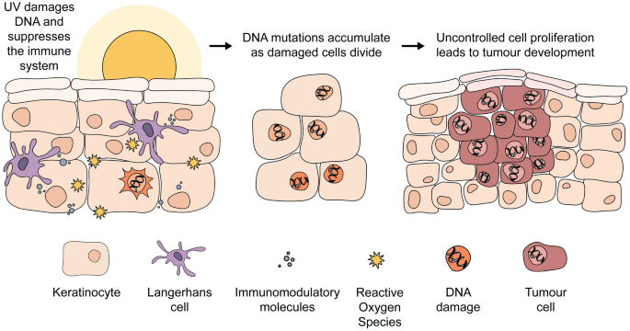

Figure 4.1: Solar radiation on human health
(Source: GUINOT, 2024)
According to Cancer Research UK, around 86% of melanoma cases in the UK are preventable and directly caused by excessive UV exposure (NIH, 2021). In addition, there are around 20,000 new cases of melanoma diagnosed each year in the UK fastest-growing cancers in adults (Cancer Research UK, 2026). Over 55 years of age, indicating the cancer rates are particularly high among adults to the sun for recreation, overseas holidays, and tanning as per the epidemiological data frequently (GUINOT, 2024).
The relationship between the exposure in UV and cancer genesis supports the research question by stressing the need for more personalized prevention strategies related to targeted interventions in sun-protection and early identification of risk.


Figure 4.2: Workers work in high sunlight
(Source: Pega et al., 2023)
Particularly among outdoor workers who are facing another major environmental contributor to skin cancer among adults in the UK, leading to highlight occupational sun exposure. Demonstrating that ultraviolet radiation on a prolonged across occupational exposure to solar basis significantly increases the risk of melanoma and non-melanoma skin cancer the International Agency for Research on Cancer, a part of WHO (Pega et al., 2023). Similarly, the outdoor workers receive cumulative UV exposure who also face problems regarding Health and Safety Executive which shows that often exceeds safety limits, resulting in increased DNA damage and cancer risk (Hamer et al., 2025).
According to the Health and Safety Executive, over 1.9 million UK workers spend a big part of their working life outside, (HSE, 2026). The sectors include construction, agriculture and transport. Studies reveal indoor workers get 5 to 10 times more annual UV radiation compared to outdoor construction workers (Ellenberg et al., 2026). In addition, non-melanoma skin cancers are disproportionately higher among those that work outside than in the general population.
The results of the analyses are in accordance with the Gene Environment Interaction Theory which postulates that the risk of disease is due to interactions between the environmental exposures and the inherited biological susceptibility of individuals. An elevated risk of cancer with prolonged occupational UV exposure leads to the highlight that the people with genetic variations may be affected by pigmentation, DNA repair which damages the immune system of different workers (Al-Sadek, and Yusuf, 2024).
The UK is affected significantly across skin cancer risk in adults by their lifestyle behaviours. The British Association of Dermatologists shows it is affected by UV exposure, individual susceptibility to carcinogenic processes. The chances of contracting malignant melanoma that indigate intentional sunbathing, which greatly increase recurrent ultraviolet radiation exposure (Dessinioti, and Stratigos, 2022).
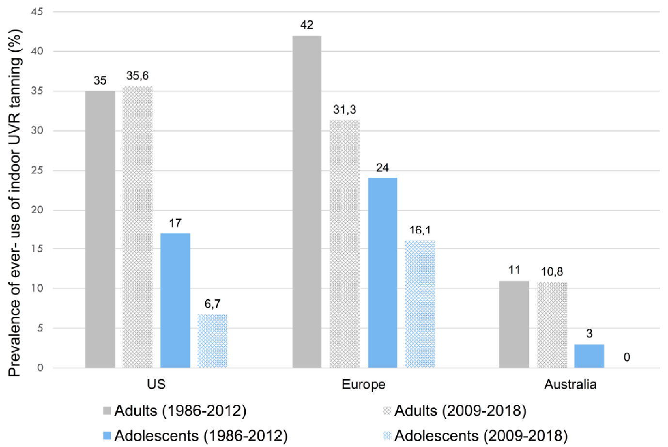

Figure 4.3: An Epidemiological Update
(Source: Cancer Research UK, 2026)
Because of changing leisure habits such as foreign holidays which increase the melanoma incidence rates according to Cancer Research UK (Cancer Research UK, 2026). In addition, the age of 35 has a 59% greater risk of skin cancer, indicating that people who have used sunbeds do not get affected (NLM, 2022). Despite awareness-raising initiatives such as public health campaigners show that many UK adults still do not use sunscreen regularly.
The findings offer support for the Multifactorial Disease Theory, which states that a disease comes about due to environmental exposure and genetic predisposition and behaviour and not one of these elements (Chapman, 2023). Behaviour patterns thereby acting with inherited susceptibility and environmental conditions affect the development of skin cancer (D’Arino et al., 2023). By understanding factors in this interconnected manner, we respond to the research question in a way that supports personalised prevention and treatment approaches integrating behavioural change with individual risk profiles.
Theme 2: Different genetic factors such as Familial Melanoma Genes, Familial Atypical Multiple Mole Melanoma, Basal Cell Nevus Syndrome have the ability to increase the individual susceptibility across skin cancer.
Contributions to skin cancer shows that genetic mutations in CDKN2A and CDK4 may make changes more than one primary compared to people from the NHS report at a younger age (NIH, 2026). The most common high-risk familial melanoma gene being CDKN2A mutations which indicates that inherited mutations are responsible for around 20% to 40% of all melanoma cases worldwide (NLM, 2026). It significantly higher than non-inherited cases with a CDKN2A mutation have a lifetime risk, so it also highlights the melanoma of over 50%. Surveillance programs to identify high-risk families, so the cancer clinics lead to indigate the early intervention strategies that indigate the genetic screening in the UK.
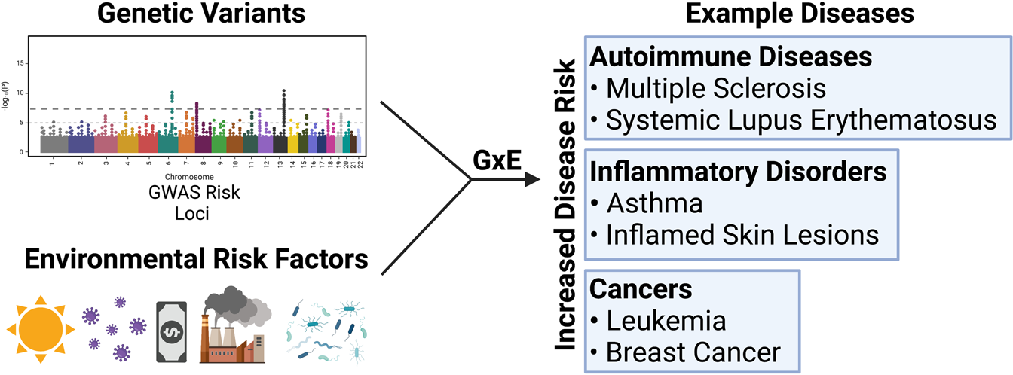

Figure 4.4: Gene–environment
(Source: Fang et al., 2023)
The Gene Environment Interaction Theory highlight the biological susceptibility which indigate the increment of inherited mutation in the environmental (Fang et al., 2023). It also may trigger the transition from genomic susceptibility, so the inherited mutation leads to highlighting regularly malignant disease.
Extremely high risk of developing melanoma across different UK familial atypical multiple-mole melanoma (FAMMM) syndrome is an inherited condition with many atypical moles (Siddiqui et al., 2025). According to the American Academy of Dermatology, FAMMM syndrome is often caused by germline mutations in the CDKN2A gene which impairs the tumor-suppressor functions and thus leads to unregulated growth of melanocytes (NLM, 2026). Researchers from the National Cancer Institute said that people with FAMMM often develop melanoma at younger ages and may suffer from a battery of recurrent or multiple primary melanomas in their lifetime.
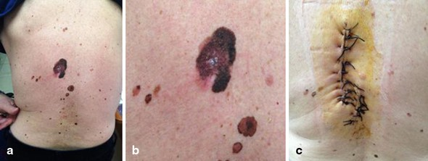

Figure 4.5: FAMMM syndrome
(Source: Springer, 2025)
According to evidence from real-world data, patients suffering from FAMMM syndrome have lifetime melanoma risk of 70–90% with some studies reporting even higher frequency (Orpha, 2026). According to this UK cancer report, some families with multiple cases of melanoma and atypical mole syndrome should undergo surveillance as well as genetic testing.
The evidence obtained directly answers the proposed research question such as inherited genetic disorders dramatically increase skin cancer susceptibility and warrant personalised screening, prevention and treatment. The proof also fits in with this Somatic Mutation Theory of Carcinogenesis (Cherrie, and Cherrie, 2022). This theory states that as a result of mutations cancer develops. These mutations include an impairment of the regulatory gene. The inherited germline mutations that underlie FAMMM syndrome create an environment in cells that is predisposed to melanoma. Additional somatic mutations and environmental triggers contribute to the more rapid development of melanoma.
Gorlin syndrome disorder highlights a syndrome such as Basal Cell Nevus Syndrome (BCNS) which is also known as the cause of increased risk of skin cancer (Ochoa-Mellado et al., 2025). National Organization for Rare Disorders academic research has shown that a person with BCNS has inherited a mutation in their PTCH1 gene signaling that regulates (Hedgehog signaling pathway), which controls cell growth and differentiation (Onodera, and Azuma, 2023). Research published by the British Association of Dermatologists shows that defective signaling of PTCH1 leads to a state of uncontrolled cell proliferation and pre-disposes patients to multiple basal cell carcinomas over the lifetime.
During adolescence at early adulthood highlight the Basal cell nevus syndrome which helps approximately 1 out of every 30,000 to 60,000 individuals worldwide (Mihu, 2025).
The healthcare sector requires repeated visits which may affect the development of tens or hundreds of basal cell carcinomas, so it can highlight a large burden on dermatologists. offering long-term follow-up with Gorlin syndrome in the UK, indicating the multidisciplinary dermatology clinics who help them by counselling with specialist genetic services (Petrov et al., 2025). an individual’s susceptibility to skin cancer development so, it is the findings that suggest inherited genetic disorders can impact on the increasing individual susceptibility to skin cancer.
Theme 3: The interaction between environmental and genetic factors such as UV Radiation as the Primary Catalyst, Genetic Predisposition and Repair, Specific Gene-Environment Interactions in influencing skin cancer development.
The genetic susceptibility factors highlight the powerful environmental agent to maintain Ultraviolet (UV) radiation which may enhance skin cancer development via interactions (Al-Sadek, and Yusuf, 2024). Also, it enhances the mutation system which lead to indigate the immunosuppression such as melanoma and non-melanoma skin cancers which helps to improve the DNA system form Ultraviolet radiation (Gieniusz et al., 2024). Especially in people who are genetically prone the sunburn and extensive cumulative UV exposure have the ability to increase the genetic changes in skin cells lead to perform skin cancer as founded by Cancer Research UK
A great deal could be prevented with better sun-protection behaviours, According to Cancer Research UK, around 86% of melanoma cases in the UK have been found to form much ultraviolet radiation (Cancer Research UK, 2025). Annual diagnosis of 17,500 melanoma cases highlights that the adults with intense recreational sun exposure have faced daily sunburn which led to impact on their skin problem BBC, 2024).
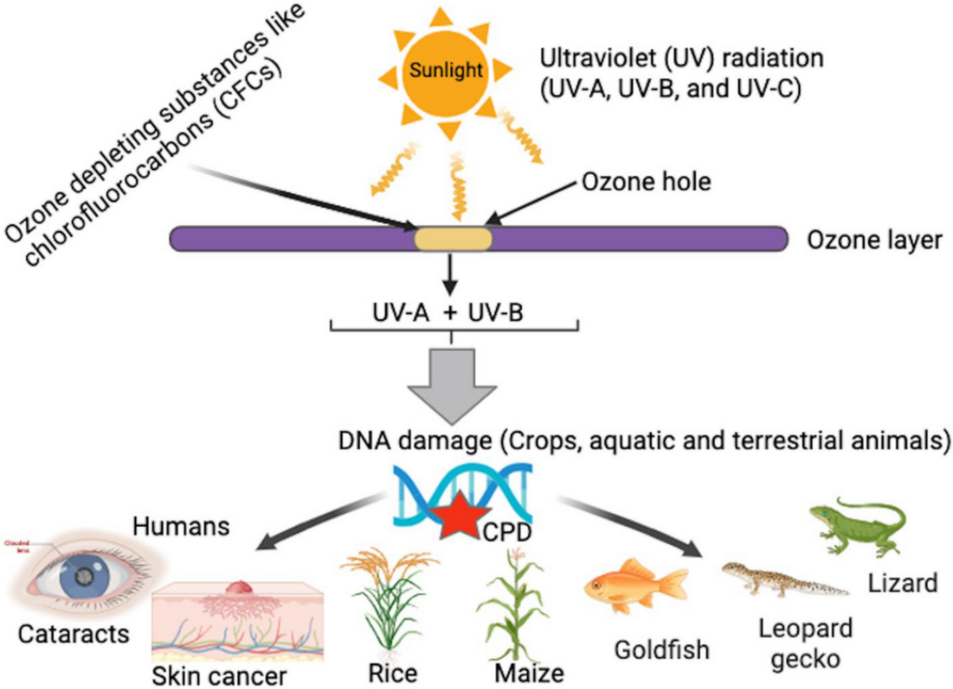

Figure 4.6: Environmental & health impacts
(Source: Springer, 2025)
The inherited susceptibility to malignant disease from UV radiation highlights that it is affected by the primary environmental factor. The Gene Environment Interaction Theory highlights that UV exposure can be carcinogenic which leads to an effect on their body system. The effect would be more pronounced because Gene Environment Interaction Theory proves that health outcomes develop "nature" or "nurture" (Li et al., 2024). Increasing DNA mutation susceptibility may affect the individuals who possess inherited genetic mutations that markedly intensified cellular defenses (Shraim et al., 2023).
The skin cancer development extends through using genetic predisposition of individuals which highlight that functioning with environmental carcinogens may maintain the stability of the genomic system. Messing with suppressors conducted by the National Cancer Institute, showing mutations in DNA interfering with genes like CDKN2A, CDK4, and MC1R may effect on their increment of melanoma risk in cell-cycle (NLM, 2024). Research published by the Institute of Cancer Research also indicates that people with inherited defects in DNA repair and pigment-related genes show increased sensitivity to ultraviolet radiation and hence are at greater risk for developing cancer (Ascsillán, and Kemény, 2024).
Research indicates that the global incidence of melanoma caused by inherited genetic mutations is about 5 to 10%, and in individuals with pathogenic CDKN2A mutations, these lifetime risks may exceed 50%. Malignant melanoma is caused at greater rates in people with fair skin, red hair, and certain variants of the MC1R gene compared to those with more natural sun protection.
In the context of the clinical disease skin cancer, these results answer my research question in that an inherited genetic predisposition pre-disposes individuals to vulnerability. Somatic Mutation Theory of Carcinogenesis highlights that mutations interfere with normal controls on cells which lead to improvement in the cause of cancer (El Nachef et al., 2024). The development of skin cancer in individuals’ DNA repair capacity across the specific gene environment interactions are crucial as it leads to indigate in influencing skin cancer development. Ultraviolet radiation can cause DNA damage as the radiation has wavelengths of 100 to 400 nanometers (nm) which damage human cells as per the International Agency for Research on Cancer, (Jin et al., 2022). The chances of accumulating mutational deficiencies in DNA that greatly increase malignant changes which are the only repair pathways (Jurkovicova et al., 2022).
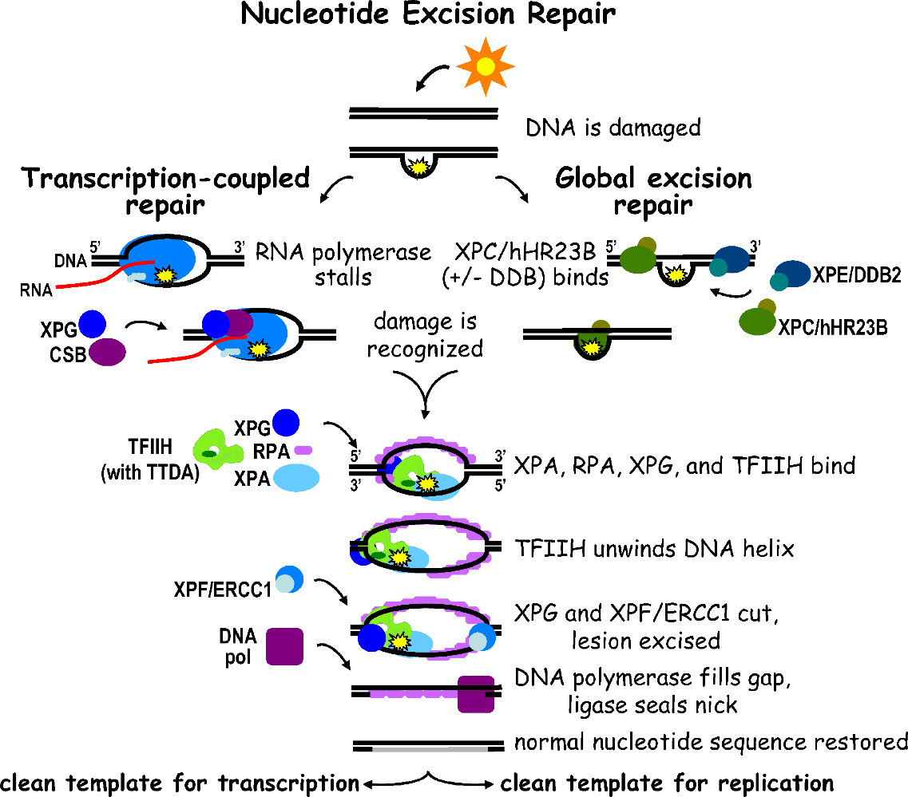

Figure 4.7: Pathway in DNA repair systems
(Source: Shraim et al., 2023)
The nucleotide excision repair pathways in DNA repair systems which lead to indigate the inherited defects, people who have shown expected rates of skin cancer. MC1R gene variants have a much higher melanoma risk than non-carrier individuals have also shown that frequently exposed ultraviolet radiation carriers’ clinical settings which lead to impact on their in influencing skin cancer development (El Nachef et al., 2024; Shraim et al., 2023; Gieniusz et al., 2024). Evidence from familial melanoma clinics also demonstrates that early identification and management of high-risk populations can be improved through genetic testing in combination with their environmental risks.
The study answered the research question by showing that skin cancer does not develop due to just the effect of the environment or through genes alone but through the interaction of the two factors. As a result, any personalisation of prevention and treatment should involve genetic screening, environmental exposure assessment, and consistent dermatological monitoring to enhance risk prediction, early diagnosis, and targeted intervention among adults in the UK.
Theme 4: Identifying strategies such as Genetic & Genomic Testing, Polygenic Risk Scores, Chemoprophylaxis which helps to prevent personalised systems by using the early screening, and targeted treatment interventions, resulting in high-risk groups.
Developing the genome of hundreds of thousands highlights that sequence of people shows how integrating genomic information into a clinical pathway can add clinical value to highlight the Genomics England, (Genomics England, 2026). Moreover, informing treatment with greater early detection rates highlights the improvement of prognosis which highlight the findings from familial melanoma clinics that indicate that mutation carriers obtain enhanced skin checks through dermatological surveillance, genetic counseling.
Identification of individuals with increased hereditary risk studies the research question that genetic across genomic testing allows for more effective prevention, treatment that is personalized (Jain et al., 2022). Also, clinicians can be aware of those individuals whose inherent susceptibility to disease can be aggravated by environmental exposure, such as ultraviolet rays, providing evidence for Gene–Environment Interaction Theory (Ward, 2023).
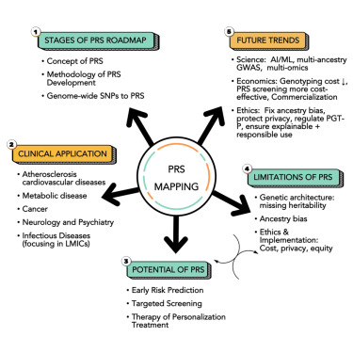

Figure 4.8: Polygenic Risk Scores (PRS) Mapping
(Source: Zhang, and Belsky, 2022)
Polygenic Risk Scores (PRS) are a novel precision medicine approach that predicts a person’s risk of disease from a variety of skin cancer susceptibility genes (Zhang, and Belsky, 2022). The models can help identify individuals with combinations of low-risk genetic variants leading to significantly increased melanoma risk and improve risk prediction. Moreover, using a polygenic model can refine the identification of populations at high risk from what we would get from just family history and clinical features (Kullo, 2026). PRS can be used to enhance DNA traits that supports the Somatic Mutation Theory of Carcinogenesis, which increases the likelihood of acquiring specific environmental factors (Smith et al., 2024). As a result, forecasting disease risk highlights introducing targeted interventions in high-risk UK adults across the PRS offers a useful approach.
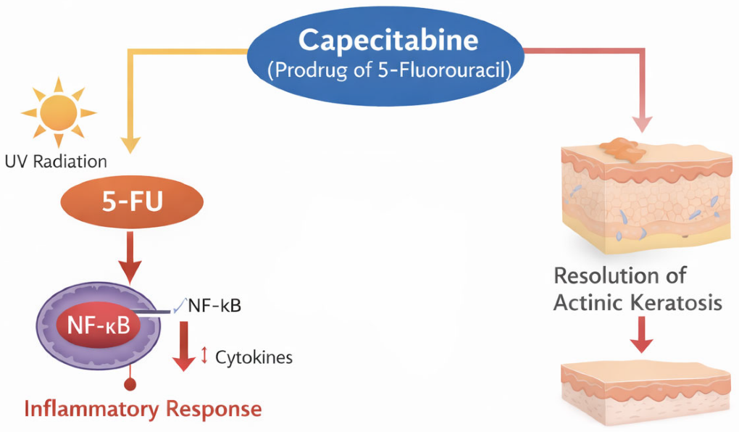

Figure 4.9: Chemoprevention in Skin Cancer
(Source: Tow et al., 2023)
A personalized preventive agent for skin cancer led to Chemoprophylaxis is being increasingly proposed to highlight the pharmacological agent to decrease cancer risk among the factors (Tow et al., 2023). DNA repair in limiting ultraviolet immunosuppression which led to highlight the American Academy of Dermatology states that agents like nicotinamide (vitamin B3) may reduce non-melanoma skin cancers (Camillo et al., 2025). As aforementioned may likewise find chemo preventive interventions beneficial which maintain the individuals sharing the same constellation of risk factors.
New non-melanoma skin cancers incidence compared to controls which randomizing clinical trials have shown that nicotinamide in high-risk people caused a 23% reduction (Oncology Central, 2025). In addition, recommending that people who have recurring skin cancers now they need to focus on their dermatology services (Nikolakis et al., 2024). It has an inherited genetic predisposition to use chemo preventive strategies, together with their sun-protection measures and regular monitoring of their skin.
These results address the study question because they demonstrate that chemoprophylaxis can support personalized prevention and targeted treatment strategies by diminishing the biological effects of environmental exposures among susceptible genetic populations. The integration of genetic testing, risk assessment, and screening with chemoprophylaxis provides a comprehensive precision medicine approach improving prevention, early intervention and long-term management of disease among high-risk UK adults.

4.4 Summary
The study illustrates that environmental exposures interact with inherited susceptibility when developing skin cancer and other diseases in UK adults. Ultraviolet radiation, workplace exposure, and lifestyle factors were significant environmental causes of diseases. (17 words) Inherited characteristics like the melanoma genes in families with melanoma, the Familial Atypical Multiple Mole Melanoma syndrome, and Basal Cell Nevus Syndrome, greatly increase the potential for skin cancer. The study indicated that the process of carcinogenesis is enhanced by gene-environment interactions in individuals at high-risk due to UV radiation.

Chapter 5: Discussion

5.1 Introduction
These discussion chapters interpret and discuss the results of the systematic review on inherited factors and environmental risks that influence skin cancer development between UK adults. The purpose of the discussion chapter is to not only present the results but also critically demonstrate what they emphasise in association to the existing literature, and research questions. Main focus is given to lifestyle-related environmental factors, occupational and UV radiation exposure, skin cancer risk and genetic susceptibility.
The results are considered in the past clinical evidence and previous epidemiological context to determine whether they aided or challenged skin cancer development related developed understanding. Therefore, this chapter also considers the interaction between genetically transmitted risk factors such as genetic predisposition, and family history instead of operating independently. It is significant as the skin cancer emerges as the multifactorial situations where cumulative exposure and individual susceptibility in combined impacts the development of the disease.
The chapter also analyses the differences and similarities with comparing the previous researches to find out the areas of possible alternative explanations, disagreements and areas for inconsistencies. Appropriate theoretical insight integrating Somatic Mutation Theory of Carcinogenesis, Multifactorial Disease Theory and Gene–Environment Interaction Theory, are also considered. Practical implication of the results has been offered for personalised prevention, targeted interventions and early screening. At the end of the chapter limitation of these reviews is demonstrated, mainly those associated with the generalisability, scope and quality of the available evidence.

5.2 Discussion on Theme 1
This theme establishes that the environmental exposure is a prior contributor to the skin-cancer developments among the UK adults, with the UV radiation, occupational sun exposures and finally the lifestyle behaviours emerging as the prior risk elements. The evidence highlights that the prolonged and intense UV exposure can cause the DNA damage and thus maximise the likelihood of the melanoma and non-melanoma skin cancers (Cherrie, and Cherrie, 2022, p.46). Moreover, the occupational exposure is specifically relevant for the outdoor workers who experience the cumulative sunlight during the employment (Jain et al., 2022). In addition, sunbathing in combination with the tanning bed used and inadequate sun protection can assist in maximising the level of the exposures. Overall, the theme highlights that skin cancer risk in highly influenced through the multiple interconnected environmental as well as behavioural elements instead of one exposure alone.
The findings strongly agree with the existing literature. The identification of the UK radiation as a major environmental risk is consistent with the findings of the Neale et al., (2023, p.1011) and Cancer Research UK (2025), which closely links the cumulative exposure with the DNA damage and the rising melanoma incidence. The findings also support the WHO (2017) concerning the sunbed-related melanoma risk and Ward (2023) concerning occupational exposure. Basically this finding extends the literature through showcasing that both the lifestyle and occupational exposure needs to be considered along with the individual susceptibility and thus supporting the multifactorial perspective identified by Laschewski and Gopalakrishnan et al., (2022, p.32) within their research findings.
The findings also closely align with the Somatic Mutation Theory of Carcinogenesis, as the observed association between prolonged UV exposure as well as the skin cancer development is consistent with UV-induced DNA damage, which notably contributes towards the abnormal cellular changes. This supports the findings of the Monti et al., (2022, p.662), specifically regarding the disruption of genes regulating both the growth and repair of the cell. However, the findings also suggest that the mutation alone might fail to explain the risks, because exposure patterns along with individual susceptibility vary significantly. Therefore, the theory offers a useful biological explanation; however, it should be considered along with the environmental and inherited elements.
Future research needs to investigates how the cumulative UV exposure closely interacts within the specific genetic mutations in order to influence the skin cancer developments among the UK adults. Moreover, cross sectional studies can offer stronger evidence of casualty compared to the longitudinal studies while the improved genetic and exposures might support more accurate individual risk prediction.

5.3 Discussion on theme 2
The results of Theme 2 demonstrated that the susceptibility of skin cancer is contributed to by genetic liability that is transmitted within families through the inheritance of specific germ cells. In particular, the presence of family history and familial risk factors, including those related to the CDKN2A and CDK4 gene mutation, were identified as significant predictors of the disease (Ferrara et al., 2024). The results highlight the fact that not all adults in the UK are equally susceptible to the development of skin cancer. Nevertheless, it is crucial to emphasise that the present findings do not prove the causal role of inherited susceptibility in the development of skin cancer. Instead, it was found that the interaction between different factors that contribute to the risk might lead to an increased likelihood of developing the disease.
The results of the study confirm many of the findings and ideas presented in the papers reviewed in Chapter 2. Firstly, the study shows that family history and the genetic predisposition to melanoma development play an important role in determining whether a person will develop skin cancer or not. The results related to CDKN2A and CDK4 genes are also consistent with previous research (Wunderlich et al. ,2024, p.1). They confirm there has been a link between gene mutations and the development of cancerous tumours (Cobaleda et al., 2024, p.397). Nevertheless, the results also show that the presence of certain genetic markers does not always indicate melanoma development. It can thus be stated that genetic predisposition may only raise the risk of developing skin cancer. Moreover, the results have clearly shown that genetics alone is not a significant factor which can determine whether a person will develop skin cancer.
The findings address the research question by showing that inherited genetic factors contribute to the risk of skin cancer in UK adults. The family history indicates possible cases of vulnerabilities passed from generations, whereas the identified hereditary variations could help to differentiate those with higher risks (Susanto et al. 2025, p.1). Therefore, the findings address the second research objective related to the influence of inherited genetic factors and family history.
However, the results show the significance of considering genetic and environmental contributors to the development of the condition. A person’s UV exposure risks combined with a possible inherited proneness to the disease might determine one’s susceptibility to skin cancer (Shraim et al., 2023). The results presented in the study support Multifactorial Disease Theory, which refers to the combination of multiple causes that lead to disease development instead of the presence of one particular factor (Saeed et al, 2024, p.2). The detection of both genetic predisposition and environmental or behavioural risk factors in the overall review supports the theory, as genetic traits may determine susceptibility to external contributors such as UV radiation. These contributors in combination with the acquired genetic risks, can lead to disease development. The reviewed research supports this genetic theory by providing evidence on the development of cancer in people with moderate, inherited predisposition (Barili et al., 2024). The theory explains the variations of cancer occurrences in such cases. However, the study cannot determine the degree to which each gene contributes to the development of the disease since the analysis combines various studies with different designs and methodologies.
The results of the research have several implications for personalised prevention and early detection measures. Family history can play a crucial role in the estimation of an individual’s risk for developing skin cancer (Muresanu and Khalchitsky, 2022, p.343). Thus enabling the recognition of the need for enhanced monitoring in specific groups of the adult population. An early identification of potentially dangerous skin conditions would give relevant clinical advantages.
Moreover, the results have implications for the process of genetic counselling and risk communication. It is necessary to estimate the inherited risk for each case, as the genetic predisposition only slightly raises the chances of developing melanoma, given the fact that one should consider overall probability (Rebuzzi et al., 2023). In addition, the process of genetic counselling will also raise awareness among individuals of their risk factors, providing them with the needed motivation for protecting their skin from excessive exposure to UV radiation.
Moreover, the results provide grounds for transitioning from the current practice of indiscriminate prevention to the concept of differentiated prevention based on the recognition of individuals and groups at higher risk. The consideration of genetic predisposition alongside the environmental and behavioural factors will help to establish the etiological role of heredity in the development of melanoma.

5.4 Discussion on theme 3
Findings have revealed that a combination of environmental exposure and inherited genetic susceptibility is effective for gaining better insights into the development of skin cancer among UK adults. It has been found that UK radiation acts as a major environmental factor for the occurrence of this skin cancer. The response to UV-induced cellular damage is found by focusing on inherited susceptibility (Gieniusz et al., 2024). Differences in biological susceptibility lead to changes in outcomes rather than identical ones. Therefore, it has been acknowledged that cellular damage is contributed to by environmental exposure. Whereas the vulnerability to damage is the result of genetic characteristics.
These findings are well aligned with the literature review section, that present that increasing exposure to UV radiation results in raise the likelihood of tumour development and Deoxyribonucleic Acid damage (Neale et al. 2023, p.1). However, the results can vary based on cancer type, genetic variation, intensity and duration of UV exposure, and individual characteristics. Thus a single environmental or genetic factor need not to be used at the time of the explanation of skin cancer development (Zhang and Belsky 2022, p.296).
Findings of this research address research questions, providing a better explanation of how skin cancer is developed among humans with a combined influence of environmental and inherited genetic factors. Environmental prevention among UK adults is effective in decreasing exposure levels. Cellular damage is reduced when there is a reduction in harmful exposure (Cherrie, 2022, p.47). An integrated interpretation thus gives a better picture of skin cancer development among UK adults. Population-level exposure patterns help in making more informed decisions and support targeted prevention strategies for decreasing exposure levels (Jean-Baptiste, 2026).
The findings strongly supports the Gene–Environment Interaction Theory which showcases that skin-cancer development might reflect the interaction between the inherited susceptibility and environmental exposure as well. It particular, individuals experiencing the similar levels of the UV exposure might have different types of risks since there are differences in the genetic susceptibility (El Nachef et al., 2024, p.1). This highlights that neither the environmental exposure nor the inherited factors alone can explain the variation within the skin-cancer developments. However, the findings should be interpreted cautiously since differences within the studies, populations, and exposure measures can restrict direct comparison and thus prevent the firm conclusions about the specific biological mechanisms (Henn et al., 2022).
The findings also have significant implications for both the personalised prevention and public-health practice. Population-level strategies need to continue to fosters the protection from the excessive UV exposures incorporating the appropriate sun protection and avoidance of the artificial tanning (Sheikh and Sheikh, 2026). However, these approaches can be strengthen through considering the both the family history and validated indicators of the genetic susceptibility when closely identifying the individuals requiring the additional prevention advice or surveillance. In essence, it can be asserted that closely aligning the inherited and environmental risk into the assessment can assist in enhancing the targeted monitoring alongside the early detection (Liebmann et al., 2023, p.754). However, genetic information requires to complement instead of replacing the UK protection behaviours since the susceptibility does not guarantee the cancer development (Hodgson et al., 2025, p.354). Overall, integrated prevention in combination with the risk assessment are supported, though the further research is required for clarifying the gene-environment interactions.

5.5 Discussion on Theme 4:
From the finding it has been discussed that Polygenic Risk Scores predict a person’s risk and improve risk prediction. Therefore, using a polygenic model helps the clinical features to enhance DNA traits and forecasting disease risk among UK adults. Whereas the use of Polygenic Risk Score (PRS) allows one to add up the effect of several variants together in order to get a wider picture of genetic risk of an individual (Scarano et al. 2025, p.5). It means that the risk assessment can go beyond the general characteristics of the population. Moreover, the results have shown that the use of chemoprophylaxis can give another way to prevent skin cancer for certain high-risk categories of people, especially those who have had several recurrences of non-melanoma skin cancer. On the other hand, the use of chemoprophylaxis should be thought of along with traditional methods of skin cancer prevention (Virolainen et al. 2023, p.6). From the findings it also noted that the findings show that genetic information becomes even more relevant when taking into consideration lifestyle aspects and environmental exposure. These results illustrated that with the mixing of environmental-risk assessment, PRS and genetic testing, appropriate preventive interventions can raise targeted prevention and early identifications among UK adults (Chuong et al., 2026). On the other side these approaches are integrated cautiously, a wider applicability and clinical effectiveness needs further evidence.
Results align with literature review 2.6 “Personalised Prevention, Early Screening, and Targeted Treatment Interventions for High-Risk Groups” and emphasised that as it is stressed that an early screening can minimize mortality risks by implementing generic prevention campaigns with less impact on risk groups (Akram et al. 2025, p. 236). Moreover, it brought a new approach to the treatment of skin cancers as it assists in diagnosing thin melanomas at the early stage before metastasizing, as it incorporates genetic predisposition or skin phenotype (Hasan et al., 2023). Consequently, it impacted advanced melanoma cases positively.
Results align with research questions illustrating that gaining knowledge about the inherited genetic susceptibility as well as environmental risk factors aided more personalised initiatives to early interventions and skin cancer prevention among UK adults (Hodgson et al., 2025). The results also aided that insight that skin cancer prevention has not depended on population wide interventions. Therefore, the regular dermatological surveillance, genetic counselling and risk stratified screening are important for people who emerge as having a bigger combination of environments and genetic risks (Koppelman et al. 2025, p.1020). These aided directly the research questions through emphasising in which way the interaction of environmental and inherited factors inform more personalised and targeted prevention strategies.
Results align with Multifactorial Disease Theory and emphasised that development of skin cancer is impacted through the mix impacts of lifestyle behaviours, environmental UV exposure and inherited genetic susceptibility instead of being caused through one factor alone (Muresanu and Khalchitsky, 2022, p.343).
Future research must assess the chemoprophylaxis, PRS and genetic testing, to build their clinical efficiency, sustainability and cost effectiveness for routine utilisation. Apart from that implementing the environmental and genetic risk information could aid more appropriate risk prediction, targeted prevention and personalised screening for high risk UK individuals.

5.6 Limitations
These systematic review results need to be evaluated based on certain limitations associated with the study. To begin with, since the study focuses on adults in the UK, the results may not be generalizable to other communities characterized by UV radiation, varying genetic compositions, and healthcare system settings (Cobaleda et al., 2024, p.397). Secondly, the study has been based on secondary literature, which emphasised that conclusion relied on the reporting of the available research.
The design of studies also differs widely as are the subjects, measures of UV exposure, and that can complicate the interpretation of the results from studies. Differences in recorded environmental exposure make it difficult to derive stable risks across available data. Similarly, there is difficulty distinguishing effects of inherited genes from environmental, shared by family; family history has been employed to define genetic components.

5.7 Recommendations for Future Research
It is essential for future research to focus on longitudinal studies specifically in the UK to understand how the interaction between the cumulative exposure to environmental conditions and genetic predisposition leads to skin cancers over time (Danishevich et al., 2023, p.1). This would allow establishing clearer connections and distinguishing between causative and concomitant risk factors.
Further analysis of gene–environment interactions is needed, mainly in particular genetic variants which have changed the UV radiation effects, lifestyle behaviours and occupational exposure. As a result, this might help to gain knowledge about why certain people develop skin cancer from identical environmental influences and not others.

5.8 Conclusion
These studies critically discuss and interpret the results of the systematic review on inherited genetic factors and influence of environmental risks on skin cancer development among UK adults. It is concluded that the effect of UV exposure in the occupational setting influence of susceptibility has led to an inaccurate assessment of skin cancers. Therefore, these differences emphasise that UV exposure among adults, though different factors like skin pigmentation and family history UV-induced damage influence individual vulnerability. Therefore, these research aided the research questions through illustrating the significance of assessing environmental risk and analysing the inherited factors, gaining knowledge of their interaction and finding out the opportunities for treatment screening and prevention. The following chapters summaries the research through demonstrating the significant finding and their entire contributions.
The next chapter will be the conclusion chapter of the entire research. This chapter will contain the summary of the research findings in relation to the aim and objectives, show the contribution of the literature review, give implications of the research for practice and research, and end with final recommendations.

Chapter 6: Conclusion

6.1 Key Summary
In this conclusion, the research was done on the role played by environmental risks and genetics in the development of skin cancer in UK adults. This research has been carried out in the form of a systematic review, which aims to provide evidence on the environmental risk factors, inherited susceptibility, interactions between them, and the significance of such knowledge in developing personalized preventive measures and targeted treatment options. The research question guiding this study has been formulated as follows: What are the environmental risk factors and genetics involved in the development of skin cancer in UK adults?
This systematic review and thematic analysis integrated the findings of the existing literature and four key themes were identified: environmental risk factors, genetic inheritance, gene-environment interaction, and personalized interventions for those at higher risk. In summary, the findings of the research indicate that skin cancer is not to be comprehended based on either environment alone or genetics alone. Instead, individual susceptibility is a result of the interaction between biological makeup and environment, especially UV rays.

6.2 Answer to the Research Question
The final conclusion of the study is that both environmental exposure and genetic susceptibility play important roles in the development of skin cancers among adult patients in the UK.
The first objective is related to the environmental risk factors. According to the systematic review, UV radiation was found to be the main environmental factor that can be prevented when skin cancers develop. Both prolonged and intermittent exposure, sunburn, recreational and occupational exposure to the sun, and artificial tanning may be causes of cumulative UV exposure and lead to damage of DNA. As for occupational exposure, it is particularly applicable to those who work outdoors in industries such as construction, agriculture, and transportation. Lifestyle factors such as sunbathing and lack of sun protection measures can add up to the level of exposure. Thus, the information suggests that environmental exposure is still a significant area in terms of prevention.
Secondly, the objectives concern inherent genetic susceptibility. The research findings show that genetic characteristics and family history may predispose a person to be susceptible to skin cancer. Some of the genes identified in the study include MC1R, CDKN2A, and BRAF, while some of the families that are linked to increased susceptibility include FAMMM and Basal Cell Nevus Syndrome. However, this research does not prove the theory that having a genetic susceptibility leads to skin cancer. Rather, it proves that genetic susceptibility predisposes one to disease, and it is still necessary to consider other determinants such as environment and behaviour when the disease is being considered (Llewellyn et al., 2023, p. 20220223). This is essential to illustrate why genetic susceptibility cannot be an independent determinant of disease.
The third objective refers to the connection between the environmental and genetic factors. As shown by the research results, people who have encountered identical environmental influences may face different risks due to different susceptibilities to the effects of the environment. In particular, biological features associated with the pigment, cellular, and DNA repair may affect the impact of UV radiation on the body. Thus, the Gene–Environment Interaction Theory can be used to explain the risk of diseases based on the interaction of biological traits and environmental exposure. The Multifactorial Disease Theory can also be considered since the development of skin cancer results from the influence of genetic, environmental, and behavioral factors (Punjabi et al., 2024, p. 119). The main theory generated from the current systematic review is the combination of risk, whereas environmental exposure may affect biological susceptibility. This is relevant to the existing problem in the introduction of the study, wherein the literature is centered either on genetics or on the environment.
Objective 4 shows that information on joint risks from the environment and genetics would lead to personalized ways of prevention, screening, and treatment. Genetic/genomic testing, family history analysis, exposure assessment, skin surveillance, and risk profile evaluation would be useful in recognizing patients who need closer monitoring. Polygenic Risk Scores could provide one more way of assessing risks, while genetics-based treatment would allow for targeted treatment of certain patients (Gupta et al., 2025, p. 4). Among the methods that were found to be relevant by the research is chemoprevention, which could be used as a part of personalized prevention in certain risk groups. Nevertheless, these techniques have to be used in the framework of risk assessment and not as alternatives to proven preventive measures such as sun protection.

6.3 Recommendation
Recommendation 1: Strengthen targeted UV prevention
UK public health programmes need to strengthen the targeted UV-protection interventions for adults with high occupational or recreational sun exposures. The advantage is that diminishing the cumulative UV exposure can help in addressing one of the most established preventable environmental risks for skin cancer. Cancer Research UK’s SunSmart messaging reveals how public campaigns can foster sunscreen, protective clothing and shade as well (Maynard et al., 2026, p. 25111). However, behaviour change remains difficult, specifically among outdoor workers and frequent sun-seekers, which means awareness campaigns alone might have limited long term effectiveness.
Recommendation 2: Integrate genetic risk into prevention
UK dermatology and the primary care services requires to consider the incorporating the previous medical history of the family while clinically relevant inherited susceptibility into skin-cancer risk assessment. This will allow the higher-risk adults to receive more personlisalised prevention advice in combination with appropriate surveillance and thus strengthening the early detection. As an example, NHS already utilises the family-history information when analysing the risks of some heredity cancer conditions (Jackson et al., 2023). However, widespread genetic testing might develop additional costs, which requires specialist expertise while raising concerns about the interpretation which means generic assessment needs to be primarily focused on the clearly established high-risk groups.
Recommendation 3: Combine environmental and genetic risk assessment
Future UK prevention strategies should effectively amalgams the environmental exposure histories with the inherited susceptibility when critically analysing the individual skin-cancer risk. The advantages is a more comprehensive approach since both the genetic predisposition and the UV exposure might concurrently influence the diseases development instead of operating it independently. As an example, the specialist dermatology services can leverage personal and family history along with the clinical assessment to identify the individuals requiring the closer monitoring (Schierle et al., 2026, p.432). However, evidence on the gene–environment interactions remains heterogeneous, which might restrict the immediate development of the standardised national risk-prediction tools.

6.4 Reflection
Systematic review strategy proved to be quite successful for answering the research question due to the fact that the study sought to synthesise the evidence that already existed as opposed to gathering new primary data. It became possible to incorporate the information on exposure to the environment, genetic susceptibility, gene-environment interactions, and personalisation into one body of evidence through the use of secondary research. The PRISMA model offered a methodical approach to the identification and selection of evidence.
Thematic analysis was also suitable since the literature covered various aspects of skin cancer risks. The six steps of Braun and Clarke allowed for identifying the patterns in the literature and helped organise the evidence into four themes, namely environmental risks, inherited genetic vulnerability, gene-environment interaction, and prevention and therapy strategies tailored to each patient.
Nonetheless, the research relied on the nature and availability of pre-existing secondary evidence. Variation in design, population, and subject matter of different studies also had to be considered carefully. As such, the results are a reflection of a combination of pre-existing evidence and not direct evidence of causation. On the whole, the research served to underline the significance of an approach that takes into consideration both genetic and environmental factors.

6.5 Contribution of the Research
The primary contribution of this research is an examination of the effects of the environment and genetic inheritance on skin cancers in UK adults. By not examining UV exposure and genetic inheritance as different factors, the study illustrates the significance of their interplay. The results add to current knowledge in that they explain the differential effects of environmental exposure based on individuals’ inherent vulnerability. This is further related to personalized approaches in preventing, screening, and treating skin cancers. In that way, this study adds a stronger base for risk stratification approaches without downplaying the significance of the prevention of environmental hazards.

6.6 Final Conclusion
In conclusion, this systematic review shows that skin cancer amongst UK adults is affected by both environmental and genetic hereditary factors. Exposure to UV rays, occupational and lifestyle practices can be regarded as the major environmental risks, while genetic susceptibility and family history can make an individual prone to the disease. In essence, the major implication of this study is that all these factors have to be taken into account collectively instead of individually, meaning that there is a need to understand skin cancer development from a multifactorial perspective. Furthermore, the results show that taking into account genetic susceptibility along with the environmental risks can be useful for more personalized prevention and treatment approaches.

Reference list

- Agustí, A., Melén, E., DeMeo, D.L., Breyer-Kohansal, R. and Faner, R., 2022. Pathogenesis of chronic obstructive pulmonary disease: understanding the contributions of gene–environment interactions across the lifespan. The lancet Respiratory medicine, 10(5), pp.512-524. https://www.thelancet.com/pdfs/journals/lanres/PIIS2213-2600(21)00555-5.pdf
- Akram, M., Rehman, U., Khan, F.S. and Ho, S., (2025). Raising awareness for skin cancer prevention, early detection, and healthy sun practices, Int. J. Eng. Trends Technol. https://www.researchgate.net/profile/Ho-Min-2/publication/400072822_Raising_Awareness_for_Skin_Cancer_Prevention_Early_Detection_and_Healthy_Sun_Practices/links/6976f03c58b9985baa8ac77c/Raising-Awareness-for-Skin-Cancer-Prevention-Early-Detection-and-Healthy-Sun-Practices.pdf
- Al-Sadek, T. and Yusuf, N., 2024. Ultraviolet radiation biological and medical implications. Current Issues in Molecular Biology, 46(3), pp.1924-1942. https://www.mdpi.com/1467-3045/46/3/126
- Ascsillán, A.A. and Kemény, L.V., (2024). The skin–brain Axis: From UV and pigmentation to behaviour modulation. International Journal of Molecular Sciences, 25(11), p.6199. https://www.mdpi.com/1422-0067/25/11/6199
- Ascsillán, A.A. and Kemény, L.V., 2024. The skin–brain Axis: From UV and pigmentation to behaviour modulation. International Journal of Molecular Sciences, 25(11), p.6199. https://www.mdpi.com/1422-0067/25/11/6199
- Asgari, M.M. and Crane, L.A., (2023). Skin cancer screening: the importance of identifying high-risk subgroups and the need for US-based population research. JAMA, 329(15), pp.1259-1260. https://pmc.ncbi.nlm.nih.gov/articles/PMC12226101/
- BBC, (2024) Melanoma skin cancer cases rising in UK. Available from: https://www.bbc.com/news/articles/c2ll0eywz37o Accessed on 09.07.2026
- Benachour, Y., Maloukh, L. and Geusens, B., 2026. Integrative Machine Learning of Genetic and Lifestyle Factors for Personalized Skin Health. IEEE Journal of Translational Engineering in Health and Medicine. https://ieeexplore.ieee.org/iel8/6221039/6563131/11447225.pdf
- Calbet‐Llopart, N., Combalia, M., Kiroglu, A., Potrony, M., Tell‐Martí, G., Combalia, A., Brugues, A., Podlipnik, S., Carrera, C., Puig, S. and Malvehy, J., (2022). Common genetic variants associated with melanoma risk or naevus count in patients with wildtype MC1R melanoma. British Journal of Dermatology, 187(5), pp.753-764. https://academic.oup.com/bjd/article-pdf/187/5/753/48529587/bjd0753.pdf
- Camillo, L., Zavattaro, E. and Savoia, P., 2025. Nicotinamide: A multifaceted molecule in skin health and beyond. Medicina, 61(2), p.254. https://www.mdpi.com/1648-9144/61/2/254
- Cancer Research UK (2026) How does the sun and UV cause cancer? Available from: https://www.cancerresearchuk.org/about-cancer/causes-of-cancer/sun-uv-and-cancer/how-does-the-sun-and-uv-cause-cancer Accessed on 09.07.2026
- Cancerresearchuk (2025). Melanoma skin cancer statistics. Available at: https://www.cancerresearchuk.org/health-professional/cancer-statistics/statistics-by-cancer-type/melanoma-skin-cancer (Accessed 24 June 2026)
- Castellani, G., Buccarelli, M., Arasi, M.B., Rossi, S., Pisanu, M.E., Bellenghi, M., Lintas, C. and Tabolacci, C., (2023). BRAF mutations in melanoma: biological aspects, therapeutic implications, and circulating biomarkers. Cancers, 15(16), p.4026. https://www.mdpi.com/2072-6694/15/16/4026
- Chapman, C.R., 2023. Ethical, legal, and social implications of genetic risk prediction for multifactorial disease: a narrative review identifying concerns about interpretation and use of polygenic scores. Journal of Community Genetics, 14(5), pp.441-452. https://pmc.ncbi.nlm.nih.gov/articles/PMC10576696/pdf/12687_2022_Article_625.pdf
- Cherrie, J.W. and Cherrie, M.P., 2022. Workplace exposure to UV radiation and strategies to minimize cancer risk. British medical bulletin, 144(1), pp.45-56. https://academic.oup.com/bmb/article-pdf/144/1/45/47785669/ldac019.pdf
- Ciombor, K.K., Strickler, J.H., Bekaii-Saab, T.S. and Yaeger, R., (2022). BRAF-mutated advanced colorectal cancer: a rapidly changing therapeutic landscape. Journal of Clinical Oncology, 40(24), pp.2706-2715. https://pmc.ncbi.nlm.nih.gov/articles/PMC9390817/pdf/jco-40-2706.pdf
- Clark, R., Herrera-Caceres, J., Kenk, M. and Fleshner, N., (2022). Clinical management of prostate cancer in high-risk genetic mutation carriers. Cancers, 14(4), p.1004. https://www.mdpi.com/2072-6694/14/4/1004
- Cobaleda, C., Godley, L.A., Nichols, K.E., Wlodarski, M.W. and Sanchez-Garcia, I., (2024) Insights into the molecular mechanisms of genetic predisposition to hematopoietic malignancies: the importance of gene–environment interactions. Cancer discovery, 14(3), pp.396-405. https://aacrjournals.org/cancerdiscovery/article-pdf/14/3/396/3421681/396.pdf
- D’Arino, A., Caputo, S., Eibenschutz, L., Piemonte, P., Buccini, P., Frascione, P. and Bellei, B., 2023. Skin cancer microenvironment: what we can learn from skin aging?. International Journal of Molecular Sciences, 24(18), p.14043. https://www.mdpi.com/1422-0067/24/18/14043
- Danishevich, A., Bilyalov, A., Nikolaev, S., Khalikov, N., Isaeva, D., Levina, Y., Makarova, M., Nemtsova, M., Chernevskiy, D., Sagaydak, O. and Baranova, E., (2023) CDKN2A gene mutations: implications for hereditary cancer syndromes. Biomedicines, 11(12), p.3343. https://www.mdpi.com/2227-9059/11/12/3343
- Dessinioti, C. and Stratigos, A.J., 2022. An epidemiological update on indoor tanning and the risk of skin cancers. Current Oncology, 29(11), pp.8886-8903. https://www.mdpi.com/1718-7729/29/11/699
- El Nachef, L., Bouchet, A., Bourguignon, M. and Foray, N., 2024. When DNA mutations interplay with cellular proliferation: a narrative history of theories of carcinogenesis. Cancers, 16(11), p.2104. https://www.mdpi.com/2072-6694/16/11/2104
- Ellenberg, E., Ingber, A., Bhagavathula, A.S., Katorza, E. and Ramot, Y., 2026. Occupational solar UV exposure and skin cancer: A quantitative framework for individual causal attribution in dermatology practice. Safety and Health at Work. https://www.sciencedirect.com/science/article/pii/S2093791126000405
- Fang, K., Li, J., Zhang, Q., Xu, Y. and Ma, S., 2023. Pathological imaging‐assisted cancer gene–environment interaction analysis. Biometrics, 79(4), pp.3883-3894. https://pmc.ncbi.nlm.nih.gov/articles/PMC10622332/
- Fiasconaro, C.A., Carbone, A., Giordano, S., Cavallo, F., Fava, P., Pasini, B., Yakymiv, Y., Marchisio, S., Quaglino, P., Ribero, S. and Roccuzzo, G., (2025) Germline Non-CDKN2A Variants in Melanoma and Associated Hereditary Cancer Syndromes, Diseases, 13(6), p.180. https://www.mdpi.com/2079-9721/13/6/180
- Fujimura, T., Muto, Y. and Asano, Y., (2022). Immunotherapy for melanoma: the significance of immune checkpoint inhibitors for the treatment of advanced melanoma. International journal of molecular sciences, 23(24), p.15720. https://www.mdpi.com/1422-0067/23/24/15720
- Gamage, A.N.K.K., (2025). Research design, philosophy, and quantitative approaches in scientific research methodology. Sch J Eng Tech, 2(1), pp.91-103. https://www.academia.edu/download/122341245/SJET_132_91_103c_published_paper.pdf
- Gbemudu, B.A., (2023). Environmental risk factors in lung and skin cancer. Available at SSRN 4579295. https://papers.ssrn.com/sol3/Delivery.cfm?abstractid=4579295
- Genomics England (2026) 100,000 Genomes Project. Available from: https://www.genomicsengland.co.uk/initiatives/100000-genomes-project Accessed on 09.07.2026
- Gieniusz, E., Skrzydlewska, E. and Łuczaj, W., 2024. Current insights into the role of UV radiation-induced oxidative stress in melanoma pathogenesis. International Journal of Molecular Sciences, 25(21), p.11651. https://www.mdpi.com/1422-0067/25/21/11651
- Gillespie, A., Glăveanu, V., Glǎveanu, V.P. and de Saint Laurent, C., (2024). Pragmatism and methodology: Doing research that matters with mixed methods. Cambridge University Press. https://eprints.lse.ac.uk/121579/1/Gillespie_pragmatism_and_methodology_published.pdf
- Gopalakrishnan, S., Jayaseelan, V.P., Ramamurthi, R., Muniapillai, S. and Chenchugopal, M., (2025) Role Of CDKN2A A Cell Cycle Regulation in diagnosis of Oral Squamous Cell Carcinoma: A. Journal of Neonatal Surgery, 14(32s). https://www.researchgate.net/profile/Sivakumar-Gopalakrishnan/publication/396237251_Role_Of_CDKN2A_A_Cell_Cycle_Regulation_in_diagnosis_of_Oral_Squamous_Cell_Carcinoma_A_Review/links/68e3e6a7ffdca73694b5a710/Role-Of-CDKN2A-A-Cell-Cycle-Regulation-in-diagnosis-of-Oral-Squamous-Cell-Carcinoma-A-Review.pdf
- Groos, S.S., Linn, A.J., Kuiper, J.I., van Schoor, N.M., van der Velde, N. and van Weert, J.C., (2024). Combining user-centered design and behavioral theory to enhance health technologies: a personas-based approach for a primary-care based multifactorial falls risk assessment tool. International journal of medical informatics, 186, p.105420. https://www.sciencedirect.com/science/article/pii/S1386505624000832
- GUINOT, C., 2024. Expatriates in High–UV Index and Tropical Countries: Sun Exposure and Protection Behavior in 9,416 French Adults. Journal of Travel Medicine. https://www.academia.edu/download/120201671/jtm14-0085.pdf
- Gupta, A., Shah, K. and Shukla, A., 2025. Bridging traditional risk factors and genetic insights: A review on polygenic risk scores in cardiovascular diseases. Advances in Biomarker Sciences and Technology. https://www.sciencedirect.com/science/article/pii/S2543106425000225
- Hamer, A., Ray, T., Norden, A., Stephenson, E. and King, E., 2025. Sun safety and outdoor workers. https://www.cancercouncil.com.au/wp-content/uploads/2025/11/Outdoor-Worker-Literature-Review-FINAL.pdf
- Harris, B.H., Di Giovannantonio, M., Zhang, P., Harris, D.A., Lord, S.R., Allen, N.E., Maughan, T.S., Bryant, R.J., Harris, A.L., Bond, G.L. and Buffa, F.M., (2024) New role of fat-free mass in cancer risk linked with genetic predisposition, Scientific reports, 14(1), p.7270. https://www.nature.com/articles/s41598-024-54291-7.pdf
- Hasan, N., Nadaf, A., Imran, M., Jiba, U., Sheikh, A., Almalki, W.H., Almujri, S.S., Mohammed, Y.H., Kesharwani, P. and Ahmad, F.J., (2023). Skin cancer: understanding the journey of transformation from conventional to advanced treatment approaches. Molecular cancer, 22(1), p.168. https://link.springer.com/content/pdf/10.1186/s12943-023-01854-3.pdf
- Hodgson, S.V., Foulkes, W.D., Maher, E.R. and Turnbull, C., 2025. Inherited Susceptibility to Cancer: Past, Present and Future. Annals of Human Genetics, 89(5), pp.354-365. https://onlinelibrary.wiley.com/doi/pdf/10.1111/ahg.70013
- HSE (2026) HSE publishes annual workplace health and safety statistics. Available from: https://press.hse.gov.uk/2025/11/20/hse-publishes-annual-workplace-health-and-safety-statistics/ Accessed on 09.07.2026
- International Agency for Research on Cancer (2025). New study on the global burden of cutaneous melanoma incidence attributable to ultraviolet radiation. Available at: https://www.iarc.who.int/news-events/new-study-on-the-global-burden-of-cutaneous-melanoma-incidence-attributable-to-ultraviolet-radiation/ (Accessed 24 June 2026)
- International Agency for Research on the Centre (2009). Media Centre – IARC News. Available at: https://www.iarc.who.int/media-centre-iarc-news-32/ (Accessed 24 June 2026)
- Jackson, L., Weedon, M. N., Green, H. D., Mallabar-Rimmer, B., Harrison, J. W., Wood, A. R., ... & Wright, C. F. (2023). Influence of family history on penetrance of hereditary cancers in a population setting. EClinicalMedicine, 64. https://www.thelancet.com/pdfs/journals/eclinm/PIIS2589-5370(23)00336-X.pdf
- Jain, N., Nagaich, U., Pandey, M., Chellappan, D.K. and Dua, K., 2022. Predictive genomic tools in disease stratification and targeted prevention: a recent update in personalized therapy advancements. EPMA Journal, 13(4), pp.561-580. https://pmc.ncbi.nlm.nih.gov/articles/PMC9727029/pdf/13167_2022_Article_304.pdf
- Jin, S.G., Padron, F. and Pfeifer, G.P., 2022. UVA radiation, DNA damage, and melanoma. ACS omega, 7(37), pp.32936-32948. https://pubs.acs.org/doi/pdf/10.1021/acsomega.2c04424
- Junjie, M. and Yingxin, M., (2022). The Discussions of Positivism and Interpretivism. Online Submission, 4(1), pp.10-14. https://files.eric.ed.gov/fulltext/ED619359.pdf
- Jurkovicova, D., Neophytou, C.M., Gašparović, A.Č. and Gonçalves, A.C., 2022. DNA damage response in cancer therapy and resistance: challenges and opportunities. International journal of molecular sciences, 23(23), p.14672. https://www.mdpi.com/1422-0067/23/23/14672
- Koppelman, G.H., Pino-Yanes, M., Melén, E., Powell, P., Bracke, K.R., Celedón, J.C. and Brusselle, G.G., 2025. Genetic and environmental risk factors for asthma: towards prevention. The Lancet Respiratory Medicine, 13(11), pp.1011-1025. https://research.rug.nl/files/1422402521/1-s2.0-S2213260025002565-main.pdf
- Kullo, I.J., 2026. Clinical use of polygenic risk scores: current status, barriers and future directions. Nature Reviews Genetics, 27(3), pp.246-263. https://waltersport.com/wp-content/uploads/2025/10/NATURE-Clinical-use-of-polygenic-risk-scores-current-status-barriers-and-future-directions-Kullo-2025.pdf
- Laschewski, G. and Matzarakis, A., (2022) Weather-related human outdoor behavior with respect to solar ultraviolet radiation exposure in a changing climate, Atmosphere, 13(8), p.1183. https://www.mdpi.com/2073-4433/13/8/1183
- Lawal, B.A. and Oguns-Obasohan, I., (2025). Dynamic capabilities and performance of small and medium scale enterprises (SMEs): A systematic literature review (SLR) through PRISMA protocol statement. NIU Journal of Humanities, 10(1), pp.321-335. https://www.niujournals.ac.ug/ojs/index.php/niuhums/article/download/2162/2955
- Li, S., Liao, X., Ma, R., Deng, N., Wu, H., Zhang, Z., Chen, L., Wang, Q., Liao, Q., Li, Q. and Ouyang, X., 2024. Effects of co-exposure to benzene, toluene, and xylene, polymorphisms of microRNA genes, and their interactions on genetic damage in Chinese petrochemical workers. Toxics, 12(11), p.821. https://www.mdpi.com/2305-6304/12/11/821
- Liebmann, A., Admard, J., Armeanu-Ebinger, S., Wild, H., Abele, M., Gschwind, A., Seibel-Kelemen, O., Seitz, C., Bonzheim, I., Riess, O. and Demidov, G., 2023. UV-radiation and MC1R germline mutations are risk factors for the development of conventional and spitzoid melanomas in children and adolescents. EBioMedicine, 96. https://academic.oup.com/bjd/article-pdf/187/5/753/48529587/bjd0753.pdf
- Link.springer (2026). Genetic risk factors for melanoma. Available at: https://link.springer.com/article/10.1007/s00439-009-0715-9 (Accessed 24 June 2026)
- Liu, J., Bitsue, H.K. and Yang, Z., (2024) Skin colour: A window into human phenotypic evolution and environmental adaptation, Molecular Ecology, 33(12), p.e17369. https://onlinelibrary.wiley.com/doi/pdf/10.1111%2Fmec.17369
- Llewellyn, C.H., Kininmonth, A.R., Herle, M., Nas, Z., Smith, A.D., Carnell, S. and Fildes, A., 2023. Behavioural susceptibility theory: the role of appetite in genetic susceptibility to obesity in early life. Philosophical Transactions of the Royal Society B: Biological Sciences, 378(1885), p.20220223. https://pmc.ncbi.nlm.nih.gov/articles/PMC10363697/pdf/rstb.2022.0223.pdf
- Lopes, J., Rodrigues, C.M., Gaspar, M.M. and Reis, C.P., (2022). Melanoma management: from epidemiology to treatment and latest advances. Cancers, 14(19), p.4652. https://www.mdpi.com/2072-6694/14/19/4652
- Martikainen, J., Lehtimäki, A.V., Jalkanen, K., Lavikainen, P., Paajanen, T., Marjonen, H., Kristiansson, K., Lindström, J. and Perola, M., 2022. Economic evaluation of using polygenic risk score to guide risk screening and interventions for the prevention of type 2 diabetes in individuals with high overall baseline risk. Frontiers in genetics, 13, p.880799. https://www.frontiersin.org/journals/genetics/articles/10.3389/fgene.2022.880799/full
- Martin, L.K., Guitera, P., Long, G.V., Scolyer, R.A. and Cust, A.E., (2024). Towards evidence‐based skin checks. Medical journal of Australia, 221(8), pp.407-409. https://www.mja.com.au/system/files/issues/221_08/mja252443.pdf
- Maynard, P., Scott, N., Dubois, S., Sugden, C., Furestad, E., McGill, S., & O’Brien, T. A. (2026). Ultraviolet arrows signal immediate, ever-present danger: development and evaluation of a skin cancer prevention campaign to improve young adults’ sun protection in Australia. Public Health Research and Practice, 36(2), PU25111. https://connectsci.au/pu/article-pdf/doi/10.1071/PU25111/1861703/pu25111.pdf
- Medsana (2026). Do Solariums Still Cause Skin Cancer Years Later? What You Need to Know About Long-Term Risk. Available at: https://www.medsana.com.au/news/do-solariums-still-cause-skin-cancer-years-later-what-you-need-to-know-about-long-term-risk/ (Accessed 24 June 2026)
- Merin, K.A., Shaji, M. and Kameswaran, R., (2022) A review on sun exposure and skin diseases, Indian Journal of Dermatology, 67(5), p.625. Available at: https://journals.lww.com/ijd/_layouts/15/oaks.journals/downloadpdf.aspx?an=00076423-202267050-00043
- Mihu, M., Basal cell carcinoma: review of etiopathogenesis, diagnosis and management. https://www.academia.edu/download/104910115/2018.1-9a.pdf
- Mmbando, G.S., (2024). Variation in ultraviolet-B (UV-B)-induced DNA damage repair mechanisms in plants and humans: an avenue for developing protection against skin Photoaging. International Journal of Radiation Biology, 100(11), pp.1505-1516. https://www.researchgate.net/profile/Gideon-Mmbando/publication/383755071_Variation_in_ultraviolet-B_UV-B-induced_DNA_damage_repair_mechanisms_in_plants_and_humans_an_avenue_for_developing_protection_against_skin_photoaging/links/66dff786fa5e11512caf8c60/Variation-in-ultraviolet-B-UV-B-induced-DNA-damage-repair-mechanisms-in-plants-and-humans-an-avenue-for-developing-protection-against-skin-photoaging.pdf
- Monti, N., Verna, R., Piombarolo, A., Querqui, A., Bizzarri, M. and Fedeli, V., (2022) Paradoxical behavior of oncogenes undermines the somatic mutation theory. Biomolecules, 12(5), p.662. Available at: https://www.mdpi.com/2218-273X/12/5/662
- Monti, N., Verna, R., Piombarolo, A., Querqui, A., Bizzarri, M. and Fedeli, V., 2022. Paradoxical behavior of oncogenes undermines the somatic mutation theory. Biomolecules, 12(5), p.662.
- Muresanu, C. and Khalchitsky, S., (2022). Updated understanding of the causes of cancer, and a new theoretical perspective of combinational cancer therapies, a hypothesis. DNA and Cell Biology, 41(4), pp.342-355. https://www.researchgate.net/profile/Sergey-Khalchitsky/publication/386337622_Updated_Understanding_of_the_Causes_of_Cancer_and_a_New_Theoretical_Perspective_of_Combinational_Cancer_Therapies_a_Hypothesis/links/674de867a7fbc259f1a5ddd0/Updated-Understanding-of-the-Causes-of-Cancer-and-a-New-Theoretical-Perspective-of-Combinational-Cancer-Therapies-a-Hypothesis.pdf
- Neale, R.E., Lucas, R.M., Byrne, S.N., Hollestein, L., Rhodes, L.E., Yazar, S., Young, A.R., Berwick, M., Ireland, R.A. and Olsen, C.M., (2023) The effects of exposure to solar radiation on human health, Photochemical & Photobiological Sciences, 22(5), pp.1011-1047. https://link.springer.com/content/pdf/10.1007/s43630-023-00375-8.pdf
- NIH (2021) Changing epidemiology and age-specific incidence of cutaneous malignant melanoma in England: An analysis of the national cancer registration data by age, gender and anatomical site, 1981–2018. Available from: https://pmc.ncbi.nlm.nih.gov/articles/PMC8454583/
- NIH (2026) Genetic testing may benefit more patients with melanoma. Available from: https://www.nih.gov/news-events/nih-research-matters/genetic-testing-may-benefit-more-patients-melanoma Accessed on 09.07.2026
- Nikolakis, G., Vaiopoulos, A.G., Georgopoulos, I., Papakonstantinou, E., Gaitanis, G. and Zouboulis, C.C., 2024. Insights, advantages, and barriers of teledermatology vs. face-to-face dermatology for the diagnosis and follow-up of non-melanoma skin cancer: a systematic review. Cancers, 16(3), p.578. https://www.mdpi.com/2072-6694/16/3/578
- NLM (2022) Sunbed use during adolescence and early adulthood is associated with increased risk of early-onset melanoma. Available from: https://pmc.ncbi.nlm.nih.gov/articles/PMC2993823/ Accessed on 09.07.2026
- NLM (2023) CDKN2A Gene Mutations: Implications for Hereditary Cancer Syndromes. Available from: https://pmc.ncbi.nlm.nih.gov/articles/PMC10741544/ Accessed on 09.07.2026
- NLM (2024) Capturing the biological impact of CDKN2A and MC1R genes as an early predisposing event in melanoma and non-melanoma skin cancer. Available from: https://pmc.ncbi.nlm.nih.gov/articles/PMC4039222/ Accessed on 09.07.2026
- NLM (2026) Familial Melanoma: Diagnostic and Management Implications. Available from: https://pmc.ncbi.nlm.nih.gov/articles/PMC6368081/ Accessed on 09.07.2026
- Occupational Cancer Research Centre (2025). Solar UV Radiation. Available at: https://www.occupationalcancer.ca/solar-uv-radiation/ (Accessed 24 June 2026)
- Ochoa-Mellado, I.G., Padua-Bracho, A., Cabrera-Galeana, P. and Alvarez-Gómez, R.M., 2025. Skin Signals: Exploring the Intersection of Cancer Predisposition Syndromes and Dermatological Manifestations. International Journal of Molecular Sciences, 26(13), p.6140. https://www.mdpi.com/1422-0067/26/13/6140
- Oncology Central (2025) Nicotinamide could decrease additional nonmelanoma skin cancers in high-risk patients. Available form: https://www.oncology-central.com/nicotinamide-can-decrease-additional-nonmelanoma-skin-cancer-in-high-risk-patients/ Accessed on 09.07.2026
- Onodera, S. and Azuma, T., 2023. Hedgehog-related mutation causes bone malformations with or without hereditary gene mutations. International journal of molecular sciences, 24(16), p.12903. https://www.mdpi.com/1422-0067/24/16/12903
- Orpha (2026) Knowledge on rare diseases and orphan drugs. Available from: https://www.orpha.net/en/disease/detail/404560 Accessed on 09.07.2026
- Pauley, K., Khan, A., Kohlmann, W. and Jeter, J., 2022. Considerations for germline testing in melanoma: updates in behavioral change and pancreatic surveillance for carriers of CDKN2A pathogenic variants. Frontiers in Oncology, 12, p.837057. https://www.frontiersin.org/journals/oncology/articles/10.3389/fonc.2022.837057/full
- Pecorelli, A. and Valacchi, G., (2022) Oxidative-stress-sensitive microRNAs in UV-promoted development of melanoma, Cancers, 14(13), p.3224. https://www.mdpi.com/2072-6694/14/13/3224
- Pega, F., Momen, N.C., Streicher, K.N., Leon-Roux, M., Neupane, S., Schubauer-Berigan, M.K., Schüz, J., Baker, M., Driscoll, T., Canu, I.G. and Kiiver, H.M., 2023. Global, regional and national burdens of non-melanoma skin cancer attributable to occupational exposure to solar ultraviolet radiation for 183 countries, 2000–2019: A systematic analysis from the WHO/ILO Joint Estimates of the Work-related Burden of Disease and Injury. Environment International, 181, p.108226. https://www.sciencedirect.com/science/article/pii/S0160412023004993
- Pervin, N. and Mokhtar, M., (2022). The interpretivist research paradigm: A subjective notion of a social context. International Journal of Academic Research in Progressive Education and Development, 11(2), pp.419-428. https://www.researchgate.net/profile/Kennedy-Panya/publication/365360270_DEMYSTIFYING_PHILOSOPHIES_AND_PARADIGMS_UNDERPINNING_SCIENTIFIC_RESEARCH/links/6371cd7f37878b3e87ac4b3d/DEMYSTIFYING-PHILOSOPHIES-AND-PARADIGMS-UNDERPINNING-SCIENTIFIC-RESEARCH.pdf
- Petrov, P., Shopova, D., Goranov, G., Dinkova, A., Stoyanova, N. and Yanev, N., 2025. Recurrent Metastatic Basal Cell Carcinomas of the Face in a Patient with Gorlin–Goltz Syndrome. Current Oncology, 32(4), p.193. https://www.mdpi.com/1718-7729/32/4/193
- Punjabi, T., Singh, V., Rani, J. and Kaur, P., 2024. Multiple factors influence skin cancer development: A comprehensive review. J. Curr. Res. Food Sci, 5(2), pp.116-122. https://www.researchgate.net/profile/Jyoti-Rani-17/publication/387442328_Multiple_factors_influence_skin_cancer_development_A_comprehensive_review/links/676e3716c1b0135465f76cd1/Multiple-factors-influence-skin-cancer-development-A-comprehensive-review.pdf
- Roberts., M. (2026). Riskiest skin cancer cases hit UK record high. Available at: https://www.bbc.com/news/articles/c4g0ryrewdxo (Accessed 24 June 2026)
- Roky, A.H., Islam, M.M., Ahasan, A.M.F., Mostaq, M.S., Mahmud, M.Z., Amin, M.N. and Mahmud, M.A., (2025) Overview of skin cancer types and prevalence rates across continents, Cancer pathogenesis and therapy, 3(02), pp.89-100. https://mednexus.org/doi/pdf/10.1016/j.cpt.2024.08.002
- Royalmarsden (2026). Skin cancer: Incidence and risk factors. Available at: https://www.royalmarsden.nhs.uk/information-gps/gp-resources/skin-cancer/skin-cancer-incidence-and-risk-factors (Accessed 24 June 2026)
- Saeed, W., Shahbaz, E., Maqsood, Q., Ali, S.W. and Mahnoor, M., (2024) Cutaneous oncology: Strategies for melanoma prevention, diagnosis, and therapy. Cancer Control, 31, p.10732748241274978. https://journals.sagepub.com/doi/pdf/10.1177/10732748241274978
- Saunders, M.N., (2023). Helping your students find what questions are answered by qualitative designs. Ensuring Quality Research Through Supervision. https://www.academia.edu/download/98910397/1c_Helping_your_students_find_what_questions_re_answered_using_qualitative_designs.pdf
- Scarano, C., Veneruso, I., & D’Argenio, V. (2025). Genetic landscape of familial melanoma. Genes, 16(8), 857. https://www.mdpi.com/2073-4425/16/8/857
- Schierle, F., Bolmgren, J. L., Deleuran, M., Welter, O., & Gebauer, V. (2026). Precision dermatology 2050: AI‐driven personalized monitoring and individualized treatment. Journal of the European Academy of Dermatology and Venereology, 40(3), 431-439. https://onlinelibrary.wiley.com/doi/abs/10.1111/jdv.70248
- Shraim, R., Farran, M.Z., He, G., Marunica Karsaj, J., Zgaga, L. and McManus, R., (2023). Systematic review on gene–sun exposure interactions in skin cancer. Molecular genetics & genomic medicine, 11(10), p.e2259. https://onlinelibrary.wiley.com/doi/pdf/10.1002/mgg3.2259
- Shraim, R., Farran, M.Z., He, G., Marunica Karsaj, J., Zgaga, L. and McManus, R., 2023. Systematic review on gene–sun exposure interactions in skin cancer. Molecular genetics & genomic medicine, 11(10), p.e2259. https://onlinelibrary.wiley.com/doi/pdf/10.1002/mgg3.2259
- Shreberk-Hassidim, R., Ostrowski, S.M. and Fisher, D.E., (2023) The complex interplay between nevi and melanoma: risk factors and precursors. International journal of molecular sciences, 24(4), p.3541. https://www.mdpi.com/1422-0067/24/4/3541
- Siddiqui, F.S., Puckett, Y. and Dunn, C., (2025). Familial Atypical Multiple Mole and Melanoma Syndrome. In StatPearls [Internet]. StatPearls Publishing. https://www.ncbi.nlm.nih.gov/books/NBK617061/
- Smith, C.E., Burger, J.A. and Zain, R., 2024. Estimating the Number of Polygenic Diseases Among Six Mutually Exclusive Entities of Non-Tumors and Cancer. International journal of molecular sciences, 25(22), p.11968. https://www.mdpi.com/1422-0067/25/22/11968
- Stewart., C. (2026). Rate of newly diagnosed cases of skin melanoma cancer per 100,000 population in England from 1995 to 2022, by gender. Available at: https://www.statista.com/statistics/313114/skin-melanoma-present-past-cancer-cases-rate-england-age-gender/?srsltid=AfmBOopDR--AKS_3542-4gKfrK9SMlBT-i2DLCAB4xDY4i-198y2SqaU (Accessed 24 June 2026)
- Sugden, C., Dubois, S., Maynard, P., Scott, N., Le Clerc, A., Clarke, M., McGill, S. and OBrien, T., (2024). UV arrows descend from above: lessons from a mass media campaign to improve sun protection behaviours among young adults. Public Health Research and Practice, 34(3), p.e3422416. https://connectsci.au/pu/article-pdf/doi/10.17061/phrp3422416/1838557/pu19495.pdf
- Susanto, A., Primiero, C., Goldinger, S.M., Soyer, H.P. and Janda, M., (2025). The Impact of Multidisciplinary Research on Progress in Skin Cancer Prevention. Cancers, 17(21), p.3473. https://www.mdpi.com/2072-6694/17/21/3473
- Tando, Y. and Matsui, Y., (2023). Inheritance of environment-induced phenotypic changes through epigenetic mechanisms. Environmental Epigenetics, 9(1), p.dvad008. https://academic.oup.com/eep/article-pdf/9/1/dvad008/56875101/dvad008.pdf
- Thomas., T (2025). Men and women getting skin cancer in different parts of the body – study. Available at: https://www.theguardian.com/society/2025/may/26/men-and-women-getting-skin-cancer-in-different-parts-of-the-body-study? (Accessed 24 June 2026)
- Tow, R., Hanoun, S., Andresen, B., Shahid, A., Wang, J., Kelly, K.M., Meyskens Jr, F.L. and Huang, Y., 2023. Recent advances in clinical research for skin cancer chemoprevention. Cancers, 15(15), p.3819. https://www.mdpi.com/2072-6694/15/15/3819
- Virolainen, S.J., VonHandorf, A., Viel, K.C., Weirauch, M.T. and Kottyan, L.C., 2023. Gene–environment interactions and their impact on human health. Genes & Immunity, 24(1), pp.1-11. https://www.nature.com/articles/s41435-022-00192-6.pdf
- Ward, J. (2023) Factors associated with skin cancer prevention: primary and secondary behaviors. https://ir.library.louisville.edu/cgi/viewcontent.cgi?article=5376&context=etd
- Ward, J., Hardin-Fanning, F., LaJoie, A.S., Harris, L. and Simpson, A., (2024) Outdoor workers perceptions of skin cancer prevention: a qualitative study, Annals of Work Exposures and Health, 68(6), pp.636-646. Available at: https://pmc.ncbi.nlm.nih.gov/articles/PMC12097892/
- WHO (2017). More can be done to restrict sunbeds to prevent increasing rates of skin cancer. Available at: https://www.who.int/news/item/21-06-2017-more-can-be-done-to-restrict-sunbeds-to-prevent-increasing-rates-of-skin-cancer (Accessed 24 June 2026)
- WHO (2021) Ultraviolet radiation Available from: https://www.who.int/news-room/fact-sheets/detail/ultraviolet-radiation Accessed on 09.07.2026
- WHO (2022). Ultraviolet radiation. Available at: https://www.who.int/news-room/fact-sheets/detail/ultraviolet-radiation#:~:text=Excessive%20exposure%20to%20UVR%20caused,skin%20in%20the%20year%202020. (Accessed 25 June 2026)
- Wu, Y.P., Hamilton, J.G., Kaphingst, K.A., Jensen, J.D., Kohlmann, W., Parsons, B.G., Lillie, H.M., Wang, X., Haaland, B., Wankier, A.P. and Grossman, D., (2023). Increasing skin cancer prevention in young adults: the cumulative impact of personalized UV photography and MC1R genetic testing. Journal of Cancer Education, 38(3), pp.1059-1065. https://pmc.ncbi.nlm.nih.gov/articles/PMC10502947/pdf/nihms-1913788.pdf
- Wunderlich, K., Suppa, M., Gandini, S., Lipski, J., White, J.M. and Del Marmol, V., (2024) Risk factors and innovations in risk assessment for melanoma, basal cell carcinoma, and squamous cell carcinoma. Cancers, 16(5), p.1016. https://www.mdpi.com/2072-6694/16/5/1016
- Yang, J., Yang, Z., Zeng, X., Yu, S., Gao, L., Jiang, Y. and Sun, F., (2023). Benefits and harms of screening for hepatocellular carcinoma in high-risk populations: systematic review and meta-analysis. Journal of the National Cancer Center, 3(3), pp.175-185. https://www.sciencedirect.com/science/article/pii/S2667005423000066
- Yuwono, M.A. and Rachmawati, D., (2023). Combined methods. Can this solve the differences between deductive and inductive methods in qualitative research?. Moroccan Journal of Quantitative & Qualitative Research, 5(3), p.1. https://www.researchgate.net/profile/Matias-Yuwono/publication/380168755_Combined_Methods_Can_This_Solve_The_Differences_Between_Deductive_and_Inductive_Methods_in_Qualitative_Research/links/662f4e2c06ea3d0b7416851d/Combined-Methods-Can-This-Solve-The-Differences-Between-Deductive-and-Inductive-Methods-in-Qualitative-Research.pdf
- Zhang, T., (2023). Critical realism: A critical evaluation. Social Epistemology, 37(1), pp.15-29. https://www.tandfonline.com/doi/pdf/10.1080/02691728.2022.2080127
- Zhang, X. and Belsky, J., (2022). Three phases of Gene× Environment interaction research: Theoretical assumptions underlying gene selection. Development and Psychopathology, 34(1), pp.295-306. https://www.cambridge.org/core/services/aop-cambridge-core/content/view/1F94AC29842B81E14E4BA08801E4DFC0/S0954579420000966a.pdf/three_phases_of_gene_environment_interaction_research_theoretical_assumptions_underlying_gene_selection.pdf
- Zhang, X. and Belsky, J., 2022. Three phases of Gene× Environment interaction research: Theoretical assumptions underlying gene selection. Development and Psychopathology, 34(1), pp.295-306. https://www.cambridge.org/core/services/aop-cambridge-core/content/view/1F94AC29842B81E14E4BA08801E4DFC0/S0954579420000966a.pdf/three_phases_of_gene_environment_interaction_research_theoretical_assumptions_underlying_gene_selection.pdf
- Ferrara, G., Paiella, S., Settanni, G., Frizziero, M., Rosina, P. and Viassolo, V., 2024. Prevalence of CDKN2A, CDK4, POT1, BAP1, MITF, ATM, and TERT pathogenic variants in a single-center retrospective series of patients with melanoma and personal or family history suggestive of genetic predisposition. Dermatology Practical & Conceptual, 14(3), p.e2024120. https://pmc.ncbi.nlm.nih.gov/articles/PMC11314473/pdf/dp1403a120.pdf
- Shraim, R., Farran, M.Z., He, G., Marunica Karsaj, J., Zgaga, L. and McManus, R., 2023. Systematic review on gene–sun exposure interactions in skin cancer. Molecular genetics & genomic medicine, 11(10), p.e2259. https://onlinelibrary.wiley.com/doi/pdf/10.1002/mgg3.2259
- Barili, V., Ambrosini, E., Bortesi, B., Minari, R., De Sensi, E., Cannizzaro, I.R., Taiani, A., Michiara, M., Sikokis, A., Boggiani, D. and Tommasi, C., 2024. Genetic basis of breast and ovarian cancer: approaches and lessons learnt from three decades of inherited predisposition testing. Genes, 15(2), p.219. https://www.mdpi.com/2073-4425/15/2/219
- Rebuzzi, F., Ulivi, P. and Tedaldi, G., 2023. Genetic predisposition to colorectal cancer: how many and which genes to test?. International Journal of Molecular Sciences, 24(3), p.2137. https://www.mdpi.com/1422-0067/24/3/2137
- Gieniusz, E., Skrzydlewska, E. and Łuczaj, W., 2024. Current insights into the role of UV radiation-induced oxidative stress in melanoma pathogenesis. International journal of molecular sciences, 25(21), p.11651. https://www.mdpi.com/1422-0067/25/21/11651
- Jean-Baptiste, C.O., 2026, January. A prevention-focused geospatial epidemiology framework for identifying multilevel vulnerability across diverse settings. In Healthcare (Vol. 14, No. 2, p. 261). MDPI. https://www.mdpi.com/2227-9032/14/2/261
- Henn, M., Martin-Gorgojo, V. and Martin-Moreno, J.M., 2022. Vitamin D in cancer prevention: gaps in current knowledge and room for hope. Nutrients, 14(21), p.4512. https://www.mdpi.com/2072-6643/14/21/4512
- Sheikh, U.A. and Sheikh, T.A., 2026. Beyond the Surface: Mechanistic Intersections Between Obesity and UVB Exposure: Adipocyte and Cell Biology. International Journal of Obesity, pp.1-7. https://www.nature.com/articles/s41366-026-02084-5.pdf
- Chuong, M., Thompson, D., Weale, M.E., Riveros-Mckay, F., Samani, N.J., Wells, D., Plagnol, V., McVean, G., Ashley, E.A., Donnelly, P. and Harrison, S., 2026. Preventing premature deaths through polygenic risk scores. Nature Communications, 17(1), p.1379. https://www.nature.com/articles/s41467-025-68129-x.pdf
- Hodgson, S.V., Foulkes, W.D., Maher, E.R. and Turnbull, C., 2025. Inherited Susceptibility to Cancer: Past, Present and Future. Annals of Human Genetics, 89(5), pp.354-365. https://onlinelibrary.wiley.com/doi/pdf/10.1111/ahg.70013
- Hasan, N., Nadaf, A., Imran, M., Jiba, U., Sheikh, A., Almalki, W.H., Almujri, S.S., Mohammed, Y.H., Kesharwani, P. and Ahmad, F.J., 2023. Skin cancer: understanding the journey of transformation from conventional to advanced treatment approaches. Molecular cancer, 22(1), p.168. https://link.springer.com/content/pdf/10.1186/s12943-023-01854-3.pdf

Appendix 1: Skin Cancer: Genetics and Prevention

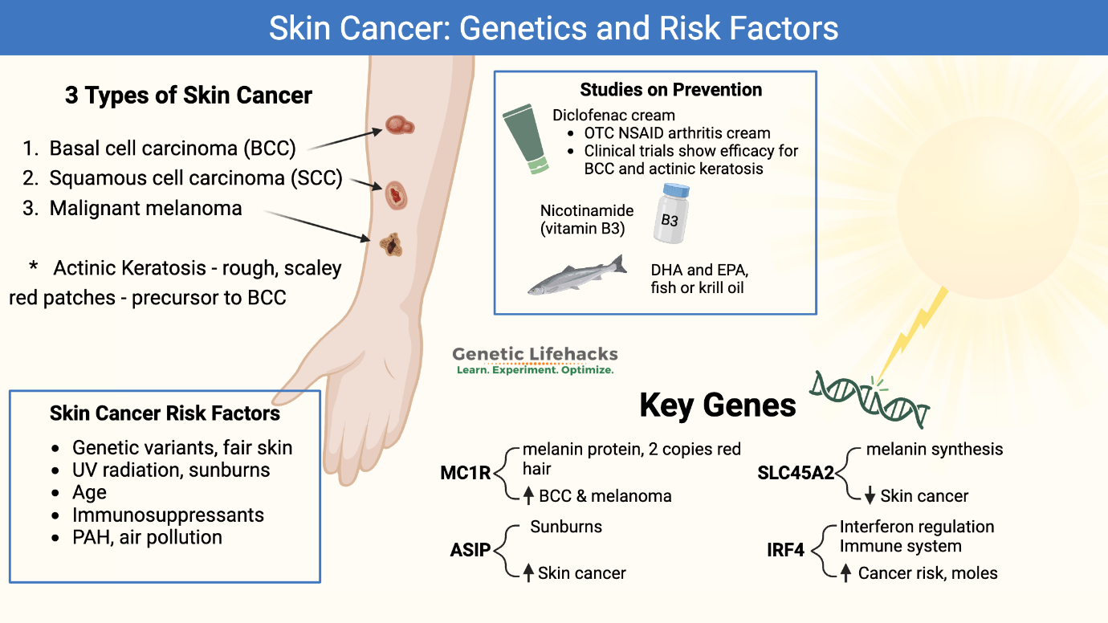(Source: https://www.geneticlifehacks.com/genetic-risk-factors-for-skin-cancer-check-your-genetic-raw-data/)

Appendix 2: Diagrammatic representation of the detailed mechanism of tumor vascularization

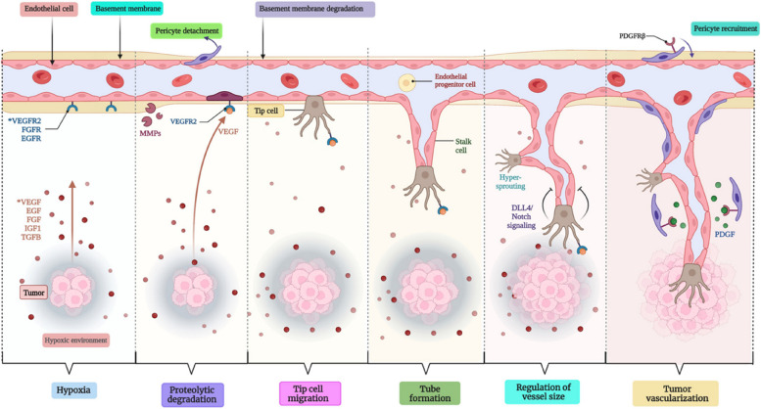
(Source: https://pmc.ncbi.nlm.nih.gov/articles/PMC10559482/)

Appendix 3: CASP
SL No. | Authors name | Was the question clearly focused? | Did the authors look for the right type of papers? | Were all relevant studies included? | Was quality assessment of included studies sufficient? | Was combining results reasonable? | What are the overall results? | How precise are the results? | Can the results be applied locally? | Were all important outcomes considered? | Are the benefits worth the harms and costs?
1 | Memon et al. (2021) | YES | YES | YES | YES | YES | YES | YES | YES | YES | YES
2 | Pega et al. (2023) | YES | YES | YES | YES | YES | YES | YES | YES | YES | YES
3 | Cherrie and Cherrie (2022) | YES | YES | YES | YES | YES | YES | YES | YES | YES | YES
4 | Shraim et al. (2023) | YES | YES | YES | YES | YES | YES | YES | YES | YES | YES
5 | Calbet-Llopart et al. (2022) | YES | YES | YES | YES | YES | YES | YES | YES | YES | YES
6 | Liebmann et al. (2023) | YES | YES | YES | YES | YES | YES | YES | YES | YES | YES
7 | Ferrara et al. (2024) | YES | YES | YES | YES | YES | YES | YES | YES | YES | YES
8 | Pauley et al. (2022) | YES | YES | YES | YES | YES | YES | YES | YES | YES | YES
9 | Jackson et al. (2023) | YES | YES | YES | YES | YES | YES | YES | YES | YES | YES
10 | Hodgson et al. (2025) | YES | YES | YES | YES | YES | YES | YES | YES | YES | YES

(Source: Self-developed)

