
Programme: Master's Public Health and Social Care in Practice
Student name: Esther Iyamu
Student ID: 2213124
Lecture’s Name: Dr Mohammad Khan
Module name: Community Care and Management of Long-Term Conditions
Module code: LCHS7003
Component 2
Deadline: 14th November 2025, (2 PM)
Title: Information Booklet on Adult Obesity

Acknowledgement
I confirm that I have not used any AI tools in the research and creation of this assignment. I confirm that I have not presented any AI-generated materials as my work. I confirm I have copies of my drafts, notes, and other resources I used, which I may be asked to provide in evidence.

Table of Contents

Obesity


Figure 1

Figure 1 (Obesity Medicine Association,2023).

1.0 Overview of The Selected Long-term Condition: Adult Obesity

1.1 What is Obesity?

Obesity, as defined by the World Health Organisation (WHO), is an abnormal accumulation of fat that poses health risks, identified by a BMI of 25 or higher for overweight individuals and 30 or higher for those with obesity (WHO, 2025) It is a complex and chronic disease influenced by various factors, elevating the risk of serious health issues such as type 2 diabetes, cardiovascular diseases, certain cancers, and musculoskeletal disorders. Managing obesity involves addressing the cycle of weight gain and metabolic changes, requiring a comprehensive, multidisciplinary approach aimed at long-term health improvement rather than just short-term weight loss (Lingvay et al., 2024), as shown in Figure 2 below.
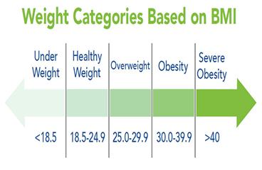

Figure 2: (Obesity Action Coalition, 2025).

1.2 The Burden and Prevalence of Obesity in England and Globally


From a global perspective, obesity has become a global epidemic, causing over 2.8 million deaths annually, according to the World Health Organisation (WHO, 2021). While it was once more common in high-income countries, its incidence is now also increasing in low- and middle-income nations. Addressing this issue requires urgent collaboration among various sectors, focusing on improving food systems, promoting physical activity, enhancing health education, and tackling social health determinants (WHO, 2021), as shown in Figure 3.

Figure 3: Source: (WHO, 2021).
Also, obesity is a significant public health issue in the 21st century, with global rates rising. In the United States, healthcare costs associated with obesity are approximately $173 billion annually, projected to increase to $481 billion as the number of overweight or obese adults rises from 172 million in 2021 to 213 million by 2050 (Pujia et al., 2025). Without effective prevention and intervention, these challenges are expected to worsen (Pujia et al., 2025).
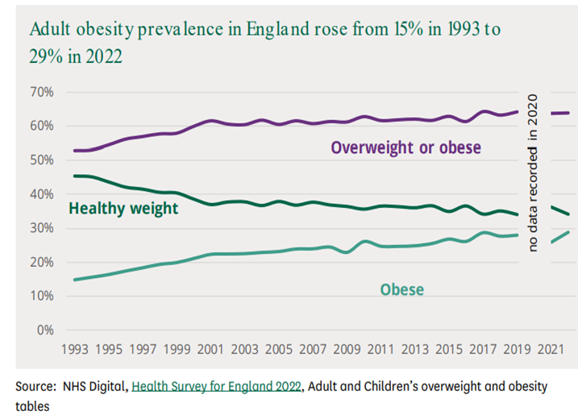
In England, between the years 1993 and 2022, the percentage of adults in England categorised as obese rose from 14.9% to 28.9%. Concurrently, the proportion of individuals classified as either overweight or obese increased from 52.9% to 63.9% (Stiebahl, 2025), see (Figure 4).

Figure 4: Obesity prevalence in England 2022 (Stiebahl, 2025).
Between 2023 and 2024, 64.5% of adults in England were classified as overweight or obese, a slight increase from 64.0% in 2022, the obesity rate remained stable at 26.5%, as men showed a higher overweight rate of 69.7% compared to 59.2% for women, while women's obesity rate was marginally higher at 26.9% versus 26.2% for men (Office for Health Improvement and Disparities, 2025).
The prevalence of overweight and obesity increased with age, peaking at 73.5% and 32.5% respectively, among individuals aged 55 to 64. Local authority obesity rates varied significantly, ranging from 11.0% to 37.9% (Office for Health Improvement and Disparities, 2025).
The prevalence of overweight and obesity among adults varies by deprivation level and ethnicity, with the highest rates found in the most deprived areas (71.2% overweight, 37.4% obese) and the lowest in the least deprived areas (59.4% overweight, 19.8% obese) (Office for Health Improvement and Disparities, 2025), see (Figure 5).
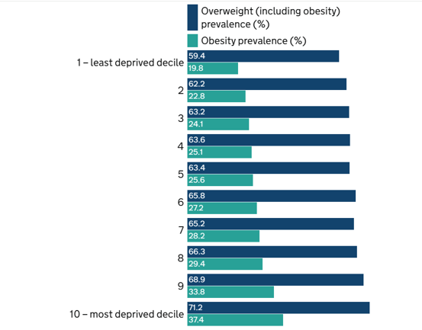

Figure 5: (Office for Health Improvement and Disparities, 2025).

Ghosh, Khan, and Vohra (2025) highlight obesity in older adults as a significant burden beyond financial implications, leading to reduced mobility, chronic health issues, and increased reliance on informal caregivers. This caregiving responsibility intensifies inequalities and stress, further straining the NHS and social care services. In the UK, managing health complications related to obesity costs over £6 billion annually, with total societal costs estimated at £27 billion (Frew, 2022).

1.3 Causes and risk factors
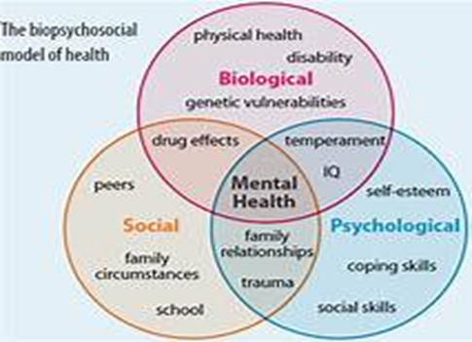
Masood and Moorthy (2023) describe obesity as a complex condition affected by genetic, environmental, and behavioural factors. Genetic predispositions influence appetite and metabolism, while modifiable factors, such as excessive caloric intake, poor diet, inactivity, and sleep deprivation, significantly contribute to the risk of obesity. Additional influences include socioeconomic status, psychological stress, ethnicity, and alterations in the gut microbiome. Dai et al. (2020) noted that high body mass index (BMI) led to 4.7 million deaths and 147.7 million disability-adjusted life years (DALYs) in 2017, far exceeding 1990 estimates. Obesity heightens the risk for numerous diseases and poses a growing public health challenge, particularly in low- and middle-income countries, necessitating effective prevention strategies.

2.0 Critical evaluations of the biological, Psychological, Social, and Physical implications of obesity

2.1 Biopsychological Model to evaluate Biological, Psychological, Social, and Physical Implications of Obesity on Individuals.

Cormack et al. (2023) describe the biopsychosocial model (BPSM) proposed by George Engel in 1977 as an enhancement to the biomedical model (BMM). Engel emphasised that health results from biological, psychological, and social interactions, challenging the purely physical view of illness. Engel argued that adequate healthcare should address the whole person, considering both internal experiences and external environments, aiming for a comprehensive, person-centred approach to understanding and treating illness. See: 6 as shown below.

Figure 6: (Biopsychosocial Model, 2025).

2.2 The multiple factors influencing the rise of obesity are illustrated in Figure 7.
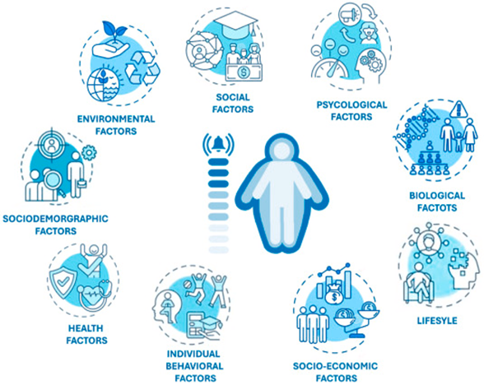

Figure 7: (Ahmed and Mohammed, 2025).
2.3 Biological Factors: Młynarska et al. (2025) highlight biological contributors to obesity, including genetic risk, hormonal imbalances, and metabolic dysfunction. They explain that altered levels of leptin, ghrelin, and insulin disrupt appetite and energy balance, thereby increasing the risk of obesity. The authors call for personalised treatments, especially digital interventions for individuals with a family history of obesity.
2.4 Psychological factors: The study by Dandgey and Patten (2023) highlights the impact of psychological factors on obesity as a chronic condition. Mental health issues, including depression and anxiety, can lead to unhealthy eating behaviours and emotional eating, contributing to weight gain. Weight stigma and discrimination exacerbate these challenges, leading to social isolation and negative self-perception. Individuals with obesity often encounter criticism, which reinforces negative body image and unrealistic standards. Hence, addressing psychological and social dimensions through therapy and supportive interventions is essential for effective obesity management.
2.5 Social factors: IKeaver et al. (2020) highlight the significant impact of social factors on obesity rates in England, identifying socioeconomic inequalities in income, education, and job status as key contributors to increased obesity risk. Individuals from lower socioeconomic backgrounds frequently have limited access to healthy foods, safe recreational spaces, and healthcare. Additionally, cultural norms and neighbourhood characteristics influence lifestyle choices. The study advocates for addressing these inequalities to formulate effective public health strategies aimed at combating obesity in England.
2.6 Physical factors: The study by Telleria-Aramburu et al. (2020) examines physical factors affecting obesity in adults in England, emphasising body composition, metabolic rate, and fat distribution. Sedentary behaviour and low physical activity contribute to weight gain, while insufficient muscle mass hampers management efforts. Chronic conditions such as hypertension and type 2 diabetes complicate obesity, highlighting the necessity for emphasis on physical activity and metabolic health for long-term management.
Wiebe and Marcello (2025) assert that obesity negatively affects mobility and joint health, leading to increased inactivity and additional weight gain, which ultimately results in substantial physical decline and a higher risk of early mortality.
Kauffman et al. (2022) found that adults with obesity and chronic pain experience worse pain outcomes, exacerbated by anxiety sensitivity, suggesting that cognitive-behavioural strategies might alleviate pain and enhance psychological well-being.

See Figure 8, which shows the signs and Symptoms of obesity.

Figure 8: (Shutterstock, 2025).
2.7 Self-determination theory to assess the physical impacts of an individual living with obesity
Self-Determination Theory (SDT), as outlined in Lee et al. (2017), emphasises that lifestyle interventions can support individuals with musculoskeletal pain and obesity in achieving long-term weight management by addressing their needs for autonomy, competence, and relatedness. These interventions enhance intrinsic motivation, leading to healthier lifestyle choices such as increased physical activity and better dietary habits. SDT underscores the importance of support and self-direction for effectively managing obesity amid chronic pain challenges.

Fadlilah et al. (2025) found that adults with obesity who engage in intermittent fasting and exercise driven by self-determined motivation see improved physical and social outcomes. This approach supports weight management and metabolic health while boosting confidence and promoting healthier relationships. In contrast, motivation from social pressure leads to inconsistent habits and limited benefits. The study highlights that personal goal-driven changes promote sustainable health improvements and overall well-being, advocating for a motivation-based, person-centred health approach.

2.8 Social Implications and Impact on Family and Caregiver.
Neller et al. (2024) indicate that family caregivers of individuals with obesity-related physical disabilities, such as severe osteoarthritis, struggle with tasks such as walking and bathing, requiring significant assistance, leading to emotional stress, fatigue, and social isolation due to caregiving demands. Despite these challenges, caregiving can strengthen family bonds and provide a sense of purpose. The study emphasises that caregiver well-being is crucial for care quality, highlighting the necessity for better support, education and resources. Additional studies by Arsha and Varma (2024) and Kuang et al. (2023) explore the challenges faced by family caregivers when caring for adults with long-term conditions, such as obesity. These studies indicate that family resilience and support networks can reduce caregiver burdens. They recommend emotional support, education, and community resources to improve caregiver well-being. Additionally, the challenges a patient faces can have a ripple effect on their entire family, significantly impacting the well-being and happiness of everyone involved.

(Psychologists Variations, 2025). See figure 9 below

Figure 9:(Psychologists Variations, 2025).
2.9 Evidence-based treatment offered by the UK to manage long-term conditions for adults with obesity
The National Health Service (NHS) 10-Year Long-Term Plan
The NHS Long Term Plan aims to integrate primary, community, acute, and mental health care in England, focusing on personalisation, digitisation, and universal coverage. A new initiative will provide support for obesity, including access to weight management services for those with type 2 diabetes or hypertension and a BMI of 30 or higher. Funding for the NHS Diabetes Prevention Programme will double, and pilots for very low-calorie diets will be introduced. NHS premises will promote healthy options and limit high-fat, sugar, and salt (HFSS) foods to enhance community care (NHS Confederation, 2019).
Additionally, obesity is a significant public health issue that affects local authorities and national finances. The NHS is expected to spend £6.5 billion annually on obesity-related healthcare, including over £100 million in 2021/22 for healthy weight programmes and £85 million for exploring new approaches to support patients. The total societal cost of obesity is estimated at £27 billion per year (Local Government Association, 2025).
According to the guidelines set by the National Institute for Health and Care Excellence (NICE), obesity is recognised as a long-term condition that impacts physical, psychological, and social well-being. The recommended approach is comprehensive, focusing on personalised behavioural interventions, dietary changes, increased physical activity, and psychological support (NICE, 2025). Care should be centred around the individual, emphasising overall health rather than solely weight loss. Long-term follow-up and support from a multidisciplinary team, which includes dietitians, psychologists, physical activity specialists, and medical professionals, are crucial for effective management. This team-based approach helps prevent relapse and ensures holistic care (NICE, 2025).
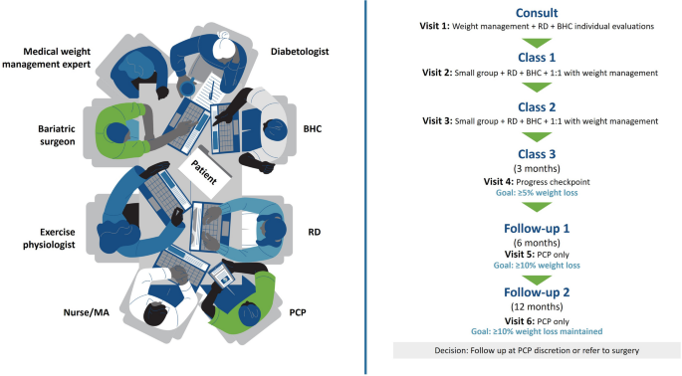
3.0 Examination of current theoretical frameworks, including models for enhancing outcomes for patients with long-term obesity in adults.
3.1 UK Model: Multidisciplinary Care Team
The Multidisciplinary Care Team (MDT) model proposed by Eid, Schultz, and Zubair (2025) at the Allegheny Health Network offers a patient-centred framework for obesity management through a dedicated metabolic centre. It emphasises four fundamental pillars: nutrition, physical activity, behavioural modification, and medical management, all integrated into a coordinated care pathway that utilises electronic medical records for monitoring purposes. Patients undergo assessments for comorbidities, with interventions ranging from lifestyle modifications to bariatric surgical procedures as required. This model demonstrates clinical efficacy and financial sustainability, particularly for older adults with complex health conditions, and aligns with the strategic health priorities of the United Kingdom, including the NHS Long Term Plan and local initiatives aimed at promoting health equity (Schultz and Zubair, 2025). See figure: 10 below for an example that demonstrates teamwork.

Figure 10: (Schultz and Zubair, 2025).

3.2 International Model: The Chronic Care Model (CCM).
The Chronic Care Model (CCM), as described by Grudniewicz et al. (2023), serves as a global framework for managing long-term conditions, such as adult obesity, through a goal-oriented, person-centred approach. Developed in the 1990s by Dr Edward H. Wagner and colleagues, the CCM emphasises proactive, continuous care over reactive treatment. It fosters collaboration among healthcare providers, patients, and communities to focus on meaningful health goals that enhance quality of life rather than just weight loss. Key elements include self-management support, delivery system design, decision support, and clinical information systems. By aligning clinical interventions with patients' personal values, the CCM encourages health systems worldwide, such as the NHS, to adopt data-driven strategies for effectively managing obesity as a chronic condition. See Figure 11 below.

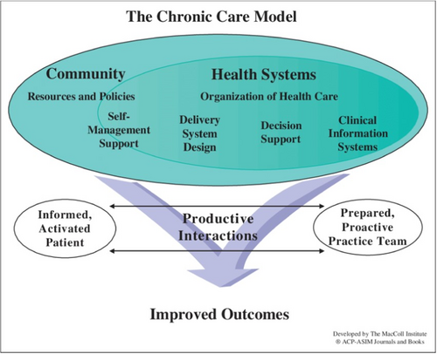

Figure 11: (Pomey et al., 2024).
CCM enhances quality care for individuals with obesity by connecting them to community resources, such as exercise programs and healthy food initiatives, empowering them to manage their conditions and improve their overall well-being (Pomey et al., 2024). Also, the Health Systems Organisation for Healthcare Leadership and Policies should focus on designing coordinated care teams that provide proactive, evidence-based support, allowing patients to make informed treatment decisions (Simpson et al., 2022). CCM aims to improve clinical outcomes, enhance the patient experience, and ensure equitable care that addresses both medical and psychosocial aspects of chronic conditions, delivering a comprehensive model for long-term care for adults living with obesity (Fortin and Stewart, 2021).
4.0 Discussion on the Implications of National and Local Political Health and Social Agendas.
4.1 Local and National
The United Kingdom (UK) has established various local and national health agendas to address obesity among adults in the country. The UK government’s strategy for tackling obesity focuses on prevention, early intervention, and equitable access to the NHS. It aims to empower adults to make healthier choices through improved information (like calorie labelling), restrictions on promotions of high-fat, sugar, and salt (HFSS) foods, and expanded weight-management services. The strategy also targets high-risk populations to reduce health inequalities and promotes a whole-government approach to support sustainable lifestyle changes and improve long-term health outcomes. (Department of Health and Social Care, 2020).
4. 2 The National Health Service (NHS) 10-year Long-term care plan:
The 10-Year Health Plan is part of the government’s initiative to create a future-ready healthcare system that manages long-term conditions through three main changes: shifting care from hospitals to communities, adopting digital technologies, and focusing on prevention rather than treatment. The NHS is tasked with implementing these changes by adopting a new operational model, increasing transparency, developing a workforce aligned with reforms, redefining its innovation strategy, and revising its financial management (Department of Health and Social Care, et al., 2025).

4.3 A Whole-System Approach
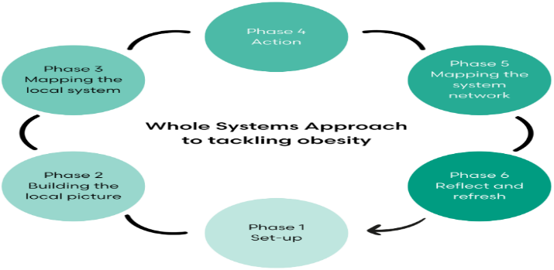
To effectively tackle adult obesity at the local level, a Whole-System Approach is essential, in line with the NHS Long-Term Plan's goals for personalised care and improved management of long-term conditions. This approach recognises obesity as a complex issue influenced by social, environmental, economic, and behavioural factors. By fostering collaboration among local stakeholders, including healthcare professionals, authorities, voluntary organisations, and residents, a holistic approach promotes a joint understanding of the challenges. Initiatives such as weight management services and community programs are valuable, as is identifying targeted opportunities for meaningful change (Public Health England, 2019). See figure 12 below.

Figure 12: (Morelife, 2025).
4.5 NHS Long-Term Plan
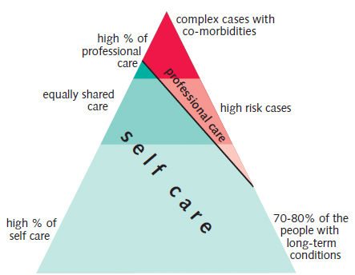
It collaborates with top professionals, handles complex cases- obesity shares care responsibilities, and enables individuals living with long-term conditions to have control over their own care (ResearchGate, 2025). See Figure 13 below.

Figure 13 (ResearchGate, 2025).

4.6 Integrated Care Systems (ICSs)
The NHS is shifting from purely clinical interventions to a long-term, comprehensive, community-based strategy. This involves leadership through Integrated Care Systems (ICSs) and local partnerships to support high-need communities. Key initiatives include workforce training for brief advice and referrals, as well as integrating clinical pathways with efforts to address broader social health determinants such as obesity (Holmes, 2021).
4. 7 Personalised Care Approach
Personalised care is a key advancement in the NHS Long-Term Plan, featuring six approaches through which individuals with long-term of obesity will have access to community services, patient choice, shared decision-making, supported self-management, social prescribing, personalised care planning, and personal health budgets. This model empowers individuals to manage their health with coordinated support, enhancing collaboration among patients, professionals, and the healthcare system to keep individuals informed and connected (Coventry and Warwickshire, 2025)

4.8 Social Prescribing
As part of a Whole-System Approach, general practitioners (GPs) can refer adults with obesity to Social Prescribing services that connect them to community activities enhancing social, emotional, and physical wellbeing. This enables individuals to make sustainable lifestyle changes, particularly those with mobility issues caused by obesity-related osteoarthritis, thereby reducing health inequalities and improving quality of life through volunteering, arts, gardening, cooking, and physical activity. The model promotes personalised, preventative care in line with the NHS Long-Term Plan (Department of Health and Social Care Disparities, 2023).
5.2 Making Every Contact Count. (MECC/brief advice, referral pathways).
Training staff to deliver concise dietary and physical activity guidance for individuals with obesity, along with establishing referral pathways to tiered services, are practical strategies that fit within social care workflows (Holmes, 2021).

5.0 Recommendations for improvement
5.1 Person-centred care
Person-centred care is essential for providing high-quality support to adults with long-term conditions, particularly obesity. This approach focuses on comprehensive assessment, collaborative goal setting, and integrated support from a multidisciplinary team, including dietitians and physiotherapists (Hudspeth, 2020). Care plans should address the physical, psychological, and social needs of individuals to promote dignity and reduce stigma. The Local Government Association emphasises the importance of prevention, early intervention, and access to community resources to encourage self-management. This personalised approach empowers individuals in managing obesity as a long-term condition (Hudspeth,2020).
5.3 Self-management
The National Institute for Health and Care Excellence (NICE) encourages healthcare professionals to tackle overweight and obesity by ensuring continuity of care and helping individuals develop sustainable habits. It advocates for the use of self-monitoring tools and access to various support options, including online communities, family-led interventions, and local activities (NICE, 2025). For instance, weekly group sessions on weight management are conducted at local community venues or online via Zoom, as these sessions include discussions on behaviour change techniques, emotional eating, nutrition, and portion sizes, as practised by Morelife, which provides community weight management in Camden and Islington (Northone Islington Primary Care Network, 2025). Also, Self-management is crucial in addressing adult obesity, particularly when healthcare professionals share essential information. Therefore, professionals should guide patients to access social support, which helps sustain behavioural changes, as the NICE guideline emphasises the importance of peer support groups, such as fitness or walking clubs, and encourages discussions of lifestyle changes with family and friends to foster independence and prevent future weight gain.

5.4 Recommendation drawn from this booklet's observation.
Adopt a Whole-System and Preventive Approach: A comprehensive, system-wide strategy should be adopted across local authorities and Integrated Care Systems (ICSs), addressing the broader determinants of health such as poverty, food insecurity, and the built environment. Policies ought to prioritise access to nutritious foods, safe recreational spaces, and early intervention programs targeting high-risk populations.
Support Caregivers and Families: Recognising the burden of care on families, local health and social care systems should provide caregivers with training, respite services, and emotional support. Also, empowering families enhances resilience and ensures continuity of care at home.

References
Ahmed, S.K. and Mohammed, R.A. (2025) ‘Obesity: Prevalence, causes, consequences, management, preventive strategies and future research directions’, ScienceDirect, 27(19), pp.1-20. Available at: https://www.sciencedirect.com/science/article/pii/S2589936825000313. (Accessed: 16 October 2025).
Coherence Among Family Caregivers’, Curēus (Palo Alto, CA), 16(4), p. e57815. Available at: https://doi.org/10.7759/cureus.57815.
Department of Health and Social Care Disparities (2023) Social Prescribing: Applying all our Health. Available at: https://www.gov.uk/government/publications/social-prescribing-applying-all-our-health/social-prescribing-applying-all-our-health (Accessed 8 November 2025).
Department of Health and Social Care (2025) Fit for the future: 10 Year Health Plan for England - executive summary (accessible version). Available at: https://www.gov.uk/government/publications/10-year-health-plan-for-england-fit-for-the-future/fit-for-the-future-10-year-health-plan-for-england-executive-summary#an-nhs-workforce-fit-for-the-future (Accessed 06 November 2025).
Department for Environment, Food and Rural Affairs, Department for Work and Pensions, Department of Health and Social Care, Ashley Dalton MP, Daniel Zeichner MP, and McGovern MP (2025). Government launches "Good Food Cycle" to transform Britain's food system. Available at: https://www.gov.uk/government/news/government-launches-good-food-cycle-to-transform-britains-food-system#:~:text=Minister%20for%20Health%20Ashley%20Dalton,Strategy%20published%20in%20the%20Autumn. (Accessed 6 November 2025).
Dai, H. et al. (2020) ‘The global burden of disease attributable to high body mass index in 195 countries and territories, 1990–2017: An analysis of the Global Burden of Disease Study’, PLoS medicine, 17(7), p. e1003198. Available at: https://doi.org/10.1371/journal.pmed.1003198.
Department of Health and Social Care (2020) Tackling obesity: empowering adults and children to live healthier lives, Available at: at:Ahttps://www.gov.uk/government/publications/tackling-obesity-government-strategy/tackling-obesity-empowering-adults-and-children-to-live-healthier-lives#:~:text=Therefore%2C%20we%20will%20be:,in%20physical%20stores%20in%20England (Accessed: 11 November 2025).
Dandgey, S. and Patten, E. (2023) ‘Psychological considerations for the holistic management of obesity’, Clinical medicine (London, England), 23(4), pp. 318–322. Available at: https://doi.org/10.7861/clinmed.2023-0146.
Eid, G.M., Schultz, M. and Zubair, F. A. (2025) ‘Comprehensive Multidisciplinary Metabolic Centre to Treat Patients with Obesity in the Allegheny Health Network’, OBESSURG 35, pp. 1983–1986 https://doiorg.ezproxy.uwtsd.ac.uk/10.1007/s11695-025-07813-9.
Fortin, M. and Stewart, M. (2021) ‘Implementing patient-centred integrated care for multiple chronic conditions: Evidence-informed framework’, Canadian family physician, 67(4), pp. 235–238. Available at: https://doi.org/10.46747/cfp.6704235.
Frew, E., Afentou, N., Borzadaran, H.M., Candio, P. and Pokhilenko, I. (2022) ‘Using Economics to Impact Local Obesity Policy: Introducing the UK Centre for Economics of Obesity (CEO)’, Applied Health Economics and Health Policy, 20(5), pp. 629-635.
Fadlilah, G.Z.S. et al. (2025) ‘A Qualitative Exploration of Individual Motivation for Intermittent Fasting Supported by Exercise Using Self-Determination Theory’, Gladi: Jurnal Ilmu Keolahragaan, 16(1), pp. 10–24. Available at: https://doi.org/10.21009/GJIK.161.02.
Ghosh, G., Khan, H.T.A. and Vohra, S. (2025) ‘A qualitative study to examine hidden care burden for older adults with overweight and obesity in England’, PLoS One, 20(3), pp.1-19.
Grudniewicz, A., Gray, C.S., Boeckxstaens, P., DE Maeseneer, J. and Mold, J. (2023) ‘Operationalizing the Chronic Care Model with Goal-Oriented Care’, The Patient, 16(6), pp. 569-578.
Hudspeth, C. I (2020) Socia Care and Obesity. Available at: https://www.local.gov.uk/sites/default/files/documents/1.112%20Social%20care%20and%20obesity_06.pdf (Accessed: 9 November 2020).
Holmes, J. (2021) Tackling obesity: The role of the NHS in a whole-system approach. Available at: https://assets.kingsfund.org.uk/f/256914/x/cead3911f6/tackling_obesity_role_nhs_whole_system_approach_2021.pdf (Accessed: 8 2025).
Keaver, L. et al. (2020) ‘Future trends in social inequalities in obesity in England, Wales and Scotland’, Journal of public health (Oxford, England), 42(1), pp. e51–e57. Available at: https://doi.org/10.1093/pubmed/fdz022.
Kauffman, B.Y. et al. (2022) ‘Anxiety and depressive symptoms among adults with obesity and chronic pain: the role of anxiety sensitivity’, Cognitive behaviour therapy, 51(4), pp. 295–308. Available at:

https://doi.org/10.1080/
Kochuvilayil, A. and Varma, R.P. (2024) ‘Navigating the Caregiving Pathway: Understanding the Contextual Influences on Sense of
Kuang, Y. et al. (2023) ‘Family resilience of patients requiring long‐term care: A meta‐synthesis of qualitative studies’, Journal of clinical nursing, 32(13–14), pp. 4159–4175. Available at: https://doi.org/10.1111/jocn.16500.

Lee, H., Wiggers, J., Kamper, S.J., Williams, A., O'Brien, K.,M., Hodder, R.K., Wolfenden, L., SZE, L.Y., Campbell, E., Haskins, R., Robson, E.K., McAuley, J.H. and Williams, C.M. (2017) ‘Mechanism evaluation of a lifestyle intervention for patients with musculoskeletal pain who are overweight or obese: protocol for a causal mediation analysis’, BMJ Open, 7(6), pp. 1-10.
Local Government Association (2025) Debate on food, diet and obesity, House of Lords, 28 March (2025) Available at: https://www.local.gov.uk/parliament/briefings-and-responses/debate-food-diet-and-obesity-house-lords-28-march-2025#:~:text=In%20March%202021%2C%20the%20Government,years%20to%20support%20healthy%20weight. (Accessed 10 November 2025).

Lingvay, I., Cohen, R.V., Le Roux, C., W. and Sumithran, P. (2024) ‘Obesity in adults’, The Lancet, 404(10456), pp. 972-987.
Masood, B. and Moorthy, M. (2023) ‘Causes of obesity: a review’, Clinical medicine (London, England), 23(4), pp. 284–291. Available at: https://doi.org/10.7861/clinmed.2023-0168.
Młynarska, E. et al. (2025) ‘Obesity as a Multifactorial Chronic Disease: Molecular Mechanisms, Systemic Impact, and Emerging Digital Interventions’, Current issues in molecular biology, 47(10), p. 787. Available at: https://doi.org/10.3390/cimb47100787.
Morelife (2025) Whole System Approach. Available at: https://www.more-life.co.uk/whole-systems-approach-to-obesity/ (Accessed: 8 November 2025).
Neller, S. A., Hebdon, M. T., Wickens, E., Scammon, D. L., Utz, R. L., Dassel, K. B., Terrill, A. L., Ellington, L., & Kirby, A. V. (2024) ‘Family caregiver experiences and needs across health conditions, relationships, and the lifespan: A Qualitative analysis’, International Journal of Qualitative Studies on Health and Well-Being, 19(1), 2296694. https://doi.org/10.1080/17482631.2023.2296694.

Northone Islington Primary Care Network (2025) Weight Management. Available at: https://www.north1pcn.co.uk/weight-management-2/#:~:text=The%20program%20is%20available%20to,diet%20and%20achieve%20weight%20loss. (Accessed: 9 November 2025).
NICE (2025) People need support to keep weight off after treatment ends. Available at:
https://www.nice.org.uk/news/articles/people-need-support-to-keep-weight-off-after-treatment-ends (Accessed: 9 November 2025).
NICE (2025) Planning and delivering overweight and obesity services and interventions. Available at: https://www.nice.org.uk/guidance/ng246/chapter/Planning-and-delivering-overweight-and-obesity-services-and-interventions#:~:text=%5B2014%5D-,1.19.,%5B2014%2C%20amended%202025%5D (Accessed: 13 November 2025).
NHS Nottingham and Nottinghamshire (2025) Personalise Care. Available at: https://notts.icb.nhs.uk/your-health/personalised-care-2/ (Accessed: 7 November 2025).
NHS (2022) Working in partnership with people and communities: Statutory guidance. Available at: https://www.england.nhs.uk/long-read/working-in-partnership-with-people-and-communities-statutory-guidance/#:~:text=We%20refer%20to%20health%20and,to%20deliver%20joined%2Dup%20care. (Accessed: 13 November 2025).
NHS Confederation (2019) NHS Long Term Plan. Available at: https://www.nhsconfed.org/system/files/media/ltp-member-briefing_4.pdf (Accessed: 10 November 2025).
NHS Coventry and Warwickshire (2025) What is Personalised Care? The Comprehensive Model and the six components. Available at: https://www.happyhealthylives.uk/integrated-care-board/resources-and-services/personalising-care-for-our-people/what-is-personalised-care-the-comprehensive-model-and-the-six-components/ (Accessed: 7 November 2025).
Office for Health Improvement and Disparities (2025) Obesity profile: short statistical commentary, May 2025. Available at: https://www.gov.uk/government/statistics/obesity-profile-may-2025-update/obesity-profile-short-statistical-commentary-may-2025 (Accessed: 13 October 2025).
Obesity Medicine Association (2023) Obesity and Pain Management: How to Treat Pain in Patients with Obesity. Available at: https://obesitymedicine.org/blog/obesity-and-pain-management-how-to-treat-pain-in-patients-with-obesity/ (Accessed: 13 October 2025).
Obesity Action Coalition (2025) What is Obesity? Available at:https://www.obesityaction.org/education-support/learn-about-obesity/causes/ (Accessed: 14 October 2025).
Psychologists Variations (2025) 7 Ways a Loved One’s Illness Affects the Whole Family. Available at: https://www.variationspsychology.com/blogs/7-ways-a-loved-ones-illness-affects-the-whole-family#:~:text=Emotional%20upheaval,Ange Ange (Accessed: 6 November 2025).
Public Health England (2019) Whole System Approach to Obesity. Available at: https://assets.publishing.service.gov.uk/media/5d396e7140f0b604de59fde9/Whole_systems_approach_to_obesity_guide.pdf (Accessed: 8 November 2025).
Pomey, P., Schaad, B., Lasserre-Moutet, A., Böhme, P., and Jackson, M. (2024) ‘Towards a New Integrated Model for Taking Into Account the Experiential Knowledge of People With Chronic Diseases, Integrating Mediation, Therapeutic Education and Partnership: The Expanded Chronic Care Patient–Professional Partnership Model’, Health Expectations, 27(5), e70054. https://doi.org/10.1111/hex.70054.

Pujia, C., Ferro, Y., Mazza, E., Maurotti, S., Montalcini, T. and Pujia, A. (2025) ‘The Role of Mobile Apps in Obesity Management: Systematic Review and Meta-Analysis’, Journal of Medical Internet Research, 27.
Physiopedia (2025) Biopsychosocial Model. Available at: https://www.physio-pedia.com/Biopsychosocial_Model (Accessed: 21 October 2025).
Quinn, H. (2025} NICE recommends better support for weight-loss patients after treatment. Available at: https://www.nursinginpractice.com/clinical/womens-health/nice-recommends-better-support-for-weight-loss-patients-after-treatment/#:~:text=Patients%20must%20have%20social%20support,to%20prevent%20future%20weight%20gain. (Accessed: 9 November 2025).
Stiebahl, S. (2025) Obesity Statistics. Available at: https://researchbriefings.files.parliament.uk/documents/SN03336/SN03336.pdf (Accessed: 13 October 2025).
Shutterstock (2025) Oversized Woman Grab Ger Back Suffer from Back suffer. Available at: https://www.shutterstock.com/image-photo/oversized-woman-grab-ger-back-suffer-2156502429 (Accessed: 20 October 2025).
Simpson, K., Wilson, N., Thariath, J., Schafer, H., Greenwood-Eriksen, M., Fetters, M.D., Serlin, D., Peterson, T. and Abir, M. (2022) ‘How health systems facilitate patient-centred care and care coordination: a case series analysis to identify best practices’, BMC Health Services Research, 22, pp. 1-17
Telleria-Aramburu, N., Rocandio, A.M., Rebato, E. and Arroyo-Izaga, M. (2020) ‘The EHU12/24 cohort: survey design, instruments and participants’, The British Journal of Nutrition, 123(3), pp. 347-360.
World Health Organisation (2025) Obesity. Available at: https://www.who.int/health-topics/obesity/#tab=tab_1 (Accessed: 11 October 2025).
Wiebe, N. and Marcello, T. (2025) ‘Associations of body fat and inflammation with non-communicable chronic diseases and mortality: a prospective cohort study of the UK Biobank’, BMJ Open, 15(10), pp. 12.
World Health Organisation (2021) Obesity. Available at: https://www.who.int/news-room/facts-in-pictures/detail/6-facts-on-obesity (Accessed: 11 October 2025).
.

