
Skills for the Workplace
Module Assignment Submission
Student Name: | Caroline Lewis
Student Number: | 1917865
Module No: | BMSK4002
Module Title: | Effective Team Working and Communication  Part 2

Statement of Confirmation of Authenticity
By the act of making this submission, the student declares that this is the work of the student named above. The work has not, in whole or in part, been knowingly presented elsewhere for assessment, or where assessment has been built on a previous assessment, this has been identified. Where materials have been used from other sources it has been properly acknowledged. If this statement is untrue, the student acknowledges that an assessment offence has been committed.
Attention is drawn to the plagiarism and unfair practice policies of both the University and of ILM.

Table of Contents
Part 2 Communication………………………………………………………………………3
1.0………………………………………………………………………………………….....3
Communication Cycle………………………………………………………….…………3
2.0……………………………………………………………………………………….…….7
Assessing Own Communication Skills……………………………………………….…7
……………………………………………………………………………………………….
………………………………………………………………………………………………..
Appendices…………………………………………………………………………………11
References…………………………………………………………………………………23

Introduction.

The author is a mature student at the age of 47. She is a single, working mum in the financial element of the local council (rent officer). The author has worked for her local council since 2010 in several different sections including council tax and business rates. Before the author joined the local council, she was a post mistress for many years. She has enrolled in this course to advance her employability skills. Her hobbies include interior design and rock music.

Report of Management Communication.

Management Synopsis.
In this report the author will explore communication theories and models to assess their effectiveness in the workplace today.
The author will then assess her own communication skills with the data she has collected from several sources including questionnaires, presentation feedback, SWOT analysis etc and set a personal development plan with the results.

Part 2 Communication.
1.0
Communication Cycle.

Communication is a key element to a successful company; good communication can save time and in doing so saves money. The progress can be swift whereas bad communication will delay tasks, due to confusion and more time in needing to refer.

“The result of bad communication is a disconnection between strategy and execution.” Martin, C (2005)

The first theory that the author has researched is Linear, this was designed by Shannon and Weaver in 1949. (Appendix 1)
A linear model is a one-way process in which the sender, encodes and transmits the message ‘via a channel’, and the recipient receives the information and decodes it.
Although this model is basic and limited, it still has its uses in business today especially in advertising, in print or in broadcasting. This type of communication does not need feedback for the purpose of the message, it is straight, direct and one way. However, there can be things that can affect the message getting to the receiver, this is known as noise. This type of communication may not have been understood by the receiver as there is no way on knowing. This is like Berlo’s communication theory, as it is also a linear model with no feedback or noise. (Appendix 2)
“According to the model many things can affect the one-way communication process. For instance, the choice of channel selected may affect the way a receiver interprets a message. Also, a number of disruptions can occur at any point – they're known as ‘noise’. It can include ‘psychological noise’, whereby the psychological state of the receiver will affect the interpretation of the message, including stress, anxiety, anger and so on.” Stanford, C (2020)
The next theory the author has researched is ‘transactional communication’ where the messages are sent to and from the sender and receiver simultaneously. This is an interpersonal communication method. This theory by Barnlund’s was developed in the 1970’s. (appendix 3)
It contains a shared field of communication, feedback, and disruption(noise). This type of communication works well if the sender and receiver understand common work codes and jargon or if they have worked together before or in the same field. However, this method can be complicated than linear, and the noise problems can disturb the communication flow; for example, talking over each other in a meeting. Both receiver and sender need to actively listen to each other for this to be successful.
There could be other effects that could hinder this communication theory such as people’s backgrounds, work grades, language etc.
‘Transactional model relates communication to social reality of an individual or a group of people in social, cultural and relational contexts. Their responses cannot be predicted because they all have different backgrounds and mental conditions. Communication pattern depends on various factors such as physical, cultural, environmental, social, psychological, emotional, etc.’ "Transactional Model of Communication," in Businesstopia, January 6, 2018

The authors last communication theory she has researched is an Interactive model, developed by Eugene White in the 1960’s (appendix 5). It has eight stages: thinking, symbolizing, expressing, transmitting, receiving, decoding, feed-backing, monitoring, and thinking. This model suggests a circular/loop action where there is no beginning or end to communication. It is like the transactional theory using feedback, but it is more involved as symbols and expressions are used in the message to help engage and understand before the message is transmitted. The author recognises how expressions can be an asset in getting the message across or sometimes a barrier, such as fear.
‘What you actually say when you communicate begins long before you open your mouth and continues after you’ve finished speaking. The human face is extremely expressive – able to communicate countless emotions without saying a word. And unlike some forms of nonverbal communication, the emotions shared through facial expressions are universal.’ “The Impact of Facial Expression in Communication” in Speakeasyinc,(30.08.18)
This theory also has a monitoring stage; therefore, it will always be adding more information to the feedback and a greater chance of improving the result.
“the most prevalent, and perhaps most important, form of communication is the feedback of information about performance, which permits the individual to adjust behavior and effort in future time periods in order to improve performance” O'Reilly III,C A et al (1980).

The author recognises that all the above theories of communication are being used in her workplace, each have their uses and a place.
In the author’s organisation of the local council they use verbal, written and non-written communication.

The author’s organisation uses the linear model to communicate with their tenants, to advertise services e.g. adverts on monitors at district housing offices, leaflets, or letters.
Often her organisation will use a poster with an image to communicate a message. This is highly successful as a large portion of the tenants first language is not English. They may also have learning disabilities, deaf or poor eyesight to read script. An image can ‘say’ or ‘explain’ without saying a word. The author’s organisation uses leaflets to offer help and advice to tenants who have an addiction or are being abused. A single ‘expressive’ image with a phone number is all that is needed. A scared girl next to a large shadow can instantly relay child abuse. A man with anger in his face holding his fist over a frightened lady can relay domestic abuse. An elderly lady looking frightened in her doorway with a salesman pushing passed her can be financial.
The downside to the linear method with regards to letters being sent is that we have no way of knowing if they have got to the tenant, read it or understood it.
Phone calls are also used to get in touch with tenants, but the organisation technology is being updated and text, emails and Skype is also now used. These methods are quicker to get the message across and a reply. The rapport with the tenant is greater as it is less formal and more friendly, and it is a much easier way to engage with the younger generation. The author recognises the importance of knowing her audience to determine what method and style of communication she uses. As a rent officer you need constant communication to and from certain tenant’s that need help due to their difficult and diverse situations. In the theories above ‘noise or disruption’ to get the message across could be intoxication, depression by the tenant and the message is not fully understood. In these cases, feedback from them is important to the author to provide the best service; the author recognises this is a transactional model.
Within the author’s organisation it communicates by email, phone, letters, and more recently Skype and Microsoft teams. The communication cycle between the rent officers and the senior rent officers has always been an important one. Problems can arise hourly needing instructions and feedback, new instructions, and feedback again: a transactional communication module. Due to recent events, working from home has been implemented and the contact between all officers has been through Microsoft teams, this is where the interactive theory is used successfully.
A mixture of all these theories is the best use of communication within the authors organisation.

2.0

Assessing Own Communication Skills.

The author has collected data from several sources to analyse and evaluate her communication skills and set a plan for improvement.
The author took an online quiz to establish what communication skills she has. The results (appendix 5) show that she is average at verbal communicating, communicating in groups, and listening skills but is higher than average in her emotional intelligence.
Emotional intelligence is empathy, where the author understands why a person acts a certain way. The author needs this skill as a rent officer due to how important it is in communicating to a tenant who may have difficult issues in their lives. The author believes that her having too much empathy can hinder her communication; she does not want to upset them and so the message to the tenant is a difficult one for her to deliver.
“Research indicates that Emotional Intelligence (EI) is a key determinant of one's success in life even more so than IQ. The most successful leaders are adept at balancing their knowledge and experience with EI skills.” Matters, E.I. (2002)
The author took the Thomas Kilmann conflict questionnaire to establish her style of handling difficult situations in the workplace. The results (appendix 6) show that she is accommodating and compromising in conflict situations. Although this can show that she is well liked in a group as she tries to keep harmony, but as a manger this can show weakness and fear that can have damaging effects in crisis situations. The author recognises she avoids confrontation in the workplace, she is quiet and feels at ease in the background and this is reflected in the results as her lowest mark was in the competitive column. This competitive streak is important in a managerial role as it shows drive and strength which is needed in quick decision making. The author believes to be a good manager, she will need to have an equal balance of all the styles to adapt to different situations as they arise.

The author collected feedback from an online presentation she delivered on ‘effective working teams’ the results are in the chart (appendix 7) and in the Johari’s Window (appendix 8). The results show that in all points were good to excellent. The results also show that she has some confidence as she spoke loudly and clearly; a place that she though would be weak. She will take this on board to improve her confidence to potentially conduct a presentation at the workplace. Although she practiced her timing of the presentation, on the actual day she believes she rushed it a little and that also reflects in the results; this was at a ‘good level.’ This is due to nerves and not breathing correctly. The author’s Diabetes also affects her in nervous situations as her sugar levels naturally rise. This can have a detrimental effect to her memory, which was evident in the feedback where she relied too heavily on reading the slides.
With all these results the author has completed a SWOT (appendix 9), SMART (appendix 10), GAP (appendix 11) and set herself a personal development plan (appendix 12) for the improvements needed in her communication as a potential manager.
The author believes to improve her communication skills is to start with her active listening. She is aware she interrupts due to anxiety of silence and will research breathing techniques self- help books to overcome these issues.
‘‘Effective Communication – Clear and concise transmission of information is an important component of effective human interaction. Though the onus is often placed on presenting clear and concise written or spoken directions, the listener also bears a responsibility to hear and understand messages.’’…. ‘‘Engage yourself. Ask questions for clarification, but, once again, wait until the speaker has finished. That way, you won’t interrupt their train of thought. After you ask questions, paraphrase their point to make sure you didn’t misunderstand. Start with: “So you’re saying…” Tyagi, B., (2013)
Her body language and eye contact also requires attention and she will practice in front of a mirror to make improvements.
To improve her confidence in the presentation the author must get her nerves under control. She will research self-help books to make her reflect that presenting is not about her as a person, but the information that she is relaying.
As Carnegie, D (2018) advises instead of being terrified of your audience think of yourself as a messenger for e.g. postman delivers a letter to you, are you more interested in the post man or letter? Or is a DJ talking more enjoyable than the music but rather to hear the music. He also advises to breathe deeply before starting to speak and that this has been used in overcoming stage fright for decades. The author needs to improve the quality of her email communication. She compares her emails to her managers and reflects on the areas the author can improve. Her manager’s emails have structure, contain all the information needed, highlights important arears, are clear and concise.
According to Delfino, D (2018) the autonomy of a good email must contain; subject line, openers, body and closing.
The author needs to proofread her emails to address all these areas, she feels that she must urgently reply and due to this, errors are missed. She also needs to be sure that spell checker and grammar tools are on to prevent mistakes due to her Dyslexic tendencies. The author believes that this ‘Skills for the workplace’ course will also improve her critical thinking and reflection skills that she could apply this to her emails. The author sends a great deal of emails and therefore has lots of opportunity to improve. Due to ‘data protection’ she also must be vigilant on the information it contains and who is receiving it, as this is a disciplinary offence in her workplace. Attention to detail is needed.
The author understands the importance of ‘expressing’ in a message as in Whites communication theory (appendix 4) and it is especially important in the use of sign language. The author has a qualification in sign language where expressions are used with hand movements to communicate with the deaf.
The last point where the author needs to improve is the tone of her voice. Her tone is too weak in communicating as a potential manager, as strength and authority in a voice is needed in difficult discussions.
“The third element of a confident, authoritative voice is resonance. You need to lower the resonance. You need to cultivate sound vibrations throughout your body, especially in your torso. Speaking from your throat and mouth makes your voice sound small, high and young. Speaking with your whole body makes your voice sound full, deep and strong.” Voice and Speech
The author will look at lowering her pitch, use breathing exercises and cultivate her sound to improve her tone and stammer: she will assess her progress through recordings of her voice.
The author concludes that by addressing all the points in this report, she hopes to improve her communication skills to managerial level.

Appendix 1
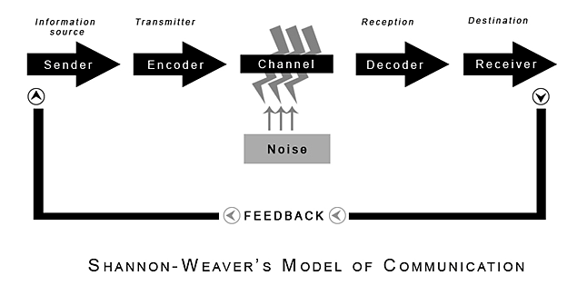
(Shannon and Weaver, 1949)

Appendix 2



Appendix 3
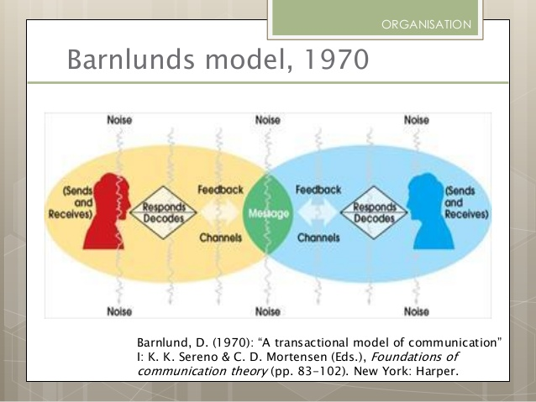

Appendix 4 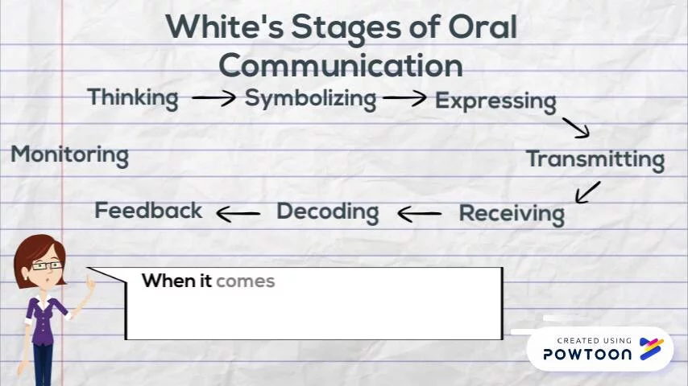

Appendix 5

The author undertook an online self-assessment communication questionnaire on 07.05.20. It contained scenarios with multi optional choices. The results show that the author is above average of her emotional intelligence, where she has strong empathy. This is also reflected in her work where she must communicate with her tenants that are going through difficult times. The author is average on communication in groups, verbal communication and on her listening skills; this confirms that the author needs to improve on these areas.

Appendix 6

The author completed a conflict handling style questionnaire on 25.04.2020. The results show that the author is equally high in the compromising and accommodating styles. A little lower in the collaborating and avoiding styles. The style where she is least likely to display is competing. The author recognises these styles in herself but is surprised that the results are so clear in reflecting her communication style.
Some key points of styles:
- Competing (concentrates on own needs ignoring others, quick decision making, can be unpopular but useful)
- Collaborating (takes on board other’s needs, decisions take longer as lots of discussions, can feel taken advantage of)
- Compromising (not a good style for important or emergency issues, lose sight of long-term goal, too sensitive to lead strongly)
- Avoiding (only good with unimportant issues, decisions can be made without you, no conflict)
- Accommodation (giving in when others show more control, fear of conflict, useful keeping harmony)

Appendix 7

The author conducted an online presentation on ‘Effective working Teams’ on the 10th of May 2020 from her home to an audience of two fellow students and her lecturer. The sample above contains the feedback.
The author’s results show that she was excellent in most of the presentation which the author was very pleased. No areas of the presentation were weak or fair. There is slight room for improvement in her eye contact, presentation without reading, better time management and respond to questions more accurately, as her results were ‘good’.
The author was pleased with the results and gives her the confidence to improve on her weaker areas.

Appendix 8
Morgan, P (2017)
The Johari Window (1955)
Unknown to Self
Known to Self

Lacking in confidence in communicating.  Not afraid to ask questions and give feedback.  Self-doubt.  The author has a stammer. | Known to Others  Good at presentation and PowerPoint design.  Lacks in eye contact.  Can speak well.  Needs to practice the timing of the presentation more.  The author’s voice is friendly with natural tone.
Dyslexia is the cause of errors in the author’s emails and written communication.  The author’s Diabetes also causes ‘brain fog’ and visual disturbances that can affect her verbal and written communication. This could be treated as ‘noise’ in the communication theories and is a barrier to good communication.  The author has passed ‘Sign Language stage one’ to improve her communication to the deaf. | The potential to lead a presentation in the workplace.  Unknown to Others  Will the author overcome her confidence issues?  Will the author overcome her stammer?  Will the authors Dyslexia improve with time and with the use of new software? e.g. Word, spell check

The unknown to self and unknown to others were compiled by the feedback of the author’s presentation on 10.05.2020.

Appendix 9

SWOT

Strengths | Weaknesses
- Good at compromising.  - Friendly/polite manner.  - Empathy.  - Wide experience of customer care and communicating with the public.  - Qualified in Sign Language.  - Conscientious. | - Interrupts.  - Lacks authority in her voice.  - Spelling/grammar in emails.  - Lacks active listening skills.  - Stammer.  - Anxious in some communication.  - Avoids confrontation.
Opportunities | Threats
- This ‘Skills for the workplace course’ is providing new opportunities to improve the authors communication skills e.g. presentation.  - The authors new workplace has recently introduced new ways of communicating e.g. Microsoft Teams. This brings along with it new opportunities to work from home.  - The author’s new skills are making an impression with her workplace managers. | - The authors Diabetes has an impact on her communication skills. If her blood levels are high, she loses concentration, and this can prevent her absorbing the information correctly.  - If there has been a miscommunication between the tenant and author, there could be serious repercussions e.g. court action.  - Data protection threats are always in mind whilst sending email and can be a disciplinary issue.

Appendix 10

S | M | A | R | T
Specific | Measurable | Achievable | Realistic | Time-bound
The author needs to improve all her communication skills, including improving her emails to be clear and concise. Improving her listening skills in meetings. Adapt a stronger voice to control difficult situations. | The author will monitor her email responses asking for more information.  The author will keep a diary of meetings to measure her involvement in the meeting due to active listening.  Being able to be forceful while on the phone to a difficult aggressive tenant. | As the author makes around 10 emails and 30 telephone calls each day, this gives great practice to achieve the goals. The author has weekly meetings to improve her listening skills to achieve improvements. | These goals are realistic and can be met with practice in the desired time. The author also has the resources to achieve these goals e.g. Computer. | The time in which is set is for the authors yearly review date of 01.08.2020.

Appendix 11

Gap Analysis

Objective | Current Position | Deficiency | Action
What do I want to do? | What can I already do? | What am I lacking? | How do I fix this?
The author would like to improve her active listening skills. | The author listens but her body language does not reflect that. | The author lacks body awareness and how it can reflect on her as an active listener. | The author will practice in front of a mirror. Making sure her body language is showing she is actively listening. Leaning forward, eye contact, unfolded arms etc.
The author would like to improve her written communication in emails. | The author sometimes misses key points of the message in her initial email and the receiver must refer to her to ask for more information. | The author lacks the full story behind the reason why the initial email is being sent. | The author needs to put the whole story in the first email and proofread it as if she is the receiver and knows nothing regarding the reason for the email.
The author needs to improve her telephone manner. | The author has a polite and sweet telephone manner. | The author lacks authority in her voice and can stammer in get her information across to a manager or an aggressive tenant. | To get as much information regarding the reason for the call before the author speaks. To be prepared and with knowledge comes confidence. The author will also try and lower her voice and speak at a slower speed to sound less sweet.
The author would like to improve her communication while speaking to one to one, especially not interrupt. | The author has good communication to one to one but at times she can interrupt the other speaker. | The author lacks confidence and wants to come across in her personality as enthusiastic and keen. This excitement can cause the author to interrupt the speaker. The author speaks too quickly and feel uncomfortable with pauses. | The author needs to slow down her side on the conversation. Not to jump in on the slightest pause. The author believes again that through breathing exercises an improvement can be made.

Appendix 12

PDP

Objectives | Tasks | Success Criteria | Time Frame | Resources
List your Goals | What do you need to do to achieve these goals? | How will you identify your success? | When do they need to be done by? | Who or what do you need to help you?
Improve listening skills and retain more information | Improve body language to reflect the authors listening attentively. | The author will identify her success if in a team meeting the manager will ask the author what her feelings are regarding the subject. e.g. the manager will engage more with the author | 01.08.20 | Active listening exercises on You-tube and practicing in front of a mirror.
To have clear concise emails, with little need for further information requested from the receiver. | The author needs to proof-read her emails before sending and be critical of them to make sure she has given all the information they require. (Review and revise) | The author will identify if an improvement has been made in her yearly review from her manager and feedback from other members of the team | 01.08.20 | Grammar and spell checker facility. The author will buy guidebooks e.g. ‘A quick guide to better emails’ by Heather Wright.
To improve her telephone voice and remove her stammer. | The author needs to lower the speed and pitch in which she talks. | To have more authority whilst on the telephone to her tenants, be more in control of the situation. | 01.08.20 | Breathing techniques books to reduce nerves as nerves make the tone of voice higher. To make recordings of the authors voice and mark improvements.
Not to interrupt in communications. | The author needs to breathe deeply not rush her side of the communication. To relax and let pauses be natural. | The author will identify this through feedback from her yearly review. | 01.08.20 | The author again will look at anxiety self-help books to relax and breathe deeply.

References
Barnlund’s model [online image] Available at:
https://www.bing.com/images/search?view=detailV2&ccid=xkzx2TB%2B&id=822D06CA81BE2EF03187D979501EB0BA9507198D&thid=OIP.xkzx2TB-lpbP-z5rCJ_l0AHaFj&mediaurl=https%3A%2F%2Fimage.slidesharecdn.com%2Fkommunikationadm-150225054327-conversion-gate01%2F95%2Fkommunikation-adm-br-31638.jpg%3Fcb%3D1424843289&exph=479&expw=638&q=barnlund%27s+communication+model&simid=608049897186919893&selectedindex=2&ajaxhist=0 [accessed 03.05.20]

Berlo’s SMCR Model of Communication. [online image] Available at: https://www.communicationtheory.org/berlos-smcr-model-of-communication/ [Accessed 03.05.20]

Carnegie, D. (2017) How to develop self-confidence and influence people by public speaking. Simon and Schuster. New York

Delfino’ D (2018) ‘How to write a proper email’ Available at:
https://www.grammarly.com/blog/email-writing-tips/ [accessed 17.05.20]

Making Good Speakers Great. Available at:
https://voiceandspeech.com/articles/stronger-voice.html [Accessed 17.05.20]

Martin, C (2005). “Tough Management: The 7 Winning Ways to Make Tough Decisions Easier, Deliver the Numbers, and Grow the Business in Good Times and Bad”, p.12, McGraw Hill Professional

Matters, E.I.,(2002) Emotional intelligence. santhwana.info

MindTools (2019) How good are your communication skills? Available at: https://www.mindtools.com/pages/article/newCS_99.htm [Accessed: 15.04.20]

O'Reilly III, C.A. and Anderson, J.C. (1980). Trust and the communication of performance appraisal information: The effect of feedback on performance and job satisfaction. Human Communication Research, 6(4), pp.290-298.

Shannon, C. and Weaver, W. (1949) The Mathematical Theory of Communication. Urbana: University of Illinois Press.
Skills You Need (2019) Interpersonal Skills Self-Assessment. Available at: https://www.skillsyouneed.com/ls/index.php/343479 [Accessed: 07.05.20]

Stanford, C. What is a Linear Model of Communication? Available at:
https://fleximize.com/articles/000561/a-linear-model-of-communication[Accessed 03.05.20]

"Transactional Model of Communication," in Businesstopia, January 6, 2018 Available at:
https://www.businesstopia.net/communication/transactional-model-communication. [Accessed 03.05.20]

Tyagi, B., (2013) Listening: An important skill and its various aspects. The Criterion An International Journal in English, 12, pp.1-8

Dialeg S, (2019) Eugene White model of communication [Image] Available at:
https://www.powtoon.com/online-presentation/flUbScyTcZw/eugene-white-model-of-communication/?mode=movie&locale=en [Accessed 03.05.20]

‘The Impact of Facial Expression in Communication in speakeasyinc.com’ (Aug 30th) Available at:
https://www.speakeasyinc.com/the-impact-of-facial-expression-in-communication/ [Accessed 04.05.20]

Bibliography

Argyle, M., (2013) Bodily communication. Routledge. Abingdon

Barnlund’s Transactional Model of Communication. Available at:
https://www.businesstopia.net/communication/barnlund-transactional-model-communication [Accessed 03.05.20]

Morgan, P. (2017) The Business Student’s Guild to Study and Employability. Sage: London

Pears, R. and Shields, G. (2010) Cite them right: The essential referencing guide. 3thedn. Basingstoke: Palgrave Macmillan.

The Communication Cycle Six Steps to Better Communication (28th Oct 2020) Available at: http://manyana-education.blogspot.com/2010/10/communication-cycle.html [Accessed 19.05.2020]

