

BA Business Management

Module: Management Economics
Module code: LCBB5008

Name of the Student and ID : Viktoriya Koleva 2111874

Table of Contents
Describe Business 2
Chosen product- Tesco: Beverages 2
Reason for choosing product 3
Identify Demand and Market Equilibrium 3
Price of substitutes 4
Price of complements 5
Consumer income 5
Consumer tastes and preferences 6
Consumer expectations of price 6
Demographics- Number of Consumers 7
Indicate demand is more elastic or more inelastic 7
Pricing policy for Tesco 9
References 12

Describe Business

Chosen product- Tesco: Beverages
Tesco PLC is a grocery and general retail that operates across the globe. Tesco is known for being the most valuable brand in United Kingdom and in Europe. Tesco operates with diversified revenue stream which includes online grocery delivery, insurance, clothing and household goods and supermarket. Over the years, Tesco has gained huge customers base with its unique selling strategy and slogan “every little help”. Tesco is well known for its wide range of food and beverages. Tesco produces around 1,600 products line across the Tesco Finest and Tesco Value ranges. The superstore offers with 40,000 product lines which includes 25,000 of food and beverages (Chen 2022). Tesco plc. is known for its wide range of products in tea. Different brands of tea bags are sold by Tesco which has gained a significant position in the market. The selected product from the wide range of products offered by Tesco is Stockwell & Co tea bags.
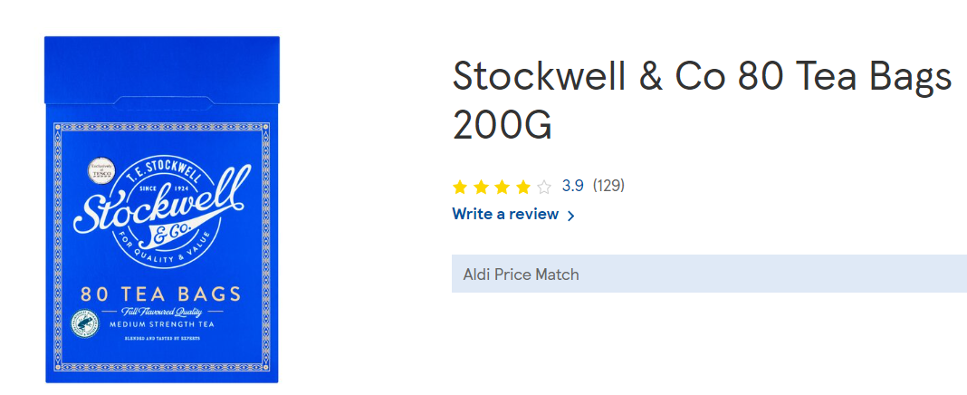
Source: (Stockwell & Co 80 tea bags 200g)

Reason for choosing product
Tesco offers with wide array of food and drinks. Tesco has focused entirely on analysing the requirements of customers. The strategy of reducing price across the products and maintaining good quality has helped in gaining a lot of appreciation from the customers. In addition to this, it has been observed that the use of advanced digital strategies and data has helped Tesco to gain customers. The first label product that was introduced by Cohen was Tesco tea. The name TE stockwell was the partner in a firm of tea suppliers. In 1929, the first Tesco store was opened (Taqatqa 2021). Tesco Tea was one of the most sold products at the store. The selected product is widely accepted by the customers in the market and has gained huge customer base. The reason behind the increasing customer base is the use of sustainability initiatives, strong brand image and customer loyalty program. Tesco tea became a hit because of the quality and value driven towards lives.

Identify Demand and Market Equilibrium
Market equilibrium refers to a state where supply and demand for a product or services are in a balance. On the other hand, market demand is referred to the total quantity of demand by all the consumers present in a market for a good (Berry and Haile 2021). Market demand analysis is carried out within a product life cycle for determining the prominence of the product in the market. in addition to this, the use of market demand curve also helps in analysing the correlation between price and product and the demand of the product in the market. There are different types of market equilibrium such as general equilibrium, competitive equilibrium, intertemporal equilibrium, Lindahl equilibrium, underemployment equilibrium and economic equilibrium (Dvorkin Jr, Kazempour and Pinson 2019). Tesco has been focusing on freezing prices of products until 2023 for managing the year profits. Stockwell & Co tea bags are widely purchased by the customers because of their brand value, unique flavour with blended taste. The rainforest alliance also stands for offering better future for people and nature (Bas, Acay and Ozarslan 2019).
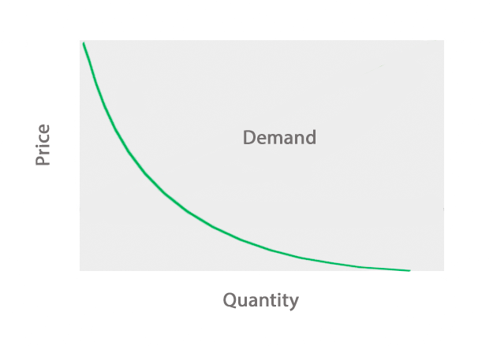
(Source: Bas et al. 2019)
The curve derived from the law of demand. As per law of demand, with the increase in price of a goods/ service, the demanded quantity among the consumers will decreases. Similarly, with the decrease in price of a good, the demanded quantity for the product will increase in the market (Ke et al. 2023). the top factors those are responsible for influencing the demand of the selected product Stockwell & Co tea bags are price of substitutes, price of complement, income of consumer, taste preferences of consumers, demographics and expectations of price from the end of consumers.

Price of substitutes
Stockwell & Co tea bags are famous for its quality in the market. the demand for the product is high in the market due to the value proposition. The product has been marked as one of the most selling products by Tesco. The substitute product of Stockwell & Co tea bags is Nescafe original instant coffee. The price for the substitute product has increased over the years. It can be stated that the price of Nescafe original instant coffee. This indicates that with the increase in price of substitute products, the demand for the original product will increase. As the market is full of competition, the availability of a greater number of products will lead to higher utility among the customers (Monte 2021). Stockwell & Co tea bags has a huge requirement in the market due to its brand value and pricing strategy. The Stockwell & Co 80 tea bags of 200G is available at a price of £0.79 which has remained constant over the past 3 years. On the other hand, Nescafe original instant coffee 300g price is £7.00. This leads to increasing the demand for Stockwell & Co tea bags in the market of UK.

Price of complements
The complementary product refers to the goods those are used together. Stockwell & Co tea bags complement product is Milk. Tesco offers wide variety of milk in the groceries department. Tesco British Semi Skimmed milk is the complement product for the selected services. The price of the complement product is £1.45 (£0.64/litre). Over the years, it has been observed that the price of complementary product has been decreasing. The decrease in price of complementary product ensures that the demand for the original product is increasing. This is due to the fact that complementary goods have a direct influence over the demand of other product (Adetunji et al. 2021). Thus, if the price of complementary goods increase, the demand for other product will decrease. Therefore, it can be stated that at presented the demand for Stockwell & Co is high in the market of UK as the price for Tesco British Semi Skimmed milk has decreased over the past years.

Consumer income
The analysis of consumer income and demand for a product is known as income effect which is a part of consumer choice theory. This relates to the preferences for consumption and consumer demand graphs. The use of graph helps in expressing the way changes in relative market prices and impact is impacting consumptions (Chen 2022). Consumer income in UK is increasing over the years. Consumer income holds a direct relationship with the demand of a product. This means that the increase in income of the customers will give rise to increasing the demand for the products. Similarly, if the income of consumers are falling, demand for the product will also automatically get reduced. These goods are considered as a normal good. Stockwell & Co tea bags falls under normal goods categories. Normal goods hold positive income elasticity of demand coefficient less than one. Henceforth, it can be stated that the normal economic goods is used for representing the way real consumers rise in income influences the demand of a product.

Consumer tastes and preferences
Consumer tastes and preferences is considered as a less tangible item which has a big impact over demand. Consumer preferences and behaviours changes continuous. This are mainly influenced by the factors such as social media, health concerns, environmental awareness, and technology. Stockwell & Co tea bags has passed the health and safety standards. Moreover, the fat percentage, saturates, and sugars are low. The product comes in recyclable package thus the environmental standard is maintained. Consumers preferences has been positive towards the product over the years (Monte 2021). As a result, it can be stated that the demand of Stockwell & Co tea bags is high as the consumer preferences has not changed over the period of time.

Consumer expectations of price
Consumer’s expectation of the price has the potential to affect the product performance in market. Stockwell & Co tea bags at present are offered at an affordable price towards the customers (Williams and You 2021). The increase in price for the product will lead to decrease the demand of the product. Consumers with the demand for increasing price Stockwell & Co tea bags, product demand will also increase.

Demographics- Number of Consumers
The number of customers for Stockwell & Co tea bags of Tesco is increasing day by day. Tesco fulfils around 1.2 million customers order every week. The sales percentage has increased by 66.1% for Tesco. Tesco’s main target audience includes the cost conscious individuals. The number of buyers for Tesco are increasing day by day as Tesco’s target market is cost conscious individuals interested towards bargains and sales and value variety (Rosnizam et al. 2020). The demand of a product is validated by evaluating the number of buyers. The greater number of buyers of a product states that the demand for a particular good is increased. Hence, it can be stated that the increasing consumers for Stockwell & Co tea bags states that the demand for the products is increasing.

Indicate demand is more elastic or more inelastic
Price elasticity of demand is referred to the measurement of change in which consumption of a product in relation to change in price is determined. This is expressed as follows:
“Price Elasticity of Demand = Percentage Change in Quantity Demanded ÷ Percentage Change in Price”
The use of this theory is to determine the price elasticity for analyzing the way supply and demand for a particular product changes with changes in its prices. Price elasticity is used for referring the relationship between change in price and change in the supply. The main product, Stockwell & Co tea bags is considered to be elastic as the change in price for the product does not lead to any change in the supply or demand. This makes the product elastic and also states that the product is considered as a necessity item (Yadav et al. 2021). The key factors those are responsible for affecting the price elasticity of demand are availability of substitutes, determining if the goods if a luxury or a necessity, analysis of income spent over goods and duration for the price change.
- Availability of substitutes: from the analysis represented, it can be stated that the more easily a shopper finds a substitute product, the more chances is that the price will fall. Stockwell & Co tea bags will be replaced by Nescafé coffee, if the price of tea increases. Thus, the substitute products for the main product are significant in the market.
- Urgency: The increase in price will lead to fall in demand quantity. The product demand tends to have a greater elasticity. Thus, it can be stated that less discretionary of a product will ensure that the quantity of demand has not fallen. The elastic nature of the product is used for defining the normal goods (Rosselló-Nadal 2022). It can be stated that the Stockwell & Co tea bags is elastic in nature as the product is capable of meeting the market standards.
- Duration of price change: this factor is used for the purpose of determining the period of price change that lasts. The need for businesses to have a clarity of time sensitive is vital for determining the price elasticity. Stockwell & Co tea bags with the price fluctuation in market will remain acceptable among the customer.
From the view point of customer it can be stated that the tea is a necessity product. Stockwell & Co tea bags are consumed by customers on a daily basis as a part of their route. The factor demand is considered as more elastic in nature (Chen 2022). The demand elasticity is represented by the analysis of ratio of percentage change in quantity demanded for a product. Thus, it can be stated that the Stockwell & Co tea bags of Tesco maintains elastic nature.
Income effects
The income effects include income elasticity of demands to sensitivity of quantity demanded for certain goods. The purchase of goods represents that large portion of consumers are associated with Stockwell & Co tea bags. This represents a large portion of consumer’s income. The factor is used for the purpose of representing that the demand is more elastic in nature. The elasticity of demand associated with a product states that maximizing profits can be achieved. the price elastic products are beneficial as this provides with the ability to achieve better benefits in the market. the way, Stockwell & Co tea bags is considered as an elastic product is by offering the following advantages:
- Sales maximizes: Products which are price elastic in nature allows the firm increase the sales and increases overall market share. This depends on the way firms react.
- Economies of scale: Tesco is producing Stockwell & Co tea bags with a great economies of scale. By cutting down the prices, the increase in output can be achieved. This also helps in increasing the overall profitability for the firm.

Pricing policy for Tesco
Pricing is identified as one of the most crucial part of decision making within a company. This focuses on introducing a product by setting its pricing. It has been observed that companies rely on different policies for meeting the business unease by providing consumers with good value. As a result, in order to achieve a better competitive advantage in the market, it is very important to apply a strong pricing policy. Pricing policy allows the company to determine the price at which the business will be providing with goods or services in the market (Aigner-Walder 2015). The use of pricing policy ensures that companies are able to remain profitable in the market by maintaining flexibility. Pricing policy allows the business to introduces services by offering good value towards the consumers. The main considerations those are needed to be taken into account while developing pricing policies includes competition, profit goals, analysing sales, former health, flexibility, method of price, adjustment, sales, venue, and government regulations. The main reason behind which Tesco should propose a suitable pricing strategy for management of the selected product is to gain profit, to limit the competition and to gain market share. It is also expected that the appropriate use of a pricing policy will allow the consumers to achieve a better satisfaction in the market. The different types of pricing policies or cost based pricing, policy, value-based pricing, policy, demand-based pricing, policy and competition-based pricing policy. The most relevant pricing policy that needs to be selected by Tesco while selling the product is value-based pricing policy. Value based pricing will provide Tesco to have a better knowledge of the market (Andreyeva, Long and Brownell 2010). This provides with the ability to analyse the market expectations, competitors and consumers preferences. The way value-based pricing policy works are as follows:
- Focused on specific market segment: Value based pricing policies will provide with the ability to narrowly focus on relevant market segment. These helps the company to sell products by analysing different dimensions. The selection of these strategy will provide Tesco to sell Stockwell & Co tea bags towards specific market segment (Ellickson 2013).
- Competition analysis: The use of value-based pricing allows the company to make a meaningful and direct competition. This helps in analysing the competitors and determines the way consumers ideas for the product will execute. Tesco will be able to analyse the competitors with the help of this strategy (Outlook 2015). Stockwell & Co tea bags will be able to stay ahead of the competitors in the market.
- Pricing for adding value: The value added towards product helps in defining the way pricing will be used. Thus, defines the way product from nearest competitor and researches is capable of operate in the market. Tesco with the use of pricing strategy will be able to add value towards Stockwell & Co tea bags.

References
Aigner-Walder, B., 2015. Effects of the Demographic Changes on Private Consumption: An Almost Ideal Demand System Analysis for Austria. Journal of Economic & Social Studies (JECOSS), 5(1).
Andreyeva, T., Long, M.W. and Brownell, K.D., 2010. The impact of food prices on consumption: a systematic review of research on the price elasticity of demand for food. American journal of public health, 100(2), pp.216-222.
Ellickson, P.B., 2013. Market structure and performance. International Encyclopedia of the Social and Behavioral Sciences,, 14, pp.9211-9216.
Outlook, O.E., 2015. Lifting Investment for Higher Sustainable Growth. OECD Economic Outlook, 2015, p.1.
Rosnizam, M.R.A.B., Kee, D.M.H., Akhir, M.E.H.B.M., Shahqira, M., Yusoff, M.A.H.B.M., Budiman, R.S. and Alajmi, A.M., 2020. Market opportunities and challenges: A case study of Tesco. Journal of the community development in Asia, 3(2), pp.18-27.
Yadav, D., Kumari, R., Kumar, N. and Sarkar, B., 2021. Reduction of waste and carbon emission through the selection of items with cross-price elasticity of demand to form a sustainable supply chain with preservation technology. Journal of Cleaner Production, 297, p.126298.
Rosselló-Nadal, J., 2022. Why elasticities from demand models using different dependent variables should not be compared. Current Issues in Tourism, pp.1-12.
Chen, J.J., 2022. Tesco Plc. In International Cases of Corporate Governance (pp. 27-44). Singapore: Springer Nature Singapore.
Taqatqa, A., 2021. 5 Tesco. Business Management Case Studies: Pran-RFL, Netflix, Mc Donalds, Google, Tesco, Apple, COCA COLA, PSA Group, Mercedes, Tesla, Toyota, Beximco, KFC, LBC Lao Brewery Company, p.97.
Williams, C. and You, J.J., 2021. Organizing for resilience: Leading and managing risk in a disruptive world. Routledge.
Berry, S.T. and Haile, P.A., 2021. Foundations of demand estimation. In Handbook of industrial organization (Vol. 4, No. 1, pp. 1-62). Elsevier.
Ke, J., Yin, Y., Yang, H. and Wang, H., 2023. Fundamentals of ride-sourcing market equilibrium analyses. Supply and Demand Management in Ride-Sourcing Markets, p.25.
Monte, A., 2021. A study of value chain reconfiguration processes under Covid-19 pressures: the case of Tesco PLC in the United Kingdom.
Adetunji, O.A., Coker-Osiwoga, T.F., Okwuanalu, C., Olusola, M., Adetayo, O.C.A., Ogunbiyi, B.T., Amah, G.H. and Adetunji, O.A., 2021. Comparative Study of Phytochemical Constituents, Caffeine Levels and Proximate Composition of Liven Alkaline Coffee, Nescafe Original Coffee and Nescafe Original Decaffeinated Coffee.
Chen, J.J., 2022. Tesco Plc. In International Cases of Corporate Governance (pp. 27-44). Singapore: Springer Nature Singapore.
Monte, A., 2021. A study of value chain reconfiguration processes under Covid-19 pressures: the case of Tesco PLC in the United Kingdom.
Dvorkin Jr, V., Kazempour, J. and Pinson, P., 2019. Electricity market equilibrium under information asymmetry. Operations Research Letters, 47(6), pp.521-526.
Bas, E., Acay, B. and Ozarslan, R., 2019. The price adjustment equation with different types of conformable derivatives in market equilibrium. AIMS Math, 4(3), pp.805-820.
Stockwell & Co 80 tea bags 200g (no date) TESCO. Available at: https://www.tesco.com/groceries/en-GB/products/300422779

