

University of Wales Trinity Saint David

School of Computing

HTML & CSS WEB Development

Internet Technology and Security

ACCA4018

Hafiz Uddin
1807533

01/01/2020

Table of Contents
Internet Technology and Security 2
1.0 Abstract 2
2.0 Introduction 2
3.0 Requirements 2
4.0 Implementation 3
4.1 screen shots of the website and the linked pages 3
Fig 1 [1] 3
4.2 Validation 9
Evaluation 11
Authors Website Evaluation 13
Conclusion 13
References 14

Internet Technology and Security

1.0 Abstract

The purpose of this report is to outline the research of producing a website and its linked pages. The author of this report will outline the purpose of the website, the target audience of the website and the relevance of the website. The author will give a brief description of the website and the software the author chose to use and why. The author will validate his website and CSS page and show the validated results showing any errors and how the author corrected those errors if possible.

2.0 Introduction

the author decided to create a website on Watches which is an area he has interest in. the webpage he has created works around that interest and shows unique watches which are not available locally. These watches are from all around the world and can be delivered to your door. The author chose the name “Transcendent Watches” as the word “Transcendent” Means “rise above the normal”.
The author used the software Microsoft Visual Studio to create his webpages and CSS Styles sheet. The author created an index.html page, a styles.css page, a registration.html page, a womens.html page, a mens.html page and a Citation.html page. The index.html page is the main webpage, the styles.css is the page that defines the colours, text background, the registration.html is where customers can register to join,
The womens.html is where there is a selection of women’s watches available for sale, the mens.html is where there is a selection of men’s watches available for sale, the citation.html is the reference page to give credit to the source of the pictures that where used in the webpage.
HTML stands for Hyper Text Markup Language, this is one of the code languages used to create websites/pages. The author used HTML as it is a very good and basic code language to start with and easy to learn when starting.

3.0 Requirements

The purpose of creating a web page for watches was due to the interest of the author and the belief of the author that there is a big market for unusual watches. The market for exclusive watches believed by the author is a lucrative one and he is under the influence that he would be able to make a living from it.
The author’s target audience is believed to be everyone from the age of 3 upwards as he believes that watches are a part of everyday wear as well as an exclusive accessary. The author believes there is a watch for every occasion and that the target audience are always looking for that unique one-off piece.
The author also believes there is a high-end market for exclusively unique, fashionable designer watches for people with deep pockets such as movie stars and pop stars.
The author has created four linked pages to the webpage these include.
- Register – where the potential customers can join the group for exclusive members offers and discounts.
- Women’s – where all the women’s watches that are available to order.
- Men’s – where all the men’s watches available to order.
- Citation – where the citation for all the pictures used for the webpages are located.
The index page is where the main page of the website and its where the code is for the website. The author has used HTML 5. The author started with the tag “DOCTYPE html” to declare the type of document it is so that the web browser knows what to display.
In the Head Tag section of the HTML document code the author provided information about the web page, this included “charset UTF 8” this is the Unicode Transformation Format using 8-bit, this is the converter which translate typed characters to machine readable code (character set used). The author also included a Title of his web page which is “Transcendent Watches”, who the author of the web page is “Hafiz Uddin”, some keywords describing the web page “Exclusive, dynamic watches, for him, for her”, these are all descriptive instructions for the webpage.
These where declared under the META tag which gives the browser instructions on how to display the content of the page.
The next tag in the head section was the links that are attached to the index page. The link that was declared was the CSS styles (cascading styles sheet). A CSS style sheet defines the structural elements of the webpage, it defines the fonts, colours, images, background, text, text style.

4.0 Implementation

In this section the author will introduce his webpage and the links through screen grabs.

4.1 screen shots of the website and the linked pages
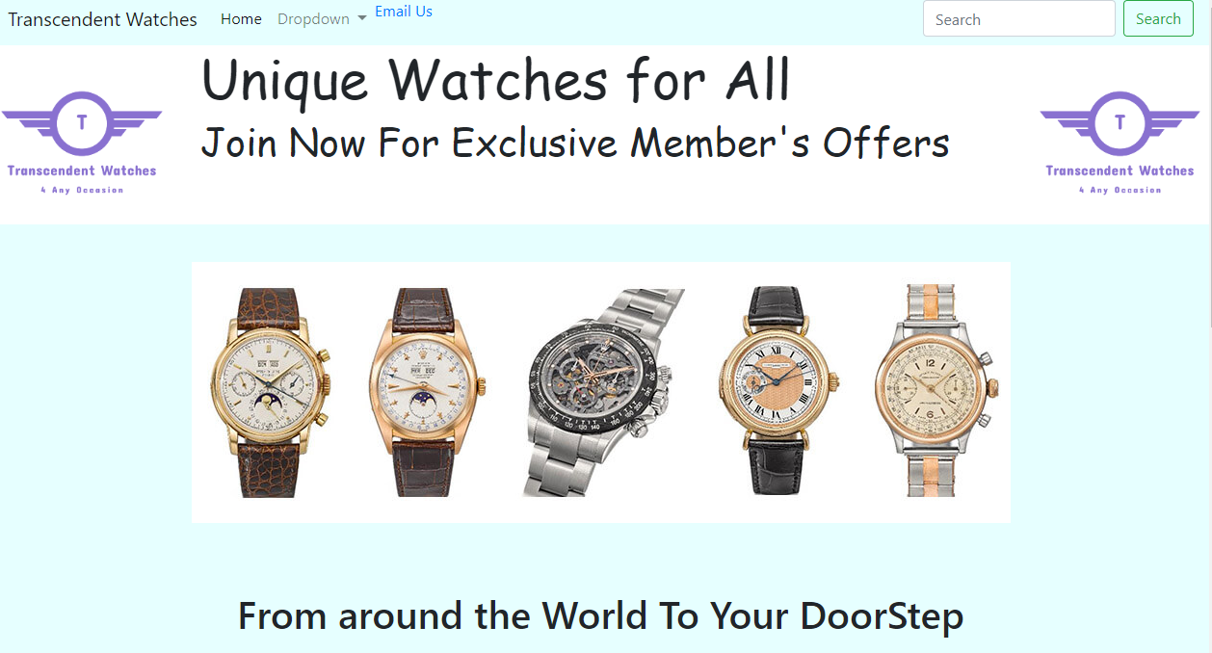

Fig 1 [1]

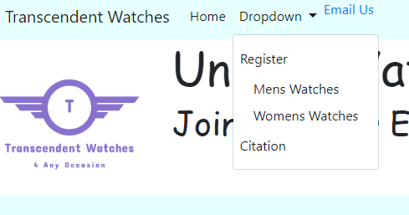

Fig 2 [1]
Fig 1 and 2 are the header part of the webpage, it contains the authors Logo, a home link, a dropdown menu with the four linked pages and an email link.
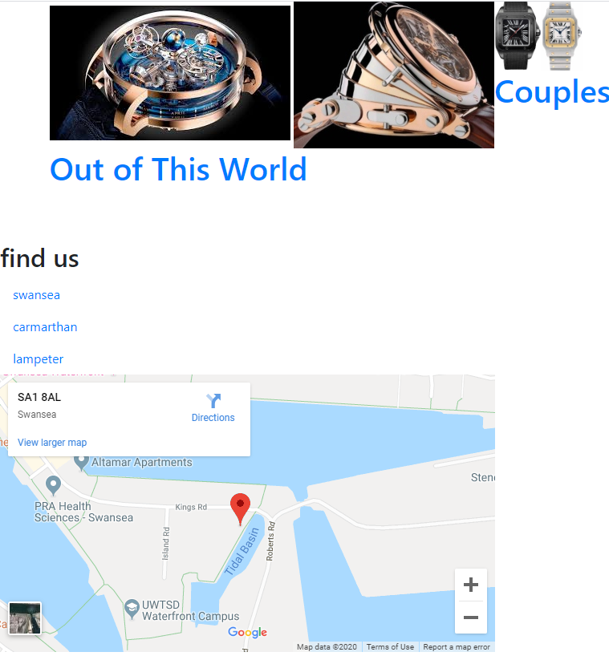
Fig 3 [1]
This is the main body and footer part of the webpage, showing some of the watches and a find us links and map.
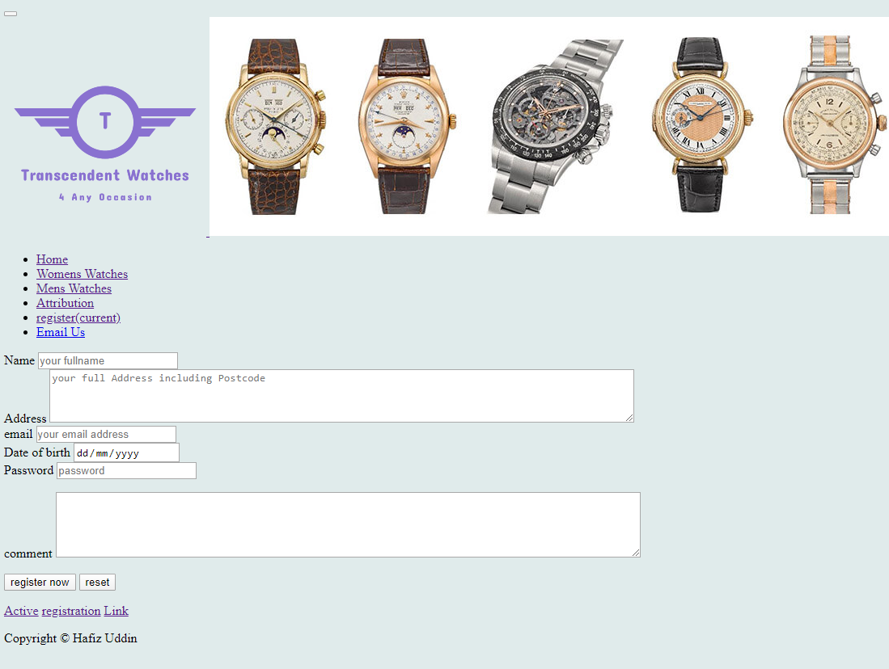
Fig 4 [1]
This is the registration page where customers can fill in their details to register/join.

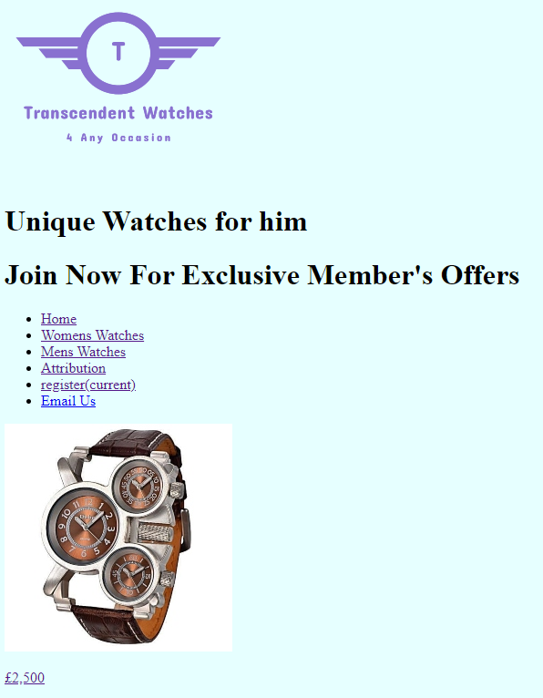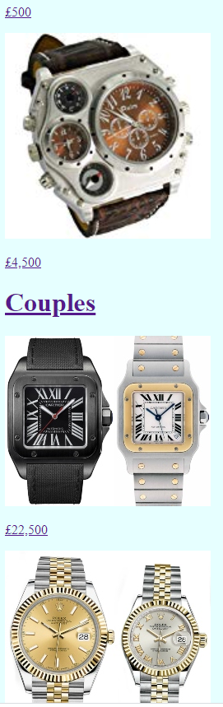
Fig 5 [1] Fig 6 [1]
Fig 5 and 6 represents the mens.html page link showing watches with prices. It has the authors logo and links to all the pages.
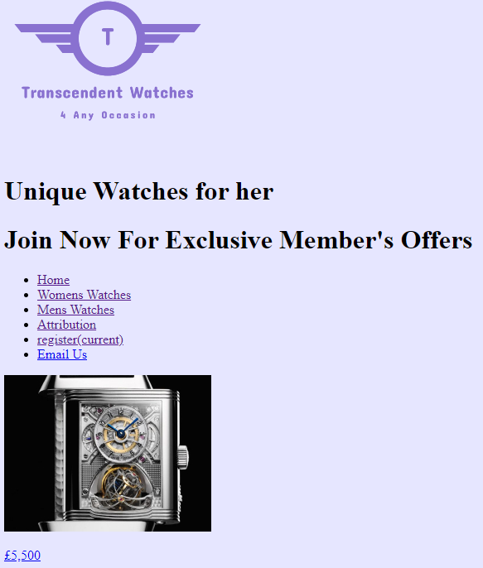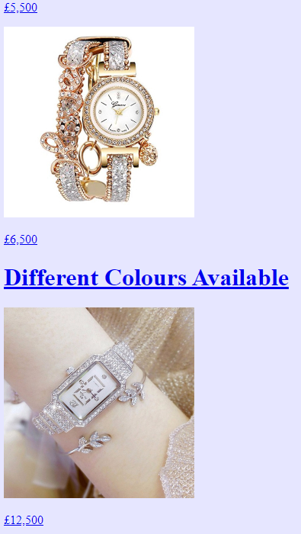
Fig 7 [1] Fig 8 [1]

Fig 7 and 8 represents the womens.html page link showing watches with prices. It has the authors logo and links to all the pages.
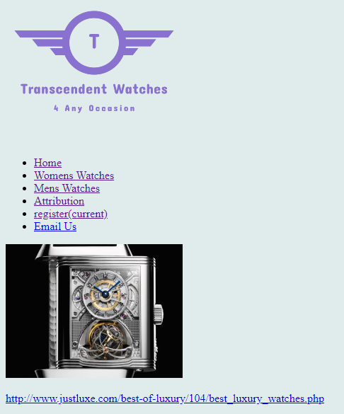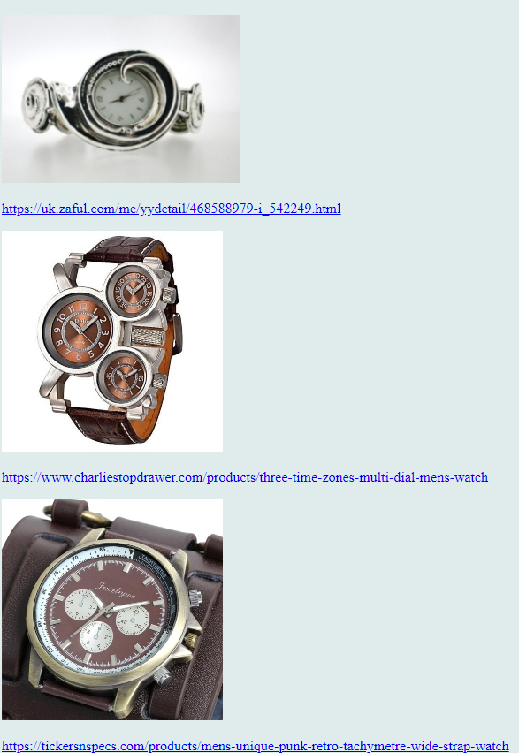
Fig 9 [1]
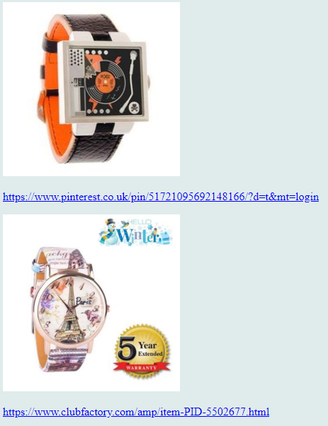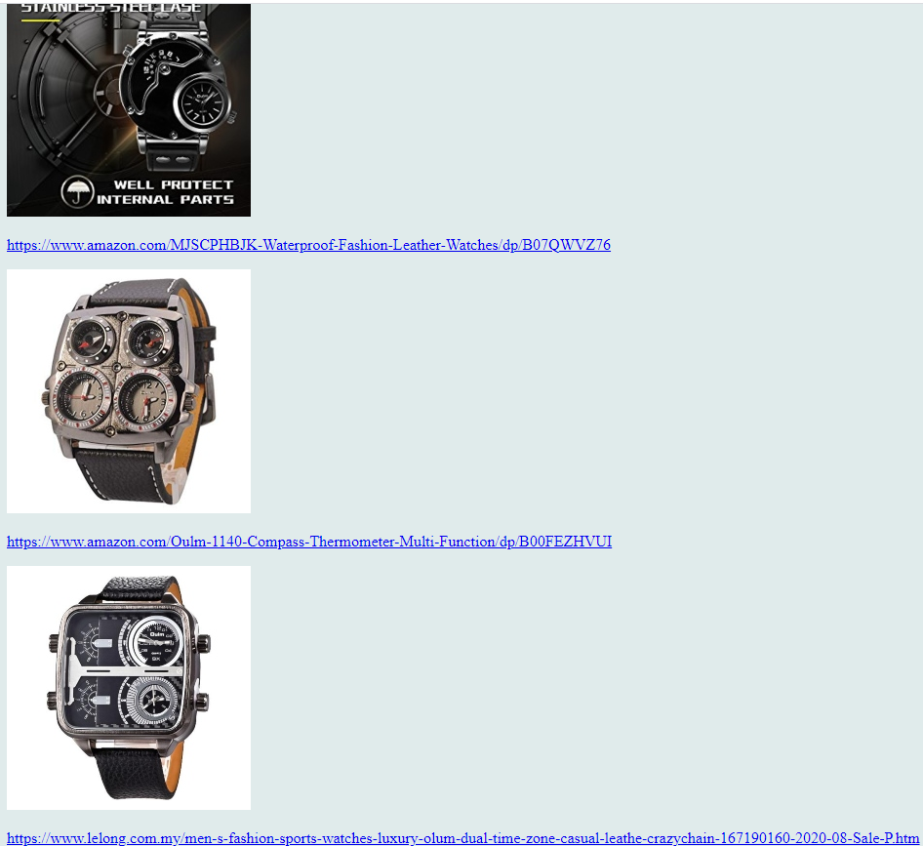
Fig 10 [1]
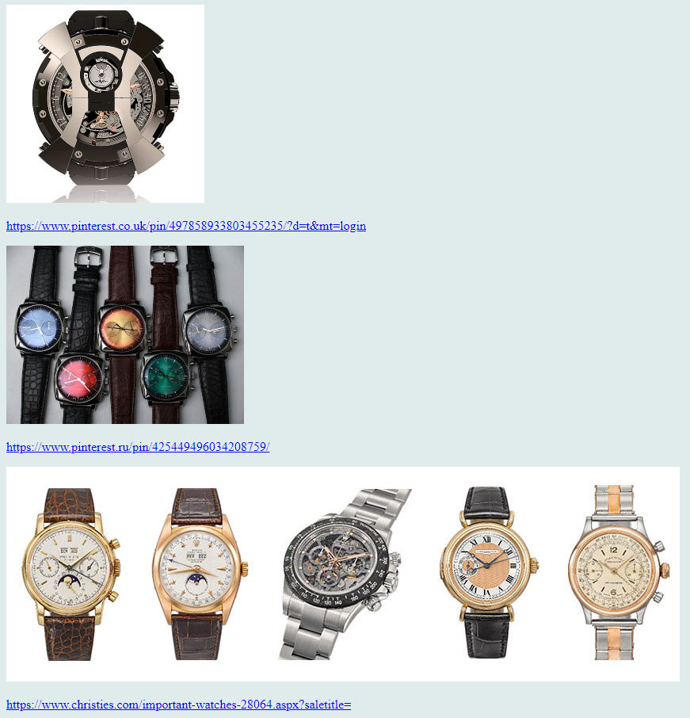
Fig 11 [1]
Fig 9, 10 and 11 shows grab shots of the citation.html page where it shows the pictures with the url links, this represents a reference page for all the pictures used in the webpages.
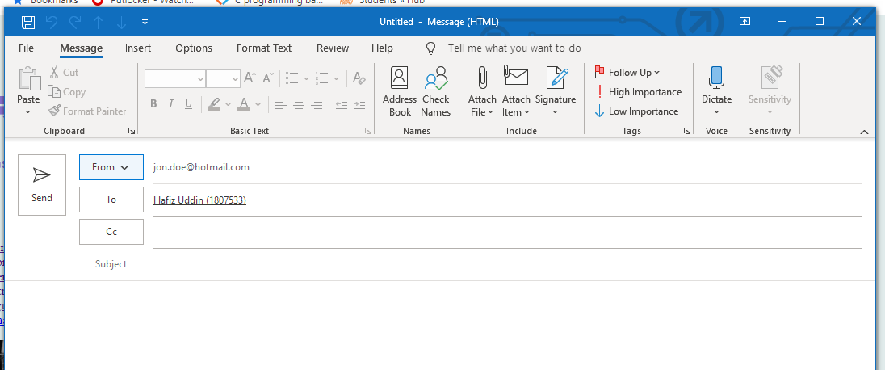
Fig 12 [1]
Fig 12 shows the email link from the email link.

4.2 Validation
After completing the website the author put his HTML code to get it validated using the https://validator.w3.org/ this brought up 9 errors on the index.html, the author will show screen grabs of the errors below.
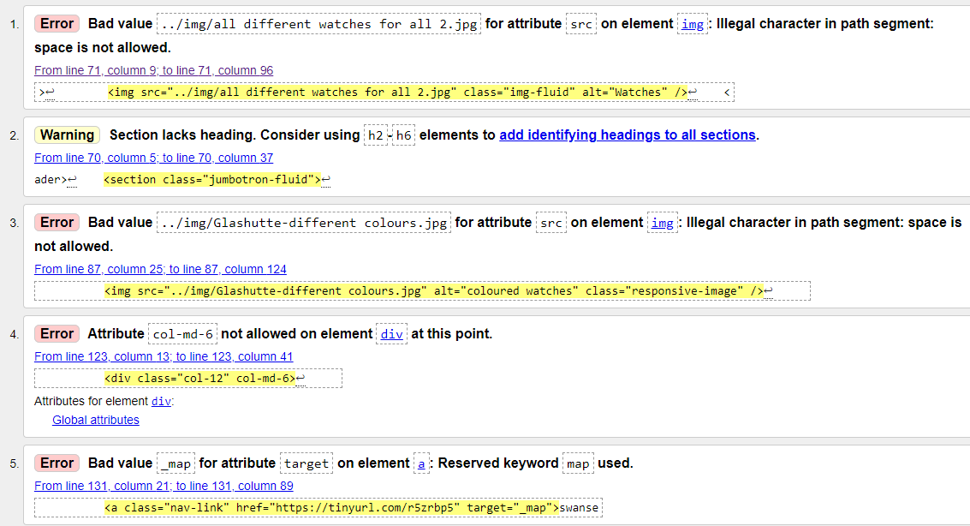
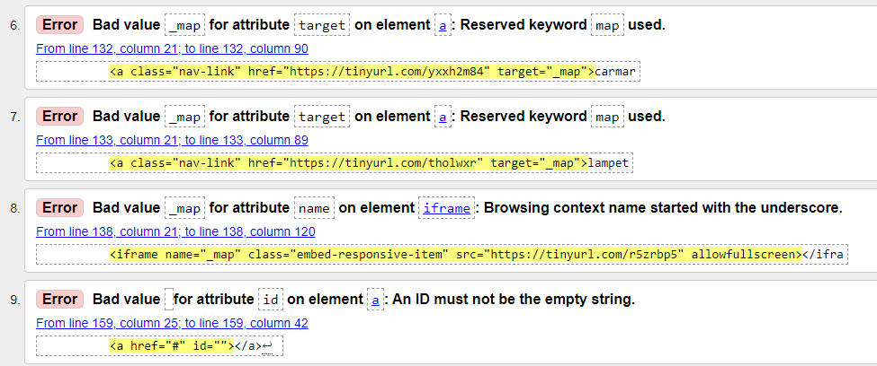
Fig 13 [2]
The author went through each of the errors listed above.
With error 1 and 3 the author renamed the files making sure that there were no spaces in the file name.
For error 2 the author moved the jumbotron and gave it a heading.
For error 4 the author removed the element as it was not needed.
For errors 5, 6, 7, 8 the author was not sure how to resolve these as they were created through google for the map in the find us section in the footer.
For error 9 the author removed the element as it was empty and was not needed for the website.
The author then re-validated the code again after fixing the errors and took a screen grab.
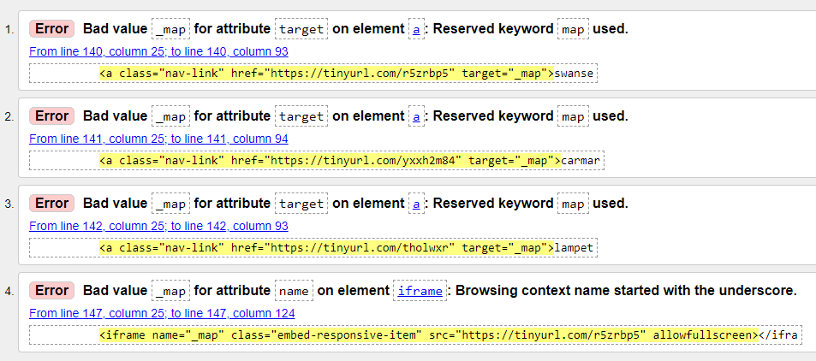
Fig 14 [2]
The remaining errors are the ones the author was not able or has the knowledge at present to change or repair.
The author then validated his styles CSS page using the W3C CSS Validation Service, the result for the validation is below:
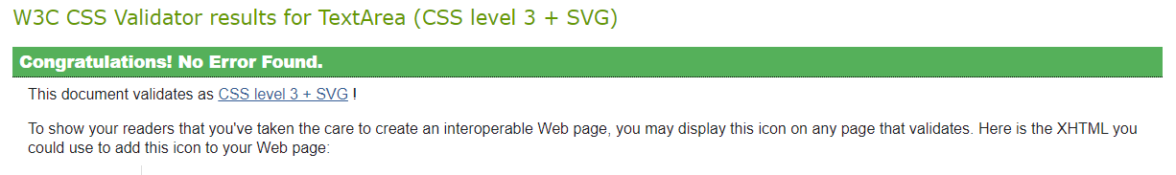
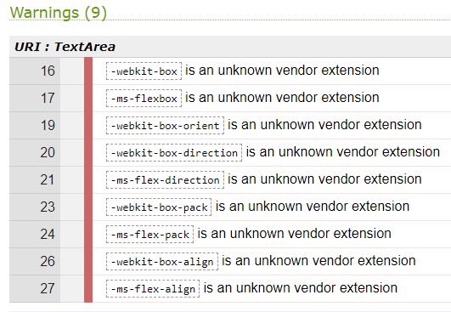
Fig 15 [3]
There were no errors on the styles CSS page but there were some warnings. The author looked through the warnings and removed these from the CSS page. The author than repeated the validation and no errors or warnings came up. The author also checked his website and did not notice any changes to it due to the change in the CCS code.

Evaluation

The author looked at and researched three important elements when analysing the quality of his website.
- Website Usability – This is a very important factor to ensure that the website is successful as it determines the user’s positive experiences of the ease of use, satisfaction consistency and loyalty to the website. Developing a usable website should give the user a learnable, memorable, efficient and error free experience. [4]
Users of the website who have or are at different levels of computer literature and knowledge would have different usable experiences, this would emphasise the need to make the website easy and simple to use, making it user friendly of all ability levels as to attract the most users. The website needs to be usable to everyone [4] [5].

- Website Accessibility – Another important factor is to ensure that the website is accessible to all users, this includes people with disability, older people who might not have as much knowledge about technology. The website needs to be accessible for people with different devices to ensure that the website can be accessible and usable on all types of devices that have internet access. A website needs to be inclusive to all.
Accessibility is good for customers and for your business, by having an accessible website you are helping to lift the barriers that excludes people from using it, providing equal access and equal opportunities for all who want to use it, making the website accessible supports people to interact, develop and recreational use giving people the freedom to access information and communicate through technology.
“Access to information and communication technologies, including the web, is defined as a basic human right in the United Nations Convention on the rights of persons with Disabilities” [5] [4].

- Search Engine Optimisation – SEO enables search engines to locate/find your website when people are looking for specific items, e.g. cars, watches, prams, shoes etc. Search engines will look for certain words or rules for optimizing the website. Research has shown that people searching on the internet will more than likely choose one of the top five results. To get the best out of your website your webpage needs to fall into this category or results. SEO improves the usability of websites, it improves social presence, user experiences and improve the result position of the website. SEO is a framework that has rules and processes, these processes include [6] [7]:

- Technical SEO – ensures that people and crawlers can access the content and be able to read the contents on the website without issues. This gives the opportunity for the crawlers to be able to index the webpage correctly, another factor to look at is webpage structure, speed and security as these will impact on the rankling of the webpage [7] [8].

- On-page SEO – This is the process in which the content and the structure of the webpage is optimized correctly to ensure that the webpage achieves higher ranking in the search engine. On-page SEO provides information that a search engine can understand and relates the contents information of the website, it also looks for key features and key words to be able to index the page and catalogue it accordingly [7] [8].

- Off- page SEO- This is a technique to establish and promote your webpage to improve its position in the search engine rankings and your credibility. It is a way to build links and credit with other websites and the users of your webpage, it is another way to promote your webpage and business through word of mouth. Search engines collect information from other websites who link or vote for your webpage leaving feedback to say how user friendly it is, how credible it is if they made a purchase how simple the process was, generally trustworthy. The more links your page gets the higher the search engines will rate the page [7] [8].

Author’s Website Evaluation

- Author’s website usefulness and usability -
The author believe that his website is simple and easy to use, the author understands that there are plenty of room for improvements such as picture quality, site structure, visual structure and possibly add sound effects. The webpage would benefit from having social media links, a payment page, FAQ page, and possibly a request page where customers could ask for specific designs or design their own. Another area which could be improved to make the page more user friendly would be to make the pictures on the main page be linked to their associated pages. E.g. the women’s watches picture could take you to that link when you press on the picture as well as the dropdown link menu.

- Authors website search engine optimisation (SEO) -
The author believes at present his webpage would not rank very highly as it does not have any links to social media, it has not been optimised and has a basic webpage structure. The author believes the webpage is user friendly and easy to use. Over time and lots of development of the page could see the ranking improve.

- Authors website Accessibility –
The author believes as his website is simple and easy to use it is user friendly and should appeal to all ages who are interested in watches. The webpage is responsive to enable the page to be used and viewed on different devices, again if it had linked pictures than it would be usable by different technological ability groups. At present the webpage is not fully accessible by most disability groups as this is an area of web development which is still developing.

Conclusion

To conclude the author understands that there are plenty of areas to make improvements to the webpage. The author understands that this is an area which needs practice and more knowledge in web development. The author has also identified that he did not work much on the styles CSS page and for future projects in web development he would have to learn and develop his skills in this area. The webpage is a simple, effective and user friendly.

References

[1] | H. Uddin, “Transcendent Watches,” 28 December 2019. [Online]. Available: http://localhost:1647/pages/index.html.
[2] | validator.w3.org, “Nu Html Checker,” validator.w3.org, 05 January 2020. [Online]. Available: https://validator.w3.org/. [Accessed 05 January 2020].
[3] | jigsaw.w3.org, “W3C CSS Validation Service,” 2014. [Online]. Available: http://jigsaw.w3.org/css-validator/validator. [Accessed 06 January 2020].
[4] | M. Macaulay, Introduction to Web Interaction Design, Florida: CRC press Taylor & Francis group, 2018.
[5] | W3C, “Introduction to Web Accessibility,” W3C.org, 05 June 2019. [Online]. Available: https://www.w3.org/WAI/fundamentals/accessibility-intro/#what. [Accessed 06 January 2020].
[6] | S. Samual, “Search engine optimisation to improve your visibility online,” ProQuest, vol. 35, no. 6, 2013.
[7] | D. R. Venkat N. Gudvada, “Understanding Search-Engine Optimization,” COMPUTING PRACTICES, pp. 43-52, October 2015.
[8] | V. K. J. R. K. P. Guddu Kumar, “On page Off page SEO Optimization of a Job Portal Website on Google Search Engine,” IJSRD - International Journal for Scientific Research & Development, vol. 7, no. 04, 2019.

marking criteria and Student FEEDBACK

This section details the extent to which the assessment criteria are demonstrated by you, which in turn determines your mark. The marks available for each category of skill are shown. Lecturers will use the space provided to comment on the achievement of the task(s), including those areas in which you have performed well and areas that would benefit from development/improvement.

Common Assessment Criteria Applied (Assignment 1) | Marks available | Marks  awarded
1. Engagement with Literature Skills

Provides a good discussion of the concepts but the supporting related research is missing. Expand the scope of reference sources consulted to further improve your research work. (Grade mark: 58.00%) | 25 | 14.5
2. Knowledge and Understanding Skills

Demonstrates a satisfactory understanding of the standards used to design and implement a website. A good attempt has been made to fix some of the validation errors. As mentioned below, aim to improve your understanding of the basic CSS and HTML concepts. A satisfactory evaluation of the website has been provided. As you have not completed the research exercise properly, this has had an impact on your ability to properly evaluate the website against the requirements of the assignment brief, especially for the accessibility and SEO sections. (Grade mark: 57.50%) | 20 | 11.5
3. Cognitive and Intellectual Skills

4. Practical Application Skills

A satisfactory attempt featuring a simple website with well-thought-out content. The main area for improvement is improving your understanding of some of the basics first. For example, the application of CSS styles and knowing when, how to correctly use specific style settings, and how to use external stylesheets. Your external stylesheet was applied to only your home page and this meant that the layout was not consistent across all pages and the menu not displaying properly on most pages. You have also used internal styles on the pages you have not been able to link to the external stylesheet. Please note that this is not good practice and it creates layout consistency issues as you have experienced and also makes it difficult to maintain your CSS styles. (Grade mark: 44.00%) | 50 | 22
5. Transferable Skills for Life and Professional Practice

The report is of a good standard. See your report for additional suggested improvements. (Grade mark: 60.00%) | 5 | 3

Assignment Mark (Assessment marks are subject to ratification at the Exam Board. These comments and marks are to give feedback on module work and are for guidance only until they are confirmed. ) | Late Submission Penalties (tick if appropriate) |  | 51%
 | Up to 1 week late (40% Max) |  | 51%
 | Over 1 week late (0%) |  | 51%

