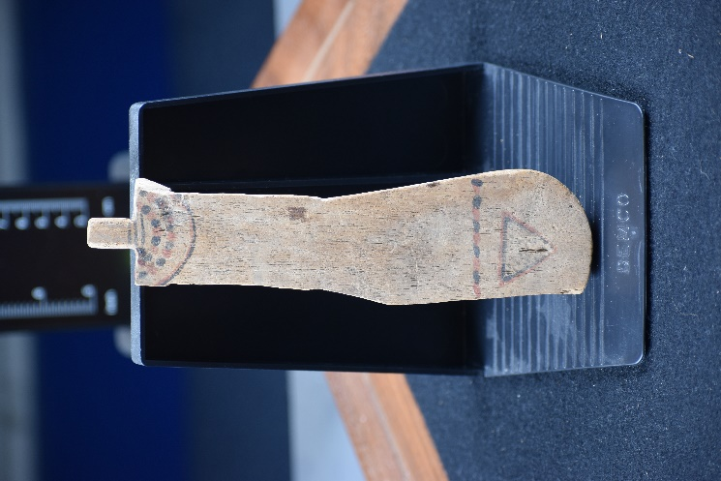
Object Museum Catalogue: Paddle Doll by Lizzie Mansfield

Object name: Paddle doll.
Cyfarthfa Castle, Merthyr Tydfil CCM (187.996)
Object type: Paddle doll.
Material: Local wood, as at yet unidentified.
Period: First Immediate, Middle Kingdom (British Museum, 2021).
Provenance: Thebes, Egypt (Metropolitan Museum of Art, 2021).
Dimensions: Full Height – 19.5 cm, Thickness – 0.4 cm,
Width of Torso – 3.4 cm, Width of Belt Line – 4.7 cm.
Object analysis by Lizzie Mansfield.

Description
The object is made out of wood, carved into that of a human figure. The human figure is missing its shoulders. The object is about the size of a pair of hands. There are markings on the front and back of the object. There is a marking of a upside down equilateral triangle at the bottom of the figure’s front side. Just above the triangular marking is a marking which is a straight line that goes completely across the front side on the figure. On the top of the front side is another marking, this one wraps around the front side and goes onto the back side. This marking resembles a scarf of some sort as when the marking continues onto the back of the figure, it looks like two ends of a scarf hanging down the back from over the shoulders with strands on each end. The triangular marking is meant to represent the pubic area of a women. Therefore, it is very likely that this paddle doll is a female figure. However, unfortunately this paddle doll is missing its shoulders and more importantly, its beaded strings that should be attached to the top of its neck, which is quite customary for paddle dolls.
Now mentioning information about what its place in the funerary sphere could be. The first connection to what the object’s function could be in the wider funerary is the Khener Dancers. The Khener Dancers were a group of dancers from Thebes, who were dedicated to the goddess Hathor (Morris, 2011, p. 72). Hathor was the goddess of the sky, fertility and rebirth, as well as other things. The Khener Dancers accepted both women and men into their group, although the female members are more commonly depicted. The dancers were heavily tattooed, and these tattoos were usually diamond in shape. These dancers clapped, danced, chanted and performed rituals. Also, the Khener Dancers used clappers to make noise. Therefore, it is theorised that the paddle dolls could be representing the Khener Dancers. Many paddle dolls have diamond shaped markings on their wooden bodies and some even have a symbol of Hathor on them. Moreover, clappers and paddle dolls have commonly found buried together with the deceased. Also, many paddle dolls have been found buried in Thebes, which is where the troupe of dancers were from. So, it is assumed that the paddle dolls are indicative of Khener Dancers, and that their dedicated goddess Hathor was the goddess of rebirth, coupled with the fact they were found buried with the dead, makes it seems that the paddle dolls were buried with the dead to protect and guide them on their journey to rebirth. The second connection to the wider funerary sphere is Menat necklaces. A Menat necklace was comprised of a multiple of strings of colourful beads attached to a metal counterpoise. When held by this counterweight, the Menat necklace could be shaken to produce a sound. The Menat necklace was an object that honoured Hathor, as Menat is another name for Hathor. Because of this when Menat necklaces were worn by a living person it boosted fertility for women and virility for men and when buried with the deceased it would give protection over them. Another theory is that paddle dolls are a type of Menat necklace. Both objects have strings of beads that mean when the object is shaken produce noise. As a Menat necklace is connected with Hathor, the noise made by the objects may be significant. Hathor had a musical instrument called a Sistrum and she used it to drive away evil spirits from the lands. Therefore, it can be assumed that the noise made by Menat necklace or a paddle doll drives away evil spirits from the dead. As both Menat necklaces and paddle dolls have been found buried with the deceased, it is reasonable to believe that the objects are there as protection for the ones to be reborn, due to their connection to Hathor the goddess of rebirth.
The wood used for the paddle doll would have been carefully prepared beforehand. It was a multi-step procedure. First a tree would be cut down with an axe and ropes holding the tree to prevent it from hitting the ground too hard. Then it would be cut into planks by using a saw. After that the planks would be thoroughly dried in a process called ‘seasoning’ (Killen, 2000, p. 355). Then the wood would be cut down to size, carved into its shape and sanded down. Finally, the markings were painted onto the paddle doll.

Bibliography
British Museum (2021) Paddle doll. Available at: https://www.britishmuseum.org/collection/object/Y_EA6459 (Accessed: 14 February 2021).
Killen, G. (2000) ‘Wood’, in Nicholson, P., I. Shaw (eds.) Ancient Egyptian materials and technology. Cambridge: Cambridge University Press.
Metropolitan Museum of Art (2021) Paddle Doll. Available at: https://www.metmuseum.org/art/collection/search/544216 (Accessed: 14 February 2021).
Morris, E.F. (2011) ‘Paddle Dolls and Performance’, Journal of the American Research Center in Egypt, 47, pp. 71-103.

