5/5/2024
Assessment
Portfolio Report on Contemporary Software Applications for Business


Student Name: Zaid Khan
Student ID: 2508983

Module NaMe: Software solutions for business
Module Code: ACCA 4026
Lecturer: Fahad ahmed
Trinity saint david University of Wales (London Campus)

Table of Contents
Introduction 2
Main Body 2
Task 1 2
e-Commerce Website builders/software solutions 2
Task 2 2
Mind-map of Contemporary Software Applications 2
Task 3 3
Office Applications for Creating, Storing, Presenting, and Analysing Data 3
a. 3
b. 3
Task 4 3
Communication and Collaboration applications 3
a. 3
b. 4
Conclusion 4
References 4
Appendices 4

Introduction
E-commerce in this digital world helps a business reach customers and heighten sales online. E-commerce website builders and software solutions provide the tools to easily create and manage online stores, even without technical expertise. The platforms offer features like customizable templates, secure payments, inventory management, and marketing tools that enable smooth operations and growth. This task explores two popular e-commerce solutions: Shopify and Wix E-Commerce. It discusses their features, benefits, and limitations [1].

Task 1

e-Commerce Website builders/software solutions
E-commerce has become an integral part of contemporary business, helping organizations reach customers from around the world, sell their products and services online, and connect in a digital marketplace. E-commerce website builders or software solutions offer tools for creating, managing, and maintaining online stores without advanced technicalities. These usually come with customization templates, secure payment processing, inventory management, and other marketing functions. Among many such solutions, Shopify and Wix E-Commerce are two of the most widely used contemporary platforms [2].

1. Shopify
Shopify is an e-commerce cloud-based platform that allows businesses to set up an online store easily and quickly. In fact, Shopify is a fully hosted solution that takes care of web hosting, security, and server maintenance, which in turn lets business owners focus on their sales and operations. Its high scalability makes Shopify suitable for both small business and big enterprises. Shopify supports multiple sales channels such as social media, online marketplaces, and physical retail stores [3].
Key Features:
Drag-and-drop store builder for easy customization
Fully responsive mobile templates for all devices
Integrated payment gateways like Shopify Payments, Stripe, and PayPal
Inventory and order management tools Marketing and SEO features such as email campaigns, discount codes, and social media integrations
Vast marketplace for apps, for adding functionalities such as analytics, shipping, or AI/ML capabilities.

Benefits:
Beginner-friendly interface that requires minimal technical knowledge
Scalable for businesses of all sizes
Secure hosting with SSL certificates included
Strong customer support and active community resources

Limitations:
Monthly subscription fees
Transaction fees for certain payment methods
Limited customization compared to fully open-source solutions

2. Wix E-Commerce
Wix is a popular website builder that includes e-commerce functionality. Its drag-and-drop editor allows users to design visually appealing online stores without any coding knowledge. Wix offers customizable templates, secure payment options, and tools for managing inventory, marketing, and SEO. This is perfectly suited for small businesses, freelancers, and beginners looking to have maximum design flexibility and ease of use [4].

Key Features:
Intuitive drag-and-drop editor with hundreds of customizable templates
Secure your online payments via multiple gateways
Inventory and order management system
Built-in SEO and marketing tools for online visibility
App Market for integrating third-party tools
Mobile-friendly websites for a seamless user experience on both smartphones and tablets.
Benefits:
Very user-friendly, ideal for beginners
Flexible and visually appealing design options
Affordable pricing plans; options for growing businesses
Marketing and analytics tools integrated into the platform

Limitations:
Not ideal for large-scale or high-volume e-commerce businesses
Some advanced features require a premium subscription.
Limited backend personalization compared to systems such as Shopify.

CONCLUSION
Conclusion Both Shopify and Wix have practical, user-friendly solutions for setting up an online store. Shopify is more suitable for businesses that want to grow, with more advanced functionality, stronger integrations, and a multitude of sales channels. Wix would be ideal for small or even personal businesses looking for ease, affordability, and visual flexibility. Your business size, technical expertise, and long-term growth goals go hand in hand with your choice between the two.

Task 2 (a)

Mind-map of Contemporary Software Applications
Mind mapping is a diagrammatic way of organizing information, ideas, or concepts on paper or a whiteboard based on a general theme. It often begins with a central main idea that has branches radiating outward, which represent related subtopics or details. Each branch may include keywords, images, colours, or symbols to help reinforce understanding and memory. It enables the division of complex information into manageable parts and the representation of the same in a visually structured manner [5].

Mind mapping is widely used in personal development, education, and business because it helps both individuals and teams to organize thoughts, plan projects, and solve problems creatively. Among the most popular software for creating digital mind maps are MindMeister, XMind, and Coggle, allowing team collaboration in real time [6].

Benefits of Using Mind Mapping in Business Operations

Enhances Creativity and Idea Generation.
Mind maps are meant to encourage free-flowing ideas, not necessarily following strict linearity. This helps teams brainstorm and come up with innovative solutions for products, marketing campaigns, or business strategies.
Example: A marketing team can utilize a mind map in mapping out a new campaign, from target audience segments to content ideas to social media strategies, by visually linking them.
Improves memory retention and understanding.
Information will be easier to remember when visual elements like colors, images, and symbols are used in mind maps.
It is especially useful for training, strategy planning, and knowledge sharing among people working in organizations.

Simplifies Complex Information
Mind mapping allows complex projects or data to be broken down into smaller, interconnected components.
Example: The project manager is able to plan activities, due dates, dependencies, and responsible team members in one diagram.
Facilitates Collaboration and Communication
Digital mind maps allow several team members to contribute and update information in real time.
This improves team coordination, aligns understanding, and reduces miscommunication during project planning or strategy sessions.
Supports Strategic Planning and Decision-Making.
Mind mapping allows businesses to analyse options, identify priorities, and make informed decisions by providing a visual overview of ideas, goals, and resources.
Enhances Productivity and Organization
Mind maps provide a structured yet flexible way to organize tasks, goals, and projects. They support managers and employees in tracking the progress, finding bottlenecks, and optimizing workflows effectively.
Conclusion
Mind mapping is a versatile tool that turns complex information into visually organized, easily understandable diagrams. For business operations, it sharpens creativity, enhances communication, aids strategic planning, and supports effective decision-making. With the use of mind mapping, organizations can foster better collaboration, smooth operations, and ensure projects and goals are well managed.

TASK 2 (b)
Contemporary Software Applications

MINDMAP LINK:
https://www.mindmeister.com/app/map/3844906863

Task 3 (a)

Office Applications for Creating, Storing, Presenting and Analysing Information
Modern business operations depend highly on office applications, which help organizations create documents, manage data, deliver presentations, and analyze information in appropriate ways. Commonly used office software solutions include Microsoft Word, Microsoft PowerPoint, Microsoft Excel, and Microsoft Access. Each application has a different purpose, yet together they comprise a strong suite for most administrative, analytical, and communicative needs of an organization. They are very important in enhancing productivity, streamlining workflow, and improving decision-making in an organization. Following is a discussion on each application in detail, covering major features, benefits, and limitations.

Microsoft Word
Microsoft Word, one of the most used word-processing applications, is mainly designed for the creation, editing, and formatting of text-based documents. Supported document types include reports, letters, proposals, essays, contracts, and newsletters. Among its major features that make it indispensable is the user-friendly interface, which enables users of different levels to comfortably create professional documents. Word allows users to structure their documents clearly and consistently with its rich set of formatting tools, including font styles, paragraph settings, themes, templates, and styles. Moreover, Word provides users with powerful editing tools such as spell-check, grammar-check, and thesaurus functions, which allow users to enhance the quality and clarity of their writing. Advanced features include track changes and comments, which enable multiple users to collaborate on the same document efficiently. This is important in business environments where teamwork and document reviews are a common practice [7].
Other key strong points concerning the usage of Microsoft Word are the compatibility with a wide range of file formats, including but not limited to PDF, HTML, plain text, and open document formats. This flexibility enables an organization to export documents in various formats that can meet different requirements, especially when sharing content across departments or with external stakeholders. Also, Word works well with other Microsoft Office applications, cloud storage services such as OneDrive, and collaboration platforms such as Microsoft Teams; these enable a user to have access, share, and co-edit documents in real time. Moreover, Word is inclusive, with a set of accessibility features that includes voice typing, screen reader compatibility, and accessibility checks that are inbuilt [8].
Offsetting its strengths, Microsoft Word does have several limitations. Most common is the tendency of the program to have difficulty handling very large or complex documents; such cases may result in performance problems, which include slow loading and inconsistencies in formatting. Secondly, while Word boasts many advanced features, some users may find the interface daunting, especially for those who are beginning and may not need such advanced tools. Thirdly, Word is a product that requires subscription, and while free alternatives exist, most of them lack some of the advanced features of the application, so affordability can be an issue for many users. However, despite all this, Word is still the most dominant word-processing tool due to its reliability, versatility, and long existence in the business setting.
Microsoft PowerPoint
Microsoft PowerPoint is a presentation tool that has been designed to assist users in creating attractive and professional presentations. PowerPoint supports many business functions, including meetings, training, marketing pitches, educational lectures, and conference presentations. Probably the most visible feature of PowerPoint, its slide-based interface, enables one to arrange information into easy-to-follow segments. There are thousands of templates available from PowerPoint, which contain themes and design inspirations for helping to keep multiple slides consistent in visual appeal. Moreover, inserting images, videos, charts, diagrams, shapes, icons, and animations helps the user make the presentation interactive and attractive to hold audience attention [9].
Another major advantage of PowerPoint is that it enhances communication through the integration of text, visuals, and multimedia elements. Integration of SmartArt diagrams and charts will enable the representation of challenging information in a simplified manner. PowerPoint's Presenter View is particularly useful for professionals working on live presentations, enabling the speakers to view their notes and upcoming slides while the audience sees only the main presentation. It also works well with online meeting tools like Microsoft Teams and Zoom so that remote presentations go smoothly. With its cloud integration via OneDrive, you can conveniently share files, co-edit slides, and work together on presentations [10].
However, PowerPoint also has a number of limitations. Perhaps the most common criticism of PowerPoint is that poorly designed slides can overwhelm or turn off audiences, a problem often called “death by PowerPoint.” This generally happens when presenters put too much text on a slide, use too many distracting animations, or make the visuals unclear. Another limitation is that while PowerPoint has very powerful design tools, sometimes producing a visually stunning presentation requires advanced design knowledge that many people lack. Finally, large multimedia presentations may not be compatible or may load slowly on older computers. In spite of these issues, PowerPoint remains one of the business professional's most valuable tools because of its flexibility, its ease of use, and its strong presentation capabilities.

Microsoft Excel
Microsoft Excel is a powerful spreadsheet application that is used for data entry, calculations, analyses, and visualisation. It is considered one of the most important tools in business environments due to its tremendous capacity to hold large bundles of data and perform complex calculations using formulas and functions. Excel possesses an exhaustive library of in-built functions, including, but not limited to, SUM, AVERAGE, VLOOKUP, IF statements, COUNTIF, and a wide range of financial, statistical, and logical formulae that support decision-making and data analysis. The grid-like structure of Excel allows its users to systematically arrange information and manage it by sorting, filtering, and formatting text, numbers, and dates with ease.
One of the advanced features of Excel includes the PivotTable, where large data can be summarized and analyzed in the shortest time. PivotTables are ideal for generating business reports and identifying patterns or trends without modifying the original data, because they allow grouping, filtering, and data calculations. Excel also includes data visualisation tools like charts, graphs, and conditional formatting, which provide structured and meaningful ways of presenting data to help display information in an attractive and readable fashion. In addition to manual data entry, Excel supports automation with macros and VBA, where one can design scripts that automate repetitive tasks in order to enhance efficiency and minimize errors [11].
Despite its strengths, Microsoft Excel does have limitations in very large or complex datasets. While it can handle several thousand rows of data, performance starts to degrade when the dataset approaches the upper limit of the software's capacity. Excel is also prone to human error, especially when complex formulas are utilized without checks or when the updating of datasets is done manually. Another limitation is that, while Excel offers powerful analytics, its full functionality requires substantial learning and practice to master. Many business users tend to know only basic features, which might impede them from fully utilising such software. Nonetheless, Excel continues to be a staple of business operations due to its flexibility, analytical power, and widespread availability.
Microsoft Access
Microsoft Access is a DBMS that is used to make, manage, and analyse structured databases. In contrast to Excel, which is usually meant for spreadsheet-based data, Access can deal with relational data. This is when information is organised across several tables that are linked to one another. This relational model allows users to store large volumes of data more efficiently and reduces redundancy by eliminating duplicate information. Access includes a set of tools for creating tables, queries, forms, and reports that can be used to construct complete data management systems without requiring high-level programming expertise. Its querying feature-which utilizes Structured Query Language (SQL)-permits retrieval, filtering, and processing of data in very specific ways and, therefore, supports analyses that spreadsheet tools alone often cannot accomplish. The key benefits of using Access are support for more intricate data relationships and workflows, such as inventory tracking, customer management, order processing, employee records management, and even creating specialized data applications. The form construction functions of Access enable users to design user-friendly interfaces for capturing data, which minimizes errors and increases consistency. Access offers reporting capabilities that make it quite easy for the user to create professional summaries, invoices, and data dashboards. Further, it seamlessly integrates with other Microsoft products like Excel and Word by allowing one to export the data therein or even automate some reporting activities by using macros or VBA. However, Microsoft Access also has some limiting factors that reduce its suitability for all business environments. One of the most critical limitations has to do with scaling. Access works best for small to medium-sized databases but struggles with extremely large datasets or high numbers of simultaneous users. In large organisations, Access is often replaced by more robust database management systems such as Microsoft SQL Server or Oracle. Another limitation is that Access is available only for Windows and does not operate natively on macOS. Moreover, while Access is much easier to use compared to SQL-based systems, it requires a quite moderate level of technical knowledge in designing and maintaining databases. Despite such challenges, Access remains a valuable tool for smaller organisations or departments that require an affordable and flexible database solution [12].

Task 3 (B)
Feature 1

Testing The “IF Function” on Excel
Scenario:
A company gives a bonus of Rs. 5,000 to employees whose monthly salary is Rs. 50,000 or more.
Employees earning less than Rs. 50,000 get No Bonus.
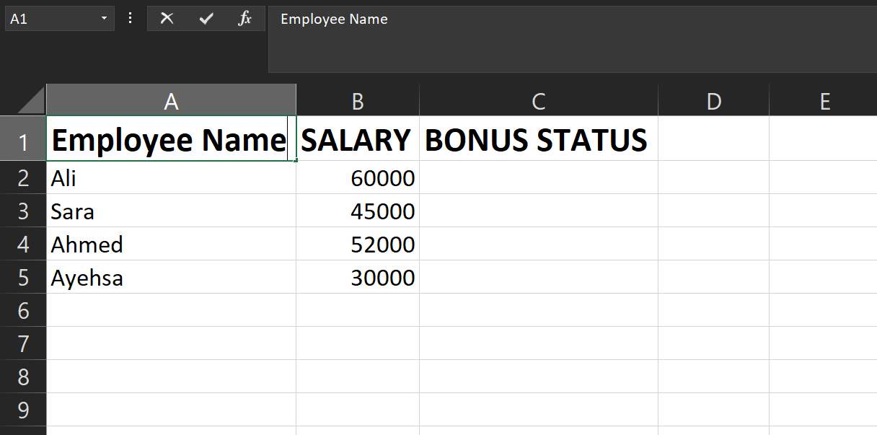

Here is the given data for testing the feature

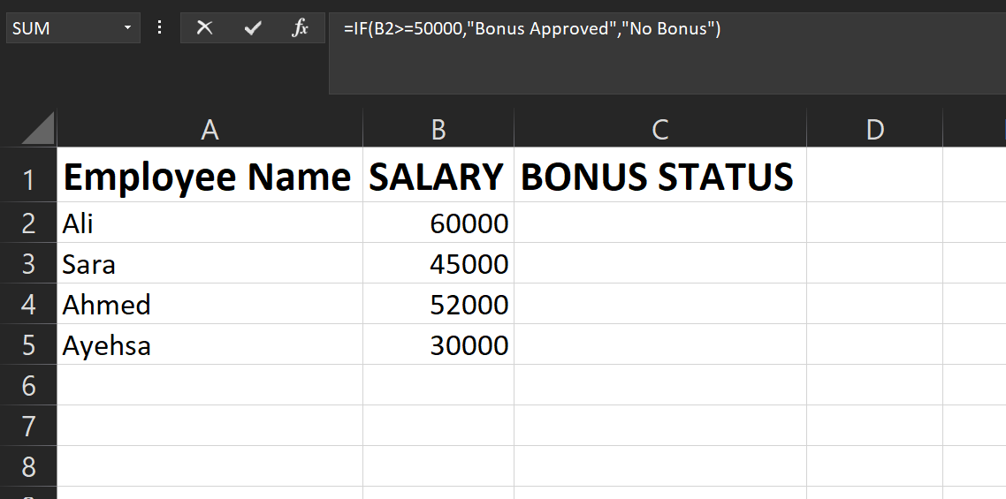

We need to add this “IF” Formula in order to test this function.

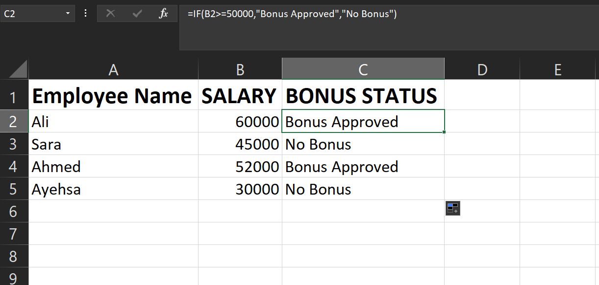

Formula added and the Function is working completely Fine.

Feature 2
PRIVOTE TABLE
Scenario
A company wants to analyse total monthly sales made by each salesperson to understand performance.

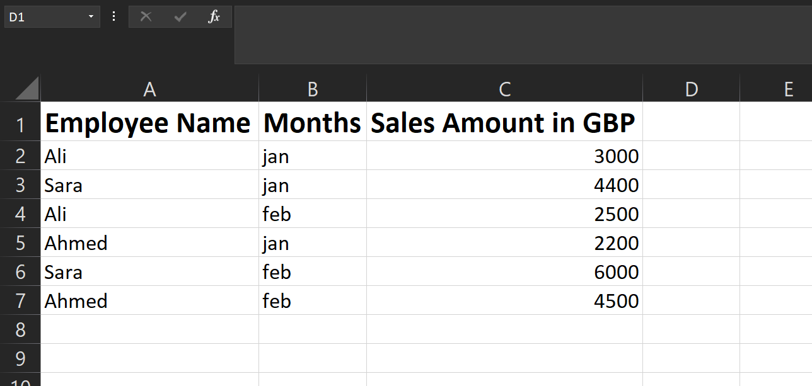

Entering all the data required to do this task.
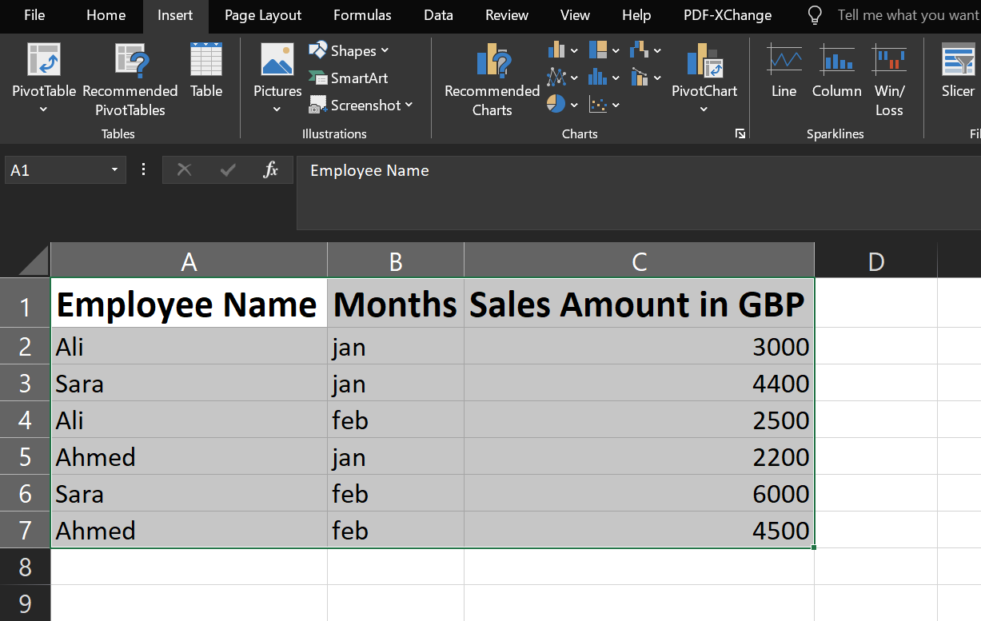

Select all the data and go to insert to find privot table.


Once you are in the Insert. Click ‘Recommended Privot Tables’
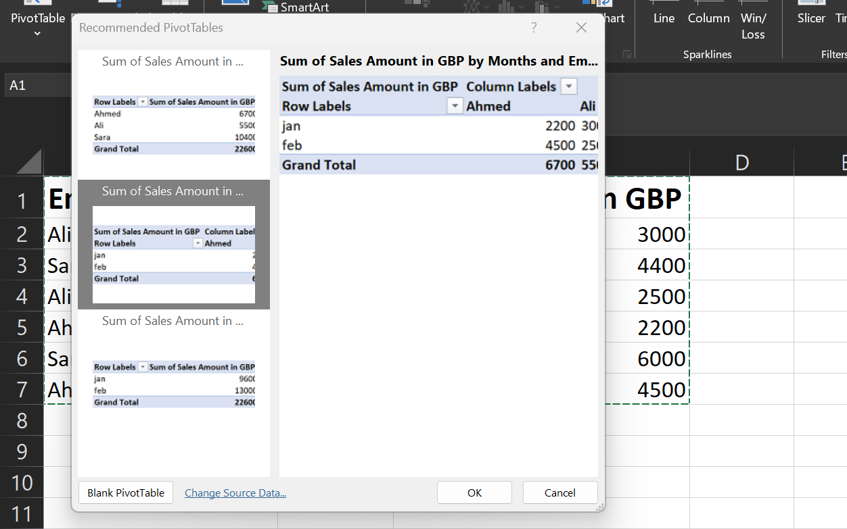

Once you click privot table you will get into this interface. Choose one of them and click ‘OK’

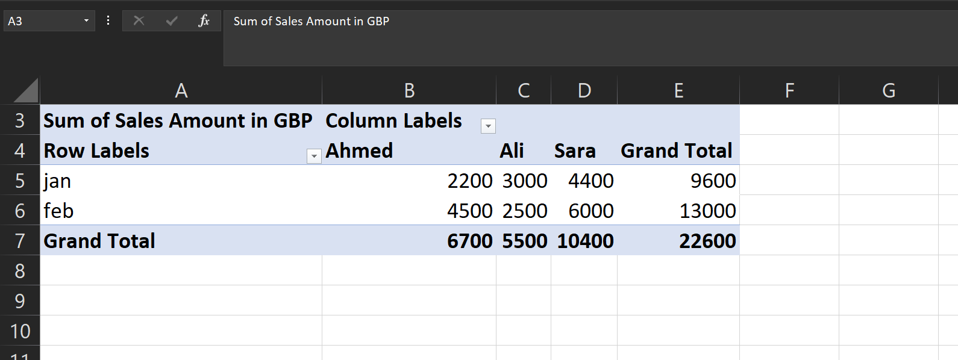

Your Privot Table will be added and it will automatically adjust all the things.

TASK 4(a)
Introduction:
In today's digital business environment, digital tools of communication and collaboration are playing a very important role in organizations. With more and more companies choosing to let their employees work from home or have hybrid situations, the need has increased for reliable platforms that allow employees to communicate clearly and collaborate efficiently. Digital communication provides different ways for interacting, either at an individual level or within groups, while digital collaboration enables groups to work together on documents and projects. This report presents an analysis of Email as a modern communication tool and OneDrive as a collaboration tool, putting into perspective their key features, benefits, and limitations, based on relevant sources.

Communication Tool
Gmail
Gmail is among the most used channels of communication by business organizations. This mode of communication enables organisations to send written messages and documents in electric form over the internet. With the availability of modern communication platforms, email remains indispensable for formal, professional, and documented communication. Businesses use email internally for coordination and externally with clients, suppliers, and stakeholders because of its reliability and universal acceptance.

Key Features of Gmail:
Enables the users to send and receive messages instantly over the internet.
Supports file attachments such as documents, images, and spreadsheets
CC and BCC options provided for groups' communication.
Folders, filters, and search tools to organize emails are available.
Includes email signatures and templates for professional use.

Gmail Benefits:
At reduced cost, it is faster to communicate, irrespective of the distance between the persons communicating [13].
Provides a permanent written record, useful for legal and managerial purposes [13].
Allows easy sharing of documents to multiple recipients.
Widely used and thus familiar; minimal employee training required [14].
Gmail Limitations:
Vulnerable to various security threats like phishing, spam, and malware [13].
Does not contain body language, which may provoke misunderstandings.
Not suitable for real-time or complex discussions, since long email threads may get confusing.
May cause information overload due to a great number of messages appearing daily.
Collaboration Tool:
OneDrive
Introduction:
OneDrive by Microsoft is a cloud-based collaboration and file storage platform. It allows individuals and teams to securely store, access, and share files from any location using an internet connection. In contemporary organizations, OneDrive facilitates collaboration by allowing staff to work on shared documents in real-time, which is particularly helpful for remote and hybrid work arrangements.

OneDrive Key Features:
Provides document and media storage in the cloud.
Allows secure file sharing with view or edit permissions
it's fully supports Microsoft's Word, Excel, and PowerPoint for real-time collaboration.
Includes version history, which allows users to revert to previous file versions.
Available on various devices including laptops and smartphones [15].
Advantages of OneDrive:
Allows access to files from any location, supporting remote and hybrid work patterns.
Improves team collaboration: Can edit documents simultaneously.
Offers secure data storage using encryption and controls of access.
Provides automatic backup- Hence minimizes the chances of data loss [16].

Limitations OneDrive:
Requires an active internet connection for full functionality [17].
Does not offer the advanced workflow and approval functionalities available in SharePoint
Some of them may also have storage limits depending on the subscription plan.
A learning curve may be created for new users in order to adapt to the use of cloud-based storage [17].

Conclusion
Email and OneDrive are two imperative tools used daily in the advanced corporate world. On one hand, email is still a strong line of formal communication. On the other hand, OneDrive enables productivity in group collaboration through the use of secure file sharing and allowing real-time document editing. Both the tools, according to some extent, are crippled with limitations, but their advantages allow these tools to be quite resourceful for better productivity, effective communication, and teamwork within organisations.
Task 4(a)
Testing Features of Gmail
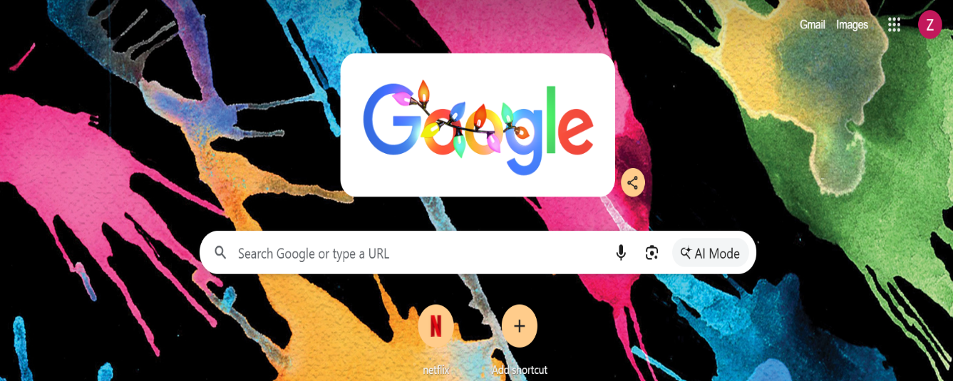


Open Gmail from your browser
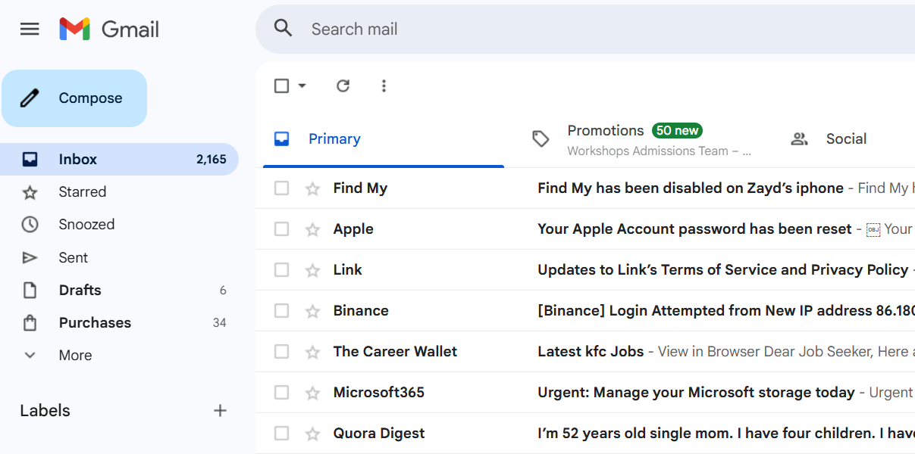
Choose “Compose” from the Gmail as shown in the figure.

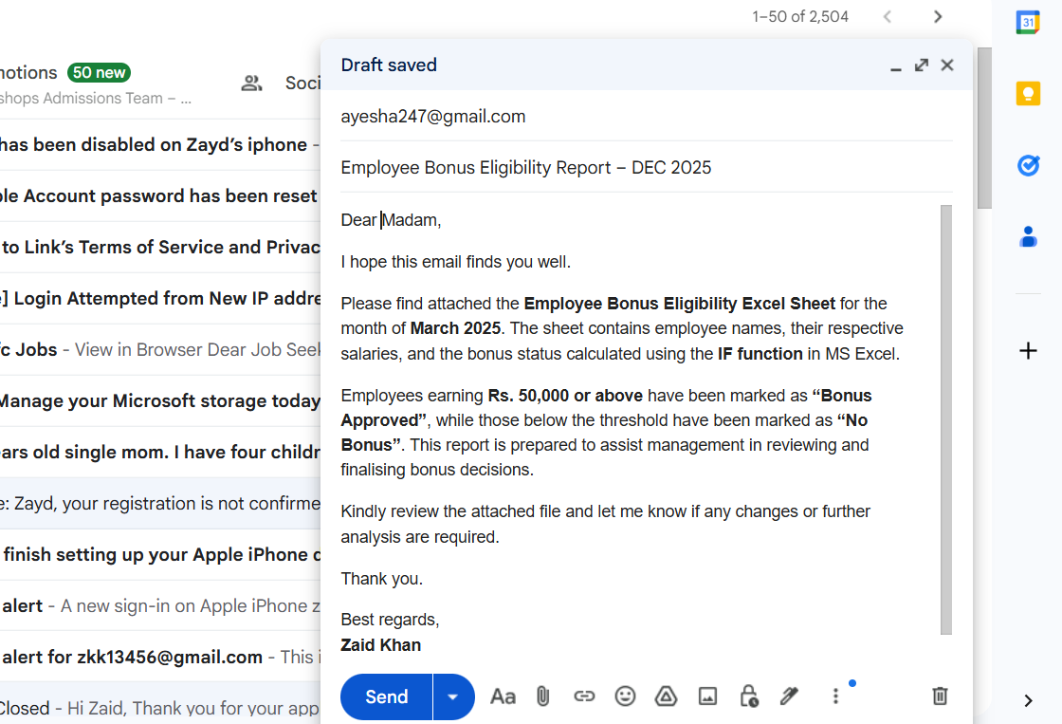
Write you details and Compose your Email and then click on the Attached files option as shown in the figure.

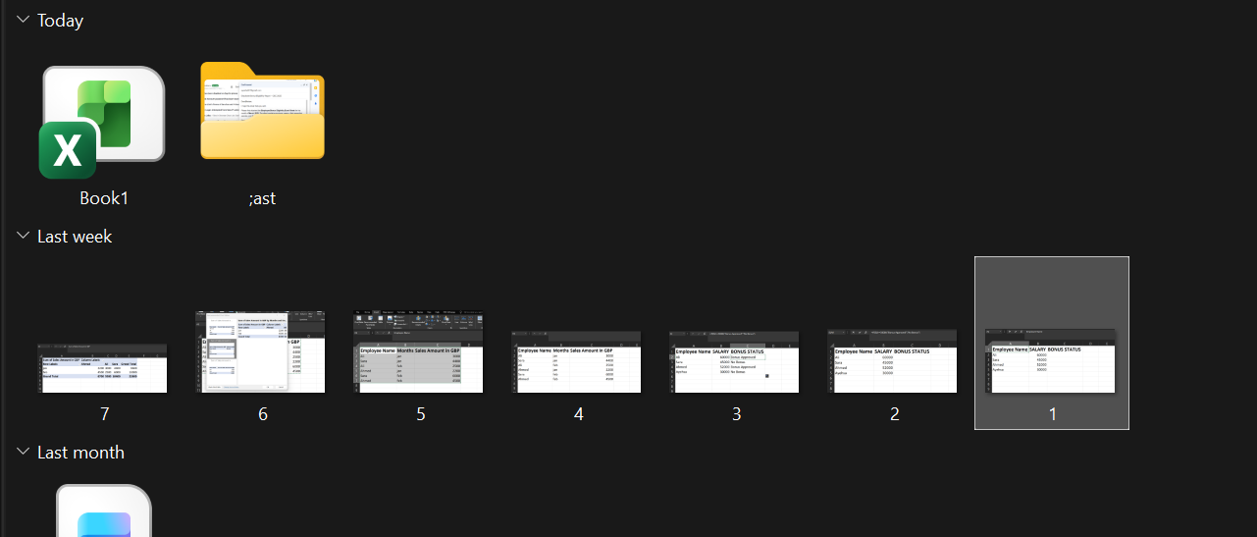

Choose your files, In my case it’s the Excel file that I am choosing.


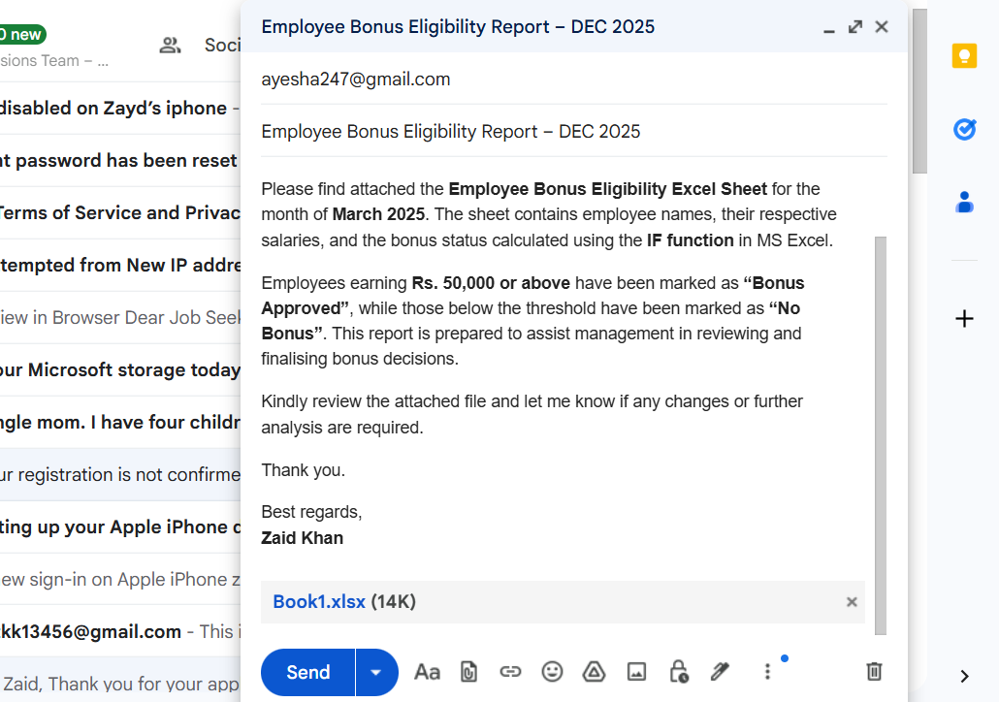
Once you are done with everything click “Send” and your Email will be send.
This shows how emails are used in business to transmit official messages and documents in a fast and professional manner.

Testing Features of OneDrive

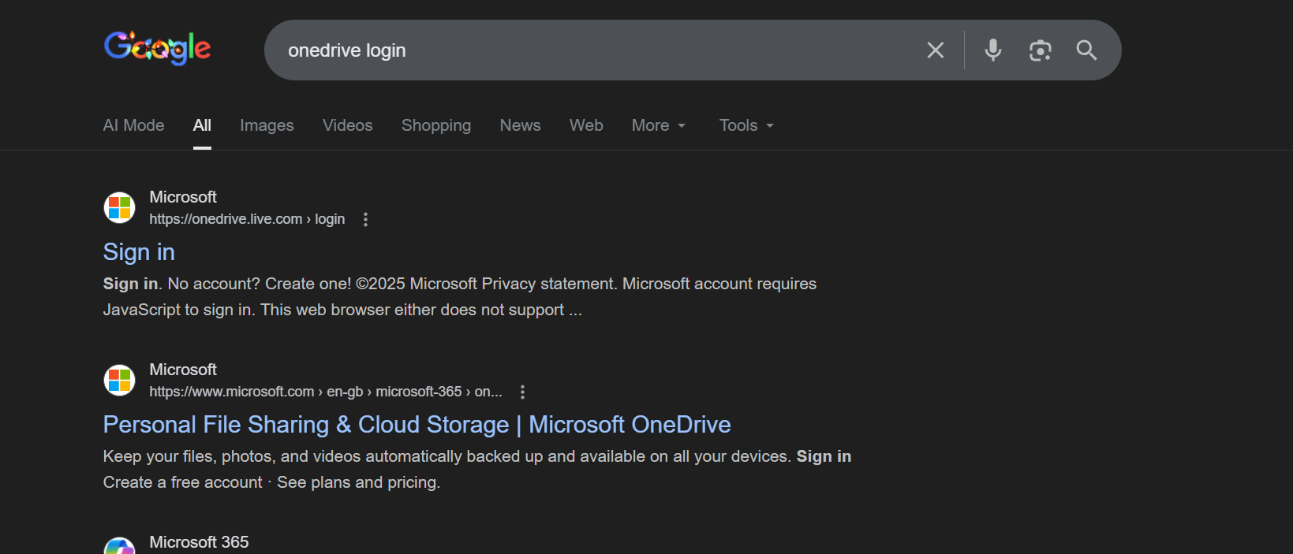
Open OneDrive in your browser

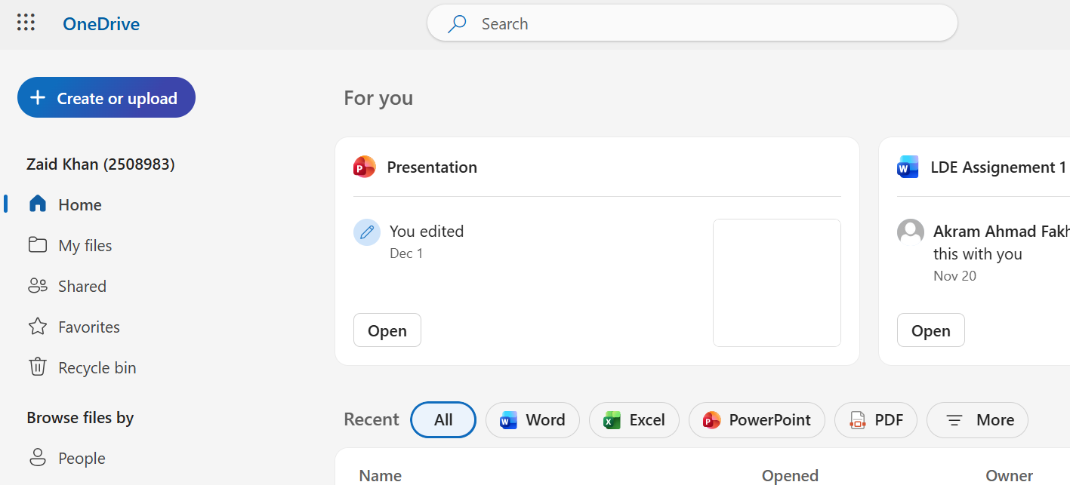
Once you are in click on “Create or Upload
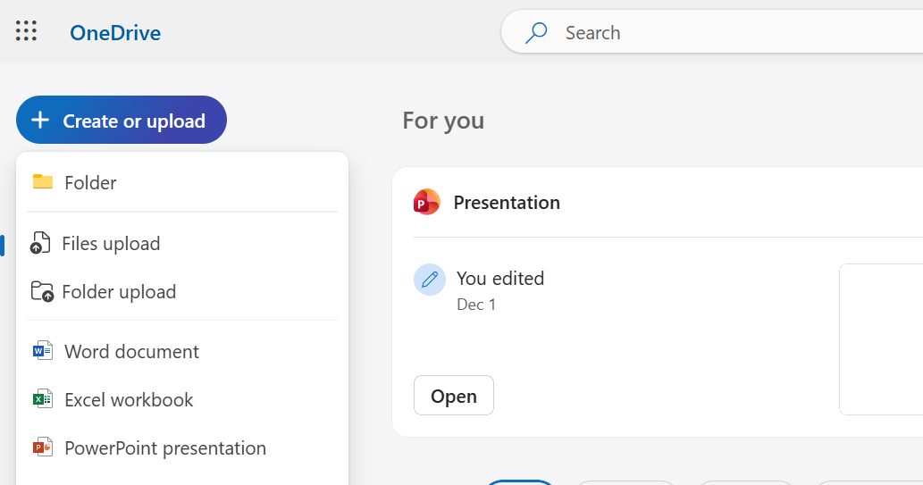

Click on upload file

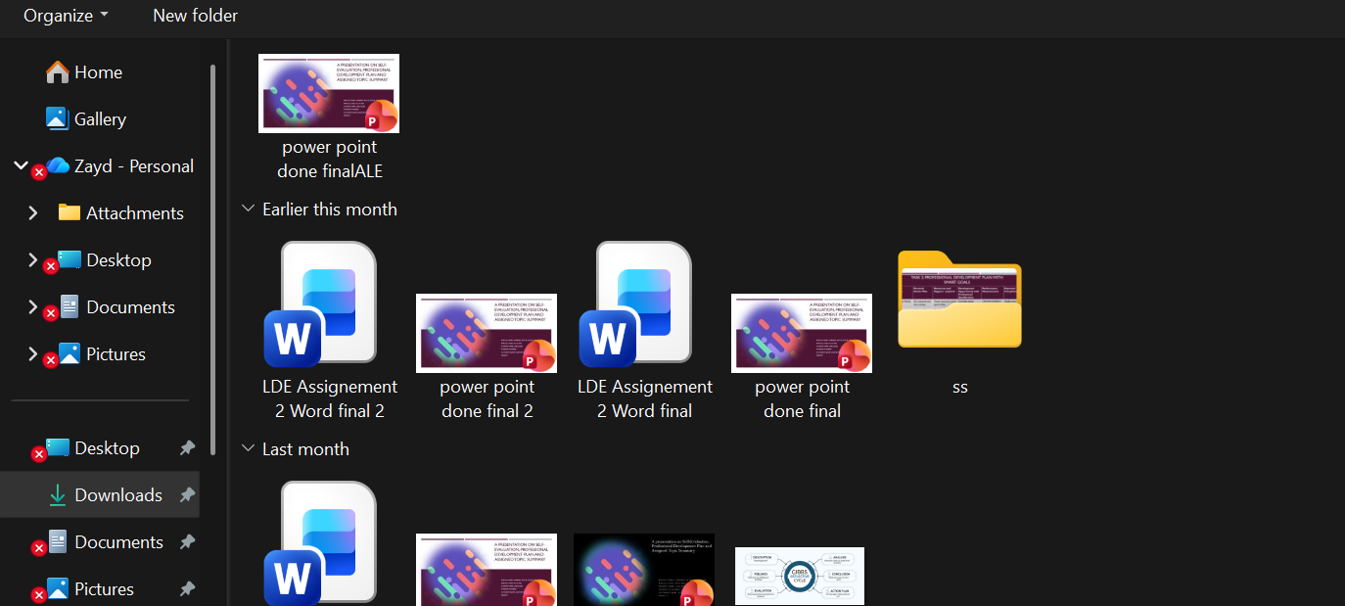

Choose the file you want to share with your Colleagues
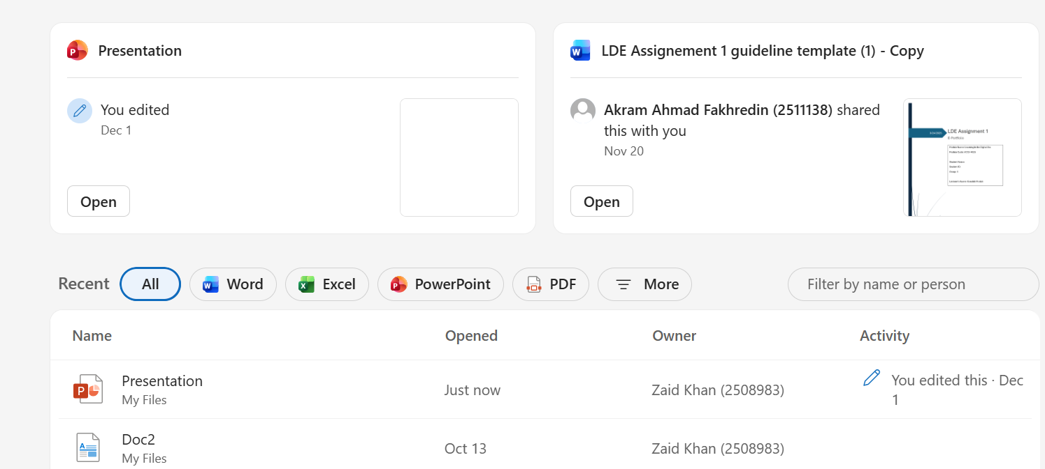
Click on your file once its uploaded

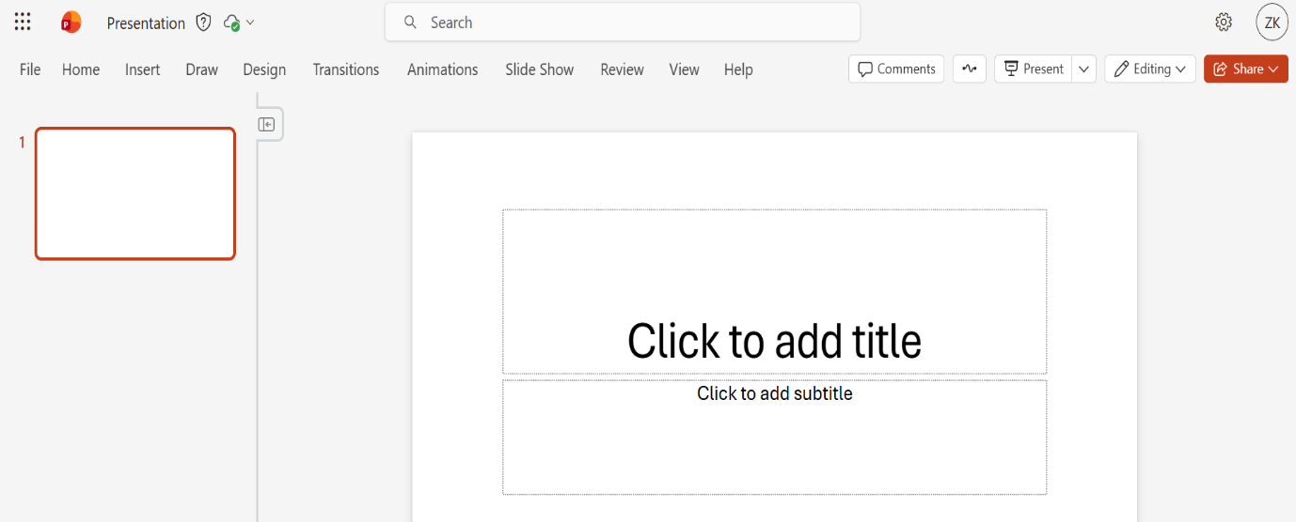

Click on share to share this file with your friend on colleague
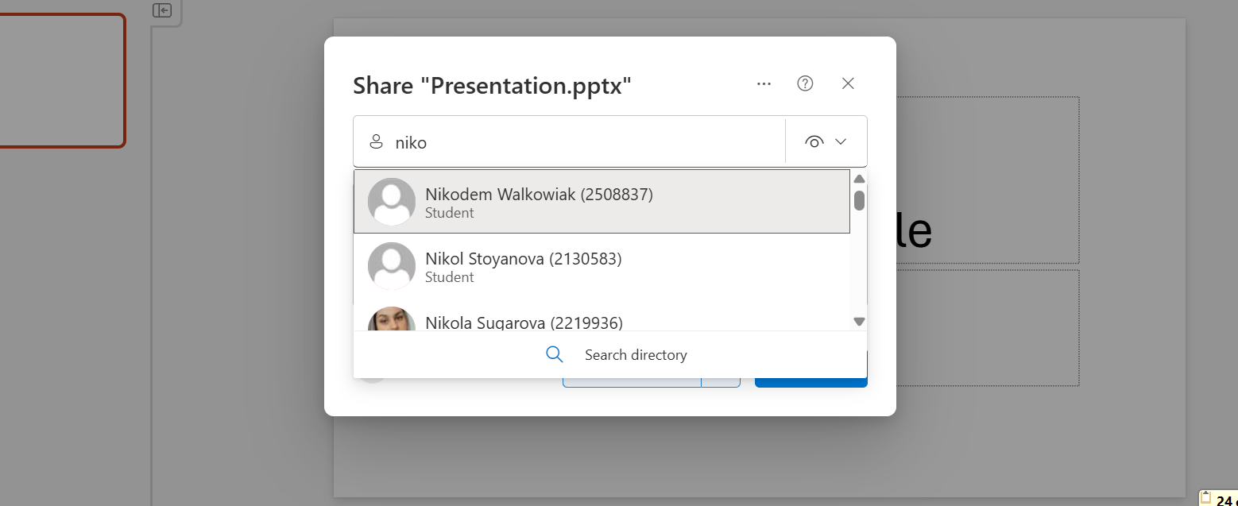
Write their Name or Email

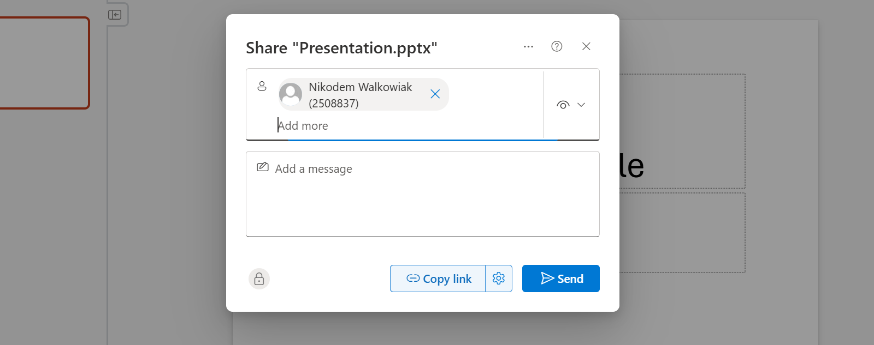
Click on send to share that file with your friend

This process shows how Google Drive supports collaboration in businesses by allowing teams to work on the same document simultaneously, reducing duplication of work and improving efficiency.

Conclusion

The above coursework has given a broad insight into how current software applications aid in the operations of a modern business. Through completing all four tasks, both theoretical and practical skill acquisition in all major subjects such as E-commerce, Information Management, Office Productivity, and Communications were achieved.

In Task 1, analysis of contemporary e-commerce website builders explained how current website builders/software solutions help firms quickly and inexpensively establish an online presence. Such solutions make technology less complicated with added functionalities such as payment systems, product handling, and mobile-responsive designs, making them ideal for small and medium-sized enterprises. The task illustrated how online e-commerce software solutions have an important role in transforming and growing online businesses.

Task 2 emphasized mind mapping, which is a technique of visual thinking. The presentation on mind mapping demonstrated its application in idea management, decision-making, and strategic planning for operations in a business. The generation of a mind map for modern application software proved how various tools are linked to facilitate organizational activities on a daily basis.

Task 3 focused on office software available for creating, processing, presenting, and analysing data. A thorough analysis of Microsoft Word, PowerPoint, Excel, and Access highlighted their main characteristics, advantages, and disadvantages. Furthermore, the hands-on evaluation of Excel functions such as 'IF function' and 'Pivot Tables' proved not only theoretical but also very application-oriented in a real-world business setup for analysing data.

Lastly, Task 4 focused on communication and collaboration tools used in today’s business environment. Through an analysis and application of freely available tools, it is evident that communication and collaboration can greatly improve teamwork, efficiency, and flexibility in a work environment, especially where working from a distance is involved.

In summary, this task has reiterated the significance of using current software application tools in increasing efficiency, communication, collaboration, and making decisions in an organization. Additionally, it has reiterated the need for relevant digital skills in today’s business world.

References

[1] | “McKinsy&Company,” January 24, 2025.
[2] | A. A. Sozinova1, “MARKETING QUALITY MANAGEMENT”.
[3] | B. K. S. Gary Dushnitsky, “Low-code entrepreneurship: Shopify and the alternative path to growth,” Nov 2021.
[4] | T. N. Lina, “Peningkatan Daya Saing Toko Safar Melalui E-Commerce dan Pemasaran Digital Berbasis Wix”.
[5] | R. Rezapour-Nasrabad1, “Mind Map Learning Technique: An Educational Interactive,” 2019.
[6] | A. V. D. Genevieve Pinto, “Applications of the Mind Map Learning Technique in Chiropractic Education: A Pilot Study and Literature Review,” 2006.
[7] | H. Tyson, “Microsoft Word Bible,” 2007.
[8] | T.-Y. Liu and W.-H. Tsai, “A New Steganographic Method for Data Hiding in Microsoft Word Documents by a Change Tracking Technique,” 2007.
[9] | R. Graham, “Expanding the use of Microsoft PowerPoint. An overview for radiologists,” 2006.
[10] | S. L. Jungheum Park, “Forensic investigation of Microsoft PowerPoint files,” 2009.
[11] | P. Kavanagh and T. J. Pitcher, “Implementing Microsoft Excel software for Rapfish : a technique for the rapid appraisal of fisheries status,” no. , 2004.
[12] | S. Bragagnolo, Analysing Microsoft Access Projects: Building a Model in a Partially Observable Domain, 2010.
[13] | N. B. info, “Advantages and disadvantages of using email in business,,” 2024.
[14] | Clearinfo, “Pros and cons of email for business communication,” 2024.
[15] | Cloudfuze, “What is OneDrive for Business?,” 2024.
[16] | Ingenotech, “Benefits of Microsoft OneDrive for Business,” 2004.
[17] | virtosoftware, “OneDrive limitations and comparison,,” 2022.

Appendices
In Appendices I am going to share all the screenshots of my practical work that I did during this Module.

Task 1
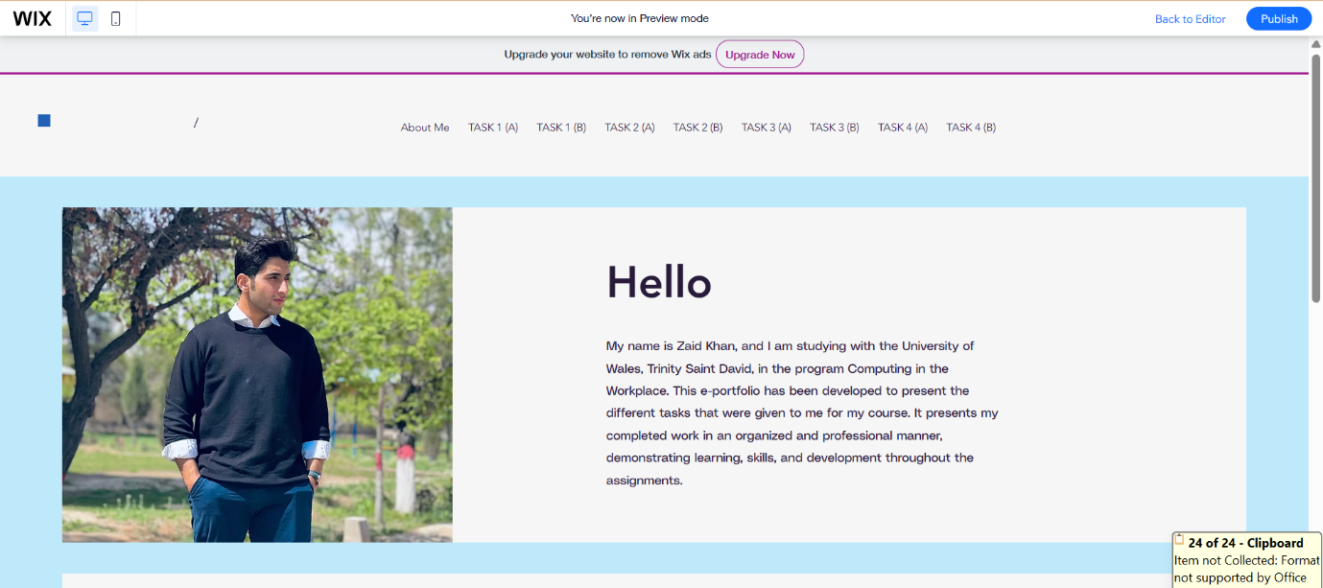
I used Wix to create a website for myself. Its an E commerce website builder tool.
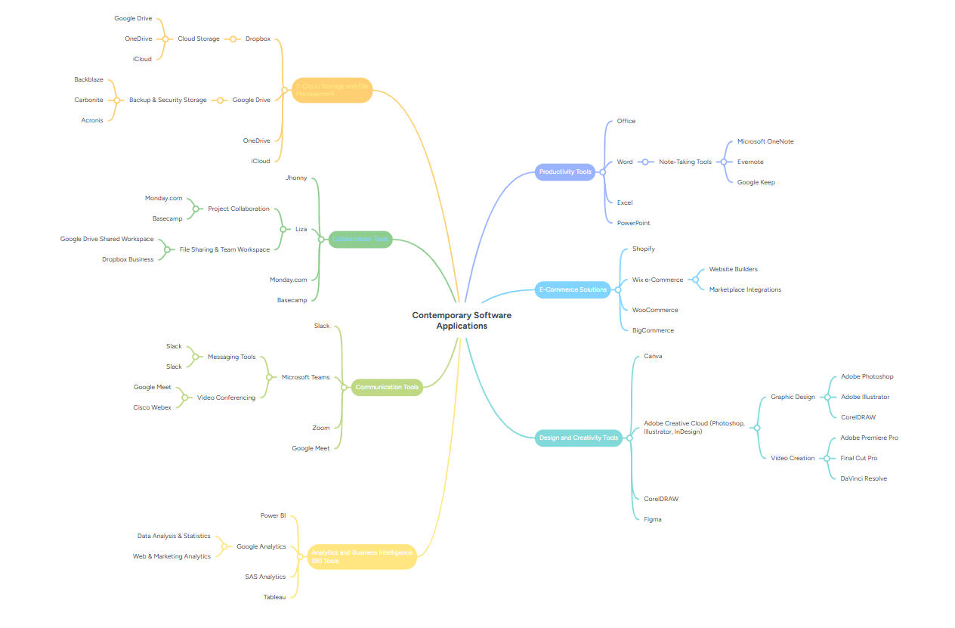
Task 2

The figure shown above is my mindmap that is created using the website Mindmesiter.

Task 3
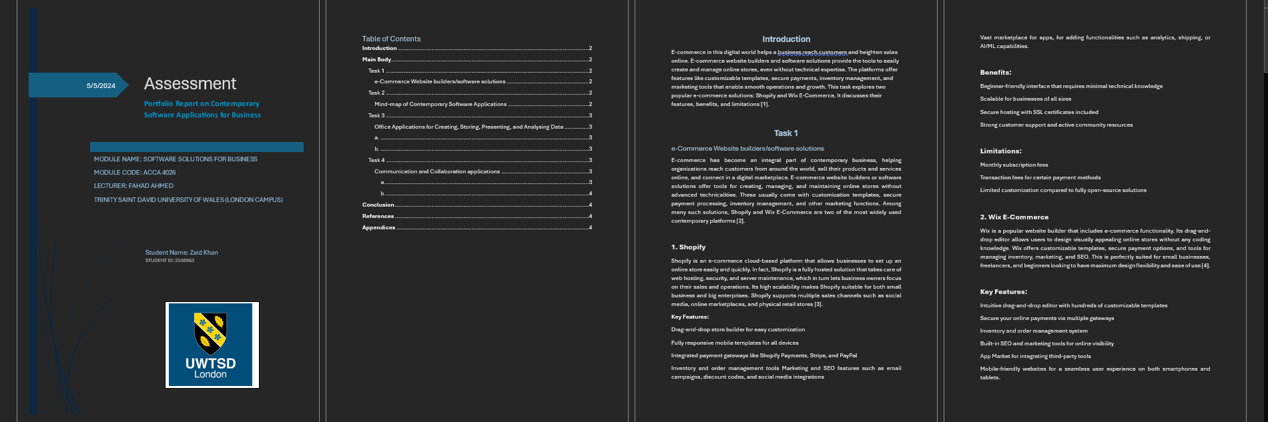
MS WORD

MS EXCEL

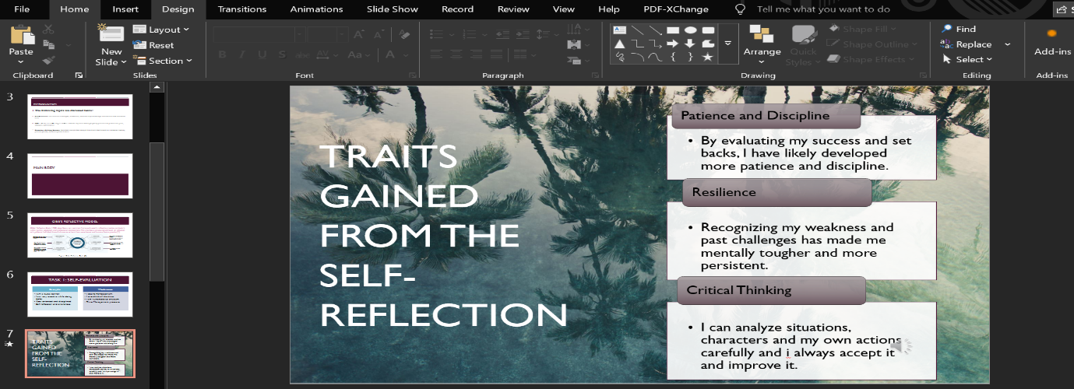
MS POWERPOINT
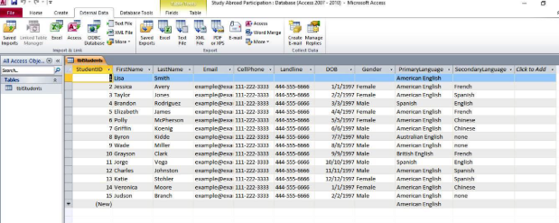
MS ACCESS

TASK 4
GMAIL

The figure shown above is from my Gmail as mentioned In the Task.

OneDrive

The figure shown above is from my OneDrive.



