Do Incremental Theory interventions improve pupils’ academic resilience?

Lucy Le Masurier
1251415
EdD ECDE7013

Contents
Chapter 1- Introduction (700/802) 4
1.1 Rationale 4
1.2 School Context 6
Chapter 2- Literature Review (3000/3091) 7
2.1 ACEs Affect Learning 7
2.2 Resilience as a Protective Factor against the Impact of ACEs on Learning 8
2.3 Academic Resilience Characteristics 10
2.4 Incremental Theory Interventions 14
2.5 Interventions in Welsh Primary Schools 17
2.6 Research Questions, Aims and Objectives 18
Chapter 3- Research Design and Methodology (3000/4429) 19
3.1 Research Design 19
3.1.1 Epistemology and Ontology 19
3.1.2 Deweyan Pragmatism 19
3.1.3 Positionality and Reflexivity 22
3.1.4 Theoretical Frame 23
3.1.5 Incremental Theory Programme 24
3.1.6 Academic Resilience Measures 25
3.2 Methodology 27
3.2.1 Equal Status Mixed Methods 28
3.2.2 Insider Action Research 29
3.2.3 Research Question 1 30
3.2.3.1 Research Question 1 Sampling 31
3.2.3.2 Research Question 1 Data Collection Methods 31
3.2.3.3. Research Question 1 Data Analysis 32
3.2.4 Research Question 2 33
3.2.4.1 Research Question 2 Sampling 33
3.2.4.2 Research Question 2 Data Collection Methods 33
3.2.4.3. Research Question 2 Data Analysis 34
3.2.6 Ethical Considerations 35
3.2.6.1 Consent 35
3.2.6.2 Power Relations/Risks 36
3.2.6.3 Confidentiality and anonymity 37
Chapter 4- Findings/Data Analysis (2500/1860) 38
4.1 Research Question 1 38
4.1.1 Sample 38
4.1.2 Intervention 38
4.1.3 Data Analysis 39
4.1.4 Paired t-Test Findings 39
4.1.5 Academic Resilience Characteristics Paired t-Test Findings 42
4.2 Research Question 2 44
4.2.1 Sample/Intervention/Data Collection 44
4.2.2 Data Analysis 45
4.2.2.3 Braun & Clarke (2006) Step 6 Write Report 47
Chapter 5- Discussion (1500) 53
Chapter 6- Recommendations (300) 54
References 55
Appendices 56

Table of Figures
Figure 1Synthesis of Academic Resilience and Incremental Theory Characteristics 23
Figure 2 Incremental Theory Intervention Lesson Topic and Objectives 25
Figure 3 Synthesis of Academic Resilience Characteristics and Responding Questionnaire Statements 27
Figure 4 Synthesis of Academic Resilience Characteristics and Responding Interview Questions 27
Figure 5 t-Test Academic Resilience Scores 39
Figure 6 Wilcoxon Signed Rank Test Pre and Post Test Academic Resilience Scores 40
Figure 7 Cohen's d Effect Sizes (adapted from Cohen et al. 2011) 42
Figure 8 Paired Sample t-Test Academic Resilience Characteristics Pre and Post Test Scores 42
Figure 9 Pre and Post Test Academic Resilience Characteristic Scores 44
Figure 10 Initial Codes NVIVO 45
Figure 11 Academic Resilience Themes NVIVO 46
Figure 12 Step 4 Revision of Themes 47

Chapter 1- Introduction (700/802)

1.1 Rationale
Adverse Childhood Experiences (ACEs) are defined as traumatic events that children can experience as they grow up that harm them directly or that are present within their homes (Barton et al, 2018). This includes abuse or neglect or living in a house where there is domestic violence; substance misuse; and caregivers with mental health illnesses or are incarcerated. The WG (2021) reports that such experiences increase the likelihood of poorer health outcomes, well-being, development, and relationships across the life span.
Worryingly, these experiences are common both globally and culturally (Bellis et al. 2019). Indeed, in a seminal US ACE Study, the CDC (Feltitti et al. 1998) reported that two-thirds of participants had suffered at least one ACE whilst over one fifth had suffered three or more. Likewise, Public Health Wales (Bellisi et al. 2015) found that in Wales over 50% of adults reported at least one ACE and 14% of participants reported four or more ACEs. Furthermore, both studies claimed that there was a correlation between the number of ACEs and likelihood of poorer outcomes across the life course. In one example, individuals who suffer 4 or more ACEs compared to those that have no ACEs are 20 times more likely to be incarcerated in their lifetime (Bellis et al. 2015).
Consequently, the WG released several policies which intended to mitigate and prevent the effects of ACEs (Wellbeing of Future Generations Act. 2015; Prosperity for All: the national strategy. 2017; A Healthier Wales: Our Plan for Health and Social Care. 2018). Subsequently, a Welsh ACE Support Hub (2018) was established aiming to make Wales the leader in mitigating and preventing the effects of ACEs. To this end, training, development and action plans are provided to social settings and practitioners in providing Trauma-Informed Care. Additionally, Ashton et al. (2016) recommend adapting current measures to a more trauma informed approach through resilience building and fostering relationships with a trusted adult.
Professional observations and discussions across a cluster of primary schools have identified that learners are presenting as having low academic resilience. Specifically, learners appear to find difficulty in regulating, adapting, applying greater and sustained effort and using additional strategies when faced with appropriate challenge. Furthermore, learners within the KS2 phase display behaviours and attitudes that are consistent with the neurologic and psych-emotional effects of ACEs. However, school practitioners i.e., teachers are limited by the sensitive nature of ACEs to assess and identify learners for individual interventions. Smith (2018) states that despite this, if practitioners within education settings understand the impact of ACEs on behaviour, mental health and development this ACE lens can address challenges more effectively which can lead to improved educational outcomes for all learners regardless of whether they have been identified as ‘having’ ACEs. In addition, trauma informed care as a response to resilience and academic outcomes has been exacerbated by the COVID-10 pandemic. Lockdown in Wales has meant that learners moved to online learning which may have increased the risk of exposure to ACEs. Srivastav et al. (2021) found that during the pandemic there was an increase in injuries relating to child abuse and an increase in domestic violence cases. The researchers concluded that this is likely caused by the additional stress brought about by the pandemic and protective factors again this stress may have been weakened. Similarly, Sanders (2020) identified the same risks and argues that the pandemic had amplified existing ACEs and asks whether the pandemic itself would be considered and ACE. In Wales, Newbury et al. (2020) explain that there has been an increase in reports of emotional, physical, sexual abuse and neglect and a 54% increase in reports of domestic abuse. The researchers conclude that education settings have a critical role in supporting the recovery of pandemic by identifying learners with trauma, prepare for a rise in disclosures and support learners’ mental health and well-being. However, the researchers do note that this could prove difficult as the changes in learners are reflected in those brought about by ACEs e.g., disengagement, withdrawal and agitation.
Indeed, whilst the WG has introduced Trauma Informed Care across all social sectors, Sciarffa. (2018) and Barton et al. (2018) emphasise the importance of TIC within in education settings. The authors suggest that as children spend a large quantity of time within these settings, practitioners are best placed to support the development of resilience to prevent and mitigate the effects of trauma. Adding further weight to this argument is the impact that ACEs has on children’s’ social, emotional, well-being and learning development.

1.2 School Context
The school is small English-medium primary school within a small community in South Wales. The school has 121 pupils on roll and serves an area of socio-economic disadvantage with a higher number than the national average of 24.1% eligible for free school meals and 12.4% identified as having ALN.

Chapter 2- Literature Review (3000/3091)

2.1 ACEs Affect Learning
Perfect et al. (2016) reviewed 98 studies relating to the impact of ACEs on such effects. The authors concluded that cognitive functioning, attention span, behaviour and attainment were significantly impacted by ACEs. Several additional studies also reported similar results, finding that the higher number of ACEs experienced: raised the likelihood of learning difficulties (Hunt et al. 2017); increased the difficulty in regulating and expressing emotions (Bellis et al. 2019); lowered reported social-emotional competencies and raised reported behavioural issues (Dee et al. 2020); and increased the likelihood of lower academic success (Jimenez et al. 2016; McDowell. 2017; Houtepen et al. 2020).
Hays-Grudo and Morris (2020) explain that children’s interactions and experiences with people affect the development of the nervous, immune and endocrine system as they mature. ACEs can affect the structure of the prefrontal cortex, increase the basal cortisol levels and compromise the immune system resulting in epigenetic effects. When this type of stress is repeated, referred to as ‘Toxic Stress’ (CDC. 2020), it affects the serotonergic, dopaminergic and noradrenergic neural system resulting in emotional and behavioural dysregulation (Dee et al. 2020). Indeed, Danese and McEwen (2012) state that the prolonged activation of allostatic systems, needed for coping with imminent threat, and its physiological consequence ‘Allostatic Load’ can affect stress sensitive regions of the developing brain (prefrontal cortex, the amygdala and the hippocampus). This increases the systems baseline response to secreting stress induced chemicals when dealing with future stress which continues in a feed forward cycle.
The importance of this for learners’ attitude to learning is two-fold. Firstly, toxic stress can affect the stress sensitive plasticity of the prefrontal cortex which is responsible for higher order cognitive behaviours and controlling Executive Functioning. Executive Functioning controls working memory, inhibitory control, sustained attention and cognitive flexibility considered fundamental brain mechanisms required for academic resilience and learning (Petchell and Pizzagalli, 2012). Secondly, dysregulated and heightened baseline stress systems can bring about survival responses when faced with any appropriate challenging learning activities. Furthermore, if learning activities are interpreted as stressful situations, this may activate the amygdala, part of the limbic system which responds to threats to survival and stress, which in turn reduces the efficiency of executive functioning.

2.2 Resilience as a Protective Factor against the Impact of ACEs on Learning
Cognitively flexible children believe that problems have many solutions and effort will bring about success (Yavuz and Kutlu, 2016). Therefore, increased cognitive flexibility or ‘Academic Resilience’ to learning situations can support learners’ in firstly reducing stress when faced with challenging learning opportunities and enabling executive functioning to maintain control by overriding the amygdala when learning. Indeed, Pearce and Davis (2021) and Traub and Boynton-Jarrett (2017) identify developed executive functions as predictive of resilience. However, Lund et al. (2020) reviewed 36 studies examining the correlation between ACEs and executive functioning outcomes in children internationally and across backgrounds. The researchers found a strong relationship between executive functioning deficits and the children’s number of ACEs in decreased attention, working memory, inhibitory control and cognitive flexibility. Hays-Grudo and Morris (2020) highlight that during sensitive periods of development, children’s brains are more susceptible to positive and negative environment interactions. Moreover, development of the executive functioning coincides with growth spurts at ages 0-2 years, 7-9 years and adolescence. From an education viewpoint, timing of interventions which seek to support the healthy development and to counteract the effects of ACEs on these functions would be beneficial at KS2 (Years 3-5).
There is much evidence that recommends developing children’s resilience to mitigate and prevent the effects of ACEs on their learning (Ashton et al, 2016; Barton et al, 2018; Estyn, 2020) . Resilience is an adaptive response to adversity even when faced with perceived stressful situations or environments. Authors believe that this is the ability to bounce back and the outcome of adapting positively across multiple domains (Cassidy, 2016; Hamby et al. 2021; Hays- Grudo and Morris, 2020). This is seen as converting toxic stress into tolerable stress and resulting in positive experiences (McCormick, 2019). Similarly, Pearce and Davis (2021) add that resilience is seen as the interplay between a positive situation and coping tools that outweigh risk factors to result in a positive experience. Risk factors and experiences that hinder resilience include internal dispositions and external experiences. Resilience is viewed as the protective factor and explains why certain children achieve despite adversity and why not all that suffer ACEs experience the long-term effects e.g., poorer health and development outcomes or academic success (Poole et al. 2017 and Hays-Grudo and Morris 2020). Indeed, findings from a longitudinal study identified a subgroup of children who demonstrated resilience as having strong internal dispositions. This included the belief that they had a mastery over their life outcomes and their capacity to overcome adversity (NSCDC, 2015). Romero et al. (2018) state that children who have suffered ACEs and have weaker resilience are more likely to have difficulties academically. They add that this is seen in their ability to plan and carry out as task, understand multi step tasks and causal relationships, blame others for their mistakes and lack the tools to seek support or solve problems. Conclusions from a longitudinal study argue that resilience is modifiable and is both multidimensional and dynamic (Poole et al. 2017). In a recent study, McCormick (2019) reported that schools were seen as key players in developing individual’s resilience. This is echoed by NHS Scotland (2017) adding that the role of teachers and support staff is crucial. Indeed, children do not acquire resilience on their own; resilience develops as the product of multiple factors that reflect the interdependence amongst families, communities and schools (Doll, 2012).
2.3 Academic Resilience Characteristics
Schoon (2006) defines resilience as an individual’s capacity to overcome environmental challenges that risk or hinder the accomplishment of developmental objectives at specific ages. Similarly, Truebridge (2016) described resilience as the dynamic process within individuals and between individuals and their external environments for the resources and support to adapt amid adversity, threat and everyday stress. Both Avci (2022) and Jowkar et al. (2014) claim that resilience relates to different areas of an individual’s life and therefore it comes in various forms i.e., psychological resilience, physical resilience, emotional resilience and academic resilience. Academic resilience is defined as the pupil’s ability to overcome difficulties that prevent academic development (Martin, 2013) and the increased likelihood of success despite adversity (Cassidy, 2016) that may be brought about by early traits, conditions and experience (Wang et al., 1994).
In their literature review study, Gafoor and Kottalil (2011) found that academically resilient individuals had similar characteristics, and these were categorised in four domains. These included within-family, within-school, within-community and within-child protective factors. The latter exemplified by characteristics such as motivational, cognitive and meta-cognitive factors and self-belief.
In exploring the links between individual academic resilience factors and levels of academic resilience, Martin and Marsh (2006) discovered that research that had been conducted into academic resilience domains (i.e. academic, family, peer, sociodemographic and psychological) had given less detailed focus given to any particular domain. The researchers note that this is most apparent in the psychological domain, where the focus tends to be just on self-esteem and locus of control. This therefore restricts how much psychologists and educators may do to improve students' psychological resilience through more multifaceted approaches.
Numerous studies have aimed to identify individual characteristics which improve academic resilience. In their most recent international testing findings, PISA (OECD, 2018) identified several characteristics. This included meta-cognition which enables learners to evaluate when problem solving and plan and allocate learning resources; motivation to master tasks; minimum or non-existent fear or failure; self-efficacy which is the individual’s belief in their own capacity to be successful in tasks despite difficulties; mastery goal orientation which refers to the individual’s aspiration and intrinsic motivation to set and complete goals; and cognitive flexibility which is the individual’s capacity for adjusting, developing and coping with novel and different tasks using their knowledge and experience.
In their study, Martin and Marsh (2006) concluded that there are five distinct characteristics connected with academic resilience and presented these as a 5-Cs model. The model consisting of confidence (self-efficacy), co-ordination (planning), control, composure and commitment. The researchers state that academic self-efficacy is a significant predictor of academic resilience as it addresses and enhances pupil’s negative beliefs about themselves and their academic capabilities and supports the development of effective goal setting. In addition, the researchers claim that two other key characteristics that enhance pupil’s academic resilience is planning and persistence brought about by self-regulation and goal setting. Planning refers to the setting of effective goals whilst persistence refers to the way in which they are achieved, particularly when pupils find tasks challenging and achieving the goal is not immediate. Pupil’s sense of control refers to their understanding of the relationship between their effort and strategy and their outcomes.
Similarly, in their research, Wang et al. (1994) found that in the psychological domain there is a correlation between academic resilience and specific characteristics i.e., motivation and self-efficacy. Indeed, self-efficacy is a key characteristic of developing academic resilience (Cheung, 2017., Rachmawati et al., 2021).
Dweck’s (2000) research explained that developing academic resilience is two-fold. Firstly, that it is the perception of academic adversity that impacts success not the academic adversities themselves. Secondly, there are two mindsets, one which positively affects academic resilience and the other which prevents academic resilience. Dweck’s research (2000) examined the malleability of the brain and dispositions referred to as ‘Mindsets’ and its potential to develop academic resilience. Dweck’s seminal ‘Implicit Theories’ research identified two mindsets: Individuals with a Fixed mindset (Entity Theory) view intelligence as innate and unmodifiable; and individuals with a Growth mindset (Incremental Theory) believe that intelligence can be developed with practice and effort over time. In later studies, Dweck concluded that if children are taught about the malleability of their brain and its ability to develop academically this results in ‘striking effects on resilience’ (Dweck and Yeager, 2012, p. 303). However, the research warns that just teaching the skills for resilience is not enough, children may not operationalise them if they do not adopt a growth mindset. Likewise, Spitzer and Aronson (2015) argue that academic resilience interventions which support the alteration of the learners’ reaction to a perceived threat and the stress brought about by that threat can provide a way to improve academic outcomes.
Dweck and Yeager (2012) define academic resilience as any behavioural, attributional or emotional response to academic challenge that is positive for development and refer to any response to challenge that is negative or not beneficial for development as not resilient. In addition, the researchers identified several characteristics that develop Growth Mindset (Incremental Theory) and explored ways in which this could be developed, fostered and enhanced in education settings. The researchers state that pupils who have an incremental theory or a growth mindset set goals that are eager to achieve they care less about looking ‘dumb’. Furthermore, these pupils believe that effort is the key to success and growth rather than innate capabilities, they adjust or try new strategies and put forth greater effort in the face of difficulties and setbacks and they persevere rather than feeling a sense of helplessness, emotional dysregulation or giving up. Supporting pupils to change their implicit theory is intended to prevent the exacerbation of a pupil’s adverse situations by interrupting the negative interpretations of the situation. However, this does not deny the complexity of the pupil’s but instead highlights the psychological factors within the student that can be more readily changed.

2.4 Incremental Theory Interventions
Indeed, Novotny and Křeménková (2016) found a correlation between academic success and academic resilience. However, there is little research which relates specifically to developing academic resilience (Cassidy, 2016). Furthermore, Boullion et al. (2020) stated that until their study, no research has examined the impact of Implicit Theories and their relationship with resilience and childhood adversity. In a study of 381 undergraduate students, they concluded that a growth mindset was an important mediating psychological resilience factor for individuals who had suffered ACEs. The age of the participants limits the generalisability learners of all ages however it identifies further research required for understanding developing academic resilience through Incremental Theory interventions in response to mitigating and preventing the effect of ACEs on academic success.
Overall, Incremental Theory interventions have impacted positively on academic resilience. This is evident in seminal studies (Aronson et al. 2002 and Blackwell et al. 2007) and in more recent studies (Costa and Farier, 2018; Orosz et al. 2017; Paunesku et al. 2015). The effects sizes of 48 studies which examined the relationship between Incremental Theory inventions and educational achievement. While the researchers (Costa and Farier, 2018) found that there was a positive correlation, they concluded that more should be done to ensure that is deployed interdisciplinary.
Aronson et al. (2002) conducted an experimental study with 109 US undergraduates over two semesters that included eight 25-minute sessions to promote a mindset shift from fixed to growth. This resulted in a significant improvement in academic attainment compared to the control group. Aronson et al. found that participants had an increased value of education, exerted more effort in tasks and viewed intelligence as modifiable. These are consistent with the resilience characteristics set out in Dweck and Yeager (2012). However, this study lacks external validity when generalising beyond the education phase. However, the researchers hypothesise that these interventions would be more effective with children. They argue that children’s brains are more malleable and may potentially have not yet cemented their perceptions of intelligence when compared to university students. Moreover, Blackwell et al. identify 10-19 years as the critical point in developing academic resilience as this tends to be the period where there is increased risk of lower self-esteem and engagement and thus lower attainment.
In a longitudinal study including 373 12–13-year-old participants, Blackwell et al. (2007) sought to examine the correlation between mindsets and academic attainment over time. The researchers focused on why some children can achieve despite adversity. The Incremental Theory interventions were implemented in one school. They found that the participants were still resilient and had more comparable academic success up to two years post intervention. The effects of the intervention on participants resilience were similar to that of Aronson et al’s. (2002) findings and consistent with Dweck and Yeager’s (2012) resilience characteristics. This included a more positive perception about how greater effort can bring about improvements and selecting effort-based strategies when responding to challenge and failings. This longitudinal study was conducted over 5 years and thus increases the internal validity of its findings however these findings lack external validity as it was conducted in one school and cannot be generalised within a different school structure or with younger children.
Paunesku et al. (2015) carried out a large-scale study which included delivering online mindset training over 5 months to 1,594 students across 13 high schools. They concluded that the interventions had supported the improvement of academic performance. In addition, the researchers argue that interventions can facilitate the shift in mindset thus enabling a more positive approach to challenges and developing resilience. They concluded that further research is required to understand the impact of mindset interventions across settings.
Orosz et al. (2017) examined how mindset interventions impacted motivation. Mindset interventions were delivered to 129 Hungarian 15–16-year-olds over 5 weeks. When measured throughout the study, the researchers found that the participants had adopted a more ‘Growth’ mindset within 3 weeks compared to the control group. However, in a follow up assessment, these improvements had reverted to baseline data. According to Orosz et al. (2017), this suggests that whilst mindsets are modifiable, this can mean just temporarily. In their discussion, the researchers emphasise the importance of the practical application of the Incremental Theory rather than providing only theoretical information. Further to this, the researchers noted that there was a lack of change in the school climate or pedagogies and recommend that it is "important to measure the perceived change reported by teachers" (Orosz et al. 2017, p.5). This suggests that incremental theory interventions would be beneficial to implement these interventions within a whole school approach and within an adapted school climate that provides opportunities for learners to develop their resilience practically when given appropriate yet challenging learning activities.

2.5 Interventions in Welsh Primary Schools
Research has shown that growth spurts occur in childhood and within the KS2 school phase. These coincide with the development of the prefrontal cortex responsible for executive functioning and thus academic resilience and the crucial role that schools, and teachers have in developing this resilience. Yet, there is still little research which determines how academic resilience is developed using Dweck’s Incremental Theory specifically in the UK or in Wales and or with primary aged children. Interventions that are situated within learning activities practically, and or with younger learners that already studied (Paunesku et al. 2015). Furthermore, when interventions are delivered simultaneously with adaptation to school culture and pedagogies, they may prove more beneficial, particularly in a more permanent mindset shift (Orosk et al. 2017). However, research reviewed has provided evidence that there is a positive relationship between Incremental Theory interventions and academic resilience particularly when implemented in daily classroom practices and within a whole school approach. Despite this, current guidance and practices for schools advise that interventions that build resilience are carried out of the classroom. For example, Estyn (2020) identifies best practice for implementing the interventions which includes identifying learners using pre-existing assessments (Pupil Vulnerability Profile, Thrive Assessments, Attachment Assessments, Boxall Profile and ELSA) and implemented out of class. Currently, there is little guidance or research on the impact of "in class and in task" resilience interventions.

2.6 Research Questions, Aims and Objectives
In response to the literature and research reviewed, this study is guided by the overall research question: ‘Do Incremental Theory interventions improve pupils’ academic resilience?’. This is divided into two further research questions: To what extent do Incremental Theory interventions impact on UKS2 pupils’ academic resilience? and to what extent do UKS2 Teachers perceive that Incremental Theory interventions impact on UKS2 pupils’ academic resilience?
Therefore, the aim of this study is to determine whether implementing Incremental Theory interventions within KS2 classrooms can improve learners’ academic resilience. Several objectives have been determined to achieve this aim.
- To define the characteristics of academic resilience to enable measurement pre and post interventions.
- To determine a scale which measures the characteristics set out in objective 1.
- To deliver and measure the impact of the intervention with KS2 learners.
- To explore teacher’s perceptions of the impact of the intervention on KS2 learner’s academic resilience.

Chapter 3- Research Design and Methodology (3000/4429)

3.1 Research Design

3.1.1 Epistemology and Ontology
The most prevalent research paradigms are Positivism and Interpretivism. Ontologically, positivism adopts the viewpoint of realism. In other words, world is external, and phenomena exist in a single objective reality. Because reality and truth are independent of context, researchers can use principles and a deductive method guided by a hypothesis drawn from scientific theory to discover truth that exists elsewhere. Experimentation is utilised to determine and measure causality (Wyse et al., 2016). Interpretivist ontology, on the other hand, rejects the notion that there is a singular, verifiable world beyond our senses and holds that there are multiple realities. From an epistemological standpoint, interpretivists believe that truth is subjective, context-dependent, and socially produced. Thus, reality and truth are not created but rather discovered (Gray, 2018).

3.1.2 Deweyan Pragmatism
Flick (2018) explains that pragmatism rejects conventional views of reality and truth, whereas Morgan (2013) argues that it can bridge the divide. Rorty (1991) asserts that pragmatism challenges the dichotomy of traditional philosophical positions and contends that pragmatism's 'approach to inquiry' combines the two epistemologically and ontologically. Pragmatism as a philosophical position derives from John Dewey's (1859-1952) classic pragmatist philosophy. According to Morgan (2013), Deweyan pragmatism aims to break down the dualism between realism and idealism. Collins, 2012; Felizer, 2010; Kaushik and Walsh, 2019) explain that Deweyan Pragmatism is concerned with a deep sense of justice, which results in a set of philosophical tools rather than a position applied practically to address and solve social issues and improve practise, such as inequality, power, and politics. This research is aligned with a pragmatic approach; that is, the aim of this research, which is to address a social issue, and the research questions that guide the research do not fully align with positivism or interpretivism.
In fact, Deweyan pragmatism rejects traditional epistemology and replaces it with an inquiry theory (Wyse et al., 2016). The Theory of Inquiry defines knowledge as the foundation of individual experiences of the world within the context of socially shared meanings. Therefore, truth is socially constructed and is utilised to enhance social outcomes. Dewey argued that knowing and doing are inextricably linked (Kaushik and Walsh, 2019). This research is guided by this view of reality as it seeks to comprehend the individual experiences of participants through practical application in order to determine its accumulated social impact. In addition, these inquiries derive from observations that identify a problem and investigate it to find solutions by revising its components in a feed-forward cycle. Observations of KS2 classrooms in a cluster revealed that students were disengaged and lacked academic resilience, which prompted this study. Parts of the problem will be investigated by implementing an intervention and analysing its effects, which will inform the next phase of the cycle. Consequently, pragmatic action research will be used to seek the truth. This perspective considers truth to be provisional, as that is as close to the truth as the current cycle has come to.
Maarouf (2019) explains that traditional ontology is replaced in Deweyan pragmatism by an emphasis on experience and subsequent action rather than what exists from a purely abstract standpoint. Dewey believed that what recurs in experiences contributes to our understanding of social worlds, which in turn informs our actions. Reality consists of cycles of exchanges between nature and experience (Wyse et al., 2016), which cannot be defined irrevocably (Kaushik and Walsh, 2019). According to Tashakkori and Teddlie (2008), pragmatic research selects the view of reality that best serves the research's intended purpose. Nonetheless, this does not imply that something is true simply because it works; rather, it is the realisation that there is no definitive answer to questions because meaning is inextricable from experience and context-dependent (Kaushik and Walsh, 2019). Pragmatism holds that reality is intersubjective; objectively, reality exists because of experience, but this reality exists because of the experiences of individuals (Tashakkori and Teddlie, 2008). Thus, both singular and multiple versions of reality exist (Morgan, 2007). This research is intersubjective and therefore influenced by this ontological stance. The first research question investigates a singular reality, which is the relationship between two variables: academic resilience and intervention. Nonetheless, the truth of this reality is subjective, as the second research question determines the unique interpretation of this truth by practitioners, thereby revealing multiple realities.
Some authors suggest that pragmatism warrants an "anything goes" research methodology (Hathcoat and Meixell, 2017). Indeed, Morgan (2013) asserts that summarising this approach as "what works" is problematic and emphasises that it is led by inquiry. Inquiry identifies the problem, and research questions determine the most suitable methods for addressing it. In the same way, Punch (2009) argues that research should be guided by research problems and questions rather than a traditional paradigm viewpoint. The author adds that the philosophical or methodological approach is selected based on its ability to effectively address the research problem and questions. The questions that guide this research were defined with the belief that they would provide the most effective solution to the research problem; however, this has resulted in philosophically opposing questions. Gray (2018) explains that debates regarding the merging of epistemological approaches of quantitative and qualitative research are philosophically incompatible. Nevertheless, some authors assert that pragmatism values both positivist and interpretivist approaches to inquiry and that mixing these approaches is sometimes complementary as well as necessary (Mitches, 2018; Morgan, 2013).
Pragmatism justifies the use of mixed methods research; however, it is frequently criticised for failing to take into account the different assumptions of interpretivist and positivist paradigms (Sale et al., 2002). On the other hand, it is viewed as utilising and integrating the tools of the various approaches to answer the research questions most effectively (Maarouf, 2019). Pragmatic mixed methods research understands knowledge both as existing in the world and discoverable through scientific inquiry, but truth of this knowledge is socially constructed (Johnson Onwuegbuzie and Turner, 2007). Therefore, in this study, the truth is discovered through abduction.

3.1.3 Positionality and Reflexivity

3.1.4 Theoretical Frame
The table synthesises the academic resilience characteristics from the literature and Dweck and Yeager’s (2012) Incremental Theory characteristics. Five key characteristics emerged from the literature that identify pupils as academically resilient: Self-efficacious, have limited fear of failure; Set goals, motivated and have positive responses to setbacks). Dweck and Yeager’s (2012) Incremental Theory incorporates all five characteristics, and they form the basis of Incremental Theory interventions which endeavour to improve pupil’s academic resilience by supporting the adoption and fostering of a ‘Growth Mindset’.
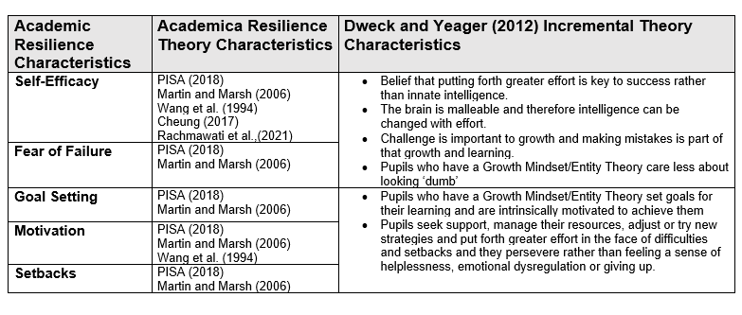
Figure 1Synthesis of Academic Resilience and Incremental Theory Characteristics

Indeed, Dweck and Blackwell (2007) founded Brainology which is a blended learning curriculum which supports pupils in developing a ‘Growth Mindset’ (Incremental Theory) through understanding that intelligence is not fixed and can be developed with effort. Within this programme, the five key characteristics are targeted and developed in addition to supporting pupil’s neuroscientific understanding in relation to brain malleability through age-appropriate activities.

3.1.5 Incremental Theory Programme
Yeager and Walton (2011) explain that Incremental Theory interventions are effective because they teach pupils how a Growth Mindset affects them in specific contexts and are delivered in a way that supports pupils in quickly internalising this. The researchers emphasise that Incremental Theory interventions require the retention of these two features. They add that to do this, these interventions require customisation for the specific pupils. They further emphasise that whilst neuroscientific information facilitates the incremental theory effect, just teaching pupils about the brain structure and its potential to change may lose sight of the required development of academic resilience.
Therefore, the principles of Brainology, which target the development of the five characteristics, are customised within an Incremental Theory intervention (Appendix A) and used to develop academic resilience in an age-appropriate delivery.
Figure 2 Incremental Theory Intervention Lesson Topic and Objectives
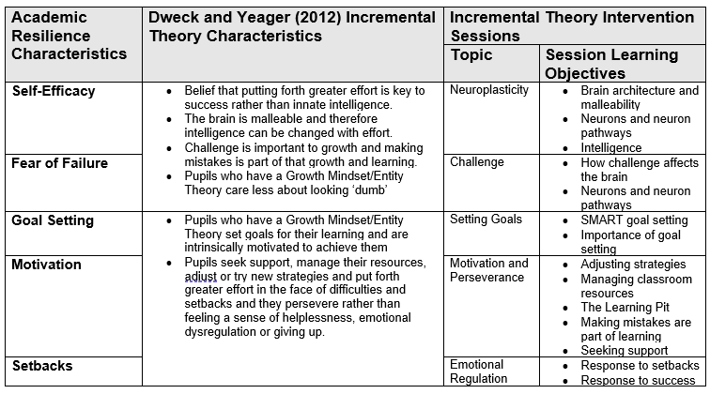

3.1.6 Academic Resilience Measures
Despite recent research interest in academic resilience in relation to incremental theory in education, there is a lack of valid and reliable measures for certain age groups and for incremental theory interventions. Indeed, Yilmaz (2021) claims that the ‘lack of a comprehensive measurement tool that measures the Mindset Theory in a valid and reliable way is considered as a major gap in the field’ (p. ). Similarly, Rammstedt et al, (2022) explain that given the attention growth mindset has received and the vast body of academic and theoretical research, there is an assumption that this would be based on reliable and validated growth mindset scales. However, there are two established scales which measure growth mindset: a six- to eight-item scale (Dweck, 1999) and a three-item scale (Dweck et al., 1995).
Rudd et al (2021) conducted a systematic literature review of 127 studies to explore the approaches to measurement and analysis of quantitative academic resilience research over the past 20 years. The researchers found that whilst there is a ‘consensus as to the definition and broad conceptualisation of academic resilience, there is no standard approach to its measurement’. Tudor and Spray (2018) add that the variability of these approaches makes estimating the occurrence of academic resilience and evaluating the effectiveness of its protective characteristics difficult. Rudd et al (2021) concluded that researchers have found it difficult to evaluate academic resilience due to its dynamic nature and multiple factors (risk and competence). Researchers must decide how to combine academic resilience's components into a single variable or statistical model in quantitative investigations. The researchers argue that these decisions are to me made by the researcher. Furthermore, they state that how academic resilience is operationalised determines how resilient and non-resilient pupils are identified.
As a result, the theoretical frame which synthesises the academic resilience characteristics found in literature with Dweck and Yeager’s (2012) Incremental Theory characteristics are applied and combined to create quantitative and qualitative questions which reflect the characteristics synthesised within the theoretical frame.
Figure 3 Synthesis of Academic Resilience Characteristics and Responding Questionnaire Statements
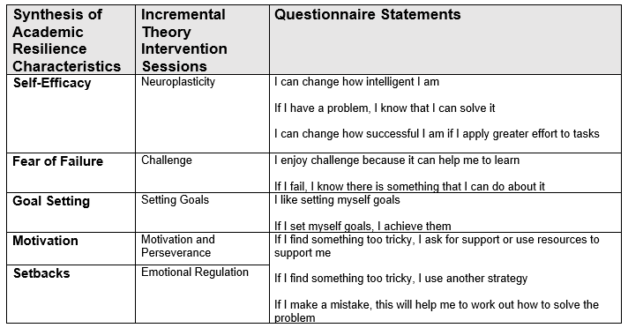
Figure 4 Synthesis of Academic Resilience Characteristics and Responding Interview Questions
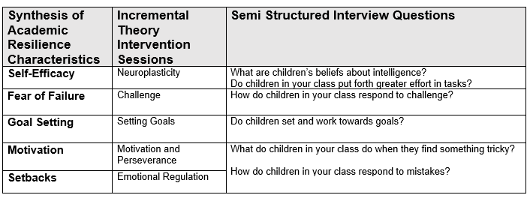

3.2 Methodology

The methodology of this research is selected as the most appropriate for responding to the research questions. This is the Positivist ontology of a single reality and the interpretivist ontology that reality and truth are interpreted. Consequently, this will result in quantitative and qualitative research. That is the first research question examines the ‘extent’ to which an intervention ‘impacts’ learners’ academic resilience which draws on a positivist paradigm and the second research question explores how practitioners ‘perceive’ impact which draws on an interpretivist paradigm. The mixing of these two paradigms to respond to a research question relies on the use of a mixed method design which is justified within a pragmatic paradigm as a guiding philosophy.

3.2.1 Equal Status Mixed Methods
The common view of mixed methods research is that it is either viewed as qualitatively or quantitatively driven which depends on the dominance of within the research. However, Johnson, Onwuegbuzie, and Turner (2007) point to a third view where the components of the research are equally dominant referred to as equal status mixed methods research. This is consistent with Deweyan pragmatism. As Wyse et al (2016) explain, Dewey rejected the either-or dualism of logic and asserted that truth and logic are discoverable at both ends of those dualisms. As this research relies on equally dominant quantifiable and qualifiable research to solving the research problem, an equal status pragmatic mixed methods is used within this research.
As this research intends on implementing an intervention and determining its impact within one setting this is aligned to Action Research. Furthermore, there is an alignment between action research and Deweyan Pragmatism in that Dewey’s Theory of Inquiry refers to the spiralling of the knowledge-action processes which can be facilitated by action research. In addition, Creswell (2014) states that the defining feature of action research is that the researcher is involved in the phenomena under study and this is aligned to Dewey’s belief that knowing and doing are not separate (Morgan, 2013).
Felizer (2010) explains that this design facilitates knowledge construction to inform change. Indeed, action research is concerned with discovering the most effective interventions which impact individuals and groups (Kaushik and Walsh, 2019). Ivankova and Wingo (2018) add that the premise of this design is to use interventions in research cycles of developing, implementing and evaluating for improvements in practice. The research uses the integration of both positivist and interpretivist paradigms to respond to the research question most effectively and this has resulted in an action research design situated within a mixed methods approach. Furthermore, the type of action research most aligned to this research is convergent parallel mixed method. Creswell (2014) states that this is collecting quantitative and qualitative data simultaneously within a single study to gain a deeper understanding to the research issue. Since neither are dominant, this is as Johnson, Onwuegbuzie, and Turner (2007) refer to as equal status mixed methods research. This is justified by mixed methods as it enables methods to be independent of one another yet operating alongside and compensating their strengths and limitations. Indeed, Felizer (2010) argues that it is this counterbalancing that makes the between methods triangulation most effective in reducing biases.

3.2.2 Insider Action Research
The type of action research used in the study has been identified as Insider Action Research. Coghlan and Brydon-Miller (2014) explain that this refers to practitioners who conduct action research within their own context. The strengths of this are that practitioners have inside knowledge of the setting and thus understand its culture and networks. On the one hand, the professional relationships that exist within the context means that there is an increased likelihood of the participants trusting and collaborating with the research. Yet on the other, this can cause difficulty in detaching from the setting to ensure objectivity in the research. Moreover, whilst the conducting the research in one setting provides specific evaluation and action for improvement this does decrease the external validity of the research for generalising to other contexts.
Pragmatism asserts that the identification of research questions is carried out before the identification of the methods used. Indeed, in this study the research questions address the research problem, and the data collection methods are selected based on their suitability for answering the research questions. This has resulted mixed methods used within an action research design. Moseholm and Fetters (2017) assert that mixed methods and action research both share a pragmatic philosophy since they acknowledge and promote the integration of positivist and interpretivist assumptions to increase knowledge of phenomena.

3.2.3 Research Question 1
Punch (2009) argues that all too much method selection is put ahead of research questions and states that the working of the questions themselves identifies the methodology. Indeed, Mills (2011) and Ivankova and wingo (2018) argue that action research usually deploys qualitative methods however they note that the research questions themselves may implicate both qualitative and quantitative methods, particularly when qualitative data explains the quantitative. The first research question seeks to explain the ‘extent’ that the growth mindset ‘intervention’ and this wording as implicates a quantitative data collection process (Cohen et al. 1011).
The intervention is a programme developed by the researcher through customisation of Brainology in relation to the synthesis of Dweck and Yeager’s (2012) Incremental Theory characteristics and the five academic characteristics identified in the literature (figure 2), which are specific to the pupils within the school (Yeager and Walton, 2011). The intervention is delivered over 5 lessons (Appendix A) in one academic term to KS2 pupils in Years 5 and 6 by their normal class teachers.

3.2.3.1 Research Question 1 Sampling
Since the research question intends to determine the extent that an intervention has impacted on a specific set of pupils, the sampling strategy adopted for this research is non-probability purposive sampling. That is, pupils are selected based on their purpose for the research. As Flick (2018) puts it, participants are selected based on a set of criteria. The research participant criteria are KS2 pupils in a specific school in Wales. Therefore, the sample is based on characteristics defined by the aim and relevance to the research (Obilor, 2023).

3.2.3.2 Research Question 1 Data Collection Methods
In response to this question this research will administer a self-report 6-point 20-item Likert-Scale questionnaire to measure baseline academic resilience and post intervention in a repeated measure process.
The questionnaire will use questions developed from the synthesis of academic resilience and Dweck and Yeager’s (2012) Incremental Theory characteristics (figure 2) on an ordinal Likert-scale (Appendix ) and adaptation and expansion of the two existing Incremental Theory Likert-scale measures(Dweck et al., 1995; Dweck, 1999). The questionnaire includes 10 positive statements which reflect an academically resilient pupil and 10 negative statements which correspond to the positive statements. The Likert-scale questionnaire is selected as it is relatively simple to generate and can be adapted to ensure that it is child friendly. Additionally, statements will be clearly defined and phrased appropriate to the ages and abilities of the learners. To mitigate central tendency bias (Cohen et al. 2011) the scale will include an even number of intervals. Bishop and Heron (2015) advise that learners’ interpretations may differ when considering the statements themselves and the distance between the interval distance. Felizer (2010) warns that using researcher constructed questionnaires instead of pre-existing and reliable instruments can decrease the research’s reliability and validity. In addition, Gray (2018) warns that this type of data collection tool is unhelpful in facilitating collaboration required in solution seeking within action research. However, Gray (2018) does add that it is valid if it provides data that could not be discovered by using alternative methods.

3.2.3.3. Research Question 1 Data Analysis
Cohen et al. (2011) explain that Likert-scales are non-parametric as they often have no previous comparable statistics for analysis. As such, Sullivan and Artino (2013) pose the question as to whether such data, converted to statistics can be managed as parametric-defined interval data. However, this research will use repeated measures in which the questionnaire is administered pre and post intervention. Consequently, a Paired Sample t-Test will be carried out with the use of linear numeric codes so that the 6-points are translated into equal intervals numerically in increments of 1 (1-6). The questionnaire responses ranging from Strongly Disagree to Strongly Agree are coded 1-6 for positive statements and reverse coded 6-1 for negative statements (Appendix B). Participants are given a participant code so that the pre and post-test questionnaire can be analysed. An academic resilience score is generated from the total points on the pre and post-test questionnaire for each participant. The Paired Sample t-test academic resilience scores will be analysed using SPSS to determine the extent of the impact of the intervention effect size (Cohen’s d). In addition, the questionnaire statements and the corresponding academic resilience characteristic will be analysed individually to determine the impact of the intervention on the specific academic resilience characteristic using pre and post test mean average scores. SPSS is selected as it is relatively easy to use, widely available and used in education research. Most importantly it includes the functions required to carry out appropriate data analysis (Muijs, 2011)

3.2.4 Research Question 2
The second research question aims to explore the practitioners ‘perceptions’ of impact of the intervention. As this question explores perceptions, it carries the methodological implication of generating qualitative data. The first question sought to determine if there was an impact on the learners’ academic resilience, whereas the second asks if then, how?
Post intervention, the teachers will be carrying out their usual daily lessons with pupils. Teachers will be interviewed to find out their perceptions of pupils’ academic resilience across the five characteristics.

3.2.4.1 Research Question 2 Sampling
This research question is concerned with exploring the perceptions of the school’s Year 5 and Year 6 teachers. Consequently, a non-probability purposive sampling method will be applied (Flick, 2018; Obilor, 2023). The criteria determines that participants should be the Year 5 and 6 class teachers since they will be carrying out daily lessons post-intervention.

3.2.4.2 Research Question 2 Data Collection Methods
In responding to this question, this research will use semi-structured interviews (Appendix C) to seek to understand the meaning that individual’s assign to their lived experience (Felizer, 2010). Cohen et al. (2011) summarise the purposes of interviewing which is mirrored in this research. That is, interviews seek multiple interpretations of a single phenomenon; determine variable within the research and understand their relationship; and provide triangulation when used with other methods.
Interviews are conducted with teachers rather than learners as they are involved with delivering the intervention and are likely to have the professional and contextual understanding of the impact on across the five characteristics. The semi-structured interview uses the synthesis of academic resilience characteristics (Figure 3) as used within the questionnaire. A semi-structured interview is selected over an unstructured or structured interview as it triangulates the quantitative ‘if’ data but provides opportunities for extended responses to understand the ‘whys and how’s’ (Gray, 2018).
Gray (2018) explains that the techniques and way in which the interview is conducted can strengthen validity. This includes, building rapport and trust between the researcher and participant and giving appropriate time for the interview as to not limit the participants’ responses nor burden them. Flick (2018) adds that internal validity is strengthened by providing the opportunity for the participant to read through the transcription, to add or remove responses and to clarify meaning and understanding. Conversely, as the interviews will be conducted with a small sample and in one setting, this will weaken the external validity of the results as they will not be easily generalised.

3.2.4.3. Research Question 2 Data Analysis
The data generated from the interviews will be analysed using thematic analysis. This is pattern and theme identification within qualitative data (Flick, 2018). Thematic analysis is selected over content analysis as whilst the latter provides data about direct participant perceptions, thematic analysis enables the interpretation of teachers meaning (Braun and Clarke, 2006). The literature provides the theoretical frame used to code predetermined themes in analysis of the data. Braun et al. (2006) warn that this type of analysis can limit language usage claims. Nevertheless, they maintain that it facilitates the comparability of multiple participant perspectives. Indeed, Nowell et al. (2017) claim that whilst thematic analysis can bring about inconsistencies it does allow for flexibility and adaptation without impeding the rich, detailed qualitative data.
Braun and Clarke’s (2006) six-step thematic analysis will be conducted using NVIVO software. This will include reading the transcripts, becoming familiar with the data and open coding the data in relation to its relevance to the predefined themes which will guide the analysis (synthesis of academic resilience characteristics). Thereafter, themes will be identified and reviewed and refined and written up.

3.2.6 Ethical Considerations
The British Educational Research Association (2018) Code of Practice and UWTSD Research Ethics and Integrity Code of Practice identifies the ethical principles required for conducting research. In addition, the UWTSD Research Data Management Policy (2022) which includes obligations under the UK Data Protection Act (2018) guide the collecting and storing of data. Consequently, throughout the research process the codes of practices and policies will be adhered to.

3.2.6.1 Consent
Before conducting the investigation, all participants will be asked for their informed consent (Appendix D). Participants will be informed of the research's purpose, aims, and objectives, as well as where and how their data will be stored and for how long. Participants will be informed of their right to withdraw from the research at any time without experiencing any negative consequences. This information will be provided both in written and verbal form. Participants will be given the opportunity to ask any questions and make an informed decision regarding their participation in the research. In addition to parental consent, all pupil's assent will be sought (UWTSD Code of Integrity and Ethics, 2022). This will be obtained through the use of a child-friendly checklist with the options yes and no. No images (such as emojis) will be used to ensure that children feel secure and comfortable saying both yes and no. To avoid pupils feeling obligated to participate as they are being asked by a professional within their context or colleagues feeling obliged to take part, all participants will be reminded that not participating in the research will not result in any negative repercussions (BERA, 2018). If pupils choose not to participate, they will be given an appropriate Growth Mindset activity, that they would normally do as part of their daily learning, to complete while other participants complete their questionnaires. Furthermore, it will be made clear throughout the research process that participants can withdraw from or resume the research at any time. This will be provided via consent forms, an information sheet, and debriefing. During the debriefing, the researcher will reiterate the aims of the study and provide opportunities for further questions.

3.2.6.2 Power Relations/Risks
As a member of staff, the researcher must ensure that the pupil’s see them as a researcher rather than their teacher. To this end, all pupil’s will be explicitly told that the research is conducted separately from the school and they can choose to participate or not participate, withdraw from the research and that there is no positive or negative consequence as a result (BERA, 2018).
In interviewing the teacher participants, the interview questions pertain to teacher's perceptions of pupil's academic resilience rather than the teacher's own practice or delivery of the intervention. As they will be involved in its implementation, teachers will be familiar with the intervention. This should therefore reduce the likelihood that the interview will cause anxiety or emotional distress. The interview questions will not be of a sensitive nature, and teachers will be reassured that there is no correct response, that they can clarify the meaning of the questions and omit their response at any time if they so choose. They will also have the opportunity to review the interview notes should they desire to modify or clarify the information (BERA, 2018)

3.2.6.3 Confidentiality and anonymity
BERA (2018) states that ‘The confidential and anonymous treatment of participants’ data is considered the norm for the conduct of research’ (p.1). As such, the research will be carried out under this normal conduct of research. This will include ensuring that participants are aware of confidentiality and anonymity within the research through written and verbal information and as part of the consent forms. In addition, the research will adhere to the UWTSD Data Management Policy (2022) and BERA (2018) guidelines when storing participants data. The list of participants which are assigned numerical codes and their corresponding data will be stored on a password encrypted file and the analysis of the data and interview notes will be stored on the researcher’s University storage cloud. In disseminating the results, no data will be shared that will enable the identification of the participants within the research which would breach to agreed anonymity and confidentiality (BERA, 2018).

Chapter 4- Findings/Data Analysis (2500/3067)

4.1 Research Question 1
To what extent do Incremental Theory interventions impact on UKS2 pupils’ academic resilience? As the method of data collection generate quantitative data, a hypothesis and null hypothesis are used to guide data analysis. The data analysis will serve to support or not support the hypothesis.
$H_{0}$ There is no statistically significant difference between pre and post intervention academic resilience scores.
$H_{1}$ There is a statistically significant difference between pre and post intervention academic resilience scores.

4.1.1 Sample
The sample consisted of 50 UKS2 pupils across 2 classes. Year 5 is made up of 27 pupils (9-10 years old) and Year 6 is made up of 23 pupils (10-11 years old). Of the 50 pupils, 40 parental consent forms were returned, and all participants provided assent. Of the 40 pupils who provided consent and assent, two of the 40 pupil’s data was removed from the research due to being absent on the pre test questionnaire. The paired questionnaire data included in this research is n=38.

4.1.2 Intervention
The Brainology programme was customised to focus on the synthesised five academic resilience characteristics (Figure2) and resulted in a five-session intervention (Appendix A). The intervention was carried out with Year 5 and 6 pupils and delivered by their normal class teachers.

4.1.3 Data Analysis
The data collection tool (questionnaire) generated pre and post-test academic resilience scores which were imputed and analysed using SPSS software. In supporting or rejecting the hypothesis, $α$ (level of significance) will be $α=0.05$as if $α ≥0.05$we can assume that the two scores are statistically different (Cohen et al. 2011 ; Gray, 2018).

4.1.4 Paired t-Test Findings
Pre and post intervention questionnaire academic resilience scores were inputted into SPPS software, and a Paired Sample T-Test was run to analyse the data. This generated the mean of both pairs with standard deviation (SD), the correlation (r) of the pre intervention and post intervention scores, the two-sided p value of significance and Cohen’s d effect size.
Figure 5 t-Test Academic Resilience Scores
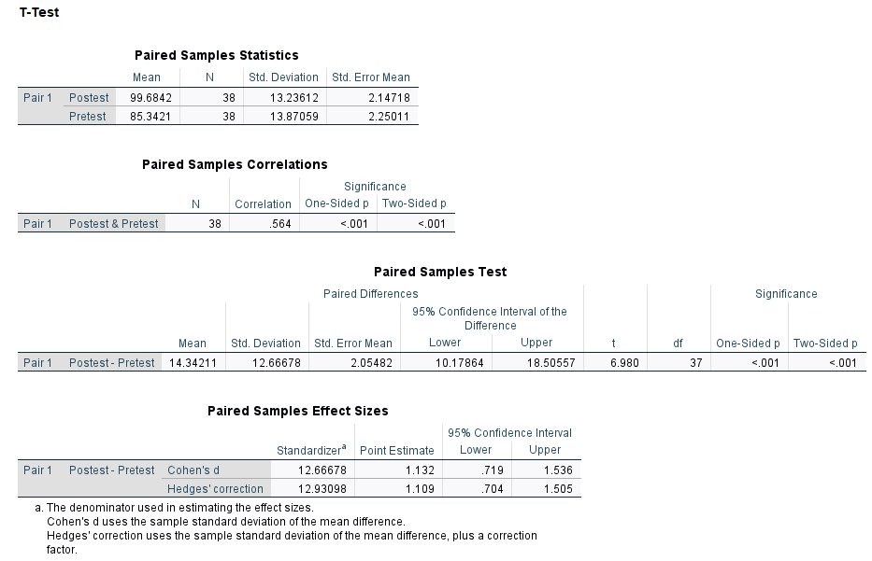
The paired samples t-Test showed that the pupil’s academic resilience had increased post intervention from (M = 85.3421, SD = 13.87059) to post intervention (M = 99.6842, SD = 13.23612; t = 6.980, p < .001, d = 37). As the p value is less than 0.05 at p < .001 , it can be said that the pre test scores are statistically significantly different from the post test scores. This supports the alternative hypothesis $H_{1}$: There is a statistically significant difference between pre and post intervention academic resilience scores and does not support the null hypothesis $H_{0}$: There is no statistically significant difference between pre and post intervention academic resilience scores.
This parametric statistical test was conducted using questionnaire ordinal statements i.e. Strongly Agree to Strongly Disagree assigned with scale measurements e.g. Strongly Agree=1. However, Davies (2022) states that ordinal statements are best analysed using non-parametric means. Consequently, ordinal data was inputted into SPSS and the Wilcoxon Signed Rank Test was used to determine the pre and post test scores were statistically different.
Figure 6 Wilcoxon Signed Rank Test Pre and Post Test Academic Resilience Scores
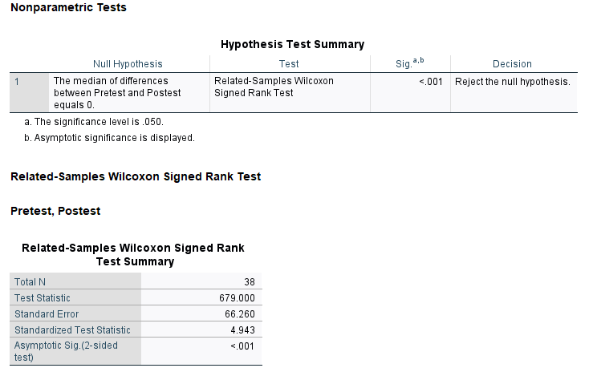
As the p value (Asymptotic sig.) is < .001 and therefore below the significance level of 0.05 in this Wilcoxon Signed Rank Test, the decision is to ‘Reject the null hypothesis’, the null hypothesis of this research is not supported. Both the non-parametric Wilcoxon Signed Rank Test and the parametric Paired t-Test analysis have generated p < .001 with a significance level of $α ≥0.05$, the pre and post-test data is statistically significantly different.
This address part of research question 1, which is to determine whether Incremental Theory interventions ‘impact’ UKS2 pupil’s academic resilience. To what extent do Incremental Theory interventions impact on UKS2 pupils’ academic resilience. The second part of research question 1 asks ‘To what extent’. Cohen et al. (2011) explain that this cannot be determined by statistical significance (p). Indeed, the authors maintain that p by itself has come to be regarded as an unsuitable indicator of effect because it is dependent on sample size and correlation. Either a large correlation and a small sample size, or a small correlation and a large sample size, can produce statistically significant differences. The problem is that it cannot determine which effect is decisive from a statistically significant study. The importance is to determine whether the difference is due to the sample size or the correlation. The effect size is able to accomplish this as it is a simplistic approach to determining the quantifiable difference between the two tests. Consequently, it can report on the effect size (Cohen’s d.) which statistical difference (p) does not. According to Cohen’s d. an effect size can lie between 0-1 (Cohen et al. 2011).

Figure 7 Cohen's d Effect Sizes (adapted from Cohen et al. 2011)
Effect Size (d.) | Rating
- - 0.20 | Weak Effect
0.21- 0.50 | Modest Effect
0.51- 1.00 | Moderate Effect
$$>1.00$$ | Strong Effect
In figure 5 the effect size for the Paired t-Test for pre and post test academic resilience scores was d 1.132. According to Cohen’s d, the effect of the Incremental Theory intervention is strong d >1.00.

4.1.5 Academic Resilience Characteristics Paired t-Test Findings
The questionnaire statements were divided into the academic resilience characteristics and were assigned scale measures to determine the pre and post test scores of the pupil’s academic resilience scores within the individual characteristics.
Figure 8 Paired Sample t-Test Academic Resilience Characteristics Pre and Post Test Scores
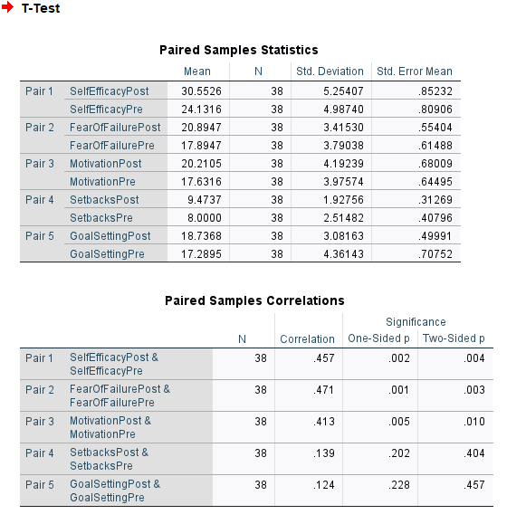
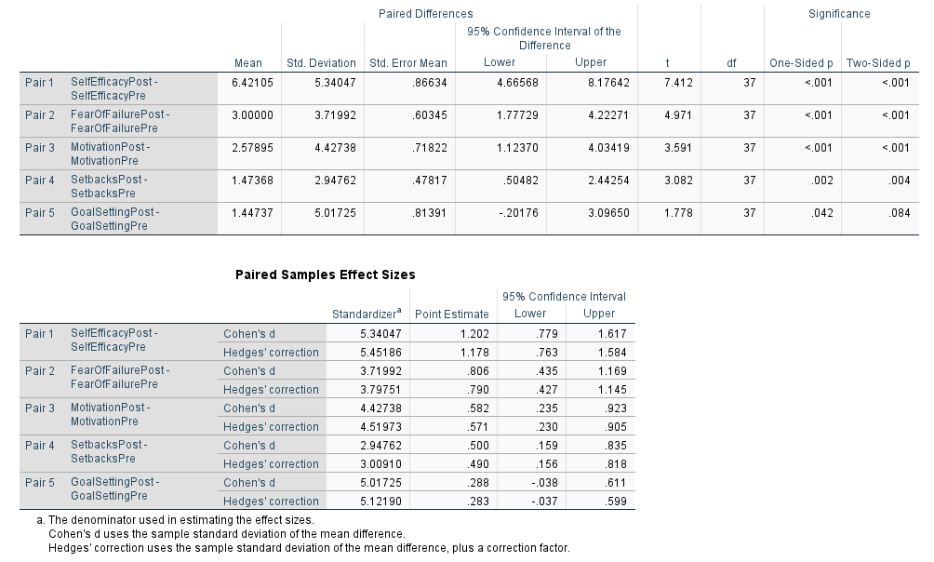
The paired samples t-Test showed that across the five academic resilience characteristics, the pupil’s mean academic resilience scores had increased post test. The p values of four of the post academic resilience characteristics show that there is a statistically significant different from the pre test as $α ≥0.05$ (Self Efficacy, Fear of Failure and Motivation = p < .001 and Setbacks = p 0.004). However, the p value of Setting Goals is p 0.84 is $α <0.05$ demonstrating that it is not statistically significantly different from the pre test score. The individual academic resilience characteristic effect sizes ranged from d = 0.288 and 1.202.
Figure 9 Pre and Post Test Academic Resilience Characteristic Scores

In figure 7 the strength of the effect size for the Paired t-Test for pre and post test was reported (Cohen et al.2011). The graph (figure 9) demonstrates that according to these effect sizes (Cohen’s d), Self-Efficacy = d.1.202 is therefore considered a strong effect size; Fear of Failure = d. 0.806 and Motivation d= 0.583 are considered moderate effect sizes; whilst Setbacks d= 0.5 and Goal Setting d= 0.288 are considered a modest effect size.

4.2 Research Question 2
What extent do UKS2 Teachers perceive that Incremental Theory interventions impact on UKS2 pupils’ academic resilience?

4.2.1 Sample/Intervention/Data Collection
The participants were the Year 5 and Year 6 Class teachers who delivered the intervention within their daily classroom teaching and learning over five sessions in one academic term. The teachers were asked about their perceptions of the extent to which the Incremental Theory Intervention had impacted on UKS2 Pupil’s academic resilience. The semi-structured interview (Appendix C) included questions which corresponded with the five academic resilience characteristics (figure 4). Within this research they are referred to as Participant A (PA) and Participant B (PB).

4.2.2 Data Analysis
The interview data was recorded and transcribed using Microsoft Teams and imported to NVIVO software. The data was analysed using the Six-Step Thematic Analysis (Braun and Clarke, 2006). In step 1, familiarisation with the data included listening to the audio recordings, checking the transcriptions and rereading the transcriptions. Conducting step 2 included reading through the transcriptions and generating initial codes by working through the data and ‘attending to each data item with equal consideration and identifying aspects of data items that are interesting and may be informative in developing themes’ (Byrne, p. 8). This generated 18 initial codes.
Figure 10 Initial Codes NVIVO
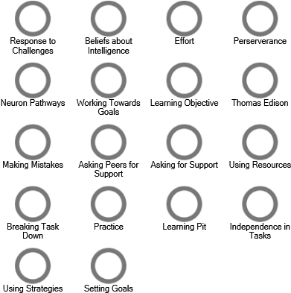
Byrne (2022) explains that a data driven, inductive approach generates codes that are seen with the data whilst theory-driven approach may generate codes based on a pre-defined theoretical framework identified. However, the author adds that coding and analysis usually includes a combined method. Indeed, despite the theoretical frame (Synthesis of academic resilience characteristics) guiding the initial coding, the data itself was not coded to these predefined themes in step 2 and was grouped under the five academic resilience characteristics after the data had been coded in step 3. This was carried out by reviewing and analysing the initial codes and grouping the codes according to their themes.
Figure 11 Academic Resilience Themes NVIVO
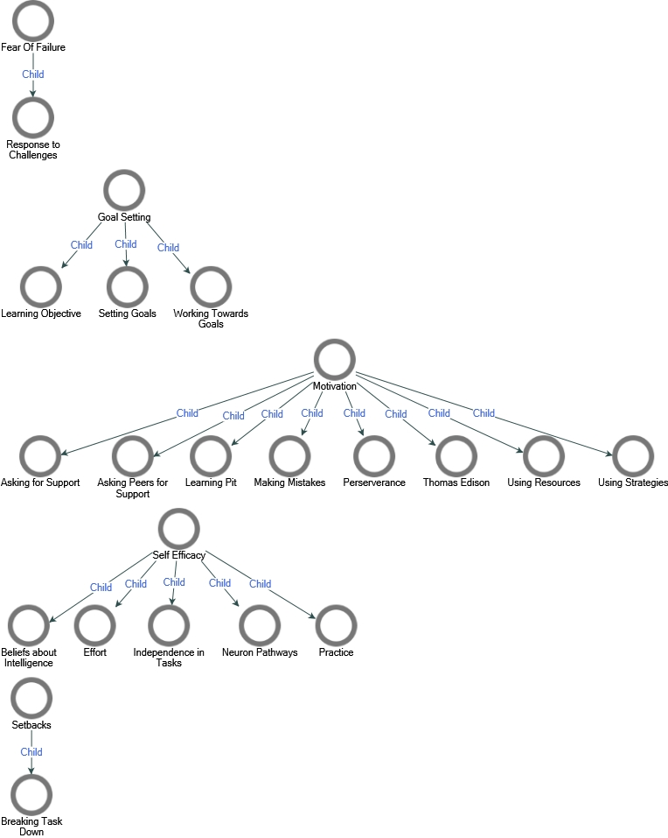
In step 4, Braun and Clarke (2006) advise that researchers revise their themes with the view of best answering the research question. As the themes set out in step 2, that is the five academic resilience characteristics when combined make up academic resilience, the themes were not revised as to best answer the research question ‘do incremental theory interventions impact on UKS2 pupil’s academic resilience. However, codes that were selected under Setbacks were relevant to that of Motivation. As a result, these themes were combined in revision.

Figure 12 Step 4 Revision of Themes
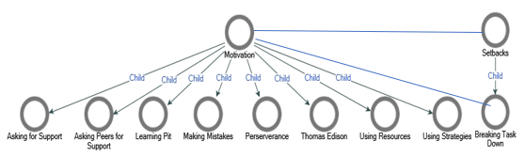
This was also the case for step 5 which advises that researchers rename and revise their themes to ensure that they are reflective of the coded content. As the themes were defined based on the five academic resilience characteristics and named as throughout this research, the themes remained the same.

4.2.2.3 Braun & Clarke (2006) Step 6 Write Report
The sixth step is writing up the data analysis which includes discussion of the codes within the themes and extracts from the data that evidence the appropriateness of the codes generated and the themes in which they sit.
Self-Efficacy
The teachers (PA & PB) both discussed how children’s beliefs about their intelligence had changed post intervention. There was discussion about how the pupil’s viewed themselves within their classroom i.e., lower, middle, and higher ability despite this never being communicated to the pupils. However, since the intervention pupils have made reference to working harder so that they could switch groups and have more challenging work. One of the teachers explained that this was most noticeable amongst ‘lower’ and ‘higher’ ability pupils, with ‘lower’ ability pupils realising that scientifically, the brain is malleable and therefore can changes and ‘higher’ ability pushing themselves in tasks despite being ‘good’ at the task in question. Both teachers discussed how they are referring to their learning as practising to make things easier. An example of this is that pupils are discussing the growth of their neuron pathways which will make them smarter and reference this post tasks during self-assessment and evaluation.
Teachers have noticed post intervention that pupils are applying greater effort in their tasks and across the curriculum particularly for those pupils who would seek support throughout the task becoming more independent. As PB stated:
I think it's been more noticeable that some of the children that almost constantly ask for help and support with each step along the way have been more independent. They're trying more on their own before they come into the point of needing to ask for help.

Fear of Failure
When challenging themselves, both teachers agreed that they view challenges as a way to ‘getting smarter’ and that without challenge or find something appropriately challenging, no real learning takes place. PA stated that the pupils now ‘relished challenge’ and ‘they love it when something's tricky because they know that they've challenged themselves’ and PB stated that ‘Some of them thrive on it and their faces light up, especially if it's a maths challenge, and they dive straight in’. However, the teachers did mention that whilst some pupils are now excited by challenge, there are a ‘few who need an awful lot of support in order to respond to challenges. That said, it was added by one of the teachers that there ‘others who have a look of fear and are hesitant but then actually do tackle it.
In answering several of the questions, both teachers continually referred to ‘The Learning Pit’ which was introduced in the intervention as a visual to explain learning, how challenges can bring about meaningful learning, and the strategies and resources that could be used to ‘get out’ of the learning pit. The teachers explained that the pupils ‘really enjoyed’ the Learning Pit and explained that it provided a ‘good visual for the children’. The pupils refer to the Learning Pit throughout their learning and this is seen by the teachers as improving metacognition and supporting them in understanding that challenge is a part of learning. Examples of this are seen in evaluating their learning, PA talked about how pupils had stated they were in the Learning Pit and evaluated the strategies and support they had to ‘get them out’.
When they find something tricky rather than thinking I can't do it, with some of them, they used to kind of shut down. We wouldn't get anything out of them because they found it too challenging. They couldn't see how they would get themselves out of it. They generally now see that as a positive. Now if something's challenging and tricky, they don't see as a negative anymore. They just realised it in the learning pit. (PA)

Motivation/Setbacks
One of the teachers reported on the impact on pupils’ motivation and commented that they saw one pupil a far greater effort and motivation to complete tasks. The pupil had recently joined the school (4 weeks previously) and had ‘little motivation with tasks’ and the difference ‘within him has been quite astonishing’.
The teachers reported that it has been noticeable that pupils are using additional strategies when finding tasks tricky. They refer to asking the teacher and their peers for support, using resources and different strategies. One of the teachers stated that there are a ‘few’ who seek support with the teacher but that it’s been noticeable that there are ‘quite a few’ asking their peers before asking the teacher for support.

It has been noticeable they're asking each other more for help as well and comparing and asking questions (PB)
Whilst the other stated that in reflection of their learning:
…they say I was in the learning pit, but I used my friend to help me, someone on another table to help me (PA)
However, one of the teachers explained that ‘there are still some who sit and wait for me to notice that they stuck and go over’.
Both teachers refer to a positive change in the way the pupils now use classroom resources. Indeed, one of the teachers found that the pupils in her class had come to realise the different ways they can support themselves during tricky tasks and that it is a part of learning to use them for tasks. The teacher felt that these were not previously utilised effectively but listing the ways in which they could support within the intervention enabled them to be more proactive in supporting themselves post intervention. This teacher then explained that in reflection of their learning, pupils were able to explain the different ways they had supported themselves
I used the strategy books in the classroom to help me. I use the work on the whiteboard to help me. I use the resources on the Google Classroom to help me. (PA)

Similarly, the other teacher stated that there have been ‘a couple who actually get up and go get things, if they haven’t got them, they get them’. The examples of this were maths resources e.g., 100 square. Likewise, both teachers saw a difference in how pupils were using alternative strategies. One of the teachers discussed how ‘some’ pupils were sitting and thinking about their work for longer and trying different strategies on scrap paper and whiteboards.
Both teachers were positive about the impact the intervention had on pupil’s understanding of mistakes and responses to mistakes. The teachers reported a shift in pupils’ understanding, that ‘it’s not about getting it right first time’, that it’s ‘okay to make a mistake’, that there are ‘little steps along the way’ and they ‘know now it’s part of the journey’. The teachers did add that there is ‘still some’ that do not like making mistakes and this leads to the pupils feeling frustrated.
Within the intervention, the pupils learned about Thomas Edison’s development of the lightbulb. In this, it was reported that Edison has made 999 mistakes before finally creating the lightbulb on the 1000 attempt. It is evident within the data that this had impacted on the UKS2 pupils, with the teachers referring to this part of the intervention several times across several questions. In one example, one of the teachers talked about a pupil who had not managed to complete her challenge. When asked the pupil stated that she would be like Thomas Edison and persevere. When returning with a successfully completed challenge, the pupil said that ‘at least it didn't take me 1000 steps’. Furthermore, PA stated that:
We know that he [Thomas Edison] had to make 999 mistakes in order for him to achieve what he wanted. So, they just know now that mistakes are not a bad thing and not a negative thing. It just means that they're doing something that is challenging them, and mistakes are part of the process

Goal Setting
Within the data analysis process, there were less codes relating to the theme of Goal Setting. In discussion with the teachers about if the intervention had impacted on Goal Setting, both teachers talked about how the pupils were setting goals but there were disparities about who was goal setting, how much support they had in goal setting and whether it was done on an individual or whole class basis. PB discussed how the pupils use their learning objective as a goal which guides their learning. They also discussed one pupil who had reflected on his learning and referred to his goal within the task ‘he hadn't managed to achieve the goal of fully, he could see that he'd made his way towards it and he said I'm really pleased I've managed to do part of it rather than achieve the whole thing’. PA stated that pupils in her class were ‘all setting themselves their own goals, and this is done automatically in their work’ and after completing tasks were able to identify their next goal and how they were going to achieve it.

Chapter 5- Discussion (1500)

Answering the question using the analysis and literature and giving a negative for each bit

5.1 Research Question 1

5.2 Research Question 2

5.3 Overall Research Question

Notes
Teachers were teaching their own classes so if the intervention worked they would look good if it didn’t they wouldn’t.
Somewhere it talks about the effect size when its done straight after an intervention-its usually higher.

Cohen et al. 2011- Some things that can affect effect size are ‘Restricted Range: the smaller th ranf

Chapter 6- Recommendations (300)

Action research- would go again with the setting goals because it had the lowest effect size and also was less talked about in the interviews
Need to redo the negative things that were said in the interviews- looking for support

References

Appendices

Appendix A: Five Intervention Lessons and Examples


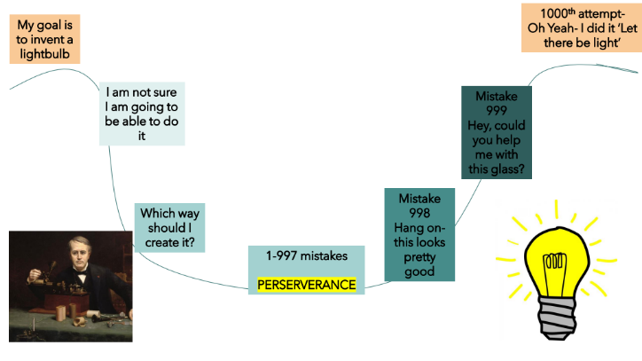
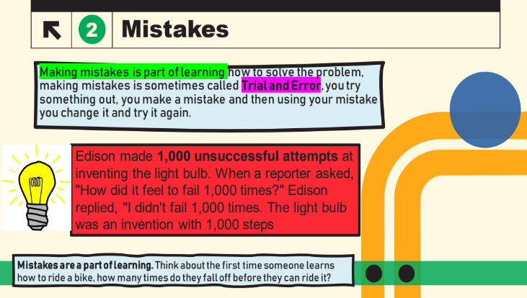
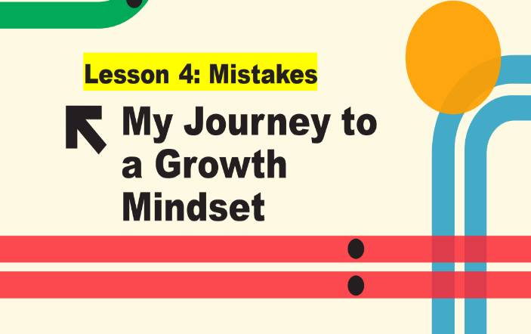
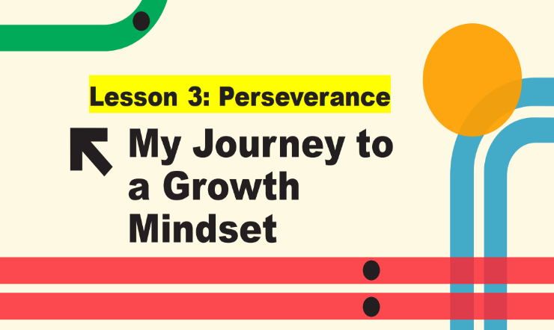
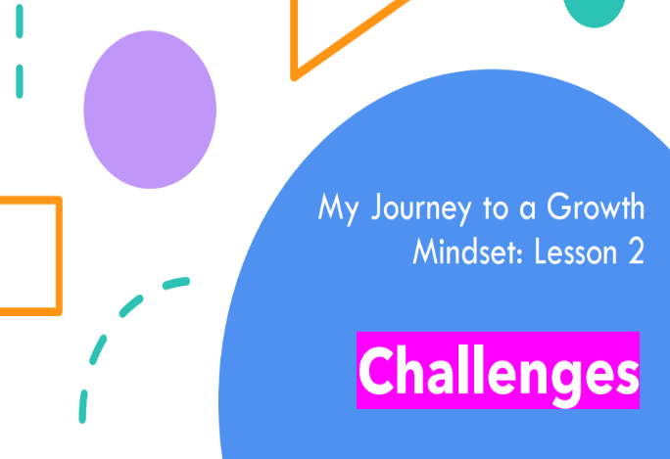


Appendix B: Questionnaire
Questionnaire
This questionnaire should take around 10 minutes. If you need any help to read these questions or if you are unsure of the meaning check with the teacher present. If you have any questions, please ask. Please tick your answer in one box. Remember there are no right or wrong answers and your results will be anonymous. Thank you

 | Question | Strongly Disagree | Disagree | Slightly disagree | Slightly agree | Agree | Strongly Agree
1 | I have a certain amount of intelligence, and I can’t really do much to change it. | Strongly Disagree | Disagree | Slightly disagree | Slightly agree | Agree | Strongly Agree
2 | I can change how intelligent I am | Strongly Disagree | Disagree | Slightly disagree | Slightly agree | Agree | Strongly Agree
3 | If I have a problem, I know that I can solve it | Strongly Disagree | Disagree | Slightly disagree | Slightly agree | Agree | Strongly Agree
4 | If I have a problem, I don’t know if I can solve it | Strongly Disagree | Disagree | Slightly disagree | Slightly agree | Agree | Strongly Agree
5 | Even if I apply greater effort, I can’t change how successful I am | Strongly Disagree | Disagree | Slightly disagree | Slightly agree | Agree | Strongly Agree
6 | I can change how successful I am if I apply greater effort to tasks | Strongly Disagree | Disagree | Slightly disagree | Slightly agree | Agree | Strongly Agree
7 | I enjoy challenge because it can help me to learn more | Strongly Disagree | Disagree | Slightly disagree | Slightly agree | Agree | Strongly Agree
8 | I don’t enjoy challenge because I may fail | Strongly Disagree | Disagree | Slightly disagree | Slightly agree | Agree | Strongly Agree
9 | If I fail, I know there is nothing that I can do about it | Strongly Disagree | Disagree | Slightly disagree | Slightly agree | Agree | Strongly Agree
10 | If I fail, I know there is something I can do about it | Strongly Disagree | Disagree | Slightly disagree | Slightly agree | Agree | Strongly Agree
11 | If I find something too tricky, I ask for support or use resources to support me | Strongly Disagree | Disagree | Slightly disagree | Slightly agree | Agree | Strongly Agree
12 | If I find something too tricky, I don’t know how to help myself | Strongly Disagree | Disagree | Slightly disagree | Slightly agree | Agree | Strongly Agree
13 | If I find something too tricky, I use another strategy | Strongly Disagree | Disagree | Slightly disagree | Slightly agree | Agree | Strongly Agree
14 | If I find something too tricky, I will give up | Strongly Disagree | Disagree | Slightly disagree | Slightly agree | Agree | Strongly Agree
15 | If I make a mistake, this will help me to work out how to solve the problem | Strongly Disagree | Disagree | Slightly disagree | Slightly agree | Agree | Strongly Agree
16 | If I make a mistake, it makes me upset or worried or angry | Strongly Disagree | Disagree | Slightly disagree | Slightly agree | Agree | Strongly Agree
17 | I like setting myself goals | Strongly Disagree | Disagree | Slightly disagree | Slightly agree | Agree | Strongly Agree
18 | I don’t like setting myself goals | Strongly Disagree | Disagree | Slightly disagree | Slightly agree | Agree | Strongly Agree
19 | If I set myself goals, I achieve them | Strongly Disagree | Disagree | Slightly disagree | Slightly agree | Agree | Strongly Agree
20 | If I set myself goals, I don’t always achieve them | Strongly Disagree | Disagree | Slightly disagree | Slightly agree | Agree | Strongly Agree

Appendix C: Semi Structured Interview

Focus Area | Example Questions
Self- Efficacy | How much effort do children in your class put into their tasks?  What are children’s beliefs about intelligence?
Fear of Failure | How do children in your class respond to challenge?
Motivation | What do children do in your class when they find something tricky?
Goal Setting | Do children in your class set goals and work to achieve them?
Setbacks | How do children in your class respond to setbacks and mistakes?

Appendix D: Participants Consent Form

PARENTAL CONSENT FORM
PROJECT TITLE: An investigation into Academic Resilience: Do Incremental Theory interventions impact academic resilience?

Name of Researcher: Lucy Le Masurier

Please initial boxes.

1.I confirm that I have read and understand the information sheet dated 07/06/2023 for the above study.

2. I understand that my child’s participation is voluntary and that I am free to withdraw my child from the study at any time, without giving any reason.
3. I understand that my child can choose to withdraw at any time, without giving a reason.

4. I understand that the information given by my child will be used in a university assignment.

5. I understand that my child’s name will not appear at any time.

6. I agree for my child to take part in the above study.

_____________________ _____________________________
Child’s name Parent signature Date

When completed, please return to Lucy Le Masurier by Monday 1st May

Thank you.

INFORMATION SHEET
PROJECT TITLE: An investigation into Academic Resilience: Do Incremental Theory interventions impact academic resilience?

Dear Parent / Guardian,

My name is Lucy Le Masurier and I am studying for an Education Doctorate (EdD) qualification at Yr Athrofa, University of Wales Trinity Saint David. I am a class teacher at Ynysfach Primary School.

I would like to invite your child to participate in my research project. The title of the project is ‘An investigation into ACEs and Academic Resilience: Do Incremental Theory interventions impact academic resilience?’. I aim to determine whether implementing Incremental Theory interventions within KS2 classrooms can improve learners’ academic resilience. Through your child’s participation, I hope to understand whether the intervention impacts academic resilience.

Your child will be taking part in incremental theory activities (Growth Mindset) as part as their learning within school. This will consist of five sessions. Prior to the first session, using a questionnaire within their registration time, they will be asked to self-report on their academic resilience. After the five sessions, they will be asked to complete the same questionnaire to determine whether their academic resilience has improved. The research is concerned whether the intervention impacts academic resilience.

All names will be kept strictly confidential, and the identity of participants will only be known to myself. Your child’s participation in this study is completely voluntary so you or your child can withdraw from the study at any stage. Your child will also be asked to give their assent before the beginning of the study.

After careful and precise analysis of the data obtained from the questionnaire, I would be happy to provide you with a copy of the findings at your request. The results of the research will be discussed in a university assignment that will contribute to my Doctor of Education (EdD) course. The results of this study will be stored on the University’s OneDrive and all raw data will be destroyed once the assessment has been marked.

I thank you in advance for your time. If any questions do arise, feel free to contact me at your convenience.

Yours sincerely,

Lucy Le Masurier
LemasurierL@hwbcymru.net

Appendix E: Ethics Form

APPLICATION FOR ETHICAL APPROVAL

In order for research to result in benefit and minimise risk of harm, it must be conducted ethically. A researcher may not be covered by the University’s insurance if ethical approval has not been obtained prior to commencement.

The University follows the OECD Frascati manual definition of research activity: “creative work undertaken on a systematic basis in order to increase the stock of knowledge, including knowledge of man, culture and society, and the use of this stock of knowledge to devise new applications”. As such this covers activities undertaken by members of staff, postgraduate research students, and both taught postgraduate and undergraduate students working on dissertations/projects.

The individual undertaking the research activity is known as the “principal researcher”.

Ethical approval is not required for routine audits, performance reviews, quality assurance studies, testing within normal educational requirements, and literary or artistic criticism.

Please read the notes for guidance before completing ALL sections of the form.

This form must be completed and approved prior to undertaking any research activity. Please see Checklist for details of process for different categories of application.

SECTION A: About You (Principal Researcher)
1 | Full Name: |  | Lucy Jayne Le Masurier
2 | Tick all boxes that apply: |  | Member of staff: | ☐ | Honorary research fellow: | ☐
 | Undergraduate Student | ☐ | Taught Postgraduate Student | ☒ | Postgraduate Research Student | ☐

3 | Institute/Academic Discipline/Centre: | Education and Humanities
4 | Campus: | Swansea
5 | E-mail address: | 1251415@student.uwtsd.ac.uk
6 | Contact Telephone Number: | 07342697296
 | For students:
7 | Student Number: | 1251415
8 | Programme of Study: | Doctorate in Education
9 | Director of Studies/Supervisor: | Dr Catherine Morgan

SECTION B: Approval for Research Activity
1 | Has the research activity received approval in principle?  (please check the Guidance Notes as to the appropriate approval process for different levels of research by different categories of individual) |  | YES | ☒ | NO | ☐
 |  |  |  |  | Date
2 | If Yes, please indicate source of approval (and date where known): Approval in principle must be obtained from the relevant source prior to seeking ethical approval | Research Degrees Committee |  | ☐
2 |  | Institute Research Committee |  | ☐
2 |  | Other |  | ☐

SECTION C: Internal and External Ethical Guidance Materials
 | Please list the core ethical guidance documents that have been referred to during the completion of this form (including any discipline-specific codes of research ethics, location-specific codes of research ethics, and also any specific ethical guidance relating to the proposed methodology). Please tick to confirm that your research proposal adheres to these codes and guidelines. You may add rows to this table if needed.
1 | UWTSD Research Ethics & Integrity Code of Practice | ☒
2 | UWTSD Research Data Management Policy | ☒
3 | BERA Guidelines 2018 | ☒

SECTION D: External Collaborative Research Activity
If there are external collaborators then you should gain consent from the contact persons to share their personal data with the university. If there are no external collaborators then leave this section blank and continue to section E.
1 | Institution
2 | Contact person name
3 | Contact person e-mail address
4 | Is your research externally funded? |  | YES | ☐ | NO |  | ☐
5 | Are you in receipt of a KESS scholarship? |  | YES | ☐ | NO |  | ☐
6 | Are you specifically employed to undertake this research in either a paid or voluntary capacity? | Voluntary | YES | ☐ | NO | ☐
7 |  | Employed | YES | ☐ | NO | ☐
8 | Is the research being undertaken within an existing UWTSD Athrofa Professional Learning Partnership (APLP)? | If YES then the permission question below does not need to be answered. | YES | ☐ | NO |  | ☐
9 | Has permission to undertake the research has been provided by the partner organisation? | (If YES attach copy)  If NO the application cannot continue | YES | ☐ | NO |  | ☐

Where research activity is carried out in collaboration with an external organisation
10 | Does this organisation have its own ethics approval system? | YES | ☐ | NO | ☐
 | If Yes, please attach a copy of any final approval (or interim approval) from the organisation (this may be a copy of an email if appropriate).

SECTION E: Details of Research Activity
1 | Indicative title: | An investigation into ACEs and Academic Resilience: Do Incremental Theory interventions impact academic resilience?
2 | Proposed start date: | November 2022 | Proposed end date: | January 2023
Introduction to the Research (maximum 300 words per section)
Ensure that you write for a Non-Specialist Audience when outlining your response to the points below:
- Purpose of Research Activity
- Proposed Research Question
- Aims of Research Activity
- Objectives of Research Activity
Demonstrate, briefly, how Existing Research has informed the proposed activity and explain
- What the research activity will add to the body of knowledge
- How it addresses an area of importance.
3 | Purpose of Research Activity  The purpose of this research is to respond to professional observations across a cluster of Primary Schools in South Wales. This has been through observation and discussion about learner’s’ lack of academic resilience which is consistent with the effects of Adverse Childhood Experiences (ACEs). A Welsh Survey found that ACEs are common in Wales and can have determinantal impacts on children social, emotional, and academic development (Bellisi et al. 2015). In addition, there is evidence to suggest that the COVID pandemic has exacerbated the effects of ACEs (Sanders, 2020). This research focuses on one of the effects that ACEs can have on children i.e., lower academic resilience, learning and attainment (Jimenez et al. 2016; McDowell. 2017; Houtepen et al. 2020). The literature highlighted that resilience building was one mitigating and protective factor against the effects of ACES (Ashton et al, 2016; Barton et al, 2018; Estyn, 2020). A literature review has identified a gap in research exploring academic resilience in the UK or Wales and with primary aged children specifically despite studies which have shown to improve resilience with secondary school aged children and adults undertaking undergraduate courses internationally (Aronson et al. 2002; Blackwell et al. 2007; Orosz et al. 2017; Paunesku et al. 2015). Additionally, a review of literature highlighted that responding to ACEs and low academic resilience in schools is usually through pre-existing interventions out of the classroom despite claims that these types of interventions are more effective as part of a whole school approach and within daily classroom teaching (Estyn, 2020). This research intends to explore the impact of Dweck’s (1999) incremental Theory interventions on learner’s academic resilience within the classroom.  References:  Aronson, J., Fried, C. B., and Good, C. (2002). Reducing the effects of stereotype threat on African American college students by shaping theories of intelligence. Journal of Experimental Social Psychology, (38) pp. 113–125.  Ashton, K., Bellis, M.A., Hardcastle, K., Hughes, K., Mably, S. and Evans, M., (2016). Adverse Childhood Experiences and their association with mental wellbeing in the Welsh adult population. Cardiff: Public Health Wales NHS Trust.  Barton, E., Newbury, A., and Roberts, J. (2018) An evaluation of the Adverse Childhood Experience (ACE)-Informed Whole School Approach. Wales: Public Health Wales NHS Trust  Bellis, M.A., Hughes, K., Leckenby, N., Hardcastle, K.A., Perkins, C. and Lowey, H., (2015). Measuring mortality and the burden of adult disease associated with adverse childhood experiences: a national survey. Journal of Public Health, 37 (3), 445-454.  Blackwell, L. A., Trzesniewski, K. H., & Dweck, C. S. (2007). Theories of intelligence and achievement across the junior high school transition: A longitudinal study and an intervention. Child Development, 78, pp. 246–263  Dweck, C. S. (1999). Self-Theories: Their Role in Motivation, Personality, and Development. Philadelphia, PA: Psychology Press.  Estyn. (2020) Knowing your children – supporting pupils with adverse childhood experiences (ACES). Cardiff: Crown  Houtepen. LC., Heron. J,. Suderman, MJ,. Fraser, A,. Chittleborough, CR,. Howe, LD. (2020) Associations of adverse childhood experiences with educational attainment and adolescent health and the role of family and socioeconomic factors: A prospective cohort study in the UK. PLoS Med. 2020 Mar 2;17(3)  Jimenez, M., Wader, R., Lin, Y., Morrow, L., Reichman, N (2016) Adverse experiences in early childhood outcomes. Paediatrics 137 (2) pp. 1-12  McDowell, N (2017) The Association Between Adverse Childhood Experiences and Educational Outcomes Among Children Ages 6-17. Thesis, Georgia State University, 2017. Available at https://scholarworks.gsu.edu/iph_theses/528 (Accessed on 12/08/2022)  Orosz, G,. Péter-Szarka S,. Bothe, B,. Toth-Kiraly,I., and Berger, R. (2017) How Not to Do a Mindset Intervention: Learning from a Mindset Intervention among Students with Good Grades. Psychology. 8 (311) pp. 1-11  Sanders, LM. (2020) Is COVID-19 an adverse childhood experience (ACE): Implications for screening for primary care. J Pediatr. (222) pp4–6.
4 | Research Question  The overall research question: ‘Do Incremental Theory interventions improve pupils’ academic resilience?’. This is divided into two further research questions: To what extent do Incremental Theory interventions impact on UKS2 pupils’ academic resilience? and to what extent do UKS2 Teachers perceive that Incremental Theory interventions impact on UKS2 pupils’ academic resilience?
5 | Aims of Research Activity  The aim of this research is to determine whether implementing Incremental Theory interventions specifically Brainology within KS2 classrooms in one school can improve learners’ academic resilience over 1 academic term.  (this box should expand as you type)
6 | Objectives of Research Activity  - To define the characteristics of academic resilience to enable measurement pre and post interventions.  - To determine a valid and reliable scale which measures the characteristics set out in objective 1.  - To deliver and measure the impact of the intervention with KS2 learners .  - To explore teacher’s perceptions of the impact of the intervention on KS2 learner’s academic resilience.  (this box should expand as you type)
Proposed methods (maximum 600 words)
Provide a brief summary of all the methods that may be used in the research activity, making it clear what specific techniques may be used. If methods other than those listed in this section are deemed appropriate later, additional ethical approval for those methods will be needed. You do not need to justify the methods here, but should instead describe how you intend to collect the data necessary for you to complete your project.
7 | Two methods of data collection are proposed: Semi-structure interviews and questionnaires.  Interviews are to be conducted with all KS2 teachers (4) at the school and are used to understand firstly their perceptions of learners’ academic resilience after the intervention has been implemented (over 1 term). Interview questions refer to the Dweck and Yeager’s (2012) resilience characteristics.  The researcher-constructed questionnaire will be administered to approximately 100 children within their usual lesson time. The questionnaire will gain baseline academic resilience data before the intervention is implemented and the same questionnaire will be given after the intervention (after terms) and used to determine whether the intervention has impacted learner’s academic resilience. The questionnaire is a Likert- scale that includes statements which refer to Dweck and Yeager’s (2012) resilience characteristics adapted to be child-friendly. This will include language and vocabulary which age appropriate and explained to the learners before it is undertaken.  Dweck, C., and Yeager, D. (2012) Mindsets That Promote Resilience: When Students Believe That Personal Characteristics Can Be Developed. Educational Psychologist, 47(4), pp.302–314.
Location of research activity
Identify all locations where research activity will take place.
8 | 1 Primary School, Neath and Port Talbot  (this box should expand as you type)
Research activity outside of the UK
If research activity will take place overseas, you are responsible for ensuring that local ethical considerations are complied with and that the relevant permissions are sought. Specify any local guidelines (e.g. from local professional associations/learned societies/universities) that exist and whether these involve any ethical stipulations beyond those usual in the UK (provide details of any licenses or permissions required). Also specify whether there are any specific ethical issues raised by the local context in which the research activity is taking place, for example, particular cultural and/or legal sensitivities or vulnerabilities of participants. If you live in the country where you will do the research then please state this.
9 | (this box should expand as you type)

10 | Use of documentation not in the public domain: Are any documents NOT publicly available? | NO | ☒
10 |  | YES | ☐
11 | If Yes, please provide details here of how you will gain access to specific documentation that is not in the public domain and that this is in accordance with the current data protection law of the country in question and that of England and Wales.  (this box should expand as you type)

 | Does your research relate to one or more of the seven aims of the Well-being of Future Generations (Wales) Act 2015? | YES | NO
12 | A prosperous Wales | ☐ | ☒
13 | A resilient Wales | ☐ | ☒
14 | A healthier Wales | ☒ | ☐
15 | A more equal Wales | ☒ | ☐
16 | A Wales of cohesive communities | ☐ | ☒
17 | A Wales of vibrant culture and thriving Welsh language | ☐ | ☒
18 | A globally responsible Wales | ☐ | ☒
19 | If YES to any of the above, please give details:
A healthier Wales: This research intends to determine whether Incremental Theory Interventions improve academic resilience which can support the people’s well-being and seeks to understand choices and behaviours that can benefit future health.

A more equal Wales: This research intends to determine whether academic resilience of KS2 learners can be improved which supports the target to enable people to fulfil their potential no matter their background or circumstance.

SECTION F: Scope of Research Activity
 | Will the research activity include: | YES | NO
1 | Use of a questionnaire or similar research instrument? | ☒ | ☐
2 | Use of interviews? | ☒ | ☐
3 | Use of focus groups? | ☐ | ☒
4 | Use of participant diaries? | ☐ | ☒
5 | Use of video or audio recording? | ☒ | ☐
6 | Use of computer-generated log files? | ☐ | ☒
7 | Participant observation with their knowledge? | ☐ | ☒
8 | Participant observation without their knowledge? | ☐ | ☒
9 | Access to personal or confidential information without the participants’ specific consent? | ☐ | ☒
10 | Administration of any questions, test stimuli, presentation that may be experienced as physically, mentally or emotionally harmful / offensive? | ☐ | ☒
11 | Performance of any acts which may cause embarrassment or affect self-esteem? | ☐ | ☒
12 | Investigation of participants involved in illegal activities? | ☐ | ☒
13 | Use of procedures that involve deception? | ☐ | ☒
14 | Administration of any substance, agent or placebo? | ☐ | ☒
15 | Working with live vertebrate animals? | ☐ | ☒
16 | Procedures that may have a negative impact on the environment? | ☐ | ☒
17 | Other primary data collection methods. Please indicate the type of data collection method(s) below. | ☐ | ☒
 | Details of any other primary data collection method:  (this box should expand as you type) | ☐ | ☒
If NO to every question, then the research activity is (ethically) low risk and may be exempt from some of the following sections (please refer to Guidance Notes).

If YES to any question, then no research activity should be undertaken until full ethical approval has been obtained.

SECTION G: Intended Participants
If there are no participants then do not complete this section, but go directly to section H.

 | Who are the intended participants: | YES | NO
1 | Students or staff at the University? | ☐ | ☒
2 | Adults (over the age of 18 and competent to give consent)? | ☒ | ☐
3 | Vulnerable adults? | ☐ | ☒
4 | Children and Young People under the age of 18? (Consent from Parent, Carer or Guardian will be required) | ☒ | ☐
5 | Prisoners? | ☐ | ☒
6 | Young offenders? | ☐ | ☒
7 | Those who could be considered to have a particularly dependent relationship with the investigator or a gatekeeper? | ☐ | ☒
8 | People engaged in illegal activities? | ☐ | ☒
9 | Others. Please indicate the participants below, and specifically any group who may be unable to give consent. | ☐ | ☒
 | Details of any other participant groups:  (this box should expand as you type) | ☐ | ☒

Participant numbers and source
Provide an estimate of the expected number of participants. How will you identify participants and how will they be recruited?
10 | How many participants are expected? | 100 participants  (this box should expand as you type)
11 | Who will the participants be? | 100 children (pupils within the school) and 4 KS2 Class Teachers  (this box should expand as you type)
12 | How will you identify the participants? | They will be attending or working at the school.  (this box should expand as you type)

 | Information for participants: | YES | NO | N/A
13 | Will you describe the main research procedures to participants in advance, so that they are informed about what to expect? | ☒ | ☐ | ☐
14 | Will you tell participants that their participation is voluntary? | ☒ | ☐ | ☐
15 | Will you obtain written consent for participation? | ☒ | ☐ | ☐
16 | Will you explain to participants that refusal to participate in the research will not affect their treatment or education (if relevant)? | ☒ | ☐ | ☐
17 | If the research is observational, will you ask participants for their consent to being observed? | ☐ | ☐ | ☒
18 | Will you tell participants that they may withdraw from the research at any time and for any reason? | ☒ | ☐ | ☐
19 | With questionnaires, will you give participants the option of omitting questions they do not want to answer? | ☒ | ☐ | ☐
20 | Will you tell participants that their data will be treated with full confidentiality and that, if published, it will not be identifiable as theirs? | ☒ | ☐ | ☐
21 | Will you debrief participants at the end of their participation, in a way appropriate to the type of research undertaken? | ☒ | ☐ | ☐
22 | If NO to any of above questions, please give an explanation
 | (this box should expand as you type)

 | Information for participants: | YES | NO | N/A
24 | Will participants be paid? | ☐ | ☒ | ☐
25 | Is specialist electrical or other equipment to be used with participants? | ☐ | ☒ | ☐
26 | Are there any financial or other interests to the investigator or University arising from this study? | ☐ | ☒ | ☐
27 | Will the research activity involve deliberately misleading participants in any way, or the partial or full concealment of the specific study aims? | ☐ | ☒ | ☐
28 | If YES to any question, please provide full details
 | (this box should expand as you type)

SECTION H: Anticipated Risks

Outline any anticipated risks that may adversely affect any of the participants, the researchers and/or the University, and the steps that will be taken to address them.

If you have completed a full risk assessment (for example as required by a laboratory, or external research collaborator) you may append that to this form.
1 | Full risk assessment completed and appended? |  | Yes | ☐
1 |  |  | No | ☒
2 | Risks to participants  For example: sector-specific health & safety, emotional distress, financial disclosure, physical harm, transfer of personal data, sensitive organisational information
 | Risk to participants:  1. Participants are interviewed in which they are asked about their perceptions of the intervention. This could affect the participant emotionally or bring about distress or anxiety.  2. The research will be conducted within the researchers own setting and with participants whom they have professional relationships with. The participants may feel coerced into taking part in the research.  3. Ensuring confidentiality and anonymity for participants.  (this box should expand as you type) | The aims, objectives and purpose of the research will be communicated to participants through an information sheet and orally with time given for discussion and questions. This will be given before the interview is conducted.  Throughout the study, participants will be continually reminded that it is their right to withdraw from the research at anytime during the research process without giving a reason or without a penalty.  The interview questions relate to their perceptions of children’s academic resilience and not about the teacher’s own practice or how the intervention is taught. Teachers will be familiar with the intervention as they will be involved in implementing it. Therefore, this should limit the potential for the interview to bring about anxiety or emotional distress.  Questions asked in the interview will not be of a sensitive nature and teachers will be reassured that there is no correct answer, reassured they can clarify meaning of the questions and omit their response if they wish at any point. They will also be given the opportunity to check the interview notes should they wish to make an adaptation or clarify.  2. All participants will be provided with clear and precise information about the purpose, aims and objectives of the research. It will be communicated to the participants that it is the right to withdraw from the research at any time and that not taking part in or withdrawing from the study will not result in any consequences.  3. Research will be conducted in compliance with GDPR law. It is known to the researcher that all participants have a right to access their data. Participant’s consent will be separately and destroyed securely when digitised. Codes information will be stored according to the UWTSD Data Management guidelines (should a participant wish to withdraw from the research when it has concluded). In disseminating any results, all participants data will be coded and they will not identifiable.
3 | If research activity may include sensitive, embarrassing or upsetting topics (e.g. sexual activity, drug use) or issues likely to disclose information requiring further action (e.g. criminal activity), give details of the procedures to deal with these issues, including any support/advice (e.g. helpline numbers) to be offered to participants. Note that where applicable, consent procedures should make it clear that if something potentially or actually illegal is discovered in the course of a project, it may need to be disclosed to the proper authorities
 | (this box should expand as you type)
4 | Risks to the investigator  For example: personal health & safety, physical harm, emotional distress, risk of accusation of harm/impropriety, conflict of interest
 | Risk to the investigator:  A risk that the researcher may be accused of impropriety.  Risk of accusation of coercion as the researcher has professional relationships with the participants. | Throughout the research process, the researcher will ensure that they are compliant with the laws governing the research (GDPR) and that they adhere to the BERA Ethical Guidelines for Education Research (2018), the UWTSD Code of Ethics and Integrity (2022) and the UWTSD Management of Data guidelines (2022). In addition, the researcher works within the research location within a professional capacity and has professional relationships with the participants at the setting.  Following the UWTSD and the BERA guidelines. Gaining consent and assent and reminding all participants that taking part in the research is voluntary and there will be no repercussions from not gaining consent, assent or withdrawal. Participants will be provided with the details of the researcher’s supervisor so that any issues can be raised directly with them.
5 | University/institutional risks  For example: adverse publicity, financial loss, data protection
 | Risk to the University:  Risk that the researcher will jeopardise the University’s Integrity | The researcher endeavours to uphold the University’s integrity by ensuring they conduct themselves in accordance to GDPR laws and according to the UWTSD research guidelines and the BERA Ethical Guidelines. In addition, in conducting the research, the researcher will ensure that the research is a true account of the data and that informed consent and assent is provided before conducting the research.
6 | Environmental risks  For example: accidental spillage of pollutants, damage to local ecosystems
 | Risk to the environment:  (this box should expand as you type) | How you will mitigate the risk to environment:  (this box should expand as you type)

 | Disclosure and Barring Service
 | If the research activity involves children or vulnerable adults, a Disclosure and Barring Service (DBS) certificate must be obtained before any contact with such participants. | YES | NO | N/A
7 | Does your research require you to hold a current DBS Certificate? | ☒ | ☐ | ☐
8 | If YES, please give the certificate number. If the certificate number is not available please write “Pending”; in this case any ethical approval will be subject to providing the appropriate certificate number.

SECTION I: Feedback, Consent and Confidentiality

1 | Feedback  What de-briefing and feedback will be provided to participants, how will this be done and when?
On both occasions, when the interview and questionnaire conclude, all participants will be reminded of the aims, objectives and purpose of the study; where they data is to be stored and for how long; that their data will remain confidential, and they will remain anonymous; and that they have the right to withdraw from the study at any time and there will be no consequences of this action. It will also be further explained that participants should not feel that there is an expectation for them to participate in the research due to their relationship with the researcher and they have the right to withdraw at anytime in addition to how the results will be disseminated. This will be communicated in child friendly language that is appropriate to the age and ability of the child. To ensure that participants are no worse off than when participating in the research, participants will be provided with opportunities to ask any questions about the research of for clarification or meaning. Furthermore, they will also be provided with the opportunity to discuss any issues arising from the research which the researcher can address or support. In addition, participants, if they wish, can be provided with the research references underpinning the research project.

(this box should expand as you type)
2 | Informed consent  Describe the arrangements to inform potential participants, before providing consent, of what is involved in participating. Describe the arrangements for participants to provide full consent before data collection begins. If gaining consent in this way is inappropriate, explain how consent will be obtained and recorded in accordance with prevailing data protection legislation.
Informed consent will be sought from all participants before the research is conducted. Participants will be informed of the purpose, aims and objectives of the research in addition as to where and how they data will be stored and how long it will be stored for. Participants will be told about their right to withdraw from the research at any time and this will not result in any adverse consequences. This information will be given on an information sheet and orally. Participants will be provided with the opportunity to ask any questions and make an informed choice about whether they would like to take part in the research. In addition to parental consent, assent will be sought from all children. This will be gained through using a child friendly tick sheet with the option yes and no. No images will be used (e.g. emojis) to ensure that children feel safe and happy to say both yes and no. Children will be reminded that there will be no negative consequence from not taking part in the research and if they do chose not to take part in the research, they will be provided with an appropriate activity to complete when their classmates are completing their questionnaire.
(this box should expand as you type)
3 | Confidentiality / Anonymity  Set out how anonymity of participants and confidentiality will be ensured in any outputs. If anonymity is not being offered, explain why this is the case.
The researcher will adhere to the UWTSD Data Management Policy when storing participants data. The list of participants which are coded instead of names and their corresponding data will be stored on a password encrypted file and the analysis of the data and interview notes will be stored on the researcher’s University storage cloud. In disseminating the results, pseudo names will be used for any included examples and no data will be shared that will enable the identification of the participants within the research.

(this box should expand as you type)

SECTION J: Data Protection and Storage

 | Does the research activity involve personal data (as defined by the General Data Protection Regulation 2016 “GDPR” and the Data Protection Act 2018 “DPA”)? | YES | NO
1 | “Personal data” means any information relating to an identified or identifiable natural person (‘data subject’). An identifiable natural person is one who can be identified, directly or indirectly, in particular by reference to an identifier such as a name, an identification number, location data, an online identifier or to one or more factors specific to the physical, physiological, genetic, mental, economic, cultural or social identity of that natural person. Any video or audio recordings of participants is considered to be personal data. | ☐ | x
 | If YES, provide a description of the data and explain why this data needs to be collected:
2 | (this box should expand as you type)
 | Does it involve special category data (as defined by the GDPR)? | YES | NO
3 | “Special category data” means sensitive personal data consisting of information as to the data subjects’ –  (a) racial or ethnic origin,  (b) political opinions,  (c ) religious beliefs or other beliefs of a similar nature,  (d) membership of a trade union (within the meaning of the Trade Union and Labour Relations (Consolidation) Act 1992),  (e) physical or mental health or condition,  (f) sexual life,  (g) genetics,  (h) biometric data (as used for ID purposes), | ☐ | x
 | If YES, provide a description of the special category data and explain why this data needs to be collected:
4 | (this box should expand as you type)

 | Will data from the research activity (collected data, drafts of the thesis, or materials for publication) be stored in any of the following ways? | YES | NO
5 | Manual files (i.e. in paper form)? | ☒ | ☐
6 | University computers? | ☒ | ☐
7 | Private company computers? | ☐ | ☒
8 | Home or other personal computers? | ☒ | ☐
9 | Laptop computers/ CDs/ Portable disk-drives/ memory sticks? | ☒ | ☐
10 | “Cloud” storage or websites? | ☒ | ☐
11 | Other – specify: | ☐ | ☒
12 | For all stored data, explain the measures in place to ensure the security of the data collected, data confidentiality, including details of backup procedures, password protection, encryption, anonymisation and pseudonymisation:
The data and the corresponding code will be managed on a password encrypted file. The analysis of the data will be kept separate on the researcher’s University cloud storage account. Paper based consent forms will be digitised and the original forms will be destroyed. The consent forms will be stored on a password encrypted file on a password encrypted removable memory device. All disseminated data will be anonymised.
(this box should expand as you type)

 | Data Protection
 | Will the research activity involve any of the following activities: | YES | NO
13 | Electronic transfer of data in any form? | ☒ | ☐
14 | Sharing of data with others at the University outside of the immediate research team? | ☐ | ☒
15 | Sharing of data with other organisations? | ☐ | ☒
16 | Export of data outside the UK or importing of data from outside the UK? | ☐ | ☒
17 | Use of personal addresses, postcodes, faxes, emails or telephone numbers? | ☐ | ☒
18 | Publication of data that might allow identification of individuals? | ☐ | ☒
19 | Use of data management system? | ☐ | ☒
20 | Data archiving? | ☐ | ☒
21 | If YES to any question, please provide full details, explaining how this will be conducted in accordance with the GDPR and Data Protection Act (2018) (and any international equivalents, where appropriate):
Analysed data will be uploaded to the researchers own University Cloud storage account immediately after it is analysed and the original file permanently deleted.

(this box should expand as you type)
22 | List all who will have access to the data generated by the research activity:
Researcher: Lucy Le Masurier

(this box should expand as you type)
23 | List who will have control of, and act as custodian(s) for, data generated by the research activity:
Researcher: Lucy Le Masurier
(this box should expand as you type)
24 | Give details of data storage arrangements, including security measures in place to protect the data, where data will be stored, how long for, and in what form. Will data be archived – if so how and if not why not.
All word processing document and spreadsheet files are encrypted with a password and saved on password encrypted memory sticks or stored on the University’s storage cloud which is secured by the university. However, the researcher will ensure that there is no access to their passwords or additional access to their accounts. Paper based consent forms are digitised and retained on a password encrypted file, these will then be immediately destroyed and original files uploaded to the University’s Cloud storage permanently deleted. Whilst GDPR laws do not define how long data should be kept for, it states that researchers must justify their decision to retain the data. The researcher will permanently destroy/ delete all data after the research is disseminated (after the research has been assessed by the University).

(this box should expand as you type)
25 | Please indicate if your data will be stored in the UWTSD Research Data Repository (see https://researchdata.uwtsd.ac.uk/ ). If so please explain. (Most relevant to academic staff)
 | (this box should expand as you type)
26 | Confirm that you have read the UWTSD guidance on data management (see https://www.uwtsd.ac.uk/library/research-data-management/) | YES | ☒
27 | Confirm that you are aware that you need to keep all data until after your research has completed or the end of your funding | YES | ☒

SECTION K: Declaration
The information which I have provided is correct and complete to the best of my knowledge. I have attempted to identify any risks and issues related to the research activity and acknowledge my obligations and the rights of the participants.

In submitting this application I hereby confirm that I undertake to ensure that the above named research activity will meet the University’s Research Ethics and Integrity Code of Practice which is published on the website: https://www.uwtsd.ac.uk/research/research-ethics/
1 | Signature of applicant: | L. LeMasurier | Date:  19/11/2022

For STUDENT Submissions:
2 | Director of Studies/Supervisor: |  | Date:
3 | Signature: |  | Date:

For STAFF Submissions:
4 | Academic Director/ Assistant Dean: |  | Date:
5 | Signature: |  | Date:

Checklist: Please complete the checklist below to ensure that you have completed the form according to the guidelines and attached any required documentation:
☒ | I have read the guidance notes supplied before completing the form.
☒ | I have completed ALL RELEVANT sections of the form in full.
☒ | I confirm that the research activity has received approval in principle
☐ | I have attached a copy of final/interim approval from external organisation (where appropriate)
☐ | I have attached a full risk assessment (where appropriate) ONLY TICK IF YOU HAVE ATTACHED A FULL RISK ASSESSMENT
☒ | I understand that it is my responsibility to ensure that the above named research activity will meet the University’s Research Ethics and Integrity Code of Practice.
☒ | I understand that before commencing data collection all documents aimed at respondents (including information sheets, consent forms, questionnaires, interview schedules etc.) must be confirmed by the DoS/Supervisor, module tutor or Academic Director.

RESEARCH STUDENTS AND STAFF ONLY
All communications relating to this application during its processing must be in writing and emailed to pgresearch@uwtsd.ac.uk , with the title ‘Ethical Approval’ followed by your name.
You will be informed of the outcome of your claim by email; therefore it is important that you check your University and personal email accounts regularly.
STUDENTS ON UNDERGRADUATE OR TAUGHT MASTERS PROGRAMMES should submit this form (and receive the outcome) via systems explained to you by the supervisor/module leader.

This form is available electronically from the Academic Office web pages: https://www.uwtsd.ac.uk/academic-office/appendices-and-forms/

