

MODULE CODE: Digital Skills for Personal Development and Business Growth BMSW4008

ASSESSMENT COMPONENT: PORTFOLIO

STUDENT NAME: Hibah Harb

STUDENT NUMBER: 2511464

LECTURER: Aqsa Shabir

DATE:30/11/2025
Contents
Task 1 3
Assessment of Digital Skills 3
References 3
Task 2 4
LinkedIn Learning Certificates for Office365 4
Task 3 5
Essay on Relevance of Excel in professional and personal life. 5
References 5
Task 4 6
7 Minute Reflective Presentation 6
References 6

Task 1

Assessment of Digital Skills
Portfolio Example
Image 1
Screen shot of your JISC report
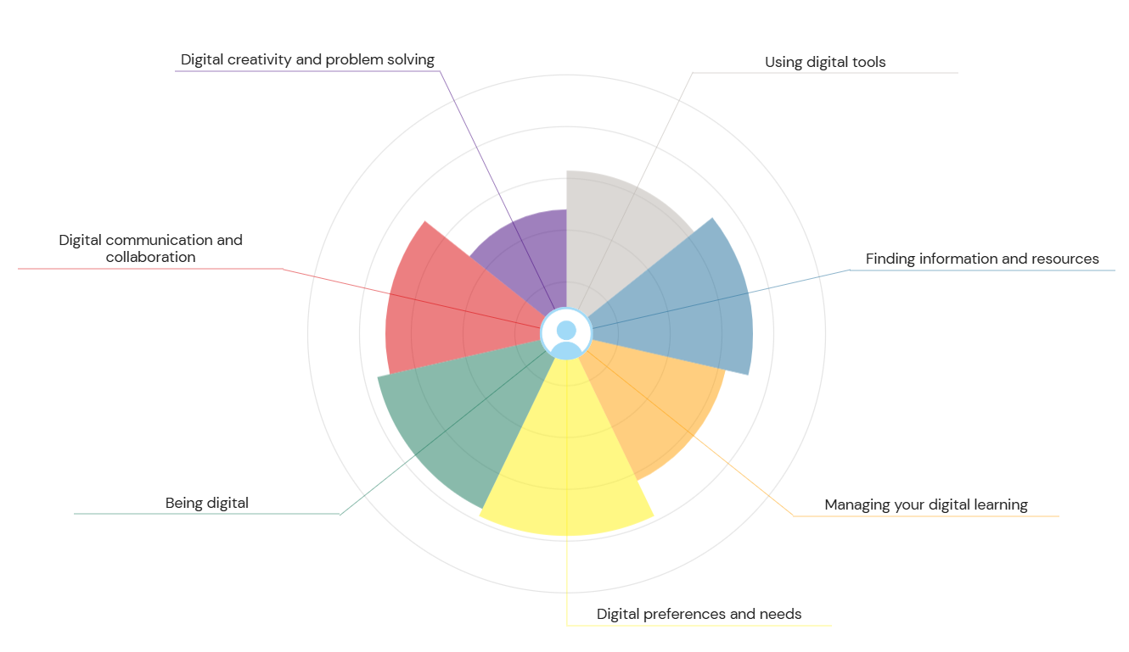

700 words on your assesment of digital skills Plus recommendations and badges you have completed because of this report
I was able to consider my present digital strengths and opportunities for improvement thanks to the JISC Digital Capabilities study. Communication, teamwork, creativity, problem-solving, digital tools, and managing digital learning were among the aspects of digital capacity that were evaluated by the tool. I thought I had a good degree of digital confidence before finishing the test, especially when it came to commonplace technologies. Nonetheless, the study made it easier for me to distinguish between more sophisticated or strategic digital behaviours that are crucial for schooling and future work and more fundamental digital abilities.
Using digital tools was one of my strong points. For routine chores like composing documents, creating presentations, and saving information, I feel at ease using programs like Google Workspace and Microsoft Office. Because I usually learn by experimenting and making mistakes, I also feel comfortable using new programs or systems when necessary. Because digital technologies are used in almost every academic and professional setting, this strength is beneficial. The report inspired me to keep honing this ability by discovering keyboard shortcuts, trying out new features in well-known applications, and investigating specialized tools related to my field of study.
The report also emphasized Digital Communication and Collaboration as a strong area. I frequently communicate with tutors and classmates via email, messaging apps, and online learning settings. I feel comfortable taking part in online forums, video conferences, and group conversations. According to the research, I may further develop this by learning how to effectively work on shared digital documents and enhancing my comprehension of professional communication etiquette. This is directly related to teamwork abilities, which are highly prized in the majority of professions.
Additionally, the report pointed me a few areas in which I could do better. Locating Resources and Information Online was one of these. Even though I am proficient with search engines, I occasionally struggle to find trustworthy sources or assess the veracity of material. This is particularly crucial for academic work, when reliable and pertinent sources are required. I intend to visit the library website more frequently, investigate scholarly databases like Google Scholar, and learn how to correctly reference utilizing citation tools in order to enhance this.
Managing My Digital Learning was a second area that needed improvement. I occasionally find it difficult to maintain organization when learning online, particularly when juggling several deadlines and several platforms. I intend to use digital calendars, reminders, and note-taking tools more effectively in order to address this. Additionally, I want to establish more precise procedures for scheduling my study sessions and reviewing announcements. I'll be able to manage my learning more independently and confidently thanks to this.
I received a digital skills badge as a benefit of finishing the JISC assessment. This badge acknowledges my participation in and advancement in the development of my digital skills. The badge is helpful since I can use it to demonstrate my dedication to developing my abilities in my resume, LinkedIn profile, and future job applications. In order to demonstrate a greater variety of digital competencies, it also inspires me to keep learning and earning new badges.

References
Jisc (2023) Digital Capabilities Framework and Discovery Tool. Available at: https://digitalcapability.jisc.ac.uk (Accessed: 16.10.2025 ).

Task 2

LinkedIn Learning Certificates for Office365
Add all the certificates from LinkedIn learning here

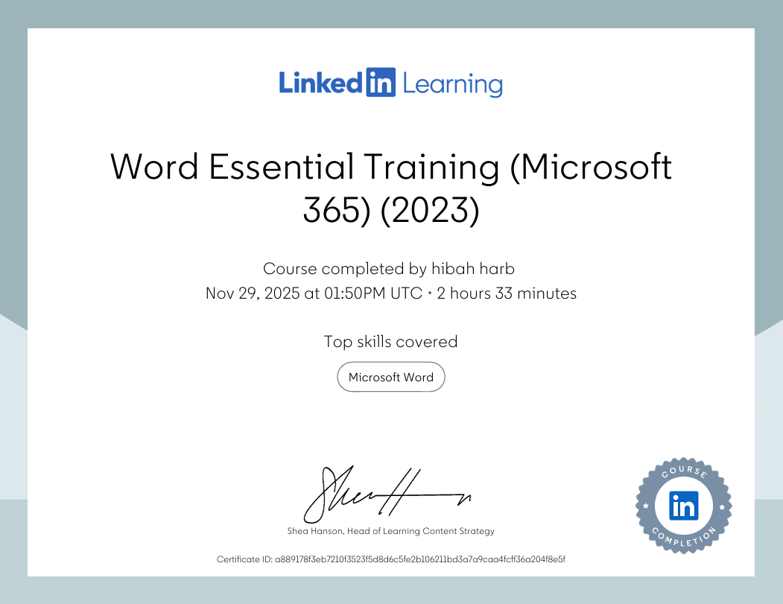

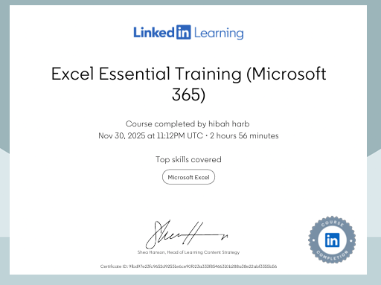

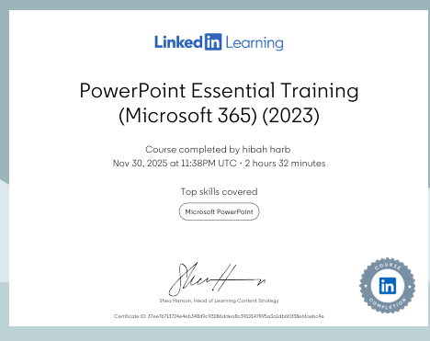

Referenace
LinkedIn Learning (2023) Word Essential Training (Microsoft 365). Available at: https://www.linkedin.com/learning (Accessed: November 30, 2025).
LinkedIn Learning (2023) Excel Essential Training (Microsoft 365). Available at: https://www.linkedin.com/learning (Accessed: November 30, 2025)
LinkedIn Learning (2023) PowerPoint Essential Training (Microsoft 365). Available at: https://www.linkedin.com/learning (Accessed: November 30, 2025)

Task 3

Essay on Relevance of Excel in professional and personal life.
Write a 1000 word essay on Relevance of Excel in professional and personal life.
8 references
Excel's Use in Both Personal and Professional Life
One of the most reliable and versatile tools available today is Microsoft Excel. Excel is still very useful because it makes it easy for users to organise information, do computations, and analyse data, even in the face of several new digital applications. Because of its adaptability, it may be used in both daily life and the office.
Achieve Success in Your Career
Excel is a crucial tool for managing and evaluating data in work environments. Workers in a variety of industries to organise vast volumes of data utilising conditional formatting, sorting capabilities, and tables use Excel. Excel is used by industries like finance, healthcare, shipping, and education to store critical information, measure performance, and manage records.

Excel in Professional Life
Excel is a crucial tool for managing and evaluating data in work environments. Excel is used by workers in a variety of industries to organise vast volumes of data utilising conditional formatting, sorting capabilities, and tables. Excel is used by industries like finance, healthcare, shipping, and education to store critical information, measure performance, and manage records.

Excel helps with commercial decision-making as well. Organisations can monitor trends and compare various scenarios with the aid of its visual tools, like dashboards and graphs. Excel is used by project managers to create schedules, track work progress, and calculate project costs. Excel is still widely used despite the availability of specialised tools because it can be tailored for any task.
Excel is also necessary for administrative activities. It is frequently used for scheduling, inventory control, document organisation, and personnel data maintenance. Because of its versatility, it can be used for a variety of operating requirements.

Excel in Personal Life
In everyday life, Excel helps individuals control their finances by creating budgets, tracking expenses, and planning savings. With the help of formulas and charts, users can easily monitor income, identify spending patterns, and follow financial goals.
Excel is also handy for household management. Families use it for grocery planning, meal scheduling, home maintenance records, and vacation planning. It makes comparisons and cost calculations simple, supporting better decision-making.
Students benefit from Excel by using it for assignments, data projects, and mathematical tasks. Teachers use it to keep track of grades, attendance, and student progress. Beyond education, Excel can be used for hobbies such as tracking workouts, maintaining reading lists, and organizing personal projects.

Why Excel Remains Important
Excel remains relevant because it is easy to use, customizable, and compatible with many other applications. Its role in improving digital and data skills keeps it valuable across all fields.

Conclusion
Excel has a significant place in both professional and personal life. Its ability to manage data, support decisions, and simplify tasks makes it a crucial tool. Whether used for work or daily activities, Excel improves organization, accuracy, and productivity.
4 out of 8 reference
• Alexander, M., & Kusleika, D. (2019). Excel Power Programming with VBA. Wiley.
• Winston, W. L. (2016). Microsoft Excel Data Analysis and Business Modeling. Microsoft Press.
• Gross, J. (2015). Excel Functions and Formulas. McGraw-Hill Education.
- OpenAI (2024) ChatGPT (GPT-5.1). Available at: https://chat.openai.com (Accessed: [11.11.2025].

Use the following information create an Excel spreadsheet, looking at income and expenditure of a typical family of 4 over the course of a year. Use formulars to achieve answers and add headings and highlight the different aspects of the finances, be realistic with the monetary amounts used for each area.
Income | Amount per month £££ | Expenditure | Amount per month £££
Wage 1 |  | Rent/Mortgage
Wage 2 |  | Council tax
Trust Funds |  | Electric
Stocks/Share payouts |  | Gas
Universal credit |  | Water rates
Student Finance |  | Food
Other |  | Car insurance
 |  | Car Tax
 |  | Fuel
 |  | Child Care Costs
 |  | Loans/credit cards
 |  | Other eg Birthdays/savings/holidays

Embed your excel here

INCOME | Amount per Month (£) | EXPENDITURE | Amount per Month (£)
Wage 1 | 2,500 | Rent/Mortgage | 900
Wage 2 | 2,000 | Council Tax | 150
Trust Funds | 200 | Electric | 120
Stocks/Share Payouts | 150 | Gas | 90
Universal Credit | 300 | Water Rates | 60
Student Finance | 0 | Food | 500
Other (e.g., Gifts, Part-time Work) | 100 | Car Insurance | 70
 |  | Car Tax | 25
 |  | Fuel | 180
 |  | Child Care Costs | 250
 |  | Loans/Credit Cards | 200
 |  | Other (Birthdays/Savings/Holidays) | 200
TOTAL INCOME → | =SUM(B2:B8) | TOTAL EXPENDITURE → | =SUM(D2:D13)
MONTHLY BALANCE (Income - Expenditure) | =B9-D14
ANNUAL SAVINGS (Balance × 12) | =B15*12

References
Title: Monthly Income and Expenditure Budget Table
Created by: myself hibah
Description:
This table presents a structured overview of monthly household income sources and monthly expenditures. It includes calculated fields for Total Income, Total Expenditure, Monthly Balance, and Annual Savings using spreadsheet formulas.
Structure:
Includes the following income categories:
- Wage 1 (£2,500)
- Wage 2 (£2,000)
- Trust Funds (£200)
- Stocks/Share Payouts (£150)
- Universal Credit (£300)
- Student Finance (£0)
- Other (Gifts/Part-time Work) (£100)
Total Income Formula: =SUM(B2:B8)
Includes monthly spending categories:
- Rent/Mortgage (£900)
- Council Tax (£150)
- Electric (£120)
- Gas (£90)
- Water Rates (£60)
- Food (£500)
- Car Insurance (£70)
- Car Tax (£25)
- Fuel (£180)
- Child Care Costs (£250)
- Loans/Credit Cards (£200)
- Other (Birthdays/Savings/Holidays) (£200)
Total Expenditure Formula: =SUM(D2:D13)
- Monthly Balance (Income – Expenditure): =B9 - D14
- Annual Savings (Balance × 12): =B15*12

Task 4

7 Minute Reflective Presentation
Create a PowerPoint presentation using techniques learned in class, reflecting on the module and what you have learned.
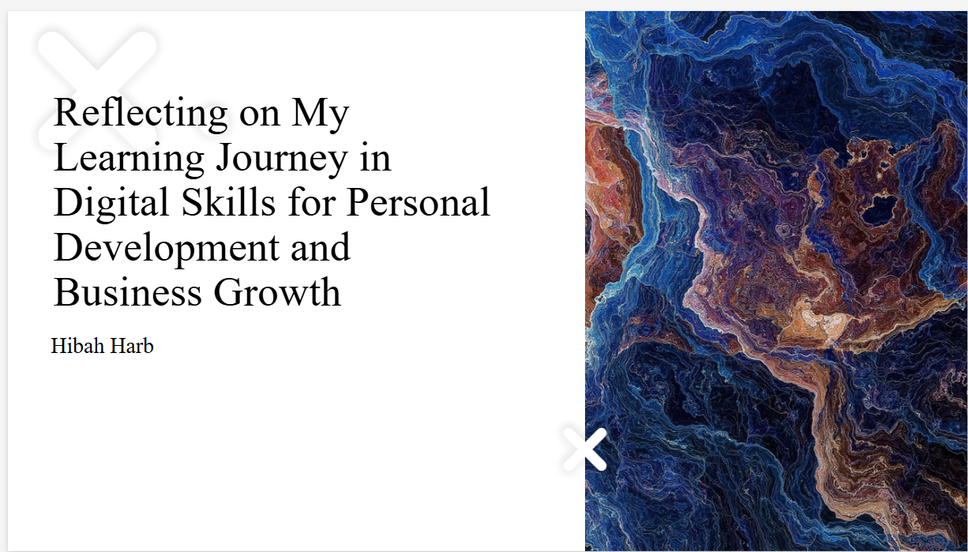
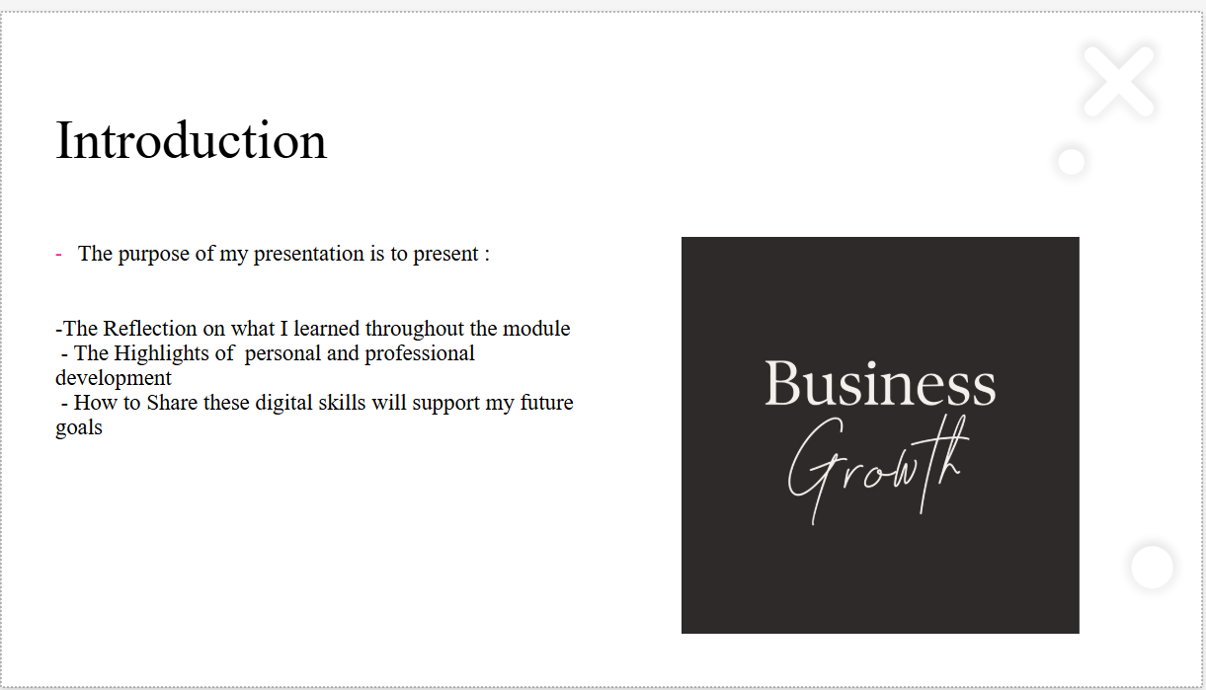
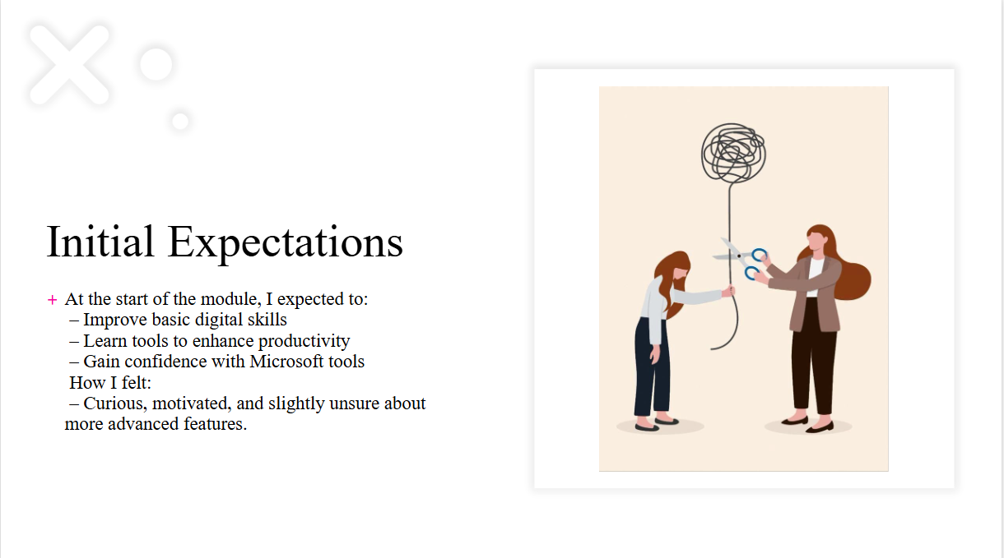
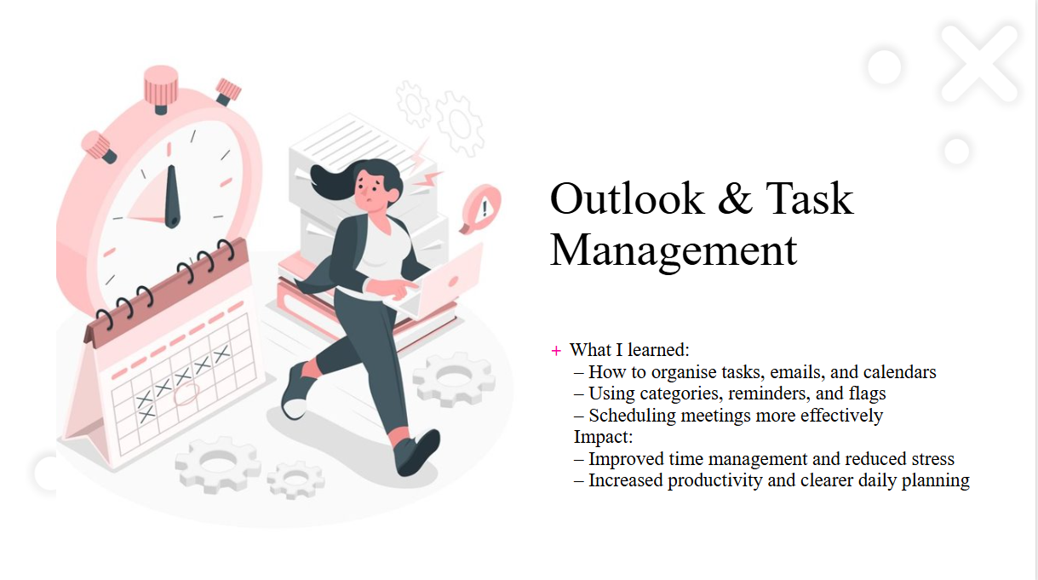
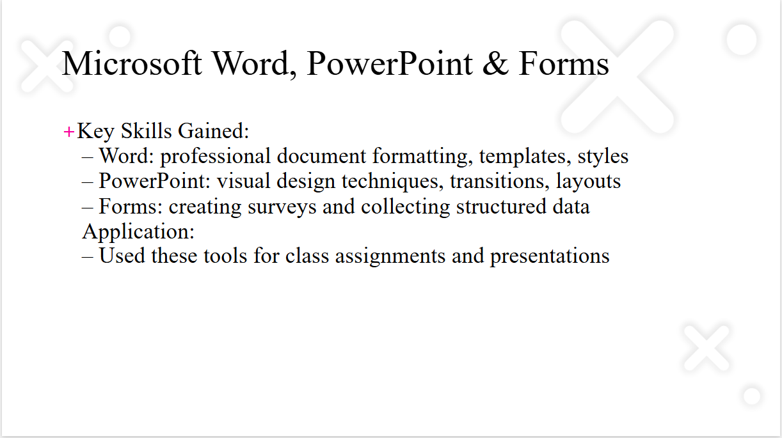
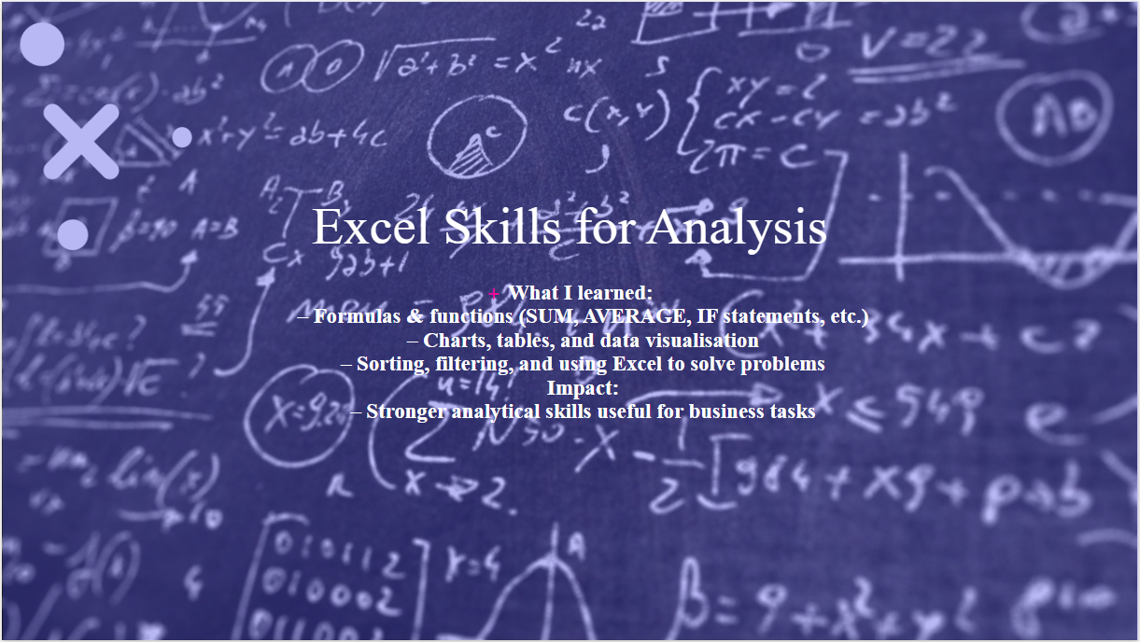
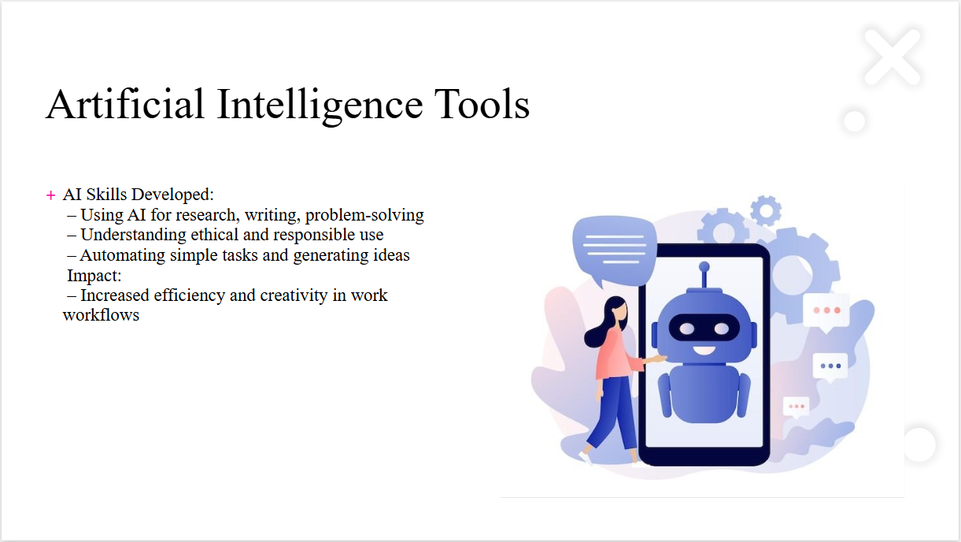
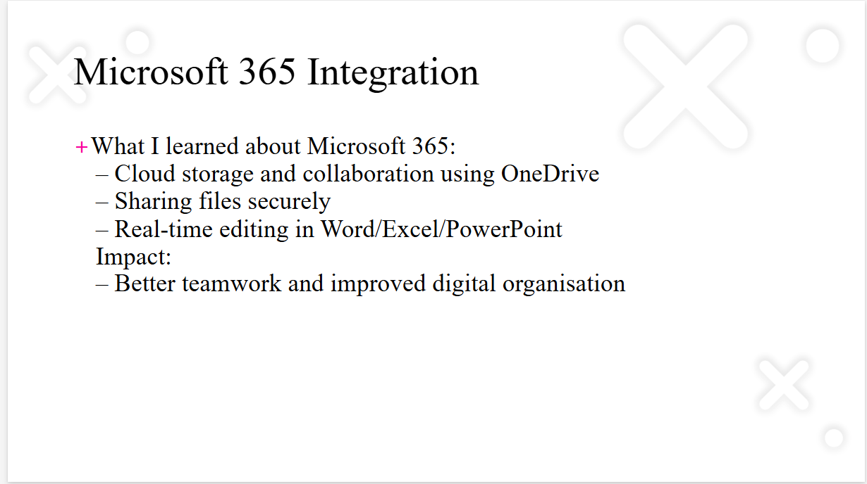
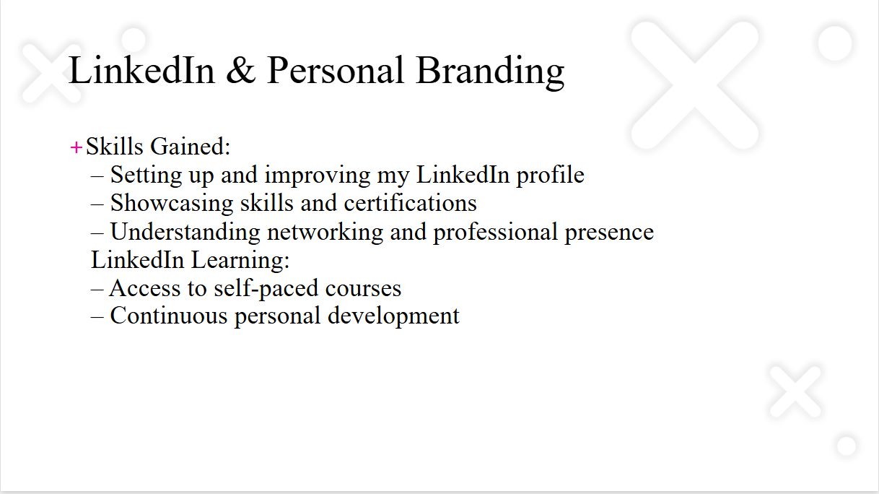
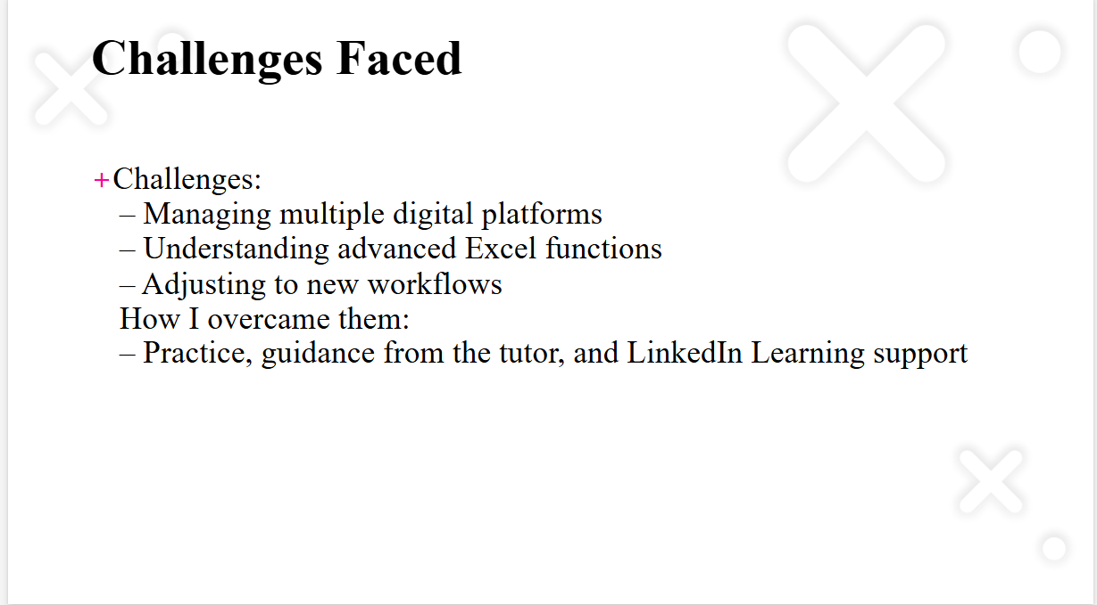
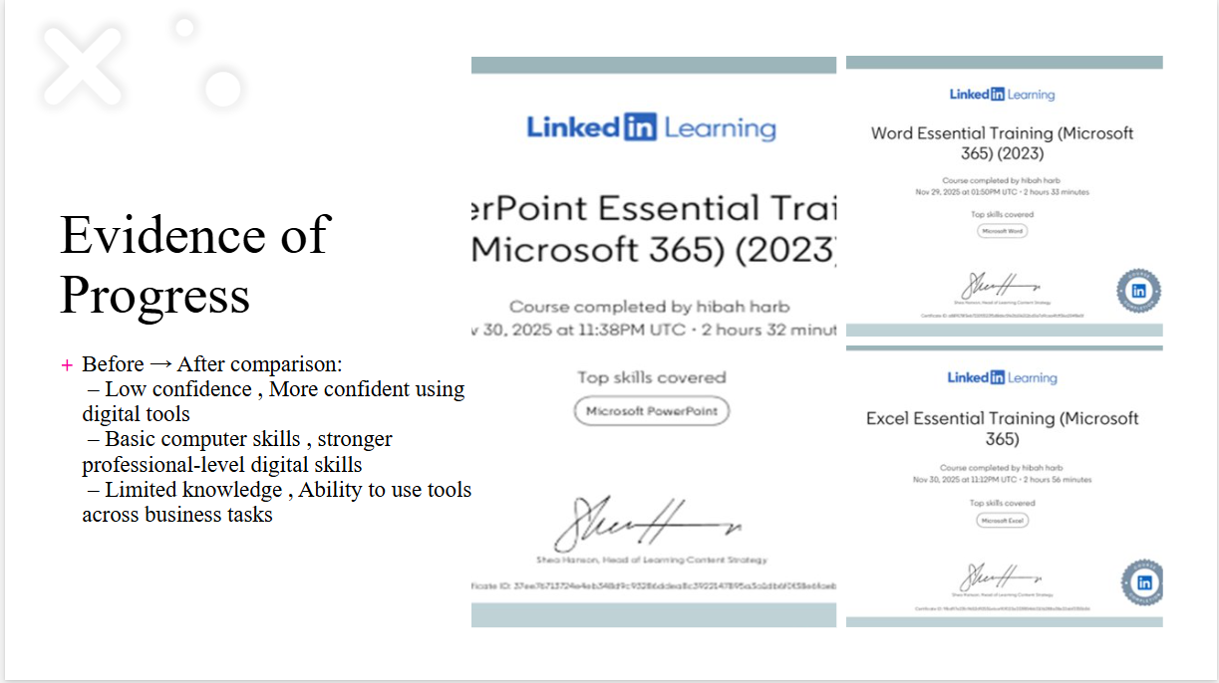
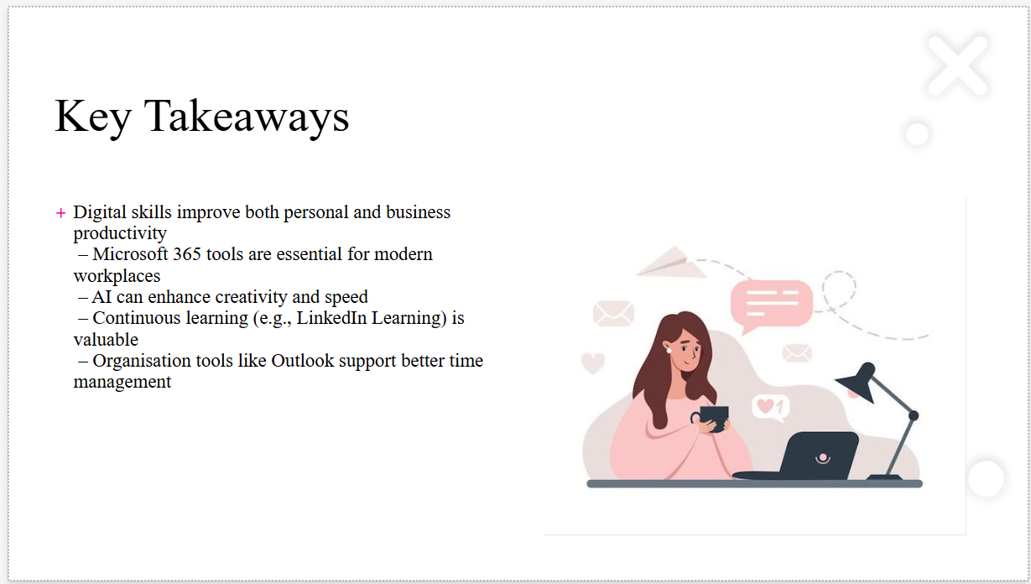
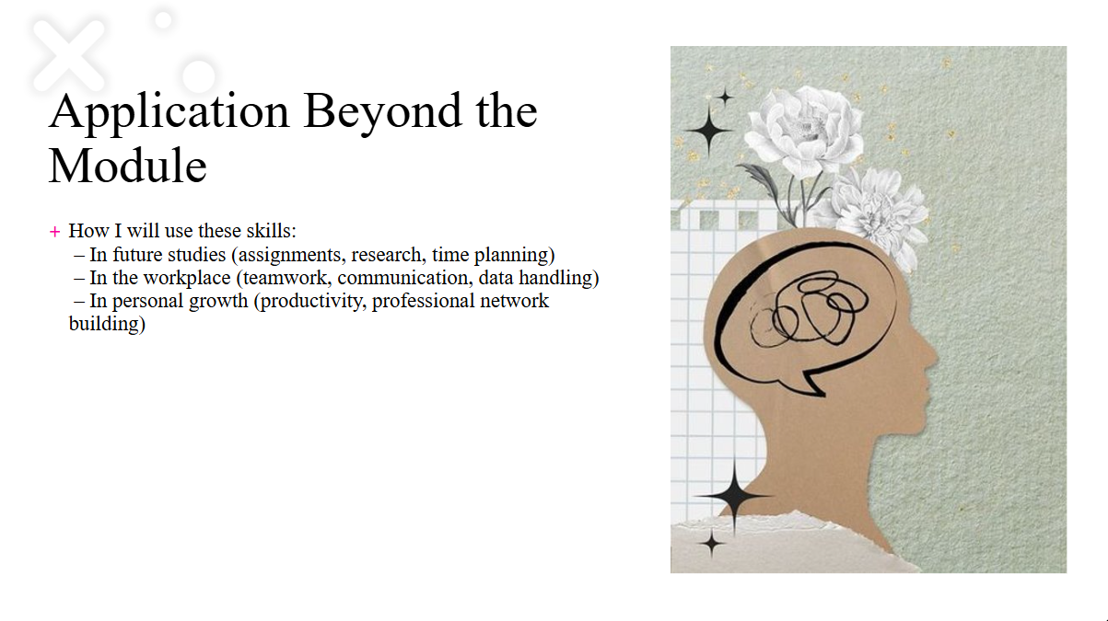
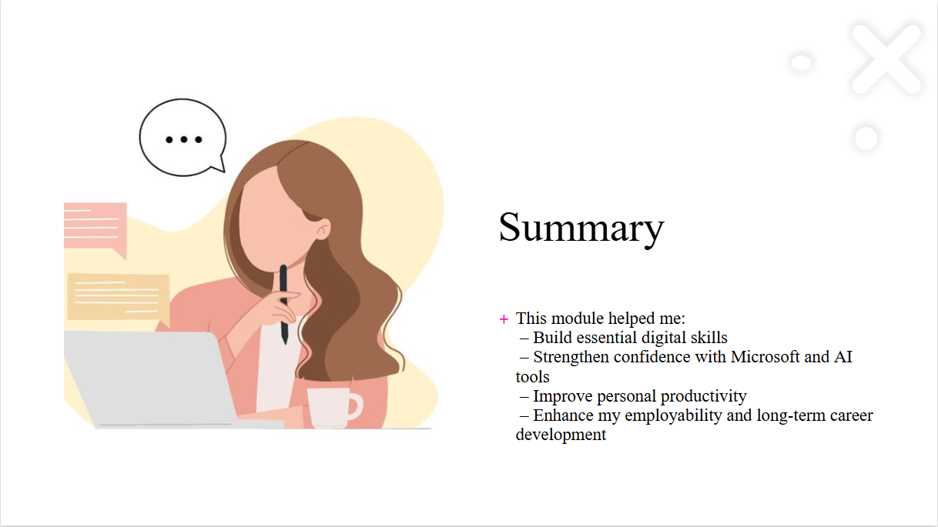

References
Jisc (2023) Digital Capabilities Framework and Discovery Tool. Available at: https://digitalcapability.jisc.ac.uk (Accessed: 12 November2025).
QuillBot (2024) AI Paraphrasing Tool. Available at: https://quillbot.com (Accessed: 11 November 2025).
OpenAI (2024) ChatGPT (GPT-5.1). Available at: https://chat.openai.com (Accessed: 12 November 2025).
LinkedIn Learning (2023) Word Essential Training (Microsoft 365). Available at: https://www.linkedin.com/learning (Accessed November 30, 2025).
LinkedIn Learning (2023) Excel Essential Training (Microsoft 365). Available at: https://www.linkedin.com/learning (Accessed: November 30, 2025
LinkedIn Learning (2023) PowerPoint Essential Training (Microsoft 365). Available at: https://www.linkedin.com/learning (Accessed: ). November 30, 2025
Unknown author (n.d.) Illustration of a female head with flowers and abstract brain design [Image]. Pinterest. Available at: https://www.pinterest.com (Accessed: November 30, 2025
Unknown author (n.d.) Illustration of woman working on a laptop with speech bubble [Image]. Pinterest. Available at: https://www.pinterest.com (Accessed: November 30, 2025
Unknown author (n.d.) Illustration of woman sitting at desk using smartphone with message icons [Image]. Pinterest. Available at: https://www.pinterest.com (Accessed: November 30, 2025 ).

