Assignment: BMSW5005 knowledge and information management skills for the workplace
Name: Asma Akhtar
Student no: 1710507
Group: 3
Lecturer: DR MD Nazam Ul Hassan

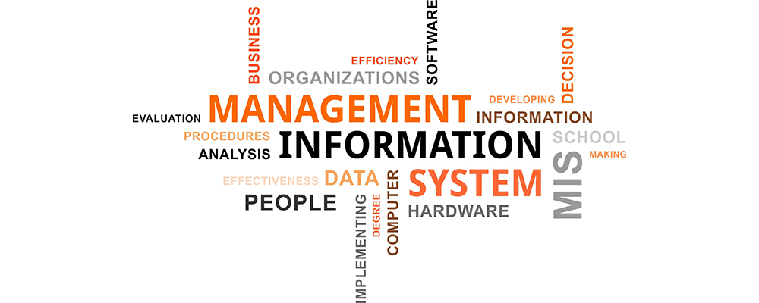

Part 1 – Case Study

1. Describe how the overall approach adopted by American Airlines incorporated the basic competitive strategies of cost leadership and product differentiation
Strategic management is the player that keeps a company ahead of the line. Leadership and management skills at the workplace largely define the effectiveness of strategic management in a company. With a weak management a huge initiative might fail but a tiny initiative might become gigantic for an opposite one.
Semi-Automatic Business Research Environment (SABRE) was developed by American Airlines in association with IBM to provide their customers with the experience of obtaining a reservation online. American Airlines brought this facility in a time when most of the competitors of the company used hand written reservation which was time-consuming and inconvenient. The thoughts of American Airlines were to achieve a competitive advantage by focusing on two business level strategies – cost leadership and product differentiation (Bosch, 2012). However, as theory says, achieving both the strategies at a time is tough for a company. From below assessment, it can be said how American Airline’s approach did work out –
Cost leadership: This refers to providing same service at a lower cost than competitors. SABRE has made the reservations easier for the customers. At a reduced cost, the customers could reserve their travels. As it is observed in the case study “SABRE system saved 30% on its investments”. Considering the convenience of the travellers and agencies, it can be safely said that American Airlines achieved cost leadership in the particular business segment of making reservations by using SABRE system (London et al., 2011). However, this observation is open to further argument which come later.
Product differentiation: Either it be cost reduction or not, SABRE brought significant product differentiation to American Airlines undoubtedly. Hand-written system was replaced by SABRE and American Airlines was the first company to do the strategic alliance with IBM in developing such a system. American Airlines could offer online reservation system whereas its competitors depended on offline methods, at least at the initial stages. Then American Airlines expanded the service from travellers to travel agencies bringing more customers under the coverage. Then American Airlines as a part of its further polishing brought the functions of importance to make the system more convenient to the customers (George, 2013). Now then customers will be able to input their important considerations for travel and find out their perfect suite. All these things being done through online; American Airlines enjoyed a significant competitive advantage for adopting the strategy of product differentiation. For the airlines business starts with reservation part and American Airlines brought differentiation in that part, competitive advantage automatically followed.
It can be said that in the approach adopted by American Airlines, product differentiation is very explicit than cost leadership. Though it is not possible for typical businesses to achieve both these business strategies simultaneously, American Airlines being a giant company achieved both of them at a time through SABRE. However, achievement of cost leadership is not as visible as product differentiation.

2. In what ways did SABRE provide American Airlines with a competitive advantage? Your analysis should refer to concepts related to the strategic use of information systems, for example, entry barriers
Most of the times the companies make big strategic decisions to achieve competitive advantage. Successful decisions give the companies a competitive edge. Introduction of SABRE gives American Airlines a competitive advantage in the following ways –
First mover advantage: Introduction of computerised system in reservation of travels in new and American Airlines is the first mover. The first mover always gets the cream of the total market share. The reputation that American Airline gets is invaluable for its branding. A particular group of customers loyal to other companies switch to a more convenient system (Abramowicz and Zurada, 2015). Thus, American Airlines will get a first mover advantage.
Entry barriers: The level of investment required, the level of sophistication of the technology, strategic alliance etc. are the factors which create an entry barrier for the other companies to offer the same platform. Competitors of American Airlines will not have the access to same platform since developer of such system is IBM and American Airlines already has a strategic alliance with IBM. Thus, for entry barriers of the other companies, American Airlines automatically reaps the benefits of competitive advantage (Haltiwanger et al., 2013).
Low cost and convenience: The system cut the cost of reservation down and the customer saved their hassle in booking their air tickets, hotels, cars etc. The customers are also now being to search their convenience through the platform by using the importance function. Therefore, the level of convenience of the customers is augmented by use of these factors and American Airlines achieved a competitive advantage being the first company in the industry to do so.
More features: SABRE was initially used for airline seat reservation but gradually the company added more features like booking hotels, cars etc. The travel agencies are also considered so that they can make reservations for the customers. The company then went on to offer services for yield management, decision support tools, crew scheduling etc. The customised search system really added huge value to the system. Therefore, the company surely grabbed a greater market share by offering more services at a lower price than the customers (Messner, 2007). The competitive advantage was achieved for more features of SABRE.
The major sources of competitive advantage are discussed and there are many more ways SABRE helped American Airlines to become more competitive strategically. SABRE was a computerised system and given the time of its implementation, the customers were really excited to see the new system. A huge turnout was successfully drawn.

3. Although SABRE was undoubtedly successful, American Airlines was not able to maintain its competitive advantage beyond the late 1980s. What factors played a part in the erosion o the company’s lead over its competitors and how did the company react?
Whatsoever the success of SABRE be, the competitors will not let it go. It doesn’t mean that American Airlines launched SABRE and the whole market will go to them and competitors will just tread without doing anything. They might not be able to bring a substitute of SABRE instantly, the facility might be patented, the competitors might lose some of their customer for the short-run (Melo-Pinto et al., 2009). But in the long-run they definitely will find some ways to regain their lost regime.
This is exactly what happened to the fate of SABRE. It was successful but it fell during late 1980s. Many factors might have contributed to that failure of the system. The possible factors for the failure of SABRE are critically analysed below –
Firstly, time is a big player in anywhere and everywhere. That is, over time the competitors of American Airlines figured out ways to outbid the system launched by American Airlines. The system might have been patented to American Airlines, but the patent has an expiry date. Internet and the computerised systems have expanded over time. During 1980s personal computers revolutionized; first laptop was produced. The computing system became better and better with internet being easier to access for all (Kiyoki, 2014). Thus, the competitors of American Airlines took the time up to late 1980s to figure out their ways.
Secondly, there was a huge cost involved in the development and maintenance of the system. Thus, the feasibility of the system came down slowly and American Airlines might have found that it is no longer usable there is a need for system upgrade. The cost-benefit analysis of the system must not have supported the company’s business strategy. The company then force shut the system.
Lastly, but not the least, the company has to update its system as the world advances towards better technology day by day. The failure of SABRE might be caused by another major factor that it was outdated. The company has to react by replacing the system. However, by the time SABRE was outdated and eroded, the competitors found out alternative ways. So, the ground that American Airlines had after launching the online system and the competitive advantage collapsed over time. The competitors have reached the level of American Airlines and again a huge competition started (Hillard, 2010). But the good thing is that American Airlines will not go downgrade. That is, the company will launch a new system which will be better than the previous one. Thus, American Airlines will be able to keep its competitive ground.

Part 2 – Information Systems

1. Define an information system
In a business context, information system refers to an integrated system that aims to support management, operations and decision-making processes. It can also be defined as the process of collecting data, analysing data, storing data and sharing them upon demand to the relevant parties (Gunasekaran and Sandhu, 2010).Information system can be defined in other ways as the set of components installed in an organisation to provide information, research knowledge and digital products. Secondary and primary data are used in information system which are processed in a particular way to generate knowledge that helps decision-making in the organisation (Messner, 2007).
Information system is also used in to keep data sets organised and stored. In different business organisations, information system is used for storing and analysing their past performance and for projecting the future. Many organisations use it as computerised supporting tool for their decision-making process. The systems help the managers very well as the system is an integrated one and does have the ability to do analysis using many inputs.

2. Describe the categories of computer-based information systems, providing relevant business examples for each category identified
There are different kinds of computer-based information systems each with its own purpose. The systems can be categorised based on their use in different level of management hierarchy –
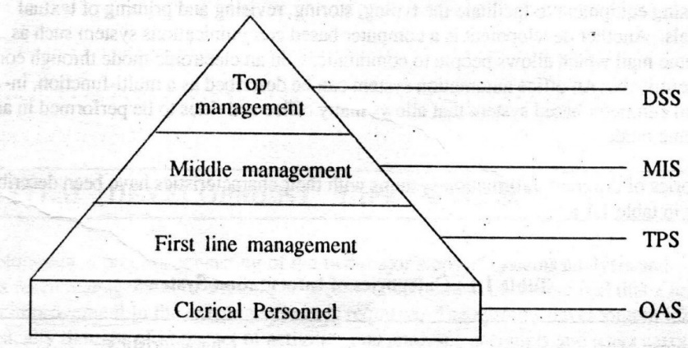
Figure 1 Types of computer-based information systems
Source: (Hillard, 2010)
Office Automation Systems (OAS): As the name itself suggests, OAS is a category of computer-based systems used for speeding up the work of secretaries, typists, administrative assistants and the like. It might include the computerised database of all paper-files to help clerics find out things quickly and working digitally (Hillard, 2010). Again, it also includes the computer mail systems that allows the customers to communicate through the computer terminals.
Transaction Processing System (TPS): This system can be called as the most basic CBIS. It is a system that records, classifies, stores, updates, maintains, and supplies day to day transaction data. This system works as the foundation to other information systems. The raw data are supplied from TPS. However, the types of transactions might vary from company to company. But this system records all kinds of transactions to produce the accounting statements. For all the bookkeeping, this system is liable. This system is also used for generating the financial statements of the organisation. There are different controlling mechanisms in this system like error detection, prevention of unauthorised access etc. The system only takes input data in a particular format which it processes for later use.
Management Information System (MIS): This system in simple terms refers to the one which supplies relevant information for the management to make operational decisions. The system provides accurate, concise, timely, relevant, and feasible information to management of all level in a company to help them run the business smoothly (Kiyoki, 2014). The information supplied by this system is used to make structured decisions where the managers rely mostly on the information provided by the system than on their judgement. This system especially is connected with other systems like OAS and TPS. MIS takes direct records from the other information systems and make analysis based on them.
Decision Support Systems (DSS): This system can be defined as the one that provides the management with most relevant and concise information that the managers use as the basis of iterating their judgement. This system supplies information to help the top-level management to make their decisions (Bosch, 2012). The system is designed in such a way that all the underneath facts are considered before the system provides any information to the top management. Because if something goes wrong with this system, the whole organisation will suffer. DSS is specialised for the use of top-level managers only. That is, it has limited access.

3. Explain how computer-based information systems can support managers at each level of an organisation
Computer-based information system in an organisation can be of different types which are explained in the previous section. The systems support managers at each level of the organisation. There are basically three levels of management in any organisation – top level, middle level, and lower level. Information systems are put into an organisation internally to support internal operation. Different software is used to develop such system.
At the lower level, information system tracks and records the activities. For example, in a company that produces consumer goods, CBIS would collect the number of production units, inventory used, labour used, working hours etc. This will help the management by producing daily reports (George, 2013). Management can then compare it with the target. The systems at the lower level also work as the supplier of raw data to the upper level information systems.
At the middle level management, CBIS helps managers with monitoring and controlling. The system takes information input from the bottom level CBIS and presents them to the managers say production manager who is liable for maintaining the whole production plant and for keeping up with the orders of the customers and other targets. The monitoring and the control of the organisation thus is facilitated by the CBIS at the middle level of management. The managers at this level also analyse data at a limited scale and make decisions (Abramowicz and Zurada, 2015).
At the top level, CBIS plays the most critical role by helping the management make policies supported by the analysis provided by the systems. The top-level management keeps an eye to the whole organisation through the information system. Then the system supplies relevant analysis and information to them. Together the information with their judgement, the top management make policies for the company.
Thus, in an organisation that decided to go digital, CBIS become part and parcel. It helps the management with all kinds of decisions and keeping records. As it is seen that all level of management is depended on the computer-based information system in an organisation that went digital from hand written age. Even all the employees are related with the systems – like their data are saved in the system, and they can take help from it.
Digitisation in an organisation always bring betterment for it. If a company can pioneer the introduction of a digital system, then it will reap the benefits ahead of anybody else. But an organisation will have to keep updating its systems in order keep pace with the ongoing upgradation in the digital systems. Otherwise, the strategic advantage that the company gets would disappear like it did in case of American Airlines. Information systems can help the managers of all level in an organisation. The organisations have to utilize it properly to get the maximum benefit. When an organisation installs and runs computer-based information system, the organisation will get a boost in its operation because the system will help the management make decisions in a better way. The richer the systems, the greater the competitive advantage.

References

Bosch G., (2012). ‘Indicators of sustainable employment’, In: Bartelmus P. (ed.) (2002), Unveiling wealth. On money, quality of life and sustainability. Kluwer Academic Publishers. Dordrecht, Boston, London.
George, B., (2013). Managing stakeholders vs. responding to shareholders. Strategy & Leadership. 31 (6). pp.36 – 40
London, T, Hart, S. and Kacou, E., (2011). Business Strategies for the Bottom of the Pyramid (Collection). FT Press.
Mindtools .com. (2019). Mind Tools: Online Management, Leadership and Career Training. [online] Available at: https://www.mindtools.com/ [Accessed 08 Oct, 2019].
Rafinejad, D., (2013). Innovation product development and commercialization. Ft. Lauderdale, FL: J. Ross Pub.
Ubeda, E. J., (2013). Communication in new technology based-firms. Management Decision. 51(3). pp.615 – 628.
Abramowicz, W. and Zurada, J. (2015). Knowledge discovery for business information systems. New York: Kluwer Academic Publishers.
Gunasekaran, A. and Sandhu, M. (2010). Handbook on business information systems. Singapore: World Scientific.
Haltiwanger, J. , Lynch, L. and Mackie, C. (2013). Understanding business dynamics. Washington, DC: National Academies Press.
Hillard, R. (2010). Information-driven business. Hoboken, N.J.: Wiley.
Kiyoki, Y. (2014). Information modelling and knowledge bases XV. Amsterdam: IOS Press.
Melo-Pinto, P. , Teodorescu, H. and Fukuda, T. (2009). Systematic organisation of information in fuzzy systems.
Messner, W (2007). Justifying information system value. Business Information Review, 24(2), pp.126-134.

1. Explain why the same set of data can be considered as useful information by some and useless data by others. Further, could this useful information be termed as “knowledge”? Why?
Data, information, and knowledge are three different things. But these three things are connected. One might argue that everything happening on the face of this earth is based on some data, information, or knowledge. However, these three things evolve around one another over time. While one depends upon another, there are differences among them.
Data, information and knowledge etc. are very different terms that people often use interchangeably. Data can be defined as the facts, assumed calculations, statistics etc. collected for making analysis in the future (Pivert and Zadrożny, 2014). Electronic form of data refers to characters, symbols, quantities and other electronic forms of visual objects that refer to some real phenomena. Electronic form of data can be transmitted over internet or through magnetic, mechanical or optical media (Carlson, 2015).
Usefulness of data is a direct function of the work in which they are being used. Data is abundant all around us. In the current world, electronic form of data is most common form of keeping data. All the data that were in paper are being transferred into electronic form. There are thousands of exabytes of data currently the world is holding, and everyday several thousand terabyte of data are being created (Moens and Spyns, 2015). But is all the data relevant for everybody? No, it is not. Because people specialize in different areas. The area of specialisation of a particular person determines the type of data he or she requires. Since everybody cannot specialise in all areas of knowledge, some data are relevant for some people while the same data is irrelevant for other people.
An example of the fact be set in the business context. There are different departments in a particular business – human resource, accounting & finance, marketing, sales, production, internal control etc. All the departments have their own human resources and department heads. Let’s say profiles of all the employees are important for the HR head but it has no utility to the marketing department. Customers’ profile and choices are important to marketing department while production department wouldn’t care about them. Production capacity in a particular day is relevant information for the production department whereas accounting has no headache about it.
Can useful information be termed as knowledge:
Information refers to the next form of data; when data is organised, processed, and presented within context it is called information. Information is useful to the intended person. Information is the processed, and transformed form of data that helps in the decision-making process. On the other hand, knowledge goes another level ahead which refers to learning of a person through discovering and perceiving places, events, people, issues and ways of doing things (Badia, 2014). It refers to learning something with deep perception of concepts, basics, and root information. Therefore, while useful information can help generating knowledge, these twos are not necessarily same. Because knowledge is what a person has inside his mind. Information helps to generate the knowledge.

2. Describe the ways in which “knowledge” differs from “data” and “information.” Justify your answer with a relevant diagram
Knowledge is in simple terms ‘what we know’. Knowledge is the connection among many things, objects, events, information and others which out brain creates a network of and keep it updates through new things, objects, and information we see. Knowledge is only store into brains and nowhere else and it can be processed by a person only. Knowledge is different from data and information (Vojtás, 2013).
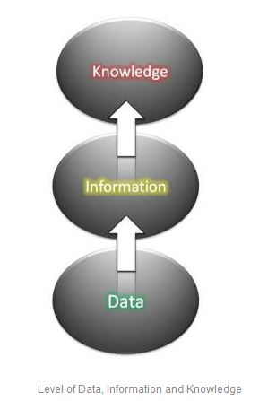
Figure 1 Level of data, information and knowledge
Source: (Infogineering.net, 2019)
Definition: Data in simple terms refer to the facts of the world. Pieces of facts about anything is known as data. But information can be defined as captured data which conveys a meaning, or data with relevance. And knowledge refers to the information processed through one’s mind to create decisions.
Level: Data is a bottom-level phenomenon. Everything starts with the facts i.e. data. Information on the other hand a one level upscale from data. And knowledge stays at the top of the three.
Storing: Data can be stored in different forms like in papers, electronic forms etc. Information is a more complete form of data which conveys knowledge. So, it comprises data. But knowledge is only stored into & exercised from the brains.
Example: There are many countries in the world; data is the name of the countries, their area, population, geographic position etc. When all the data are depicted as a world map, it becomes information. And when somebody studies the information along with data, it becomes knowledge. The knowledge here is the connection between this country and that country, history, connection among facts etc. which are not presented on the map.

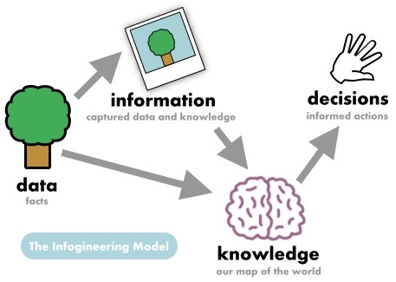
Figure 2 Diagram of data, information and knowledge
Source: (Infogineering.net, 2019)
The infogineering model above shows the relation among data, information and knowledge. The model shows that data stays beneath the other two. Data leads to information and them together lead to knowledge. A person then taking support from all three makes decision. This model presents all the ways of differentiation between knowledge and data, information.

3. Does a player in a card game use tacit or explicit knowledge? Explain why. Define and explain the difference between the two
Before commenting on the type of knowledge card game players use, it is necessary to define and make distinction between tacit and explicit knowledge. Tacit knowledge refers to the personal cognitive wisdom, intuitive, experience & job-based, context-specific knowledge that cannot be easily identified, extracted, or taught. On the other hand, explicit knowledge refers to knowledge obtained from books, readings, memos, reports, documents etc. This knowledge is structured. It can be shared, articulated, identified and employed (Cohen et al., 2012).
Distinction between tacit and explicit knowledge is very clear. The following table represents tacit and explicit knowledge –
Point of distinction | Tacit knowledge | Explicit knowledge
Type | Cognitive, subjective, intuitive and learned through experience | Objective, technical, rational and learned through wide reading especially through academic learning
Context | Application of knowledge might vary according to different contexts i.e. context specific | Way of application is fixed
External/internal | Internalized knowledge | Externalized knowledge
Documentation | Tacit knowledge cannot be codified into text, hard to identify, difficult to capture the way of application | Originates from written documents, so easily can be codified
Sharing | Can be shared on rare occasions | Easily shared
Volume | Doesn’t exist in touchable format, so volume is very low | Exists in very high volume
Teach | Cannot be taught in almost all occasions | Can be taught
Usefulness | Thought to be more useful in highly-tensed contexts | More useful in routine works
Dependent | This knowledge comes automatically to someone, need to flourish, needn’t to be learned | Need to learn. And learning speed largely depend on the cognitive ability which in turn is tacit knowledge

Now, in a card game, the players definitely use tacit knowledge. The reasons are very clear. In a card game, the context is not fixed but dependent upon how the other players respond. It is strategic game; the rules are written; the players learned the rule that gives them the explicit knowledge about how to play the game. But a player must not win until he becomes good in applying his tacit knowledge. Because a little cognitive touch, intuitive decisions, decisive recognition of other’s behaviour etc. matter a lot in giving a player the winning leads. So, it can be said safely that in a card game the players use tacit knowledge.
The application of these two types of knowledge is visible in management. The managers of lower-level use explicit knowledge to achieve day to day goals. For example, in a manufacturing company, the line supervisors need to know how to operate the machines properly for the whole day. Mid-level managers use both explicit and tacit knowledge. But the top-level managers use tacit knowledge in most occasions. For example, the top management need to fix up the strategy to achieve competitive advantage by bidding the competitors. Here the managers use their cognitive powers.

4. Consider five decisions you have made today. In each case determine the data, information, or knowledge that were involved in the decision
The five decisions are listed below –
- Woke up at the first alarm ring
- Had lunch at 2:00 pm
- Study two hours at one stretch
- Met my teacher to discuss a topic
- Went for cycling instead of walking
First decision: Waking up when the alarm first goes off really helps a person keep his schedule clean for the whole day. Data shows most of the people couldn’t wake up at the first ring of their alarm. But they would do better if they could. However, the information I had is that I can do better for the whole day if I can manage to wake up at the first ring of the alarm. Here data and information played role.
Second decision: Maintaining the correct food habit is beneficial for health. The believe that taking lunch within the routine will help me maintaining a good health is a knowledge. The information behind decision are huge. There is many established information on the fact. The doctors always encourage not to have lunch too late. Because the body couldn’t take the load of hunger for a long time. However, a wide reading and experience of the information led to knowledge and to the decision (Rieke and Sillars, 2014).
Third decision: The fact that I need to secure good grades in the exams is the data behind this decision. Information being the fact that I have to study regularly to do so successfully. And the knowledge is that if I keep the mind setup like let sit to study and see where it goes, there is a possibility that my study will be stalling. So, I decided to study two hours at one stretch.
Fourth decision: I have the information that my teacher will be able to solve my problem that I am facing with my assignment. So, I consulted my teacher based on the information and confidence that I got from my knowledge.
Fifth decision: Data here is that one can go either for cycling, or walking, or swimming etc. Information being walking burns as much calorie as cycling does. Knowledge here is that I will have to burn my calorie and do exercise for a certain time period, so I either choose walking or cycling. But I do as much cycling as to burn calories that I do regularly.

5. Now consider how those decisions would have been influenced by the lack of pre-existing data, information, or knowledge
It is definite that the decisions made above would have been different and suboptimal if I hadn’t had enough data, information, or knowledge previously. Following discussion deals with that –
First decision: This decision is an easy one and everybody knows that waking up late is bad. But let’s for the sake of argument assume that I didn’t know or care about what people say; i.e. I didn’t have the knowledge that I should wake up early. Then what would happen I would snooze the alarm multiple times a day thus thousand times over the years. And I would lose a huge portion of my time by oversleeping.
Second decision: In this case, I had the data that one can take his or her lunch at around noon. If I hadn’t this data, I would maybe take my lunch at afternoon. Thus, my health would be affected in the long-run. If I didn’t recognise the knowledge that I need to maintain a good health to work better, I wouldn’t have cared about taking my meals regularly.
Third decision: Since exams are ahead, I need to study. If I hadn’t possessed the data, information, and knowledge about this decision discussed above, I might have failed to study properly. Then I might have secured very poor marks eventually failed to pass in the exam. So, the knowledge that I have to study regularly without interruption helped me a lot.
Fourth decision: My information that the teacher could give me directions on the topic helped me to get help from right place without any hassle. But without that information I might have been wandering here and there, to this and that friend, online etc. wasting much time but ending up with nothing (Carlson, 2015).
Fifth decision: This decision is dependent upon data, information, or knowledge the most. If I were ignorant that cycling burns calories, I might have gone for a walk in a say wet weather. Or I might have been forced to walking when I do not like it every day. Or at another extreme I might have just sit around wondering which decision to take.

6. You have recently invented a new product. Collect demographic data from a sample population, determine how you would use this data, and convert it into information and possibly knowledge for promoting the product
A newly invented product requires research on the market. Say, the newly invented product is baby toys that replicate different shapes of historical places. The target customer is the parents with toddlers. Below is the collected information from a sample of 50 respondents on five basic questions –
Question | Type of answer | Positive/Yes | Negative/No | Indifferent
Do you think children toys shall be innovative? | Yes/No | 35 | 1 | 14
Do you like the idea that your child is playing with a toy and learning different historical things spontaneously? | Yes/No | 45 | 0 | 5
Would it be okay to press a child, passively though, to learn something at that young age of 2/3? | Positive /Negative | 8 |  | 42
Do you think we have brought a new and innovative idea into the market? | Yes/No | 30 | 4 | 16
Would you purchase our products if affordable? | Yes/No | 23 | 25 | 2

Every cell in the above table presents data to the readers. Some data says what the question was, some says how the respondents should respond and others say how many of the respondents responded in a particular way. These data can be transformed into information and knowledge. For example, if we see a pie chart for the responses to the fourth question –

Figure 3 Response to the question no - 4
Now, the 60% of the respondents think that yes, we have brought a new idea to the market whereas 32% are negative and 8% are indifferent about the matter. So, this chart presents information on market sentiment based on data.
Now, data and information can be transformed into knowledge. For example, based on the data of this survey, the entrepreneur might think that the product is feasible. Then he might decide to start working based on that knowledge.
Business decisions, personal decisions, professional decisions or anything are based on some knowledge. And knowledge depends upon data and information. So, everything in here is connected to each other. But it should be said that careful shall be the decision maker of misrepresentation of data, or information. Because that will lead to wrong knowledge. Making decisions based on mistakenly built-up knowledge will be suboptimal for the person who is making the decision.

References
Badia, A. (2014). Data, information, knowledge: An information science analysis. Journal of the Association for Information Science and Technology, 65(6), pp.1279-1287.
Carlson, J. (2015). Data information literacy. West Lafayette, Indiana: Purdue Univ. Press.
Moens, M. and Spyns, P. (2015). Legal knowledge and information systems. Amsterdam: IOS Press.
Pivert, O. and Zadrożny, S. (2014). Flexible approaches in data, information and knowledge management. Cham: Springer.
Vojtás, P. (2013). Information Modelling and Knowledge Bases XXIV. Amsterdam: IOS Press.
Wurman, R. (2009). Information Anxiety. New York ; London ; Toronto: Doubleday.
Cohen, H., Horak, W. and Staley, F. (2012). Teaching science as a decision making process. Dubuque, Iowa: Kendall/Hunt Pub. Co.
Infogineering.net. (2019). The Infogineering Model :: Infogineering - Master Your Information. [online] Available at: http://www.infogineering.net/infogineering-model.htm [Accessed 26 Oct. 2019].
Rieke, R. and Sillars, M. (2014). Argumentation and the decision making process. Glenview, Ill.: Scott, Foresman.

