

Assignment Title: Evidence of Learning (E-Portfolio)
Module Name: Learning in the Digital Era
Module Code: BMPS4009 & BMPL4007
Program of Study: Public Service Portfolio
Student Name: Ali Fayyaz
Student ID #: 2243570
Lecturer Name: Ms. Zita Draper

Table of Contents
Preparing for Higher Education 3
Mind Map: How to become a digital Learner 4
Mind Map Outline 5
Gibbs Model of Reflection 10
Description 10
Feelings 11
Evaluation 11
Analysis 12
Conclusion 12
Action plan 12
Personal Development Plan 13
Personal Development Plan Chart 13
Self-evaluation: 13
Personal/Professional Development Needs: 13
SMART Development Goals: 13
References 18

Preparing for Higher Education
Advanced and higher education is a significant achievement in one's academic process. Hayward Keniston defines is as the opportunity to delve deeper into their chosen field of study, gain specialized knowledge and skills, and open doors to a wide range of career opportunities.

In higher education, students pursue undergraduate and graduate degrees, such as bachelor's, master's, and doctoral degrees. These programs offer a more in-depth and advanced curriculum compared to secondary education.
One of the key benefits of higher education is the chance to explore and specialize in a particular subject area. Students can choose from a wide range of disciplines, including sciences, arts, humanities, business, engineering, and more. This allows people to seek after their interests and develop expertise in their picked field (Gigliotti and Ruben, 2017). While the students start to prepare for their further studies, colleges also prepare themselves in terms of arranging scholarships, campus and updating curriculum and faculty and international students (Das, 2023).
Once the student has passed the secondary level education and have decided to move on to the further studies, here are some points which can help in preparation for better higher studies;
- Explore your options: It is extremely important to decide the area of expertise they are passionate about (Geertshuis et al., 2014).
- Explore colleges: There will be a wide range of colleges offering an area of expertise. It is always a good idea to look at their offerings, their fee structure and location and then decide the one which meets needs the best (Geertshuis et al., 2014).
- Take the tests: Most of the colleges or universities take tests before enrolling students. Preparation of those tests. For example; a law student will take an LNAT while a medical student will undertake a BMAT or GAMSAT. Preparing for these tests is mandatory in order to get into the chosen university.
- Financial planning: Attending colleges or university is costly. After assessing the colleges, students have to think and manage beforehand as to how they will be managing the financial cost. There are options like scholarships, grants and student loans which they can consider for managing their costs.
Higher education impacts earning potential, employment prospects, and overall economic growth. Published by Macmillan, the study highlights the long-term benefits of higher education on individuals and society, serving as a valuable resource for policymakers and educators (Kruss et al., 2015).
Plus, higher education provides access to top-notch facilities, libraries, research centres, and resources, enhancing the learning journey (Gigliotti and Ruben, 2017). Students can conduct experiments, exploration, and access abundant information to support their studies.

Mind Map: How to become a digital Learner
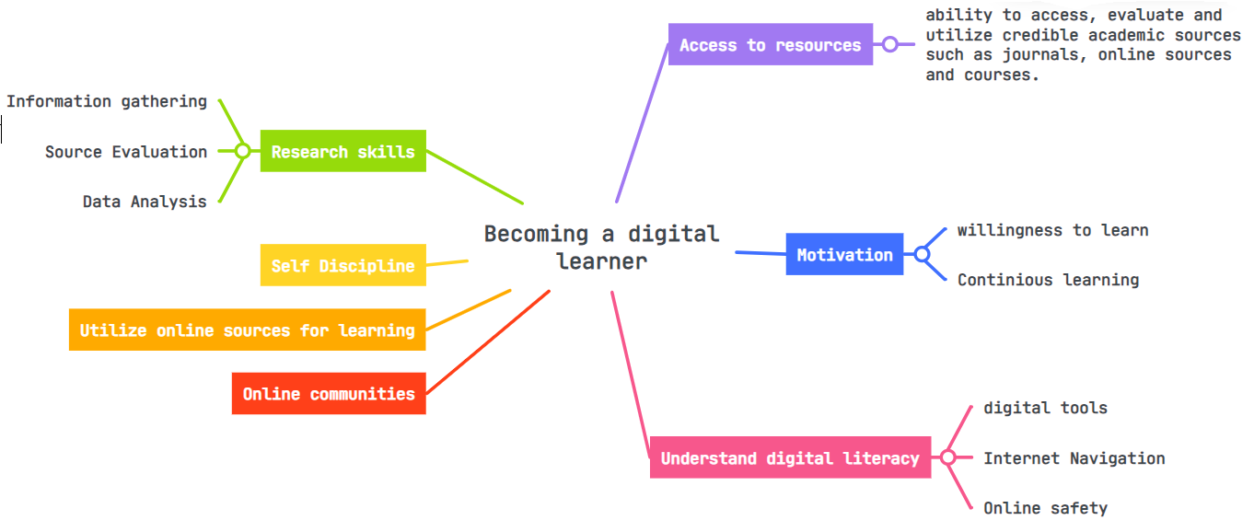

This mind map has been made using the website https://www.mindmeister.com/app/map/3056900474

Mind Map Outline
Research skills
- Get data from the credible sources, such as, libraries, online databases & academic journals and websites (Manzoor et al., 2012).
- The ability to collect, evaluate and analyse information.
- This includes understanding what credible sources are and from information can be extracted and used.
- The ability to read thoroughly and picks out relevant information.
- The ability to do data analysis using statistical tools to draw meaningful conclusion.
- The ability to write research findings in a proper format such as, report and presentations.

Self-Discipline
- Creating goals, managing schedules and maintaining consistency in learning.
Utilize online sources for learning
- Individuals can get enrolled in online courses.
- YouTube is a great source to learn things online.
- Get access to virtual libraries for wide research.
- Approach digital tutorials for learning purpose.
- Learn about the industry from professionals through webinars.
Online Communities
- There are numerous communities where individuals help each other to understand things better.
Access to resources
- Ability to access, evaluate and utilize credible academic sources such as journals, online sources and courses.
Motivation
- The individual must possess the willingness to learn and adapt to the new curriculum.
- Learning is an ongoing process and the individual must remain motivated to achieve outcomes.
- A motivated individual will be more confident in his studies and career.

Understand digital literacy
- Expert use of computer programmes including Moodle, Adobe Photoshop, Microsoft Office, and Grammarly
- Capabilities for navigating the internet, such as proficiency with different browsers (Manzoor et al., 2012)
- Knowing about firewalls, malware, and cybercrimes as well as having an understanding of internet safety
- The ability to effectively use digital platforms for information retrieval, collaboration, and communication
- Knowledge of programming ideas or rudimentary coding skills
- Understanding the value of safe online behaviour and data privacy
- Aptitude to learn new digital tools as necessary and adjust to changing technologies
- Proficient utilisation of search engines for investigation and resolution of issues
- Familiarity with storage options and the cloud
- Proper knowledge about social media platforms and applying responsible behaviour online
- To assess the trustworthiness and dependability of internet content, use critical thinking abilities.
Video Presentation Screenshots

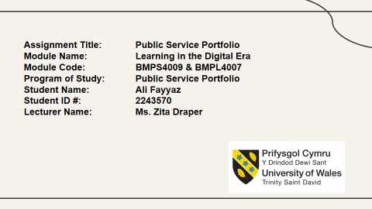
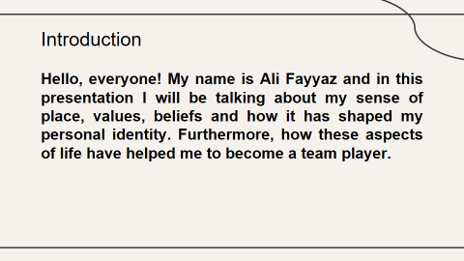
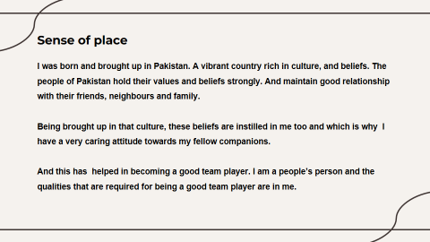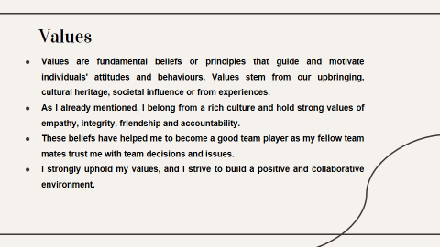
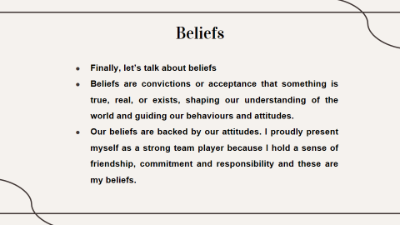
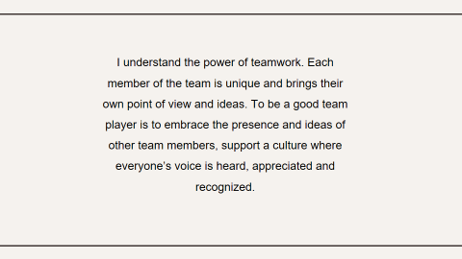
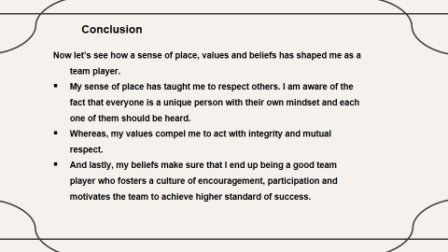
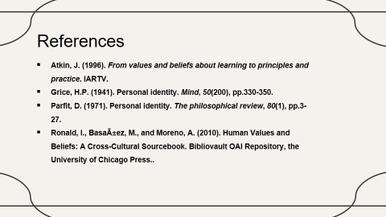

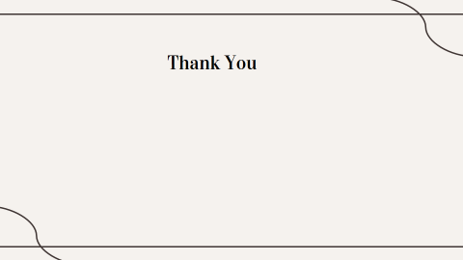

Gibbs Model of Reflection
Gibbs model of reflection was presented by Graham Gibb in the year 1988. This model is a reflection cycle which allows an individual to share his experience from begging till the end (Gibbs 1998). The experience he gained, the weaknesses he found and the areas of improvement that he needs to work on. The figure shows in detail Gibb’s reflective cycle.
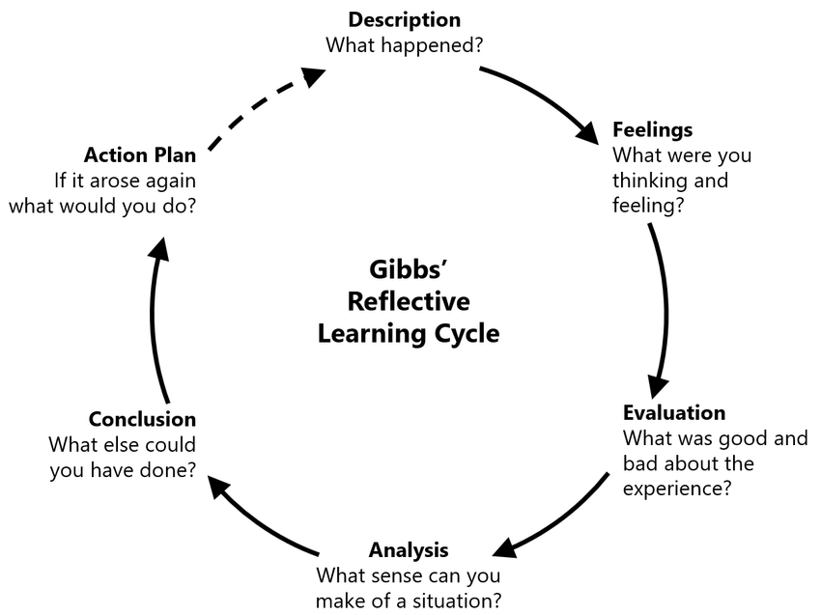
Today, using this reflection model I’ll be sharing the journey of my reflection cycle the day when I entered the college, was introduced to digital learning material and the first assignments.

Description
Starting University: The first step in this reflective cycle is to describe the experience in detail (Mind Tools, 2022). The first year of the college is always very overwhelming. I had a mix of emotions I was internally excited but scared too. What if, I can’t cope with the studies, what if I am unable to achieve my goals, is this the right path for me? These were some of the questions that were roaming in my mind.
At first, I even thought that law school will be a dry and boring place. Law study is itself quite difficult. Hence, having to cope up with up with that might be a task.
Online learning: Technology is everywhere. So, definitely it has to play a role in our curriculum as well. Our teachers introduced us with online educational platforms where we can find all our lectures, assignments and learning material. They also introduced us with a number of online learning platforms which can be beneficial for our studies.
Writing first assignment: the first assignments are always the scariest one. First of all, you are new to the place and have been taking your time in making adjustments, understanding the curriculum. Then along came the assignment. Which was a bit hard to understand as it was the very first one and the fear of not understanding it completely and failing it was there.

Feelings
Starting university: There were feelings of excitement and nervousness. We were introduced to the law books which were quite wholesome to give a panic attach. Then came in the jargons which I thought I would never be able to learn. At this point, I was looking for some human sources who I can befriend and talk to and share my eagerness and excitement.
Online learning: I have always been good with computer. The ability to grasp technology and navigate between browsers is on my fingertips. I was happy with accessing the work material online and was exploring more digital platforms to enhance my knowledge.
Writing first assignment: It was a task to understand the assignment correctly. However, I took baby steps. I used to read the assignment guide carefully, make notes and solving it accordingly. Our teachers were there to guide us at each and every step which also makes the process easier.

Evaluation
If I had to access the whole situation and summarize an outcome out of that, I would say that confidence is the key to survive in the initial days. Anxiety and insertions are not going to lead us anywhere. From the day one you should be sure about your choices and confident about them that you are going to achieve them.
Online learning: Online learning felt like a blessing and a curse. While there was plenty of information, skimming through those to get the required information is a daunting task. Additionally, legal writing is something that was new to be. Grasping the intricacies of legal writing and analysis required concerted effort and practice which was a challenging task.

Writing first assignment:
Writing the first assignment was a journey of self-growth. It exhibited my ability to research, basically analyse information, and present my thoughts rationally. Additionally, looking for input from companions and tutors highlighted the importance of collaboration and continuous improvement. However, I realize the need to further enhance my time management skill to meet future assignment deadlines more effectively.

Analysis
The key to become confident in your initial years is to complete your homework, make companies, and talk with seniors. Seniors are someone who you can look up to for guidance and assistance and your friends will be the one to stand by you in your low times. This is what I have experienced and is practicing till now.
Online learning: Adapting to online learning gave a sense of self-discipline and adaptability. It teaches to adapt and be open to new things while also, it develops a sense of self-discipline among students. I got to know that apart from university online portal, online libraries, forums, and webinars was crucial to supplementing lectures.
Writing first assignment: It builds a sense of how an assignment should be. What areas should we focus on and what is the formal way of writing. Also, the process of writing assignments involved not just understanding legal principles but also mastering the art of constructing persuasive arguments supported by case law and statutes.

Conclusion
The journey into law school, despite its initial challenges, has been immensely rewarding. Each assignment has served as a stepping stone, honing not only legal knowledge but also critical thinking and analytical skills. Over time, becoming familiar with legal databases and learning to sift through pertinent information became second nature.

Action plan
Moving forward, I aim to enhance my legal writing skills by continuously practicing and seeking feedback. Additionally, I plan to engage more actively in online discussions, collaborate with peers, and make the most of available resources to deepen my understanding of legal concepts.
Transitioning into university as a law student, adapting to online learning, and conquering the intricacies of legal writing has been formidable yet enriching experiences. They've laid a strong foundation for my journey into the world of law, shaping not only academic prowess but also fostering resilience and adaptability in the face of new challenges.

Personal Development Plan

Personal Development Plan Chart
Self-evaluation: | Personal/Professional Development Needs: | SMART Development Goals: | Time Duration needed
Working on this assignment and my reflection made me realize the mistakes and the areas of improvement that I should work upon.  These are;  - Reading and note-taking skills  - Time Management skills  - Communication skills  - Attention to detail  - Legal writing  - Analytical thinking | Reading and note-taking skills:  Excessive reading is something that law students are bound to do (Griffiths, 2021). As a law student, I have to go through a lot of information in order to get the desired one. Being a lawyer means to memorize laws, of course, and scrutinize information for which deeper concentration is required. | Specific: Aim is to develop reading habit for which I have to read at least two articles per week from a credible source or a newspaper carefully and make notes out of it.  Measureable:  Proof read the notes I have made to check whether it covers the main theme of the article.  Also, will have to ask a classmate to do the same for me.  Achievable: Articles can be accessed through online platforms and university authorized portals too.  Relevant: Attaining this skill will help me to excel in the law career.  Timely: It is important to achieve this and to do that I will set a weekly goal and conduct my weekly evaluation. | Per week assessment
 | Time management: the ability to complete the work on time is important now more than ever. Law is a comprehensive study which demands time and attention to detail. Managing the time effectively is essential to keep up with coursework and also to participate in extracurricular activities as well (Schwartz, 2008). | Specific: Be punctual. Try to do all the work/ assignments on time.  Measureable: Submitting assignment before the deadline is a way to understand if I am able to follow a schedule or not.  Achievable: I have to build a sense of responsibility in myself. I have to keep reminding myself how important my studies and my future goals are.  Relevant: Time is money and to be successful one must learn to make the most out of their time.  Timely: weekly self- assessment. | Weekly evaluation
 | Legal writing: Law school has taught me the art of legal writing. Previously, I have never paid attention to my writing school, but now this is the area I have to work on. I must practice to articulate arguments clearly and persuasively. Writing memos, briefs, and other legal documents requires concise and precise language. | - Specific: As discussed before the art of legal writing should be perfected by a law student Schwartz, 2008). So my goal here is to enhance my legal writing skills by focusing on constructing concise arguments.  - Measurable: Look for an online community that will help me to construct these skills. Also, I will complete and submit two practice legal memos per month for review and feedback.  - Achievable: Construction of these is backed by extensive research. Therefore, I will allocate 1-2 hours daily for researching, outlining, and drafting each memo.  - Relevant: Attend a legal writing workshop or seminar to gain additional insights into effective legal writing techniques (Schwartz, 2008).  - Time-bound: Aim to improve memo writing skills within six months by consistently practicing and incorporating feedback. | 3-6 months
 | Analytical Thinking: Being able to critically analyse cases, statutes, and legal principles is crucial for a law student (Griffiths, 2021). It involves breaking down complex information and identifying key points. A law graduate must be able to critically analyse, make legal reasoning and must be able to creatively think. (Kalinowski, 2015). | Specific: To be able to analyse and interpret information correctly and make sound arguments on that.  Measureable: Brainstorming and team discussions are a great method to view different opinions on a same topic (James, 2012). This enhances a person’s ability to think outside of the box and encourage analytical and creative thinking (James, 2012).  Attainable: building on-campus group meetings, and online communities or even discussing a paper with your instructors are a great way to enhance this skill.  Relevant: this skill is necessary if I want to pursue a career in law. Hence, building this skill at this stage would be beneficial.  Time-bound: bi-weekly assessment. | Bi-weekly.

References

Bjerke, M.B. and Renger, R., (2017). Being smart about writing SMART objectives. Evaluation and program planning, 61, pp.125-127.

Das, S. (2023). UK universities paying millions in agent fees to secure international students. The Observer. [Online] 18 Nov. Available at: https://www.theguardian.com/education/2023/nov/18/uk-universities-paying-millions-in-agent-fees-to-secure-international-students [Accessed 27 Nov. 2023].

Diggs, P. L. (1970). Communication skills in legal materials: The Howard Law School program. University of Toledo Law Review, 2-3, 763–789.

Geertshuis, S., Jung, M. and Cooper-Thomas, H. (2014). Preparing Students for Higher Education: The Role of Proactivity. International Journal of Teaching and Learning in Higher Education, 26(2), pp.157-169.

Gibbs, G. (1998). Learning by Doing: A Guide to Teaching and Learning Methods. Oxford: Further Education Unit, Oxford Polytechic.

Gigliotti, R.A. and Ruben, B.D. (2017). Preparing higher education leaders: A conceptual, strategic, and operational approach. Journal of Leadership Education, 16(1), pp.96-114.

Griffiths, C. (2021). The law schools’ “easy win”? Improving law students’ experience through embedded and non-embedded writing support, The Law Teacher, 55:3, 377-391.

James, N. (2012). Logical, critical and creative: Teaching ‘thinking skills' to law students. Law and Justice Journal, 12(1), pp.66-88.

Kalinowski, B.A. (2018). Logic Ab Initio: A Functional Approach to Improve Law Students' Critical Thinking Skills. Legal Writing: J. Legal Writing Inst., 22, p.109.

Kruss, G., McGrath, S., Petersen, I.H., and Gastrow, M. (2015). Higher education and economic development: The importance of building technological capabilities. International Journal of Educational Development, 43, pp.22-31.

Manzoor, M., Hussain, W., Ahmed, A. and Iqbal, M.J. (2012). The importance of higher education website and its usability. International Journal of Basic and Applied Sciences, 1(2), pp.150-163.

Mind Tools, (2022). Gibbs Reflective Cycle. [Online] www.mindtools.com. Available at: https://www.mindtools.com/ano9qiu/gibbs-reflective-cycle [Accessed on: 28th November, 2023].

Schwartz, M.H., (2008). Expert learning for law students. UK: Carolina Academic Press.

University of California (2017). SMART goals: A how to guide. [Online] Available at: https://www.ucop.edu/local-human-resources/_files/performance-appraisal/How%20to%20write%20SMART%20Goals%20v2.pdf [Accessed on: 28th November, 2023].

