

Managing Enterprise in the 21st Century

Business Plan
Student Name: Duaa Alhaj Ahmad (2439821)
Course Name: Enterprise and Entrepreneurship (LCLM4006_LON)
assignment title: Individual Written Business Plan (Blush & Bloom Salon)

Submission Date: 28/3/2026
Lecturer: Richard Ashaye
Table of Contents
Group Information 2
Executive Summary 3
overview……………………………………………………………………………………...3
business concept……………………………………………………………………………4
Business Description (Legal format) 4
Business Objectives (SMART Objectives) 4
Short-Term Objectives (less than a year) 4
Long-Term Objectives (less than a year) 4
Market Analysis and Marketing Plan 5
Market Analysis (Competitors, Customers, Target Groups) 5
PESTEL Analysis 5
Marketing communication 5
Market Segmentation………………………………………………………………………5
Management Team and Their Background 6
Organisational Chart 6
Financial Plan (One Year) 7
Sources of Finance 7
Cash Flow Forecast 7
Sales Forecast 7
Cost of Production Forecast 7
Break Even Analysis 7
Operations and Management Plan 8
Production of Good and Service 8
Human Resource Plan 8
Expansion Plan 8
References List…………………………………………………………………………9

Executive Summary

The business Blush & Bloom Salon is about a beauty salon for women mainly that are aged between 16-50 years old. The business will be providing beauty and self-care services. It will be in London nearby banquet hall, as the owner is already seeing the potential in its location. The start up costs will be around £10,000 focusing on legal fees such as insurance and rent and it will be containing the materials like chairs and tables. The business expects to breakeven in the first 2 to 3 months and it will be successful further in future.

Overview

The business is in beauty industry that offers various of beauty services such as makeup look and hair care and hair styles, and nails care and nails designing. The common issues in the salon and middle stander results, the salon will be providing affordable prices in a high-quality result. The main site will be in London nearby banquet hall. The privilege about this business is about offering in Arabic traditional make up look for occasions. For the hair sector it will be service with Arabic useful hair products to treat the hair.

Business Concept

The business is aiming to be gain its popularity by getting known by it is own services. For the makeup service we will be offering wide range of makeup looks such as Arabic makeup, bridal makeup, graduation makeup and photoshoots makeup looks. The hair will be hold in having creative and there will also be hair treatments for the clients, and we will allow them to discover the suitable treatments for their hair. As we will offer nails care and polish and unique nails designs. All these services will be targeting the satisfactions and comfort for the clients.

Business Description (legal format)

The business will be as sole trader; it allows the owner to have the full control on the profits and the losses. For the founding it will by personal saving and the support of the family. The sole trader will be beneficial as it is easy to create by the owners. Also, the taxes on the business owner must file an annual taxes self-assessment. The business will be offering roles starting from manager, secondly, there will be receptions for managing the booking and any assist for the clients. The owner will be the main makeup artist there will be also a skilled makeup artists. For the nails and hair sectors, the owner and the manager will be hiring the freshly gradations beauty students to permit the students to pick creative staff and let them to experience a professional career.

Business Objectives (SMART Objectives)

The business will set clear and measurable goals:

Short-Term Objectives (less than a year)
• Attract at least 25 customers within the first month
• Build a strong page on social media and website.

Long-Term Objectives (More than a year)
• Developed services and hire more staff
• Move to a larger location

Market Analysis and Marketing Plan (Competitors, Customers, Target Groups)

The beauty industry in London is highly competitive. However, Blush & Bloom Salon will be offering affordable prices and unique products.
Competitors:
• Local beauty salons in London
• Independent makeup artists
Target customers:
• Women aged 16-60
• Students, professionals and brides

PESTEL Analysis
Political: the UK government has regulations for small businesses. There is also health and safety rules. There is license for the business.
Economic: the business will be depended on people income.
Social: is about what popular in the community and what are the trends which can include the Salon
Technological: the Salon will build strong website for booking appointments. And there is social media which will allow people to sight on the salon.
Legal: is to make sure the business pay the insurance and registration to enhance the business.
Environmental: customers are looking now for ecofriendly and natural products.

Marketing communication
The business will use social media platforms such as Instagram and TikTok to promote services and showcase makeup results. These platforms will help attract customers and build brand awareness. The business will be promoted in TikTok ads and influencers. There is also will be loyalty programs.

Discounts will be offered during peak seasons such as graduations. Affordable pricing will be maintained to attract a wide customer base. The salon location near banquet halls will also support marketing efforts by increasing visibility
Market Segmentation
Segmentation: The target market for Blush & Bloom Salon is segmented based on demographic, geographic, behavioural, and psychographic factors. Demographically, the business focuses on women aged between 16 and 60, including students, working professionals, and brides. Geographically, the salon will be in London, specifically near banquet halls to attract customers attending special events. Behaviourally, the business targeting customers who require beauty services for special occasions such as weddings, graduations, and parties during peak seasons. Psychographically, the salon focuses on women who value beauty, self-care, and confidence, and who prefer high-quality services at affordable prices. Targeting: The business will focus mainly on women who need beauty services for special occasions. The salon will position itself as a high-quality yet affordable beauty service provider in London. It aims to stand out by offering professional makeup services, using effective Arabic hair products, and providing a comfortable and welcoming environment.
Blush & Bloom Salon will be recognised as a reliable choice for customers who want professional results at reasonable prices.

Management Team

Management Team and Their Background

Organisational Chart

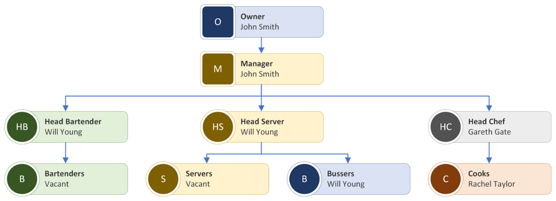

Key Milestones

Financial Plan (One Year)
The business requires approximately £10,000 to start up. This founding will be sourced from personal saving and family support and sole trade format, which reduce financial risks. For one year the finance will be paid for the rent, equipment, materials and taxes.
Fixed cost
Variable cost

Sources of Finance

Personal saving and family support

Cash Flow Forecast
The business expects around 3 to 6 clients per day. The average price per makeup service is £30 and for the hair it will be £25 for the nails it will be £35. In these prices the business can gain around £165 to £200 per day. For the monthly revenue is estimated to be between £3,000 and £5000 depending on demand

Sales Forecast

Cost of Production Forecast

The main costs of the business including makeup, hair, nails products, rent and marketing. Monthly rent is estimated at £1,500. Makeup products cost around £1,000. For the hair products cost £1,300 and for nails products cost around £1,200 initially. Equipment such as chairs and mirrors and tables cost £900. Marketing costs are estimated at £500.

Break Even Analysis

The business is expected to break even within 2 to 3 months, depending on customer demand and effective marketing strategies. This means the business will start making a profit after covering all initial costs.
Break - even = Fixed Costs Price per service = £5,000 £30 = 167 customers per month

Operations and Management Plan

Th5 ere will be career for specific hours from 9 to 5, seven days a week. My mainly focus will be to hiring graduation students staff. The owner will be managing to all the services in the salon. the equipments will be used is makeup kits, chairs, mirrors.

Production of Good and Service

Technology Plan

Human Resource Plan

Expansion Plan

In the future, the business plans to expand by hiring more staff and increasing service offerings. The salon may move to a larger location and introduce new beauty treatments. The long-term goal is to build a strong brand and potentially open additional branches in other areas of London.

Reference List

Barrow, Barrow, P., & Brown, R. (2012). The business plan workbook (7th ed.). Kogan Page.
Kotler, P. and Keller, K.L. (2016) Marketing Management. Marketing Management 15th edn. Harlow/Boston: Pearson
Mariotti, S., & Glackin, C., (2017). Entrepreneurship: Starting and Operating A Small Business, 4th Edition, Pearson.

