UNIVERSITY OF WALES TRINITY SAINT DAVID
LONDON CAMPUS
Assignment 2
Learning in the Digital Era
Video Link
A presentation on Self-Evaluation, Professional Development Plan and Topic Summary.pptx

Module Name: Learning in the Digital Era
Module Code: ACCA 4025

Student Name: SHEKHAR ANANT NAIK .
Student ID: 2544915
Group: Group 3

Lecturer’s Name: Anees Baqir

Table of Contents
Introduction 2
Main Body 2
Conclusion 9
References 9

Introduction
This document provides evidence of my presentation slides through screenshots of each slides with brief explanations. It focuses on Self – evaluation, Reflective model, Professional Development Plan and Unit4. Topic summary – Learning to Learn.

Main Body
This document includes all slides from cover page to contents followed by Gibbs Reflective Model, Self - evaluation, traits gained from self-reflective, Professional Development Plan and Unit 4 – Learning to Learn, following with conclusion and references.
Video Link: A presentation on Self-Evaluation, Professional Development Plan and Topic Summary.pptx

Slide 1 COVER PAGE
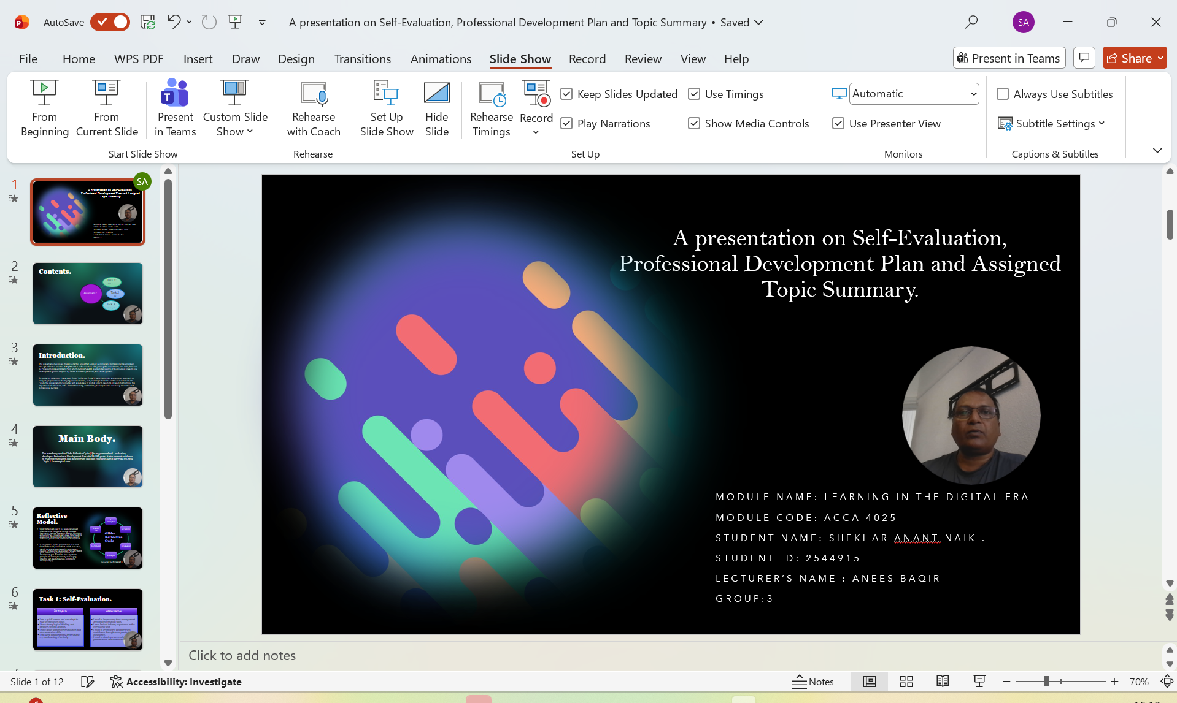
Slide 2 CONTENTS
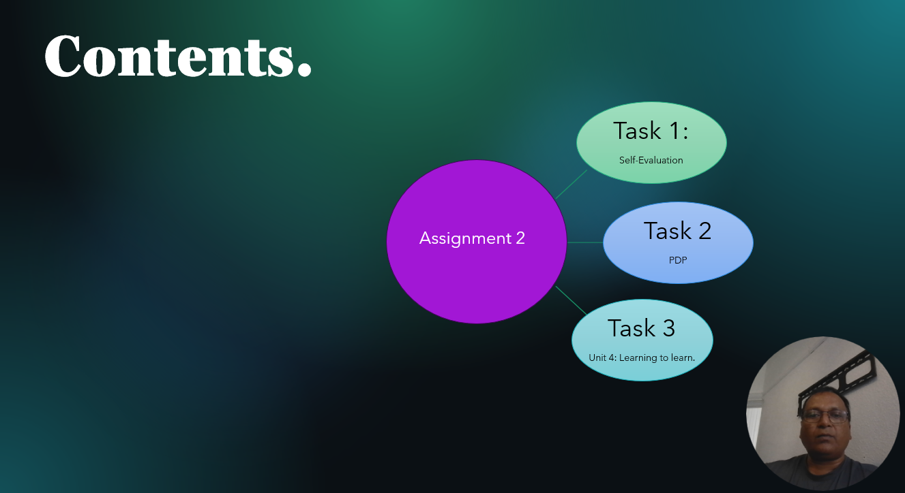

Slide 3 INTRODUCTION
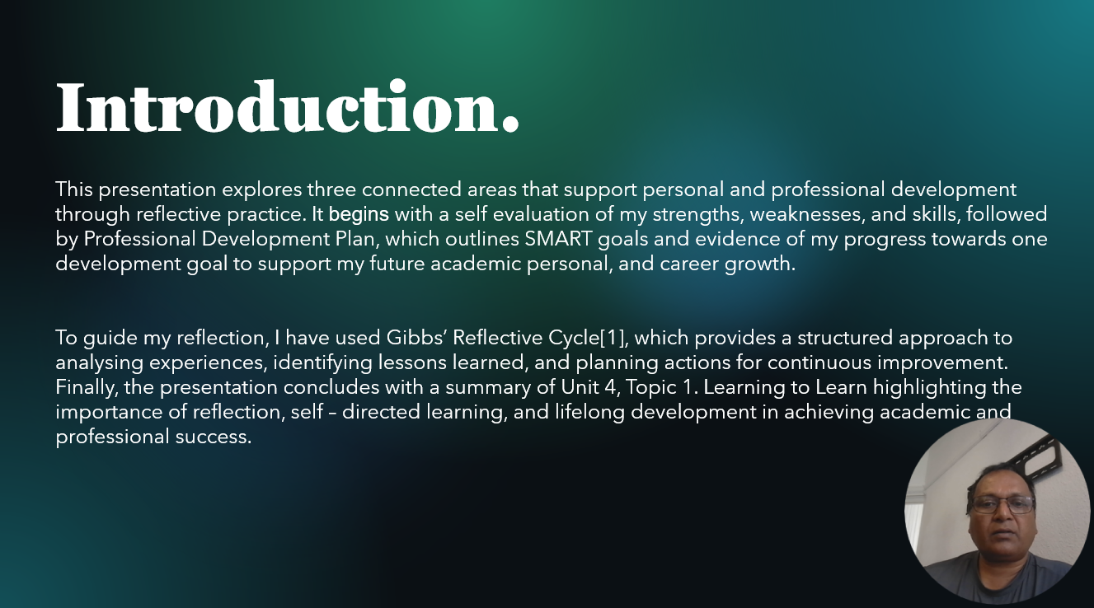

Slide 4 MAIN BODY
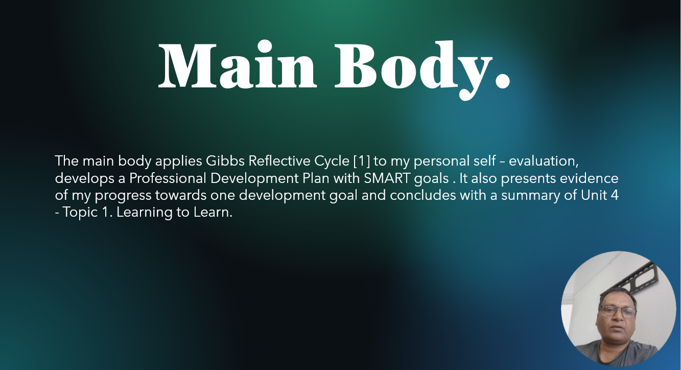

Slide 5 GIBB’s REFLECTIVE MODEL
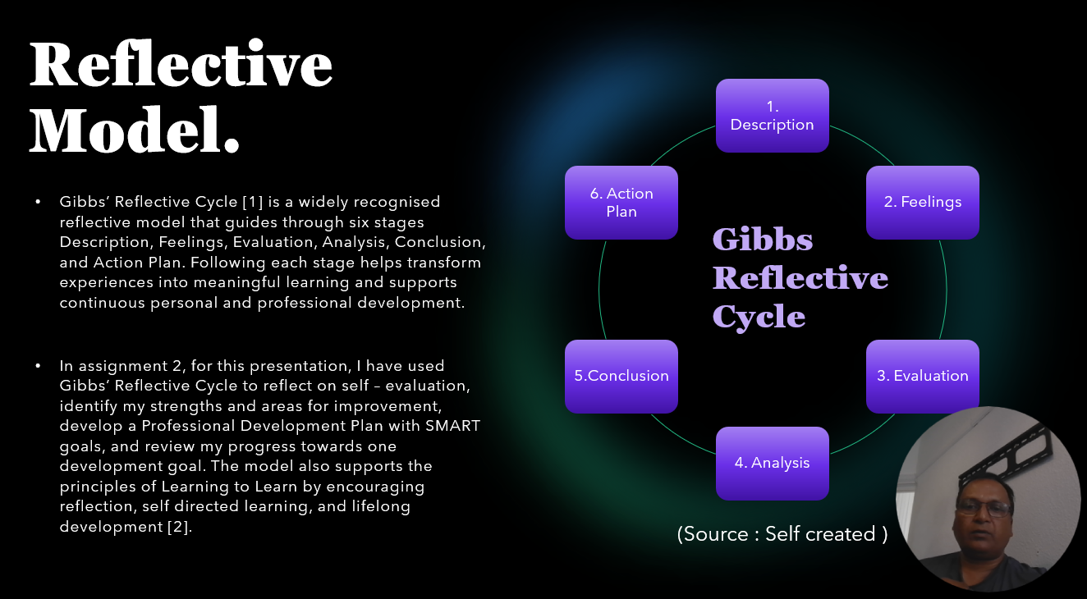
Brief explanation: Gibbs Reflective Cycle is a model with six stages such as Description, Feelings, Evaluation, Analysis, Conclusion, and Action Plan. It helps me reflect on my experiences and identify what I have learned.
For this assignment I have used Gibbs model to reflect on my self-evaluation, identify my strengths and areas for improvement, create SMART goals, and review my progress towards my developmental goal.

Slide 6 TASK 1: SELF EVALUATION
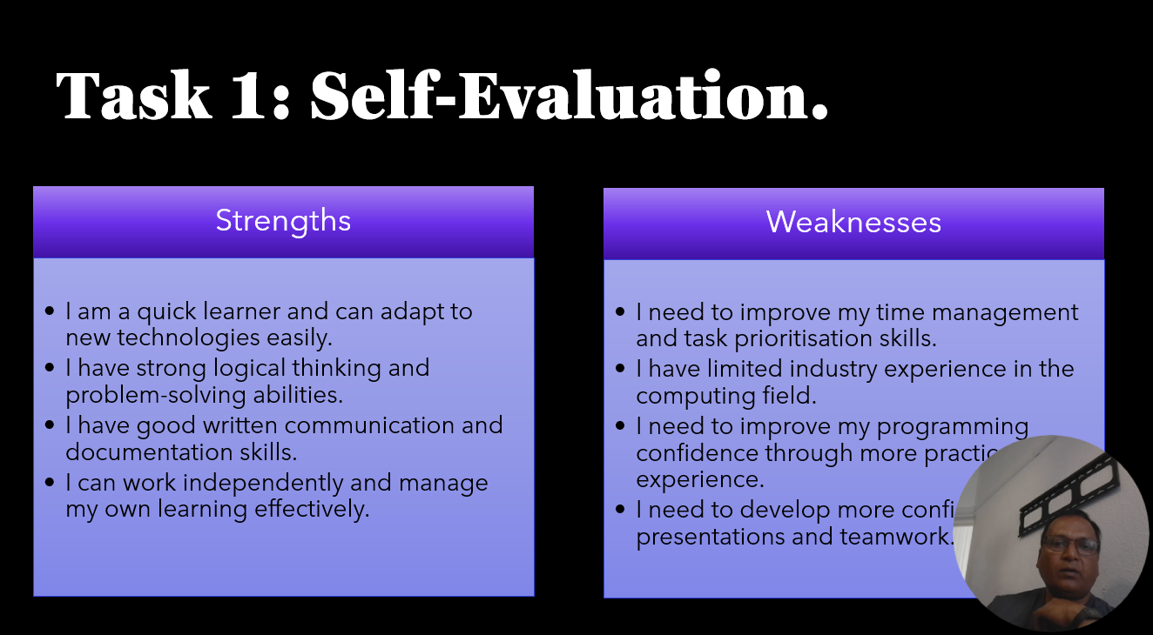

Brief explanation: For the self-evaluation task, I looked at my own strengths and weaknesses. I found that I learn new things quite quickly, I am good at solving problems, and I can work independently. At the same time, I realised that I need to improve my time management, programming skills, teamwork, and confidence when presenting. This self-evaluation helped me understand which areas I should focus on improving.
Slide 7 TRAITS GAINED FROM THE SELF EVALUATION
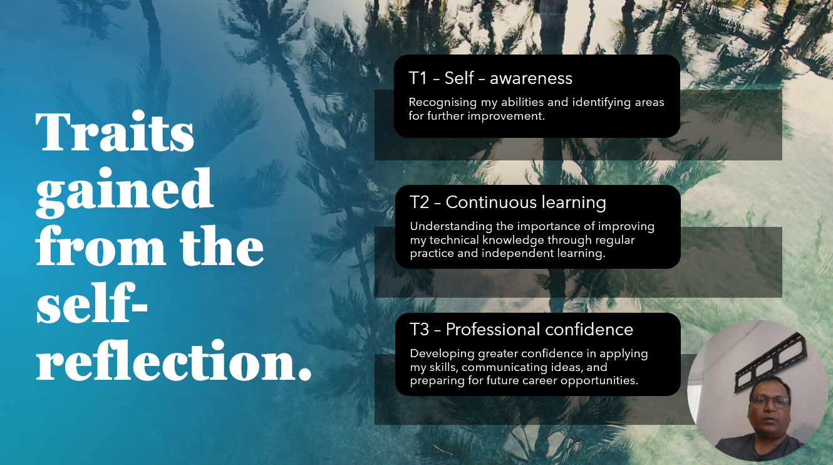

Brief explanation: Through self – reflection, I developed better self – awareness by understanding my strengths and areas for improvement. I also recognised the importances of continuous learning through regular practice and improving my technical skills. This helped me build professional confidence in applying my skills, sharing ideas and preparing for future career opportunities.
Slide 8 PROFESSIONAL DEVELOPMENT PLAN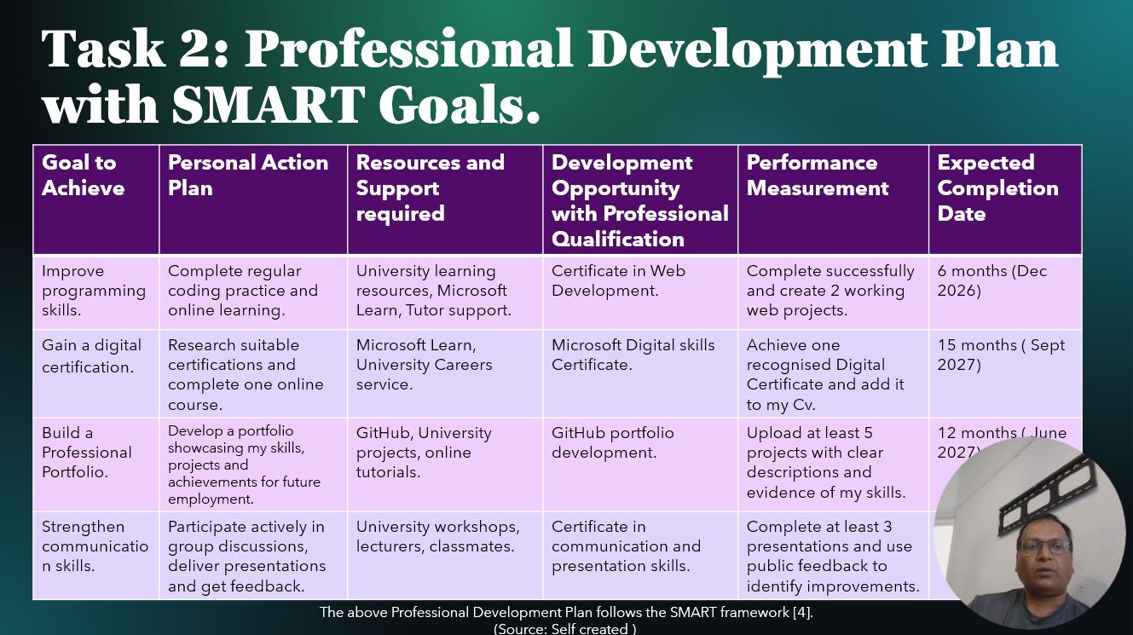Brief explanation: This slide shows my Professional Development Plan with the SMART goals. My main goals are to improve my programming skills, gain a digital certification, build a professional portfolio, and improve my communication skills. I have set clear actions and deadlines for each goal so I can track my progress and prepare for my future career in computing.
Slide 9 UNIT 4 TOPIC SUMMARY
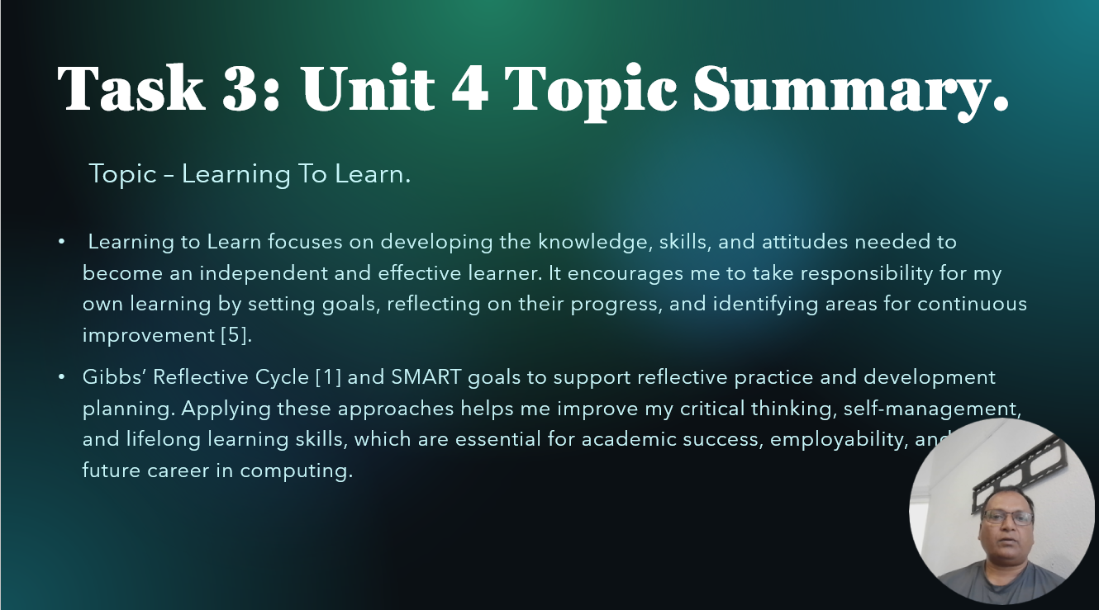
Brief explanation: Learning to Learn is about understanding how I learn and taking responsibility for improving my skills. Gibbs reflective Cycle helps me think about my experiences and understand what I can do better, while SMART goals helps me plan clear and realistic targets.
Slide 10 CONCLUSION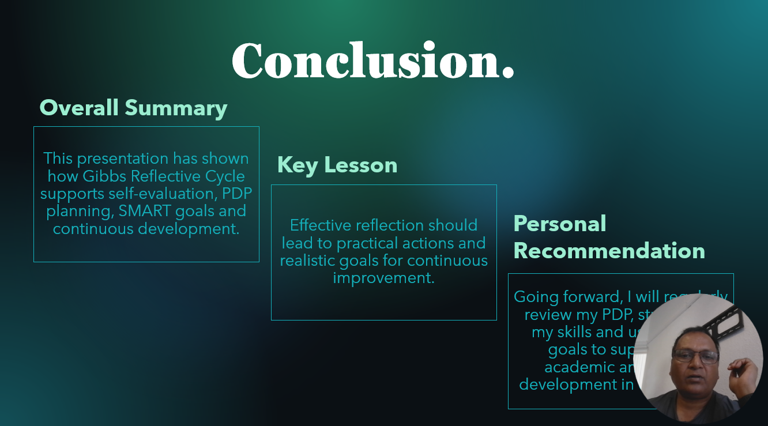
Brief explanation: Overall, Gibbs reflective cycle helped me identify areas for improvement and set realistic SMART goals. I will continue reviewing my Professional Development Plan, developing my skills, and working towards my academic and career goals in computing.
Slide 11 References
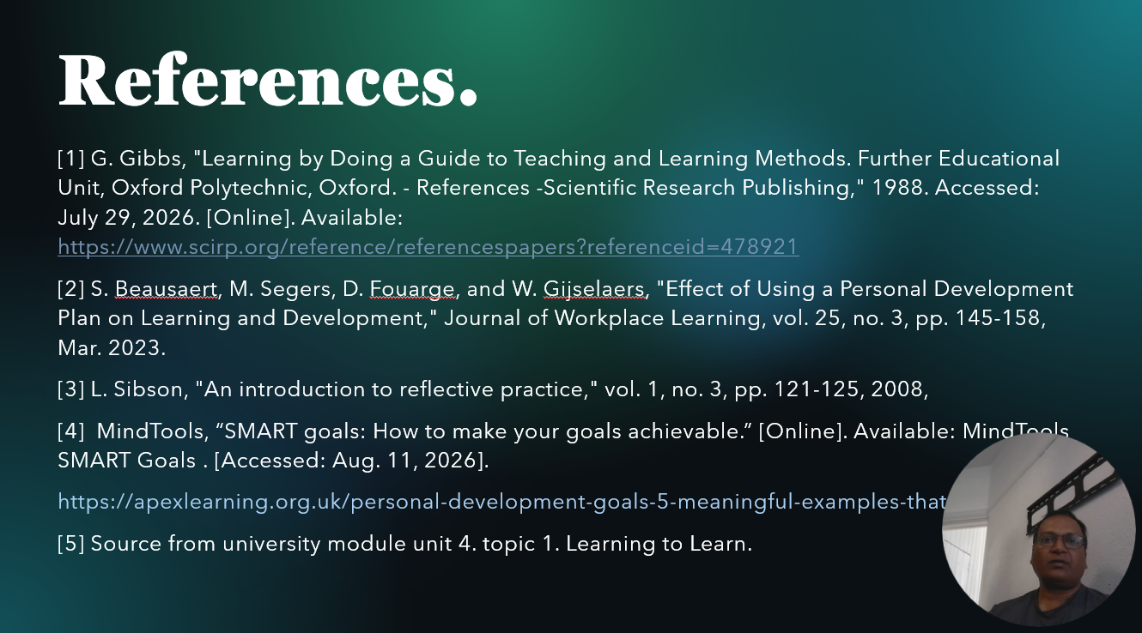

Conclusion
To conclude, this document provides presentation slides through screenshots of all slides with brief explanations. The slides demonstrate my understandings of self-evaluation, Reflective model, Professional Development Plan, Learning to Learn.

References
[1] G. Gibbs, "Learning by Doing a Guide to Teaching and Learning Methods. Further Educational Unit, Oxford Polytechnic, Oxford. - References -Scientific Research Publishing," 1988. Accessed: July 29, 2026. [Online]. Available: https://www.scirp.org/reference/referencespapers?referenceid=478921
[2] S. Beausaert, M. Segers, D. Fouarge, and W. Gijselaers, "Effect of Using a Personal Development Plan on Learning and Development," Journal of Workplace Learning, vol. 25, no. 3, pp. 145-158, Mar. 2023.
[3] L. Sibson, "An introduction to reflective practice," vol. 1, no. 3, pp. 121-125, 2008,
[4] MindTools, “SMART goals: How to make your goals achievable.” [Online]. Available: MindTools SMART Goals⁠￼. [Accessed: Aug. 11, 2026]. https://apexlearning.org.uk/personal-development-goals-5-meaningful-examples-that-work/
[5] Source from university module unit 4. topic 1. Learning to Learn.

