Dissertation
Correlation between serious offenders and ACEs
Adverse childhood experiences cause impact to behaviour in adulthood. Does this link to serious convictions of crime?



Name: Ela Roberts
Student ID:1900589
School: UWTSD Swansea
Word Count: 8500
Declaration



Acknowledges

Firstly, I would like to thank Rhiannon Lloyd my project supervisor for her knowledge, encouragement and motivation during the procedure and process of writing the paper. I would also like to thank Mike Durke, the main module tutor for his support and for providing relevant resources.
I would also like to thank all the participants who took the time to answer my questionnaires. These valuable responses have enabled me to help gather a substantive amount of information which has contributed to me being able to formulate a conclusion to my topic.
As well as these, I would like to again thank my family and friends for their support throughout the three years of my study, particularly during the period where I have been completing my dissertation. They have shown encouragement and support throughout the whole completion of the paper which I am very thankful for.

Abstract

Individuals who have experienced adverse childhood experiences and later gone on to be serious offenders of crime are seen to be linked due to the impact their experience has placed on them in adulthood. The negative impact of such an experience without appropriate support and intervention can be considered as a contributing factor in relation to poor decision making and life course choices. For some individuals this is particularly evident where there have been multiple adverse childhood experiences.

For the purpose of this study a questionnaire was devised and sent out to a range of individuals to identify if there is a link, what support was missing for them and whether any support at the time would have assisted in reducing the risk of serious criminality during adulthood.

Following the conclusion of the data collated, it evidenced many people have experienced adverse childhood experiences but have not gone on to be involved in crime however, for some it has been linked to the lack of support and poor opportunities and guidance at home, school and within certain communities.
Table of Contents
Chapter One: Introduction 8
1.1 Background 8
1.2 Rationale 9
1.3 Objectives 9
1.4 Research Techniques 10
1.5 Conclusion 11
Chapter Two: Literature Review 12
2.1 Introduction 12
2.2 What are ACEs? 12
2.3 What are the effects of ACEs? 13
2.4 What is a serious offender? 14
2.5 What are the links between ACEs and offending behaviour? 15
2.6 Preventing ACEs to reduce crime 17
2.7 Conclusion 18
Chapter Three: Methodology 19
3.0 Introduction 19
3.1 Research Onion: 19
3.1.2 Philosophy 20
3.1.3 Approach 21
3.1.4 Strategies 21
3.1.5 Choice: 22
3.1.6 Time Horizon 22
3.2 Techniques for data collection, process, and analysis 23
3.2.1 Data Collection: 23
3.2.2 Survey Design 23
3.2.3 Literature review matrix 24
3.2.4 Pilot study 26
3.2.5 Reliability and validity 26
3.2.6 Limitations 27
3.2.7 Ethical Considerations 27
3.3 Conclusion 27
Chapter 4: Findings 28
4.1 Introduction 28
4.2 Data analysis 28
4.3 Methods 28
4.4 Demographics and Descriptive Statistics 29
4.5 Data presentation 29
Chapter 5 - Conclusion and Recommendations 39
5.1 Introduction 39
5.2 Findings 39
5.3 Conclusion 39
5.4 Recommendations 40
Chapter Six- Bibliography 41

List of Figures

Figure 3.1: The Research Onion (Saunders et al., 2016)
Figure 4.1: Graph Presenting Data Findings from Question 2
Figure 4.2: Showing the percentage of male and female participants
Figure 4.3: Showing the ethnic background of the participants
Figure 4.4: Showing the amount of people that experienced adverse childhood experiences
Figure 4.5: Showing what way the participants that answered yes experienced childhood experiences
Figure 4.6: showing the percentage of people that stated if parents understood their worries/problems whilst growing up.
Figure 4.7: Showing the participants opinions on if their parents/guardians were aware of what they were doing with their free time when they were younger.
Figure 4.8: Showing whether any of the participants lived with a member who was ever sent to prison.
Figure 4.9: Showing results of if the participants parents were ever separated or divorced.
Figure 4.10: Showing results of participants that have been involved in criminal activity.
Figure 4.11: showing results of the people that answered yes to question eleven and what age they were involved in the criminal activity.
Figure 4.12: Showing if the participants agreed with the statement ‘A stable up bringing leads to less likely hood of being involved in crime in adulthood?’
Figure 4.13: Showing results on if the participants thought that serious crime results from poor models in childhood.
Figure 4.14: Results from asking participants if they think positive education reduces risk of being involved in crime.
Figure 4.15: Results of people’s opinion on if they believe ACEs link to serious crime.

Degree: Professional Policing
Due Date: 6th May 23:59 2022

Chapter One: Introduction

This dissertation is designed to investigate the correlation between serious offenders and Adverse Childhood Experiences (ACE’s). The topic of my dissertation will highlight research and knowledge I have gained when considering connections between ACE’s and serious offending behaviours. Identification of differing types of behaviours will be discussed along with potential reasonings for such behaviours. Theoretical understanding will be utilised in demonstrating its assistance in analysing behaviour and consequences. Finally, a conclusion with recommendations will be provided.

This topic was important to me to research as it relates to an area of interest, I am keen to further explore through my future career. Evidence gathered as part of criminalised outcomes will be considered to inform knowledge and analysis of convictions imposed for crimes. Interest in this particular domain will consider whether convictions are comparative and whether there are links to reduction of penalties imposed in relation to the ACE’s. Consideration of this will assist in the development of a hypothesis and whether changes to understanding and acknowledging ACE’s for an individual should be considered or whether crime in adulthood should be the same for all no matter what a person has experienced throughout their life.

1.1 Background

Within England and Wales at least one ACE has occurred for more than half of the adult population however, over four ACE’s have been experienced by one in ten of the adult population. By eliminating ACE’s, levels of violence would be lowered by half. Additionally, drug and alcohol dependence would be reduced, and general wellness would increase. Adults with fewer ACE’s are less likely to acquire illnesses including cancer, diabetes, and heart disease.
Stressful and/or traumatic events that occur throughout childhood or adolescence are known as adverse childhood experiences. ACE’s can be referred to as single experience or a series of events considered to place a child or young person at risk of safety, physicality, or as misuse of trust or threat.

ACE’s can affect a child’s future development in addition to potentially having an impact on mental and physical health. Thus, this highlights a child can be significantly harmed by ACE’s in the long term. Traumatic experiences can result in high amounts of toxic stress, which can have an influence on brain development and functioning if they are sustained and persistent.

ACE’s are also said to have an impact on serious offenders. A serious offender is someone who has committed one of the following crimes in a twelve-month period: car theft, burglary, robbery, stealing from a person, assault with injury, or dealing Class A narcotics.

1.2 Rationale

The researcher aims to analyse the effect adverse ACE’s have on individuals and if there is any relation between serious offenders. The researcher feels this topic should be concentrated on as childhood experiences can have a big impact on individuals futures, as it is believed to affect the way people turn out to be. With positive up bringing this could reduce the amount of people that end up criminalised. If the main cause is figured out, then policing and social strategies can help to reduce this.

1.3 Objectives

Key objectives that will be considered will be:

- Identify whether ACE’s have a clear definition in a person’s adult behaviour when linked to behaviour of crime.

-Access the consideration of ACE’s and whether these have an impact on other siblings/relatives where mirrored experiences have occurred.

-Consideration of preventive work or support implemented for the individual and whether this had any positive effect, re-offending/recurrent behaviours and conviction imposed for the offense

-Evaluate whether ACE’s is considered at the time of conviction.

In this regard, this research study will add value to the existing training by making suggestions and laying the groundwork for future research in the issue area.

1.4 Research Techniques

This research project will be divided into five chapters to achieve all four objectives. The first chapter will be an introduction; the second will be a literature review; the third will be the method and methodology for research; the fourth will be the data analysis; and the fifth will be the conclusion and recommendations. Information based on an interview with an anonymous individual who has experienced ACE’s and gone on to commit crime in adulthood, will also be referred to and used to formulate an analysis and potential recommendations for change in preventative crime in the future. Consideration will also be given to the work already being done in this area such as restorative justice.

The researcher wants to employ questionnaires and case studies as the primary research methods for this dissertation. This form of data collation provides participants with the space to be able to respond with information at a depth they feel comfortable, due to the anonymous remits of a questionnaire. For this dissertation, the researcher intends to use questionnaires and case studies as primary research methodologies. Not all participants within research studies share their sensitive information. This could pose some complications in achieving accurate primary and secondary data results for analysis. The final chapter within the research study will conclude by presenting a review of the data discovered and the consequences it entails. This chapter will also highlight potential recommendations in relation to future studies and societal changes including work within this area.

1.5 Conclusion

The purpose of the study, as well as the reasoning and background of the topic, were explained in this chapter. It has also clearly defined the objectives which are to be met. The next chapter discussed will be the literature review. It will examine, assess, and synthesise research findings, theories, and practises by scholars and researchers in a certain field.

Chapter Two: Literature Review

2.1 Introduction

This chapter’s purpose is to evaluate some previous research in relation to ACE’s and the correlation with those who are offenders of serious crime. It is to obtain a better knowledge of the ideas and subjects being discussed throughout this dissertation by reviewing previous literature on the subject. Academic journals, publications, and primary research on the issue have all been included in the literature evaluation.

2.2 What are ACEs?

Traumatic events that occur before the age of 18 are known as ACE’s. These events are listed to include physical, sexual, mental, and verbal abuse of children and also neglect and being exposed to domestic abuse, alcohol misuse/drug misuse within their home (Grasso et al, 2016). Children who have been exposed to ACE’s have a higher chance of developing health problems and anti-social behaviour problems as adults, they are at a higher risk of developing poor health throughout their lives and may require more healthcare and other public services (Centers for Disease Control and Prevention, 2021).

ACE’s are also described to have a damaging impact on well-being, life course and opportunities including education and career. Negative life course can result in maternity issues for mother and child, poor sexual experiences, chronic diseases such as cancer, suicidal tendencies, and injury (CDC, 2021).
Children who have to deal with a lot of stress from a young age may struggle to build healthy and secure relationships. During adulthood they might have difficulties sustaining security within careers, suffer long term depression and have ongoing issues with managing finances.

According to a survey in 2015, ACE’s are very common. In Wales, nearly half of the adults have experienced at least one type of ACEs in their life. By the time people get to the age of 49 years old, 24.9 percent of people with four or more ACE’s had been diagnosed with one or more chronic diseases. The ones with no ACE’s the figure was 6.9% (Welsh government, 2021). Coccoran and McNulty, (2018) state:

“Adverse childhood experiences (ACEs) are traumatic events or chronic stressors that are uncontrollable to the child.” (Coccoran and McNulty, 2018).

An ACE can happen to anyone and having one raises your chances of having another (Felitti et al., 1998). As a result, these childhood events rarely occur in isolation, but rather frequently co-occur (Anda et al., 1999).

2.3 What are the effects of ACEs?

According to KCSEI:

“Where children have suffered abuse and neglect, or potentially traumatic adverse childhood experiences, this can have a lasting impact throughout childhood, adolescence, and into adulthood. It is key that staff are aware of how these children’s experiences can impact on their mental health, behaviour and education.” (KCSIE, 2021).

Adverse childhood experiences can have a negative impact on all aspects of life, not only preventing the development of essential emotional and cognitive skills in young children and adolescents, but also eroding existing talents in older children and adolescents (Daines et al, 2021). Children who have experienced complex trauma may exhibit behaviours or attitudes that match diagnostic criteria for a variety of psychiatric disorders (Furnival and Grant, 2014). Early adversity is linked to poor results later in life, according to ACE’s studies and highlight ACE’s can trigger stress response reactions/behaviours due to the interconnection and impact this has. When a youngster is exposed to repeated ACEs over time, especially when there are no supportive adult connections to provide neutralising protection, the events will cause an exaggerated and long-lasting stress reaction, which can wear down the body. In addition, there is a growing amount of evidence about the long-term impacts (Harvard University, 2022). Information collated and researched by professionals proves ACE’s can contribute to health issues such as autoimmune or heart disease including (Anda et al., 2008; Danese et al., 2009). As well as these diseases it has been proven that ACEs cause mental health issues within individuals such as depression, post-traumatic stress disorder, and anxiety disorders (Anda et al., 2008; Danese et al., 2009). (Anda et al., 2006; Chapman et al., 2004; DeBellis & Thomas, 2003). ACEs can also cause social or behavioural issues, such as an increase in the use of illegal drugs, tobacco, and alcohol, risky sexual activity, antisocial behaviour (Schilling, Aseltine, & Gore, 2007), an elevated risk of suicide attempt (Felitti et al., 1998), and even unemployment are all factors (Liu et al., 2013). It is important that children are helped with their experiences from a young age to prevent any outcomes like these (Ramiro, Madrid, & Brown, 2010). Children that suffer and experience long term stress in younger years can have an impact on normal brain development. Whilst children are young it can be shown in emotional and certain behaviour issues, as they get older and become more mature it can result in showing as risk taking and could even lead to criminal behaviour (Levinson et al, 2016).

2.4 What is a serious offender?

The Criminal and Justice Act 2003 describe a dangerous criminal to be a person who presents as a significant risk or serious injury as a result of committing a crime. This is deemed as a serios offence. An individual is defined as dangerous when they have committed serious crime. These include violent, sexual or terrorist offences that have taken place within the UK and have resulted in the offender serving a long term prison sentence of 10 years or life (Crown prosecution service, 2019). In the United Kingdom, dangerous offenders face three types of punishments: imprisonment for public protection, usually known as IPP, life imprisonment, and prolonged sentences. Other offenders who have been charged with long term sentence include a variety of sexual offences, causing death by dangerous driving and manslaughter (Defence Solicitors, 2018). A court of law can deem an offender dangerous if all relevant information regarding the circumstances of the crimes is evaluated, as well as whether the individual has committed crimes in the past, whether in the UK or elsewhere. Even prior offences can be scrutinised before an offender is deemed harmful to the public and sentenced differently. British solicitors representing an individual can investigate case detail and circumstances upon request which can assist with a valid court defence. This is particularly necessary in some cases where the status of serious crime is being highlighted and could be determined otherwise (Crown prosecution service, 2019).

2.5 What are the links between ACEs and offending behaviour?

The justice system is impacted upon due to ACE’s as many adults and children who have had such negative experiences enter the criminal justice system for reasons such as being perpetrators of crime, victims or having witnessing crime. This could also mean they engage with the 'family law' system of civil justice. Due to this the judicial processes and system are a key link in reducing the effects of ACE’s and preventing them. ACE’s are clearly linked to criminal behaviours as highlighted in research (Reavis et al, 2013). Individuals who have experienced numerous ACE’s are more likely to display behaviours that cause harm to their health. They are also more likely to be involved within the criminal justice system due to involvement in crime. Individuals with four or more ACE’s were fourteen times more likely to be victims of violence during the 12 month period prior to the Welsh study by Public Health Wales NHS Trust (2015). Within this study it also identified from those who participated that they would be fifteen times more likely to be a perpetrator of crime and have been in prison. Offenders are more likely than the average population to have had a terrible childhood. ACEs are more common in specific offender groups, according to studies in the United States (Leitch, 2017). At present there is no research within the United Kingdom however, from studies undertaken within prisons, outcomes highlight many have experienced ACE’s (SPS, 2015; MOJ, 2012).

The type of future criminal routes is influenced by the age at which delinquent behaviour begins, as well as the intensity and frequency of offending (Liberman et al., 2008; Loeber & Farrington, 2000; Van Hazebroek et al., 2019). During adolescence to adulthood numerous occupations forms have been referred as developmental including non-offending behaviours, recidivists, chronic offending, non-offenders and first time offenders, all considered to be types of offenders (Blokland & Palmen, 2015). The life course routes of persistent and adolescent-limited offending conduct were described by Moffitt (2018). Dolescent-limited offending is common and widely regarded as a normal reaction to an adolescent's social environment, whereas life-course persistent offending is less common and frequently linked to adversity in the family, insufficient parenting, neurocognitive issues, and temperament and behaviour issues (Moffitt & Caspi, 2001). According to prior research, children who commit multiple and significant crimes throughout their youth are less likely to succeed later in life than non-offending adolescents: During their adolescence, they are frequently involved in a variety of crimes (Piquero et al., 2012) and they might also find it difficult to completing their studies and finding jobs. This is in relation to the negative quality of life in young adulthood.
There are many areas that remain unidentified regarding the impact of ACE’s and criminal involvement during adolescence and whether a person can overcome this by reverting to a positive functioning ability within society. These young adults are socially dysfunctional and suffer from a variety of issues, including financial difficulties, a lack of education, judicial encounters, psychological issues, and substance misuse (Van Duin et al, 2017). According to prior research among young adults, the prevalence of violent and nonviolent crime rises in late adolescence and then declines during early adulthood. However, some research demonstrates that offending peaks later in life, particularly among young individuals with substantial mental health issues (Davis et al, 2015).
Young people with various difficulties are more susceptible than other young adults, they appear to be at an increased risk of continuing their criminal conduct into adulthood. As a result, it is hypothesised that previous violent and nonviolent offences are linked to (non-)violent recidivism. Furthermore, recent research suggests that past (non-)violent offending has a detrimental impact on young adult engagement in education or work (Ministry of Justice, 2012). Research shows that 45 percent of adult prisoner survey respondents said they were physically mistreated as children in their homes, in a study of adult prisoner respondents, 61% said they had been harassed at school or elsewhere and an adult in their household swore at, degraded, or put them down, according to 56% of young people in detention (Ford et al, 2019)

Not everyone who has had a difficult or traumatic upbringing becomes a victim or perpetrator of crime. It's critical to understand why some children succeed despite early adversity. Identifying whether buffers, or 'protective variables,' might mitigate the impacts of early adversity and trauma can assist policymakers and practitioners help more children attain their full potential while reducing crime and victimisation (Welsh Government, 2021).

2.6 Preventing ACEs to reduce crime

ACEs and the problems that they cause can be prevented and all children's health and life potential can be realised by creating and maintaining secure, stable, caring relationships and surroundings for all children and families (Centers for Disease Control and Prevention, 2021). Technology has become more advanced, available and utilised within communities to support reduce risk of crime and violence particularly where there is risk of harm to those who are deemed vulnerable including children. A “technical package” is a select collection of measures to achieve and sustain large reductions in a certain risk\factor or result (National Centre for Injury Prevention and Control, 2016).

Research has been conducted across sectors to better understand current responses to vulnerability and to explore ways to improve multi-agency, collaborative working to better meet the needs of vulnerable people. Trauma-informed services have been implemented across Wales following the implementation of a public health strategy. This promotes services to work in partnership to respond to trauma and essentially support victims. At present youth justice, housing, government, probation, police, education, and the prisons are part of working together to deliver this (Home Office, 2022). Wales has been given the chance to establish a national response to ACEs and to promote change across sectors thanks to support from the Home Office and the Welsh Government (Violence prevention unit, 2022). ACE Assistance Hub Cymru and the Early Action Together Programme, for example, have made significant progress in reducing vulnerability responses and increasing access to early intervention and preventative support. These programmes which are being introduced can help reduce ACEs and in future reduce certain crime that takes place (Hardcastle et al, 2021)

2.7 Conclusion

Within this chapter it has been evidenced that research into the effect of ACEs within adulthood has highlighted this can be reduced through early intervention where this is identified as a factor. However, early intervention to support and address this can only be achieved where it is noted in the first instance. For children and young people this is not always noted as an issue unless there has been a report to the police or involvement of services such as social care. Many children and young people may go unnoticed as having had adverse childhood experiences until they are themselves involved in crime during adulthood. It is highlighted that working in partnership with multi-agencies at any point is beneficial to the success of reducing potential crime in adulthood and ensuring a child or young person is supported emotionally to understand their life course and emotional management strategies are put in place to assist with coping strategies.

Chapter Three: Methodology

3.0 Introduction

Chapter 2 succeeded in offering a knowledge of the current academia around the understanding of Adverse childhood experiences causing an impact to behaviour in adulthood and the link to serious convictions of crime. Providing a detailed understanding of what classifies as adverse childhood experiences, what a serious offender is known as and how these link to offending.

This chapter seeks to examine the decision-making processes involved in developing techniques for acquiring public data on the topic of adverse childhood experiences and serious offenders. The technique by which data will be collected is referred to as research methodology. Saunders et al (2012) describe research as “a process by which researchers attempt to learn new things in a systematic way to increase their knowledge” (Bakhit Al Zefeiti & Mohammad, 2015). To achieve this, the research onion model which was presented by Saunders et al (2012), will be utilised to help with decision-making process. There will also be talks on reliability, validity, limits, and ethical issues throughout the process of selecting which approach is best and while developing such methods.

3.1 Research Onion:

The fundamental framework for this chapter will be Saunders et al (2016) research onion, which gave a valuable understanding of the importance of research as well as how it should be handled. Saunders describes the research onion as an approach to form a research study however, it requires several considerations (Crossley, 2021). This approach has flexibility and is practical which enables a wide capacity of use for a variety of contexts (Bryman, 2012).

The following is an onion diagram, as well as the path travelled in this study project:



Figure 3.1: The Research Onion (Saunders et al., 2016)

3.1.2 Philosophy

Bryman (2012) highlights a collaboration of beliefs regarding within the world being investigated is a research philosophy A research philosophy. The research philosophy is the basis of studies as it has an explanatory form of beliefs which underpin the research topic, this is ethical or epistemic. This is the basis of defining knowledge however, philosophies from research can argue that the best way forward is to gather the objectives (Goddard & Melville, 2004). A research philosophy may not always clear, but the philosophy will always be based around the topic chosen for the research study (May, 2011).

The outermost layer is the research philosophy, which in this case is a pragmatic research philosophy. With the ability to apply a variety of research methodologies, the pragmatic research philosophy may provide superior research outcomes. The use of the interpretivist research philosophy or the positivist research philosophy, which are the principal philosophies employed in the conduct of research, as an alternative to the pragmatic research philosophy, did not meet with the needs of the research (Crossley and Jansen, 2021).
Pragmatism is a research philosophy that believes concepts are only meaningful if they assist action. Saunders (2012) states that pragmatics “recognise that there are many different ways of interpreting the world and undertaking research, that no single point of view can ever give the entire picture and that there may be multiple realities”.

3.1.3 Approach

The approach layer of the research onion refers to the researcher's approach, which may be broadly classified as inductive or deductive.
The deductive technique commences carefully and develops during its course. A hypothesis is evidenced at the start based or one is formulated on factual information, or it begins with a particular hypothesis or hypotheses generated from the researchers’ identified facts or repetitions found with a following investigation of the hypothesis to form a wider thesis. The opposite technique is the inductive method which commences with an overall opinion and follows onto smaller and more defined parts. This is a change from specific to universal.

An inductive technique will be advantageous since it will allow the study to collect more data. The use of interviews allows participants to freely discuss their experiences without being constrained by established approaches (Thomas, 2003). It was considered that a deductive method would be ideal for this research because there are earlier results from comparable studies that looked at public perceptions of ACEs and offending. Consequently, the findings of this study may be compared to earlier studies to see if there are any parallels or differences (Saunders et al., 2009) and perhaps discover common themes.

3.1.4 Strategies

The research onion promotes the use of action research, experimental research, interviews, surveys, case study research, or a systematic literature review however, this is defined by the purpose of the research and the required amount of data to fulfil the objective (Crossley and Jansen, 2021). The methods utilised to collect and analyse data will be part of the study plan (Kirsch and Sullivan, 1992). When planning the assignment, the idea of conducting interviews was considered but later decided that a questionnaire would be more considerate and the chosen method for primary data collection. Saunders et al. (2009) believe questionnaires are the most positive manner in which to gather information in a prompt way and for the purpose of having the information for comparison/analysis. They believe this is particularly pertinent for quantitative data (Gillham, 2007; Sue & Ritter, 2012; Fowler, 2008). Questionnaires provide participants with a space to be able to remain anonymous and only provide information they chose to. The questionnaires enabled the researcher to collect a large amount of data from members of the public who might otherwise be hesitant to reveal particularly personal information because they could participate in the survey/questionnaire anonymously.

3.1.5 Choice:

The research onion overall recommends that research is done using either a single technique, a mixed method, or a multi-method approach. For this study the mixed method was chosen. The mixed method is based on the employment of two or more research methodologies and generally refers to the use of qualitative and quantitative approach (Sahay, 2016). This method will allow the researcher to gather a range of research and in turn it will allow them to gather more insight on how adverse childhood experiences cause impact to behaviour in adulthood and if there is a way that these have a connection. It would, for example, have restricted the researcher to just employing one form of data collecting, either qualitative or quantitative.

3.1.6 Time Horizon

Cross-sectional research is gathered in a short amount of time and the data is collected from a single subject in that exact moment of time. Cross-sectional research is a lot less expensive when comparing it to other methods such as the longitude method (Lavrakas, 2008).

3.2 Techniques for data collection, process, and analysis

3.2.1 Data Collection:

For the purpose of the research, it was decided on the use of a survey/questionnaire to collect primary research. This form of data collection is regarded as the principal tool for researchers to gain information from a specific target group. The use of open-ended, closed-ended, or combination of both are used to enable the researcher to obtain both qualitative and quantitative data based on their needs. When it comes to the benefits of questionnaires in research, the list is extensive, especially when it comes to online surveys (Zohrabi, 2013). The benefits of employing a survey/questionnaire include the ability for participants to complete the survey/questionnaire anonymously if they do not want to attract unwelcome attention as a consequence of giving highly personal information. While surveys have numerous advantages, dishonesty may be a problem. Respondents' replies may not be completely truthful. During the use of questionnaires, it is known that some questions will be omitted by the respondent however, If questions are not purposeful, there is always a worry the query will not attain its outcome (Debois, 2022).

3.2.2 Survey Design

The researcher employed a survey/questionnaire to gather data, which had three open-ended questions and sixteen multiple-choice questions. This allowed the participants to completely express their thoughts on the topic at hand, as well as provide the researcher with a greater understanding of what and how people’s opinions are on how ACEs cause an impact on adulthood and criminal behaviour and potentially find a theme from the responses that assisted them in reaching a more thorough conclusion to their investigation. Some questions may be regarded as intrusive by the respondents thus it was important the researcher highlighted participants did not have to answer all the questions and could omit any they chose to.

3.2.3 Literature review matrix
Questions
Q1. I hereby acknowledge that the data collected by this survey will be anonymous and confidential and will be used by the University of Wales Trinity Saint David for academic and educational purposes only. | This question was added to ensure that participants understood what the responses they provided for the research will be used for and by whom.
Q.2 Which age group describes you? | Question 2, 3 and 4 were all demographic questions designed to offer background data for analysis.
Q.3 What is your gender?
Q.4 Ethnic Background
Q.5 What do you understand by the term adverse childhood experiences? | This question has been included to gain an understanding of individuals perception of the term.
Q.6 Have you ever experienced adverse childhood experiences? | This question will provide a key answer to whether the respondents has had direct experience of the overall topic of this assignment.
Q.7 If yes to the previous question were any of them in relation to: | This will provide data for an analysis in relation to individual experiences to be collated.
Q.8 When you were growing up, did your parents/guardians understand your problems/worries? | Responses to question 8 and 9 will provide insight in relation to stability during childhood.
Q.9 Did your parents/guardians know what you were doing with your free time when you were not at school or work?

Q.10 Did you live with a household member who was ever sent to prison? | This question will provide information as to whether people have directly associated with someone involved in crime within their own home.
Q.11 Were your parents ever separated or divorced? | This was included as it will give valuable information as to whether parental loss or separation has been experienced.
Q.12 Have you ever been involved criminal activity? | The data sourced from this question and question 13 will provide a direct answer that will be utilised long side the responses regarding childhood experiences for an analysis.
Q.13 If yes at what age were you involved in criminal activity?

Q.14 'A stable up bringing leads to less likely hood of being involved in crime in adulthood?' Do you: | Individual views will provide information in relation to their value base.
Q.15 Do you think serious crime occurs because of poor role models in childhood | The outcome to this will again provide more information into people’s beliefs and values.
Q. 16 Do you think a positive educational experience reduces risk of being involved in serious crime in adulthood? | Information gathered from this question will highlight beliefs regarding educational retainment and the importance of positive experiences within the education system. The outcome of this will also provide information that can be linked to question 12 for analysis.
Q.17 Do you believe adverse childhood experiences links to serious convictions of crime? | Question 17 and 18 was included to allow the public to give their viewpoint on what they think of link between adverse childhood experiences and serious convictions of crime are.
Q. 18 If yes to previous question, what is your reason for this?

Q.19 Other thoughts or comment | Having a range of qualitative data is important for assessing, analysing, and understanding individuals’ thoughts and feelings regarding the subject.

3.2.4 Pilot study

A pilot study is defined as “A small-scale test of the methods and procedures to be used on a larger scale” (Porta, Dictionary of Epidemiology, 5th edition, 2008).
A pilot study is used by a researcher to identify methodology or develop and review an ongoing study or topic of research. A pilot study will assist in understanding whether a further information, resources and time will be needed to achieve the desired outcome of a larger (Morin, 2013). The survey was published following small adjustments.

3.2.5 Reliability and validity

Reliability is determined by repeating a study with the same methodology. This will provide consistent outcomes and findings for reviewing and analysing (Saunders et.al., 2019). In contrast, validity refers to the accuracy of data collecting, such as the use of tried-and-true methodologies, research tactics, and approaches (Young, 2015).
The necessity of ensuring that the study is accurate and legitimate cannot be overstated, since the research would become irrelevant without them. The social desirability of replies in surveys exploring sensitive personal matters may have an impact. To come to terms with this each person that participated in the survey were informed that the questions were optional and if for any reason they did not want to continue that was their own choice. They were also informed that all answers were anonymous and confidential.

3.2.6 Limitations

One problem of this sort of study is the lack of solutions that are socially desired. Because the issue under debate is so sensitive, some participants may offer false answers in order to avoid retribution for their responses. To solve and prevent this the researcher ensured that the participant was aware that the answers were anonymous. The questionnaire was made available online to alleviate any anxieties about openly expressing their opinions and to promote honest responses rather than complying to societal standards.

3.2.7 Ethical Considerations

A researcher is required to adhere to ethical protocol in line with human rights and ensuring dignity, respect and scientific reliability is upheld. This provides a positive and necessary link between society and scientific studies through trust. These principles ensure that study participants' involvement is voluntary, informed, and safe (Bhandari, 2021). To reduce the risk of vulnerability participants had to be over the age of 18 to complete the survey. All participants involved gave their consent to take part and had the option to withdraw at any point. The project supervisor authorised this study to ensure that it adhered to the UWTSD's ethical practises.

3.3 Conclusion

The third chapter explained the rationale and specifics of the research plan. To reduce the effect of potential criticism, limitations were identified and remedied. Chapter four will contain an analysis of data that was collected using methods which were discussed in this chapter

Chapter 4: Findings

4.1 Introduction

In this chapter of research that was conducted, the primary data which has been gathered will be analysed and then presented. There were 176 people that took part in the questionnaire which consisted of 19 questions which is not including the declaration at the beginning. The questionnaire was created, and data was collected using google forms. They were sent out to the public to institute their own views on how adverse childhood experiences cause an impact to behaviour in adulthood. It will provide the researcher with the public opinion on if these experiences link to serious convictions of crime.

4.2 Data analysis

The goal of data analysis is to comprehend the trends, patterns, and relationships of the study's setting. It is critical to remember that while analysing data, the usage of valid tools is critical in order to get a legitimate result (Albers, 2017). The data gathered from the questionnaire will be evaluated through google sheets. This will help provide a percentage of each answer to the questions and determine the opinion on childhood experiences. Question 5, 18 and 19 were analysed through google docs as this will provide in detail how the questions were answered. The overall analysis of this chapter will enclose all the data retrieved from each of the questions using google docs.

4.3 Methods

Participants in the questionnaire were asked to provide information about their gender, age, and ethnicity. The answers to these questions will protect the participant's identity while also allowing for easy analysis and clear outcomes. The use of google docs for the questionnaire was beneficial as it was easy to access and share the link through social media and email.

4.4 Demographics and Descriptive Statistics

There was a total of 176 people that gave responses for the questionnaire. Each respondent agreed that they were 18 years or over and they volunteered to participate out of their own choice. All the participants that completed the questionnaire were recruited from social media, direct emails, or direct contact numbers. The first question asked if they acknowledged that the data was anonymous and if they were willing to participate, 100% of the people agreed to this and took part. 77.3% of the participants were female and 22.7% were male. No respondents chose “other” to describe their sex. It was made clear to the participants that they could withdraw at any point whilst answering the questions.

4.5 Data presentation

Sixteen of the questions asked were multiple choice and the other two were open ended questions which gave the chance for the participants to voice their opinion. The sixteen multiple choice questions are explained below.

Q.2. Which age group describes you?

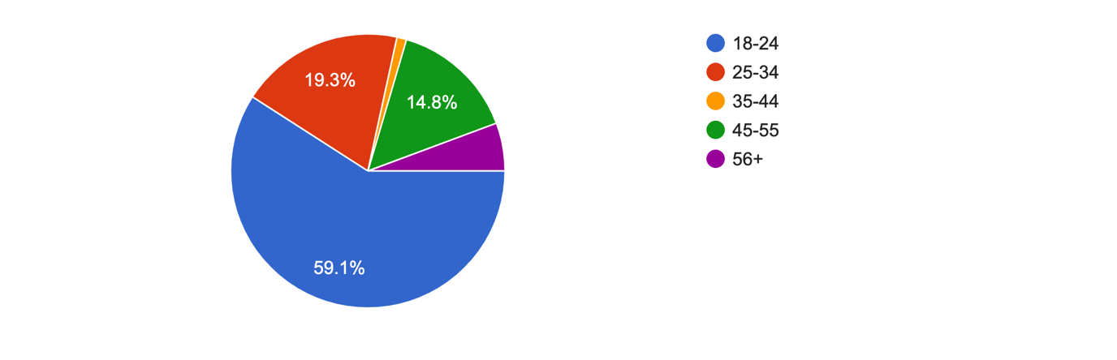
Figure 4.1: Graph Presenting Data Findings from Question 2

Question two of the questionnaire, focused on the age of the participants. The purpose of this question provided help with determining what age group the majority audience was and to provide insight into whether there was a strong correlation between age in relation to the responses to following questions.

Q.3 What is your gender?

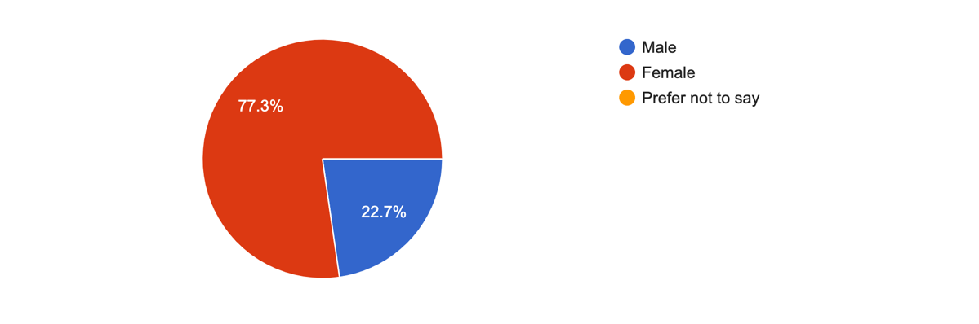
Figure 4.2: Showing the percentage of male and female participants

Question three asked the question of what gender the participants were. The options included were male, female or prefer not to say. All participants that answered chose either male or female. This gave an analysis of whether being male or female correlates to ACE’s and links to serious convictions of crime. 77.3% of the participants were female and 22.7% were male. This response also provided detail for further analysis of other question responses as there may have been a difference to the experiences of males or females in relation to the topic.

Q.4 Ethnic background
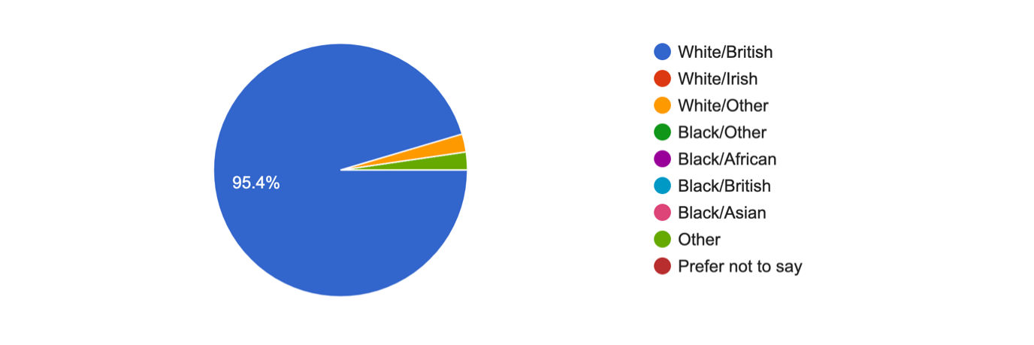
Figure 4.3: Showing the ethnic background of the participants

Question four identified the ethnicity of participants. The majority of responses from people were they considered themselves White/British. This response highlighted areas for consideration such as potential discrimination and whether this was a factor for reflection within analysis. This answer also allows the researcher to cross-tabulate and compare the categories to examine the variety in replies and to see if ethnicity has a role in the respondents' decision or experiences.

Q.6 Have you ever experienced adverse childhood experiences?

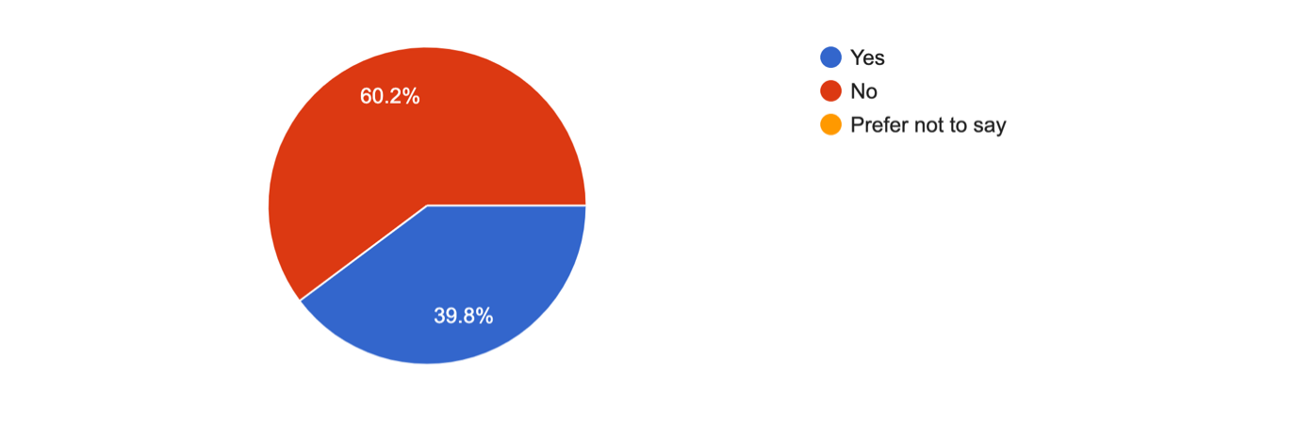
Figure 4.4: Showing the amount of people that experienced adverse childhood experiences

Question 6 asked participants if they had experienced ACE’s within their life. 60.2% of the participants answered with no and 39.8% of participants answered yes.
Following on from this question, question 7 then asks the participants who answered yes to question 6 to elaborate by highlighting what ACE’s they had endured.
Below shows the results of the 38.8% participants that answered yes:

Q. 7 If yes to the previous question, were any of them in relation to:
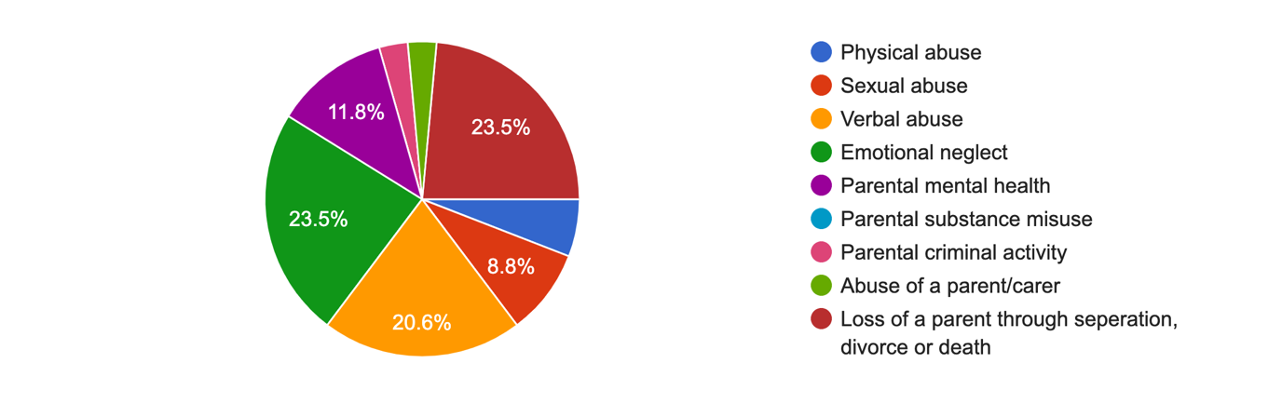
Figure 4.5: Showing what way the participants that answered yes experienced childhood experiences

Question seven had responses from all the participants who answered yes to the previous question. 23.5% of people answered with experiencing a loss of a parent through separation, divorce, or death, 5.9% of people answered with experiencing physical abuse, 8.8% of people experienced sexual abuse, 20.6% of people experienced verbal abuse, 23.5% experienced emotional neglect, 11.8% experienced parental mental health, 2.9% experienced parental criminal activity and 2.9% experienced abuse of a parent/carer. The ACE experienced by the most people was loss of a parent through separation, divorce, or death. Divorce may appear more regularly and is more common these days, but this is what makes it such a threat to children and young people. It can affect children’s mental health and physical development. Whilst divorce and separation of parents has grown increasingly in recent years, or even made normalised the experience it has for children is almost uniformly traumatic and can have a major effect in later life (Jamieson, 2019). As societal norms evolve it is important to ensure support is in place to assist with minimising the impact of ACE’s.

Q.8 When you were growing up, did your parents/guardians understand your problems/worries?
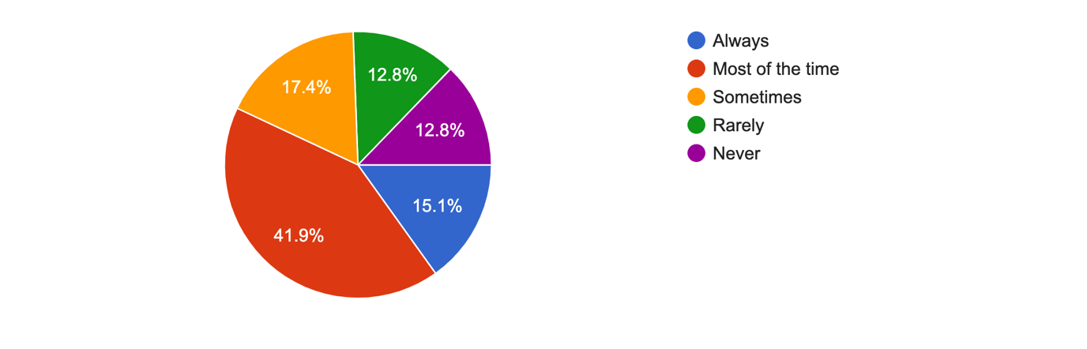
Figure 4.6: showing the percentage of people that stated if parents understood their worries/problems whilst growing up

The majority of 41.9% of participants answered this question with the answer ‘most of the time’. 12.8% of people answered both rarely and never. When looking at results the participants which answered yes to question six are involved in the 12.8% of the people that have answered rarely and never to this question. This could prevent a child’s cognitive, emotional, and social development.

Q. 9 Did your parents/guardians know what you were doing with your free time when you were not at school or work?

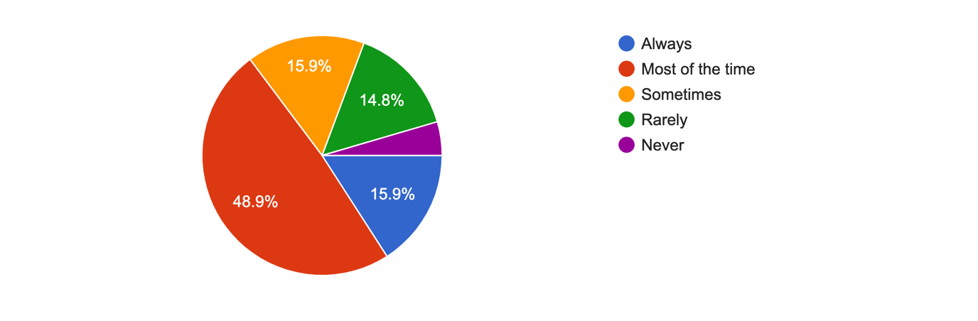
Figure 4.7: Showing the participants opinions on if their parents/guardians were aware of what they were doing with their free time when they were younger.

Question 9 was in relation to the responses of question 8 and whether participants parents were supportive and aware of what they were doing at a young age during periods of free time. Almost half of the participants, 48.9% answered with most of the time and only 4.5% of the participants answered with never. There were close results with the participants who answered with sometimes and rarely.

Q.10 Did you live with a household member who was ever sent to prison?

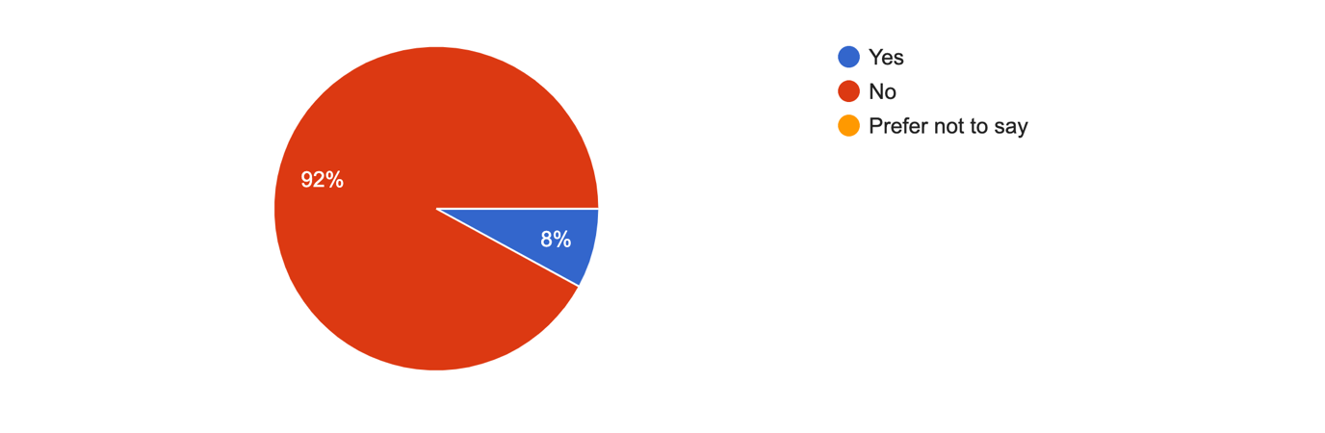
Figure 4.8: Showing whether any of the participants lived with a member who was ever sent to prison.

Almost all the participants answered this question with no however, 8% answered yes. When considering results there is a relation between the people that answered yes to this question and rarely/never to questions eight and nine. Thus, lack of supervision or guidance from a parent could be a contributing factor. Additionally, a role model being in prison potentially normalises this situation.
Q.10 Were your parents ever separated or divorced?
,
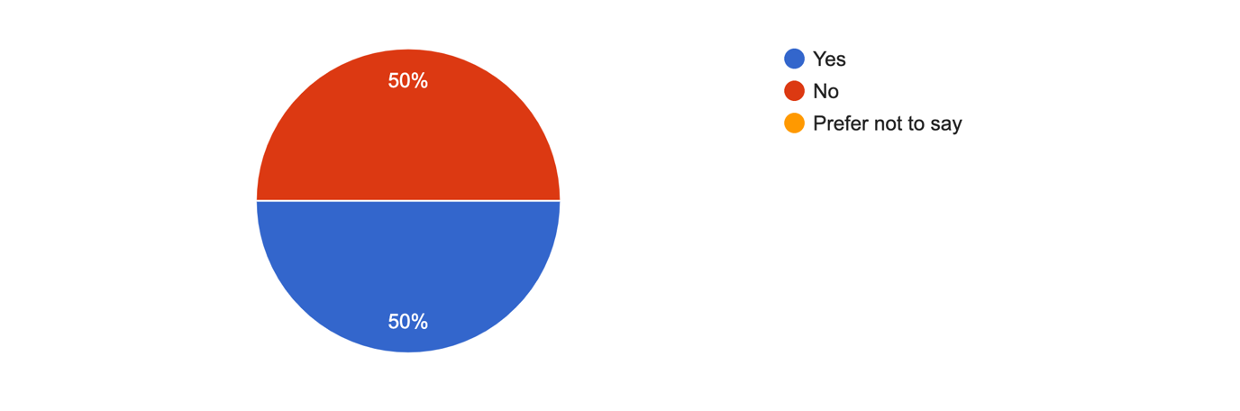
Figure 4.9: Showing results of if the participants parents were ever separated or divorced.

Half of the participants answered yes to this question and half answered no. When looking at the results of the age of participants who participated in this questionnaire most participants were ages between 18 and 34 which suggests it is mainly in the last 15 years where there are more complications in relationships. This can be due to diversity and contemporary changes and opportunities. This too can have an impact on children, as it can disrupt a child’s stability resulting in the child becoming insecure, which can result in further complications.

Q. 11 Have you ever been involved criminal activity?

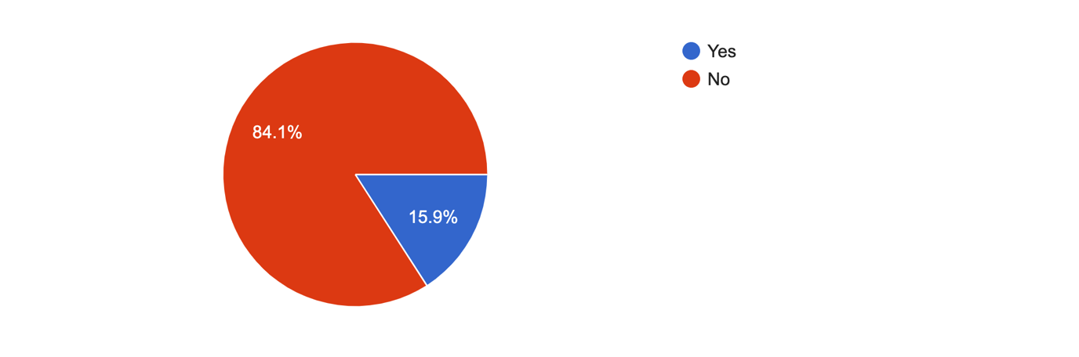
Figure 4.10: Showing results of participants that have been involved in criminal activity.

15.9% of the participants answered yes to this question meaning out of 176 participants, 28 of them have in been involved in crime. Given the majority of respondents were aged between 18 and 34 this highlights young people are more likely to commit crime than those older.
Q.12 If yes at what age were you involved in criminal activity?

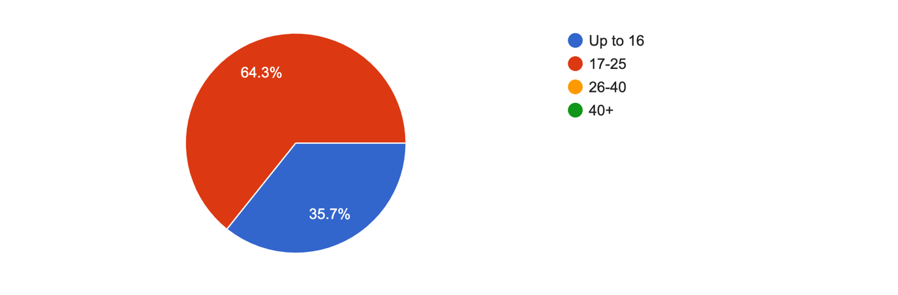
Figure 4.11: showing results of the people that answered yes to question eleven and what age they were involved in the criminal activity.

Following on from question 12, this question asks the participants who answered yes what age they were involved in the criminal activity. The most popular answer to this was ages 17-25 with 64.3%. 35.7% answered with up to age 16. Criminality rates are known to rise during adolescence, peak at 17 years old, and then fall as the individual ages.

Q.13 'A stable up bringing leads to less likely hood of being involved in crime in adulthood?' Do you:
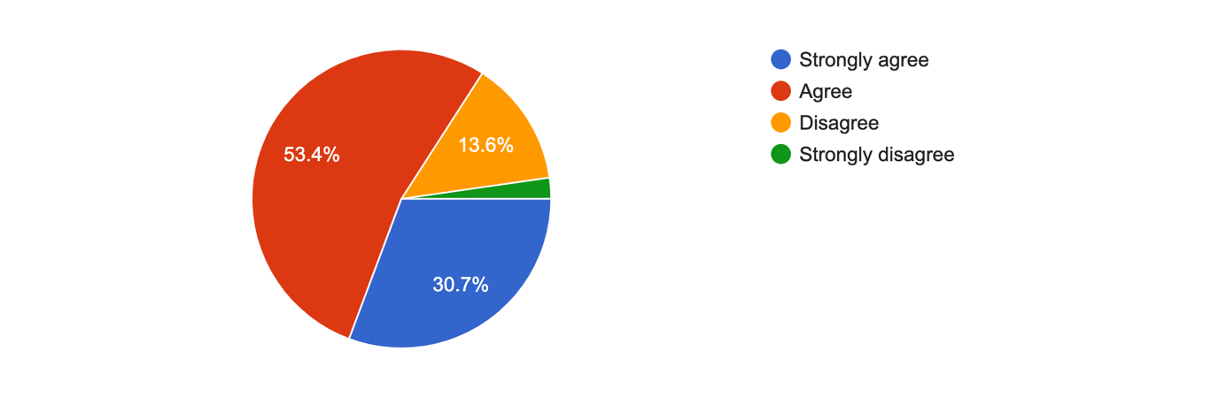
Figure 4.12: Showing if the participants agreed with the statement ‘A stable up bringing leads to less likely hood of being involved in crime in adulthood?’

This question had a mixed range of answers with over half answering they agree with the statement, 30.7% strongly agree, 13.6% disagree and only 2.3% strongly disagree. Stability is noted as a key factor for ensuring a child’s basic needs are met as outlined in the assessment framework for children and their families (Department of Health, 2000).

Q.14 Do you think serious crime occurs because of poor role models in childhood?
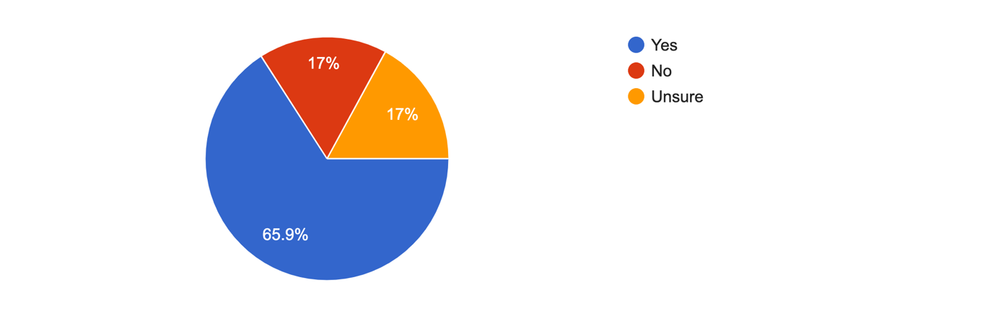
Figure 4.13: Showing results on if the participants thought that serious crime results from poor models in childhood.
Over half the participants agreed with this question with 65.9% answering yes. Some were unsure and 17% answered with unsure and 17% disagreed and answered with no. It is believed young individuals are more prone to engage in violent behaviour if they lack empathy, shame, and remorse and do not believe violence is bad. Morality is instilled in children which enables them to attain a value base and establish morals. This is founded by those they are taught by and those who they associate with. If this is not demonstrated by positive role models, morality can be distorted and inappropriate. However, should not be deemed as wrong but recognised as a life course learning they have developed by default from those who have had an influence on them (Swartz, 2010).

Q.15 Do you think a positive educational experience reduces risk of being involved in serious crime in adulthood?
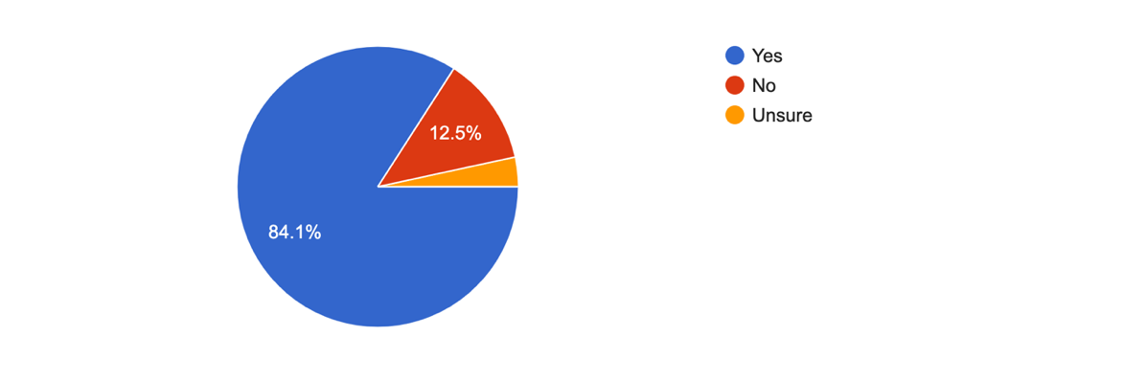
Figure 4.14: Results from asking participants if they think positive education reduces risk of being involved in crime.
Almost all the participants agreed and answered yes to the fact that educational experience reduces risk of being involved in serious crime. Only 12.5% answered no. Participation in education may help to reduce crime by raising income and hence the opportunity cost of engaging in illegal activities. Education may help enhance parental skills, which are vital in the intergenerational transfer of advantage that may keep young people from being involved in criminal activity.

Q.16 Do you believe adverse childhood experiences links to serious convictions of crime?
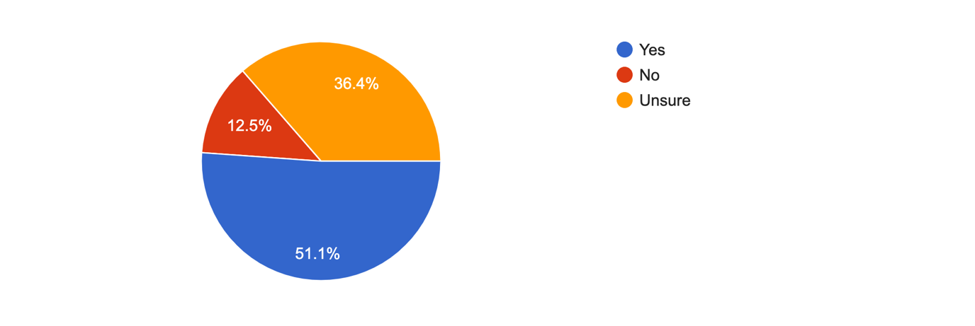

Figure 4.15: Results of people’s opinion on if they believe ACEs link to serious crime.

The use of open-ended questions gave participants the opportunity to give their own opinion about the topic in their own words. This provided the researcher more detail about certain areas being explored within the assessment and assisted with achieving a more effective conclusion. In the survey, the first open ended question was Q.5 What do you understand by the term 'Adverse childhood experiences'?. The main responses were that the majority of the people who participated in the survey referred to traumatic events or experiences which occurred during childhood. Thus ACE’s were confirmed as a contributing factor to the reference of trauma.

The word trauma was used in almost every response to this question. This shows that majority of the participants have an understanding of what ACE’s are. The next open-ended question was Q.18 If yes to previous question, what is your reason for this? This question followed on from question 17 of one of the multiple-choice questions which asked Do you believe adverse childhood experiences links to serious convictions of crime? 82 participants responded to this open-ended question, so a range of opinions were provided. Most responses stated that many people who are involved in the criminal justice system have experienced ACE’s such as neglect and other forms of abuse, as well as the effects of poverty and poor educational experiences and lack of parental/family support and stability.
Therefore, the impact of ACE’s also coincides with those who access health and social care services as adults and where family narratives commonly point to them having experienced adversity as children. The last open-ended question was question 19 which asked if there were any other thoughts or comments. For this question there were 17 responses which highlighted opinions on the overall title and on the questionnaire in general, again mirroring knowledge of ACE’s and opinions of the impact of these in relation to the main topic of correlation of ACE’s and serious crime.

Chapter 5 - Conclusion and Recommendations

5.1 Introduction

The data gathered from the Survey, which the researcher utilised to obtain some of the general public's perspectives on adverse childhood experiences and criminal activity provided the researcher with a better understanding of how the public perceives the problem. The overall analysis throughout this study has been to consider the link between serious crime and ACE’s and whether a person subject to these is more likely to commit serious crime and why. The study has utilised sources directly and indirectly from individuals who have experienced ACE’s and from studies that have considered the impact of ACE’s.
The use of questionnaires have assisted in looking at the responses and how this direct information feeds into the outcome of the research topic.

5.2 Findings

The data compiled from questionnaires highlighted a response believed to be open and honest. It is believed this is largely due to the respondents being informed their responses would be anonymous and only used for the purpose of this study. ACE’s are often linked to periods of time that are difficult for individuals to revisit in adulthood due to the emotional impact this has when reminiscing therefore, the responses have been greatly received and respected in the detail they contain. According to research, ACEs have a long-term and frequently disastrous influence on adolescents and, eventually, society. Officers of the law are not required to become social workers, medical practitioners, or mental health counsellors. To positively affect the difficulties of juvenile criminality, they must first understand the environment in which many adolescents encounter ACEs and then collaborate with specialists from various protective agencies.

5.3 Conclusion

Any trauma experienced by an individual will undoubtedly have an impact on their well-being in the short term and sometimes in the long term. The management of this is often achieved with the support and stability of those who surround a person, If support and stability is appropriate and safe. Where ACEs have occurred during childhood or adolescence the impact of this may only manifest later in life/adulthood if it has not been addressed and supported at the time. Much of the information compiled throughout this study indicates with stable support through education, health, social care, police, and support networks many individuals are able to find sustainable ways to reduce the likelihood of being involved in serious crime.
Based on a review of the literature and current findings, criminal activity can be included to the list of negative outcomes related with the ACE Questionnaire scores. Childhood hardship is linked to adult crime. We propose that, in order to reduce criminal recidivism, therapeutic programmes should focus on the consequences of early life experiences.

5.4 Recommendations

Recommendations for future study and social structures can be made based on what has been learned from the data and the findings reached. Having gathered and analysed the information sourced from the questionnaire carried out, it was recognised that if a more tailored sample group were targeted the results may have been more specific however, this would have required a finer search, additional time, and resources to establish this group firstly. A specific target group of those who have been involved in serious crime could have highlighted more direct results however, this may have been more negative and not provided as much insight into the wider outcomes achieved from the random target group used.

To reduce risk of serious crime for those who have experienced ACE’s it is apparent from the study that identification of potential risk needs to be addressed and resources in place via preventive work at an early stage.

Individuals who have committed serious crime and experienced ACE’s would benefit from preventative work and support as it has been identified this can reduce the risk of recurring criminal behaviours. Therefore, resources are required to identify this need and have in place to achieve this as early as possible.

Chapter Six- Bibliography

/, R., 2022. Adverse Childhood Experiences (ACEs). [online] Violence Prevention Unit. Available at: <https://www.violencepreventionwales.co.uk/research-evidence/adverse-childhood-experiences-aces> [Accessed 10 March 2022].

Anda, R. F., Brown, D. W., Dube, S. R., Bremner, J. D., Felitti, V. J., & Giles, W. H. (2008). Adverse childhood experiences and chronic obstructive pulmonary disease in adults. American journal of preventive medicine, 34, 396-403. [Accessed 7 March 2022]

Assets.publishing.service.gov.uk. 2012. Prisoners’ childhood and family backgrounds Results from the Surveying Prisoner Crime Reduction (SPCR) longitudinal cohort study of prisoners. [online] Available at: <https://assets.publishing.service.gov.uk/government/uploads/system/uploads/attachment_data/file/278837/prisoners-childhood-family-backgrounds.pdf> [Accessed 3 May 2022].
Blokland, A. A. J., Palmen, H. (2015). Patterns of criminal careers. In Loeber, R., Hoeve, M., Slot, W., Van der Laan, P. H. (Eds.), Young offenders growing up. What affects their behavior and what function does justice have? (1st ed., pp. 39–76). SWP Uitgeverij. [Accessed 14 March 2022]

Bryman, A. (2012). Social research methods (5th ed.). Oxford: Oxford University Press. [Accessed 9 February 2022]

cdc.gov. 2016. Preventing Child Abuse and Neglect: A Technical Package for Policy, Norm, and Programmatic Activities. [online] Available at: <https://www.cdc.gov/violenceprevention/pdf/can-prevention-technical-package.pdf> [Accessed 3 May 2022].

Cdc.gov. 2019. Preventing Adverse Childhood Experiences (ACEs): Leveraging the Best Available Evidence. [online] Available at: <https://www.cdc.gov/violenceprevention/pdf/preventingACES.pdf> [Accessed 10 March 2022].

Cdc.gov. 2021. Preventing Adverse Childhood Experiences |Violence Prevention|Injury Center|CDC. [online] Available at: <https://www.cdc.gov/violenceprevention/aces/fastfact.html> [Accessed 7 February 2022].

Center for Child Counseling. 2019. ACEs and Divorce - Center for Child Counseling. [online] Available at: <https://www.centerforchildcounseling.org/aces-and-divorce/> [Accessed 27 April 2022].

Center on the Developing Child at Harvard University. 2022. What Are ACEs? And How Do They Relate to Toxic Stress?. [online] Available at: <https://developingchild.harvard.edu/resources/aces-and-toxic-stress-frequently-asked-questions/> [Accessed 3 May 2022].

Centers for disease control and prevention. 2022. Violence Prevention. [online] Available at: <https://www.cdc.gov/violenceprevention/aces/fastfact.html> [Accessed 3 May 2022].

Chapman, D. P., Whitfield, C. L., Felitti, V. J., Dube, S. R., Edwards, V. J., & Anda, R. F. (2004). Adverse childhood experiences and the risk of depressive disorders in adulthood. Journal of Affective Disorders, 82, 217-225. [Accessed 3 May 2022]

Cps.gov.uk. 2019. Sentencing Dangerous Offenders | The Crown Prosecution Service. [online] Available at: <https://www.cps.gov.uk/legal-guidance/sentencing-dangerous-offenders> [Accessed 3 May 2022].

Daines, C.L., Hansen, D., Novilla, M.L.B. et al. Effects of positive and negative childhood experiences on adult family health. BMC Public Health 21, 651 (2021). https://doi.org/10.1186/s12889-021-10732-w [Accessed 16 January 2022]

Danese, A., Moffitt, T. E., Harrington, H., Milne, B. J., Polanczyk, G., Pariante, C. M., . . . & Caspi, A. (2009). Adverse childhood experiences and adult risk factors for age-related disease: depression, inflammation, and clustering of metabolic risk markers. Archives of pediatrics & adolescent medicine, 163, 1135-1143. [Accessed 7 March 2022]

Davis, M., Sheidow, A. J., McCart, M. R. (2015). Reducing recidivism and symptoms in emerging adults with serious mental health conditions and justice system involvement. Journal of Behavioral Health Services & Research, 42(2), 172–190. https://doi.org/10.1016/j.physbeh.2017.03.040 [Accessed 16 January 2022]

DeBellis, M., & Thomas, L. (2003). Biologic ﬁndings of post-traumatic stress disorder and child maltreatment. Current Psychiatry Reports, 5, 108–117. [Accessed 12 January 2022]

Debois, S., 2022. 10 Advantages and Disadvantages of Questionnaires - Survey Anyplace. [online] Survey Anyplace. Available at: <https://surveyanyplace.com/blog/questionnaire-pros-and-cons/> [Accessed 3 May 2022].

Defencesolicitorslondon.co.uk. 2018. Criminal solicitors London - Dangerous Offender. [online] Available at: <https://www.defencesolicitorslondon.co.uk/the-definition-of-dangerous-offender-in-uk> [Accessed 9 February 2022].

Felitti, V.J., Anda, R.F., Nordenberg, D., Williamson, D.F., Spitz, A.M., Edwards, V., & Koss, M. P. (1998) Relationship of childhood abuse and household dysfunction to many of the leading causes of death in adults: The Adverse Childhood Experiences (ACE) Study. American journal of preventive medicine, 14, 245-258. [Accessed 3 May 2022]

Fowler, F. (2009). Survey research methods. 4th ed. Thousand Oaks: Sage Publications. [Accessed 9 March 2022]

Grasso, D.J., Dierkhising, C.B., Branson, C.E., Ford, J.D. and Lee, R., 2016. Developmental patterns of adverse childhood experiences and current symptoms and impairment in youth referred for trauma-specific services. Journal of abnormal child psychology, 44(5), pp.871-886.[Accessed 5 May 2022]

Gillham, B. (2007) Developing a questionnaire. 2nd ed. New York: Continuum. [Accessed 3 March 2022]

Goddard, W. & Melville, S. (2004). Research Methodology: An Introduction, (2nd ed.) Oxford: Blackwell Publishing. [Accessed 9 February 2022]

Gov.scot. 2018. What have ACEs got to do with Justice?. [online] Available at: <https://www.gov.scot/binaries/content/documents/govscot/publications/research-and-analysis/2018/05/understanding-childhood-adversity-resilience-crime/documents/00535550-pdf/00535550-pdf/govscot%3Adocument/00535550.pdf> [Accessed 3 May 2022].

Gov.wales. 2022. Reducing the criminalisation of care experienced children and young adults. [online] Available at: <https://gov.wales/sites/default/files/publications/2022-03/all-wales-protocol-reducing-the-criminalisation-of-care-experienced-children-and-young-adult.pdf> [Accessed 3 May 2022].

GOV.WALES. 2022. Review of Adverse Childhood Experiences (ACE) policy: report [HTML] | GOV.WALES. [online] Available at: <https://gov.wales/review-adverse-childhood-experiences-ace-policy-report-html> [Accessed 10 March 2022].

Hawthorne, H. and Hawthorne, H., 2021. Adverse Childhood Experiences | Guidance on ACEs for Schools. [online] The Hub | High Speed Training. Available at: <https://www.highspeedtraining.co.uk/hub/adverse-childhood-experiences/?gclid=Cj0KCQiA0eOPBhCGARIsAFIwTs5NI_ng7jLIbo2gLCJt3nU-4qn4LzMAcbOt-MPGDHoY2uDmgdZXMbEaAueMEALw_wcB> [Accessed 1 February 2022].

Hardcastle, K., Bellis, M. and Hopkins, J., 2021. The Early Action Together Programme: Authors: Katie Hardcastle, Mark A Bellis & Joanne C Hopkins February 2021 Outcomes, impacts and lessons for future transformation. [online] Phwwhocc.co.uk. Available at: <https://phwwhocc.co.uk/wp-content/uploads/2021/02/PHW-EAT-Summary-Report-English-Final-09.02.21.pdf> [Accessed 5 May 2022].

Iriss. 2014. Trauma sensitive practice with children in care. [online] Available at: <https://www.iriss.org.uk/resources/insights/trauma-sensitive-practice-children-care?gclid=CjwKCAiA6Y2QBhAtEiwAGHybPdjheKD-TWNG3WRk3v_vmttIciQkuOyj2sdfOA9pCd1JUhddKRxoMBoCL_wQAvD_BwE> [Accessed 9 February 2022].

Itv. 2019. More than 80% of men in prison suffered 'childhood adversity'. [online] Available at: <https://www.itv.com/news/wales/2019-04-29/more-than-eight-in-ten-men-in-prison-suffered-childhood-adversity-new-report> [Accessed 7 February 2022].

Kirsch, G. and Sullivan, P. (1992) Methods and methodology in composition research. 1st ed. Carbondale, Ill.: Southern Illinois University Press. [Accessed 3 February 2022]

Lavrakas P (2008) Cross sectional data. Available at: https://methods.sagepub.com/reference/encyclopedia-of-survey-research-methods/n119.xml [Accessed on: 22 February 2022]

Law Insider. 2022. Serious offender Definition | Law Insider. [online] Available at: <https://www.lawinsider.com/dictionary/serious-offender> [Accessed 1 February 2022].

Liberman, A. M., Piquero, A. R., Shaw, D. S., Gross, H. E., Krohn, M. D., Thornberry, T. P., Siennick, S. E., Osgood, D. W., Uggen, C., Wakefield, S., Huizinga, D., Henry, K. L., Loeber, R., Farrington, D. P. (2008). The long view of crime: A synthesis of longitudinal research (Liberman, A. M. , Ed.). Springer Science & Business Media [Accessed 10 February 2022]

Loeber, R., Farrington, D. P. (2000). Young children who commit crime: Epidemiology, developmental origins, risk factors, early interventions, and policy implications. Development and Psychopathology, 12(4), 737–762. https://doi.org/10.1017/S0954579400004107 [Accessed 12 March 2022]

May, T. (2011). Social research: Issues, methods, and research. London: McGraw-Hill International. [Accessed 10 February 2022]

Mersky, J. P., Topitzes, J., & Reynolds, A. J. (2013). Impacts of adverse childhood experiences on health, mental health, and substance use in early adulthood: A cohort study of an urban, minority sample in the US. Child abuse & neglect, 37, 917-925. [Accessed 3 February 2022]

Mind (2013) Police and mental health. How to get it right locally. Available at: https://www.mind.org.uk/media-a/4356/2013-12-03-mind_police_final_web.pdf [Accessed on: 16 January 2022]
Minnis H (2013) Maltreatment-associated psychiatric problems: an example of environmentally triggered ESSENCE? Scientific World Journal, Article ID 148468 [Accessed 10 March 2022]
Moffitt, T. E. (2018). Male antisocial behaviour in adolescence and beyond. Nature Human Behaviour, 2(3), 177–186. https://doi.org/10.1038/s41562-018-0309-4 [Accessed 14 March 2022]

Morin, K.H., 2013. Value of a pilot study. Journal of Nursing Education, 52(10), pp.547-548. [Accessed 6 March 2022]

Phw.nhs.wales. 2019. Understanding the prevalence of adverse childhood experiences (ACEs) in a male offender population in Wales. [online] Available at: <https://phw.nhs.wales/files/aces/the-prisoner-ace-survey/> [Accessed 3 May 2022].

Piquero, A. R., Hawkins, J. D., Kazemian, L. (2012). Criminal career patterns. In Loeber, R., Farrington, D. P. (Eds.), From juvenile delinquency to adult crime (pp. 14–46). Oxford University Press. [Accessed 23 February 2022]

Reavis, J. A., Looman, J., Franco, K. A., & Rojas, B. (2013). Adverse childhood experiences and adult criminality: how long must we live before we possess our own lives?. The Permanente journal, 17(2), 44–48. https://doi.org/10.7812/TPP/12-072 [Accessed 3 February 2022]

Sahay, A., 2016. Peeling saunder's research onion. Research Gate, Art, pp.1-5. [Accessed 1 May 2022]

Saunders, M., Lewis, P. and Thornhill, A. (2009) Research Methods for Business Students (5th ed). Essex, England: Pearson Education Limited. [Accessed 23 February 2022]

Saunders, M.N.K. et.al., (2019) Research methods for business students. 8th Ed. Harlow, United Kingdom. Pearson Education Limited. [Accessed 4 February 2022]

Schilling, E. A., Aseltine, R. H., & Gore, S. (2007). Adverse childhood experiences and mental health in young adults: a longitudinal survey. BMC public health, 7, 30. [Accessed 6 February 2022]

Sue, V. and Ritter, L. (2012) Conducting online surveys. 2nd ed. East Bay, USA: Sage Publishing. [Accessed 6 February 2022]

Swartz, S., 2010. ‘Moral ecology’and ‘moral capital’: tools towards a sociology of moral education from a South African ethnography. Journal of Moral Education, 39(3), pp.305-327. [Accessed 3 March 2022]

Thomas R (2003) A general inductive approach for qualitative data analysis. Available at: https://citeseerx.ist.psu.edu/viewdoc/download?doi=10.1.1.462.5445&rep=rep1&type=pdf [Accessed on: 25 February 2022]

Van Duin, L., Bevaart, F., Paalman, C. H., Luijks, M. J. A., Zijlmans, J., Marhe, R., Blokland, A. A. J., Doreleijers, T. A. H., Popma, A. (2017). Child Protection Service interference in childhood and the relation with mental health problems and delinquency in young adulthood: A latent class analysis study. Child and Adolescent Psychiatry and Mental Health, 11(66), 1–15. https://doi.org/10.1186/s13034-017-0205-0 [Accessed 23 February 2022]

Van Hazebroek, B. C. M., Blokland, A. A. J., Wermink, H. T., De Keijser, J. W., Popma, A., Van Domburgh, L. (2019). Delinquent development among early-onset offenders: Identifying and characterizing trajectories based on frequency across types of offending. Criminal Justice and Behavior, 46(11), 1542–1565. https://doi.org/10.1177/0093854819876306 [Accessed 12 March 2022]

Young, T.J. (2015) ‘Questionnaires and Surveys’, in Hua, Z. Research Methods in Intercultural Communication: A Practical Guide. Chichester, United Kingdom. John Wiley & Sons Inc. [Accessed 12 February 2022]

Zohrabi, M., 2013. Mixed Method Research: Instruments, Validity, Reliability and Reporting Findings. Theory & practice in language studies, 3(2). [Accessed 4 May 2022]

