Manufacturing process and material selection
materials and introduction to manufacturing
M4X01163
LEON KNIGHT
The Dow Chemical Company

CONTENTS
Introduction |  | 2
The Component |  | 2
The Current Process  The Process  Hardware/Software requirements  Materials |  | 3  4  4
The Additive  The Process  Hardware requirements  Software requirements  Materials |  | 5  5  6  6
The Comparison |  | 7
The Conclusion |  | 8
References |  | 9
Appendices |  | 10



I have decided that I will investigate manufacturing methods used to produce the frames of eyeglasses. I will find an additive that offers the user greater personalisation and intricacy of design whilst ensuring the materials are durable enough to resist wear from general use.

In this Project, I will look at an existing manufacturing system used to produce a product and provide the justification to why a different additive would be better.
Introduction
The Component
A typical process used to manufacture metal wire frame glasses follow the listed actions:
Firstly, the frames for the lenses are made with a three-axis eye winding machine and a spool of metal wire. Metal rollers feed the wire into the machine, it is bent and cut into shape using a pre-programmed code. The wire has pre-cut grooves along the edge of the material, this is used to align and hold the lenses in the frame.
Inserts are placed between the two ends of the freshly cut frame. The inserts are held in a vice and the frame is held above in place. Both parts are cleaned using a fluid called flux which cleans and acts as an oxidation prevention for the metal. Next, a filler wire is heated with an electrical current which fuses the metal pieces together; this process is known as brazing.
The brazing process is repeated on the screw hinge which is used to connect the arms to the eye frame later.
The bridge of the frame is created using a small piece of metal which is cut to length and inserted into a press. The press creates the arc shape which will sit on the wearers nose.
These parts are now placed into a Jig which holds all the pieces into place, ensuring they are aligned straight. Once secured, all the pieces are then brazed together.
The brow bar is created using an automated machine which cuts into a length of metal, creating grooves which will sit on top of the lens frame. The bar is then pressed to create the shape required for it to sit in place properly. Again, this piece is the held into place and brazed.
The hooks used to house the pads are brazed onto the underside of the bridge, these are used to rest frame on the user’s nose.
A strip of metal is stamped with the company/brand label on its length. The strip then has a hinge brazed onto one end and a plastic sleeve is placed onto the other. This will produce one of the arms for the frame. This process is repeated for the other side.
The lenses are now placed into the frame and a machine is then used to hold and insert screws that will hold the frame and the arms together.
Once completed, the arms are then inserted into a mechanical CAM where the arms are then bent to a 45$°$ angle.

The Current Process
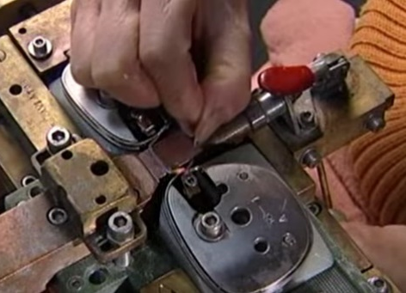
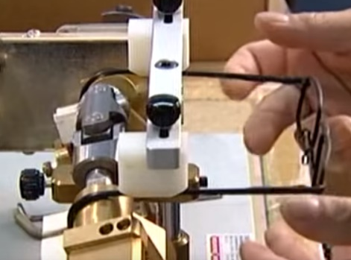
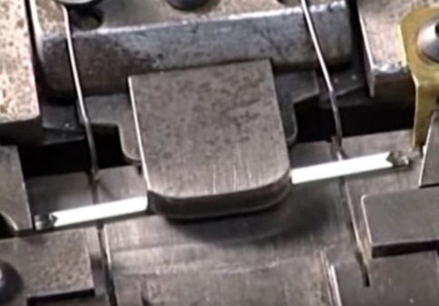
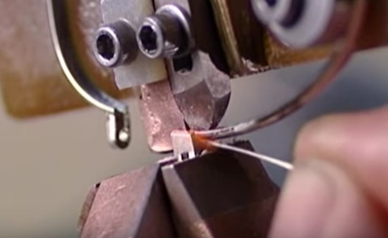
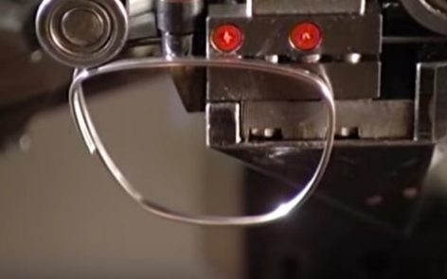
0
Hardware Requirements
Reel of metal Wire – The consumable raw material, pre-cut grooves are required.

Hinges, hooks and sleeves - Consumables

Specialised Jig and clamps – These need to be specially made to the correct shape and size of the finished product, essentially a mould. These would need to be maintained or replaced regularly to ensure that the finished products are manufactured accurately.

3-axis winding machine – This would need to be routinely maintained/calibrated.

Brazing equipment – This will include: 1 x oxygen regulator
1 x acetylene regulator
1 x brazing torch and mixer
Filler wire
The user will need to be properly trained and will require a high level of PPE to ensure safety.

Mechanical Press – Minor maintenance required, would need to be calibrated routinely.

Automated Drill – The user will need to be suitably trained to use the equipment.

Mechanical CAM – Appropriate training would be required to use.

Software Requirements
The CNC coding software designed to be used in conjunction with the 3-axis winding machine – This would require the user to be able to read and write CNC programs to gain the maximum potential out of the software.

Materials
The materials used to make wire frame glasses can be one of many metals/alloys including: titanium, beryllium, flexon and aluminium. Each material has its own benefits. Such benefits can include: Flexibility, Strength and if they are resistant to any corrosion. Appendix 3
Monel frames are another type of metal that unfortunately comes with a side effect of being hypoallergenic. This means for some individuals it may cause irritation and other reactions.
The metal frames are a sleek choice and preferable to some. This is adequate for those with lower prescriptions; however, it leaves those with higher prescriptions and thicker lenses without the option.

The Current Process

I have decided that 3D printing will be the additive I will use to manufacture eyeglass frames. Also using a different type of material to combat some of the short comings of metal frames.
The Process
Initially, the user will be able to scan a 3D image of their face. This could be done on a simple app on a mobile phone. Using current facial recognition software and the high-quality cameras available to modern mobile technology, a high quality rendered 3D image of the face could be created. This 3D image can be sent digitally to the manufacturer who can then use the 3D image to develop a design that will ensure the frame can sit on the users face comfortably and align on the face straight. The design will provide the user with an augmented personalised frame for their face.
The designer can produce their 3D model onto one of the many 3D printer friendly software (including Solidworks, Sketchup, Blender.. etc). The 3D software can allow for further personalisation by allowing greater aesthetic choices for the frames and the arms. The finished 3D model can then be sent to a 3D printer.
The designer will need to design the lens frame and the arms. The hinges can be attached to each part by fitting a screw through holes pre-designed into the frame and arms.

The Additive
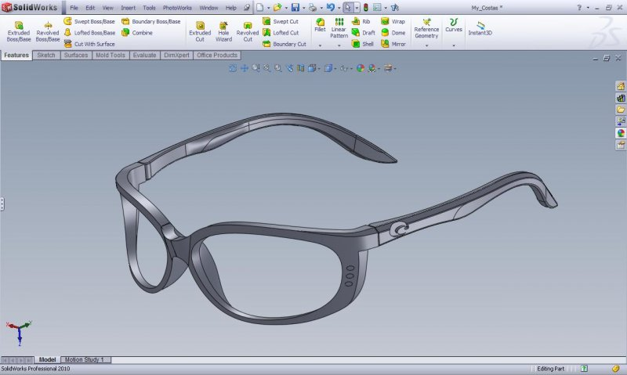
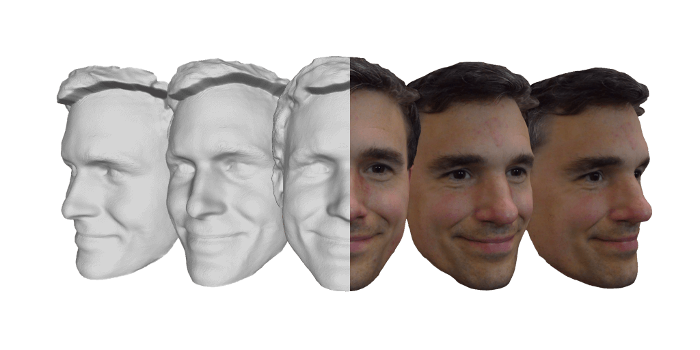
Image Sourced from:
https://www.cadtutor.net/forum/topic/23204-glasses-modeling/
Hardware Requirements
Camera – This requirement is negligible because the end user can digitally send the images over.
3D Printer – This would need to be maintained with spare nozzles, operator must be trained.
SILASTIC™ 3D 3335 Liquid Silicone Rubber – The consumable raw material
Hinges - Consumables
Hand tools – Screwdriver for fitting the hinges
Deburring kit for any burrs left from the 3D printer

Image Sourced from: https://www.bellus3d.com/

Software Requirements
Camera Software – looking into existing brands, external mobile apps can be used to generate a 3D image of an individual’s head. This image can then be exported to a 3D printer friendly software.
3D software – Someone who is trained to use 3D software will be required to design the frames to specification. They will also need to be able to operate the 3D printer. One of many compatible software exist and are relatively affordable.

Materials
One of the potential materials I researched was to use an elastic filament to 3D print frames. From researching different potential materials, I found that the flexible filament produced by eSUN provided a material that was flexible and returned to normal shape after pressure had been applied to it. The material would meet most criteria; however, it would need to be sturdier as it may not be able to hold the lenses without requiring becoming a thicker size to hold the weight. This is not desirable as the typical user would prefer a sleeker design. Also, looking at the data sheet, it does not match up compared to the next material’s Elongation factor. Appendix 1

The next material I looked at was silicone rubbers. The technology to use liquid silicone rubber (LSR) to 3D print already exist. The material is already ideal for making prototypes and complex parts and is produced at a promptly rate. Dow silicones has produced its own SILASTIC™ 3D 3335 Liquid Silicone Rubber which comes in clear but can also be dyed to different colours. This is ideal for aiding the personalisation of the eyeglass frames. The materials accomplishments under tests shows it to be a viable option. Appendix 2

The Additive

Current | Additive
Speed
This method takes a moderate amount of time to complete a single product, mostly due to the need for many parts to be individual manufactured. On the other hand, mass production lines using this method can produce great quantities in a similar time. | This can be a lengthier process in the design stage. This is due to the requirement of getting the design to fit properly for the individual. Outside this, the other stages can be done with great speed.
Accuracy
The current process allows the product to be produced to a pre-set specification. The accuracy of the equipment will remain great for as long as all equipment for each stage has been calibrated efficiently. CNC coding will need to be used to produce the frames on the winding machine. The code will need to be tested with prototypes to ensure accuracy. There is room for error when manually brazing the parts. | The 3D printer itself replicates the model in the software highly accurately. The potential inaccuracies come with the designer. However, using the 3D model of the customers head should minimise such mistakes from forming. Care should be taken when fitting the hinges onto the frame and arms.
Potential intricacy
There is opportunity for different styles to be produced. Unfortunately, this method is limited due to the frame being made of a single wire and the arms are made of a single length of metal. | The 3D printer has a near limitless potential when it comes to intricacy. If it can be developed in the software, it can be printed. The only limits are due to any structural concerns the design produces.
Waste
With accurate preparation, this method can produce very little waste, although there will be small amounts of metal waste when cutting the bridges and brow bars. | The only waste materials produced in this method is any burrs they require removing from the printed parts.
Safety
There are far greater risks with this method, specifically when it comes to brazing. The majority of the production process requires manual labour to complete the product. This means the operator of the process will be in the line of fire often. | There are very few safety risks. Care should be taken when setting up and using the 3D printer. There should also be care taken when deburring the material.
Efficiency
The automated system will make certain manual tasks run quickly and with accuracy. Efficiency is dependable on how the operator conducts the manual tasks in the process. | The overall process is slower per product, but it will ensure higher quality. Whilst waiting for the 3D model to complete printing, the designer can move onto the next frame design. Minimal machinery is involved in the process.
Customer Potential
This process will produce batch products that are designed for generic audiences. | This process will produce single high-quality products tailored to the individual. It also allows those with thicker lenses to have more options over todays current selection.

The Comparison

The new additive’s aim is to produce a higher quality product that will be personalised specifically for each customer.
It succeeds over the other method by:
- Ensuring it produces less waste.
- Allowing greater design possibilities with more freedom to create superior levels of intricacies.
- Using a material that will not rust, corrode and will remain flexible but will still return to its original shape under everyday stress.
- Personalising the product so that it can work at its most efficiently for the end user.
- Allowing people with all sight abilities to have frames that suit them.
- Ensuring the product is created to a higher level of accuracy.
- Making the production style safer by eliminating health and safety risks in the workplace.
Overall, the additive improves over the other methods weaknesses and builds upon its strengths.
The Conclusion

Artec3d.com. (n.d.). 3D Face Scan | Professional 3D Scanning Solutions. [online] Available at: https://www.artec3d.com/3d-models/face. [Accessed 4 Jan. 2020].
Bellus3D. (2019). FAQ | FaceApp | Bellus3D: High-quality 3D face scanning. [online] Available at: https://www.bellus3d.com/faceapp/faq [Accessed 12 Jan. 2020].
CADTutor.net. (2010). Glasses Modeling - Solidworks - AutoCAD Forums. [online] Available at: https://www.cadtutor.net/forum/topic/23204-glasses-modeling/ [Accessed 11 Jan. 2020].
Dow.com. (n.d.). 3D Printing | Dow Inc. [online] Available at: https://www.dow.com/en-us/market/mkt-consumer-goods-appliances/sub-consumer-3d-printing.html?cid=ppc_dcs2019_western-europe---3d-printing---3d-printing_google_plastics-and-rubber_emea_apr-2019_na_na&gclsrc=aw.ds&&gclid=EAIaIQobChMI8Ynoj5G75wIVS7TtCh1nEghxEAAYASAAEgJMj_D_BwE [Accessed 9 Jan. 2020].
Dow.com. (2019). SILASTIC™ 3D 3335 Liquid Silicone Rubber. [online] Available at: https://www.dow.com/en-us/document-viewer.html?ramdomVar=6601097741808558644&docPath=/content/dam/dcc/documents/en-us/mark-prod-info/45/45-1612-01-liquid-silicone-rubber-3d-printing.pdf [Accessed 9 Jan. 2020].
How Its Made. (2005). How Its Made - 258 Eyeglass Frames. [Online Video]. 31 December 2014. Available from: https://www.youtube.com/watch?v=19C-aSQQ8-s. [Accessed: 4 January 2020].
Le, H. (2018). Plastic vs Metal Eyeglass Frames – Which Eyeglass Frame Should You Pick? | Eye Health HQ. [online] Eye Health HQ. Available at: https://eyehealthhq.com/plastic-vs-metal-eyeglass-frames-which-one-should-you-pick [Accessed 4 Jan. 2020].
Marcello Fera, Roberto Macchiaroli, Fabio Fruggiero and Alfredo Lambiase (October 10th, 2018). Production Management Fundamentals for Additive Manufacturing, 3D Printing, Dragan Cvetković, IntechOpen, DOI: 10.5772/intechopen.78680. Available from: https://www.intechopen.com/books/3d-printing/production-management-fundamentals-for-additive-manufacturing. [Accessed: 5 January 2020]
Morgan, E. (2018). Eyeglass frame materials: Metal, plastic and unusual. [online] Allaboutvision.com. Available at: https://www.allaboutvision.com/eyeglasses/eyeglass_frame_materials.htm [Accessed 8 Jan. 2020].
RCLifeOn. (2017). Awesome Flexible 3D Prints - How to Print Flexible Filament. [Online Video]. 20 March 2017. Available from: https://www.youtube.com/watch?v=lMu_XNEohjw. [Accessed: 5 January 2020].
Sirrine, J., Meenakshisundaram, V., Moon, N., Scott, P., Mondschein, R., Weiseman, T., Williams, C. and Long, T. (2018). Functional siloxanes with photo-activated, simultaneous chain extension and crosslinking for lithography-based 3D printing. Polymer, 152, pp.25-34.
Vecteezy.com, (2018), Glasses Icon Symbol Sign [ONLINE]. Available at: https://www.vecteezy.com/vector-art/639048-glasses-icon-symbol-sign [Accessed 5 January 2020].

References

Appendices
Appendix 1: eSUN 3D Filament data sheet
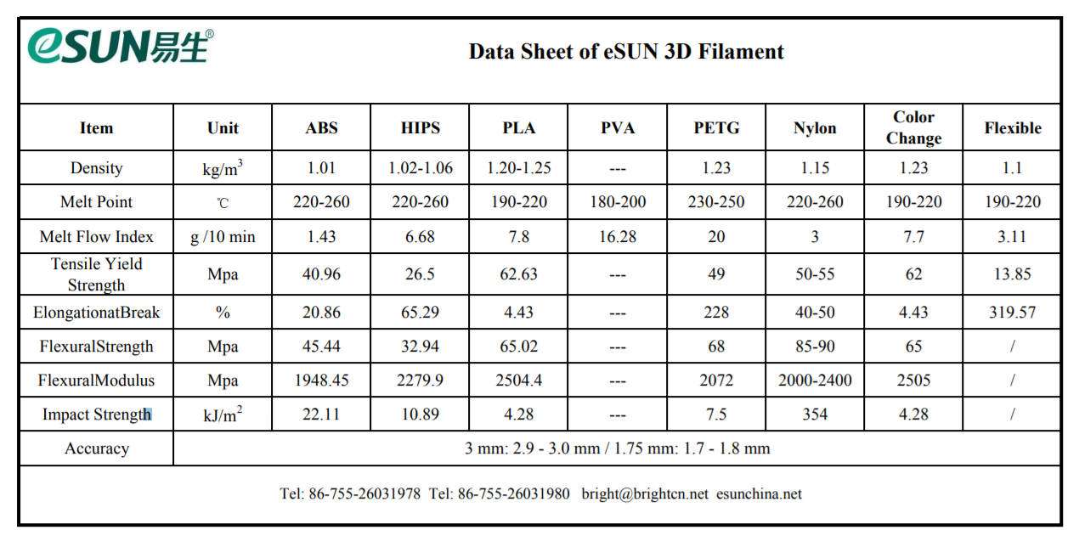
Appendix 2: SILASTIC™ 3D 3335 Liquid Silicone Rubber data sheet
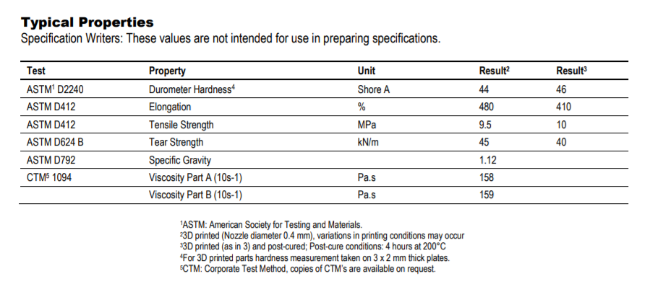
Appendix 3: Benefits of different metals.

