1800042
Kaylie Shoulder
UWTSD
Smart and Connected Devices
Web Based Assignment + Report

Smart and Connected Devices Report

For web applications, especially those that include database management, PHP accompanies HTML and CSS in a very complimentary way. The aim of the assignment was to create a database which allowed three sensor’s rainfall data to be collected and transferred into it – equip with good security measures, and a clear and concise way to display the recorded data.
Throughout the course of this particular report, all technicalities regarding the web aspect of this assignment will be analysed and discussed, touching upon why the application was approached in the way that it was.
The first page the user sees is the ‘landing page’ which is the page that allows users to sign in, or rejects those that don’t have any correct login information.
Here is an image of the landing page:
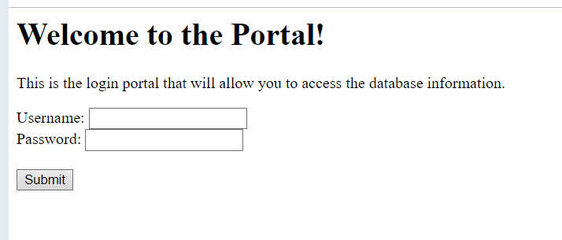
As you can see, the website welcomes the user and asks them to log in to access information. This page has been configured using validation, which was done in order to prevent those without permissions from accessing the information, and those who do have the rights to access the information, the permissions to sign in.
The result of the incorrect credentials being submitted: 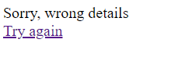
The result of the correct credentials being submitted:
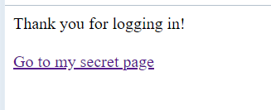
When the correct credentials are submitted, this screen displays and from there, the user can click on the link, and there they are able to access the data information.
Here is a screenshot of the code that was used in order to create this page:
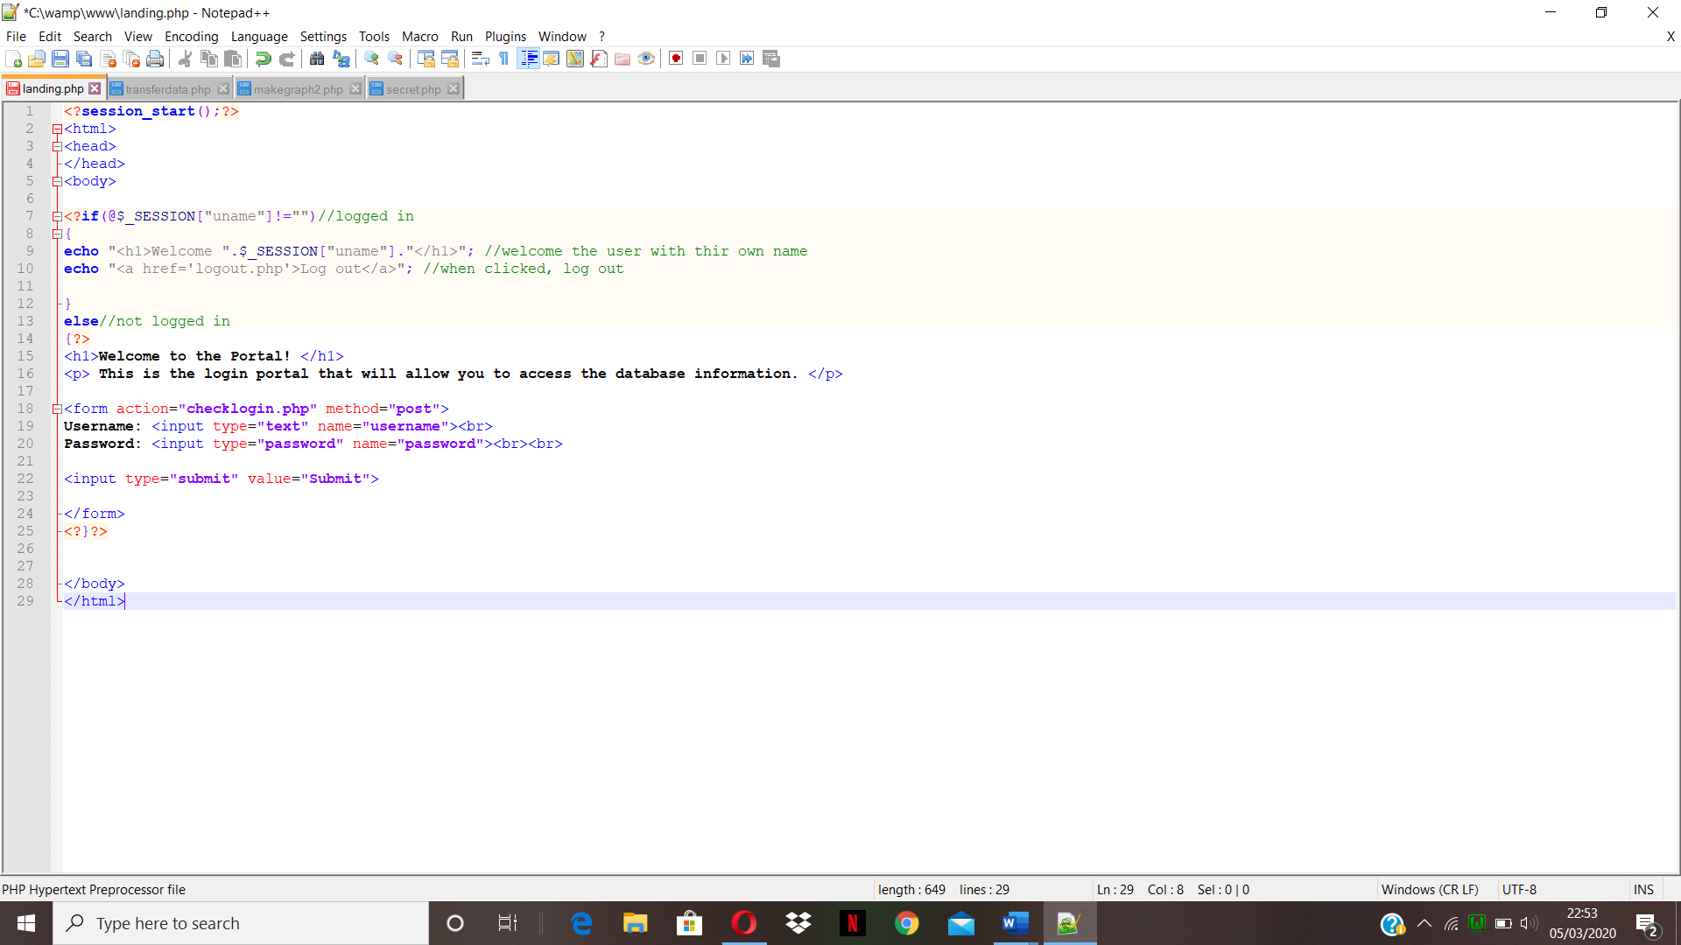
As you can see, the code above emphasises on allowing or denying the user access to their information, using the method of a form to submit user input, thereon validating the information provided.
Once the user has signed in, from the picture above, you can see that the user can then forward themselves to a link which states ‘Go to my secret page’.
The link forwards the user to a page which displays the data that was collected from all three text files separately – allowing data interpretation to be a much easier task. Here is an image of what the ‘secret’ page looks like: 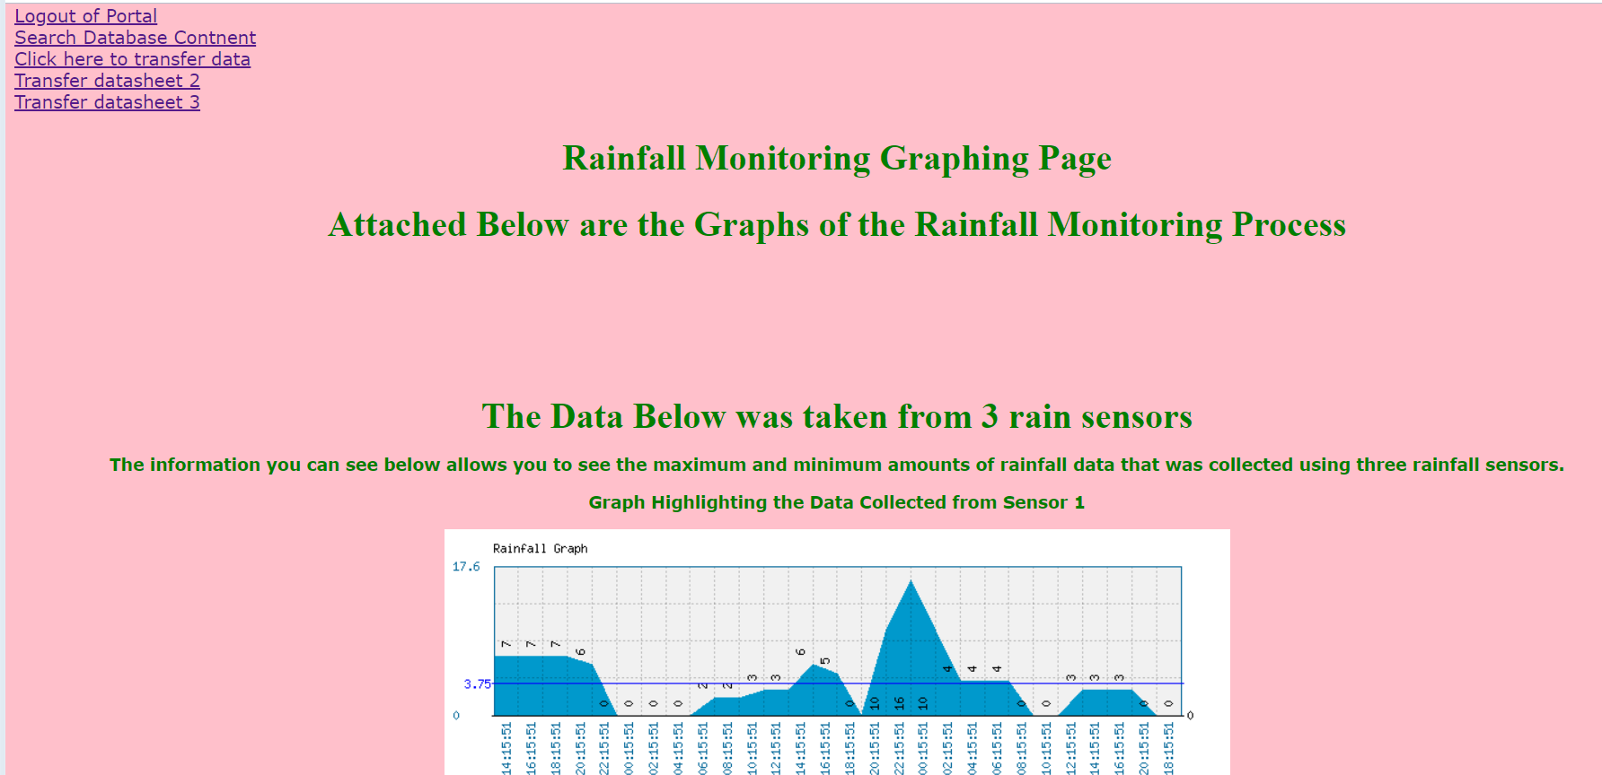
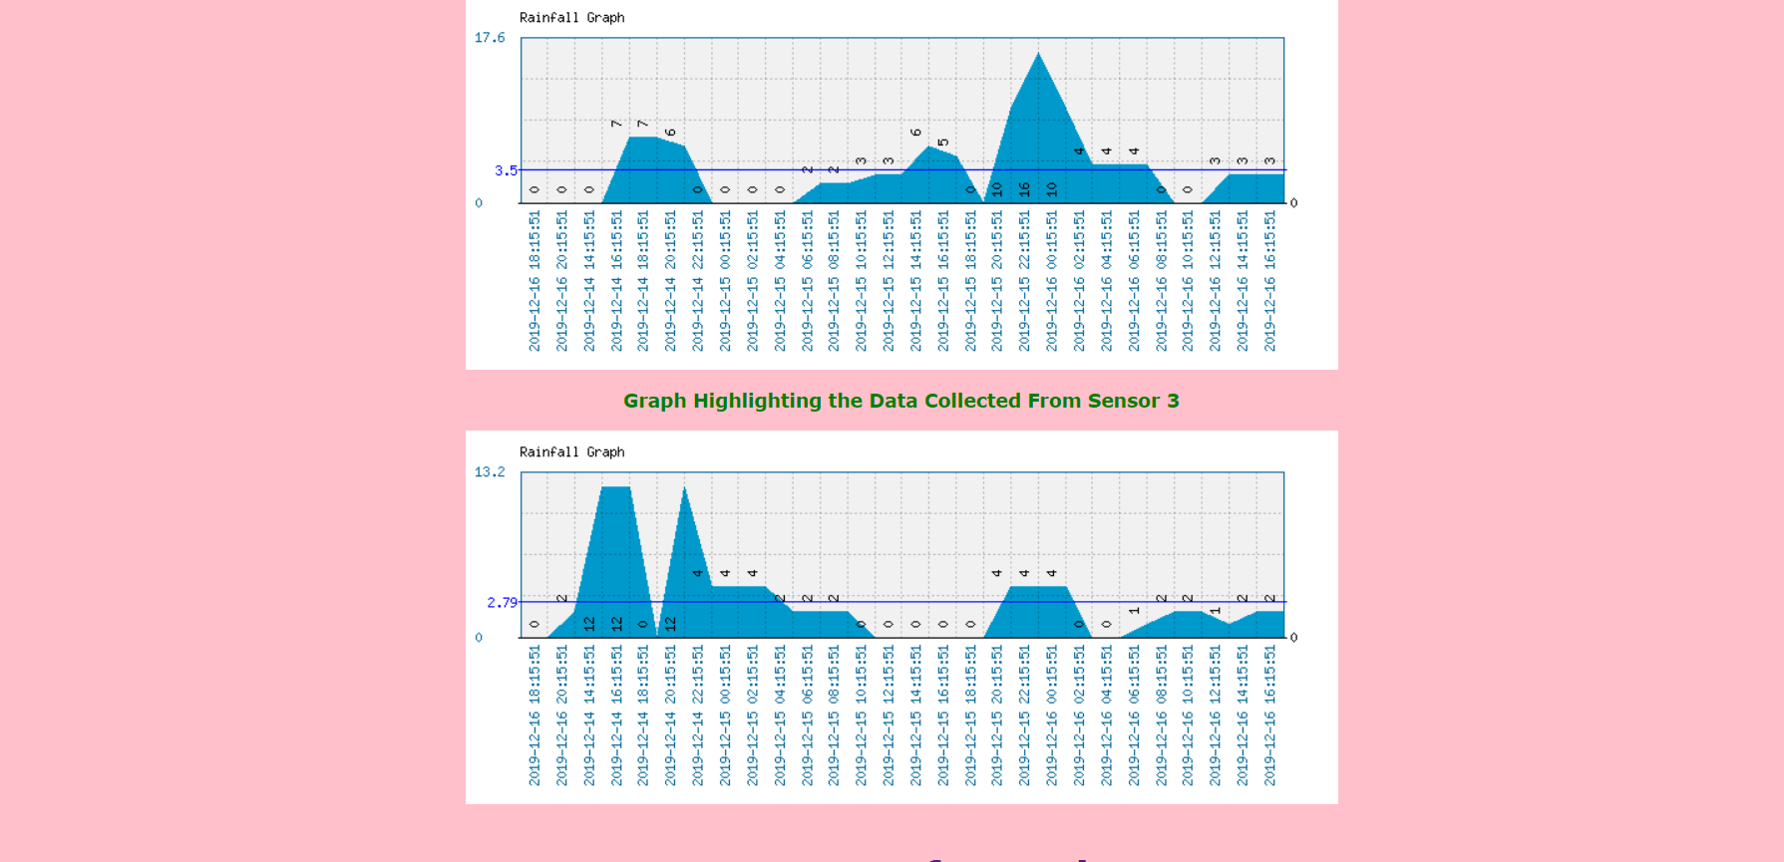
As you can see from the two images attached above, once the user has signed in they are able to view the data on the table in the format of a polygon graph – this particular type of graph was chosen as it was the best suited for the set of data that was stored in the database. It is compared using the amount of rainfall and the date in which the rain occurred. The reason that the graphs were implemented in such a way was because it is much easier for the reader to interpret the data, it is clear and concise and you are able to clearly compare the differences between the three data sets that were uploaded onto the database.

Attached is the code which was used in order to allow this website to function correctly: 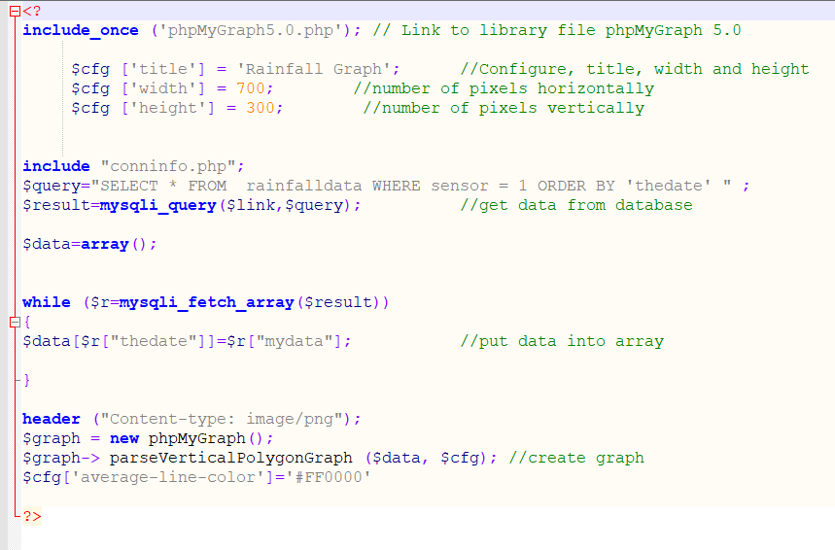
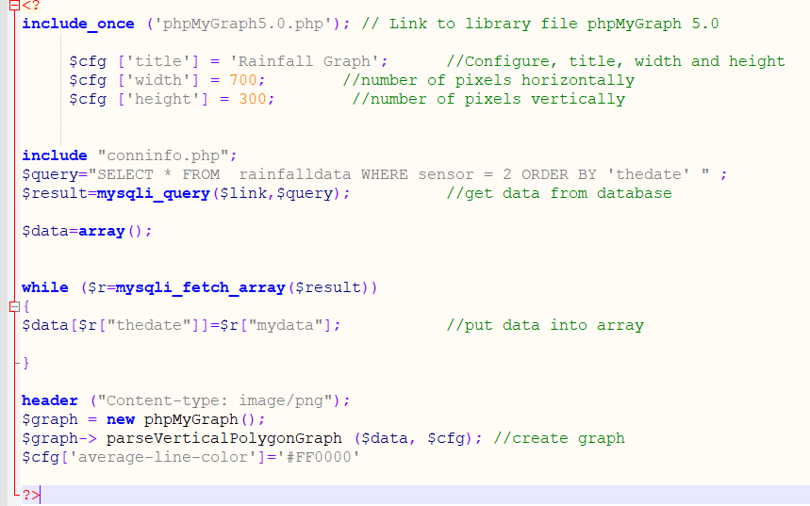
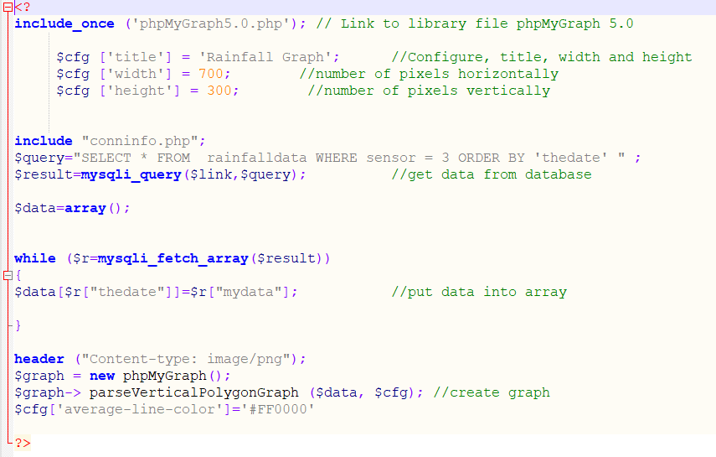
The three graphs use the same base code, changing only one thing every single time and that is the line that states ‘’$query=*SELECT * FROM rainfalldata WHERE sensor = ___ ORDER BY “thedate” “;.
For each graph the value after ‘sensor =’ changes from 1, to 2 or 3 – allowing each sensor addition to be separated and have their own graph. The way in which the graph should display is stated first, then telling the database where to retrieve the information, onto the drawing/creation of the graph. The graphs that are drawn are transferred to display on the secret website using the following code:
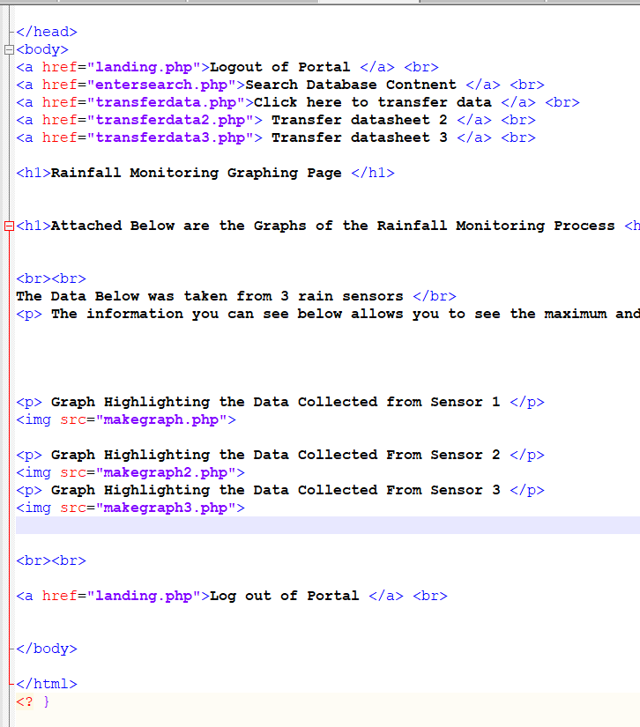
This page essentially allows user navigation using the <a href tags, and then inserts the graphs using <img src=”makegraph.png”> and so on.

The website also has a page which allows the user to search the database which unfortunately does not work as well as hoped. Here is an image of how the search page looks:
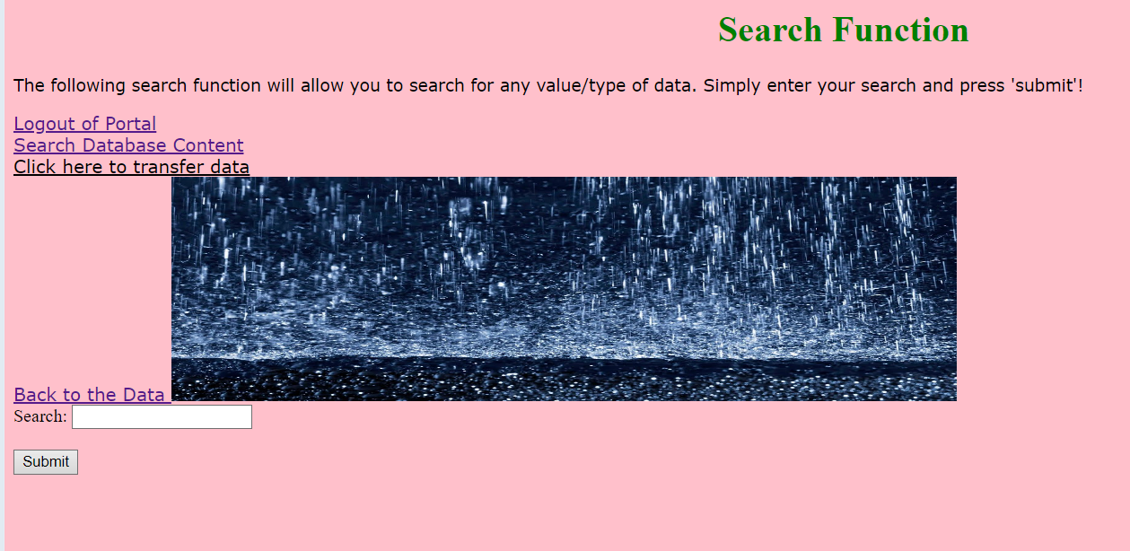
The user can enter something into the search bar and hit the ‘search’ button, which will then put out the results.
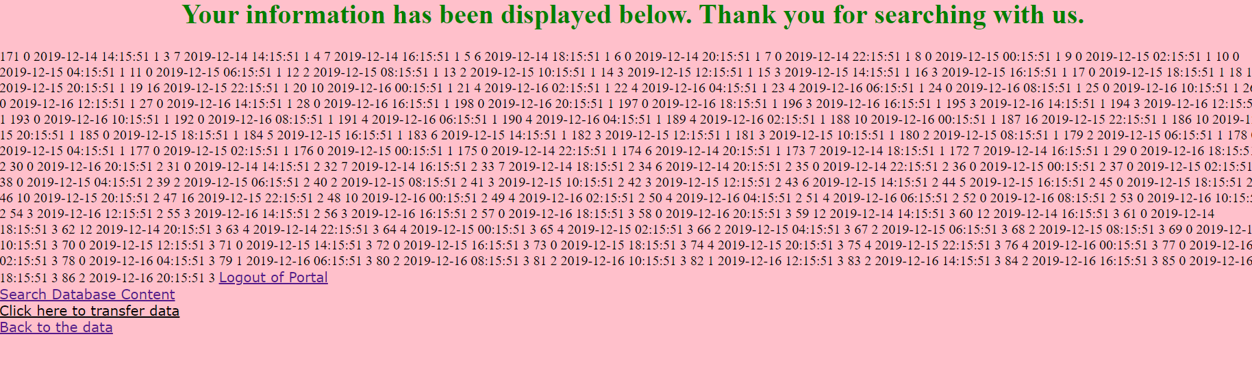
This is the result of searching ‘9’, this is poorly organised and splurges out all the data that the database can find rather than refining it as it should have been done. Here is the code behind these pages:
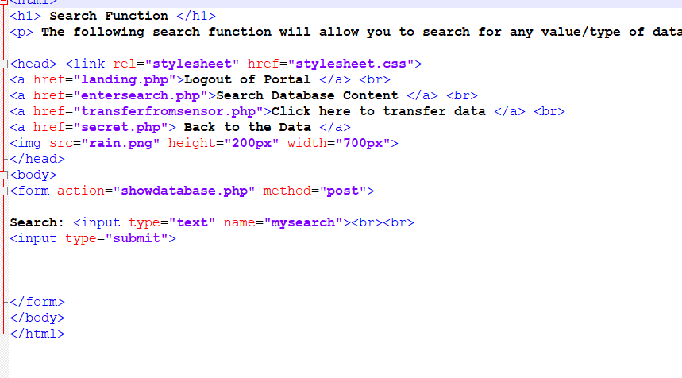
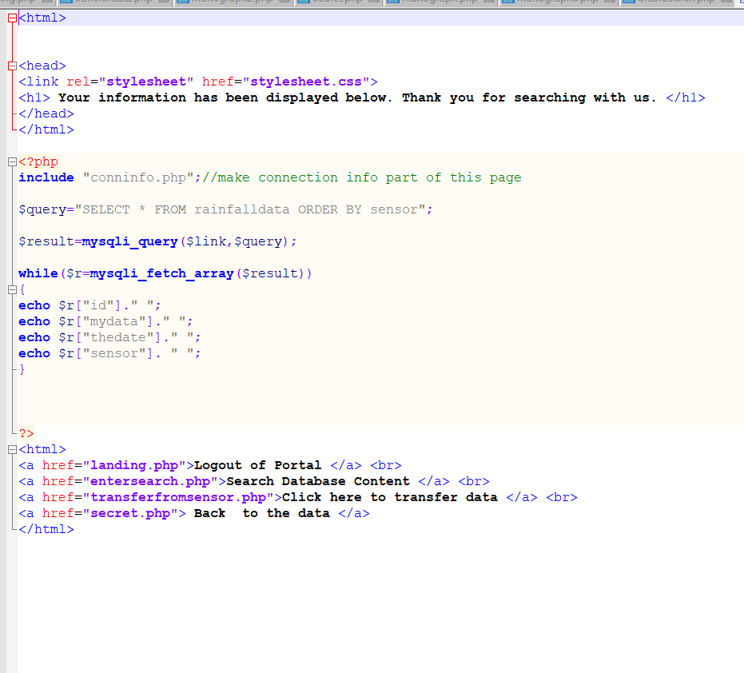
This search method was used in the hopes of providing the user with an easy way to view any data, however it was poorly programmed and lacks the use of radio buttons, instead focusing on simply splurging the data onto the screen, but sorting it into the date that the data was obtained/uploaded rather than have any refined/filtered results.
As a part of the links, the user is able to click on ‘Transfer Data Sheet’ and this will then upload the data from the linked text file to the database. Unfortunately, at the moment the code only uploads new data and does not replace the previous. Here is what happens when this link is clicked:
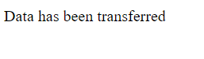
And the database looks as follows after the upload: 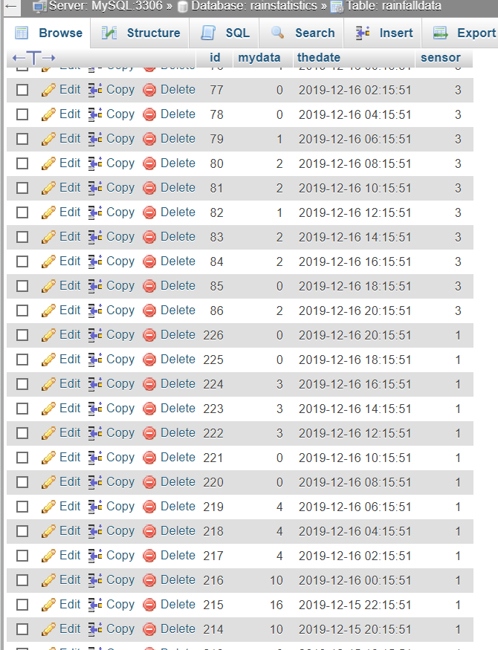
The code simply adds rather than deletes and adds:
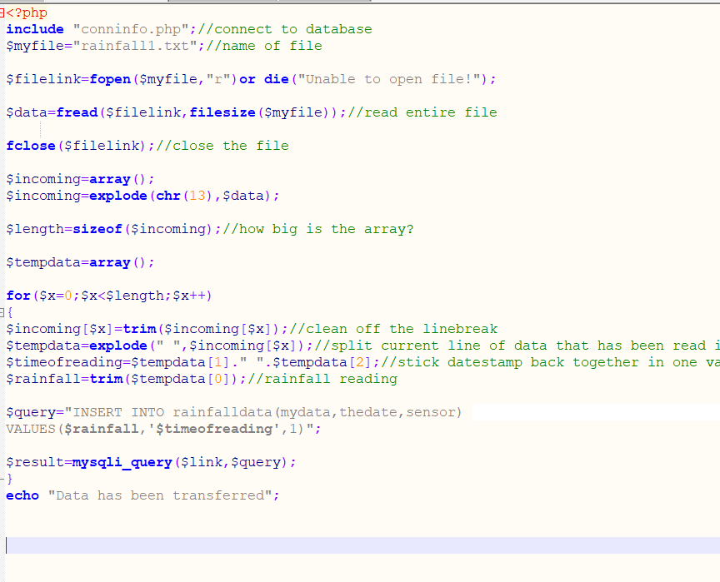
The code aims to connect to the database, and access/read the text file that has been called. It will detect the size of the file, add a timestamp and then add the information onto the database. As of yet, it does not delete prior information.
When the user logs out they cannot access any information, as you can see below:
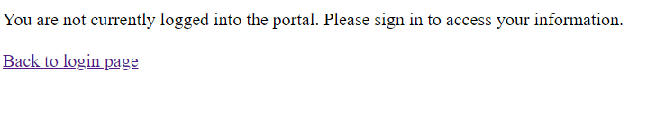
This is the code used to create the login/logout system:
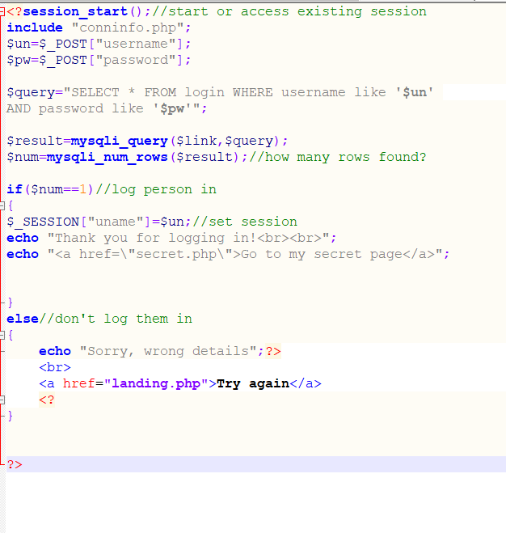
This code checks the credentials and states whether they are right/wrong, and will reject/grant the user access to the information.
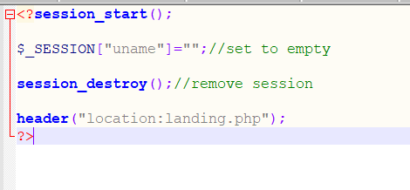
This is what happens when the user selects ‘logout’ – the session is terminated. If the user is not logged into the portal they won’t be able to access any information on the database.
To summarise, the way in which this application was approached was to allow the user to use the application easily and interpret the data in the easiest manner – whilst providing the application with the right means of security. In some ways, it has accomplished this aim, and in other ways has failed to meet this basic criteria.

