

University of Wales Trinity Saint David School of Engineering

Approaches to Innovation and Organizational change
Report writing

Management, Innovation and Sustainability
(ACMA5007)

Mohamed Rithwan Thangeswaran
2313855
12/05/2025

Contents
1. Introduction 3
2. Innovation and Organisational Change in Eurogrind Manufacturing Ltd. 4
2.1 Background of the Change 4
2.2 Managing the Change 5
2.3 Implementation Challenges in Eurogrind Manufacturing Ltd. 6
3. Application of Lewin’s Force Field Analysis Model 6
3.1 Comparison with Other Companies 7
4. Change Management Strategy – Kotter’s 8-Step Model 7
5. Impact on Employee Motivation – Herzberg’s Two-Factor Theory 9
6. Recommendations 11
7. Conclusion 12
8. References 13

List Of Table
Table 1 Implementation Challenges 6

List Of Figures
Figure 1 Introduction to the company Eurogrind Manufacturing Ltd 3
Figure 2 Eurogrind Manufacturing Ltd 5
Figure 3 Application of Lewin’s Force Field Analysis Model 7
Figure 4 Change Management Strategy – Kotter’s 8-Step Model 8
Figure 5 Impact on Employee Motivation – Herzberg’s Two-Factor Theory 12

1. Introduction
Innovation and organizational change are essential for businesses to remain competitive in an era of rapid technological advancements and evolving industry demands (Burnes, 2021). Eurogrind Manufacturing Ltd., a mid-sized engineering company specializing in precision grinding and manufacturing, has recently undergone a significant transformation. The company has implemented a major restructuring initiative, introduced advanced machinery, and optimized its workforce to enhance operational efficiency and sustain its competitive edge (Johnson & Scholes, 2022).

Figure 1 Introduction to the company Eurogrind Manufacturing Ltd
This report critically examines Eurogrind’s change management process, assessing how the company navigated this transition. Lewin’s Forcefield Analysis model is applied to evaluate the driving and resisting forces that influenced the change (Cummings & Worley, 2021). Driving forces such as technological advancements, market competition, and productivity enhancements are weighed against resisting forces, including employee resistance, skills gaps, and adaptation challenges (Hayes, 2022).
Additionally, Kotter’s 8-Step Change Model is used to propose a structured approach for managing the transition, highlighting the importance of leadership, communication, and stakeholder engagement (Kotter, 2018). Herzberg’s Two-Factor Theory is also utilized to assess the impact of change on employee motivation, emphasizing the role of job security, career development, and workplace satisfaction in maintaining workforce morale (Robbins & Judge, 2020). Through this analysis, the report aims to provide a comprehensive understanding of Eurogrind’s organizational change and recommend effective strategies for successful change management and employee motivation.

2. Innovation and Organisational Change in Eurogrind Manufacturing Ltd.

2.1 Background of the Change
Organisational change is often driven by the need to improve efficiency, enhance competitiveness, and respond to market demands (Burnes, 2021). Eurogrind Manufacturing Ltd., a mid-sized engineering firm specializing in precision grinding, faced challenges related to inefficiency and declining productivity. To address these concerns, management implemented a major restructuring initiative that involved downsizing the workforce and integrating advanced technology into production.
Previously, the company employed 30 workers in its production unit. However, after a performance evaluation, the management decided to dismiss 10 employees due to perceived low motivation and work ethic. The reduction in staff aimed to eliminate inefficiencies and streamline operations. The remaining workforce of 20 employees was expected to adapt to the changes and maintain productivity with the support of newly introduced, highly efficient grinding machines.
Technological advancements in manufacturing, such as automation and precision engineering, have been shown to improve operational efficiency and reduce long-term costs (Johnson & Scholes, 2022). However, workforce reductions can lead to unintended consequences, such as decreased employee morale and resistance to change (Hayes, 2022). In Eurogrind’s case, while the adoption of advanced machinery improved production capacity, concerns about job security and increased workloads impacted employee motivation.
According to Kotter (2018), organisational change must be managed with a clear vision and strong leadership to address employee concerns and ensure smooth transitions. Although Eurogrind aimed to enhance efficiency, the sudden dismissal of employees without adequate communication or engagement strategies may have contributed to resistance and uncertainty within the workforce. Understanding these challenges is crucial to implementing sustainable change management practices.

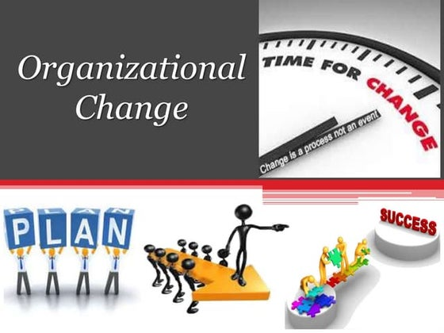
Figure 2 Eurogrind Manufacturing Ltd

2.2 Managing the Change
Change management is a structured approach that ensures a smooth transition from the current state to a desired future state (Cummings & Worley, 2021). At Eurogrind Manufacturing Ltd., the restructuring process was managed using a top-down approach, where decisions were made by senior management with limited involvement from employees. While this method ensured a swift transition, it also led to initial resistance and uncertainty among the remaining workforce.
Top-down change management strategies often focus on efficiency and quick implementation but may overlook employee engagement and concerns (Burnes, 2021). In Eurogrind’s case, while the introduction of advanced machinery streamlined production, the lack of communication regarding job security and career development contributed to lower motivation levels. Studies indicate that employees are more likely to accept change when they are involved in decision-making and when leadership fosters a culture of transparency and trust (Robbins & Judge, 2020).
To facilitate the transition, the company introduced a short training program to familiarise employees with the new grinding machines. While technical training is essential in technology-driven changes, it must be complemented by motivation strategies to maintain workforce morale (Hayes, 2022). Herzberg’s Two-Factor Theory suggests that job satisfaction is influenced by both hygiene factors (e.g., job security, fair policies) and motivators (e.g., skill development, recognition) (Herzberg, 1966). In this context, Eurogrind’s approach, while addressing skill enhancement, may not have fully considered the psychological impact of downsizing on remaining employees.
A more effective approach would involve Kotter’s 8-Step Change Model, which emphasizes clear communication, stakeholder involvement, and ongoing support to sustain change (Kotter, 2018). By integrating employee feedback mechanisms, career development opportunities, and transparent communication, Eurogrind could improve workforce morale and commitment to the change. Eurogrind’s restructuring aimed to enhance productivity, the limited involvement of employees in decision-making and the psychological impact of downsizing posed challenges. A balanced approach that combines technological advancements with effective people management strategies is crucial for sustainable organizational change.

2.3 Implementation Challenges in Eurogrind Manufacturing Ltd.
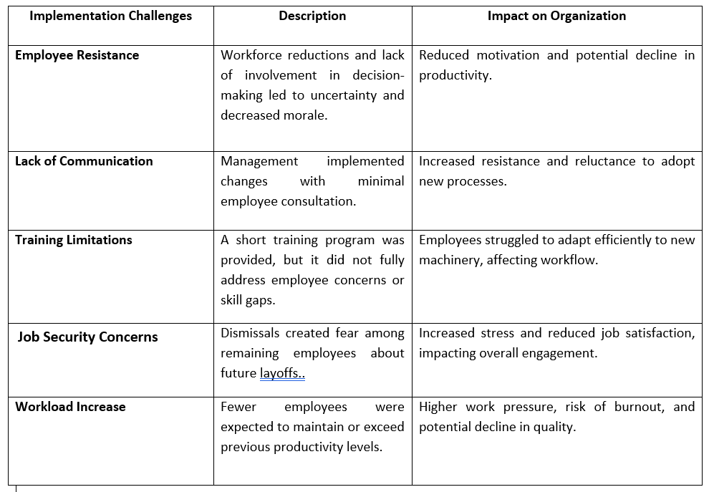Table 1 Implementation Challenges

3. Application of Lewin’s Force Field Analysis Model
Lewin’s Force Field Analysis model is an essential framework for assessing the forces that either drive or resist change within an organization (Burnes, 2021). In the case of Eurogrind Manufacturing Ltd.’s workforce restructuring and adoption of advanced grinding machines, the driving and resisting forces can be categorized as follows:
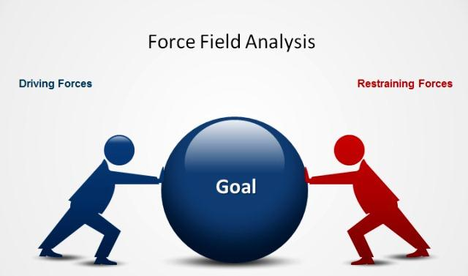
Figure 3 Application of Lewin’s Force Field Analysis Model
Driving Forces:
Technological advancements, such as the introduction of highly efficient grinding machines, enabled Eurogrind to improve productivity and maintain quality despite a reduced workforce. Market competition pressured the company to enhance efficiency as rivals embraced automation. Cost reduction through automation and a leaner workforce aimed to boost profitability. Management’s vision focused on modernising production for long-term sustainability (Kotter, 2018). However, resisting forces included employee resistance, skill gaps, increased workload, and uncertainty about long-term gains (Burnes, 2021).

3.1 Comparison with Other Companies
When compared to other mid-sized manufacturing firms, similar driving and resisting forces are evident. Companies investing in automation often experience technological advantages but face challenges with workforce adaptation and resistance. Firms that neglect employee engagement and communication risk reduced productivity despite investments (Robbins & Judge, 2020). Addressing these factors is crucial for Eurogrind’s smoother transition.

4. Change Management Strategy – Kotter’s 8-Step Model
Kotter’s 8-Step Change Model provides a structured approach to managing organizational transformation effectively (Kotter, 1996). For Eurogrind Manufacturing Ltd., the recent workforce restructuring and integration of advanced grinding machines required careful change management to address resistance and enhance adoption. Below is an application of Kotter’s model to Eurogrind’s transformation:
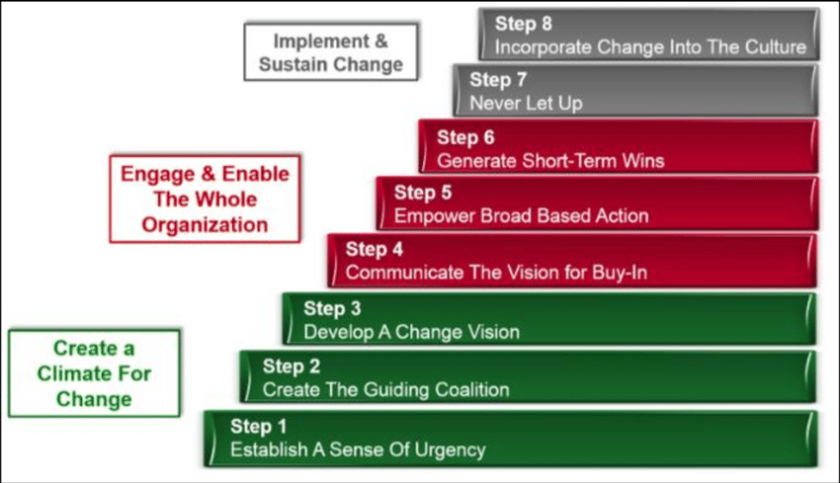
Figure 4 Change Management Strategy – Kotter’s 8-Step Model
- Create Urgency: The urgency for change at Eurogrind was driven by inefficiencies, poor productivity, and rising competition in the manufacturing industry. Without adopting advanced machinery and automation, the company risked losing its competitive edge and profitability. Management needed to emphasize the risks of inaction, including declining market share, reduced efficiency, and increased operational costs. Communicating financial losses, delayed production, and customer dissatisfaction could have secured buy-in from employees. Highlighting industry trends, competitor advancements, and potential job security threats would have reinforced the necessity of embracing automation. A compelling case for immediate action would ensure employee engagement and commitment to the transition.
- Form a Powerful Coalition: With only 20 employees remaining, forming a strong coalition was essential. A team comprising key managers, production supervisors, and skilled employees should have been involved in leading the change. Their role would be to support communication efforts, provide training, and address concerns regarding job security and work adjustments. By including experienced employees in the coalition, Eurogrind could have fostered trust among the workforce, ensuring that automation was seen as an opportunity rather than a threat. This approach would help gain employee confidence and reduce resistance to change.
- Develop a Vision and Strategy: To successfully implement automation, Eurogrind needed a clear vision and strategic roadmap. The vision should emphasize “Enhancing efficiency and maintaining market competitiveness through automation and a skilled workforce.” This approach would reassure employees that technology aimed to support their work rather than replace them. A structured plan outlining machinery integration, training programs, and role adjustments would provide employees with clarity. The strategy should also define measurable goals, key milestones, and employee benefits to ensure a smooth transition. Aligning automation with business growth, cost reduction, and job stability would create a compelling vision that employees could support.
- Communicate the Change Vision: Effective communication is critical in securing employee trust and engagement in the automation transition. Eurogrind needed a transparent communication strategy that provided employees with consistent updates, leadership messages, and detailed explanations of the benefits of automation. Regular meetings, internal newsletters, Q&A sessions, and leadership briefings could have ensured that employees understood how restructuring would lead to long-term business sustainability. Encouraging open discussions, feedback sessions, and addressing employee concerns would have reduced uncertainty. Clear messaging about training opportunities, skill development, and long-term job security would reassure employees and build confidence in the change initiative.
- Empower Employees for Broad-Based Action: Resistance to automation often stems from job security concerns and inadequate training opportunities. To empower employees, Eurogrind needed to invest in comprehensive training programs, upskilling initiatives, and involvement in decision-making processes. Encouraging employees to participate in pilot projects, contribute insights, and attend training sessions would have eased their transition. Providing mentorship programs, cross-training, and career development pathways would reinforce the idea that automation enhances roles rather than eliminates them. A supportive approach, where employees felt respected, valued, and prepared for new responsibilities, would have significantly increased engagement and willingness to adapt to change.
- Generate Short-Term Wins: Recognizing and celebrating small achievements was crucial to sustaining morale among the 20 employees. Short-term wins could include successful machine integration, improved production metrics, and positive employee feedback. Rewarding employees for adapting quickly and demonstrating efficiency with new technology would reinforce motivation. Additionally, highlighting how automation led to higher output and reduced downtime could reassure employees that the change was beneficial. These incremental successes would build confidence and encourage continued support for the transformation.
- Consolidate Gains and Produce More Change: After achieving initial success with machine integration, Eurogrind should have focused on continuous improvement. Refining machine operations, offering ongoing training for employees, and addressing technical challenges would sustain momentum. The 20 remaining employees should have been encouraged to provide feedback, ensuring that their concerns were addressed promptly. Investing in employee development and optimizing workflows would have solidified the changes and ensured that Eurogrind maximized the benefits of automation.
- Anchor New Approaches in Culture: For the transformation to be sustainable, automation needed to become part of Eurogrind’s organizational culture. The 20 employees had to see automation as an essential part of daily operations rather than a temporary adjustment. Aligning employee incentives with productivity goals, recognizing outstanding performance, and embedding training into company policies would help secure long-term adoption. By continuously reinforcing the value of automation and innovation, Eurogrind could ensure that employees remained engaged and committed to the company’s future success.
Applying Kotter’s 8-Step Model would have helped Eurogrind navigate automation more effectively, reducing employee resistance and increasing engagement. Addressing concerns about job security, skills development, and technology integration would have created a smoother transition. Focusing on urgency, communication, empowerment, and reinforcement strategies ensures that automation remains a long-term success. Through continuous training, employee involvement, and cultural alignment, Eurogrind could sustain higher efficiency, market competitiveness, and workforce adaptability. The company’s ability to balance technological advancement with workforce development would ultimately determine the success and sustainability of its automation journey (Kotter, 1996).

5. Impact on Employee Motivation – Herzberg’s Two-Factor Theory
Herzberg's Two-Factor Theory highlights that employee motivation is influenced by two types of factors: motivators and hygiene factors. Motivators lead to job satisfaction, while hygiene factors prevent dissatisfaction.
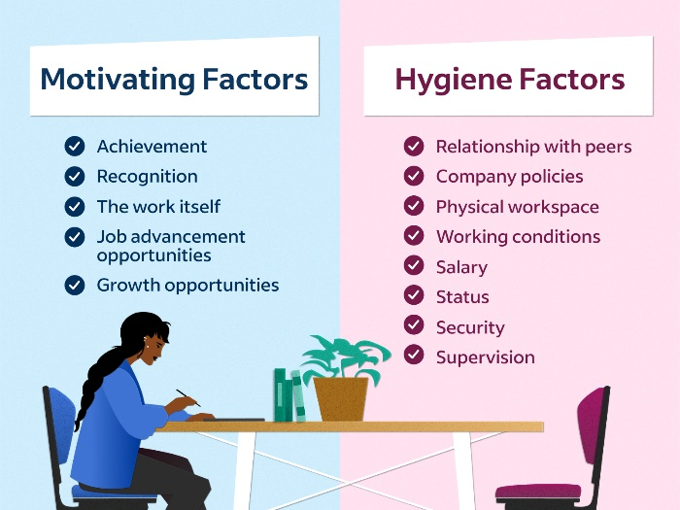
Figure 5 Impact on Employee Motivation – Herzberg’s Two-Factor Theory
At Eurogrind Manufacturing Ltd., motivators play a critical role in maintaining employee engagement during periods of change. Opportunities for employees to work with advanced machinery can significantly enhance job satisfaction (Herzberg, 1959). Recognition for adapting to new technologies and contributing to improved productivity serves as a strong motivator. Eurogrind’s emphasis on professional development through training and skill-building initiatives fosters a sense of achievement and growth. Furthermore, reinforcing employees' sense of purpose by linking their contributions to the company’s competitive advantage strengthens long-term engagement (Robbins & Judge, 2020).
Addressing hygiene factors is equally crucial to prevent dissatisfaction. During the transition to automation, job security remains a primary concern. Offering upskilling programs ensures employees are equipped to succeed in a technologically advanced environment (Herzberg, 1959). Transparent communication regarding job roles, career progression, and the impact of automation helps mitigate fear and uncertainty. Additionally, fair compensation aligned with new responsibilities, alongside benefits supporting work-life balance and well-being, reinforces employees' sense of value within the organization (Robbins & Judge, 2020).
By balancing motivators and hygiene factors, Eurogrind can maintain high levels of motivation during its automation transition. Motivators such as opportunities for personal growth, recognition, and alignment with organizational purpose foster deep commitment. Simultaneously, addressing hygiene needs—such as job security, fair compensation, and open communication—prevents dissatisfaction. This balanced approach is essential for navigating organizational change successfully while retaining a motivated and adaptable workforce, ensuring long-term stability and competitiveness in the manufacturing sector.

6. Recommendations
Improve Communication and Transparency: A major source of resistance at Eurogrind was the lack of clear communication. Management should develop a transparent communication strategy using regular meetings, town halls, and newsletters to update employees on the transition, address concerns, and highlight the benefits of automation. Emphasizing that automation enhances productivity without threatening job security will help reduce uncertainty and fear.
Involve Employees in Decision-Making: Eurogrind’s top-down approach limited employee engagement. To foster greater buy-in, employees should be involved in decisions, particularly regarding training programs and role adjustments. Empowering employees to participate in discussions will create a sense of ownership and commitment to change.
Expand Training and Development Opportunities: The initial short training program was inadequate. Eurogrind should invest in comprehensive technical and soft skills training, supplemented by mentorship programs, to ensure employees feel confident and supported during the transition.
Focus on Job Security and Career Development: Upskilling initiatives and clear career paths are essential to easing job security concerns. Offering opportunities for advancement and communicating these prospects will enhance engagement and motivation.
Recognize and Reward Employee Contributions: Implementing a formal recognition system to celebrate achievements and adaptation efforts will boost morale and reinforce positive behaviors.
Promote Work-Life Balance: To prevent burnout from increased workloads, Eurogrind should introduce flexible working hours, wellness initiatives, and stress management programs, supporting employee well-being and long-term job satisfaction.

7. Conclusion
Eurogrind Manufacturing Ltd.’s transition to advanced machinery and workforce restructuring highlights key challenges in managing organizational change and sustaining employee motivation. The company’s experience emphasizes the importance of a structured change management approach, effective communication, employee involvement, and continuous support during transformation. Using frameworks such as Lewin’s Force Field Analysis, Kotter’s 8-Step Change Model, and Herzberg’s Two-Factor Theory, this report identified the critical driving and resisting forces impacting change at Eurogrind. Initially, the company's top-down approach and limited employee participation contributed to resistance, illustrating the need for transparent communication and greater employee engagement in future initiatives.
To manage future transitions effectively, Eurogrind must expand training opportunities, address job security concerns, and recognize employee contributions. Automation should be positioned as an opportunity for employee growth, not just technological advancement. Providing a clear vision, aligning technological changes with career development, and fostering a supportive environment will enhance long-term success. By adopting a more inclusive, communicative, and balanced change management approach, Eurogrind can cultivate a motivated, adaptable workforce that drives enhanced efficiency and strengthens the company’s competitive advantage.

8. References
Armenakis, A.A. and Bedeian, A.G. (1999) 'Organizational Change: A Review of Theory and Research in the 1990s', Journal of Management, 25(3), pp. 293–315. Available at: https://doi.org/10.1177/014920639902500303 (Accessed: 5 May 2025).
Bridges, W. (2009) Managing Transitions: Making the Most of Change. 3rd ed. Da Capo Lifelong Books. Available at: https://www.hachettebookgroup.com/titles/william-bridges/managing-transitions-25th-anniversary-edition/9780738219653/ (Accessed: 5 May 2025).
Burke, W.W. (2017) Organization Change: Theory and Practice. 5th ed. Sage Publications. Available at: https://us.sagepub.com/en-us/nam/organization-change/book249891 (Accessed: 5 May 2025).
Burnes, B. (2021) Managing Change. 8th ed. Pearson Education. Available at: https://www.pearson.com/en-us/subject-catalog/p/managing-change/P200000006105/9781292393190 (Accessed: 5 May 2025).
Burnes, B. and Cooke, B. (2013) 'Kurt Lewin’s Field Theory: A Review and Re-evaluation', International Journal of Management Reviews, 15(4), pp. 408–425. Available at: https://doi.org/10.1111/j.1468-2370.2012.00348.x (Accessed: 5 May 2025).
Cameron, E. and Green, M. (2019) Making Sense of Change Management: A Complete Guide to the Models, Tools and Techniques of Organizational Change. 5th ed. Kogan Page. Available at: https://www.koganpage.com/product/making-sense-of-change-management-9780749496975 (Accessed: 5 May 2025).
Carnall, C.A. (2018) Managing Change in Organizations. 6th ed. Pearson. Available at: https://www.pearson.com/en-gb/subject-catalog/p/managing-change-in-organizations/P200000005599/9781292211784 (Accessed: 5 May 2025).
Cummings, T.G. and Worley, C.G. (2021) Organization Development and Change. 11th ed. Cengage Learning. Available at: https://www.cengage.com/c/organization-development-and-change-11e-cummings/9780357116957/ (Accessed: 5 May 2025).
Ford, J.D., Ford, L.W. and D’Amelio, A. (2008) 'Resistance to Change: The Rest of the Story', Academy of Management Review, 33(2), pp. 362–377. Available at: https://doi.org/10.5465/amr.2008.31193235 (Accessed: 5 May 2025).
French, W.L. and Bell, C.H. (1999) Organization Development: Behavioral Science Interventions for Organization Improvement. 6th ed. Prentice Hall. Available at: https://www.pearson.com/store/p/organization-development/P100000602074 (Accessed: 5 May 2025).
Hayes, J. (2022) The Theory and Practice of Change Management. 6th ed. Palgrave Macmillan. Available at: https://www.macmillanihe.com/page/detail/the-theory-and-practice-of-change-management-john-hayes/ (Accessed: 5 May 2025).
Herzberg, F. (1966) Work and the Nature of Man. Cleveland: World Publishing Company. Available at: https://archive.org/details/worknatureofman00herz (Accessed: 5 May 2025).
Hiatt, J.M. (2006) ADKAR: A Model for Change in Business, Government and Our Community. Prosci Research. Available at: https://www.prosci.com/bookstore/adkar-book (Accessed: 5 May 2025).
Johnson, G. and Scholes, K. (2022) Exploring Corporate Strategy. 12th ed. Pearson. Available at: https://www.pearson.com/en-us/subject-catalog/p/exploring-strategy-text-and-cases/P200000005765/9781292282456 (Accessed: 5 May 2025).
Kotter, J.P. (1996) Leading Change. Harvard Business School Press. Available at: https://hbr.org/product/leading-change/4661-HBK-ENG (Accessed: 5 May 2025).
Kotter, J.P. (2018) Leading Change. 2nd ed. Harvard Business Review Press. Available at: https://store.hbr.org/product/leading-change-revised-and-updated-edition/1871 (Accessed: 5 May 2025).
Kotter, J.P. and Cohen, D.S. (2002) The Heart of Change: Real-Life Stories of How People Change Their Organizations. Harvard Business Review Press. Available at: https://store.hbr.org/product/the-heart-of-change-real-life-stories-of-how-people-change-their-organizations/3441 (Accessed: 5 May 2025).
Lewin, K. (1951) Field Theory in Social Science: Selected Theoretical Papers. Harper and Row. Available at: https://psycnet.apa.org/record/1952-02200-000 (Accessed: 5 May 2025).
Lines, R. (2005) 'The Structure and Function of Attitudes Toward Organizational Change', Human Resource Development Review, 4(1), pp. 8–32. Available at: https://doi.org/10.1177/1534484304273818 (Accessed: 5 May 2025).
Lunenburg, F.C. (2010) 'Forces for and Resistance to Organizational Change', National Forum of Educational Administration and Supervision Journal, 27(4), pp. 1–10. Available at: https://files.eric.ed.gov/fulltext/ED508409.pdf (Accessed: 5 May 2025).
Oreg, S. (2006) 'Personality, Context, and Resistance to Organizational Change', European Journal of Work and Organizational Psychology, 15(1), pp. 73–101. Available at: https://doi.org/10.1080/13594320500451247 (Accessed: 5 May 2025).
Prosci (2022) ADKAR: A Model for Change in Business, Government and our Community. Available at: https://www.prosci.com/resources/articles/adkar-theory-overview (Accessed: 5 May 2025).
Pugh, D.S. and Hickson, D.J. (2007) Great Writers on Organizations: The Third Omnibus Edition. Ashgate. Available at: https://www.routledge.com/Great-Writers-on-Organizations-The-Third-Omnibus-Edition/Pugh-Hickson/p/book/9781138255880 (Accessed: 5 May 2025).
Robbins, S.P. and Judge, T.A. (2020) Organizational Behavior. 18th ed. Pearson. Available at: https://www.pearson.com/en-us/subject-catalog/p/organizational-behavior-global-edition/P200000005901/9781292314409 (Accessed: 5 May 2025).=
Schein, E.H. (2010) Organizational Culture and Leadership. 4th ed. Jossey-Bass. Available at: https://www.wiley.com/en-us/Organizational+Culture+and+Leadership%2C+4th+Edition-p-9780470190609 (Accessed: 5 May 2025).

