
Effective Team working and Communication

Student Name: Samanta Skroblaite
Student Number: 1814061
Module Name: (BMSK4002_LON)
Module Title: Effective Team Working and Communication
Lecturer: Richard Small

*Due to technical problems I can not make referencing. I am apologize for any inconvenience.

Table Contents
- Introduction………………………………………………………………………….p.3
- Communication Channels …………………………………………………….p.4
  - Verbal Communication……………………………………………………
  - Nonverbal Communication…………………………………………….
- Team communication at Workplace……………………………………..p.5
- Communication models………………………………………………………..p.6-7
  - Shannon-Weaver model………………………………………………….
  - Berlo’s model………………………………………………………………….
- Communication skills strengths and weaknesses………………….p.8
- Conclusion……………………………………………………………………………p.9
- References…………………………………………………………………………..p.10

Introduction
In this report I will be discussing about communication at workplace, verbal and nonverbal communication and why these channels of communication are important at workplace. Then I will be analyzing about effective team working and how to manage the conflicts between teams, and also I will be presenting two communication models: Shannon – Weaver and Berlo’s models, and explain how these two models work as a communication. Finally, I will present my own weaknesses and strengths of my communication skills.

Communication Channels
Important component of communication process, is a selecting a communication channel. It means that messages are transmitted. I will be discussing in this chapter about two communication channels which is; Verbal and Nonverbal communication. Various channels of communication is the amount of information we are transmitting through each type of these channels.

Verbal Communication – the meaning of verbal communication is when you share information with individuals through using by speech. In a workplace we have to use verbal communication effectively so that employers understand spoken words and as well ensuring the tone of the voice are expressed appropriate. This process also involves in business meetings between member of staff and management, they present a different views and issues, develop and ideas, engaging and motivating. Verbal communication involves dialogue between individuals and business organizations and give a result in more effective communication. There are different forms of verbal communication two examples are; face -to- face meetings which is the best source of information, it allows managers and staff emotions to be transmitted and get immediate feedback. Another form of verbal communication is written communication. Today written communication considered as slow, because we got new technologies as electronic emails and computer communications. Computer technologies has improved a lot when it comes to written communication, you can talk to your business partners from across the world.

Nonverbal Communication - nonverbal communication is means the information sharing without using words to encode the messages. According to iedunote.com article ‘’ even if we use no words in nonverbal communication many human feelings more accurate than methods of verbal communication’’. But there are four basic form of nonverbal communication:
Facial expressions - are the huge proportion of nonverbal communication. We can get a lot information about the person by looking into smile or a frown. The look of the person’s face is the first thing we’ll see , before we can hear what they have to say.
Gestures - Gestures are significant amount of information without a individuals open their mouth. In the workplace we use a lot of gestures as part of nonverbal communication. We use our hands on presentations at work to engage and interest audience. According to Catherine Johns article she explains that ‘’ If we use gestures in simple conversation, then we should able to use gestures, when we are in front of the audience’’.
Eye contact - eye contact are most of the biggest evident of nonverbal communication. According to classroom.com that ‘’ eyes are the window of the soul’’. At job interview is very important to have eye contact with your hiring manger it will show that you are listening and interesting in the role.
Body language - If you use properly the body language it can be the key to the greatest success. Body language can help to develop positive business relationships influence and motivate with the co-workers improve productivity and have a good bond with the members of the team, and also present ideas with bigger impact.

Team communication at workplace
Working in teams means different individuals have come together and function as a one powerful unit. According to Maund ‘’Teams exist to accomplish specific tasks that are related to common goals, in order to do that teams must interact with each other to achieve these tasks’’ (Maund,2017).

For business to grow and to be successful, teams have to collaborate together on every projects and tasks, with the aim of using different strengths and individual components. Working in teams can be really frustrating, when it comes to conflicts between groups. There is five common problems that people experience when they work in teams:
Lack of commitment - It can be extremely frustrating for those who are often doing little or nothing and putting the pressure for those who are of higher performing members. This social ‘’loafing’’ can be irritant for countless team members.
Productivity losses - Productivity losses comes from poor structure and little of planning, it might take longer to make a decisions and time will be wasted on trying to schedule meetings between each team members.
Poor communication - Poor communication often happens when the team are poorly performed, when team members fail to communicate effectively, then confusion and conflict might erupt.
Interpersonal conflict - In every team is likely that we get along better with these people and maybe some of others we might dislike. Some team members are taking things too personally, that they do not realize, that spirited debate can effect the ability of team to make good decisions.
Poor leadership – Poor leadership can effect teams to work effectively in the business. According to Neil ‘’ Poor leadership can bring several negative effects to the company and staff ‘’ (Neil, 2018). Staff who are not motivated and had enough of the organization they giving up by quitting their job and this is escalates profitability of concerns for the business as they lose good, experienced employees and they have to replace with the new one’s.

Communication Models
Communication models are conceptual models whom are used to explain the human’s communication problems. Communication is the process of sending and receiving messages, or transferring information from sender to receiver.

Shannon – Weaver Model
Shannon – Weaver was designed to function radio and telephone technology. This model are consisted in four primary parts: sender, message, channel and receiver. Sender is a part of telephone, the person speaks into it and the channel is telephone itself, receiver is the part of the phone which receiver can hear the other person on the other end of the line. The original Shannon – Weaver have five elements; Information source, transmitter, channel, receiver and the destination. The first main process of information source when the information it is stored. In order to send the information the message had to be encoded into the signal so could travel to reach destination, once the message is encoded it goes through the channel which is the signals are adapt for transmission. The channel carries the noise source which is that might happen to lead the signal receive a different information from a source, and finally the message reaches the destination.
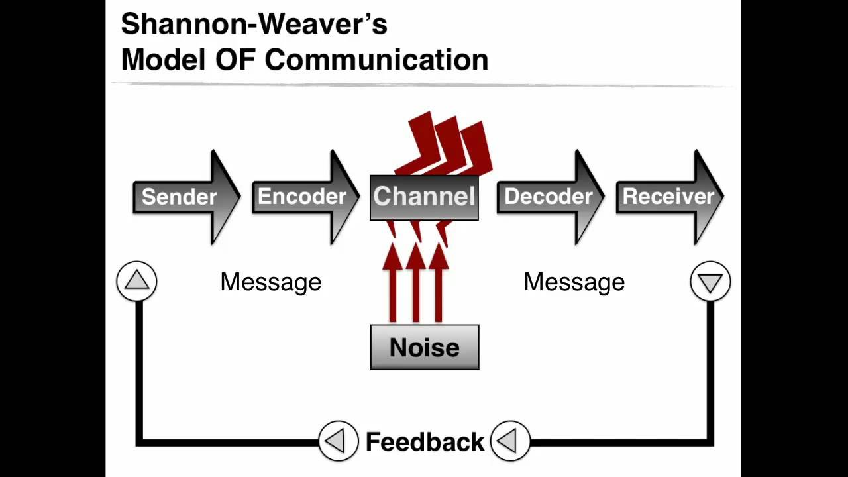

Berlo’s Model
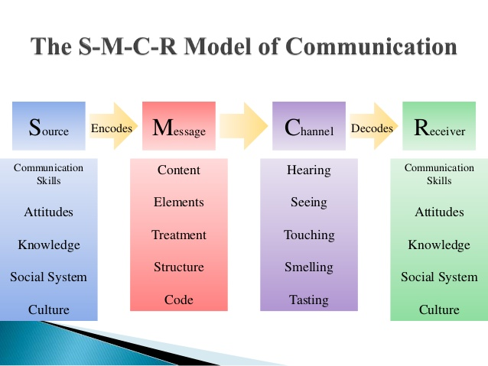
Berlo created the sender – message – channel – receiver (SMCR) model of communication. This model of communication is very clearly separated into the parts. Berlo’s communication process is very simple communication from person to person, it is includes source, encoder, message, channel, decoder and receiver. He is also presented the communication process between two people which is include; communication skills, awareness level, social system, cultural system and attitude. Berlo’s model is starting from source which is observe the communication skills, attitude, knowledge, social system and culture of the people whom are involved in the communication. Afterwards when message it is developed then the encoder start to step it in, encoding process taking place by writing or speaking. The message goes all the way through channel, and carry the message by hearing, seeing, touching, smelling or tasting. Then decoding process begins, in this process the receiver interprets the message with receptive skills, and finally the receiver gets the whole message clearly.

Communication Skills strengths and weaknesses
Every day on my daily life I constantly communicating with people, especially with my co- workers and managers at my workplace. Before I get my current job, during the interview my hiring manager asked me what is my strengths and my weakness in communication skills?. I was a bit nervous at the interview, so I was wondering how to answer this question with the best professionalism. I started talking about my strengths. I am always good at working in teams, I work well to inspire team members and work side to side with them to achieve every goals. My other strengths are writing skills, I do work well under pressure and I never missed a deadline. Also I am good at solving problems, working in hospitality can be really frustrating especially when it comes to unsatisfied customers. One of the specific example is that the customer ordered two meals, but he only got one. Due to the costumer and my staff lack of communication and miss understanding I have to solve the problem as soon as possible, because the customer was unhappy about the costumer service so the problem got heated and costumer and the staff start to blame each other. I apologized the customer and told him that I will take care of everything and make sure his meal arrive as soon as possible and that he do not need to pay. The customer got his meal a few minutes later and he left highly satisfied and even apologized for getting overreacting.
My weaknesses are sometimes I am overcritical to myself whenever I do my job well, but I still feel like I could have done more even if my General manager are happy in a positive response. This often leads me to overwork myself and leaves me burned out. I also very introverted, which is makes me a lack of sharing my ideas with the team. I feel like I have good ideas but I am not comfortable to explore my thoughts. When my team did not meet the expectations I decided to make a changes and slowly speaking about my ideas and the benefit for my team. It is a still working process, but I already improved myself a lot over the last six months.

Conclusion
I have no doubt that communications skills are very important especially at workplace. For us to work with success we have to communicate with our co-workers effectively, and ways we can communicate is verbally or nonverbally, using gestures facial expression or even body language helps for our co-workers communicate even better, it shows that you express your emotions and let them listen and understand you. Shannon – Weaver and Berlo’s communication models are an examples for us how to communicate effectively at workplace. Also communication between the teams is very important when we doing the business projects, we have to know how to communicate with our team if we want to have a high success in a business. According to Morgan ‘’ Working in high performed team can be extremely rewarding experience. All these team understand each other, encourage and support each other as the task of progress, they put their ego away for the great result of the team’’. (Morgan,2017).

References
Provizorca,(2011). How New technology changes the way we communicate. Available at:https://www.youtube.com/watch?v=c1uURVbQCs8
‘’ A primer on communication studies’’, (2012). Dowloaded by Andy Schmitz.
Andrew Maund, M. S. P. K. T.(2017). Certificate in Higher Education: Skills for the Workplace Student Yearbook. London: SAGE publications Ltd.
Neil Kokemuller,(2018) Poor leadership & It’s effects on the staff and company.
‘’Shannon and Weaver model’’. (2015) Available at: https://www.youtube.com/watch?v=tCIsNt03egE
Samantha Tadena, (2017). Berlo’s Model of communication Available at: https://www.youtube.com/watch?v=KHGMNV95NkQ
Peter Morgan,(2017) The Business Students Guide to Study and Employability Skills. London: SAGE publications Ltd.

