Marketing Essentials BMIH4005
Component A: Marketing Plan

Student Name: Abdul Quiyum
Student ID: 2229328
Lecturers name: Luciana Suardi
Word Count: 1321

Table of Contents

Introduction 3
Situation Analysis 3
Objectives 5
Strategy 5
Tactics 5
Action 6
Control 6
Conclusion 7
References 7
Appendices 9

Introduction
The purpose of this study is to give an idea about the marketing plan of Premier INN Company. This study is prepared by connecting various information of Premier INN Company (Aprilioni et al. 2017). This study analyses the information of Premier INN Company with the help of some theories, those theories are SWOT, Marketing Mix, 5C and PESTLE. This study explains about Premier INN company's segmentation and targeting methods along with other important activities. The main objective of this study is to give an idea about the overall operations and marketing plan of this company and to suggest changes in the marketing plan.

Situation Analysis
Company: SWOT analysis
Strengths | Weaknesses
Occupancy rate of Premier INN hotels is more than 76.3%. Pillows, Cosy duvet, and blackout curtains of this hotel are very much liked by the guests. Premier INN Hotels has 800 hotels with 80,000 rooms. This hotel serves about 5 million guests every month. Premier INN hotels are located at airports and various tourist places. | Premier INN serves very few countries, the hotel has been accused of cancelling guest bookings and the hotel environment is not hygienic enough (Ramadhani et al. 2017).
Opportunities | Threats
Premier INN can achieve more success by setting up branches in other countries of the world except UK, UAE, Germany, and Qatar. Currently the demand of tourists is increasing in the world which can be the reason for the business success of this hotel. | Premier INN Hotels can be harmed by excess taxes, lack of customer recognition, competing companies, epidemics, and inflation (Steenbeck et al. 2021).

Customers: Segmentation and Targeting/ Customer profile’s’.
Premier INN does proper customer analysis to achieve business success. Premier INN conducts customer profile analysis to implement the first segmentation method. The hotel targets travellers and backpackers after analysing the customer profile (Poroasih et al. 2017). The hotel builds hotels in UK airports, main cities and travel destinations where the highest number of guests can be accommodated.
Competitors: Perceptual positioning map, Bowman’s strategy clock
The competing organizations of Premier INN Company are Travelodge, Trivago, Late rooms and Jurysinns. Premier INN companies must control the competitive market by adopting some unique strategies (Nabhan et al. 2022). This company can follow Bowman's Strategies Clock to compete with rival companies. Bowman's strategies are Low Price, Value added, Hybrid, Differentiation, Risky High Margins and Monopoly Pricing. Premier INN can compete with competing companies by following these strategies.
Collaborators: Demonstrate an awareness of your organisations B2B Relationships, Partnerships, Franchises.
Premier INN maintains relationships with various relevant organizations by managing B2B relationships. This company uses modern technology in a very good way to build good relationship with customers (Wicaksana et al. 2017). Premier INN has entered several partnerships to develop new hotels in various countries.
Climate: PESTLE
PESTLE Analysis
Political | Premier INN being a British brand is affected by UK politics and BREXIT.
Economical | Due to increase in labour cost and inflation, the cost of Premier INN Company has increased a lot.
Social | Premier INN Company operates hotels in different countries according to local social traditions and policies.
Technological | This company controls the hotel rooms by using the latest technology to provide maximum service to the customers (Billah et al. 2018).
Legal | This company also uses technology to ensure customer security. This company operates hotels in accordance with the local legal regulations of United Kingdom, United Arab Emirates, Germany, and other countries.
Environmental | This company operates in various countries without harming the local environment.

Objectives
The aim of Premier INN Company is to provide all kinds of services with technology and modern facilities to the customers coming to different hotels, to always treat the guests well, to protect the maximum safety of the guests and to act according to the demand by analysing the guests (Lane et al. 2016).

Strategy
Premier INN Company provides all types of modern hotel services to customers. All the hotel staff of this company is very flexible and treat the guests well (Aziz et al. 2017). Guests feel very comfortable and secure in receiving services from these company's hotels. Premier INN Company implements all kinds of facilities in every room to satisfy the customers. This company has always provided guests with a safe and secure stay that customers love. It is for these reasons that customers always feel comfortable staying in the hotels of this company. The company targets all types of customers, especially those with a penchant for travel. The objective of this company is to provide all kinds of benefits to the customers short of technology (Pearson et al. 2020).

Tactics

Marketing mix
Product | Premier INN Company provides all kinds of services related to hotel hospitality to the customers. The hotel ensures various facilities to the guests based on the demand of the customers. The facilities that Premier INN Hotel provides to customers are En-Suite Bathroom, Bed with Duvet, Remote Control TV, Hairdryer, Free Travel Cot Hire, Irons, Tea, and Coffee making facility, Security and Super Comfy Double or Kingsize (Vigilia et al. 2017).
Place | Premier INN is a popular hotel in UK. This company provides services in United Kingdom, United Arab Emirates, Ireland, Germany, Qatar, Guernsey, and Jersey countries. Premier INN has 800 hotels and 80,000 rooms in these countries. Premier INN builds hotels in airports and main cities of countries as such places are always crowded with guests. Premier INN company hotels are also present in travel places of other countries including UK.
Price | Premier INN provides hospitality services to guests by building hotels in the United Kingdom, United Arab Emirates and Germany and several other countries. The hotel provides online and offline services to its customers. The hotel mainly provides three types of packages which are high, middle, and low rates. Premier INN hotels provide services according to the financial status of the guests. The hotel adopts different pricing strategies in different regions. The hotel charges relatively low prices in competitive areas and high prices in other areas. The hotel determines the price of the service by analysing the purchasing power of the customers (Pratidina et al. 2020).
Promotion | Premier INN Company has built around 800 hotels across the world and has taken the help of modern technology to promote the hotels. In modern era, no company can gain popularity without promotional activities. Premier INN Company has taken the help of YouTube, Facebook, Instagram, and TV programs to complete the promotional activities of each hotel. Following the advertising method, the hotel has disseminated information-rich videos of the company through various social media channels.

Action

Gannt Chart of marketing activities: Marketing channels schedule

Control

Premier INN can analyse the behaviour of the guests to achieve success and implement some features that will increase the satisfaction of the guests. Technology dependent facilities should be implemented to attract new customers (Bas et al. 2021). Premier INN can create new branches within Europe, Asia, and Americas to increase profits. Stealing hotels in new countries will get more guests which will increase organizational profits. The hotel can analyse the customers and implement modern and technological facilities to increase the profit which will increase the number of guests of the hotel (Bower et al. 2018). Premier INN must ensure guest safety and service by adopting integrity to enhance positive brand image. The management of this hotel should always control the healthy food and environment which will help to increase the positive attitude of the brand.

Conclusion
This study discusses the marketing analysis activities of premier INN hotels. Premier INN hotels have been successfully providing hospitality briefs to guests in several countries including UK, UAE, Germany, and Ireland as highlighted in this research analysis.
Premier INN Company can achieve success by building more hotels in other countries of the world (Wood et al. 2017). The company can select different countries in Europe to build hotels. The company can achieve customer satisfaction by adding digital and modern amenities to hotel rooms that will help achieve organizational success.

References

- Aprilioni, J.R., (2017). Studi Deskriptif Pengembangan Sumber Daya Manusia Pada Premier Inn Hotel Surabaya. Agora, 5(2).
- Aziz, M.A. and Ardila, R., (2017). Perencanaan Ulang Struktur Hotel 6 Lantai Di Surabaya Dengan Metode Sistem Rangka Pemikul Momen Menengah (SRPMM) (Doctoral dissertation, Institut Teknologi Sepuluh Nopember).
- Bas, T. and Sivaprasad, S., (2021). COVID-19 and Implications for Future Trends in the UK Travel and Tourism Sector. Available at SSRN 3623404.
- Billah, M.K., (2018). Perencanaan Struktur Gedung Hotel Premier Inn Surabaya Dengan Menggunakan Metode Beton Pracetak (Precast) Pada Elemen Balok Dan Pelat (Doctoral dissertation, Institut Teknologi Sepuluh Nopember).
- Bower, J., (2018). Whitbread: Routines and resource building on the path from brewer to retailer. Management & Organizational History, 13(1), pp.1-23.
- Lane, L., (2016). Belfast City Story-CASEreport 102: May 2016-Laura Lane, Ben Grubb and Anne Power.
- Nabhan, M.B.G., (2022). Perhitungan Waktu Dan Biaya Pelaksanaan Pembangunan Hotel Premier Inn Surabaya Dengan Menggunakan Perth Construction Hire (PCH) (Doctoral dissertation, Institut Teknologi Sepuluh Nopember).
- Pearson, C., (2020). Mock Tudor. Architectural Theory Review, 24(2), pp.211-213.
- Pratidina, T.M., (2020). ANALISIS KOMPETITIF MENGGUNAKAN TEXT MINING MELALUI TWITTER: STUDI EMPIRIS HOTEL BERSKALA INTERNASIONAL (Doctoral dissertation, Universitas Atma Jaya Yogyakarta).
- Ramadhani, F., Raka, I.G.P. and Tavio, T., (2017). Desain Modifikasi Struktur Gedung Hotel Premier Inn Surabaya dengan Menggunakan Beton Prategang dan Sistem Rangka Pemikul Momen Khusus (SRPMK). Jurnal Teknik ITS, 6(2), pp.D309-D314.
- ROROASIH, R.A., (2017). ANALISA STRATEGI ADMIN FOOD & BEVERAGE DALAM MENGOPTIMALKAN KEGIATAN ADMINISTRASI DI PREMIER INN HOTEL SURABAYA (Doctoral dissertation, Universitas Airlangga).
- Steenbeck, A., (2021). Lübeck:„Premier Inn “baut direkt am Hauptbahnhof ein neues| SHZ.
- Viglia, G., (2017). Customer satisfaction and pricing decisions. In The Routledge Handbook of Consumer Behaviour in Hospitality and Tourism (pp. 201-207). Routledge.
- Wicaksana, G.A., (2017). Perancangan Interior Hotel Premier Inn Satoria Yogyakarta (Doctoral dissertation, Institut Seni Indonesia Yogyakarta).
- Wood, R.C., (2017). Hotel accommodation design. In Hotel Accommodation Management (pp. 46-56). Routledge.

Appendix

Slide 1
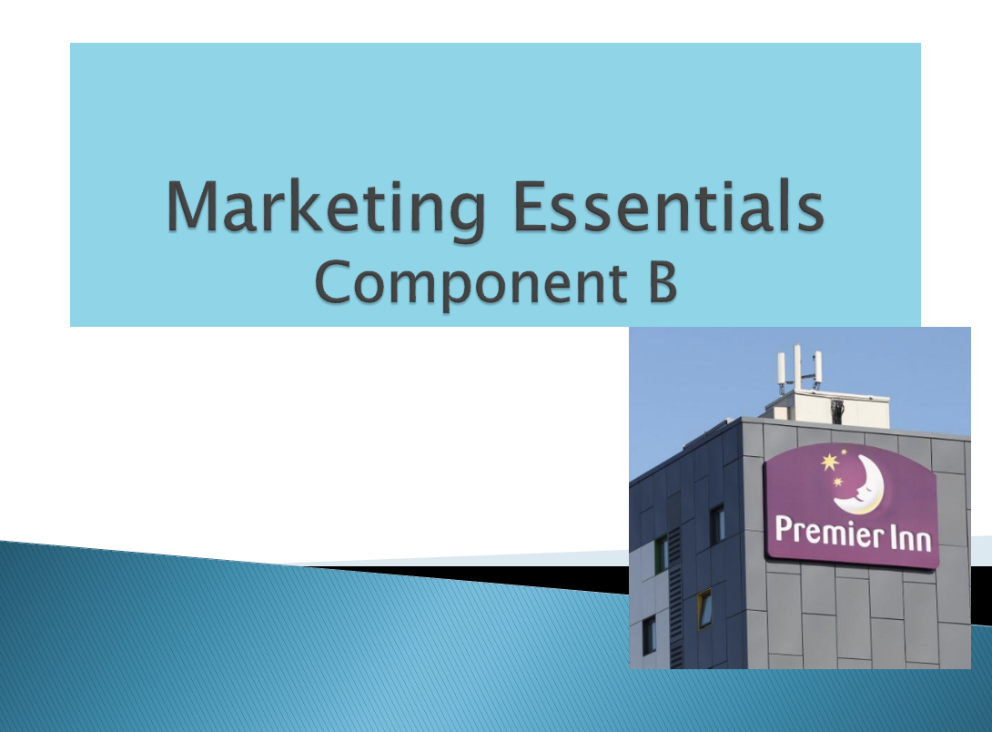

Slide 2
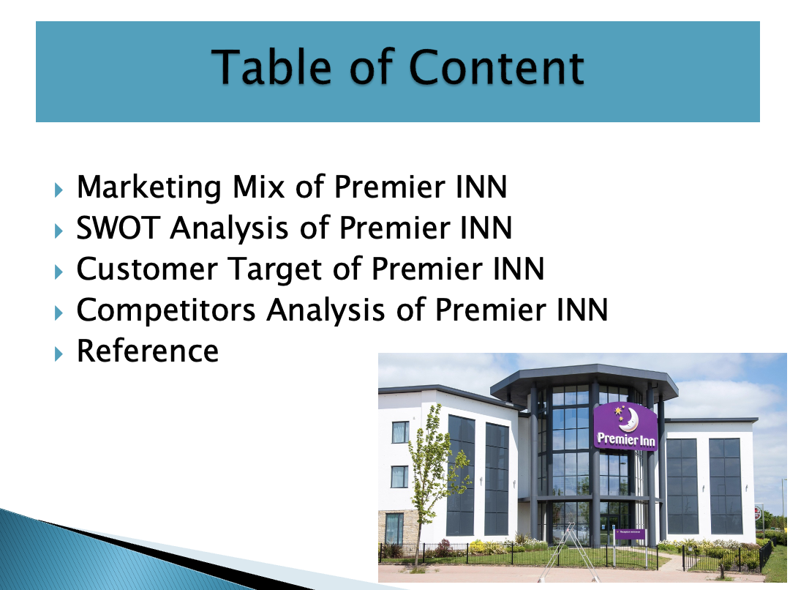

Slide 3
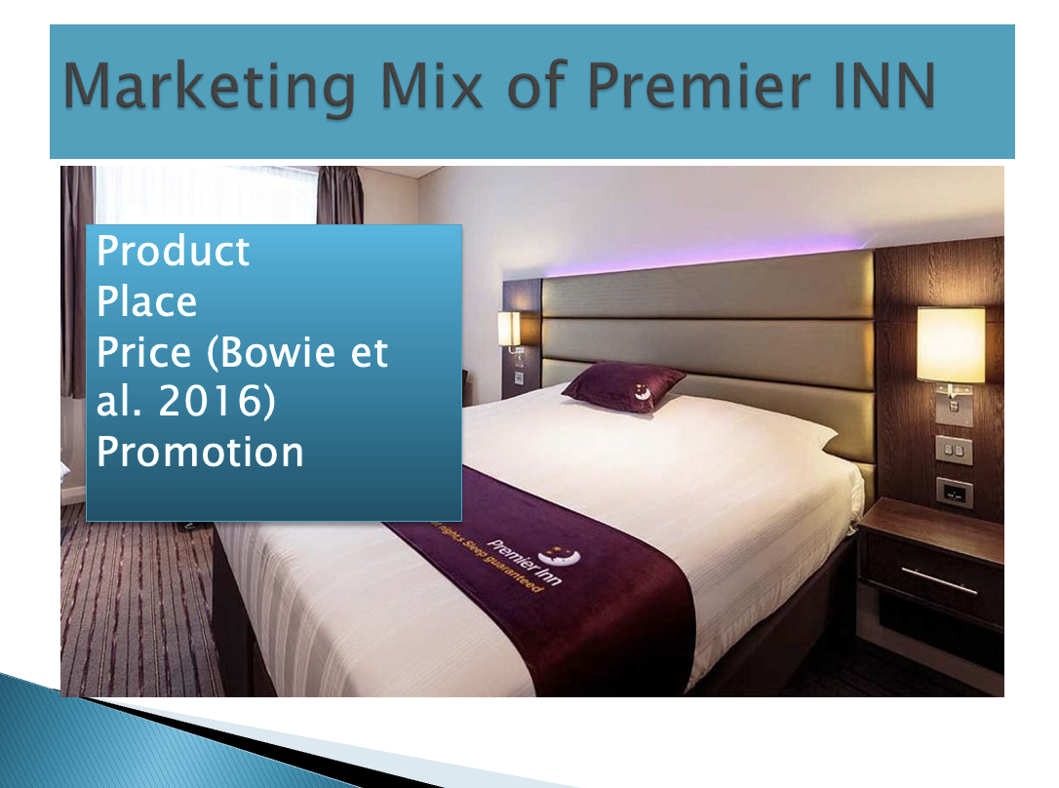
Premier INN Company provides hospitality related services to customers by building hotels in different countries. The facilities that the company provides to the customers are Digital Room, TV, WiFi and Security. Premier INN has developed around 800 hotels with 80,000 rooms in the UK, UAE, Ireland, Qatar, and other countries. The company has developed hotels in places where there is constant influx of guests such as business districts, airports, and tourist spots by analyzing them (Bowie et al. 2016). Premier INN Company prices the packages in such a way that it is within the purchasing power of its guests. This company controls the pricing strategy by analyzing the customers in different areas. Premier INN uses Facebook, Instagram, YouTube, and advertising to promote the hotel.

Slide 4
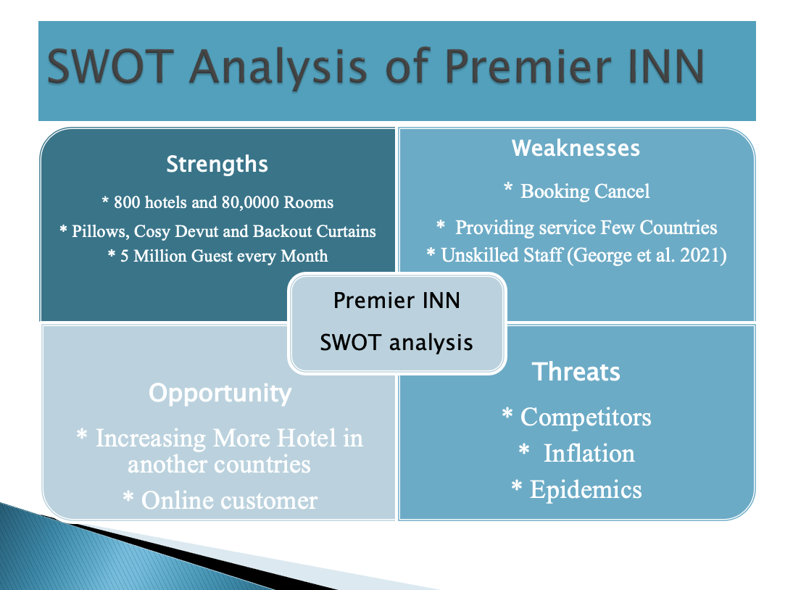
Premier INN strength is about 80,000 rooms in 800 hotels. That is, in the United Kingdom, United Arab Emirates, Qatar, Ireland and other countries, this company has about 80,000 sleeps to provide services to guests. This company has several facilities that guests like very much, they are Pillows, Cozy Devout and Blackout Curtains. Weakness of Premier INN Hotels is service in very few countries. This company provides services in several countries including United Arab Emirates and Germany. The company has been accused of canceling customers' bookings after confirming them. This company has some staff who are not experienced. Premier INN Company can achieve much more success by building its own hotels in all European countries. If this company can implement online service properly then it will get many guests (George et al. 2021). The biggest threats for Premier INN companies are inflation, epidemics, and rival companies.

Slide 5
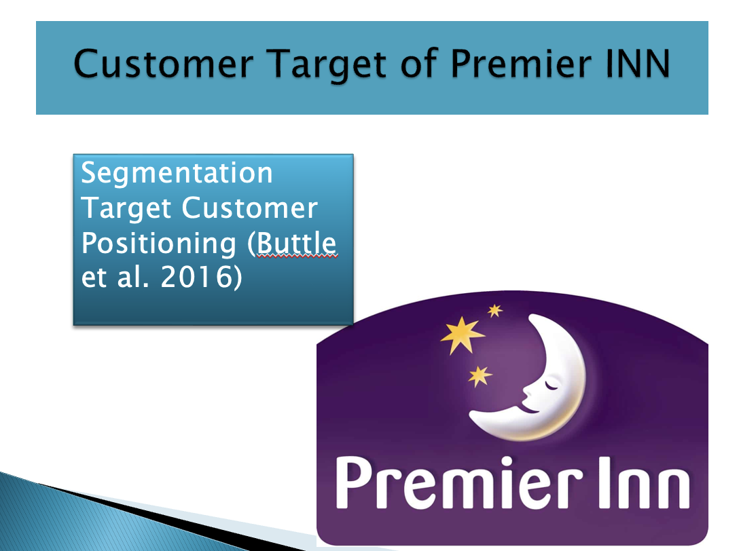
Premier INN Company finds out the type of people who have travel habit by analyzing customer profile. Then this company targets travelers and backpackers (Buttle et al. 2016). Premier INN Company develops hotels in various places of the country where there is constant influx of guests like tourist spots, airports, business areas, main cities etc.

Slide 6
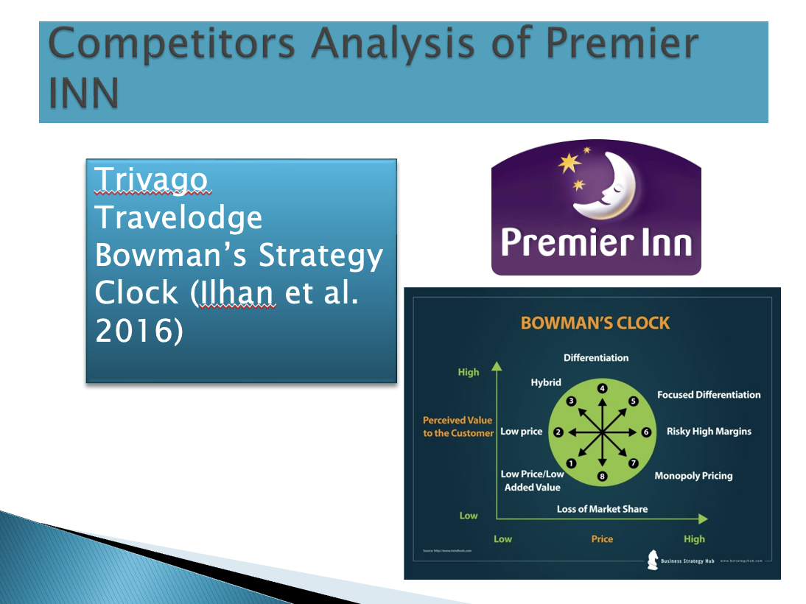
Premier INN Company has many competitors like Jurysinns, Laterooms, Travelodge and Trivago. This company must make competitive strategy to achieve business success with rival companies (Ilhan et al. 2016). Premier INN Company can achieve success with rival companies by following Bowman Clock Strategy. Following this theory, Premier INN can take steps that are Low Price, Risky High Margin and Differentiation.

Slide 7



