Report 1
LinkedIn – “The Impact of Organisational culture change and development."

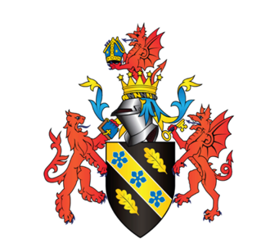

March 2023

MODULE NAME: Human Resource Management (BMMB7007)
NAME: Chan Kong To
STUDENT NUMBER: 2215161

Executive Summary:
LinkedIn, a professional social networking platform, has built a positive organizational culture through the implementation of Maslow’s Hierarchy of Needs Theory and High-Performance Work Systems (HPWS). However, there are negative impacts of the current culture, including layoffs and a lack of diversity and inclusion. This report provides recommendations for LinkedIn to improve its culture and address these negative impacts.

Maslow’s Hierarchy of Needs Theory has helped LinkedIn prioritize employees’ needs, including physiological needs, safety needs, love and belonging needs, esteem needs, and self-actualization needs. LinkedIn has also transformed into an HPWS that values employee engagement, productivity, and innovation. The company’s leadership, employee engagement, diversity and inclusion, and adaptability have been instrumental in driving its success and competitiveness in the market.

Despite these successes, LinkedIn has experienced negative impacts. The company has announced several layoffs in recent years, including a reduction in its recruitment team and the layoff of nearly 1,000 employees globally in 2020. These layoffs have undermined employees’ safety needs and job security, damaging the company’s organizational culture.

Furthermore, LinkedIn’s diversity and inclusion initiatives have yet to fully address the representation of underrepresented groups in leadership positions. This lack of diversity and inclusion can harm employee morale and productivity, leading to lower job satisfaction and retention rates.

To address these negative impacts, LinkedIn should prioritize employee safety and job security by avoiding unnecessary layoffs and providing clear communication about any layoffs that may occur. The company should also increase its efforts to promote diversity and inclusion, such as implementing more diverse hiring practices and providing leadership opportunities for underrepresented groups.

Additionally, LinkedIn should continue to invest in its employees’ professional growth and development to enhance their motivation and engagement. The company can achieve this by providing more opportunities for career advancement, such as mentorship and coaching programs.

LinkedIn can improve its human resource management practices and gain a competitive advantage by implementing the following recommendations based on the Resource-Based View theory of HRM:
- Develop core competencies through employee training and development.
- Build a strong employer brand by offering attractive compensation, opportunities for career growth, and a positive work environment.
- Focus on employee engagement by promoting motivation, recognition, feedback, and teamwork.
- Leverage human capital by implementing talent management strategies to identify and develop high-potential employees.
- Foster a learning organization by promoting continuous learning, knowledge sharing, collaboration, and feedback.
By implementing these recommendations, LinkedIn can achieve its strategic objectives and stay ahead of changes in the industry.

Contents

Executive Summary: 2
LinkedIn Introduction 5
What is HRM 5
Maslow’s Hierarchy of Needs Theory of LinkedIn 6
High-Performance Work Systems (HPWS) 7
The Weakness of Organisational Culture Change and Development Within LinkedIn 9
Over-reliance on HR practices 9
Resistance to Change: 10
Lack of diversity and inclusion 10
Inability to Measure Cultural Changes: 11
The Impact of Culture Change and Development on LinkedIn 11
Cultural alignment issues 11
Loss of key employees 12
Recommendations 12
Conclusion 13
Reference 15

LinkedIn Introduction
LinkedIn is a social networking platform primarily used for professional networking, job searching, and career development. It was founded in 2002 and launched in 2003 by Reid Hoffman, Allen Blue, Konstantin Guericke, Eric Ly, and Jean-Luc Vaillant. LinkedIn is headquartered in Sunnyvale, California, and was acquired by Microsoft in 2016. LinkedIn has over 830 million members in more than 200 countries and territories worldwide. The platform allows users to create a professional profile that highlights their work experience, education, skills, and accomplishments. Users can also connect with other professionals in their industry, join groups, and follow companies and organizations (Reynolds, 2022).

In addition to networking, LinkedIn offers job postings, career development resources, and educational content such as courses and articles. It is also used by recruiters and companies to find and hire talent, and to promote their employer brand and company culture (LinkedIn, n.d.-d).

LinkedIn is considered one of the most influential social media platforms for professionals, and its mission is to "connect the world’s professionals to make them more productive and successful."

Organizational culture refers to the shared values, beliefs, practices, and behaviors that shape the way employees think and behave in an organization. Organizations that focus on developing a positive and strong organizational culture tend to have higher employee engagement, better performance, and a competitive advantage in the market (Wong, 2020). LinkedIn, a professional social networking site, has been successful in building a positive organizational culture. This report critically evaluates the HRM priority area of organizational culture change and development within LinkedIn.

What is HRM
The management of human resources (HRM) encompasses various processes, including recruitment, training, compensation, policy development, and retention strategies. Over the past two decades, HRM has evolved significantly, assuming a critical role in contemporary organizations. In the past, HRM was limited to administrative duties such as payroll processing, organizing employee activities, and ensuring accurate completion of forms. However, in today’s context, HRM has become a strategic function that plays a vital role in the success of the organization (University of Minnesota, 2016). The new role of HRM, as expressed by Jack Welch, former CEO of General Electric and management expert, is to move beyond organizing parties, birthdays, and enrollment forms. HRM should recognize its importance during prosperous periods, but more crucially, its definition is shaped during challenging times (Frasch, Shadovitz and Shelly, 2009).

Maslow’s Hierarchy of Needs Theory of LinkedIn
The Maslow Model, a psychological theory of motivation, consists of a pyramid-shaped hierarchy of human needs categorized into five levels. The lowest level is physiological needs, such as food and clothing, followed by safety needs like job security, love and belonging needs, which include friendship, esteem, and finally, self-actualization. Individuals must satisfy lower-level needs before being able to fulfill higher-level ones, according to this theory (Mcleod, 2023).

Figure 1：
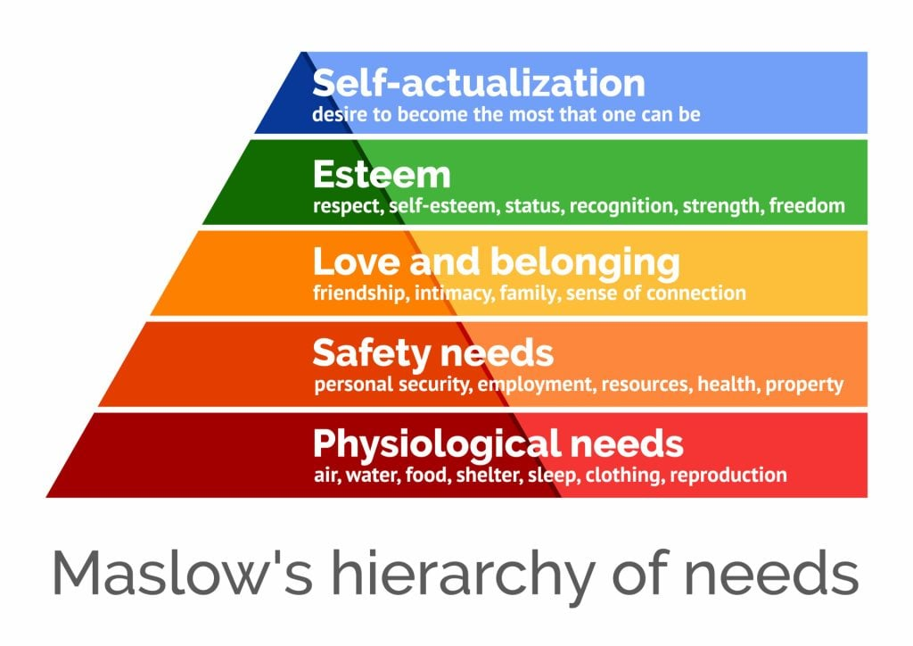
The Concept of Maslow’s Hierarchy of Needs (Mcleod, 2023)

- Physiological needs: At the most basic level, individuals need to meet their physiological needs, such as food, water, shelter, and other basic necessities. On LinkedIn, this might translate to individuals looking for job opportunities that will provide them with a stable income and basic benefits.

- Safety needs: Once physiological needs are met, individuals seek safety and security. In the context of LinkedIn, this might mean that individuals are looking for job opportunities that provide a sense of stability and security, such as long-term contracts or the ability to work remotely. However, LinkedIn has become another tech company to declare layoffs in recent times, as it is reducing the size of its worldwide recruitment team. In October, LinkedIn had already revealed job cuts due to unfavorable foreign exchange rates and prolonged production shutdowns in China, affecting roughly 1,000 jobs. The last instance of LinkedIn announcing job cuts was in 2020 when the company let go of almost 1,000 employees globally, accounting for a 6% reduction in the workforce due to decreased demand caused by the pandemic (Gain, 2023).

- Love and belonging: Humans have a need for social connection and a sense of belonging. LinkedIn has several ERGs that provide opportunities for employees to connect with colleagues who share similar interests or backgrounds, promoting a sense of belonging and community within the workplace (LinkedIn, n.d.-b).

- Esteem: Individuals also have a need for self-esteem and recognition from others. LinkedIn has several internal awards programs to recognize outstanding work and contributions by employees. These awards range from individual performance to team accomplishments and can include financial rewards and other incentives. LinkedIn partnered with Workhuman to launch Bravo!, a global program that uses peer-to-peer recognition and rewards to boost employee retention and performance. The results have been impressive: employees who receive 4+ Bravo! awards have a 96% retention rate, while 54% show a year-over-year increase in their performance rating when they receive 3+ awards. New hires who receive 4+ awards have a 95% retention rate, compared to just 86% for those who receive zero awards (Workhuman, n.d.).

- Self-actualization: Finally, individuals seek self-actualization, which means fulfilling their full potential and achieving their goals. LinkedIn offers its employees opportunities for career growth and advancement, providing a sense of purpose and fulfillment in their work (LinkedIn, n.d.-c).

High-Performance Work Systems (HPWS)
Studies on strategic human resource management (SHRM) have indicated that implementing high-performance work systems (HPWS) can enhance organizational effectiveness and provide a key competitive edge (Bowen and Ostroff, 2004). HPWS can be defined as a set of internally consistent and aligned HR practices aimed at fostering employee competency, motivation, and commitment (Datta, Guthrie and Wright, 2005).

LinkedIn is a social networking platform for professionals that has undergone a significant culture change under the leadership of Jeff Weiner, who served as the CEO from 2009 to 2020 (Garibay, 2023). The company transformed from a startup culture to a high-performance work system (HPWS) that prioritized employee engagement, productivity, and innovation.

High-performance work systems (HPWS) prioritize employee involvement and promote a culture of commitment rather than control within organizations. Simultaneously, high-performance organizational cultures stress the importance of pursuing excellence and expect employees to possess high qualifications, skills, and a constant drive to enhance the organization (Caldwell and Floyd, 2014).

- Evaluation: The role of leadership in developing a positive organizational culture: LinkedIn has a strong leadership team that is committed to developing a positive organizational culture. The leadership team sets the tone for the company’s culture by promoting values such as collaboration, innovation, and transparency. The CEO, Jeff Weiner, is known for his focus on compassionate leadership, which has been instrumental in building a positive work environment at LinkedIn. The company has a culture of open communication, and employees are encouraged to provide feedback to the leadership team. LinkedIn’s leadership team also invests in the development of its employees, which has helped create a strong and engaged workforce (Yang, 2020).

- Employee engagement: LinkedIn recognizes the importance of employee engagement in building a positive organizational culture. LinkedIn invests in its employees’ professional growth and development through initiatives such as LinkedIn Learning and leadership development programs. Providing such opportunities increases employee motivation and engagement, as it conveys a message that the organization values its employees’ career progression (LinkedIn, 2023a).

- Diversity and inclusion: LinkedIn is committed to building a diverse and inclusive workplace. The company has a range of initiatives that are aimed at promoting diversity and inclusion, such as unconscious bias training, diverse hiring practices, and employee resource groups. LinkedIn also regularly publishes diversity and inclusion reports, which provide transparency around the company’s progress in this area. While LinkedIn has made progress in promoting diversity and inclusion, there is still room for improvement, particularly in terms of increasing the representation of underrepresented groups in leadership positions (LinkedIn, 2022).

- Adaptability: LinkedIn recognizes the importance of adaptability in today’s fast-paced business environment. The company has a culture of continuous learning and development, and employees are encouraged to be adaptable and embrace change. LinkedIn has a range of initiatives that are aimed at promoting adaptabilities, such as training programs, mentorship, and coaching. The company’s adaptability has been particularly evident during the COVID-19 pandemic, where LinkedIn quickly adapted to remote working and implemented a range of initiatives to support employees during this challenging time (LinkedIn, 2023b).

LinkedIn has been successful in building a positive organizational culture that values leadership, employee engagement, diversity and inclusion, and adaptability. The company’s culture has been instrumental in driving its success and competitiveness in the market. However, there is still room for improvement, particularly in terms of increasing diversity and inclusion in leadership positions. LinkedIn should continue to invest in its organizational culture to ensure that it remains a great place to work and attracts top talent.

The Weakness of Organizational Culture Change and Development Within LinkedIn
LinkedIn has been recognized as a company that has undergone significant organizational culture change and development. The company transformed from a startup culture to a high-performance work system (HPWS) that prioritized employee engagement, productivity, and innovation. However, despite the success, there were still some weaknesses in the culture change and development within LinkedIn.

Over-reliance on HR practices
LinkedIn relied heavily on HR practices to drive its culture change and development. While this helped the company to implement consistent and aligned HR policies, it also led to a situation where employees felt that their value was being measured solely by the company’s HR metrics. For example, LinkedIn’s performance review process called "inDays" placed significant emphasis on measurable outcomes such as meeting targets and completing projects, which led to some employees feeling like they were being evaluated based solely on these metrics rather than on the quality of their work (Cantrell, 2021).

Resistance to Change:
One of the significant weaknesses of organizational culture change and development within LinkedIn is resistance to change. Employees who have been working in a particular culture for a long time may be resistant to change, and this can be a significant challenge for the company. Resistance to change can be due to several reasons, including fear of the unknown, loss of control, or lack of trust in the management. For instance, LinkedIn’s shift from a purely professional networking platform to a more social platform met with resistance from some employees and users who felt that the company was losing its original focus (Alhezzani, 2022).

Figure 2:
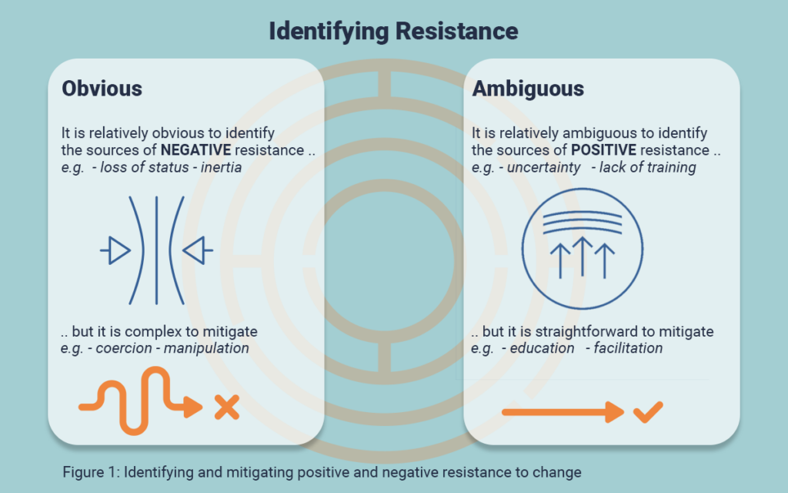
Identifying and mitigating positive and negative resistance to change (Alhezzani, 2022)

Lack of diversity and inclusion:
While LinkedIn did prioritize diversity and inclusion in its hiring practices, there were still some weaknesses in this area. For example, LinkedIn’s leadership team was predominantly male, which led to some concerns about gender equality within the company (LinkedIn, n.d.-a). Additionally, LinkedIn’s focus on recruiting from elite universities and hiring individuals with certain types of experience may have inadvertently created a homogenous corporate culture that did not sufficiently value diversity of thought or background. The majority of LinkedIn employees hold at least a bachelor’s degree, with 73% having attained this level of education. Business is the most common major among LinkedIn employees, with 20% having majored in this field (Zippia, 2023).

Inability to Measure Cultural Changes:
Another significant weakness of organizational culture change and development within LinkedIn is the inability to measure cultural changes. Measuring cultural changes is crucial to determine the effectiveness of the change initiatives and to make necessary adjustments. LinkedIn may face challenges in measuring cultural changes due to the complexity of the process and the lack of appropriate metrics. For instance, it may be challenging to measure the impact of LinkedIn’s shift towards a more social platform on employee behaviour and customer satisfaction (Ellie, 2021).

In conclusion, while LinkedIn’s culture change and development initiatives were largely successful, there were still some weaknesses in the implementation of these initiatives. These weaknesses included over-reliance on HR practices, resistance to Change, lack of diversity and inclusion, and Inability to Measure Cultural Changes. By addressing these weaknesses, LinkedIn may be able to further improve its organizational culture and drive even greater success in the future.

The Impact of Culture Change and Development on LinkedIn
Organizational culture change and development are two important aspects of any business that can have a significant impact on its success or failure. In the case of LinkedIn, a popular social media platform for professionals, changes in organizational culture and development can pose both threats.

Cultural alignment issues
The first negative impact of organizational culture change and development is cultural alignment issues. When a company changes its culture, it can be challenging to ensure that all employees are aligned with the new values and practices. LinkedIn has a diverse workforce, and it may be difficult to ensure that everyone is on the same page when it comes to the new culture. If employees are not aligned with the new culture, it can lead to confusion, misunderstandings, and a lack of buy-in, which can undermine the success of the organizational culture change. For example, some employees expressed the view that "All Lives Matter" during a meeting to address issues of racism at the company. This incident occurred during a period of heightened racial tensions in the United States, following the killing of George Floyd, and has been criticized by some as a tone-deaf response to the Black Lives Matter movement. it was discussing the broader context of racism and diversity issues at LinkedIn (Tani, 2020).

Loss of key employees
When a company changes its culture, it may lose key employees who are not aligned with the new values and practices. This loss of talent can be a significant negative impact on the company’s performance. At LinkedIn, some employees may have left the company due to the changes in the culture. Losing talented employees can lead to a loss of institutional knowledge, a decline in productivity, and an increased cost of recruitment and training. Around 33% of employees at LinkedIn tend to leave the company within a year, representing the largest proportion of employee turnover. Moreover, a small percentage of only 6% of LinkedIn employees tend to stay with the company for a duration of 3-4 years, making it an unusual occurrence for an employee to remain with LinkedIn for that length of time (Zippia, 2023).

Recommendations
here are some recommendations for LinkedIn based on the Resource-Based View (RBV) theory of HRM. The resource-based view theory suggests that a company’s success is determined by its resources. This theory gained popularity in the early ‘90s after the publication of Jay Barney’s article "Firm Resources and Sustained Competitive Advantage." According to this theory, organizations can utilize their key resources, assets, and capabilities to achieve a competitive advantage. In other words, sustainable competitive advantage and business performance are a result of strategic resource development (Picincu, 2020).

- Develop Core Competencies: LinkedIn can develop core competencies by investing in employee training and development programs. This involves identifying the skills and knowledge that are critical to the company’s success and providing employees with the resources they need to develop those skills. By developing core competencies, LinkedIn can create a competitive advantage that is difficult for competitors to imitate.
- Build a Strong Employer Brand: LinkedIn can build a strong employer brand by developing a reputation as a desirable place to work. This involves offering attractive compensation and benefits packages, providing opportunities for career growth and development, and fostering a positive work environment. By building a strong employer brand, LinkedIn can attract top talent and retain current employees.
- Focus on Employee Engagement: LinkedIn can focus on employee engagement by promoting a work environment that supports employee motivation and commitment. This involves implementing HR practices that recognize and reward employee contributions, providing opportunities for employee input and feedback, and fostering a culture of collaboration and teamwork. By focusing on employee engagement, LinkedIn can improve productivity and performance, as well as reduce turnover.
- Leverage Human Capital: LinkedIn can leverage its human capital by using HR practices to identify and develop talent within the organization. This involves implementing talent management strategies that identify high-potential employees and provide them with opportunities for development and advancement. By leveraging its human capital, LinkedIn can improve its competitive advantage and achieve its strategic objectives.
- Foster a Learning Organization: LinkedIn can foster a learning organization by promoting a culture of continuous learning and improvement. This involves providing employees with opportunities for training and development, encouraging knowledge sharing and collaboration, and using feedback to drive organizational learning. By fostering a learning organization, LinkedIn can improve innovation and adaptability, as well as stay ahead of changes in the industry.
By implementing these recommendations based on the Resource-Based View theory of HRM, LinkedIn can improve its human resource management practices and create a competitive advantage that is difficult for competitors to imitate. This can help the company to achieve its strategic objectives and stay ahead of changes in the industry.

Conclusion
Maslow’s Hierarchy of Needs and High-Performance Work Systems (HPWS) are two concepts that are critical to understanding the success of LinkedIn. Maslow’s Hierarchy of Needs explains how individuals’ needs evolve over time, from basic physiological needs to self-actualization. Meanwhile, HPWS refers to a set of HR practices that prioritize employee competency, motivation, and commitment, leading to increased organizational effectiveness and competitiveness.

LinkedIn’s success in building a positive organizational culture can be attributed to its strong leadership team, commitment to employee engagement, diversity and inclusion, and adaptability. The company’s leadership team sets the tone for the culture by promoting collaboration, innovation, and transparency. LinkedIn invests in employee professional growth and development through initiatives such as LinkedIn Learning and leadership development programs, which increases employee motivation and engagement. The company is committed to building a diverse and inclusive workplace and has made progress in this area through initiatives such as unconscious bias training and diverse hiring practices. Lastly, LinkedIn recognizes the importance of adaptability in today’s fast-paced business environment, with a culture of continuous learning and development.

While LinkedIn’s culture has been instrumental in driving its success and competitiveness, there is still room for improvement, particularly in terms of increasing diversity and inclusion in leadership positions. LinkedIn should continue to invest in its employees’ growth and development, promote a culture of inclusion and belonging, and embrace change and adaptability to remain competitive in the market. Overall, LinkedIn serves as a prime example of how Maslow’s Hierarchy of Needs and HPWS can create a positive organizational culture that drives success and competitiveness.

Reference
- Alhezzani, Y. (2022) When resistance to change is an enabler to change. Available at: https://www.talentmgt.com/articles/2022/11/29/when-resistance-to-change-is-an-enabler-to-change/ (Accessed: 13 March 2023).
- Bowen, D.E. and Ostroff, C. (2004) ‘Understanding HRM–firm performance linkages: the role of the “strength” of the HRM system’, Academy of Management Review, 29(2), pp. 203–221.
- Caldwell, C. and Floyd, L. (2014) ‘High performance work systems: building commitment to increase profitability’, Graziadio Business Review, 17(3). Available at: https://gbr.pepperdine.edu/2014/12/high-performance-work-systems/ (Accessed: 13 March 2023).
- Cantrell, S. (2021) ‘Beyond the job’, Deloitte Insights, 26 October. Available at: https://www2.deloitte.com/us/en/insights/topics/talent/new-work-models.html (Accessed: 13 March 2023).
- Datta, D.K., Guthrie, J.P. and Wright, P.M. (2005) ‘Human resource management and labor productivity: does industry matter?’, Academy of Management Journal, 48(1), pp. 135–145.
- Ellie (2021) The power of LinkedIn – why it became the new Facebook. Available at: https://24sevensocial.com/blog/why-linkedin-became-the-new-facebook/ (Accessed: 13 March 2023).
- Frasch, K.B., Shadovitz, D. and Shelly, J. (2009) There’s no whining in HR. Available at: http://www.hreonline.com/HRE/story.jsp?storyId=227738167 (Accessed: 11 March 2023).
- Gain, V. (2023) LinkedIn is cutting jobs in its recruitment team globally. Available at: https://www.siliconrepublic.com/business/linkedin-layoffs-job-cuts-recruitment-talent-acquisition-team (Accessed: 11 March 2023).
- Garibay, C. (2023) Jeff Weiner: 3 surprising facts about the LinkedIn CEO. Available at: https://valiantceo.com/jeff-weiner/ (Accessed: 13 March 2023).
- LinkedIn (2022) Our 2022 workforce diversity report. Available at: https://news.linkedin.com/en-us/2022/october/2022-workforce-diversity-report (Accessed: 13 March 2023).
- LinkedIn (2023a) 2023 Workplace learning report: building the agile future. Available at: https://learning.linkedin.com/resources/workplace-learning-report (Accessed: 13 March 2023).
- LinkedIn (2023b) What is reach? Available at: https://careers.linkedin.com/reach (Accessed: 13 March 2023).
- LinkedIn (n.d.-a) About us. Available at: https://news.linkedin.com/about-us#Leadership (Accessed: 13 March 2023).
- LinkedIn (n.d.-b) Employee resource groups (ERGs). Available at: https://careers.linkedin.com/diversity-and-inclusion/employee-resource-groups (Accessed: 13 March 2023).
- LinkedIn (n.d.-c) Get started with LinkedIn learning hub. Available at: https://learning.linkedin.com/customer-success-center/get-ready-lil-hub-en (Accessed: 13 March 2023).
- LinkedIn (n.d.-d) Get the job that’s right for you. Available at: https://opportunity.linkedin.com/en-us?lr=1 (Accessed: 11 March 2023).
- Mcleod, S. (2023) Maslow’s hierarchy of needs theory. Available at: https://simplypsychology.org/maslow.html (Accessed: 11 March 2023).
- Picincu, A. (2020) Resource-based view: definition, advantages & disadvantages. Available at: https://bizfluent.com/13725649/resource-based-view-definition-advantages-disadvantages (Accessed: 13 March 2023).
- Reynolds, R. (2022) The complete history of LinkedIn: everything you need to know. Available at: https://history-computer.com/the-complete-history-of-linkedin/ (Accessed: 11 March 2023).
- Tani, M. (2020) ‘LinkedIn staffers go all-lives-matter during ‘dumpster fire’ meeting on racism’, The Daily Beast, 5 June. Available at: https://www.thedailybeast.com/linkedin-staffers-go-all-lives-matter-during-dumpster-fire-meeting-on-racism (Accessed: 13 March 2023).
- University of Minnesota (2016) ‘What is human resources?’, in: Human resource management. Minneapolis, MN: University of Minnesota, pp. 2–10. Available at: https://open.lib.umn.edu/humanresourcemanagement/chapter/1-1-what-is-human-resources/ (Accessed: 11 March 2023).
- Wong, K. (2020) Organizational culture: definition, importance, and development. Available at: www.achievers.com/blog/organizational-culture-definition/ (Accessed: 11 March 2023).
- Workhuman (n.d.) Linking social recognition to retention: a case study. Available at: https://www.workhuman.com/resources/case-studies/case-study-linkedin (Accessed: 13 March 2023).
- Yang, P. (2020) How to lead with compassion from Jeff Weiner, Ex-CEO of LinkedIn. Available at: https://creatoreconomy.so/p/how-to-lead-with-compassion-from (Accessed: 13 March 2023).
- Zippia (2023) LinkedIn statistics and demographic. Available at: https://www.zippia.com/linkedin-careers-29662/demographics/ (Accessed: 13 March 2023).

