

Student name: Charmaine Roach
Student ID: 1913890

Module name: Mental Disorder and Psychopathology
Module code: BMHP6006
Lecturer name: Bianca Sanfilippo
Date: 29/04/2022
Words: 3000

Table of contents
Page

- Introduction/ clarification of (GAD)…………………………………….......... 3
- General Anxiety Disorder / Statistics related to (GAD)………... 4
- General causes of (GAD) / Symptoms of (GAD)………………………....... 5
- Photo of Anxiety……………………………………………………………..... 6
- Anxiety Disorder / Treatment for (GAD)……………………………… ....... 7
- Measurements Rehabilitation………………………………………………..... 8
- Appendix for questionnaire relating to number (8) …………………......... 9
- Recommendation......................................................................................... 10
- Apendendix................................................................................................... 11
- Schizophrenia
Difinition..................................................................................................................10
- Clarification schizophrenia.....................................................................................11
- Data people with schizophrenia.............................................................................12
- Causes of schizophrenia.........................................................................................12
- Signs and Symptoms ...............................................................................................13
- Diagnosis...................................................................................................................14
- Current.......................................................................................................................14
- Measurrements..........................................................................................................14
- Appendix (b)...............................................................................................................15
- Continuation page (15-..............................................................................................16
- Recomemdation.........................................................................................................16
- Autism/ Definition of autism...................................................................................................17
- Data for Autism....................................................................................17
- Causes of Autism.................................................................................18
- Sign / symstoms...................................................................................18
- Continued page....................................................................................19
- Diagosis................................................................................................20
- Children and Adults..............................................................................20
- Recommendation........................................................................21
- Conclusion..................................................................................22
- References.
- Appendix

INTRODUTION

In this report I will be looking into DC10 (2010) chapter 5 F20 on Schizophrenia,
F41. On General disorder, and Autism F84.1. This over report I will be looking into treatments, the causes, signs, and symptoms, dialogised, measurements the classification DC10 manual. And the level of severity this report will also focus on the borderline personality disorder.

Classification Of GAD (General Anxiety Disordered within ICD10 Mentally ill, Stress related, (SSD) Somatic Symptom Disorder or somatoform disorder, F40-48. General Anxiety disorder.

General Anxiety Disorder
General Anxiety disorder is where you may feel anxiety, because of worrying, stress, alcohol intake, loss of someone, brake of a marriage and many more this could also link to depression. GAD is one of the most common anxiety types this is mainly due to over stressing one’s selves cause by worrying. There is time one will fell on edge and very much alert of your surroundings.
According to Ruscio, (2017) a survey was done in 26 countries, this survey was done with around 150,000 adults in the 26 countries DSM-5 generalized anxiety disorder has linked “lifetime prevalence of 3.7%. in 12-momnths, prevalence of 1.8% and 30-days prevalence of 8.0%”. The Disorder is substantially more common and damaging in high-income countries than low- or middle-income countries. (Ruscio, 2017)
"Generalized anxiety disorder”, (2022) stated “its normal to feel anxious at any time especially if your life is stressful” living with every day anxiety can become a problem especially when it cannot be control and it affects with your everyday life. This could be a sign of general anxiety disorder which may requires one to get help as soon as possible. (Generalized anxiety disorder 2022)
This disorder can be developed from childhood because of a trauma or other troubles in one life. This could continue right through adult hood.
Having this disorder can be very challenging and, in several cases, it follows with other moods disorders. However, this can improve with speaking to someone (Psychotherapy) or medication. (Generalized anxiety disorder 2022)
Statistic Related to people within the Untied Kingdom suffering from GAD:
According to Bandelow MD, PHD & Michaelis MD, (2022) “anxiety disorders, as well as panic disorder, with or without agoraphobia, generalized anxiety disorder, social anxiety disorders, specific phobias, and separation anxiety disorder, are the maximum widespread mental disorder and are linked with immense health costs and a high burden of disease”.
“According to the large population-based survey up to 37.7% of the inhabitants are affected by an anxiety disorder at some point in the lifetime”. (Bandelow MD, PHD & Michaelis MD, 2022).
“General disorder is a common disorder, estimated to affect up to 5% of the UK inhabitants. A little more woman than men and the disorder is more widespread in people from the ages of 35-59”. (Overview-Generalised anxiety disorder in adults, 2022).

Causes of General Anxiety disorders:
According to "Generalized anxiety disorder" (2022) generalized disorder likely to occur from a complicated communication of natural environmentally friendly factors or can be genetic which may involve.
- “Differences in brain chemistry and function”
- “Genetics”
- “Differences in the way threats are perceived”
- “Development and personality”
(Generalized anxiety disorder 2022)
Symptoms of General Anxiety Disorder
There are many symptoms which is of general anxiety disorder. Some of the general symptoms includes
- Fear of dying.
- Feeling dizzy or faint.
- Hot flushes.
- Muscle tension aches or pain.
- Restlessness.
- On edge, mental tension.
- Sensation of lump in the throat.
- Difficulty in concentrating due to worrying.
- Trembling or shaking.
- Chest pain or discomfort.
(Diagnostic and Statistical Manual of Mental disorder fifth edition DSM-5, 1844)
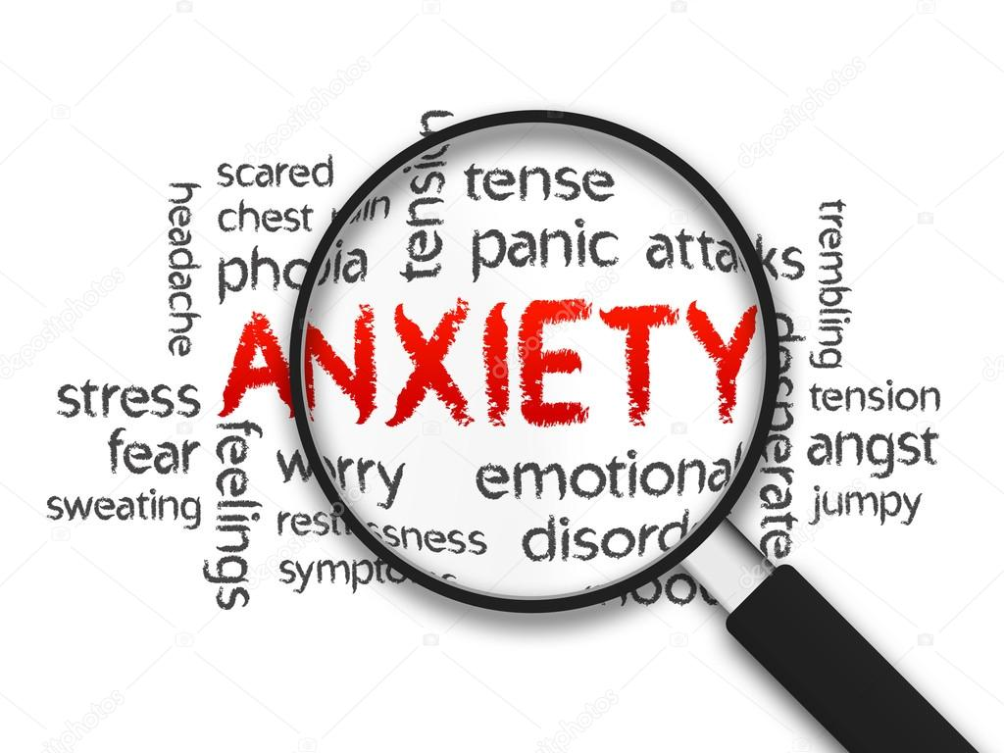("Deposit Photo-Anxiety", 2022)

Anxiety Diagnosed
According to Diagnosis- Generalized anxiety disorder adults, (2022) if your daily live have been affected by anxiety or stress one must speak to the (GP) general practitioner. This disorder can be difficult to be diagnose. few cases it can be complicated to recognize from other mental health condition for (example) depression.
“Your GP may ask you a few questions about your anxiety which will be any physical or psychological symptoms and how long have you had them for. Your worries your fears, or your personal life”.
“It is important that your GP ask question to understand your symptom and your circumstances to make the correct diagnosis”
“To help with the diagnosis GP may carry out a physical assessment or blood test to rule out other illness such as anaemia, or overactive thyroid glands” ("Diagnosis- Generalized anxiety disorder adults", 2022)

Treatment for current anxiety disorder
According to Treatment - Generalized anxiety disorder in adult, (2022) “(GAD) is a long-term disorder, but there are number of treatments that can help”
- “Psychological therapies (before you can prescribe medication)”
- “Cognitive behavioural therapy (one of the most effective treatments)”
- “Applied relaxation (focuses on relaxing the muscles)”
- “Medication (some medication is for short-term basis while other medication is recommended for longer periods)”
- “Selective serotonin reuptake inhibitors (SSRI) Antidepressant.”
- Serotonin and noradrenaline reuptake inhibitors (SNRIs)
- “Benzodiazepines”
- “Referral to a specialist (mental specialist)”
- Exercise regularly for example swimming football, walking,
- Relaxation listens to music, reading, yoga.
- Avoid drinking coffee, smoking, and drinking
(Self-help - Generalised anxiety disorder in adult, 2022)

Measurements Rehabilitation
Patients should be asset every two weeks along with family’s input, there should be a framework put in place for review, the questionnaire on general anxiety disorder (GAD-7) should be more in depth. Questionnaire should also include communication or being vocal, identify their own personal recovery, their values, their goals what do they want to achieve, their skills, and their feelings. Care providers and family member should also be involving around the questionnaire for example have they seen any progress in the last two weeks, is there any worries about behaviour changes, are they taking their treatment regularly, is medication working, how often are they monitoring the situation, is there a plan in place for the patients for example yoga classes depending on the seriousness of their illness.

(See questionnaire on page 9)
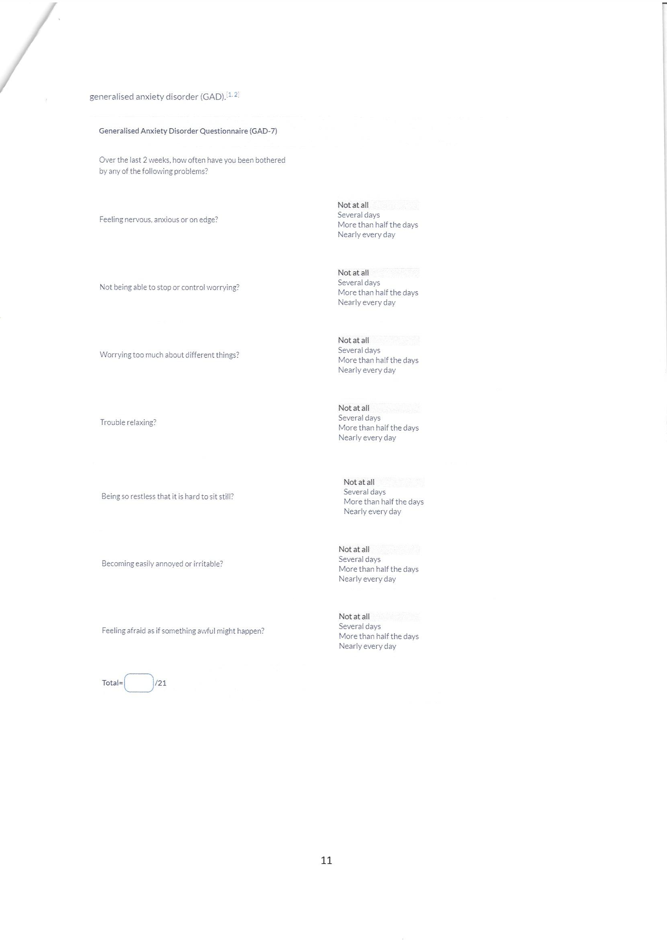

Recommendation
There should be an ongoing care plan in place for people with (GAD) regular reviews, activities, getting the correct support needed depending on the seriousness of the problem ensure communication, review their medications, Care programme Approach (CPA) "Care Programme Approach", (2022)
With general anxiety disorder one needs to look after their health and wellbeing, its important we talk about our feelings which can help us to stay focus and in good health especially when we are worried. We need to keep active our intake of alcohol should be minimum treat our selves occasionally, take a brake and relax for example yoga, listening to music, lots of walk explore somewhere new know who we are, don’t be scared to ask for help, and most importantly have a good night rest. By prioritising these things, we will have a productive lifestyle and decrease the risk of having (GAD) general anxiety disorder.

Schizophrenia

Definition
According to World Health Organisation Schizophrenia (2022) “schizophrenia causes psychosis and is linked with considerable disability and may affect all areas of life including personal, family, social education, and occupational functioning. The stigma discrimination, and violation of human right of people with schizophrenia are common”. ("Schizophrenia", 2022)
According to Psychosis and Schizophrenia what is it? (2021) “Schizophrenia is the most popular psychotic disorder. The Diagnostic criteria for schizophrenia in the international Classification of Disesases-10 [ICD-10] criteria involve the following symptoms to be submitted most of the time for one month. ("psychosis and schizophrenia what is it?", 2021)

Clarification (Schizophrenia within the ICD-10

Schizophrenia within the ICD-10 is classified as Schizotypal and delusional disorder
(F20-F29)
According to Schizophrenia, schizotypal and delusional order (F20) - ICD10 Version (2016) “The Schizophrenic disorder are considered in usual by fundamental and characteristic misrepresentation of thinking perception and affects that are unacceptable or blunted.
The most valuable psychopathological phenomena include thinking echo; taught insertion or isolation taught broadcasting; delusional perception and delusional of control; influence or passiveness; hallucinatory voices commenting or conversing in the third person; taught disorders and negative symptoms”. ("Schizophrenia, schizotypal and delusional order (F20-F29) - ICD10 Version 2016",)

Data people with Schizophrenia

According to WHO, Magnitude and Impact, (2022) Schizophrenia impact around 24 million individuals or 1 in 300 individuals (0.32%) global. This rate is 1 in 222 individuals (0.45%) amongst adult. It’s not as popular as many other mental disorders. The beginning of Schizophrenia is more regularly during late young years and the twenties, and the beginning tends to happen earlier amongst men than amongst women. ("magnitude and impact", 2022)

According to Walsh & D., BCPS-AQ ID, (2022) “Schizophrenia affects 20 million people globally (Global Burden of Disease). The annual number of new cases of schizophrenia is 1.5 per 10,000 persons (Epidemiol Review 2008). Schizophrenia is one of the top 15 leading cases of disability globally. (Global Burden of Disease 2016) Around 5% of individuals die by suicide with mostly a higher risk of mental illness. (Archives of General Psychiatry, 2005) Around 20% of individuals with schizophrenia have tried suicide at least once (The recovery Village, 2020)”. (Walsh & D., BCPS-AQ ID, 2022)

Causes of Schizophrenia.
According to Legg, PhD & Holland, (2020) “Schizophrenia is a chronic psychiatric disorder that affects an individual”. For example (a) their behaviour might have change, (b) Lost in thoughts, (c) their feeling is affected.
“There are several causes to schizophrenia and a person with the disorder may feel lost and may lost touch with reality. However, research do not know what exactly causes schizophrenia, but they may be mixture of issues may have played a part in this mental disorder. One of the substantial risks factors of schizophrenia could run in the family genes, stress related can trigger this disorder and this could be people at high risk”.
“Researchers found if one identical twin siblings had schizophrenia there is a change of 1 in 2 can develop this disorder. Also, if a nonidentical have been diagnosed with schizophrenia the chances are 1 in 8 in the other twin have a chance of developing it.”
“Structural changes in the brain. If schizophrenia have been diagnosed one may have subtle physical changes in the brain. This may occur with individuals who may have been diagnosed with mental disorder”.
“Chemical changes in the brain. There is a complex related chemical in the brain called neurotransmitters which is accountable for sending communicates among the brain cells, Dopamine seems to play a particular part in the development of schizophrenia. However, low level or imbalances play a role of developing schizophrenia.”
“Pregnancy or birth complications may enhance the possibility of a person develop mental health disorder including schizophrenia the complication is low birth weight, infection during pregnancy, lack pf oxygen during the delivery this is called (asphyxia) premature labour and maternal obesity diagnosis in pregnancy.”
“Women with schizophrenia are at an increased risk for problem during their pregnancy.” (Legg, PhD & Holland, 2020)

Sign / symptoms of schizophrenia:

Signs of schizophrenia:

Bhandari, MD, (2022) “The early sign of schizophrenia is a sudden change of actions, schizophrenia involves a psychosis, a type of mental illness in which they cannot tell what is true from what is seen. They actions is strange and can be even surprising. This illness usually shows signs in men in their late teens or early 20. It mainly effects women in their early 20s and 30s” (Bhandari, MD, 2022).
According to What is Schizophrenia (2022) some of the signs are.
Hearing voices
Seeing thing that others don’t see
Sound of buzzing
Negative and disturbing
No motivation
Loss interest in the thing you loved. ("What is Schizophrenia", 2022)

Symptoms of schizophrenia:
The symptoms of schizophrenia one has been affected and cannot cope with everyday life are as follows.
- Delusions
- Lack of motivation
- Slow movements
- Change pattern in sleeping
- Poor hygiene
- Body language and emotion have change
- Lost interests in daily activities
- Not interested in social life
- Low sex drive
- Hallucination Delusions
("What is Schizophrenia", 2022)

ICD10 – (F25 – 2) Delusion of control, impact, or passiveness, clearly indicated to body or limb changes or certain thoughts action, action or feelings (F20-G1.1b)
Hallucinatory voices giving a running report on a patient behaviour or talk about him between themselves or other type of hallucinatory voices coming from part of the body (F20 – G1.1c). (Schizophrenia and effective symptoms ICD10- F25. 2016).

Diagnosis for Schizophrenia:
According to NHS Diagnosis - Schizophrenia, (2022) “there is no single test for schizophrenia and the disorder is normally analysed after evaluation by a consultant in mental health. General Practitioner will ask about the symptoms and check they are not the result of other causes such as recreational drug use”
The general practitioner ought to refer you to a community mental health team if you have been diagnosis with suspected schizophrenia.
Schizophrenia is a sickness that changes every part of a one's life, one way or the other way of how we think, understand and experience things in physical moto ways. It affects a human being functioning to the point where they lose contact with the real world, with that they become unable to differentiate what is reality from what is imagined. ("Information on Schizophrenia Support Service", 2022)
Current Treatment for Schizophrenia schizophrenia is tailored with a combination of talking therapy and medication. However, most individuals with the disorder are treated by (CMHTs) community mental health teams (NHS Treatment – Schizophrenia, 2022)
"Treatment - Schizophrenia”, (2022) “schizophrenia requires a lifelong treatment even when treatment collapsed. Treatment with medication and psychosocial therapy can help.
According to "Treatment - Schizophrenia", (2022) If this disorder is treated (schizophrenia) is manage it can reduce the change of severe deteriorations. ("NHS Treatment - Schizophrenia", 2022).
Measurements of rehabilitation
With the condition of schizophrenia, the measurement can only be quality of care and treatments provided to control and manage the condition and avoid complications for example self-harm, suicide, misuse of substance, neglect, self-neglect, lack of dignity and violation of human rights.
Quality of life can only be measured with the indicators that are used for long-term mental disorder,
“(QuIRC-SA) Quality Indicator form Rehabilitative Care” This tool includes specific indicators that shows that quality of care and effective are provided to manage the condition. (See appendix b)

Appendix B Killaspy, White, Dowling and Krotofil, 2016)


(Continued from page15-16)
In a case like Schizophrenia this is a long-term condition and it’s important that we support the service users to have good quality of life. The measurement can be use by using the indicators for rehabilitative care which apply to all long tern medical requirements.

Recommendation
In cases like schizophrenia, one should educate themselves, about this disorder gain more knowledge and understand the causes, there must also be more service uses who must deal with such’s cases be more recognised, more training should be put in place, communities should be more involved. Once schizophrenia is recognized this should be treatment should start as quickly as possible to ensure that the disorder do don’t get out of control. there should be a plan put in place and the outreach team should be notified. There should be regular one to one therapy with the individuals of concern. Medication and other alternative treatment should be monitored on a regular basic. The quality indictors should be considered and uses as an everyday tool. people with post-traumatic stress should have counselling immediately to prevent schizophrenia disorder.
According to Chivilginia et al., (2022) “There is an important need to address the effect of the non-existence of ethnical design in the early progress of technologies some sources have notice the gap amongst technology improvement and ethical issues raised by digital technologies. In this statement this suggestion particular in relation to digital healthcare technologies for patients with schizophrenia spectrum disorder”. (Chivilginia et al., 2022)
It important as technology improves people with schizophrenia will have a better source of life and would bale to manage their disorder in a way that they are able to control their schizophrenia.

Autism:
Definition of Autism
According to NHS What is autism, (2022) “People with Autism may act in differently to other individuals. They find it hard to communicate and interact with other persons, they also find it difficult to understand how other humans feel or even think, bright light and other loud noises overwhelm them. They become stressful and very difficult. Unfamiliar situation gets them anxious and social events. They take longer to understand information and do the same things repeatedly. ("NHS What is autism", 2022)
“Autism is not an illness, the brain works in a different way from other individuals, this is something that happens when you are very young, or you may have born with it. Some individuals may need support, but its not a medical condition where you may need treatment. Being Autistic do not stop one from being productive or have a wonderful life, or have friends, relationship, have a job. It does not mean that people must struggle in life. The medical term for autism is called (ASC) autism spectrum disorder, this is also use by other people”. (" NHS What is autism", 2022).
Classification (F80-F89 Disorder of Psychological development, ICD10, 2010).

Data for Autism:
"Autism Statistics and facts", (2022)” 2021the CDC stated that around 1 in 44 children in the US is identified with an autism spectrum disorder according to data 2018”.
“1 in 27 boys found with autism”.
“1 in 116 girls was found with autism”.
“Boys are more likely to be diagnosed with autism four time than girls. Many children were still being diagnosed after the age of 4, autism can be dependably diagnosed as early as 2 years”.
“31% of children with (ASD) have an intelligent disability. 25% are in the marginal range. 44% have IQ scores in the normal to above normal range/” ("Autism Statistics and facts", 2022)
According to " WHO Autism", (2022) “One in 100 children has autism, traits may be identified in early childhood, but autism is often not identified until much later.”

Causes of autism
According to "Autism Statistics and facts", (2022) “research shows that heredities are involved in the vast mass of cases. Older parents who have children late is at more of a higher risk of having an autism child. Parents who have a child with (ASD) have 2 to 18% of chance having a second child who is also impacted with autism. Report also shows that among indistinguishable twins, if one child has autism the other will be impacted about 36-95% of the time, whereas in no-identical twins if one child has autism then the other is impacted about 31% of the time.” ("Autism Statistics and facts", 2022)
In ICD-10 (F84.0) report stated “A disorder described by mark reducing in social contact and communication come with a pattern of tedious, categorised actions and activities. Progress delays in social communication and language surface prior to the age of 3”. ("2022 ICD- 10-CM Diagnosis Code F84.0", 2022)
According to “WHO Autism", (2022) “there is no proof to indicate that any other childhood vaccine may improve the risk of autism. Data reviews of the possibility involvement amongst the preservative thiomersal and aluminium adjuvants contained in inactivated vaccines and the risk of autism effectively established that vaccines do not develop the risk of autism”. (“WHO Autism", 2022).
Sign /Symptoms
Autism Spectrum Disorder Signs and Symptoms of Autism Spectrum Disorder, (2022) “ASD is a progressive disability caused by changes in the brain/ people with autism spectrum disorder often have difficulties with social communication and interaction, and tedious actions or concern”.
“Social interaction and communication abilities can be challenging for people with ASD”
(Examples)
- “Avoids eye to contact”
- “Does not show facial looks like been happy, sad, surprised, angry by the age of 9 months”.
- “Occasionally they show no actions by 12 months (example do not wave goodbye)”
- “Do not show concern with others by 15 months”
- “Do not observe when others are upset or hurt by 24 months”
- “Do not join or play with other children or become aware of them by 36 months”
- “Do not pretend to be something for example being a teacher during interactive at 48 months”
- “Do not play games like pat-a-cake by 12 months”
(Autism Spectrum Disorder Signs and Symptoms of Autism Spectrum Disorder, 2022)

Diagnosis
The Diagnostic Assessment, (2022) “Some self-referral may be accepted by some diagnostic team however, in most area you will be referred from your GP. A team of professional might ask you to bring someone with you who may have known you from your childhood or maybe a parent or an older sibling the reasons for this may may give some important information about your childhood”
“For a diagnosis to be made you will usually have to be assessed as having had persistent problems with social communication, social interaction and repetitive patterns of behaviours, activities or notice these problems, will have been presented at an early stage of childhood, which have affected your everyday lifestyle”. (The Diagnostic Assessment, 2022)
If your child show symptoms of autism its important that you get support as soon possible, you can speak to your GP, health visitors or any other professionals for example a therapist, special educational needs.
You may have a lot of question to ask when been diagnosed with autism disorder there is a team of professionals who will be able to offer a follow-up service and will be able to answer lots more of your question including what support and services you may be intitled to. (The Diagnostic Assessment, 2022)

Children/ Adults
If the Child is at school the child may need lots of support may be at home or at school, you can start getting help before your child is being access. Your GP can suggest some support group. There is also other local support group for example National Autistic Society. Speak to a special educational need, teacher, your local council can give you a need assessment to see what support can be recommended.
The team may also watch how your child interact with other children, read reports from the school, the GP also the nursery. A member of the Team may also visit your child school to watch them during paly time. (NHS what happens during an autism assessment, 2022)
For the adults the Assent Team may ask you to fill out a questionnaire form and ask you about any other problems you may have also speak to someone who may have known young as a child also read reports from your GP about other health problem you may have. (NHS what happens during an autism assessment, 2022)
Current Treatment
According to Treatment and Intervention Services for Autism Spectrum Disorder, (2022)
There are numerous types of treatments available
- “Behavioural targeting on changing behaviours having an insight of what happens before and after”
- “Development aiming on enhancing development skill for (example) language or physical skills”
- “Educational in a classroom setting (example) everyday training can be drawn and placed in a clear sight, restrictions can be set around learning”
- “Pharmacological there are no medication that can treat the underlying symptoms of ASD”
- “Psychological methods can help people with ASD able to cope with Anxiety, depression and other mental issues”
- “Social-Rational focuses on developing skills and building emotional bonds”
- “Complementary and Alternative can always be used to enhances more traditional methods for example this could be a special diet, herbal supplement, chiropractic care animal therapy, art therapy, mindfulness or relaxation therapies”. (Treatment and Intervention Services for Autism Spectrum Disorder, 2022)
Measurements of rehabilitation: ‘Childhood Autism Rating Scales (CARS)’ is an Observation called ADOS – Autism Diagnostic Observation Schedule.

Recommendation
“Children and adults of all ethnic background with autism disorders or any other mental disorder regardless of their intellectual ability or any coexisting diagnosis” should have full access to social care, healthcare and given a lot of support, families should be fully involving around their everyday care and wellbeing. There should have a plan put in place children and adult and monitored often whether it’s very forthright or on a weekly basics”. (Autism spectrum disorder in under 19s: support and management, 2021)
A social networking of teacher’s carers, the assessment team therapy GPs, all should be involved and offer support which will be beneficial to their everyday needs which also could be activities such as yoga, water aerobics exercises. They can offer more of traditional medication therapy and other alternative medication. (Autism spectrum disorder in under 19s: support and management, 2021)
Conclusion:
According to James, (2020) “The Autism act, is a specific Act which do not cover only children, but it covers adults also. The National Autistics Society run a campaign which the government had to focus on autism and individuals, creating a piece of legislation that outlined the right of those with autism as well as protecting them from discrimination. (James, 2020)
Equality Act 2010 What do I need to know? Disability Quick start guide, (2010) protect individuals who has any disability or mental health it also protects them from being discriminated against. it protects individuals from being treated less favourable.
“The Equality Act 2010 brings together synchronizes and in some respect extent the recent equality law it aims to make it more constant, clear, easier to follow.
Service providers are expected to make changes where needed to develop service for disabled customers or potential customers. (Equality Act 2010 What do I need to know? Disability Quick start guide, 2010)

References

Bandelow MD, PHD, B., & Michaelis MD, S. 2022. Epidemiology of anxiety disorder in the 21st century. PMC Dialogues in Clinical Neuroscience. Available at https://ncbi.nlm.nih.gov, (Online) [Accessed April 21, 2022].
Care Programme Approach. 2022. 50Rethink mental illness. Available at https://www.rethink.org, (online) [Accessed April 22, 2022].
Diagnostic and Statistical Manual of Mental disorder fifth edition DSM-5. 1844.. https://DSM-5 Available at www.Psychiatry.org/com ,(online) [Accessed April 21, 2022].
Deposit Photo-Anxiety. 2022. St deposit photos. Available at Https://st.depositphotos.com (online) /1034557/1245/I/950, [Accessed April 21, 2022].
Diagnosis- Generalized anxiety disorder adults. 2022. NHS. Available at http://https.nhs.uk, (online) [Accessed April 21, 2022].
Generalized anxiety disorder. 2022. MAYO CLINIC. Available at http://mayoclinic.org,com (online) [Accessed April 20, 2022].
Generalized anxiety disorder. 2022. MAYOCLINIC. Available at http://https.//www.mayoclinic.org.com. (online), [Accessed April 20, 2022].
Overview-Generalised anxiety disorder in adults. 2022. NHS. Available at Https://www.nhs.uk, (online) [Accessed April 21, 2022].
psychosis and schizophrenia what is it? 2021. NICE National Institute for Health and Care Excellence. Available at https://cks.nice.org.uk (online), [Accessed April 22, 2022]
Ruscio, A. 2017. Cross-sectional comparison of the DSM-5 Generalized Anxiety Disorder across the globe. Available at https://www.jamanetwork.com (online) [Accessed April 20, 2022].
Self-help - Generalised anxiety disorder in adult. 2022. NHS. Available at https://www.nsh.uk, (online) [Accessed April 21, 2022].
Schizophrenia. 2022. World Health Organization. Available at https://www.who.int.com, (online) [Accessed April 22],
2022.
Schizophrenia, schizotypal and delusional order (F20-F29) - ICD10 Version 2016. Available (Online). International schizophrenia and effective symptoms ICD10- F25. 2016. [Accessed April 22, 2022]
Treatment - Generalized anxiety disorder in adult. 2022. NHS. Available at https://www.nhs.uk, (online) [Accessed April 21, 202]2.
Magnitude and Impact. 2022. World Health Organisation. Available at https://www.who.int.com (online), [Accessed April 22, 2022]
Walsh, M., & D., BCPS-AQ ID, P. 2022. Schizophrenia statistics. CHECKUP Single Care. Available at https://www.singlecare.com,(online) [Accessed April 22, 2022].
International statistical classification of diseased related health version 2016. Available at https://www.icdwho.int.com, (online) [Accessed April 22, 2022]. statistical Classification of Disease and related health problem 10th Revision (ICDF-10).
Available at https://www.icdwho.int.com, (online) [Accessed April 22, 202]2.
Legg, PhD, T., & Holland, K. 2020. 6 Causes of Schizophrenia that may surprise you. Healthline. Available at http://https//:www.healthline.com, (online) [ Accessed April 22, 2022].
What is Schizophrenia. 2022. 50 Rethink mental illness. Available at http://https//www.rethink, org.com, (online) [Accessed April 22, 2022].
Bhandari, MD, S. 2022. Schizophrenia: An Overview. WebMD. Available at http://https//www.webmd.com,( online) [Accessed April 22, 2022].
Diagnosis - Schizophrenia. 2022. NHS. Available at https://www.nhs.uk, (online) [Accessed April 23, 2022].
Information on Schizophrenia Support Service. 2022. MentalHelp.net. Available at https://www.mentallhelp.net,o- (0nline) [Accessed April 23, 2022].
Schizophrenia. 2022. MAYO CLINIC. Available at https://www.mayoclinic.org, (online) [Accessed April 23, 2022].
Killaspy, H., White, S., Dowling, S. and Krotofil, J., 2016. Adaptation of the Quality Indicator for Rehabilitative Care (QuIRC). BMC Psychiatry, pp.101(2016) Available (online) [Accessed April 25, 2022]
Psychosis and schizophrenia in adults: prevention and management. (2014, Available at (<https://www.nice.org.uk.(online>). [ Accessed 25 April 2022]
Chivilginia, O., Elger, B., & Jotterand, F. (2022). Digital Technologies for Schizophrenia Management a Descriptive Review. Science and engineering Ethics, Available at < https://ncbi.nlm.nih.gov. (online>). [Accessed 25 April 2022]
What is autism. NHS. (2022). Retrieved 25 April 2022, Available at <https://www.nsh.uk.(online>) [Accessed April 25, 2022]
Autism Statistics and facts. autism speaks. (2022) Available at <http://htpps://autismspeaks.org.com.(online>) [Accessed 26 April 2022,]
2022 ICD- 10-CM Diagnosis Code F84.0. ICD-10 Data.com. (2022)., available <https://icd10data.com. (online>) [Accessed 26 April 2022]
Autism. WHO World Health Organization. (2022) Available at <https://who.int.com>. (online [Accessed 26 April 2022],
CDC Centres for Disease Control and Prevention. 2022. Autism Spectrum Disorder Signs and Symptoms of Autism Spectrum Disorder. [online] Available at: https://www.cdc.gov.com (online) [Accessed 26 April 2022].
National Autistic Society. 2022. The Diagnostic Assessment. [online] Available at: <https://austism.org.ukonline> [Accessed 26 April 2022].
NHS. 2022. what happens during an autism assessment? [online] Available at: <https://www.nhs.uk> [Accessed 26 April 2022].
CDC Centres for Disease Control and Prevention. 2022. Treatment and Intervention Services for Autism Spectrum Disorder. [online] Available at: <https://www.cdc.gov> [Accessed 26 April 2022].
NICE National Institute for Health and Care Excellent. 2021. Autism spectrum disorder in under 19s: support and management. [online] Available at: <https://ww.nice.org.uk> [Accessed 26 April 2022].
James, C., 2020. Using a person-centred approach to support individuals with Autism. [online] Adventures in Learning Technology. Available at: <https://www.adventuresinlearningtechnology.com> [Accessed 26 April 2022].
Government Equalities Office. 2010. Equality Act 2010 What do I need to know? Disability Quick start guide. [online] Available at: <https://assets.publishing.service.gov.uk> [Accessed 26 April 2022].





