
MBA Change module 2023
Name: Neha Devi Stu. No. 2227827
[Date]
[Company name]
[Company address]

Table of Contents
Introduction & Background: 2
Reason For Change: 2
Triggers of Change for Ford Motors: 3
Key Change Management Models: 4
i. Planned change: 5
ii. Emergent change: 5
Lewin’s Model of Change: 7
Incremental (Small Scale) Or A Large-Scale Change Program 8
Incremental Change: 8
Large-scale Change: 8
Driver factors for change: 9
Resistance Factors to the Change: 10
Stakeholders’ analysis: 11
Assessing Effectiveness and Completeness: 12
Conclusion: 13
References 15

Introduction & Background:
This report is based on one of the biggest and most established automakers worldwide that is known as Ford Motor Company. Henry Ford, who is regarded as one of the people most responsible for the growth of the car industry, launched the business in 1903. Ford Motor Company played a key role in the industrial revolution that resulted from the mass manufacture of vehicles that made them accessible to the common customer (Charles Richard Baker, 2015). Individuals from every aspect of life now have easier access to automobiles because of the company's revolutionary production techniques, such as the assembly line which has significantly augmented productivity and reduced prices.

Ford has made numerous of the greatest iconic automobiles in history throughout the years, notably the Mustang Ford Model T, and the F-Series pickup truck, which has served as the most popular car in the United States for more than 40 years. Ford is still a leader in the automotive industry by emphasizing electric and driverless vehicles, as well as sustainable and ecologically friendly production techniques.

Reason For Change:
For Ford Motors, there are several reasons that were needed to be considered in order to make enormous changes that the company has endured recently (Errida and Lotfi, 2021). The following are a few primary factors of change:
- Developing Autonomous & Electric transport: One of Ford's largest transformations over the past few years has involved the company's development of electric and driverless cars. Changes in customer tastes, higher pollution rules, and the necessity to compete with other manufacturers who are making significant investments in this area have all driven this (Khaw et al., 2022).
- Cost-Cutting measures: Ford has recently undertaken a considerable reorganization in an effort to increase profitability and compete more successfully (Ogbonnaya et al., 2022). In order to do this, it had to slash costs by shutting plants, offering fewer models, and simplifying its international operations.
- Focusing on Digital and Connected Services: As technologies and IoT (Internet of Things) have advanced, Ford has been making investments in digital and connected services to improve its customers' driving experiences (Verhoef et al., 2021). Predictive maintenance, improved safety measures, and smartphone connection are some of these characteristics.
- Changing Market Conditions: Ford has had to adjust to shifting market conditions since the automobile business is continuously changing. This covers changes in consumer tastes, modifications to the state of the world economy, and interruptions like the COVID-19 epidemic.
- Emphasis on Sustainability: Ford has been emphasizing sustainability more and more as uncertainties about climate change have increased. The corporation has made investments in energy sources that are renewable as well as improved manufacturing techniques in an effort to reduce its carbon impact.

Triggers of Change for Ford Motors:
The triggers for analyzing the change are necessary and could be done by concentrating on the external and internal factors of the firm’s environment. For example, PESTLE analysis is a framework for examining the external influences that could have an impact on an organization to be competitive and sustainable, it must adjust to new problems and opportunities (Frue, 2018).

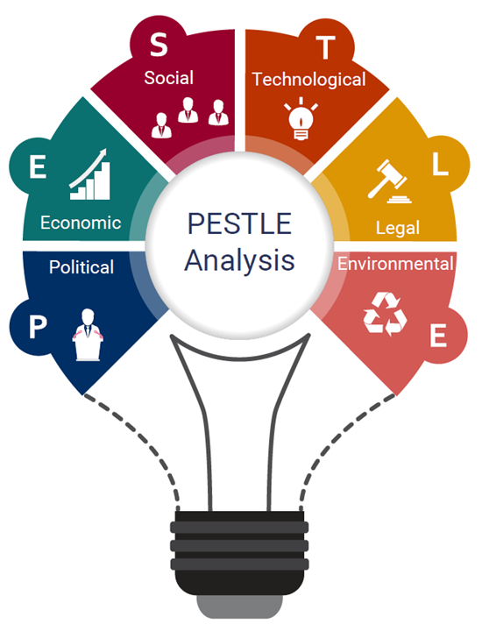
In terms of PESTLE, the following are some of the major change catalysts for Ford Motor Company:
Political: Ford Motors may be significantly impacted by changes to governmental rules, laws, and trade agreements. Ford might be forced to modify its manufacturing procedures or product offers, for instance, in response to changes in tariffs or emission-related legislation.
Economic: The need for Ford's products could be impacted by economic issues like trust among customers, interest rates, and price inflation. Financial crises could end up in lower sales and profits, but economic prosperity may open up prospects for investment and development.
Sociocultural: Ford Motors may be affected by sociocultural variables such as shifting customer preferences and perceptions of transportation. For instance, growing environmental awareness may raise consumer interest in electric or hybrid cars.
Technological: Ford Motors may be impacted by new technologies in a variety of ways. For instance, Ford might require investments in new R&D projects as autonomous driving technology develops, and production process adjustments may be necessary as manufacturing technology advances (Parekh et al., 2022).
Legal: Ford Motors could be impacted by changes to employment, security, and intellectual property laws and regulations. For instance, new safety standards might force Ford to undergo changes to its manufacturing procedures or make purchases of new safety gear.
Environmental: Ford Motors may be impacted by environmental variables including climate change and resource constraints (Bremser, Jermakowicz and Reinstein, 2021). For instance, growing environmental awareness may necessitate Ford making investments in more environmentally friendly manufacturing techniques or alternative fuel technology.

Key Change Management Models:
Such change management models are the concepts and processes that are utilized by businesses for the planning, execution, and overseeing of initiatives involving change. They offer a systematic method for managing change, assisting companies in recognizing and addressing the numerous possibilities and difficulties brought on by change. Here are two key change management models for Ford Motors:

Planned change:
It serves as one of the most important change management strategies employed by businesses like Ford Motor Company for bringing about change (Karasvirta and Teerikangas, 2022). This strategy is predicated on the notion that change must be thoroughly planned and carried out in a systematic manner. The following are some of the main advantages and disadvantages of this model when used with Ford Motor Company:
Advantages:
- The planned change model offers a clear direction and action plan for change. This is especially beneficial for major firms like Ford Motors, which must guarantee that change is well-organized and uniform across departments and operations.
- The planned change model places an emphasis on a systematic approach to change, which can assist to guarantee that all essential steps are performed and that change is executed in a logical and orderly way.
- By anticipating possible problems and barriers, the planned change model can aid in risk management. This can lessen the adverse impact of change and guarantee that it is effectively carried out.
Disadvantages:
- The planned change model could be quite rigid, which might make it challenging to adapt to unforeseen difficulties or changes in the environment. This is particularly troublesome in businesses that change quickly and unpredictably, such as the automobile industry.
- The planned change model makes the assumption that employees will be open to change and that it is desired. Employee resistance to change, however, can compromise the success of the intended change model for a number of reasons.
- This model frequently focuses on certain areas of change, including systems or processes. It might not, however, address more significant organizational or cultural problems that might be affecting Ford Motors’ performance.

Emergent change:
This approach places a strong emphasis on adaptation, flexibility, and the capacity to react to changing conditions. This strategy is predicated on the notion that change is a continuous, natural process rather than a single, isolated event or effort (Garnett, Venter and Geldenhuys, 2022). The emergent change model's main advantages and disadvantages when used to analyze Ford Motor Company are as follows:
Advantages:
- The emergent change model places a strong emphasis on agility and adaptability, which might be helpful specifically in sectors like the automobile industry where change can happen quickly and without warning. Ford Motors is able to adapt swiftly to new trends and opportunities because of this strategy.
- This model places a strong prominence on employee empowerment, which may support Ford Motors' efforts to cultivate a culture of innovation and continuous improvement (Darmawan and Azizah, 2020). This strategy encourages staff members to take charge of change and participate in the change management process.
- This approach addresses change management holistically because it understands how change affects every part of an organization. By using this strategy, Ford Motors can make sure that change is done in a way that is compatible with its corporate culture and larger strategic objectives.
Disadvantages:
- Coordination of change across several Ford Motors departments and functions may be challenging due to the emergent change model's potential for ambiguity and lack of direction. Change may be chaotic and disorderly without a defined plan.
- Employee resistance to change can be a concern because the emergent change model strongly relies on employee engagement and empowerment. The change could not be successful if employees don't buy in enough.
- As the process at Ford Motors is frequently divided across several departments and activities, the emergent change model might make it challenging to determine who is responsible for the change. Because of this, it may be challenging to monitor development and measure the success of change management initiatives.

Lewin’s Model of Change:
Considering another change model for Ford Motors would aid in analyzing and evaluating the change initiatives in a better way. The three steps of unfreeze, change, and refreeze are the core components of the well-known Lewin's Model of Change for change management. According to this concept, a company must first "unfreeze" its existing condition, make the required adjustments, and then "refreeze" to make sure the changes take impact. Here is a full explanation of how Ford Motors may be used to apply Lewin's Model of Change:
- Unfreeze:
At this point, Ford Motors must recognize the need for change and let its staff members aware. This could entail outlining the justifications for the change as well as any potential advantages. The objective is to instil a sense of urgency and to persuade staff that change is necessary. For instance, Ford Motors would need to inform its staff and stakeholders if the company decided to switch to electric vehicles as a result of shifting customer preferences and environmental concerns.
- Change:
Ford Motor Company would now make the necessary changes. This can entail making modifications to its production processes, investing in cutting-edge technology, or retraining the workforce. The goal is to implement the necessary modifications quickly and efficiently.
Ford Motors would be forced to spend revenue on novel research and development projects, update its production processes, and train its employees in the latest methods, for example, if it decided to move to electric-powered cars.
- Refreeze:
Ford Motors would make sure that the changes were thoroughly integrated and had grown into the new standard at this point. This could consist of revising regulations and processes, promoting new habits, and acknowledging accomplishments. Getting the improvements in place and establishing themselves in the culture of the company is the goal in mind.
Ford Motors would need to revise its rules and processes to reflect this new direction, emphasize the significance of sustainability and environmental responsibility, and recognize accomplishments and milestones along the way, for instance, if it were to successfully transition to electric vehicles.

Incremental (Small Scale) Or A Large-Scale Change Program
Businesses like Ford Motors might employ a range of change management models to successfully plan and implement changes while thinking about incremental (small scale) or big scale change projects (Patora-Wysocka and Sułkowski, 2019). Here is an explanation of how Lewin's model, emergent change, and planned change could be implemented in small-scale or extensive change initiatives at Ford Motor Company:

Incremental Change:
For implementing small progressive changes to the company procedures or methods, the process is known as incremental change. This could be putting in place new guidelines or processes, upgrading tools, or making minor adjustments to current goods or services.

Large-scale Change:
Making considerable adjustments to the procedures or operations of the company is considered as a large-scale change. This might entail changing the organization's structure, launching innovative products or offerings, or going after new market segments.
Planned Change Management Model: An organized and methodical approach to change management is part of the planned change management concept. This approach is appropriate for gradual adjustments since it offers a clear road map for executing modest changes inside an organization. For Ford Motors, a planned change management approach may be used to accomplish small-scale changes like updating the company's rules and procedures or making minor adjustments to its production processes (Phillips and Klein, 2022). The model could be implemented for determining the need for change, analyze the effect of the change, plan and carry out the change, and finally evaluate the efficacy of the change.
Considering an example, a planned change management model could be used for evaluating the effect of a change, creating a strategy for releasing the new cars, and then tracking and assessing the success of the change if Ford Motors decides to launch a new line of electric vehicles.
Emergent Change Management Model: A more adaptive and flexible approach to change management is part of the emergent change management concept. This style is appropriate for more significant adjustments or for changes that are unpredictable and call for an agile strategy. Ford Motor Company can react to evolving market conditions or consumer preferences by using an emergent change management methodology. As part of the concept, new concerns are identified, a flexible response strategy is created, and the strategy is subsequently modified as necessary depending on feedback and evaluation.
For instance, if Ford Motors notices a rapid shift in customer preference for electric vehicles, it may utilize an emergent change management model to adapt by switching manufacturing to electric vehicles, creating new marketing plans, and retraining staff as necessary.
Lewin's Model of Change: This change model could be applied to Ford Motor Company to accomplish significant changes like organizational restructuring or a shift in the company's emphasis toward new technologies. In order to guarantee that the changes take effect, the model calls for unfreezing the existing situation, making the required adjustments, and then refreezing the organization.
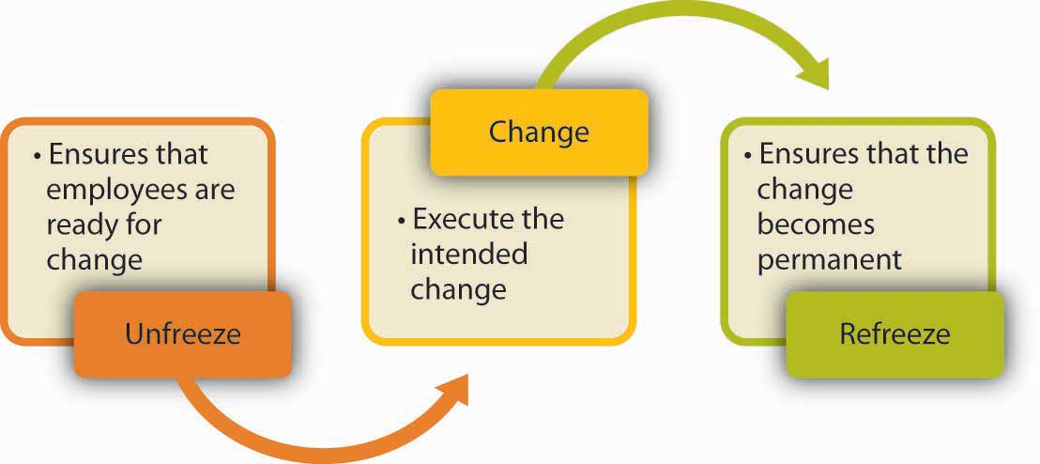
In the event of less significant changes, the technique could be implemented in finding the need for change, communicating the advantages of the change, securing support from important stakeholders, and ultimately implementing the plan while ensuring the plan's long-term viability.
For instance, is able to be used for assessing the essentials for change, creating a plan for switching production to electric vehicles, and then making sure that the adjustments become part of the organizational culture through changes in policy, training for workers, and other initiatives. This is how Ford Motors might decide to shift its focus towards electric vehicles.

Driver factors for change:
External or internal forces might operate as drivers for change in an organization. Depending on the industry, business size, and other variables, these variables can change. The following list of change-spurring causes may be applicable to Ford Motor Company:
Factors | Reasons
Culture: | The force that drives the change is often the organizational culture. Any change may be challenging to successfully execute if the current culture does not accept it. For Ford Motors, a culture of innovation and adaptation is crucial to effectively navigate change.
Leadership: | Effective management is required for implementing change in every company. Ford Motors executives need to have the capacity to able to motivate their team members to adopt cutting-edge concepts and technology by clearly communicating their vision for change.
Power: | The capacity to influence change within an organization may also be impacted by power dynamics. It may be difficult to execute changes if there is opposition from influential stakeholders or organizations inside the company. Ford Motors executives must be able to deal with resistance to change and negotiate power relationships.
Digitalization: | Ford Motors experienced significant changes as a result of the automobile industry's digitization. The company needs to adopt advanced manufacturing methods, autonomous cars, and electric vehicles for staying competitive among rivals.
Competition: | The competitive environment in the automobile sector is always changing, and new companies are upsetting the status quo. For Ford Motors to stay competitive, it must be able to react to emerging rivals and shifting customer tastes.

Resistance Factors to the Change:
- It is critical to determine the Ford Motor Company's opposition to change. Talking to the staff, examining the feedback, and monitoring behavior may all be used to do this. Workers, stakeholders, or other organizations could be the source of opposition (Furxhi, 2021).
- After the resistance's origin has been located, it is crucial to comprehend the causes of the resistance. Speaking with workers and stakeholders can help you learn about their issues and difficulties.
- To lessen change resistance, issues raised by stakeholders and employees must be addressed. This may be accomplished by explaining the advantages of the change, resolving any misunderstandings or worries, and offering staff training and support.
- Participating in the change process with the staff might assist to lessen resistance. Regular communication, feedback sessions, and including them in the planning and implementation of the change are all effective ways to engage employees.
- Offering assistance and tools will help your staff members adjust to the shift. This might involve offering resources like new tools and technology, coaching, and training.
- It is crucial that you maintain updated on the transformation's development and alter course if necessary. Any resistance factors that may have initially gone unnoticed might be found with regular feedback and examination.

Stakeholders’ analysis:
High
Power
- Industry analysts  - Media | - Customers  - Employees  - Shareholders  - Suppliers  - Government regulators
- Competitors | - Local communities  - NGOs
Low
High
Interest

Assessing Effectiveness and Completeness:
By accomplishing the intended results of the change initiative, it is possible to tell when a change program has been finished. Determining specific goals and objectives at the start of the change program and monitoring progress toward them throughout the implementation process are therefore essential (O’Grady, Morlidge and Rouse, 2016). To assist you determine whether the change program is over, consider the following steps:
- For the change program, establish SMART (specific, measurable, attainable, relevant, and time-bound) goals and objectives. This will provide the implementation process a clear direction and aid in assessing the change program's effectiveness.
- Track your progress as you go through the implementation process toward reaching your goals and objectives. Key performance indicators (KPIs) may be used to track development and pinpoint areas that require improvement.
- Conduct a thorough analysis of the outcomes in relation to the targets and goals. Analyze both quantitative and qualitative data to determine whether the change program is effective.
- Determine any issues that still need to be resolved before the modification program is finished. These problems might include unresolved opposition, unexpected difficulties, or unanticipated effects of the change endeavor.
- Inform all interested parties that the change program has been completed after its goals and objectives have been met. This will contribute to the growth of the organization's reputation for competent change management.
Assessing:
- Create key performance indicators (KPIs) that will allow you to compare the organization's performance before and after the transformation program. Metrics relating to money, operations, and clients may be included. To assess the success of the change program, compare the results.
- Surveys and feedback sessions should be held to get opinions from stakeholders on the change program. Surveys, focus groups, and one-on-one feedback sessions can all fall under this category. Utilize this input to pinpoint areas that want improvement and modify the change program.
- Determine the degree of stakeholder involvement and engagement in the change initiative. This might include coworkers, clients, vendors, and partners. Analyze the success of the change program's communication and engagement initiatives.
- To make sure the organization continues to benefit from the change endeavor over the long run, assess the program's viability. Making sure they are in line with the change program, might involve assessing the organization's procedures, rules, and culture.
- Check the change program's usage of the change management methodology for effectiveness. Evaluation of the change program's design, implementation, and evaluation phases might fall under this category. Make modifications for upcoming change efforts in areas that require improvement.

Conclusion:
In conclusion, the debate has centered on the methods and tactics Ford Motors might employ to meet a variety of possibilities and difficulties in the automotive sector. We've looked at the many change management models, such as Lewin's Model, Planned Change, and Emergent Change, and how they may be used to handle small-scale or significant changes in the company.
Additionally, we have looked at the forces that drive change, such as culture, leadership, power, digitization, and competition, and how these factors may be used to propel projects and get beyond the opposition. Additionally, we've spoken about stakeholder analysis and mapping and how to utilize it to find influential people and possible blockades as well as create specialized communication and engagement plans to control their expectations and handle their issues. Overall, such discussions offer important insights into whether Ford Motors might deal with change in a sector that is evolving quickly. Ford Motors can take advantage of its benefits as well as threats, concentrate on its weaknesses and challenges, and preserve its competitive advantage in the automotive market by taking a planned and proactive approach to change management.

References
Bremser, W.G., Jermakowicz, E.K. and Reinstein, A. (2021). Sustainability Reporting Insights: The Case of Ford Motor Company. Issues in Accounting Education. doi:https://doi.org/10.2308/issues-18-032.
Charles Richard Baker (2015). Organizational change at Ford Motor Company in the face of international financial crisis. Recherches en Sciences de Gestion, [online] 110(5), pp.23–35. Available at: https://www.cairn.info/revue-recherches-en-sciences-de-gestion-2015-5-page-23.htm.
Darmawan, A. and Azizah, S. (2020). Resistance to Change: Causes and Strategies as an Organizational Challenge. [online] Available at: https://www.atlantis-press.com/article/125932614.pdf.
Errida, A. and Lotfi, B. (2021). The Determinants of Organizational Change Management success: Literature Review and Case Study. International Journal of Engineering Business Management, [online] 13(1), pp.1–15. doi:https://doi.org/10.1177/18479790211016273.
Frue, K. (2018). PESTLE/PESTEL Analysis of Ford Motors: Shifting towards Electric Automobiles to Combat Saturation. [online] PESTLE Analysis. Available at: https://pestleanalysis.com/pestle-analysis-of-ford/.
Furxhi, G. (2021). Employee’s Resistance and Organizational Change Factors. European Journal of Business and Management Research, [online] 6(2), pp.30–32. doi:https://doi.org/10.24018/ejbmr.2021.6.2.759.
Garnett, G., Venter, J.M. and Geldenhuys, D.J. (2022). Experiences of emergent change from an applied neurosciences perspective. Journal of Applied Neurosciences, [online] 1(1), p.11. doi:https://doi.org/10.4102/jan.v1i1.2.
Karasvirta, S. and Teerikangas, S. (2022). Change Organizations in Planned Change – A Closer Look. Journal of Change Management, [online] 22(2), pp.1–39. doi:https://doi.org/10.1080/14697017.2021.2018722.
Khaw, K.W., Alnoor, A., AL-Abrrow, H., Tiberius, V., Ganesan, Y. and Atshan, N.A. (2022). Reactions towards organizational change: a systematic literature review. Current Psychology. [online] doi:https://doi.org/10.1007/s12144-022-03070-6.
Ogbonnaya, C., Dhir, A., Maxwell-Cole, A. and Gorny, T. (2022). Cost-cutting actions, employment relations and workplace grievances: Lessons from the 2008 financial crisis. Journal of Business Research, 152, pp.265–275. doi:https://doi.org/10.1016/j.jbusres.2022.07.055.
O’Grady, W., Morlidge, S. and Rouse, P. (2016). Evaluating the completeness and effectiveness of management control systems with cybernetic tools. Management Accounting Research, 33, pp.1–15. doi:https://doi.org/10.1016/j.mar.2016.02.003.
Parekh, D., Poddar, N., Rajpurkar, A., Chahal, M., Kumar, N., Joshi, G.P. and Cho, W. (2022). A Review on Autonomous Vehicles: Progress, Methods and Challenges. Electronics, [online] 11(14), p.2162. doi:https://doi.org/10.3390/electronics11142162.
Patora-Wysocka, Z. and Sułkowski, Ł. (2019). Sustainable Incremental Organizational Change—A Case of the Textile and Apparel Industry. Sustainability, 11(4), p.1102. doi:https://doi.org/10.3390/su11041102.
Phillips, J. and Klein, J.D. (2022). Change Management: From Theory to Practice. TechTrends, [online] 67. doi:https://doi.org/10.1007/s11528-022-00775-0.
Verhoef, P.C., Broekhuizen, T., Bart, Y., Bhattacharya, A., Qi Dong, J., Fabian, N. and Haenlein, M. (2021). Digital transformation: A multidisciplinary reflection and research agenda. Journal of Business Research, [online] 122, pp.889–901. doi:https://doi.org/10.1016/j.jbusres.2019.09.022.

‌
‌
‌
‌

