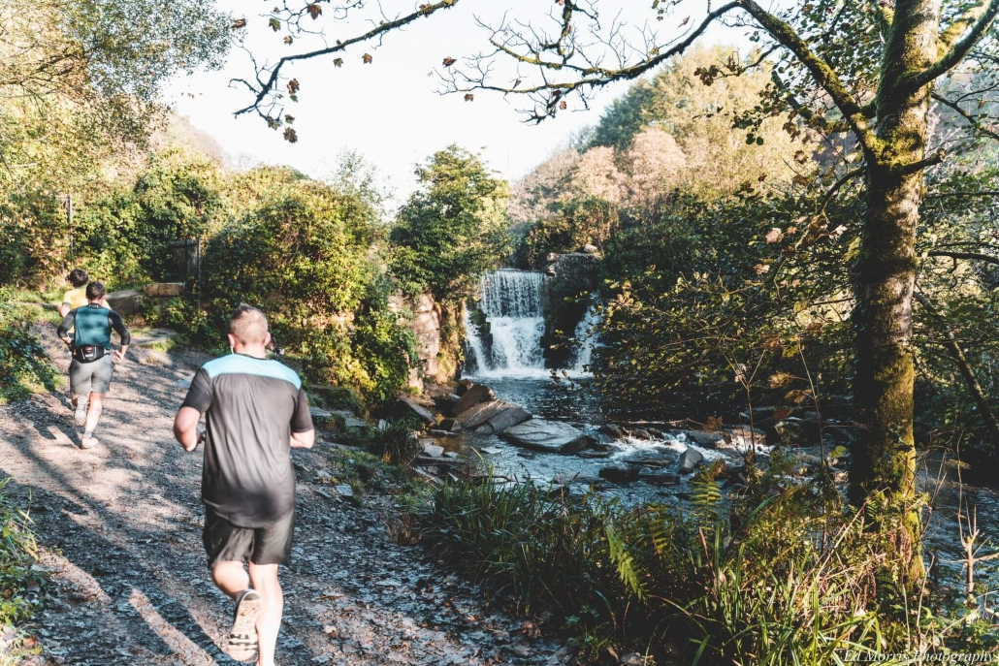
ECAD4005- Spaces and Places to Learn

‘Choose either ‘the beach’ or ‘the woods’ to plan a visit for a group of children. Describe how visiting this location can support learning.’

By Abigail Charles

Introduction
As a child, school trips meant the world to me as they were so much fun and full of excitement. The learning that took place on these trips was invaluable looking back on my school years. With this assignment I am going to be explaining how I would plan a school trip as being the primary school teacher. The school that I am currently working in is called Village Coast C.P primary school and the year group I will be taking is a year 1 class. There will be 25 children of all learning abilities and therefore I will need to take 7 additional adults. The school trip will be to Penllegare Woods in Swansea as it is a secret, magical place within the local area. The children will be transported via a 36-seater coach and the cost will be kept to a minimum by asking for a possible donation from the school PTFA committee.

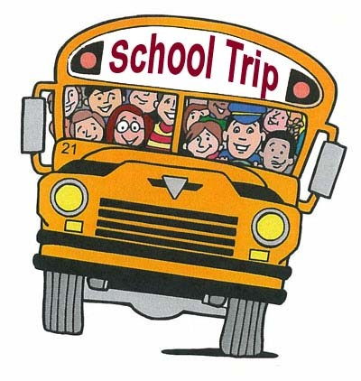

Village C.P

What do we mean by Learning Environments?
The learning environment is the core to children’s learning. It is essential that “young children get frequent and regular opportunities to explore and learn in the outdoor environment” (Learning outside the classroom, 2011). This quote states that in order to get the best learning out of a child, they need to experience the real life and what goes on in the world. An environment develops a child and promotes holistic learning which should be incorporated within their learning not something the children do occasionally. The learning environment explores different areas whether these are in the classroom or outside. Making use of these learning environments is crucial when teaching because it gives the children lots of new learning experiences. According to Froebel, he states that the outdoors offers “rich, sensory first-hand experience which is essential for growing minds” (Tovey, no date). Frobel also believed that “the people we meet, the environment and atmosphere, are as important as what we learn” (Early-education 2019). This means that the more we get from our society and environment, the better the learning is going to be. From looking at different researches and theorists I can see the importance of the learning environments and how this can affect the children’s learning. Hillary Harriman is another theorist that promotes the importance of learning environments and how this impacts the child. “Learning within four walls is surely an adult concept that has more to do with control than with children’s well-being.” (Harriman, 2006 p67). This quote states that over the past couple of years, teaching has only been taking place within the four walls of the classroom. Harriman believes that the teacher was not putting the child’s health and wellbeing first which impacted on their learning. When children have an interest in the environment, they will learn more efficiently than in the classroom. Donaldson (2015) wants to develop and personalise the learning for every child. He believes that by having a “rich, stimulating environment” (p.66) where the children can explore, they need to make “dynamic connections with a clear sense of purpose to construct meaning” (Donaldson, 2015, p.66). The children need to make sense of what they are doing by having a clear purpose.

References
- Learning outside the classroom. (2011). [Shrewsbury]: Council for Learning Outside the Classroom.
- Tovey, H. (n.d.). Outdoor play and exploration. London: Frobel Trust.
- Early-education (2019). About Froebel | Early Education. [online] Available at: https://www.early-education.org.uk/about-froebel [Accessed 3 May 2019].
- Donaldson, G. (2015). Successful Futures. No publisher or where it was published. Available at: file:///C:/Users/Laptop/Downloads/Donaldson%20Report%20-%20Successful%20Futures%20-%20Independent%20Review%20of%20Curriculum%20and%20Assessment%20Arrangements%20in%20Wales%20(2).pdf.

Aims of Educational Visits

From my personal experience I know how excited I was to go on an educational visit. These educational visits will help children in numerous ways. Educational visits provide lots of hands on experiences that the children can undertake in a real-life situation rather than the classroom. Educational visits “encourage students to engage with people, places and buildings in new ways” (National Justice Museum, 2019). Educational visits can have a “lasting impact on students” (Dillon et al, 2005, p.28) and can help the children to develop a “greater empathy with insects” (Dillon et al, 2005, p.28) and the environment. Educational visits are the best aspect to develop children’s learning. Jerome Bruner believes that “it is important for teachers to provide opportunities for children to constantly learn new things” (Wheeler, 2017) On an educational visit it allows the children to learn new things and opportunities outside the classroom or school walls which will help the children to remember what had been taught in that lesson. As a child I remember nearly every primary school trip that I went on as they were fun and exciting and enhanced my learning. From a social constructivist view, they believe that the environment plays a big part to their learning. Brown (1999) believes that a big part of children’s childhood is the “relationships which are established between the child and the social environment that surrounds him/her” (p. 59). The Foundation Phase Outdoor Learning Handbook states how the environment is ideal for “experiential learning” (WAG, 2009, P.2) because it allows the children to be able to take risks, be creative and to move around. Teachers should use the learning environment “as a resource for children’s learning” (WAG, 2009, P.2). According to Article 31 of the UNCRC Rights of the Child, they state that “every child has the right to relax, play and take part in a wide range of cultural and artistic activities” (UNCRC, n.d) so having the opportunity to go on an educational visit is the child’s right.
References
- Brown, J. (1999). Why Vygotsky? The role of social interaction in constructing knowledge. In P. Lloyd & C. Fernyhough (Eds.), Lev Vygotsky: critical assessment (volume 3) UK: Taylor & Francis.
- Dillion, J. Morris, M. Donnell, L. Reid, A. Rickinson, M. Scott, W. (2005) Engaging and Learning with the Outdoors – The Final Report of the Outdoor Classroom in a Rural Context Action Research Project. National Foundation for Education Research: Bath. Available at: http://www.bath.ac.uk/cree/resources/OCR.pdf. (Accessed 4th May 2019)
- Welsh Assembly Government (2009) Foundation Phase Outdoor Learning Handbook. Welsh Assembly Government: Cardiff. Available at: https://learning.gov.wales/docs/learningwales/publications/140828-foundation-phase-outdoor-learning-handbook-en.pdf (Accessed 8th May, 2019).
- Wheeler, S. (2017) Learning Theories: Jerome Bruner On The Scaffolding Of Learning. Teach thought Staff. Available at: https://www.teachthought.com/learning/learning-theories-jerome-bruner-scaffolding-learning/. (Accessed 5th May, 2019).
- UNCRC (n.d.). UN Convention on the Rights of the Child (UNCRC) - Unicef UK. [online] Available at: https://www.unicef.org.uk/what-we-do/un-convention-child-rights/ [Accessed 9 May 2019].
Choice of location and rationale
For the children to have the best hands on experiences, I have decided to take the year 1 class to a forest in Swansea. This forest is called Penllegare Woods. The school that I will be working with is called Village Coast C.P primary school which is situated in the town of Bynea in Llanelli. Penllegare Woods is 6.5 miles / 11minutes away from the school which means that the journey will be short and is local. The location is perfect as it is easily accessible and there are lots of resources that the children can use. I have chosen to go to this forest because there is plenty of space and different areas where I can conduct the activities. As we arrive at the Woods there are toilets so when the children come off the bus, they can go to the toilet then if they need to. As there are lots of trees and branches that surround Penllegare Woods, there is some shelter so if it did rain, the Woods will be appropriate. To add to this, before leaving the school, I would make sure that every child has suitable footwear and clothing preferably ‘boiler suits’ that will cover their clothes and if any child did not have one of these then I would ask the office if I could borrow suits from the school so the children do not get wet or harmed by anything in the woods. Before lunch, as part of one of their activities, I would ask the children to make a shelter with the help of the additional adults. The children will take it in turns to have a go at building the shelter. After I had researched about Penllegare Woods I noticed that there were lots of good reviews of other school trips attending the woods as there was so much space to plan activities.

The Curriculum and Statutory Protocols
This educational visit links to the curriculum in lots of ways. When going on an edcuational trip it enhances the curriculum and enriches the children’s learning opportunites. (See Appendix 1.) I have outlined all the different areas that this trip links to the curriculum. The children will get first hand experience of what they have been learning which is a big part of the curriculum. A risk assessment has been completed to make sure that any risks have been identified and how we can overcome these risks (See Appendix 7). Primary school teachers need to ensure that they follow the national guidance from OEAP (Outdoor Education Advisers’ Panel). OEAP is “ a forum for sharing and developing good practice in Off Site Visits, Outdoor Learning and Learning Outside the Classroom” (National Guidance, 2019). They believe that teachers need to have specialist advice about outdoor learning to make sure that the children have every opportunity to enhance their learning. The OEAP provides legal requirements and protocols for teachers to follow. For example, staff ratio, consent forms and insurance. These protocols all need to be in place before the children can go on the trip. Schools would then use this guidance to create their own school policy. I have included the school policy for educational trips to show exactly the procedure that needs to take place before the trip (See Appendix 8).
References
- National Guidance. (2019). About OEAP. [online] Available at: https://oeapng.info/about-ng/ (Accessed 5 May 2019).
- Welsh Government (2015) Foundation Phase Framework (online) Available at: https://gov.wales/sites/default/files/publications/2018-02/foundation-phase-framework-revised-2015.pdf (Accessed 9 May 2019).
- Welsh Government (2019). Learning Wales. [online] Literacy and Numeracy Framework. Available at: https://learning.gov.wales/resources/browse-all/nlnf/framework?lang=en (Accessed 8 May 2019].

Skills development
Children will develop numerous skills on this school trip. I will be explaining how this school trip links to their Physical, Intellectual, Emotional and Social skills (PIES). The children will be developing their physical skills as they will be constantly moving around and can control their senses. The children will develop their intellectual skills because they will be able to tell me what they have learnt/learning and will be able to tell or teach their peers on different subjects. Another skill that will be developed with this school trip is the emotional skill and this is because the children will be able to express their own opinions and respect the opinions of their peers. The social skill is the last skill that will be developed through this school trip because the children will constantly be interacting and discussing what they have learnt/ doing with each other.

Prior to the visit
There are lots of steps when planning a school trip. The first step to planning a school trip is to ask the headteacher if it is possible to arrange a meeting to talk about this trip. The first question I will ask is if Penllegare Woods will be appropriate and suitable to take Year 1 children. I will also make sure I explain the reason why I am taking the children there and the dates I am thinking of going. Once the headteacher says yes, I will make sure that I contact different bus companies to make sure I have a suitable price (See Appendix 2). I will hand out letters to parents telling them about the school trip, but I will try and avoid the parents paying any of the cost or only a small part of it as it would not be fair on some children’s parents that will not be able to afford it. If the headteacher is unable to contribute towards the cost I would even contact the school PTFA (Parent Teacher, Friends Association). I would explain to them that the trip was of educational importance and if they would be prepared to give a donation. Within this letter I need to make sure that the parents clearly know that the children will need their own packed lunch and if any child is in receipt of free school meals then I will make sure they get this on the day. Within this letter I will need to make sure that the parents state any medical conditions so that the staff are fully aware of this on the trip. (See Appendix 3). I have already made a lesson plan that I will use during the trip which outlines the different activities and the duration of these activities (See Appendix 4). Before going on the school trip, I need to make sure that there are enough additional adults to supervise the children. For this school trip I will need to take at least 6 adults, including myself to make sure that a group of 5 children always has 1 additional adult however, the more adults I can take on this trip, the better I will feel when arriving at Penllegare Woods. One child on the trip has Autism which means that he will always need an additional adult that stays with and that is fully trained in ALN and the different support strategies. The week that I will be going to Penllegare Woods, I will make sure that my lessons revolve around the woods. I will make sure the children learn about different minibeasts, plants, how to care for the environment and how to be safe within the community. To add to this, I have also made a checklist for the school trip to make sure I have everything before leaving the school. (See Appendix 5). As well as the checklist I will take the register, so I know exactly when everyone is present and their different medication throughout the day (See Appendix 6).

During the visit
During the visit there are lots of fun and exciting activities for the children. I have created a lesson plan which outlines the schedule for the day and exactly how long these activities will last for. (See Appendix 4). I have also included the resources that I am going to use and take on the trip. During the visit it is important that the children get an opportunity to take some risks in the forest. Marian Dowling believes that when you give children the opportunity to take risks, it allows them to develop their: confidence, independence skills, values, social and emotions. To monitor and assess what the children are learning, I will not have a group. This means that I can walk around and ask questions so the children will be able to tell me what they are learning. I will record what the children say to make sure that the teaching is of a good standard and that every child understands. This will also give me an idea of what to plan for lessons if the children do not understand a specific topic.

Post Visit
When the school trip comes to an end, I will ask the children to get into their groups with their additional adults and then to find their pairs. Once the children are in pairs, I will lead the way by walking the children back to the bus. The additional adults should always be amongst the children to supervise. When the children are getting on the bus, I will count and tick off their names on the register to make sure that they are all back on the bus safely. When we get back to the school, I will call out the register and whoever I call will come to the front of the bus and find their additional adult. When all the children are off the bus, I will go and check around the bus to make sure that the children have not forgotten anything. After the school trip, there are lots of aspects that I will need to consider doing. When the children arrive back at the school the following morning, I will ask the children about their feelings of the trip and what they enjoyed and what they didn’t enjoy. I will also ask the children what they have gained and learned from the trip. As I had been taking lots of pictures of the children throughout the day, I will create a display board for them to look back and to show their parents when they come to collect them. I will make sure that I plan my lessons to include the day trip and to establish whether the children would like to go again.

Conclusion
Research has shown that the great outdoors has no end of benefits, both mental and physical, for a child’s well-being and learning ability. The term ‘Cotton Wool Kids’ has seen a change in society whereby parents have become quite fearful of their children playing outside for example. They worry about ‘a danger around every corner’ but in the meantime children are becoming more delicate. However, outdoor learning can change these perceptions and encourage children to become more one with nature and their environment. Children should be able to explore and experience the outdoors to improve their learning. A “more relaxed attitude to raising children can lead to happier, healthier families” (O’Malley, 2015). School trips are a very important aspect for children as their participation with hands-on activities will broaden their horizons and develop their thinking skills.
References
- O'Malley, S. (2015). [online] Cotton Wool Kids. Available at: http://www.stellaomalley.com/cotton-wool-kids [Accessed 10 May 2019].

