

DISSERTATION PROPOSAL – FOR VEGAN FOOD PRODUCTION AND PRODUCTS IN INDIA

Student Name: Manjula Babubhai Odedra
Student ID: 2331788
Program: Master of Business Administration
Module Code: LCBM7035
Module: Dissertation
Supervisor: Dr Amare Desta

Submitted on: 14th March 2025
Table of Contents
1. Introduction 3
1.1 Introduction 3
1.3 Problem of small business in India 4
1.4 Aim 4
1.5 Objectives 4
1.6 Questions 4
1.6 Rationale 5
1.7 Significance 5
1.8 Way of finding out 5
2. Methodology 6
2.1 Research Philosophy 6
2.2 Research Approach 6
2.3 Research Design 6
2.4 Research Method 7
2.5 Data Collection and Sampling 7
2.6 Data Analysis 7
2.7 Ethical considerations 8
2.8 Time Line 8
3. Literature review 8
3.1 Market Trends and Growth of the Vegan Food Industry in India 8
3.2 Consumer Behavior and Demand for Vegan Products 9
3.3 Challenges and Growth Strategies for Small-Scale Vegan Businesses 10
3.4 Theoretical Integration 11
3.5 Limitations 12
4. Conclusion 13
References 14
Appendices 17
Appendix-1 17

1. Introduction

1.1 Introduction
In the present business dynamics, there are frequent changes in Indian consumers, especially when it comes to the food sector. The specific aspect of plant-based food consumption is only prominent when they are more concerned about health, environmental sustainability and on a further note, animal protection. The traditional Indian vegetarian cultural background has given way to emerging vegan dietary choices throughout the country (Campbell et al. 2022). This research study evaluates the existing market conditions of vegan food products by analyzing consumer patterns and it investigates barriers that impede small businesses while providing growth strategies for the vegan food industry in India.
1.2 Background Overview

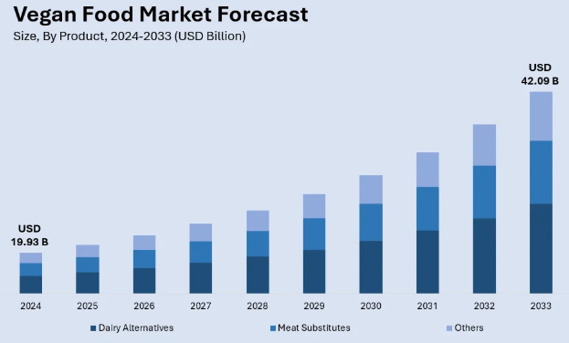
Figure 1: Global Vegan Food Market Size
(Source: Imacgroup, 2024)
As the figure reflects, global vegan food will be valued at USD 19.93 billion in 2024, whereas the Indian market will reach USD 1,468.3 million. By the end of 2033, the CAGR is expected to match the target of 10% (Imacgroup, 2025). The market shows expanding growth of plant-based alternatives, which include dairy substitutes such as mock meats and plant-based protein products.
Despite a notable expansion, the industry confronts major hurdles because consumers doubt the products, its components and production expenses remain high. Small-scale vegan businesses encounter difficulties with market regulation and competition in the marketplace.

1.3 Problem of small business in India
The production cost is higher as the prices of plant-based materials are highly expensive (Pais et al., 2022). Besides, many people in India are not fully aware of the concept of a vegan diet. Compliance with regulations for small companies can also be challenging when dealing with the supply, production and distribution of plant-based podcasts.

1.4 Aim
The aim of this research is to analyze the vegan food industry in India by exploring the potential for growth, production rate, and demand in the market and distribution process. Also, the study explored the preferences of people, regulatory requirements and different sustainability aspects of the vegan market in India.

1.5 Objectives
● To evaluate the current market size and types of food being used in the vegan food market in India
● To analyze the demand of consumers and their purchasing behaviour regarding vegan food items.
● To explore the challenges encountered by small-scale businesses in the Vegan food market
● To examine the strategies for possible growth of the vegan food industry in India

1.6 Questions
● What is the current market size, and what types of food are being used in the vegan food market in India?
● What is the level of customer demand and their purchasing behaviour regarding vegan food items?
● What types of challenges are seen in small-scale businesses in the Vegan food market?
● How can strategic intervention help in improving the growth of the vegan food industry in India?

1.6 Rationale
The vegan population in India is growing due to environmental consciousness, health awareness and ethical factors. The production of vegan food is responsible for comparatively lower carbon emissions, which can increase sustainability consumption (Benvenuti et al., 2022). Considering these factors, government regulations are also getting updated. Choosing the idea, therefore, holds high significance as it can offer many valuable insights that have not been explored before.

1.7 Significance
The research will help in acknowledging the potential of the Vegan Food industry in the Indian market. Also, the motivation behind the purchasing behaviour of consumers can be acknowledged. With the research, understanding the barriers faced by small-scale vegan food businesses to expand into new markets will be possible. Besides, the innovative models of business and their effectiveness upon implementation in the vegan sector will be acknowledged through this research.

1.8 Way of finding out
In the process of identifying the growing market demand and preferences of people towards vegan food items, conducting surveys can be highly useful. Precise, numeric data can be received from the Primary Quantitative method, which is a survey that can help in understanding the perspectives of all the stakeholders of the vegan food industry in India.

2. Methodology
Research methodology stages the conduction of the research process with a proper setting.

2.1 Research Philosophy
Philosophy denotes the way of knowledge through which the objectives can get results based on the data analysis (Mwita, 2025). This study will follow the positivism philosophy as it has to observe and measure data for consumer behaviour. The areas of exploration of this topic are market trends, business challenges and the perception of consumers, and positivism can ensure proper objectivity. Using this could give a proper conclusion to the researcher with relevant evidence of the research. As the proposal is based on purchasing trends and business contradictions in the vegan food industry, this approach will help to maintain the reliability of the data process.

2.2 Research Approach
A proper research approach is required to test the existing theories and conditions set against the gathered data. A deductive approach will be employed for this study as the study needs to evolve around the pre-established business concepts and consumer perception of a specific industry. The deductive research approach is beneficial for the methodology as it can relate to the diverse dynamics of the Indian food industry. As depicted by Hall et al. (2023). The resulted analysis derived upon applying the approach can be beneficial for further research regarding the business market in India.

2.3 Research Design
As opined by Date et al. (2023), the purpose of a research design in methodology is to frame the whole research process. It helps to align the objectives with the data results properly. It enables the researcher to define and address the set objectives transparently. In this study, the explanatory design will be implicated for exploring combining market analysis that will show how the vegan food industry matches with the consumer demands. The reflected aspects of behavioural insights are necessary to investigate the vegan food industry's growth potential in India. Explanatory design works on the present landscape of any given topic, helping to comprehend the business dynamics.

2.4 Research Method
Choosing the research method properly is important for collecting data and making an analysis with the context. This study will follow a quantitative research method based on the requirements of the subject concern. The quantitative method generally deals with numerical data or extensive information gathered from its sources (Sharma et al. 2023). This method applies to the study as it can pose a structured examination of industrial observation and can shed light on the current challenges of the industry. This method can be applied to surveys, opinions and other analyses based on software such as Excel, SPSS, Google Surveys and so on. Choosing the relatable options as opinions from mass participants can provide meaningful insights. Unlike the qualitative method, it does not hover around the pre-existing information; rather, it focuses on the present perspectives of the selected participants and is bias-free.

2.5 Data Collection and Sampling
Data collection is one of the most significant aspects of methodology because the pattern implemented in the collection process will lead to the analysis aspect (Taherdoost, 2021). Primary data collection is appropriate for this study to gain practical insights from the collected data. A total of 120 participants would be chosen for the collection of data. The participants would be sorted as the stakeholders of vegan food industries in India to learn how they relate to the context. Purposive sampling can ensure the demographic representation based on the participant's age, income level and dietary preferences. The data collection will take place in an online Survey with 10 industry-related questions. The opinion of each query in the survey form would help the researcher to gain accurate knowledge of their purchase pattern, food habits, price sensitivities and other conditions. Primary data collection can leverage more real-time and individual opinions of each section of questions, making it more evident than observed perception in secondary data collection (Mazhar et al. 2021).

2.6 Data Analysis
It is the final stage for research conduction, and the results based on this segment will deliver potential insights to the researcher. The survey will take place on the Google Survey online platform. The chosen participants will be made aware of the research conduction, and their consent will be asked. No participants will be entertained by the research process if they deny the confirmation for survey conduction. The multiple-choice questions, along with answers with different intensities, will be set against the questions, which will help the participants to understand their relevance with the interacted topic and answer accordingly. The responses received from the participants will be framed in graphical analysis such as a pie chart or bar graph reflecting the percentile of each section that the participants have chosen. This survey will also assess consumer willingness to pay for vegan products, the impact of marketing strategies, and barriers to vegan food adoption.

2.7 Ethical considerations
Apart from the overall research process, it has to be made sure that the data protection and confidentiality of the involved participants are ensured by strict ethical restrictions. All the respondents who participated in the research process had to be pre-aware of the research purpose along with informed consent before the data collection process. Any personal data received in these actions would be kept private and anonymous, putting the individual's opinion in safe hands. This process would increase the research standards if followed by the university guidelines. As the survey questions are presented in the form of a real-life topic, the respondents may or may not answer any individual question that does not match their sense.

2.8 Time Line
Gantt Chart
(Referred to Appendix 1)

3. Literature review

3.1 Market Trends and Growth of the Vegan Food Industry in India
There is a noticeable growth in the vegan food industry by a group of the population who focus more on theri health consciousness and think of environmental considerations. It is a paradigm that is backed up by government initiatives for the regulation as well as promoting plant-based diets. In 2022, the Government of India, through its Food Safety Standards (FSS), Regulation-5 has prominently announced that smaller businesses need to follow a guideline to specify the vegan logo in their product (Fssai, 2025). This helps teh consumers to have the best quality of products as the suppliers are licensed.

Figure 2: Vegan Trademark
(Source: Buxton, 2021)
These business regulations specify the products to have followed certain parameters of food quality that enhance consumer's trust. Indin business leaders with all these conditions present an upward trajectory. The Indian vegan food market valued at $1,372.3 million in 2022 and aims to grow to $2,756.6 million by 2030 (Coherentmarketinsights, 2023). For instance, the production and consumption of different types of mushrooms are a prime vegan business. For instance, in Goa, Wakao Foods is famous for jackfruit meat products that align with the tags of 'Ready-to-Cook' and 'Ready-to-eat'. It is evident that in India, around 34.3% of the market share is held by the states of Northern India (Coherentmarketinsights, 2023).

3.2 Consumer Behavior and Demand for Vegan Products
The adoption of veganism in Indian consumers are expanding from packaged fruits to restaurants and other food carts. At present, consumer behaviours depend on their exhibition of Indian costumes. Health and awareness are becoming the primary concern; a major part of the urban population, especially Gen Z and Millenials, are prone to try plant-based dietary products (Raptou et al. 2024). The primary target of this consumer group is to find alternatives to animal-based meat products. Taking the concept into an opportunity from smaller to bigger restaurants makes a huge business out of it.
Benefits of vegan foods
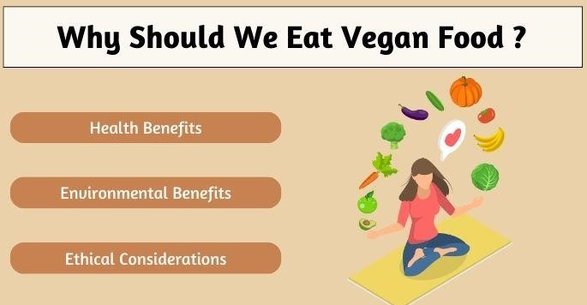
Figure 3: Benefits of eating vegan Food
(Source: Fhafnb, 2025)
- Abundance of Nutrition: These foods are rich in natural resources and dietary fibers. Vitamins along with phytochemicals in vegan food are beneficial for human health.
- Disease Mitigation: The Consumption of vegan foods regularly can decrease blood sugar as well as manage cholesterol levels up to a certain level. This prevents some crucial heart diseases and diabetes (Type-2) (Diaz, 2024).
- Social Impact: Saving animals to enrich the environment can reflect a newer perception of Indian society. Consumers are becoming more conscious of animal agriculture, including greenhouse gas emissions and deforestation.

3.3 Challenges and Growth Strategies for Small-Scale Vegan Businesses
Apart from the benefits, the vegan food sector faces critical challenges. Such as:
High Production Costs: The production costs of components of vegan food, such as almond milk, soy protein, and plant-based meats, are higher than any traditional food products Quach and O’Donohue, 2024). Vegan food generally targets customers with financial affluence in terms of daily usage.
Lack of Awareness: Most Indians are unfamiliar with the term vegan; as a result, the base of engaging with such a food category is not prominent among them. They are often diluted with the misconception of any newer category, especially in the food sector.
Regulatory Barriers: Smaller businesses often find it difficult to apply for certain government certifications to align with safety standards (Konudula and Kuruvanparamb, 2024). It can be hard on their budget to comply with the rules and eventually lose customer engagement.
Supply Chain complexity: India has a surge in this business but is not fluent in every corner due to lesser availability of high-quality plant-based ingredients. The distinctive process of food making might have to depend on a selected supply chain that often makes the business complex due to disruption and increasing costs.
Growth Strategies for Small-Scale Vegan Businesses
- Budget optimization can be done through collaboration with local suppliers of raw materials. It would help to reduce the production costs.
- Awareness campaigns, such as hosting meetings, online influencer collaboration or offline campaigns, can potentially educate consumers regarding the benefits and attributes of veganism (Antonelli, M. and Isernia, 2024).
- Strategic partnerships with restaurants and cafes, along with making business deals with retail chains and food delivery platforms can enhance product reach and visibility.
- Government support in the medium of grants, business loans, subsidies can help the small business vendors to promote and establish brands (Crawford et al. 2024).

3.4 Theoretical Integration
Theory of Planned Behavior (TPB)
Consumers’ perception and their decision-making approaches can be analyzed through the Theory of Planned Behavior (Dangelico et al. 2024). It intends to check on the behaviour of any brand, based on how individual can assess their decision. TPB consists of 3 factors:
a. Attitude: An Individual’s personal beliefs about the benefits of veganism
b. Subjective Norms: Acts in the impact of peers, family, and society
c. Perceived Behavioral Control: People having ease or complexity about accessing vegan products
India being shaped by regional norms and awareness understanding TPB helps businesses design effective marketing strategies to address these influences and encourage plant-based dietary choices.

3.5 Limitations
This research is limited by its sample size of 120 participants, which may not fully represent the diverse Indian consumer base, as there are people with different dietary needs in every region. Moreover, the study focuses primarily on urban markets, which restricts the insights into rural consumers. Contrarily, time limitations prevent a deeper exploration of government policies and long-term industry trends.

4. Conclusion
The Indian vegan food industry underwent notable expansion because more people embraced plant-based nutritional products. Adopting ethical dietary habits is proving a positive condition that pose significant implications for eating habits in the Indian environmental. The researcher, further, taking the results from the analysis, based on set methodology, can thrive on making meaningful decisions contributing to the recommendation in business accessibility and market penetration in India.

References
Antonelli, M. and Isernia, P. eds., 2024. Food Sustainability and the Media: Linking Awareness, Knowledge and Action. Elsevier.
Buxton, A., 2021. What does vegan certification mean and is it necessary? Available at: https://www.theveganreview.com/what-does-vegan-certification-mean-and-is-it-necessary/ (Accessed on: 11th March, 2023)
Campbell, L., Prosser, A.M. and Whitmarsh, L., 2022. “Sometimes you identify as a vegetarian, and sometimes you don’t”. Influences on Meat-Eating Practices Among Indian International Students.
Coherentmarketinsights, 2023. Indian vegan food market- drivers. Available at: https://www.coherentmarketinsights.com/market-insight/indian-vegan-food-market-5428?utm_source=chatgpt.com (Accessed on: 11th March, 2023)
Dale, R., Warlaumont, A.S. and Johnson, K.L., 2023. The fundamental importance of method to theory. Nature Reviews Psychology, 2(1), pp.55-66.
Diaz, A., 2024. Vegan diet can make you wealthy, in addition to healthy, study finds. Available at: https://nypost.com/2024/11/22/lifestyle/vegan-diet-can-make-you-wealthy-in-addition-to-healthy-study-finds/?utm_source=chatgpt.com (Accessed on: 11th March, 2023)
Fhafnb, 2025. Benefits of Vegan Food. Available at: https://fhafnb.com/glossary/vegan-food/(Accessed on: 11th March, 2023)
Fssai, 2025. In 2022, the Food Safety and Standards Authority of India (FSSAI) introduced comprehensive regulations for vegan food products, Available at: https://www.fssai.gov.in/cms/standards-vegan-food.php#:~:text=Foods)%20Regulations%202022%2C%20Food%20Authority,logo%20on%20the%20product%20applied. (Accessed on: 11th March, 2023)
Hall, J.R., Savas-Hall, S. and Shaw, E.H., 2023. A deductive approach to a systematic review of entrepreneurship literature. Management Review Quarterly, 73(3), pp.987-1016.
Imacgroup, 2024. Vegan Food Market Size, Share, Trends, and Forecast by Product, Source, Distribution Channel, and Region, 2025-2033Available at: https://www.imarcgroup.com/vegan-food-market (Accessed on: 11th March, 2023)
Imacgroup, 2025. India Vegan Food Market Report by Product (Dairy Alternatives, Meat Substitutes, and Others), Source (Almond, Soy, Oats, Wheat, and Others), Distribution Channel (Supermarkets and Hypermarkets, Convenience Stores, Specialty Stores, Online Stores, and Others), and Region 2025-2033Available at: https://www.imarcgroup.com/india-vegan-food-market (Accessed on: 11th March, 2023)
Konudula, S. and Kuruvanparamb Krishnan, M., 2024. A Case Study on Sustainability Certifications and Governance in the IndianEdible Oil MSMEs-Fostering Commitment to Organizational Sustainability.
Mazhar, S.A., Anjum, R., Anwar, A.I. and Khan, A.A., 2021. Methods of data collection: A fundamental tool of research. Journal of Integrated Community Health, 10(1), pp.6-10.
Mwita, K., 2025. Understanding Research Philosophies and Designs: A Guide for Early-Career Researchers. Eminent Journal of Social Sciences, 1(1), pp.43-52.
Quach, S. and O’Donohue, W., 2024. Is Veganism Socially Just?. In The Plant-based and Vegan Handbook: Psychological and Multidisciplinary Perspectives (pp. 89-107). Cham: Springer International Publishing.
Raptou, E., Tsiami, A., Negro, G., Ghuriani, V., Baweja, P., Smaoui, S. and Varzakas, T., 2024. Gen Z’s willingness to adopt plant-based diets: Empirical evidence from Greece, India, and the UK. Foods, 13(13), p.2076.
Sharma, L.R., Jha, S., Koirala, R., Aryal, U. and Bhattarai, T., 2023. Navigating the research landscape: A guide to the selection of the right research design. International Research Journal of MMC, 4(1), pp.64-78.
Taherdoost, H., 2021. Data collection methods and tools for research; a step-by-step guide to choose data collection technique for academic and business research projects. International Journal of Academic Research in Management (IJARM), 10(1), pp.10-38.
Crawford, J., Cui, Z.Y.A. and Kewley, D., 2024. Government finance, loans, and guarantees for small and medium enterprises (SMEs)(2000–2021): A systematic review. Journal of Small Business Management, 62(5), pp.2607-2637.
Dangelico, R.M., Ceccarelli, G. and Fraccascia, L., 2024. Consumer behavioral intention toward sustainable biscuits: An extension of the theory of planned behavior with product familiarity and perceived value. Business Strategy and the Environment, 33(6), pp.5681-5702.
Benvenuti, L., De Santis, A., Ferrari, M., Martone, D. and Rossi, L., 2022. The carbon footprint of Italian schools meals: An optimal choice of dishes in vegan, vegetarian, and omnivorous menus. Frontiers in Nutrition, 9, p.854049.
Pais, D.F., Marques, A.C. and Fuinhas, J.A., 2022. The cost of healthier and more sustainable food choices: Do plant-based consumers spend more on food?. Agricultural and food Economics, 10(1), p.18.

Appendices

Appendix-1
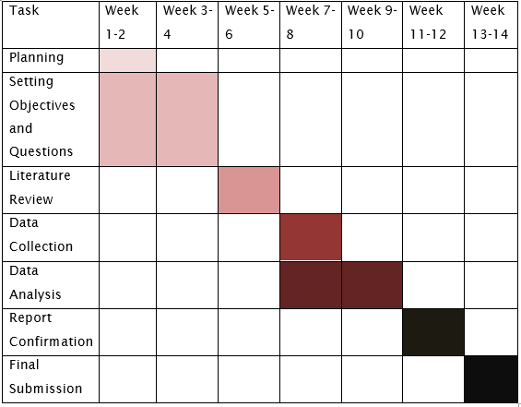
Table 1: Research Time Line
(Source: Self-Developed)
Research Time line reflects a division of tasks-through Gantt chart to be accomplished in the segmented period of time.

