Sumitra Gurung (P148163)
university of wales trinity ST. DAVID
Research Proposal
“A critical assessment on Primark’s market strategy and corporate social responsibility”

Table of Contents
1.Introduction III
1.1 Background III
1.2 Research Rational III
2. The Research aims III
2.1 The Research Objectives III
2.2 Proposed Research Methodology IV
2.3 Types of research method IV
2.3.1 Data collection and Data analysis IV
2.3.2 Research strategy V
2.3.3 Limitations and ethical considerations VI
3. Resources and Planning VI
4. Bibliography VII

1.Introduction
Dissertation is the research conducted to the area of interest for the final year of study. During first and second year of study of the researcher, Primark was used as an example for some of the topics. Moreover, it grew as a part of interest to the researcher due to which it was chosen as a part of the research. Primark has been facing some ethical challenges therefore, this report will be based on how the organisation’s marketing strategy has effected the society.

1.1 Background
Primark is one of the first Irish retail store who delivers ranges of product for men, women, children, accessories, beauty products and home decors. Their value core is “taking care of our people, being good neighbours, and fostering ethical business relationships” (Primark, 2017). Primark is very well known for using a cost leadership to gain competitive advantage over it rivals however, people aren’t aware of the ethical issue that it has caused in some part of the society therefore, through this report critical evaluation will be made on the corporate social responsibility. Most of the goods that has been supplied to the organisation are from the Asia and Europe as they don’t manufacture their goods themselves.
Furthermore, Primark operated on more than 320 countries, yet, they still haven’t adapted to the new part of the society which is providing online shopping service to the users. Thus, through the report, research will be done to find out if it’s a part of their strategy for not creating online service to keep the customers involved with the shop or not.

1.2 Research Rational
This research will look at the market strategy used by Primark to gain competitive advantage over it rival. The research will look at Porter’s five forces model and value chain. This study will also aim to expand on the ethical issue faced by the organisation. After the disastrous collapse of Rana Plaza, which was the most tragic incident happened to the garment industry, there has been a question arising if there are any more ethical issue that the customer are unaware about the organisation (Business, 2013). Therefore, through this research the researcher will try to find if there are more ethical issue that the consumer should be aware about.
Among the high street brand, Primark is very well known for producing fashionable clothes on the lowest prices. However, Primark still hasn’t introduced an online shopping service for the consumer even though digital marketing has become a part of the changing society. Furthermore, online survey will be arranged to analyse if the customer prefers an online service will make a difference for the organisation.

2. The Research aims
The aim of this title is to analyse a critical assessment on Primark’s market strategy and corporate social responsibility.

2.1 The Research Objectives
- To analyse the strategies established by the organisation related to marketing and business development.
-This will be conducted through desk research on the organisation itself and through the case study.
- To analyse if Primark should use online shopping store as a part of their strategy.
-To achieve this object, online survey will be done to gather the information from both customer and the employee.
- To critically evaluate if Primark is involved in unethical practices and consequences on the society and the environment.
-This will be achieved through case study of the organisation, published literature and accredited websites relating to ethical issue. To also see what other research has been done.

2.2 Proposed Research Methodology
Research is defined as “the systematic process of collecting and analysing information (data) in order to increase our understanding of the phenomenon about which we are concerned or interested” (J.K.Sachdeva, 2007). According to Crotty (1998), research methodology is defined as “the strategy, plan of action, process or design lying behind the choice and use of some particular methods and linking the choice and use of methods to desire outcome” (Hesse-Biber & Leavy, 2013).
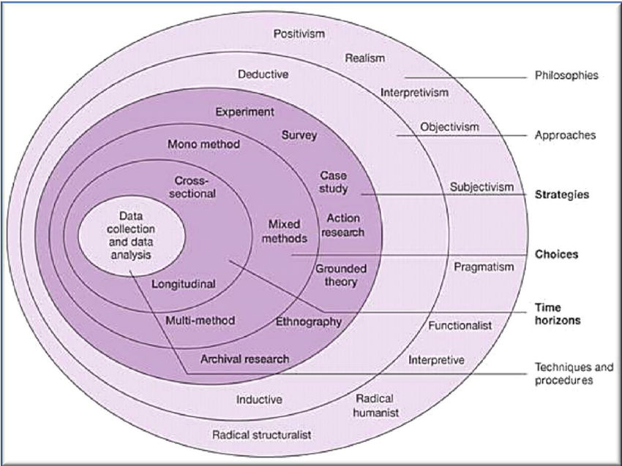
Fig 1.1 Research 'Onion' {reprinted from (Saunders, Lewis and Thornhill 2009)} (Mcmonagle, 2014)
The research onion demonstrates the stages of research strategy therefore, the research will be addressed according to the outline of the onion. Theses layers plays a vital role in regard of effective development for the methodology of the research study. The layers of onion will be used in depth to find the answers to the research question.

2.3 Types of research method

2.3.1 Data collection and Data analysis
Data refers to “a collection of natural phenomena descriptors, including the results of experience, observation or experiment, or a set of premises. This may consist of numbers, words, images, particularly as measurements or observations of a set of variables” (J.K.Sachdeva, 2007). There are two sources of data and they are primary source and secondary source. Primary source is the consistent technique of gathering data by going on the field and it involves direct observation, interviews and survey. It requires the researcher to interact with the sources to extract the information. Whereas, Secondary is the analysis of the primary data or the pre-existing data and includes sources like journal, books and newspaper. The primary data collection can cost more time, money and effort than they secondary analysis. However, primary data is more reliable than the secondary data.

2.3.1.1 Quantitative research and Qualitative research
Qualitative research is “an approach for exploring and understanding the meaning individuals or groups ascribe to a social or human problem by emerging questions and procedures, data typically collected in the participant’s setting, data analysis” (Sagepub, 2008). Qualitative analysis involves participant observation, interviewing, audiotape, case study and document analysis. The final written report is flexible and has focus on participant view which concentrate the intensity of a situation arouse.
Quantitative research is “an approach for testing objective theories by examining the relationship among variables which can be measured, typically on instruments, so that numbered data can be analysed using statistical procedures” (Sagepub, 2008). Quantitative analysis involves large number of data of the respondents to the question or survey and needs to work on mean, median, mode, range and average. The final written report has an assumption about the findings.
Table1.1 Comparing Qualitative and Quantitative Research
Induction | Deduction
- Involves qualitative data.  - Gathers information from small samples.  - Validity is high and reality is low.  - Involves theory from observation and takes longer to gather data. | - Involves quantitative data.  - Information is gathered from large number of participant.  - Reality is high and validity is low.  - Test theory through observation and is quick with data gathering.

2.3.2 Research strategy
The purpose of research strategy is to help the researchers to adopt particular method to search for answer and to meet the objectives the research questions. From Fig 1.1, there are some of the strategies that can be used to achieve the research objectives and answer, and they are; survey, experiment, case study, grounded theory, ethnography, action research and archival research.
The researcher will use desk research, online survey, interview and questionnaires to gather the information for the research. Survey will be done using a large number of populations to produce a quantitative data and interview will be taken to produce a qualitative data. The advantages of using online survey are that they are cost effective, saves time, can be collected in short period of time. However, it can have disadvantage in terms of limited information and people might not participate actively. The questions will be based on the marketing strategy that organisation has develop and it consequences on the society.

2.3.3 Limitations and ethical considerations
“Ethics can be defined as the critical, structured examination of how we should behave in particular, how we should constrain the pursuit of self-interest when our actions affect others” (MacDonald, 2010). The researcher will have to look out for the ethical consideration like only conducting the research with the people above the age of 18. Ethical consideration is more complex than the quantitative research because there are some of the consideration that needs to be followed and they are (Stevens, 2013):
- To respects the dignity of the participants.
- The participant should not be endangered to harm during research.
- Permission should be acquired from the participants prior to the study.
- Not to make a judgement on the choice of the participant.
- The confidentiality of the research data should be safeguarded.

3. Resources and Planning
The resources that will be used for the completion of the dissertation will be journals, case study, books, website and articles. These resources will be obtained through the virtual and online library, online research, lecture notes and from online survey. These resources will contribute towards the literature review and make up the secondary data.

A Gantt chart is “a simple tool which represents time as a bar or a line on a chart. The start and finish times for activities are displayed by the length of the bar and often the actual progress of the task is also indicated” (Basu, 2004). Gantt chart acts as a beneficial source during the projects because it helps the researcher to keep the track of the project and motivates them for the completion. The following represents the sample of the Gantt chart that researcher is planning to follow to meet the deadline.
Fig. 1.2 Gantt Chart

4. Bibliography
Basu, R., 2004. mplementing Quality: A Practical Guide to Tools and Techniques : Enabling the Power of Operational Excellence. [Online]
Available at: https://books.google.co.uk/books?id=JHdT8rF4GCwC&dq=gantt+chart+definition&source=gbs_navlinks_s
[Accessed 12 November 2017].
Business, 2013. Rana Plaza collapse: Primark extends payments to victims. [Online]
Available at: http://www.bbc.co.uk/news/business-24646942
[Accessed 14 November 2017].
Hesse-Biber, S. N. & Leavy, P., 2013. Handbook of Emergent Methods. [Online]
Available at: https://books.google.co.uk/books?id=vbyxBkkjFeYC&pg=PA363&lpg=PA363&dq=quantitative+definition+by+neil&source=bl&ots=cO0lUJzm7c&sig=9ZMKjU6qgaNkFPY15La87IIp6y4&hl=en&sa=X&ved=0ahUKEwi3-rm_qszXAhXInBoKHZ3SCpYQ6AEISTAG#v=onepage&q=strategy&f=false
[Accessed 10 November 2017].
J.K.Sachdeva, 2007. Business research methodology, Mumbai: Himalaya Publishing House.
MacDonald, C., 2010. Ethics: Definition. [Online]
Available at: https://businessethicsblog.com/2010/03/21/ethics-definition/
[Accessed 14 November 2017].
Mcmonagle, H., 2014. Evaluation of the role of advanced wastewater treatment in the removal of priority pollutants from municipal point-discharges. [Online]
Available at: https://www.researchgate.net/figure/269400117_fig11_Figure-20-Research-%27Onion%27-reprinted-from-Saunders-Lewis-and-Thornhill-2009
[Accessed 1 November 2017].
Primark, 2017. Ethical Trading. [Online]
Available at: https://m.primark.com/en/about-us/ethical%20trading
[Accessed 5 November 2017].
Sagepub, 2008. The Selection of a Research Design. [Online]
Available at: https://www.sagepub.com/sites/default/files/upm-binaries/22780_Chapter_1.pdf
[Accessed 12 November 2017].
Stevens, M., 2013. Ethical issues in qualitative research. [Online]
Available at: https://www.kcl.ac.uk/sspp/policy-institute/scwru/pubs/2013/conf/stevens14feb13.pdf
[Accessed 15 November 2017].

