Michael Cunniffe (P148021)
Mcunniffe.148021@student.ac.uk

Alternative Powertrain Technology
Series Hybrid Vehicle Part 1(a)


Student of BSc Motorsport Engineering Year 3 2019

Contents
Introduction 2
Methodology 3
2.1) Calculations 4
2.2) The Track 5
Conclusion 6
References 6
Appendices 7

Introduction

The purpose of the assignment is to select an adequate off road buggy that has the capabilities of achieving thrilling speeds across a loose soil and gravel surface for corporate event use and fun day racing experiences. The second part of the assignment is to design a track that the vehicle will run on with loose surfaces and elevation changes must reach at least 22m incline across a full lap, something similar to a dirt bike or endure circuit. Then to validate that the vehicle chosen is adequate for the terrain of what the designed circuit demands we must use excel spreadsheets to calculate the chosen vehicles: Velocity (m/s), Acceleration (m/s), Gradient (degrees), Rolling drag (N), Aero resistance (N), Total resistive forces (N), Tractive forces ie Power required (kw), Residual power ie Available power (kw) each have to be clearly graphed in excel opposite the time (s) along the course of a lap. We must work out the Average power used (kw) and Max power used (kw).

Methodology
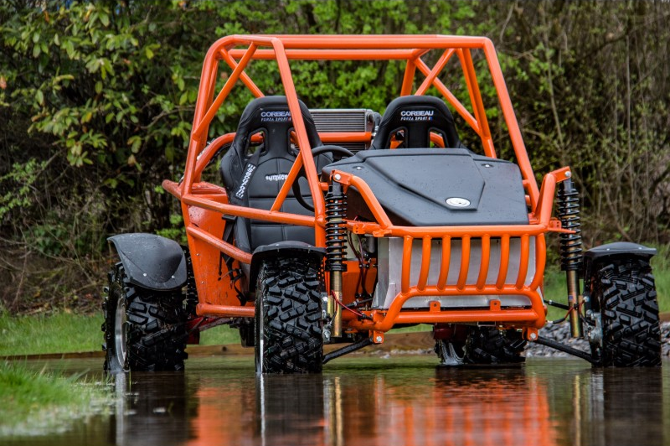
BEAST Zetec Track (BZT) Buggy

The buggy presented is a BEAST Zetec Track (BZT) buggy. The buggies designed application is for off road use for example dirt, loose soil gravel use that can be easily converted to tarmac use with the altering of tyre compound and tread design. The market this buggy is aimed at is for the fun day out experience that large enterprises may have or even just off road racing experiences for upwards of 18 years of age. The vehicles engine is 2000cc 4cyl 16v zetec engine mapped to 150bhp driven through a 5 speed H-pattern syncromesh gearbox to the back axle I which has a limited slip differential. The vehicles weight is on 500kg therefore the vehicle has a power to weight ratio of 280bhp per tonne. The buggy has a top speed of 130mph but realistically will not be able to reach this on loose surface tracks as there not that long and traction is much less than tarmac.

Buggy info
Engine capacity (cc) | 2000
Engine power (bhp) | 150
Engine torque (Nm) | 174
Acceleration (0-60) (s) | 4
Acceleration (0-60) (m/s) | 6.7056
Weight (kg) | 500
Weight + Driver (kg) | 575
Height (mm) | 1500
Width (mm) | 1600
Cd | 0.45
Frontal Area (65% of w x h) | 1.56
Wheel size | 25"x10"x12"
Rims size | 12"

Track info
Gravity | 9.81
Rolling resistance coefficient (loose soil, gravel) | 0.12
Air density | 1.2

2.1) Calculations
Acceleration: (convert mph to m/s) $60 x 2.237 = 26.8224m/s$
(Divide acceleration by the 0 – 60 time) $26.8224 / 4 = 6.7056m/s$
Velocity = $distance ÷ time$
Gradient drag (resistance):$m x g x sin (Ѳ$) $= N$
Rolling resistance:$m x g x rolling coefficient$ $= N$
Aero resistance:$0.5 x coefficient of drag x frontal area x velocity² (m/s) x air density$ $= N$
Total resistance: $Sum of all the resistances = N$
Gradient: ${Sin}^{-1}x(\frac{change in height}{distance travelled in that section})$
Power required: $Total tractive resistance x velocity$

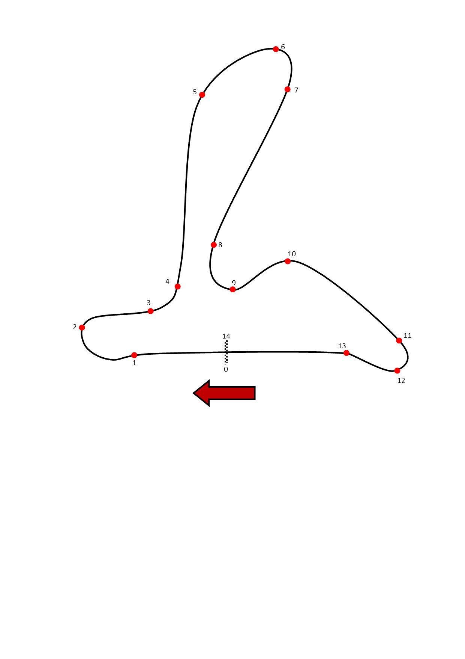
2.2) The Track
The track designed for the BEAST Zetec track buggy is an exact replica of the Mondello Park national circuit in Naas, Co.Kildare, Ireland. The length is identical of 1.86km or 1860m but the gradient changes of the track are totally exaggerated to accommodate our buggy and is fun racing experience. The circuit is a clockwise circuit as you can see above with the direction of the circuit shown by the red arrow and he first corner is a right hander. The big difference is the surface as the original national circuit is all asphalt where as ours is loose soil and gravel which makes sure that in theory the rolling resistance is the same all the round as shown in figure 5 in the appendices. The elevation changes is another big difference as the changes are much more steep on both inclines and declines. To try keep some originality at the beginning of entering or exiting a corner where the height changes on the original track, we have kept them same points where the gradient changes between sections. The sections of the designed track go from 1 to 13 and 14 is back at the start finish straight. The sections of braking zones are labelled and acceleration zones. For example above shows section 1 marked with a red dot, at the red dot is where the brakes are applied between section 1 to 2 this can be shown in in figure 2 of the appendix where the speed of the vehicle decreases (21ms – 13.14ms) between section 1 to 2. Section 2 where the red dot is shown is coming out of the corner onto a short straight where the vehicle would be accelerating up a height of 3m between section 2 to 3. This proven is figure 2 of the appendix where speed increases from section 2 to 3 (13.14ms – 17ms). The track starts on the level surface and finishes on back on the level surface as you can see in figure 1 of the appendix where the start is at 10m height and finishes at 10m height. To add a fun side to the track design, the track has good diverse cornering speeds with 4 high speed sections for example as seen in figure 2 between section 4 to 5 the vehicle can reach 60mph with a hard down-hill braking section between 5 to 7 with a much slower cornering speed 36mph.

Conclusion
The BEAST is perfectly suited to our dirt track showing its ability to increase speed up inclined planes at an acceptable rate to give occupants a thrill of speed on a surface that is loose. The track has been redesigned with technical sections such as the decreases in elevation in braking zones a shown in section 1 to 2, 5 to 6, 8 to 9 and 11 to 12. One place where our buggy could benefit from a lower final drive would be section 9 to 11 and is discussed next. The power output of the BEAST Zetec buggy is plenty for inclines that the vehicle has to face as shown in figure 1 between section 9 to 11 where the climb is 6m in height over a distance of 329m which is a considerable climb that is harder on an engine than accelerating down-hill. This has been stated by (Denton .2016) “while travelling up hill the vehicle has to cope with the gradient resistance”. Which makes clear sense as when diving down-hill the vehicle is getting a push from gravity as when driving up-hill the vehicle has to push against gravity. The climb in this section 9 to 11 has a gradient resistance of 166.55N which is the second highest gradient resistance that vehicles have to face on this track but that isn’t taking into account the aero resistance. This is also backed up at section 11 where the total resistance is 1195.18N. At this point the elevation has peaked on our track shows that it has a serious impact on our vehicle to accelerate. At this point the speed between section 10 and section 11 has only 8mph in the difference of speed over a distance of 200+ metres.

References
- Electric hybrid and vehicle technology, April .2016, Pub Routledge By Tom Denton

- Advanced motorsport engineering, September .2011, Pub Routledge By Andrew Liversey

- http.//www.engineeringtoolbox.com/drag-coefficient-d 627.html

- http.//www.engineeringtoolbox.com/rolling-friction-d 1303.html

- https://www.racingcircuits.info/europe/ireland/mondello-park.html

- https://www.blitzworld.co.uk/high-performance/BEAST-Off-Road

Appendices
  - Figure 1: Track height along the distance of the track, Cunniffe 2019.

Figure 2: The vehicles speed at sections against time along the lap, Cunniffe 2019.

Figure 3: Acceleration of the vehicle at sections against time along the lap, Cunniffe 2019.

Figure 4: Gradient change of track, Cunniffe 2019.

Figure 5: Rolling resistance along the course of the lap (same because same surface), Cunniffe 2019.

Figure 6: Aero resistance of the vehicle along the course of the lap, Cunniffe 2019.

Figure 7: Total resistance forces at each section along the course of the lap, Cunniffe 2019.

Figure 8: Power required to move at sections along the circuit, Cunniffe 2019.

Figure 9: Residual power (unused, available) power along the course of the lap, Cunniffe 2019.

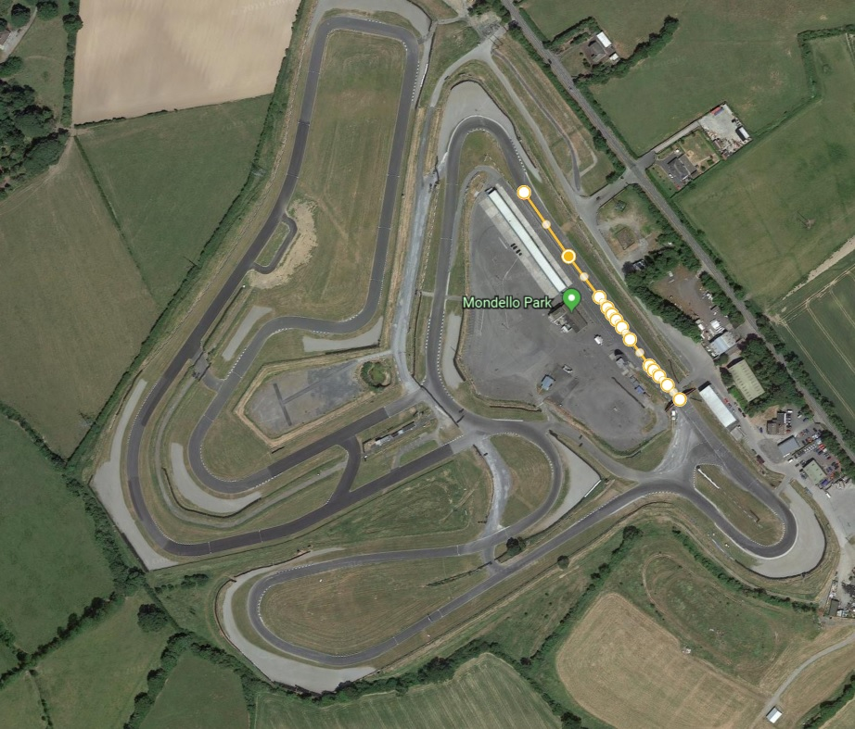
Figure 10: Google earth ariel view of the international/national circuits.

