Module Name: Digital Skills for Personal Development and Business Growth
Module Code: BMSW4008
Assignment Title: Portfolio
Student Name: Darina Holomkova
Student Number : 2513906
Lecturer: Scott James
Deadline: 16th March 23.59 2026

Acknowledgement Statement

I confirm that I have not presented AI generated material as my own work. I confirm that I have copies of my drafts, notes, and other resources used to complete this assignment if needed.

Table of Contents

Task 1: Assessment of Digital Skills
Introduction
Overview of the JISC Digital Capability Tool
Summary of Results
Strengths in Digital Skills
Areas for Improvement
SMART Action Plan
Reflection
Task 2: LinkedIn Learning Certificates – Office 365

Task 3: Relevance and Importance of Microsoft Excel

Task 4: Reflective Presentation Summary

Reference List

Task 1: Assessment of Digital Skills

Introduction: Importance of Digital Skills

Digital skills are particularly important in modern education and work. Most jobs today require people to use computers, online systems, and digital tools. Because of this, students need to develop strong digital skills during their studies.

Digital skills include searching for information online, communicating with others, creating digital work, and solving problems using technology. These skills help people work more efficiently and complete tasks faster.

In universities, students often use digital systems to give work, research information, and communicate with lecturers. Without digital skills it can be difficult to complete academic work successfully.

Digital skills are also important for future careers. Many companies use digital tools for communication, data management, and decision making. Employers expect graduates to feel confident using different types of technology.

Because technology continues to develop, it is important for students to keep improving their digital skills. Learning these skills now will help me succeed in my studies and prepare for my future career.

Overview of the JISC Digital Capability Tool

The JISC Digital Capability Tool is an online self-assessment that helps people understand their digital skills. The tool asks questions about how confident someone feels when using several types of digital technology.

The questions cover several areas of digital skills, such as finding information online, communicating using digital tools, creating digital content, and managing digital wellbeing.

After completing the assessment, the tool produces a chart that shows the user’s strengths and areas where improvement may be needed. The results help people understand their digital abilities more clearly.

The JISC tool is useful because it allows students to reflect on their current skills and think about how they can improve. It also helps people find areas where they may need more training or practice.

Using this tool helped me understand my own digital skills and find areas where I can continue to develop.

Summary of My JISC Results

My results show that I have a good overall level of digital skills, but some areas are stronger than others.

My strongest areas are digital identity management and digital wellbeing. This means that I understand how to manage my online profile and how to use technology in a balanced way. I am careful about how I present myself online and I understand the importance of keeping personal information safe.

My results also show good levels of digital communication and digital learning activities. This shows that I feel comfortable using digital tools for communication, such as email and online learning platforms.

However, my results also show lower scores in data literacy, digital creation, and problem solving. These skills involve analysing data, creating digital materials, and solving technical problems when they occur.

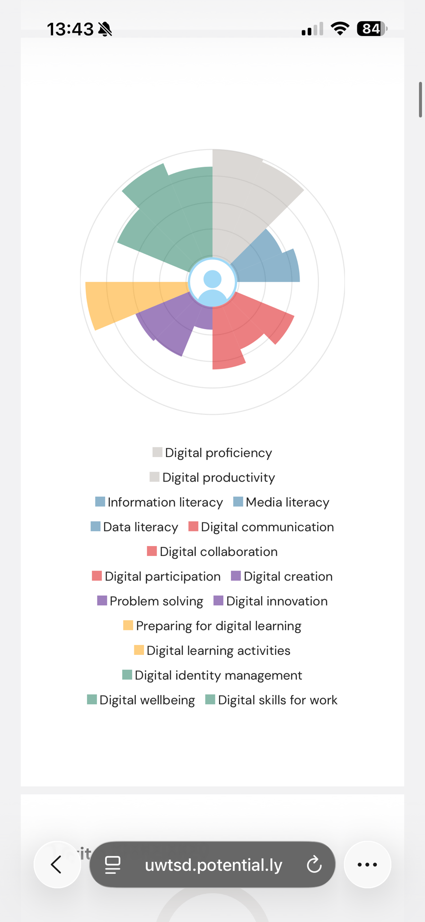
This means that while I feel confident using technology in general, I still need to improve some more practical and technical skills.

Strengths in Digital Skills

One of my main strengths is digital identity management. I understand that it is important to have a professional online presence. For example, I use LinkedIn to present my education and skills in a professional way. This can help me when applying for jobs in the future.

Another strength is digital wellbeing. I try to manage my screen time so that I do not spend too long online. This helps me stay focused when studying and prevents digital fatigue.

I am also comfortable using digital tools for communication. For example, I use email, online learning systems, and group communication tools for my university work.

These strengths help me complete my studies more effectively and communicate with others in a professional way.

Areas for Improvement

Although I have good digital skills in some areas, there are also areas where I need to improve.

One area is data literacy. Data literacy means understanding and analysing information using digital tools. Many organisations use data to make decisions, so this is an important skill for business students.

Another area is digital creation. This involves creating digital materials such as reports, presentations, or visual content. Improving this skill will help me produce higher quality academic work.

I would also like to improve my digital problem-solving skills. This means being able to deal with small technical problems and understand how digital systems work.

Improving these skills will help me become more confident when using digital tools.

Action Plan Using SMART Goals

Goal 1 – Improve Data Skills

Specific: Learn how to analyse data using Microsoft Excel.
Measurable: Complete training modules and practise using formulas.
Achievable: Use university resources such as LinkedIn Learning.
Relevant: Data analysis skills are important for business careers.
Time-bound: Complete this by June 2026.

Goal 2 – Improve Digital Creation

Specific: Improve my ability to create clear digital reports and presentations.
Measurable: Create at least three digital reports or presentations.
Achievable: Practise using tools such as PowerPoint and Canvas.
Relevant: These skills will improve the quality of my academic work.
Time-bound: Complete this within two months.

Reflection and Conclusion

Completing the JISC digital skills assessment helped me understand my digital abilities more clearly.

The results show that I am confident using digital tools for communication and managing my online identity. However, the assessment also showed areas where I need to improve, especially data skills and digital creation.

By working on these areas, I will be able to develop stronger digital skills and improve the quality of my academic work.

Developing digital skills will also help prepare me for future employment. Many organisations expect employees to use digital tools effectively. Improving my digital skills will help me adapt to modern working environments and increase my career opportunities.

Task 2: LinkedIn Learning Certificates – Office 365

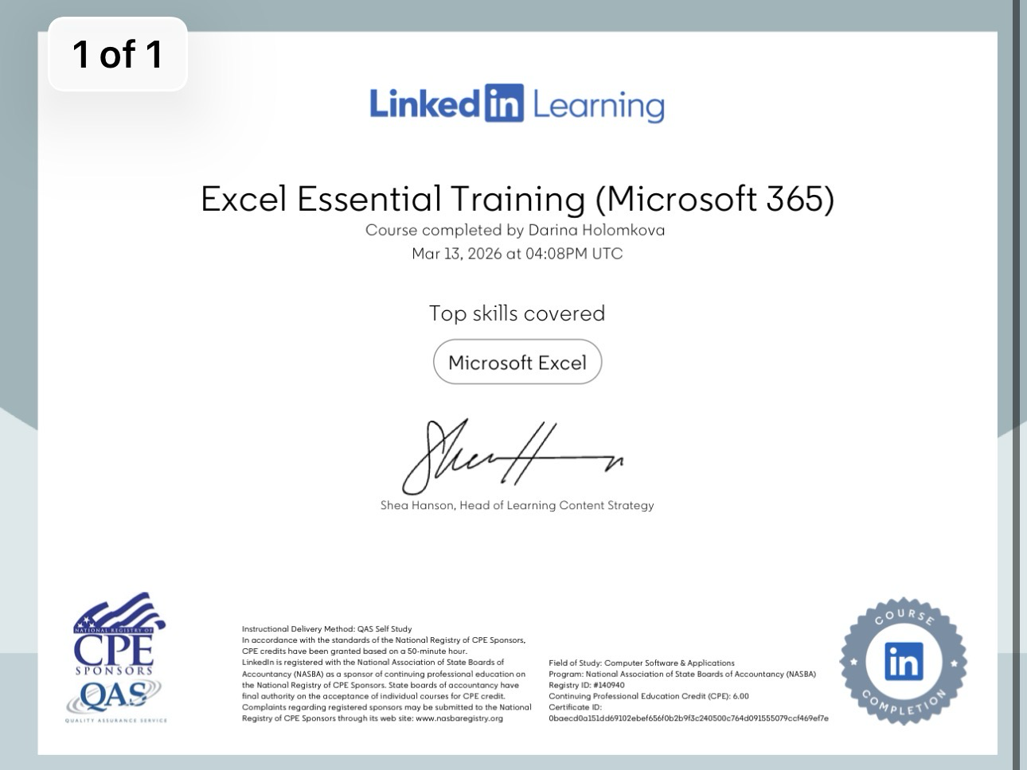
As part of developing my digital skills, I completed several training courses on LinkedIn Learning related to Microsoft Office tools. These courses helped me improve my knowledge of software that is widely used in education and business.
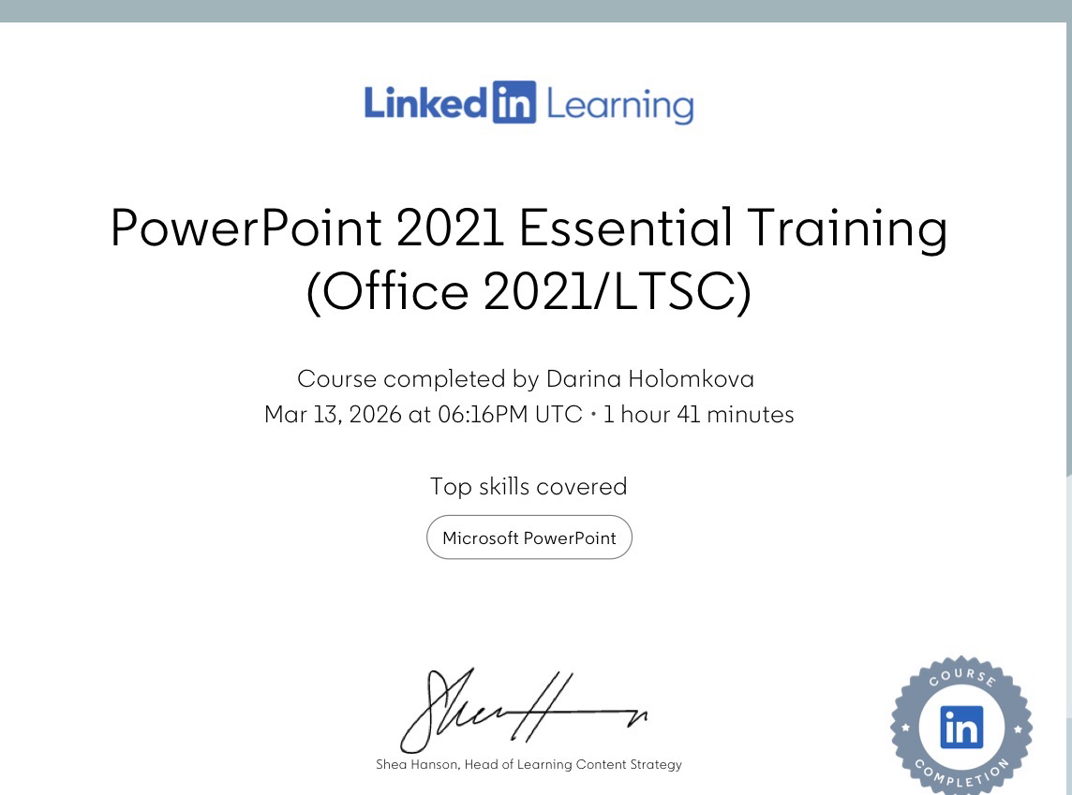
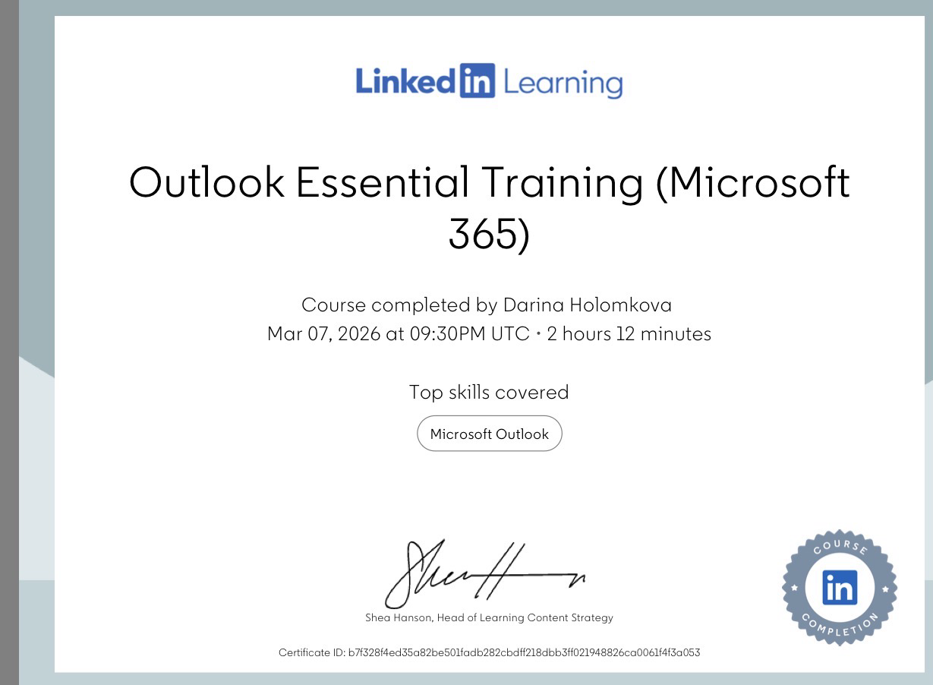
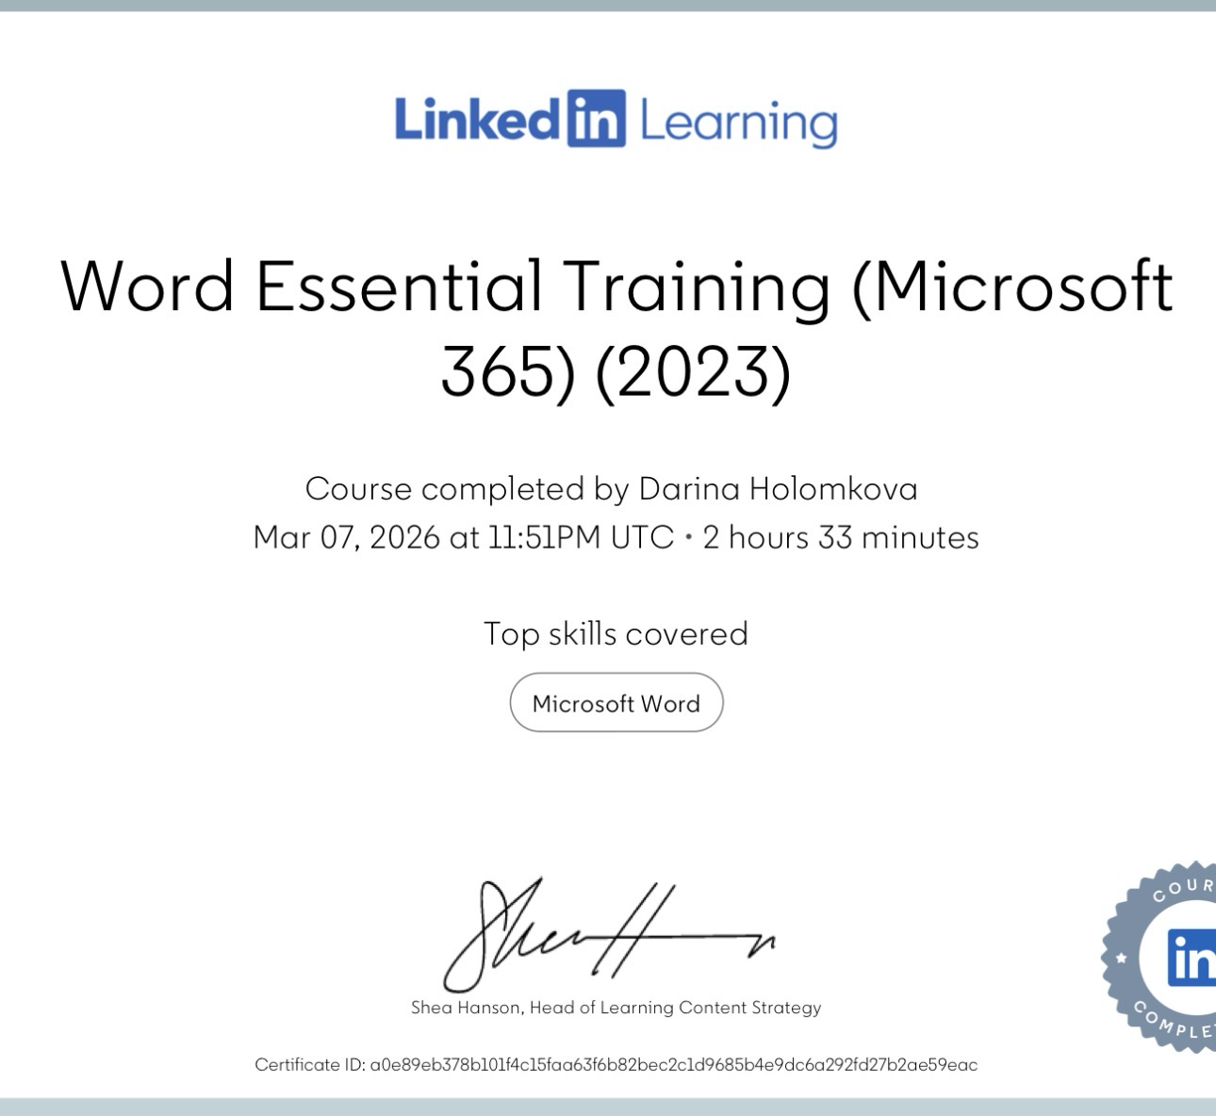
Learning how to use these tools correctly helps students complete academic work more efficiently and communicate more professionally.

Task 3: Relevance and Importance of Microsoft Excel

Introduction

Microsoft Excel is one of the most used spreadsheet programs in education and business. It allows users to organise data, perform calculations, and analyse information.

Excel is widely used because it helps people manage generous amounts of information in a simple and organised way. Students, businesses, and organisations use Excel to track data, create reports, and support decision making.

Learning how to use Excel is an important digital skill. Many employers expect graduates to understand how to work with spreadsheets and data.

Data Analysis

One of the main uses of Excel is data analysis. Excel allows users to organise large amounts of information and analyse it quickly.

The program includes many formulas and functions that perform automatic calculations. For example, functions such as SUM and AVERAGE can calculate totals and averages very quickly.

Excel also allows users to sort and filter data. This makes it easier to find patterns and understand information more clearly.

These tools help people understand data and make better decisions based on the results.

Budgeting and Financial Management

Excel is also widely used for budgeting and financial management. Many people use spreadsheets to track income and spending.

For example, a household budget can be created in Excel to record monthly income and expenses. This allows people to see how much money they are earning and how much they are spending.

Businesses also use Excel for financial planning. They can track sales, calculate costs, and monitor profits. This helps organisations manage their finances more effectively.

Reporting and Decision Making

Another important use of Excel is creating reports. Excel can turn data into charts and graphs that make information easier to understand.

Charts such as bar charts, line graphs, and pie charts help show trends and comparisons clearly. This allows people to see patterns that may not be obvious when looking at numbers alone.

Many organisations use Excel reports to support decision making. Managers can analyse the information and use it to make better business decisions.

Real life spreadsheet using excel. This spreadsheet demonstrates how Excel can be used to organise financial information and calculate totals using formulas. A pie chart was created to visually present the distribution of household expenses.

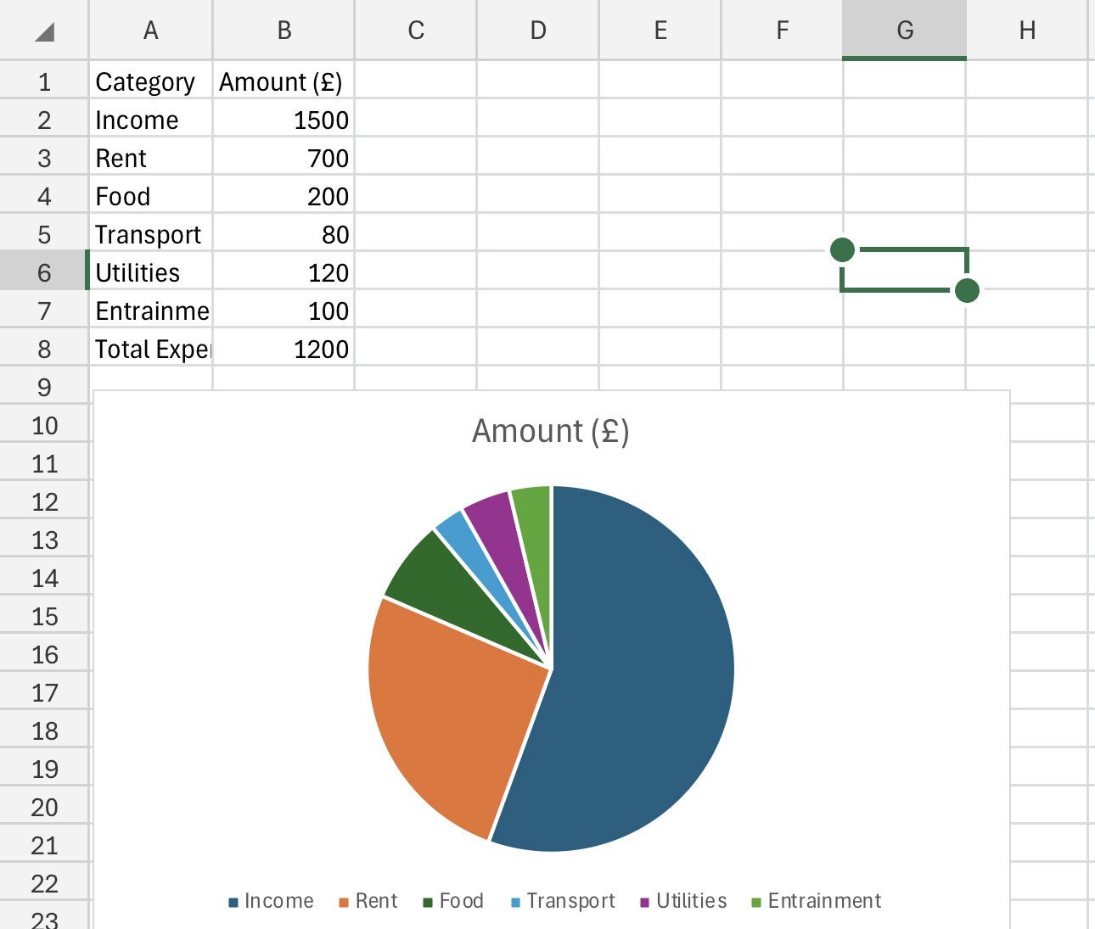

Reflection and Conclusion

Completing the digital skills assessment helped me understand my current level of digital ability and how important digital skills are for both education and employment. Before completing the assessment, I did not fully think about the unusual types of digital skills that are required in modern learning environments. The results helped me reflect on my strengths as well as the areas where I need to improve.

One of my main strengths is managing my digital identity and using online communication tools. I feel confident using email, online learning platforms, and professional networks such as LinkedIn. These skills help me communicate effectively with lecturers and classmates and allow me to present myself professionally online.

However, the assessment also showed that I need to improve my data literacy and digital creation skills. These skills are important because many organisations use data to support decision-making and problem solving. Improving my ability to analyse information and create clear digital reports will help me produce better academic work and develop stronger professional skills.

Creating a SMART action plan helped me find practical steps that I can take to improve these weaker areas. For example, I plan to practise using Microsoft Excel for data analysis and continue learning how to create professional presentations and reports using digital tools. By practising regularly and using available learning resources, I can gradually improve my digital confidence.

Overall, this reflection helped me realise that digital skills are essential for success in both university and future employment. Technology is used in every industry, and employers expect graduates to feel comfortable using digital tools. By continuing to develop my digital skills, I will be better prepared for my studies, future career opportunities, and the changing digital workplace.

Reference list

M., Qadri, M.A. and Suman, R., 2022. Understanding the role of digital technologies in education: A review. Sustainable Operations and Computers, 3, pp.275–285. Available at: https://www.sciencedirect.com/science/article/pii/S2666412722000137.
Microsoft, n.d. 5 reasons why you should start using Microsoft Teams today. Available at: https://pulse.microsoft.com/en/work-productivity-en/na/fa2-reasons-why-you-should-start-using-microsoft-teams-today/.
Kaplan, 2024. What is Microsoft Excel used for and is it still relevant? Available at: https://kaplan.co.uk/blog/features/is-microsoft-excel-still-relevant.
IRIS Connect, 2025. The importance of self-reflection. Available at: https://blog.irisconnect.com/uk/community/blog/importance-of-self-reflection/.
FD Capital, 2023. The importance of a strong LinkedIn profile. Available at: https://www.fdcapital.co.uk/the-importance-of-a-strong-linkedin-profile/.
Jisc, n.d. Discovery tool. Available at: https://digitalcapability.jisc.ac.uk/our-service/discovery-tool/.
Brookfield, C. (2023) Why use Microsoft Excel for social research projects? SAGE Research Methods Community. Available at: https://researchmethodscommunity.sagepub.com/blog/why-use-microsoft-excel-for-social-research-projects

