Project Management LCBB5005
Assessment 1
By Aniko Pongo 2010922

Table of Contents
Purpose of Project Initiation Document 3
Background of the University 3
Objectives and Success Criteria of the Project 4
Restriction on Project 5
Assumptions and Predictions for the Project 5
The Project's Costs 5
Summary of the Project Options. 7
Approach of the Project 7
Project Management Team 10
Communication Strategy for Project 11
Risk Log 12
References 14

Purpose of Project Initiation Document
This Initiative Initiation Document is based on the Salisbury House (SH) project. It describes why and how the implementation phase should proceed, as well as who should be involved and what their responsibilities are throughout the process (Daddey and Watt, 2021). It will act as a baseline for project management and an evaluation of the overall effectiveness of the project.
Detailed The Initiative's Description
The University of Wales Trinity Saint David (UWTSD) London campus has purchased a new building block previously known as Salisbury House. The location is within the Kennington industrial park, which also serves as the home of the university's main campus building. The new structure will include additional teaching rooms to handle the centre’s growing student population, as well as administrative offices for the centre’s key workers. The building block is divided into several sections, including a welcome area, classrooms, a lecturer's office, an administrative office, a students' lounge, a kitchenette, and a restroom facility.

Background of the University
The University of Wales Trinity Saint David is a multi-campus institution having three main campuses in South West Wales, in Carmarthen, Lampeter, and Swansea, as well as a fourth campus in London, England, and learning centres in Cardiff, Wales, and Birmingham, England. The University of Wales Trinity Saint David is a multi-campus institution having three main campuses in South West Wales, in Carmarthen, Lampeter, and Swansea, as well as a fourth campus in London, England, and learning centres throughout the country.
In 2010, the University of Wales, Lampeter (UWL) and Trinity University College (TUC) amalgamated to form the University of Wales, Lampeter (UWL). The University of Wales, Lampeter (UWL) and Trinity University College (TUC) are Wales’s two oldest higher education institutions (TUC). Lampeter's royal charter, awarded in 1828, enabled the merger. In 2011, it was announced that the University of Wales would be merged with Trinity Saint David as part of the schools' overall consolidation. The university merged with Swansea Metropolitan University on August 1, 2013 to establish Swansea Metropolitan University.
The Prince of Wales, R. Brinley Jones, who serves as President, and Medwin Hughes, who serves as Vice-Chancellor, are among those who have provided their support to Trinity Saint David.
Recent events have created an ideal opportunity to rekindle this possibility. Among the most recent developments are the following:
- On April 1, it was announced that the Law Courts would close.
- Chichester Vision came forth as a result of the District Council's acceptance.
- Thirdly, the area's planned adoption of a new masterplan
- The government's focus on growth and its efforts to expand the number of students studying higher education

Objectives and Success Criteria of the Project
The project's outcomes are the first thing that must be addressed. The following are concrete outputs that could be prepared precisely: • Establishing the successful Local Growth Fund (LGF) and other funds, which will leverage around £83 million in private sector investment; (excluding relocation and acquisition costs).
- Acquisition of any privately owned property necessary to complete the project.
- Successful facility repurposing
- A strategy implementation group has been formed.
- If a Compulsory Purchase Order (CPO) is necessary, the CPO must be approved.
- Securing a development partner
- The project is expected to result in the creation of new jobs, job retention, and the delivery of new dwellings and student housing.
- Floor space dedicated to students, instructors, staff, and administrative personnel, as well as equipment
- Construction is underway on a new community health centre (subject to funding and specification)
- Any capital funds granted by the CDC may earn a profit.
When implemented, these recommendations will significantly contribute to and support the Community Strategy and Corporate Plan, particularly in the areas of education and employment.
This project will build on Kennington's current economic success, which is already robust, and where the business sector has demonstrated its readiness to join in neighbourhood efforts by previous involvement in similar projects. These final prospects will be realised with the assistance of public funds supplied by the government.
Concerning the project's disadvantages, it continues to have a negative impact on a range of sectors, including traffic patterns, utility bills, and legal fees linked with the property acquisition.
The idea lacks a master plan that would make it easier for students to navigate the newly constructed university building block. Similarly, the educational institution's management would be responsible for any regulatory processes or for obtaining consents and approvals on their behalf. Perhaps management of the new facility is not included in the project's scope of work.

Restriction on Project
- Approval and Timeline for Masterplan Delivery
- Approval and timeline for delivery of any necessary CPOs
- Strategic Partner Agreements
- Timing and budget constraints on certain financing streams
- Planning constraints
- Fragmented land ownership

Assumptions and Predictions for the Project
The project's delivery is premised on the following assumptions: Financing for development expenses and funding shortfalls connected with relocations can be obtained from public and private sources.
The initiative continues to get political and public backing. Partners are eager to engage in the process of strategic implementation. By the end of February 2018, the Law Courts will be closed and turned over to the HCA.

The Project's Costs
The delivery costs of the project are included in the project costs.
The entire cost of the project includes the Project Team's salary and benefits, which are already included in the existing base budget, as well as the cost of consulting and professional services, which is currently estimated to be up to £295,000.
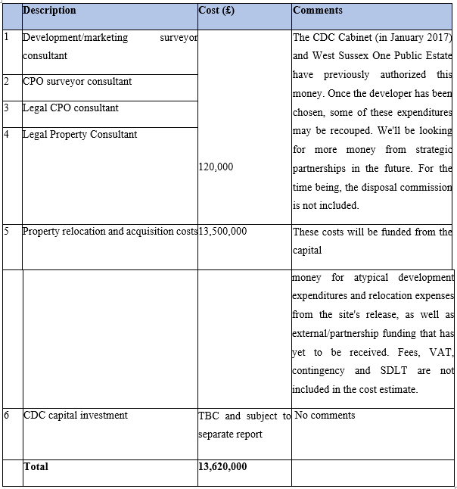
The project will be helped by the CDC's Executive Director, estates, legal, finance, public relations, procurement, and project management teams, as well as many other people. The developer who has been hired will take care of the costs that aren't in the above figures.
After the project is done, the cost will be worked out.
In the event that the council keeps a development share, the only thing that would cost money on a regular basis would be the management of that share. This would be part of the existing estates service's job description.
It is also thought that whatever is built will be profitable and will not need any more money from the government in the future to keep it going.

Summary of the Project Options.
There are a lot of ways this project could be done, including: CDC and its partners buy land, get planning permission, and build the project themselves. • Allow a third party to draw down the land at an agreed price for a set amount of time. This will allow them to do so. A third party can buy the land after certain conditions, like an acceptable planning permit, have been met. This type of sale is called a "conditional sale."
As with an unconditional sale, an unconditional contract with planning coverage has a clause that allows the CDC/partners to be paid more money if the project turns out better than planned, just like with an unconditional sale. There must be a new legal entity formed in order for Public-Private Partnerships to work. Landowners may be part of the partnership, and it would show how they would pay for things and share the benefits.
Any of these ideas could be done with or without the help of a CPO. The main landowners, including the Homes and Communities Agency, the West Sussex County Council, and the CDC, have met with outside consultants to figure out what to do about the issue. It has been decided that a conditional sale to a developer is the best way to go. So, the landowners' financial risk is reduced, they have some say in the final development's content, and they can join in on the investment if one or more partners choose to do so, but they don't have to.

Approach of the Project
The University of Wales Trinity Saint David will be put into place with the help of in-house, partnership, and outside consulting resources. In order to do this, there will be the formation of a Strategic Land Ownership Group. This group will be in charge of managing the disposal programme, timetable, and choice of development partners. It will also agree on how costs and benefits will be split up, and how they will be shared.
Project Management Plan

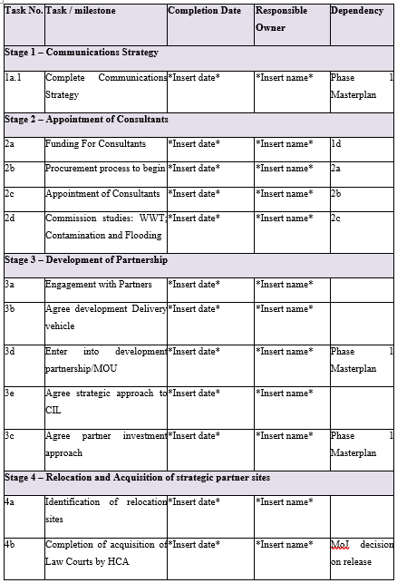
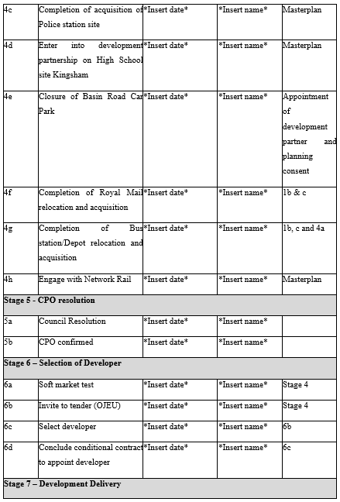
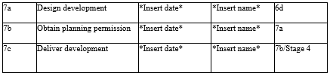

Project Management Team
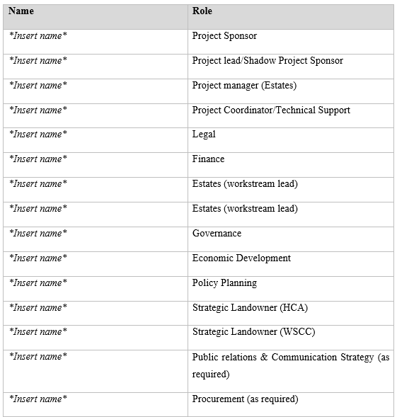
A Steering Group, or the proposed Growth Board, will oversee the project and report to it. Its membership will include senior political and officer representation from both the CDC and the WSCC, in addition to the Project Sponsor, who will act as a link between the Project Team and the Steering Group. The Project Team will report to the Steering Group or to the proposed Growth Board, depending on the situation. We will give strategic direction to the project with the assistance of the Steering Group/Growth Board, and we will address resource concerns that cannot be managed within the timeline and money allotted to the project team.

Communication Strategy for Project
On an ongoing basis, CDC Members will be kept informed through the monthly Members' Bulletin, as well as through bespoke email communication as needed, workshops, and reports to the Commercial Programme Board, Steering Group/Growth Board, as required, in accordance with the project's communication strategy (Renfro et al., 2018). In addition, reports to the Corporate Management Team will keep CDC officers abreast of the latest advances in their field.
Participants who are critical to the project's success but are not strategic partners, i.e., who are not landowners, will be kept informed of its development and will be given the opportunity to provide input at critical stages of the process (Shukor et al., 2021). A few examples include the Chichester Business Improvement District (BID), the Chichester City Council, and Visit Chichester.
Documents for public consultation will be made available for viewing on the Council's website as well as in hard copy at Council offices and public libraries throughout the community. All public discussions will be conducted in accordance with the Council's Statement on Community Involvement, which will be made accessible upon request to anybody who wishes to participate. Developing a communication strategy is something that will be done in the near future.
According to the Communication Strategy, which has been agreed upon by all parties to the agreement, Strategic Partners will use their own communication channels to publicise and inform their constituents about the activities of the organisation.
Planning-related factors such as pre-applications and planning applications will be taken into account in accordance with the standard regulatory communication and consultation process, which will include participation by the Development Plan and Infrastructure Panel and the Planning Committee in the case of a planning-related factor.

Risk Log
On this page, you will find a list of potential hazards, as well as an assessment of their severity and advice for precautions that can be done to mitigate or reduce the risks. As and when new project hazards are uncovered, detailed information about them will be documented.
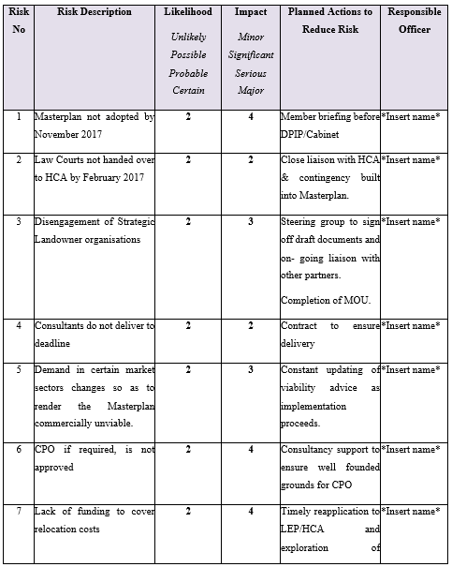
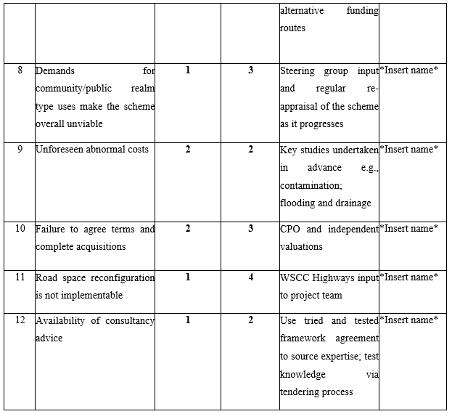

References
Daddey, F. and Watt, A., 2021. Project Initiation. Project Management.
Renfro, C.P., Ferreri, S., Barber, T.G. and Foley, S., 2018. Development of a communication strategy to increase interprofessional collaboration in the outpatient setting. Pharmacy, 6(1), p.4.
Shukor, N.S.A., MohdSuradi, N.R., KamarulAdzhar, Z.A., Adnan, Z., Teridi, N.A. and Abd Rauf, M.F., 2021. Information System Development with MVC Approach: A Case Study On Team Communication Strategy. Turkish Journal of Computer and Mathematics Education (TURCOMAT), 12(14), pp.4380-4390.

